 CHEMICAL ENGINEERING TRANSACTIONS  VOL. xxx, 2025 | A publication of  
The Italian Association
of Chemical Engineering
Online at www.cetjournal.it

Guest Editors: Fabrizio Bezzo, Flavio Manenti, Gabriele Pannocchia, Almerinda di Benedetto
Copyright © 2025, AIDIC Servizi S.r.l.
ISBN 979-12-81206-17-5; ISSN 2283-9216

A Preliminary Comparative Analysis of Sodium-Ion and Lithium-Ion Batteries: A Focus on Safety and Sustainability
Elpida Piperopoulos*, Maria Francesca Milazzo
Department of Engineering, University of Messina, Contrada di Dio, 98166 Messina, Italy
*epiperopoulos@unime.it
While sodium-ion batteries have emerged as a promising alternative to lithium-ion batteries due to their potential for lower costs and for the greater availability of raw materials, a comprehensive understanding of their environmental and social footprint is crucial. This research seeks to provide an initial comparison between sodium-ion and lithium-ion batteries, specifically examining aspects of safety, sustainability, and their impacts across the entire life cycle. This life cycle encompasses key stages such as raw material extraction, cell manufacturing, the usage phase, and end-of-life management. By employing risk identification techniques used for preliminary safety assessment, the risks of each stage are quantified and compared for both battery types. A particular emphasis is placed on the manufacturing phase and the production processes for the anode, cathode, and electrolyte materials. The potential risks associated with the use of hazardous chemicals and energy-intensive processes are identified and evaluated. Additionally, the safety performance of both battery types is assessed, considering factors such as thermal stability, flammability, and the risk of electrolyte leakage. The highest risk index is 1.35 and it is attributed to the autoclave process used in the production of cathode for lithium-ion batteries. By comparing the safety profiles of sodium-ion and lithium-ion batteries, information is gathered regarding their suitability for different applications, including electric vehicles, stationary energy storage, and portable electronics. The findings of this research contribute to a deeper understanding of the trade-offs between safety, sustainability, and performance for different battery technologies.
  - Introduction
The global energy transition necessitates a rapid shift away from fossil fuels towards cleaner and more sustainable energy sources. Renewable energy technologies, such as solar and wind power, play a crucial role in this transition. However, the intermittent nature of these sources needs efficient energy storage solutions to ensure a stable and reliable grid. Maintaining stable grid operation requires a consistent and uninterrupted electricity supply. However, renewable energy sources like solar and wind power are inherently intermittent due to their dependence on environmental factors such as sunlight and wind availability. Solar power generation is entirely reliant on sunshine, resulting in negligible output during nighttime. Wind power exhibits significant variability, fluctuating from high output (gigawatts) during strong winds to lower output (megawatts) or even zero during calm periods. As the grid increasingly depends on renewable energy sources, integrating these variable sources into existing grid operations sets a significant challenge (Zhao et al., 2023). Batteries, as electrochemical energy storage devices, have emerged as a cornerstone technology for integrating renewable energy sources, powering electric vehicles, and enabling grid-scale energy storage (Hamdan et al., 2024).
Lithium-ion batteries (LIBs) currently dominate the market due to their high energy density, long cycle life, and widespread commercial availability (Song et al., 2021). However, the growing demand for LIBs has raised concerns regarding the environmental and social impacts associated with lithium extraction and processing (Arshad et al., 2022) as well as its risk. Furthermore, the limited global lithium reserves and the potential for supply chain disruptions present significant challenges to the long-term sustainability of LIBs. The expanding market is anticipated to intensify pressure on lithium supplies, leading to a sustained increase in lithium prices globally (Zhao et al., 2023). The safety issues associated with lithium are traced back to risks due to the explosiveness and toxicity of the substances and manifest themselves instantly and/or in the medium-long term. The risks can be present in various phases which, beyond the battery’s use, include their production and transport (Rudola et al., 2021; Russo et al., 2018).
For this reason, Sodium-ion batteries (SIBs) have emerged as a promising alternative due to the abundance and low cost of sodium, a readily available and widely distributed element. This abundance mitigates items related to resource scarcity and supply chain vulnerabilities (Yabuuchi et al., 2014). Moreover, SIBs offer potential advantages in terms of safety, with a lower risk of thermal runaway and fire compared to some LIBs. However, SIBs currently face challenges in terms of energy density and cycle life, which are critical parameters for many applications (Cai et al., 2024).
A comprehensive analysis of battery safety in life cycle is fundamental to ensure a completely sustainable and efficient use of these technologies. A complete analysis allows to identify potential risks associated with the extraction, production, and disposal of these devices. Moreover, by understanding the entire life cycle, the most impactful phases can be identified to implement strategies to reduce the risk. This includes optimizing production processes, researching more safe alternative materials, and developing effective recycling systems.
Furthermore, a more accurate knowledge of battery life cycles allows identifying areas where further research and investment are needed. The search for new materials for electrodes and safer, higher-performing electrolytes can lead to the development of batteries with longer lifespans and a lower environmental impact. The aim of this study is to analyse the life cycle of lithium-ion batteries and, using risk identification techniques, to obtain the identified possible scenarios. To understand the potential impact of replacing LIB batteries with SIBs, a comparison of risks associated with the two systems is needed. In this work, a preliminary investigation of each phase from battery production to use will be performed. Section 2 introduces the methodology used for the study; Section 3 illustrates the investigated systems and the application of the methodology to them; Section 4 presents and discusses the results of the study; finally, Section 5 reports the main conclusions and future perspectives of the work.
  - Methodology
The methodology employed in this study is based on the analysis of the life cycle of the batteries. The main steps of the methodology are the following: (1) definition of system boundaries; (2) schematisation of the battery life cycle; (3) description of each phase of the battery life cycle; (4) application of risk identification techniques; (5) definition of risk indicators; (6) comparative analysis of systems.
It begins with the definition of the system's boundaries that comprise the raw materials required to produce the battery components, up to and including the production of the cathode, anode, and electrolyte solution. Subsequently, the life cycle will be constructed and the quantity of commonly used raw materials and obtained products will be estimated. Since this preliminary study focuses on the identification of hazardous scenarios due to process deviations involving dangerous substances and on a comparative risk assessment for the batteries, the employed risk identification technique is the Hazard and Operability Analysis (HazOp), obviously a complete study should include also the identification of mechanical failures. The qualitative assessment has been combined with a semiquantitative approach to derive some risk indexes.
HazOp is a structured and systematic method of analyzing a complex system to identify hazards to personnel, equipment or the environment, as well as operability problems that could affect the efficiency of operations of production of cathode, anode, and electrolyte solution. The technique is based on breaking down the overall process into simpler sections (called nodes) that are then examined individually. It is a qualitative technique and consists of identifying process deviations through the application of standardized guide words to process parameters in which hazardous substances are involved.
The definition of semiquantitative indexes allows a ranking of the identified process deviations. The indicators integrate the weights of four factors that contribute to the risk of the processes. These factors are:
- hazard factor for the substance involved in the process
- probability factor for the occurrence of the scenario
- consequence factor for the impact of the scenario
- prevention and/or mitigation factors
Table 1 shows the criteria for assigning weight to each factor and combining the contributions of each of them. The first three factors are elements that increase the hazard while the fourth is a reduction factor that can act on the probability or consequence factors of the event. The hazard classes for toxicity and flammability are defined in accordance with the classification defined in the Global Harmonization System; while, for explosiveness, reference is made to the criteria reported by the Health and Safety Executive (HSE). The probability factor refers to the occurrence probability of the event (Ps) as indicated in the literature or by the operator's field experience, while the consequence factor is a measure of the extension of the impact area (i.e. radius of the impacted area in meter r). The prevention and mitigation factors refer to the effectiveness of the safety systems installed in preventing and mitigating the scenario respectively.
Table 1: Factors and criteria for assigning weights
Hazard factor |  |  | Probability factor  PF | Consequence factor  CF | Prevention factor  PM | Mitigation factor  MM
Toxicity* T | Flammability* F | Explosivity** E
1 ⇒Category 4 | 1 ⇒T_{f} ≥ 60°C  and T_{ib} ≤ 93°C | 1 ⇒Class 4 | 1 ⇒Ps < 10⁻⁶ | 1 ⇒r = 0 | 1 – efficiency in preventing the event | 1 – efficiency in mitigating the event
2 ⇒Category 3 | 2 ⇒T_{f} ≥ 23°C  and T_{ib} ≤ 60°C | 2 ⇒Class 3 | 2 ⇒10⁻⁶<Ps≤10⁻³ | 2 ⇒1 < r ≤ 5
3 ⇒Category 2 | 3 ⇒T_{f} < 23°C  and T_{ib} > 35°C | 3 ⇒Class 2 | 3 ⇒10⁻³<Ps≤0.1 | 3 ⇒5 < r ≤ 25
4 ⇒Category 1 | 4 ⇒T_{f} < 23°C  and T_{ib} ≤ 35°C | 4 ⇒Class 1 | 4 ⇒Ps>0.10 | 4 ⇒r > 25
*GHS categories; **(Health and Safety Executive, 2024)
T_{f} = flash point; T_{ib} = initial boiling point
  - Case studies
This study focuses on LIB and SIB coin cell batteries (Batuecas et.al., 2024), whose components are made from the materials described below.
The anode of the LIB consists of approximately 4 mg of lithium, while the cathode is a mixture of lithium iron phosphate (LiFePO₄ ∼ 2.3 mg), polyvinylidene fluoride (PVDF - 0.3 mg), and carbon black (0.45 mg) deposited on an aluminum foil (5 mg). A 15 mm diameter glass microfiber disc filter (25 mg) is used to support the liquid electrolyte, which is introduced by impregnation (∼ 160 μL). The electrolyte is a commercial patented 1 M solution of lithium hexafluorophosphate (LiPF₆) in ethylene carbonate (EC) and dimethyl carbonate (DMC), or EC/DMC (50/50, v/v).
The anode of the SIB consists of approximately 4 mg of sodium, while the cathode is a mixture of sodium iron phosphate (NaFePO₄ ∼ 2.3 mg), polyvinylidene fluoride (PVDF - 0.3 mg), and carbon black (0.45 mg) deposited on an aluminum foil (5 mg). The electrolyte (1 M solution of sodium hexafluorophosphate, NaPF₆, in diglyme, ∼ 160 μL) is supported, as in LIBs, by a commercial separator (glass microfiber filter, 25 mg disc, 15 mm diameter), which is impregnated with the solution.
In both systems, a 2032 stainless steel coin cell is used for assembly the elements. The study's boundaries were defined to exclude the transportation, use, and end-of-life phases for the lifecycle. The risk assessment was concentrated on the production phase and exclusively on its associated chemical processes.
    - Production processes for anode, cathode and electrolyte solution
The production of LIBs involves a complex process that begins with the extraction of lithium from minerals, particularly spodumene. This mineral undergoes a series of treatments, including crushing, grinding, flotation, and roasting, to obtain purified lithium. Subsequently, lithium is combined with other elements to form the key components of the battery: the anode, the cathode, and the electrolyte as shown in Figure 1.
The electrolyte, typically a solution of LiPF₆ in organic solvents like dimethyl carbonate and ethylene carbonate, is prepared through chemical reactions and purification processes. The LiPF₆ solution is prepared by dissolving the salt in the two solvents (Figure 1(a)).
The anode is lithium, it is obtained from spodumene (Figure 1(b)). The spodumene is heated to a high temperature in an oven, to convert the crystalline phase of α-spodumene into the more valuable form of β-spodumene. This is followed by purification with sulfuric acid. Lithium carbonate or lithium hydroxide is then precipitated and crystallized from the acid-treated solution. The process is an electrolysis of the LiCl component of a LiCl-KCl eutectic in the temperature range between 400 and 450°C, to produce high-purity lithium metal.
The cathode consists of LiFePO₄, polyvinylidene fluoride, and carbon black, obtained through synthesis and mixing processes (Figure 1(c)). Lithium sulfate monohydrate (Li₂SO₄·H₂O), potassium dihydrogen phosphate (KH₂PO₄), and ferrous sulfate heptahydrate (FeSO₄·7H₂O) are dissolved in a mixture of ethylene glycol/H₂O (1:1 by volume) by magnetic stirring, forming a suspension as a raw material for the hydrothermal synthesis. Potassium hydroxide (KOH) is added and, after stirring for 30 minutes, the suspension is transferred to a Teflon-lined autoclave made of stainless steel. The sealed autoclave is heated to 200°C for 16 hours for the hydrothermal reaction. The cooled LiFePO₄ product is washed with distilled water and ethanol and, after drying, is mixed with sucrose at 600°C for 4 hours in a nitrogen atmosphere to form carbon. Finally, they are deposited, in the presence of polyvinylidene fluoride, on aluminium. Polyvinylidene fluoride (PVDF) is the alternating homopolymer of vinylidene fluoride and is obtained through a polymerization reaction.
(a) 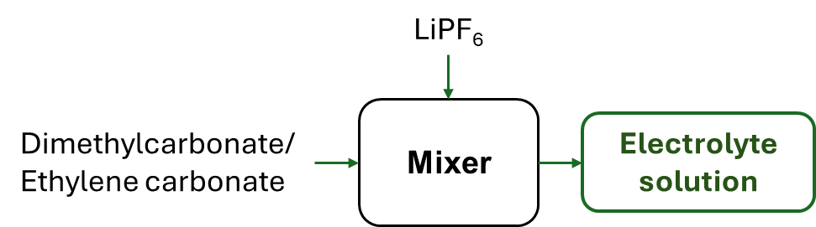 (b)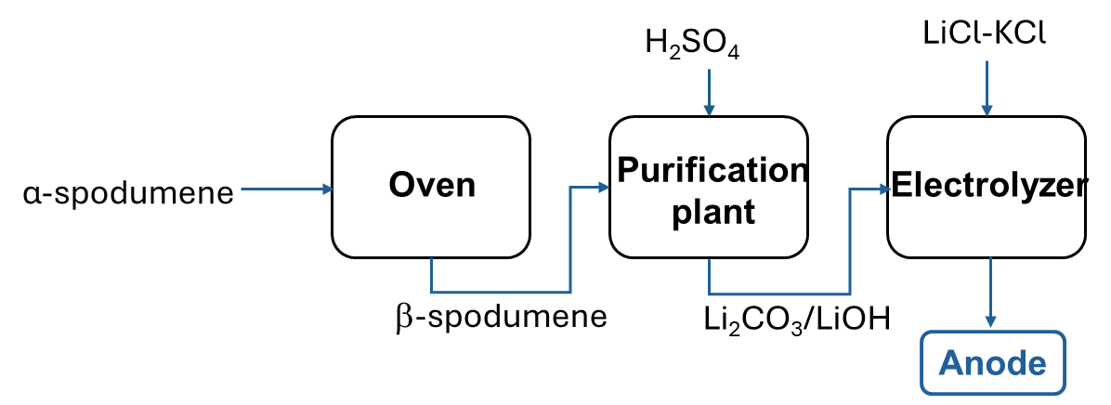
(c)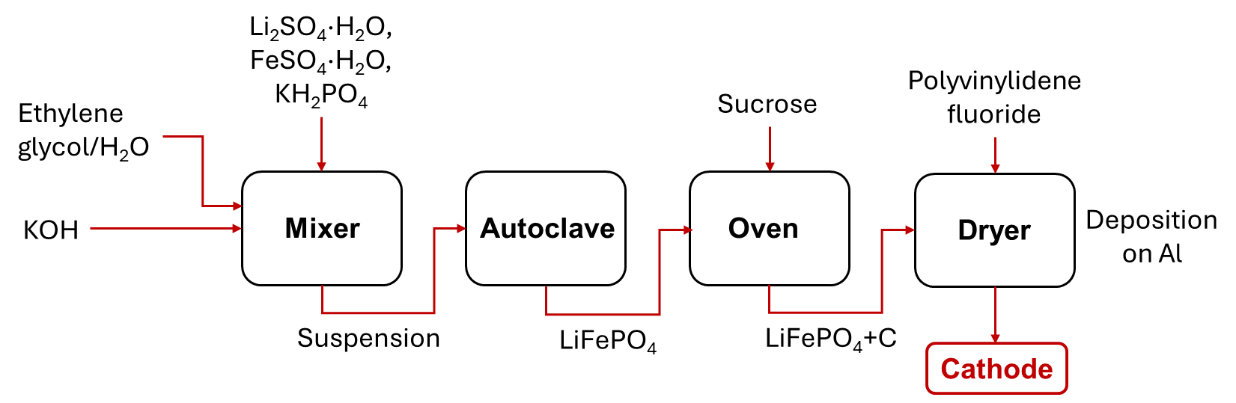
Figure 1: Production process of LIB’s components: (a) electrolyte solution, (b) anode, and (c) cathode
Concerning SIB, the production processes of the key components are given in Figure 2. The electrolyte, typically a solution of NaPF₆ in organic solvents like diglyme, is prepared through chemical reactions and purification processes. The NaPF₆ solution is made by mixing the salt in the diglyme solvent (Figure2(a)).
The sodium used for the anode of SIBs is obtained from common salt (NaCl) through electrolysis (Figure 2(b)). Sodium chloride can be extracted through mining, following different steps (accumulation, transfer, sieving, classification, packaging and transport). The purified salt undergoes high-temperature electrolysis as the low reduction potential prevents obtaining sodium from the electrolysis of aqueous NaCl solutions. In the electrolysis of molten NaCl, calcium chloride (CaCl₂) and alkali fluorides are added to lower the melting point to ∼ 600°C (Downs process).
The cathode is a mixture of NaFePO₄, polyvinylidene fluoride, and carbon black (Figure 2(c)). The carbon black can be obtained by the Channel Black process, in which methane is burned at low temperature (500°C) and in a low presence of air, insufflating it at low pressure. The combustion gas laps the external bottom of iron channels in which water flows, depositing very fine dust. The channels are vibrated to detach the produced carbon black. Then, it needs to be purified to separate gravel, coarse particles, and scales, through sieving. The powder is transported after agglomeration into spherules and granulation and drying at 65°C.
The NaFePO₄ salt is obtained by electrochemical insertion of sodium into delithiated ferric phosphate (FePO₄). This method requires two steps: delithiation and insertion of sodium into the delithiated FePO₄ in a new cell with metallic sodium as the anode. Electrochemical sodiation is carried out in an electrochemical cell containing 50 mL of 1 M sodium perchlorate (NaClO₄) electrolyte in propylene carbonate. FePO₄/Al is used as the working electrode with metallic Na as the counter electrode, also the reference electrode is metallic Na. The calcined FePO₄ powder is mixed with carbon black and polyvinylidene fluoride. The mixture is dispersed in N-methyl-2-pyrrolidone and the suspension is cast on aluminium foil and dried at 60°C for 2 hours in a vacuum oven.
(a)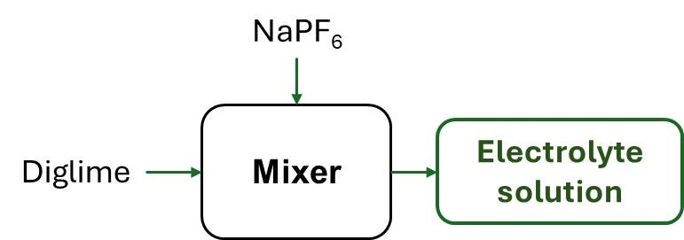 (b)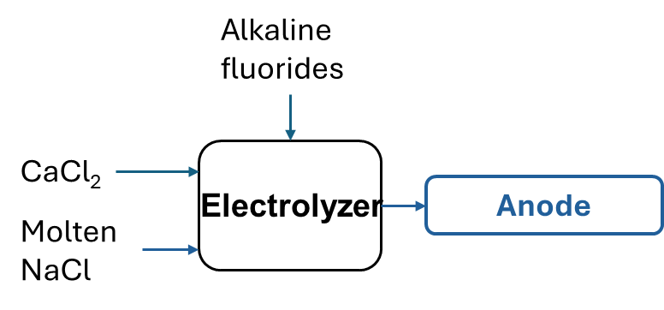
(c)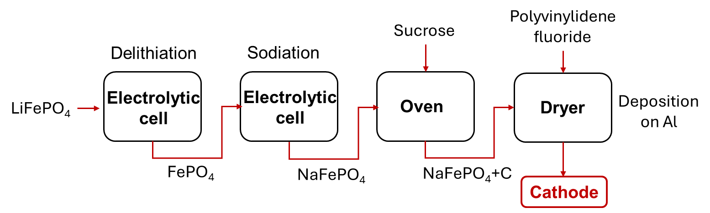
Figure 2: Production process of SIB’s components: (a) anode; (b) cathode, and (c) electrolyte solution
  - Results
The scenarios, identified as a result of the HazOp application, can be traced back to the chemical treatments shown in the Figures 1 and 2. The process deviations are reported in Table 2 and 3. The rows include some explanatory examples of possible process deviations, causes, consequences and corrective actions. Furthermore, the results of risk indexes elaboration have been added. The examples have been chosen to show the application of the methodology to processes characterized by greater complexity.
Table 2: Process deviations in the LIB production cycle, their causes and consequences, corrective actions, and risk indexes
Component | Deviation  process parameter/keyword | Cause | Consequence | Corrective action | Partial index | Risk index
LIB anode | Temperature in the electrolyzer above 450°C  More/temperature | Electrolyzer heating system malfunction | Increased reaction rate  Possible formation of by-products (HCl)  Explosions | Continuous temperature monitoring  Extractor hood | T = 4; F = --; E= 1 | 0.24
 |  |  |  |  | PF = 2
 |  |  |  |  | CF = 2
 |  |  |  |  | PM = 1 – 0.95
 |  |  |  |  | MM = 1 – 0.70
LIB cathode | Temperature in autoclave above 200°C  More/temperature | Autoclave heating system malfunction | Increased reaction rate  Possible formation of by-products (decomposition of LiFePO₄)  Explosions | Continuous temperature monitoring | T = 1; F = --; E= 3 | 1.35
 |  |  |  |  | PF = 3
 |  |  |  |  | CF = 3
 |  |  |  |  | PM = 1 – 0.95
 |  |  |  |  | MM = 1 (no system)
LIB electrolyte | Undesired LiPF₆/DMC ratio More/Less LiPF₆/DMC ratio | Incorrect incoming flows | Undesired concentration of the mixture  Ionic conductivity reduction | Continuous ratio control of incoming flows | T = 1; F = 2; E= 1 | 0.60
 |  |  |  |  | PF = 3
 |  |  |  |  | CF = 1
 |  |  |  |  | PM = 1 – 0.90
 |  |  |  |  | MM = 1 (no system)
Table 3: Process deviations in the SIB production cycle, their causes and consequences, corrective actions, and risk indexes
Component | Deviation  process parameter/keyword | Cause | Consequence | Corrective action | Partial index | Risk index
SIB anode | Temperature in the electrolyzer above 600°C  More/temperature | Electrolyzer heating system malfunction | Increased reaction rate  Explosions and release of Cl₂ | Continuous temperature monitoring | T = 4; F = --; E= 2 | 1.20
 |  |  |  |  | PF = 2
 |  |  |  |  | CF = 3
 |  |  |  |  | PM = 1 – 0.95
 |  |  |  |  | MM = 1 (no system)
SIB cathode | Temperature in the oven above 600°C  More/temperature | Oven heating system malfunction | Total combustion of sucrose and alteration of the cathode composition | Continuous temperature monitoring | T = 1; F = 2; E= 2 | 0.40
 |  |  |  |  | PF = 2
 |  |  |  |  | CF = 2
 |  |  |  |  | PM = 1 – 0.95
 |  |  |  |  | MM = 1 (no system)
SIB electrolyte | Undesired NaPF₆/diglyme ratio More/Less NaPF₆/Diglyme ratio | Incorrect incoming flows | Undesired concentration of the mixture  Ionic conductivity reduction | Continuous ratio control of incoming flows | T = 1; F = 2; E= 1 | 0.60
 |  |  |  |  | PF = 3
 |  |  |  |  | CF = 1
 |  |  |  |  | PM = 1 – 0.90
 |  |  |  |  | MM = 1 (no system)

Before commenting on the results, some considerations must be made:
- the assignment of the score to the hazard factor is carried out by considering the highest level of dangerousness between toxicity, flammability and explosiveness;
- each partial score is assigned on the basis of indications provided by researchers with experience in the processes under study;
- the prevention and/or mitigation factors reduce the risk index, decreasing it by a percentage equal to the efficiency of the prevention and mitigation systems installed.
The findings of this analysis reveal a significantly elevated risk profile for electrolytic processes that inherently involve the generation of hazardous byproducts, for example by the Downs process for sodium metal production. This heightened risk stems from the potential release and exposure to toxic substances during operation. However, the strategic implementation of robust prevention and mitigation systems, such as advanced ventilation, containment measures, and real-time monitoring, can effectively attenuate the calculated risk indicator values when these systems are diligently installed and maintained. Conversely, the highest risk index is attributed to the autoclave process. This is primarily due to the intrinsic dangerousness of the substances handled within the autoclave, notably their potential for explosiveness under specific temperature and pressure conditions. A limitation of the study concerns its scale that is currently limited to the laboratory level. The extension on a larger scale would allow to better understand the safety associated with the processes studied, taking into account the effects of all the installed systems for the prevention and mitigation of risks and also considering the contributions of mechanical failures.
  - Conclusions
This study compared safety risks in lithium-ion (LIB) and sodium-ion (SIB) battery production using HazOp analysis, focusing on anode, cathode, and electrolyte chemical production processes. Risk analysis considered hazard levels, probabilities, consequences, and mitigation effectiveness. Higher risks were found in electrolytic (Risk Index =1.20) and autoclave processes (Risk Index = 1.35), respectively for SIBs and LIBs, reduced by mitigation systems. Future work should expand to transportation, usage, end-of-life, and industrial-scale failures for improved safety in battery development.
Acknowledgments
This research was funded by Consiglio Nazionale delle Ricerche CNR within the “Piano Triennale della Ricerca del Sistema Elettrico Nazionale 2022-2024 (AdP PT 22-24)”, Project “ACCUMULO 1.2 - Progetto Integrato su Tecnologie di accumulo elettrochimico e termico”, Activity 1.8 “Risk analysis associated with the extraction and processing processes of the materials constituting the electrochemical storage devices and their use”.
References
Arshad F., Lin J., Manurkar N., Fan E., Ahmad A., Tariq M., Wu F., Chen R., Li L., 2022, Life Cycle Assessment of Lithium-ion Batteries: A Critical Review, Resources, Conservation and Recycling, 180, 106164-106188.
Batuecas E., Martínez-Cisneros C.S., Serrano D., Varez A., 2024, Life cycle assessment of lab-scale solid sodium-ion batteries: A sustainable alternative to liquid lithium-ion batteries, Journal of Energy Storage, 80, 110355-110364.
Cai X., Yue Y., Yi Z., Liu J., Sheng Y., Lu Y., 2024, Challenges and industrial perspectives on the development of sodium ion batteries, Nano Energy, 129, 110052-110070.
Hamdan A., Daudu C.D., Fabuyide A., Etukudoh E.A., Sonko S., 2024, Next-generation batteries and U.S. energy storage: A comprehensive review: Scrutinizing advancements in battery technology, their role in renewable energy, and grid stability, World Journal of Advanced Research and Reviews, 21, 1984–1998.
Health and Safety Executive <hse.gov.uk/explosives/licensing/hazard-classification.htm> accessed 18.02.2024
Rudola A., Wright C.J., Barker J., 2021, Reviewing the Safe Shipping of Lithium-Ion and Sodium-Ion Cells: A Materials Chemistry Perspective, Energy Material Advances, 2021, 1-12.
Russo P., Mazzaro M., De Rosa A., 2018, Effective fire extinguishing systems for lithium-ion battery, Chemical Engineering Transactions, 67, 727-732.
Song, G., Son, H. B., Han, D. Y., Je, M., Nam, S., & Park, S. (2021). A renewable future: a comprehensive perspective from materials to systems for next-generation batteries. Materials Chemistry Frontiers, 5, 3344-3377.
Yabuuchi N., Kubota K., Dahbi M., Komaba S., 2014, Research development on sodium-ion batteries, Chemical Reviews Journal, 114, 11636-11682.
Zhao L., Zhang T., Li W., Li T., Zhang L., Zhang X., Wang Z., 2023, Engineering of Sodium-Ion Batteries: Opportunities and Challenges, Engineering, 24, 172-183.

