 CHEMICAL ENGINEERING TRANSACTIONS  VOL. xxx, 2025 | A publication of  
The Italian Association
of Chemical Engineering
Online at www.cetjournal.it

Guest Editors: Fabrizio Bezzo, Flavio Manenti, Gabriele Pannocchia, Almerinda di Benedetto
Copyright © 2025, AIDIC Servizi S.r.l.
ISBN 979-12-81206-17-5; ISSN 2283-9216

Development of water-alkaline electrolyzer based on nickel alloy electrodes
R.L Oliveriª *, B.Patellaª, S. Geraciª, N. Moukriª, G. Aielloª, S. Longoª, A. Affranchi^{b}, M. Cellura^{a,b}, R. Inguantaª
ª Dipartimento di Ingegneria, Università degli Studi di Palermo, 90128 Palermo, Italy
^{b} Centro di Sostenibilità e Transizione Ecologica, Università degli Studi di Palermo, 90133 Palermo, Italy
robertoluigi.oliveri@unipa.it

The electrochemical water splitting is regarded as an appealing method for transforming and storing surplus energy from renewable sources. Nevertheless, the production of hydrogen by water electrolysis is not economically viable. To reduce the cost of the resulting hydrogen, it is necessary to transition from noble-metal catalysts (Pt, Pd, etc.) to more cost-effective alternatives that can guarantee high levels of electrocatalytic activity for both oxygen and hydrogen evolution reactions, while also being more affordable on a per-unit-energy basis. Among transition metals, nickel was selected as the active material due to its low cost and high chemical stability in alkaline media.
This work investigates the fabrication and characterization of nanostructured Ni alloy electrodes to reduce the overpotential losses associated with driving the anode oxygen evolution reaction (OER) and the cathode hydrogen evolution reaction (HER) in alkaline environments. Ni alloy nanowires (NWs) with very high surface area and high electrocatalytic activity were prepared by template electrosynthesis. A complete AW laboratory-scale electrolysis system was designed to simultaneously tracks the electrolyser H₂ and O₂ yield, as well as operating current and voltage. It has been found that alkaline electrolyzers with Ni nanowire electrodes coated with different electrocatalysts have good performance and are stable even at room temperature.

  - Introduction
In the last years, considerable attention has been dedicated to finding viable methods for producing green hydrogen from renewable sources (Amores et al., 2014). Among the various methods, electrolysis of water is an interesting way to produce green H₂. This is possible if the electrical input is provided by a renewable energy source (RE). Alkaline electrolysis has recently gained considerable attention as a viable method for producing green hydrogen from renewable sources, as its technology is cheaper than that based on acid solutions and not require precious metals as electrocatalysts (Ganci et al., 2021). Researchers are currently focusing on improving electrolysers, for example, by trying to increase their dynamic performance and efficiency.
In the improvement and optimization of the electrode material, of fundamental importance is the morphology of the electrodes which, to ensure high performance, must have very large surface areas (Lopez-Fernandez et al., 2020). For this reason, different types of nanostructured electrodes, which guarantee high aspect ratios, have been developed with 1D (WEY et al., 2018), 2D (Chandrasekaran et al.,2020) and 3D morphology (Yan et al., 2015). Among the different nanostructured morphologies, nanowires (NWs) are extremely interesting for the development of electrodes for HER reaction (LI et al., 2017) (Nairan et al., 2019). As reported by (Yan et al., 2015), well-ordered NW arrays are ideal to make electrodes for gas evolution because they decrease the pathway of ionic diffusion, enable the ionic motion towards electrode inner part, improve the electrode material utilization degree and favour a rapid release of the gas bubble. The unique NWs morphology provides many electrocatalytically active sites, offers efficient conductive paths, facilitates the electrolyte mass transport and the release of gas bubbles. A straightforward method for obtaining electrodes based on ordered arrays of NWs is template electrosynthesis. Through this method, we have fabricated Ni alloy electrodes NWs that have a very high surface area and good catalytic performance (Carbone et al., 2023). For comparison, Ni Sheets (NS), differently functionalized with the same electrocatalysts, were tested. These alloys were selected due to their promising properties. A ternary alloy of nickel-iron-phosphorous nanowires electrode was fabricated by electrodeposition and its performance was compared with the binary nickel-iron alloy and nickel obtained in our previous work by template electrosynthesis (Carbone et al. 2023). The environmental impacts of the fabrication of Ni alloys NWs through the application of LCA methodology were also evaluated. The results show that electrodeposition is a process with a low impact. Nanostructured electrodes were used to build a laboratory-scale water electrolyser cell for hydrogen production. The laboratory-scale electrochemical cell was constructed by using a laser cutter. Results obtained with nanostructured electrodes were compared using planar electrodes tested in identical conditions. The results showed that water-alkaline electrolysers with nickel alloy nanowire electrodes exhibited good and stable performance at room temperature.
  - Experimental
2.1 Electrode Fabrication
Nickel, Nickel-Iron and Nickel-Iron-Phosphorus nanostructured electrodes were fabricated through template electrosynthesis, using a polycarbonate membrane as a template. This method consists of four essentially steps. At the beginning, the membrane was made conductive through a sputtering process. Using a Scancoat Six Sputter Coater from Edwards Ltd, a thin film of gold (about 30 nm) was deposited on one side of the template. Deposition takes place by applying a continuous current of 30 mA for 3 minutes. Subsequently, on the gold side, Nickel was electrodeposited using a Watt’s bath (300 g/L Nickel sulphate hexahydrate, 45 g/L nickel chloride, 45 g/L boric acid), by potentiostatic electrodeposition at -1.5 V vs. Saturated Calomel Electrode (SCE) for 1.5 h. The electrodeposited Ni layer was successively used as a current collector for electrodepositing the nanostructures inside the template. For the electrodes sheet, a commercial Ni sheet was used. To remove the oxide layer and impurities on the surface of nickel sheet (1 cm × 1cm), it was ultrasonicated in 3 M HCl solution and absolute ethanol for 20 min, respectively. Then the sheet was rinsed with deionized water and dried in air. The Nickel-Iron and Nickel-Iron-Phosphorus NWs and sheet manufacturing processes differs in the deposition in terms of solution composition and operating parameters. For the Ni-Fe deposition, a Watt’s bath with 0.44 M FeSO₄∙7H₂O was used. Ni-Fe-P NWs were manufactured by adding 20 g/L of sodium hypophosphite monohydrate to the previous solution (Watt’s bath with FeSO₄). The deposition technique is a pulsed square wave where the potential switches from -1.2 (for 6 s) to -0.75 V (for 4 s) vs. SCE for 70 cycles, for a total duration of approximately 20 minutes. The electrodeposition was carried out in a standard three electrodes cell at room temperature. A Pt mesh was used as a counter electrode and a saturated SCE as a reference. After the nanostructures growth, the template was dissolved in chloroform. The electrode was immersed in fresh chloroform for 5 minutes, and the procedure was repeated four times to guarantee the complete dissolution of the membrane. The obtained NWs electrodes were characterized by scanning electron microscopy (SEM) using a FEG-ESEM microscope (QUANTA 200 by FEI), and energy dispersive spectroscopy (EDS) to evaluate the morphology and the composition of the nanowires.

2.2 Electrochemical Characterizations
Ni, Ni-Fe and Ni-Fe-P sheet and NWs electrodes were tested both as anodes as cathodes to study their performances as bifunctional catalysts in alkaline electrolysers. Electrochemical tests were carried out in a 30% w/w KOH aqueous solution to simulate industrial condition. The electrochemical measurements were performed in a standard three-electrode system: Ni sheet electrode and NWs electrode are the working electrode (A ≈ 0.6 and 2 cm² for NWs and sheet respectively), a Ni strip was used as counter-electrode and Hg/HgO 0.1 M NaOH as reference. In the following, all the potentials will be referred to the value of the Reversible Hydrogen electrode (RHE) at pH 14. All the tests were performed at room temperature without stirring. Quasi Steady State Polarization (QSSP) was performed in a potential range of 0.7 V around the thermodynamic potential of HER and OER at a scan rate of 0.1667 mV s^{–1}. A multichannel Cell Test System was used to perform the electrochemical characterization and the data were recorded by MultiStat Software.

2.3 Cell Design
Figure 1 shows an exploded view of the cell. The electrolyser contains two Ni foils used as collectors and NWs as catalyst electrodes or NS as funzionalized electrodes and a commercial diaphragm (Zirfon®).
The design is symmetrical with respect to the central membrane and consists of the following components:
1. An endplate with a thickness of 10 mm made from plexiglass with inlet and outlet for electrolyte
2. Flow channel made of plexiglass of 2 mm thickness. There is an inlet for the electrolyte at the right bottom and an outlet to capture generated gas at the top
3. Flow Chamber in line made of plexiglass of 2 mm thickness for the electrolyte bath
4. PTFE seal of 0.5 mm
5. PTFE seal of 0.5mm with cut-out for separator
The PTFE seal with cut-out ensures gas and liquid tightness between the electrode and electrolyte chamber. The electrolyte is supplied through the lower inlet ports at the side of the spacer via a reservoir. The gas bubbles will rise and leave the electrolyser via the ports at the top of the spacers. The tapered electrolyte chamber improves gas removal. Overall, this is a simple design with components that are easy to manufacture from readily available materials. Bolts are used to make the electrolyzer watertight by compression.
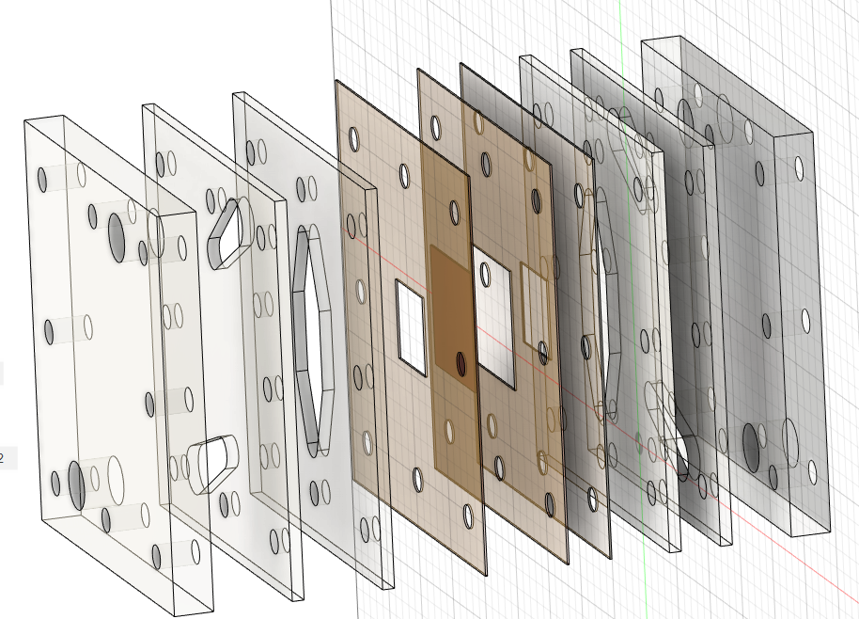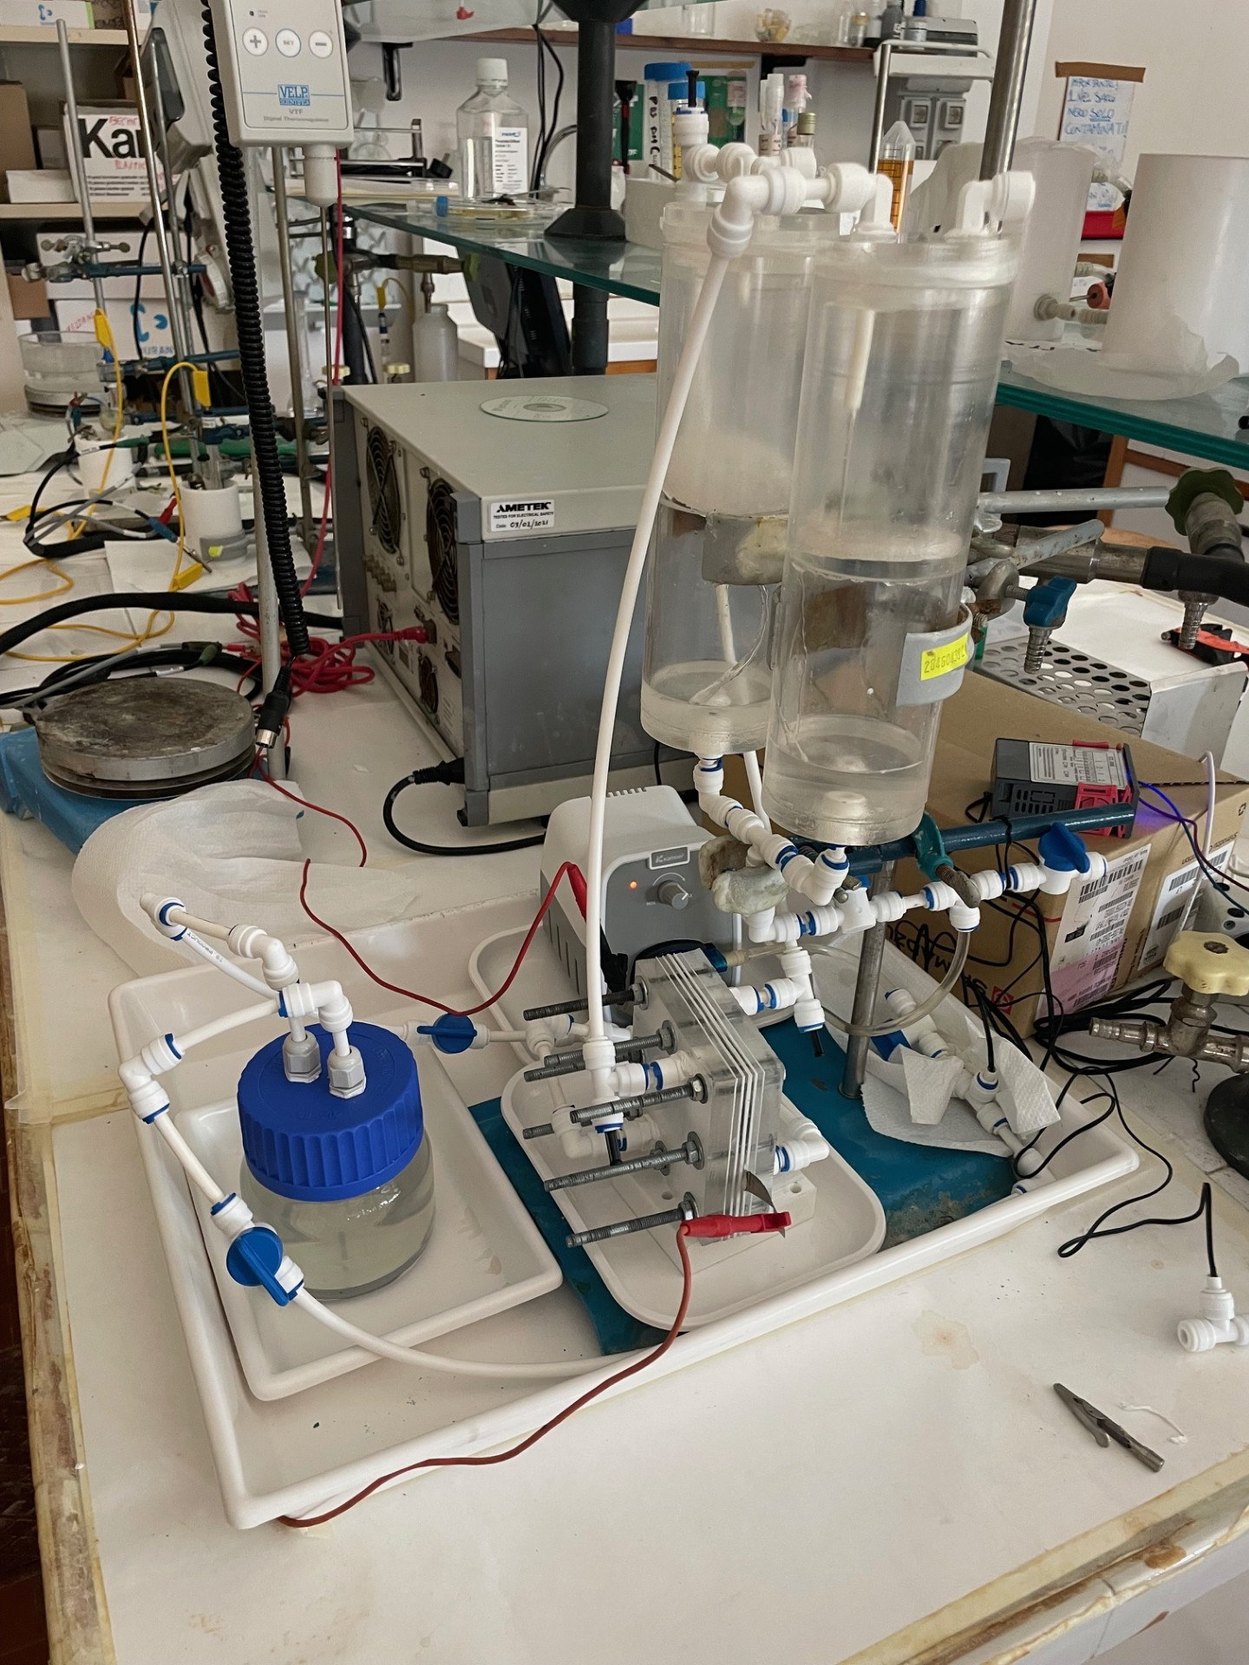
b
a
2
1
3
4
5
2
1
3
4
Figure 1: Exploded view of cell design (a) assembled cell (b)
2.4 LCA
Life cycle assessment (LCA) is a powerful tool to evaluate the potential environmental impacts of a product throughout its lifecycle. The analysis of the entire life cycle detects all hidden environmental impacts, identifying improvement areas and avoiding burden shifting (UNI EN ISO 14040; UNI EN ISO 14044). The aims are the assessment of the energy and environmental impacts of the Ni alloy nanowire electrodes. Secondly, the study aims at the identification of the energy and environmental hot spots by means of contribution analyses conducted in each phase of manufacturing process.
  - Results and discussions
In order to check the complete PCM dissolution and NWs uniformity, SEM and EDS analyses were conducted. Figure 2a shows cylindrical Ni-NWs having a regular shape with almost 20 nm diameter and around 5 μm long, smooth and regular surface and are evenly distributed over the entire surface of the nickel collector.They are highly interconnected owing to geometry of the template. To observe the structure morphology of two different kind of electrodes, SEM has been employed. Figures 2a and 2b showed the SEM images, of Ni, NiFe NWs and NiFeP sheet and NWs, respectively. The films formed on sheet cover the entire Ni substrate after the electrodeposition process, leading to the formation of a planar morphology.
To investigate the NWs composition, EDS analysis were carried out. To obtain the EDS spectrum measurement with a more exact estimate of the composition, the NWs were ripped from the nickel collector. The table 2, shows the EDS of the sheets and NWs. By EDS, the presence of phosphorus has been confirmed. Both types of alloys were obtained from a solution richer in nickel than in iron. However, in agreement with the data in the literature (Carbone et al.2023; Buccheri et al. 2021), the sheet and NWs appear richer in iron, confirming the anomalous deposition of iron.
By cyclic voltammetry, at different scan rates, ECSA was evaluated by the double layer capacitance method (Buccheri et al. 2021). Current density values have been utilised to estimate the ECSA of NWs electrodes to be 7-8 times larger than that of the planar electrode. However, it should be noted that this value is approximate due to the existence of different methods for evaluating ECSA, each of which can yield different results using the same material. This discrepancy can be attributed to the fact that each electrocatalyst, even if made from the same material, is typically unique in size, shape, morphology and porous structure.
The electrocatalytic activity of sheet and NWs, was characterized through recording QSSP curves shown in Figure 3 and 4. For the cathodic reaction, the potential was scanned from 0.1 V to -0.9 V vs RHE at 0.1667 mVs -1. For the anodic reaction, the potential was scanned from 1.1 V to 2.1 V vs RHE at 0.1667 mVs ⁻¹.

NiFeP Sheet
NiFe Sheet
Ni Sheet
Figure 2a: SEM images of Ni, NiFe and NiFeP Sheet

Ni Nanowires
NiFeP Nanowires
NiFe Nanowires
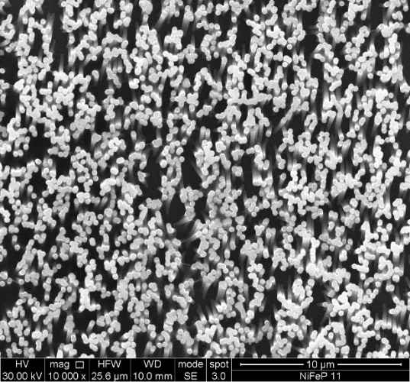

Figure 2b: SEM images of Ni Nws, NiFe NWs and NiFeP

Table 1: Ni, NiFe, NiFeP atomic concentration of electrodeposited sheets and NWs
Element | Ni Sheet |  | NiFe Sheet | NiFeP sheet | Ni NWs | NiFe NWs | NiFeP NWs
Ni  Fe  P  O | 100%  0  0  0 | 19.10%  51.42%  0  29.48% |  | 18.74%  57.33%  6.20%  17.7% | 100%  0  0  0 | 53.03%  38.55%  0  9.42% | 53.68%  40.00%  6.22%  0

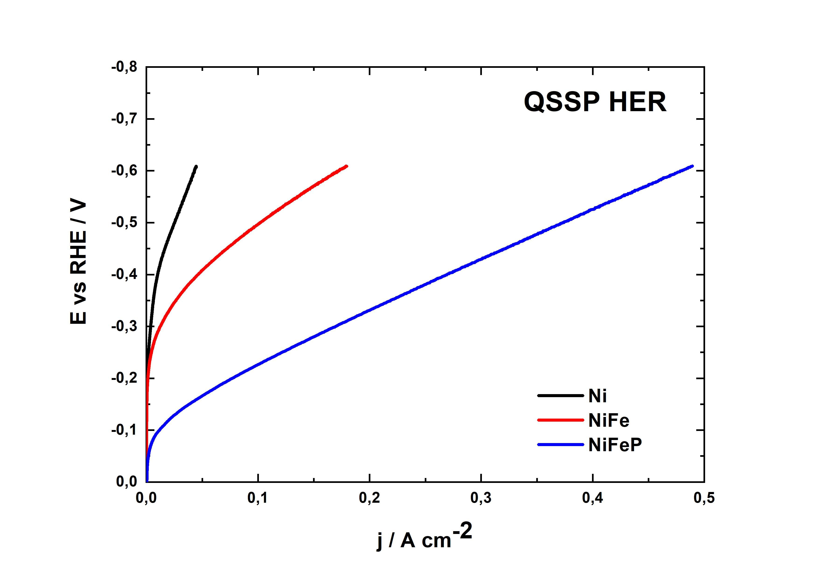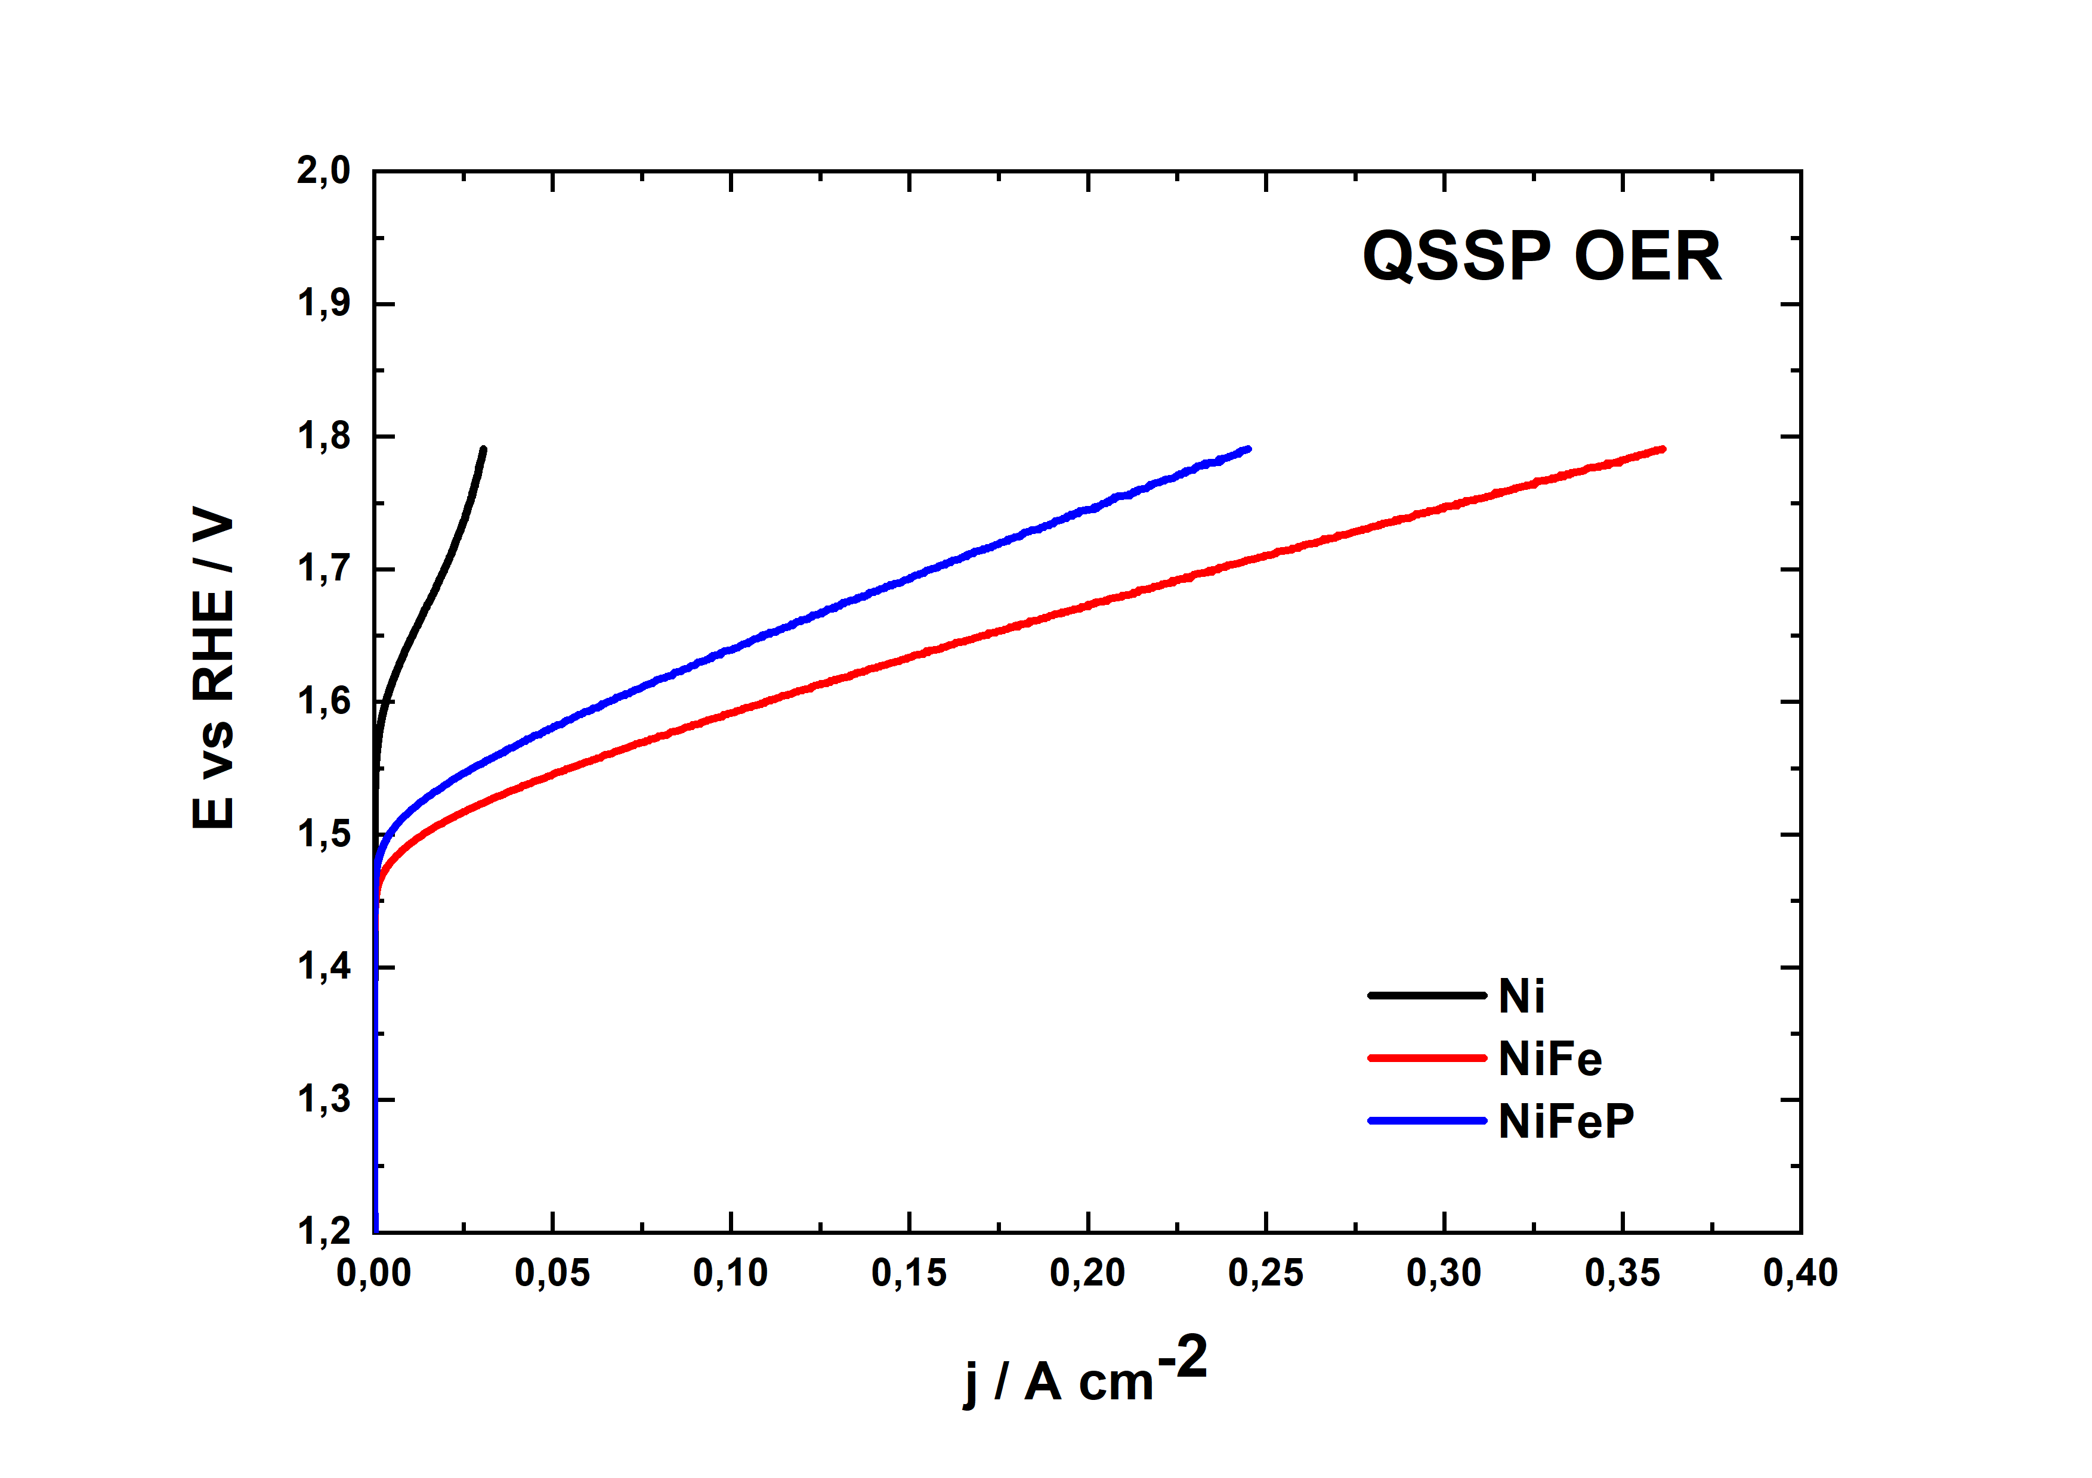
Figure 3. Potentiodynamics for the a) HER and b) OER of sheet

As can be observed in Figures 3 and 4, in all three types of materials, the presence of the catalyst has a clear positive effect on performance. In the case of OER, the difference between NiFe and NiFeP is less pronounced. Conversely, in the HER case, the ternary alloy exhibits superior performance, with a reduction in overvoltage at the same current density. This result is consistent with the findings of previous studies (Carbone et al., 2023).
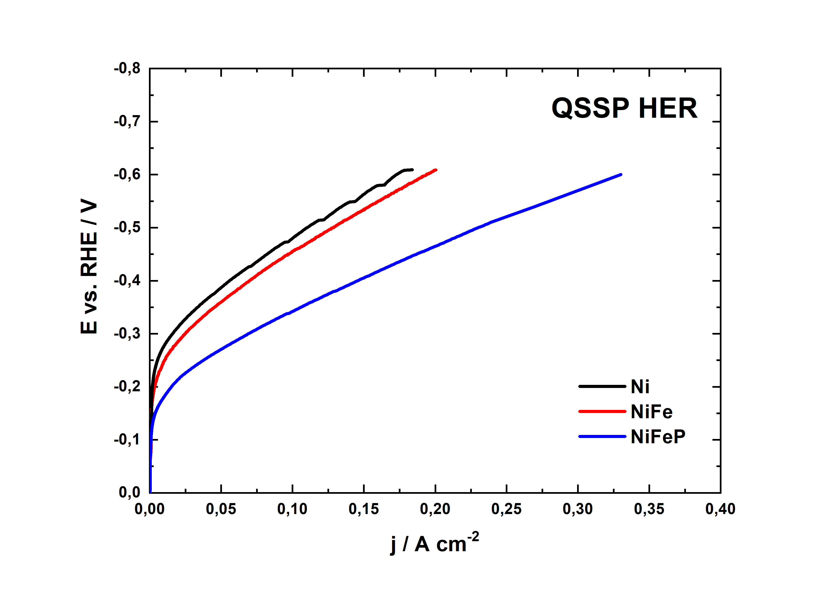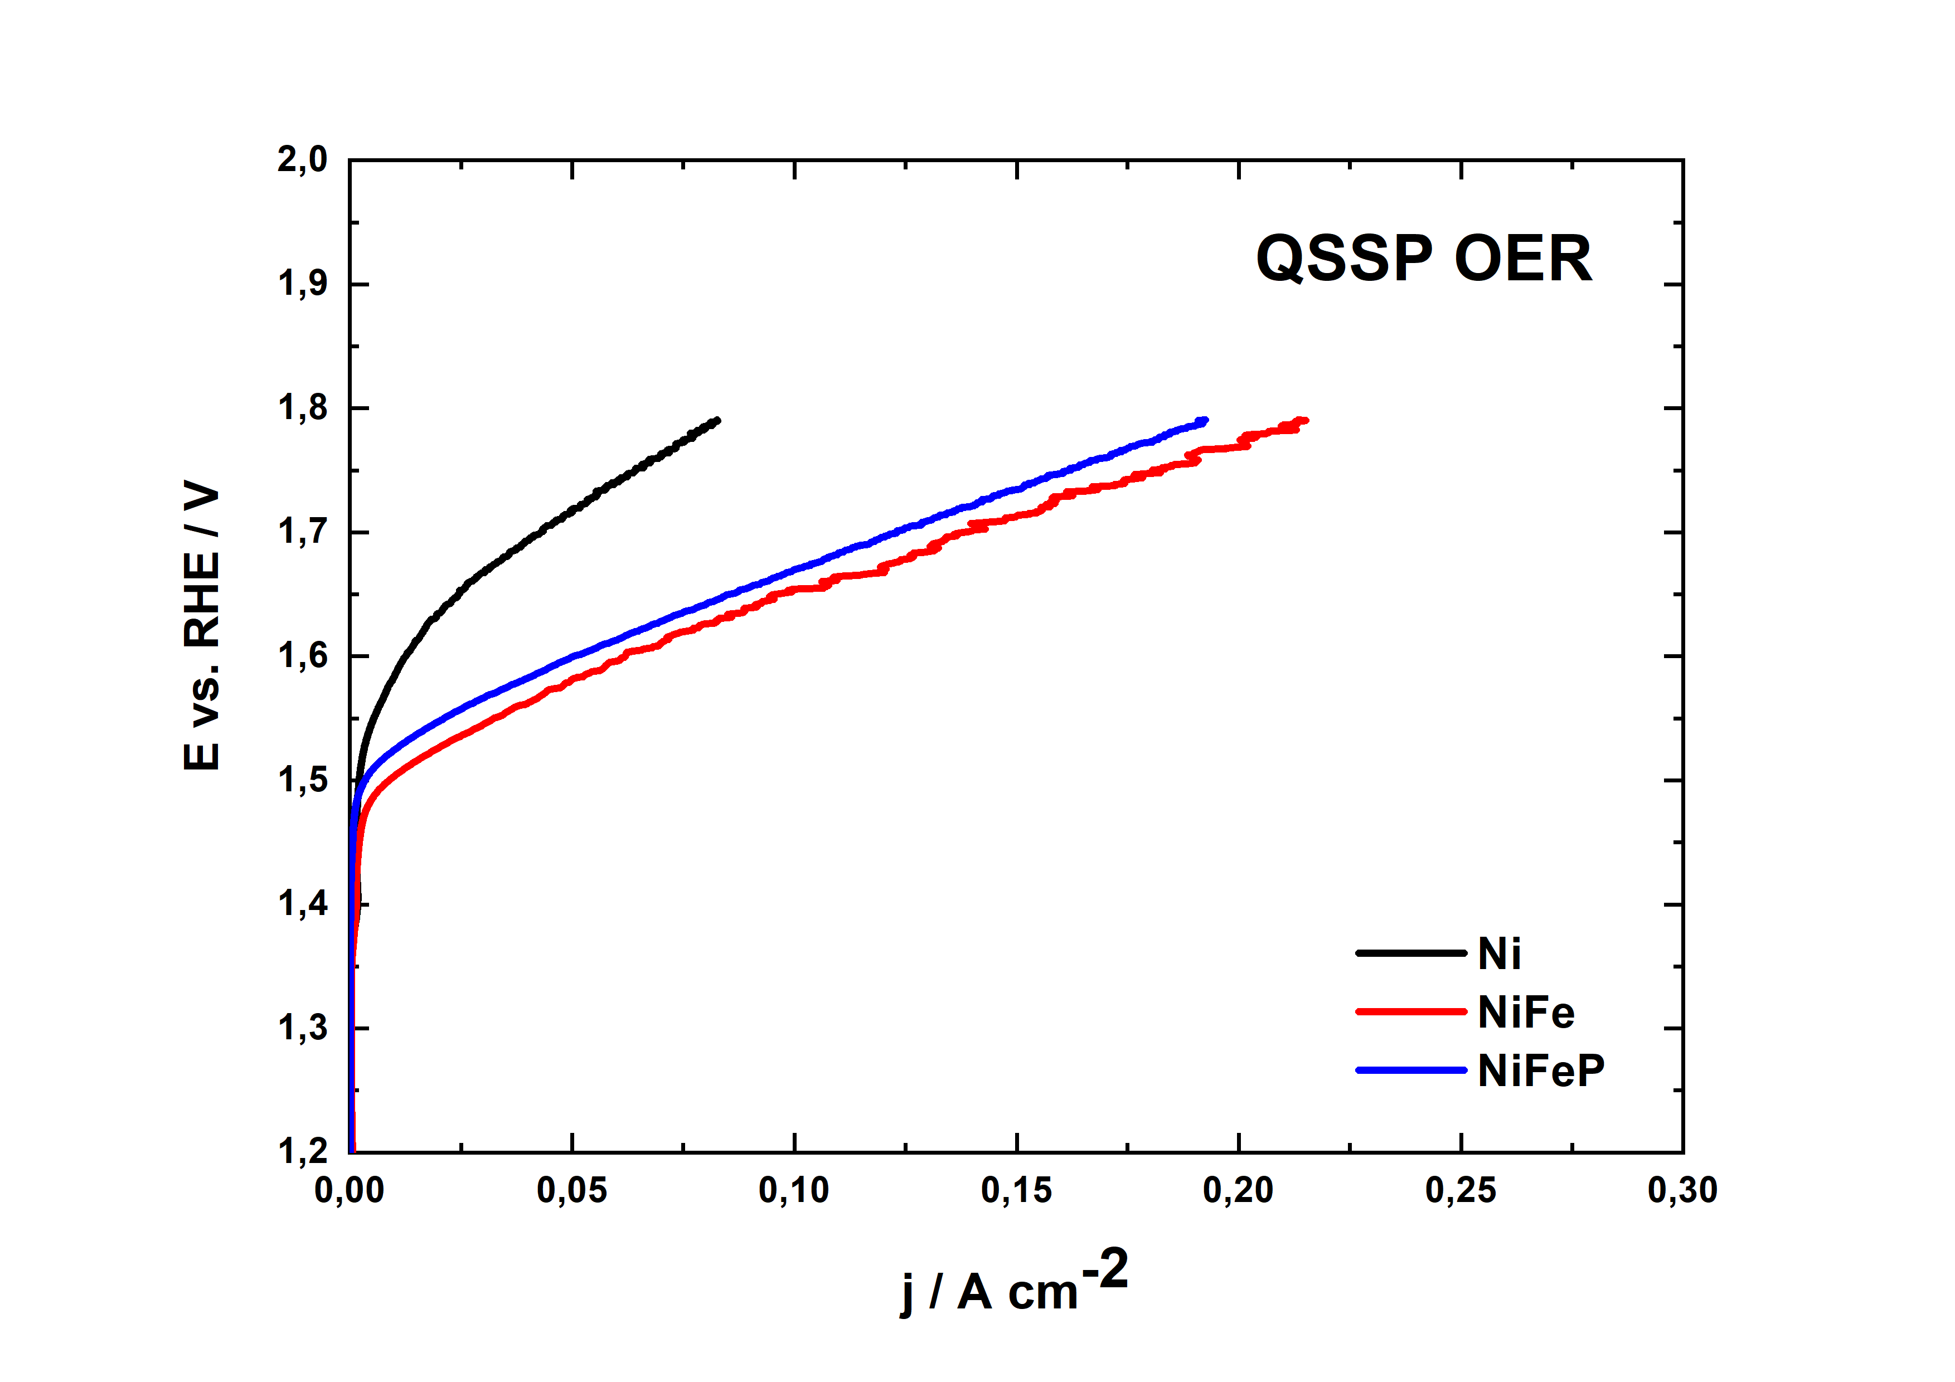
Figure 4. Potentiodynamics for the a) HER and b) OER of NWs

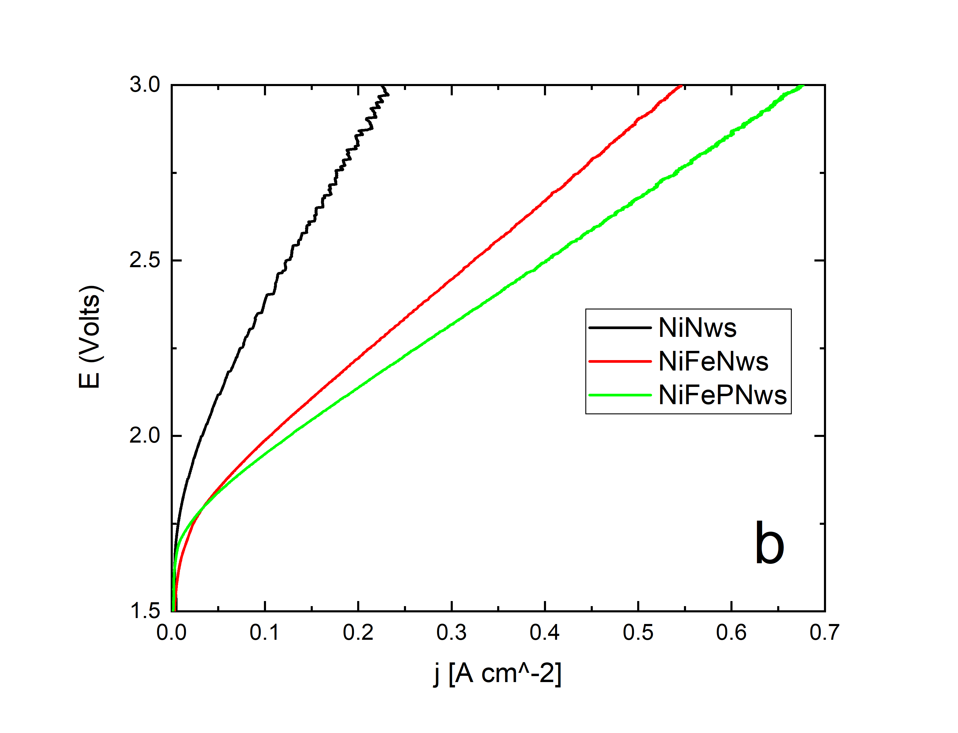
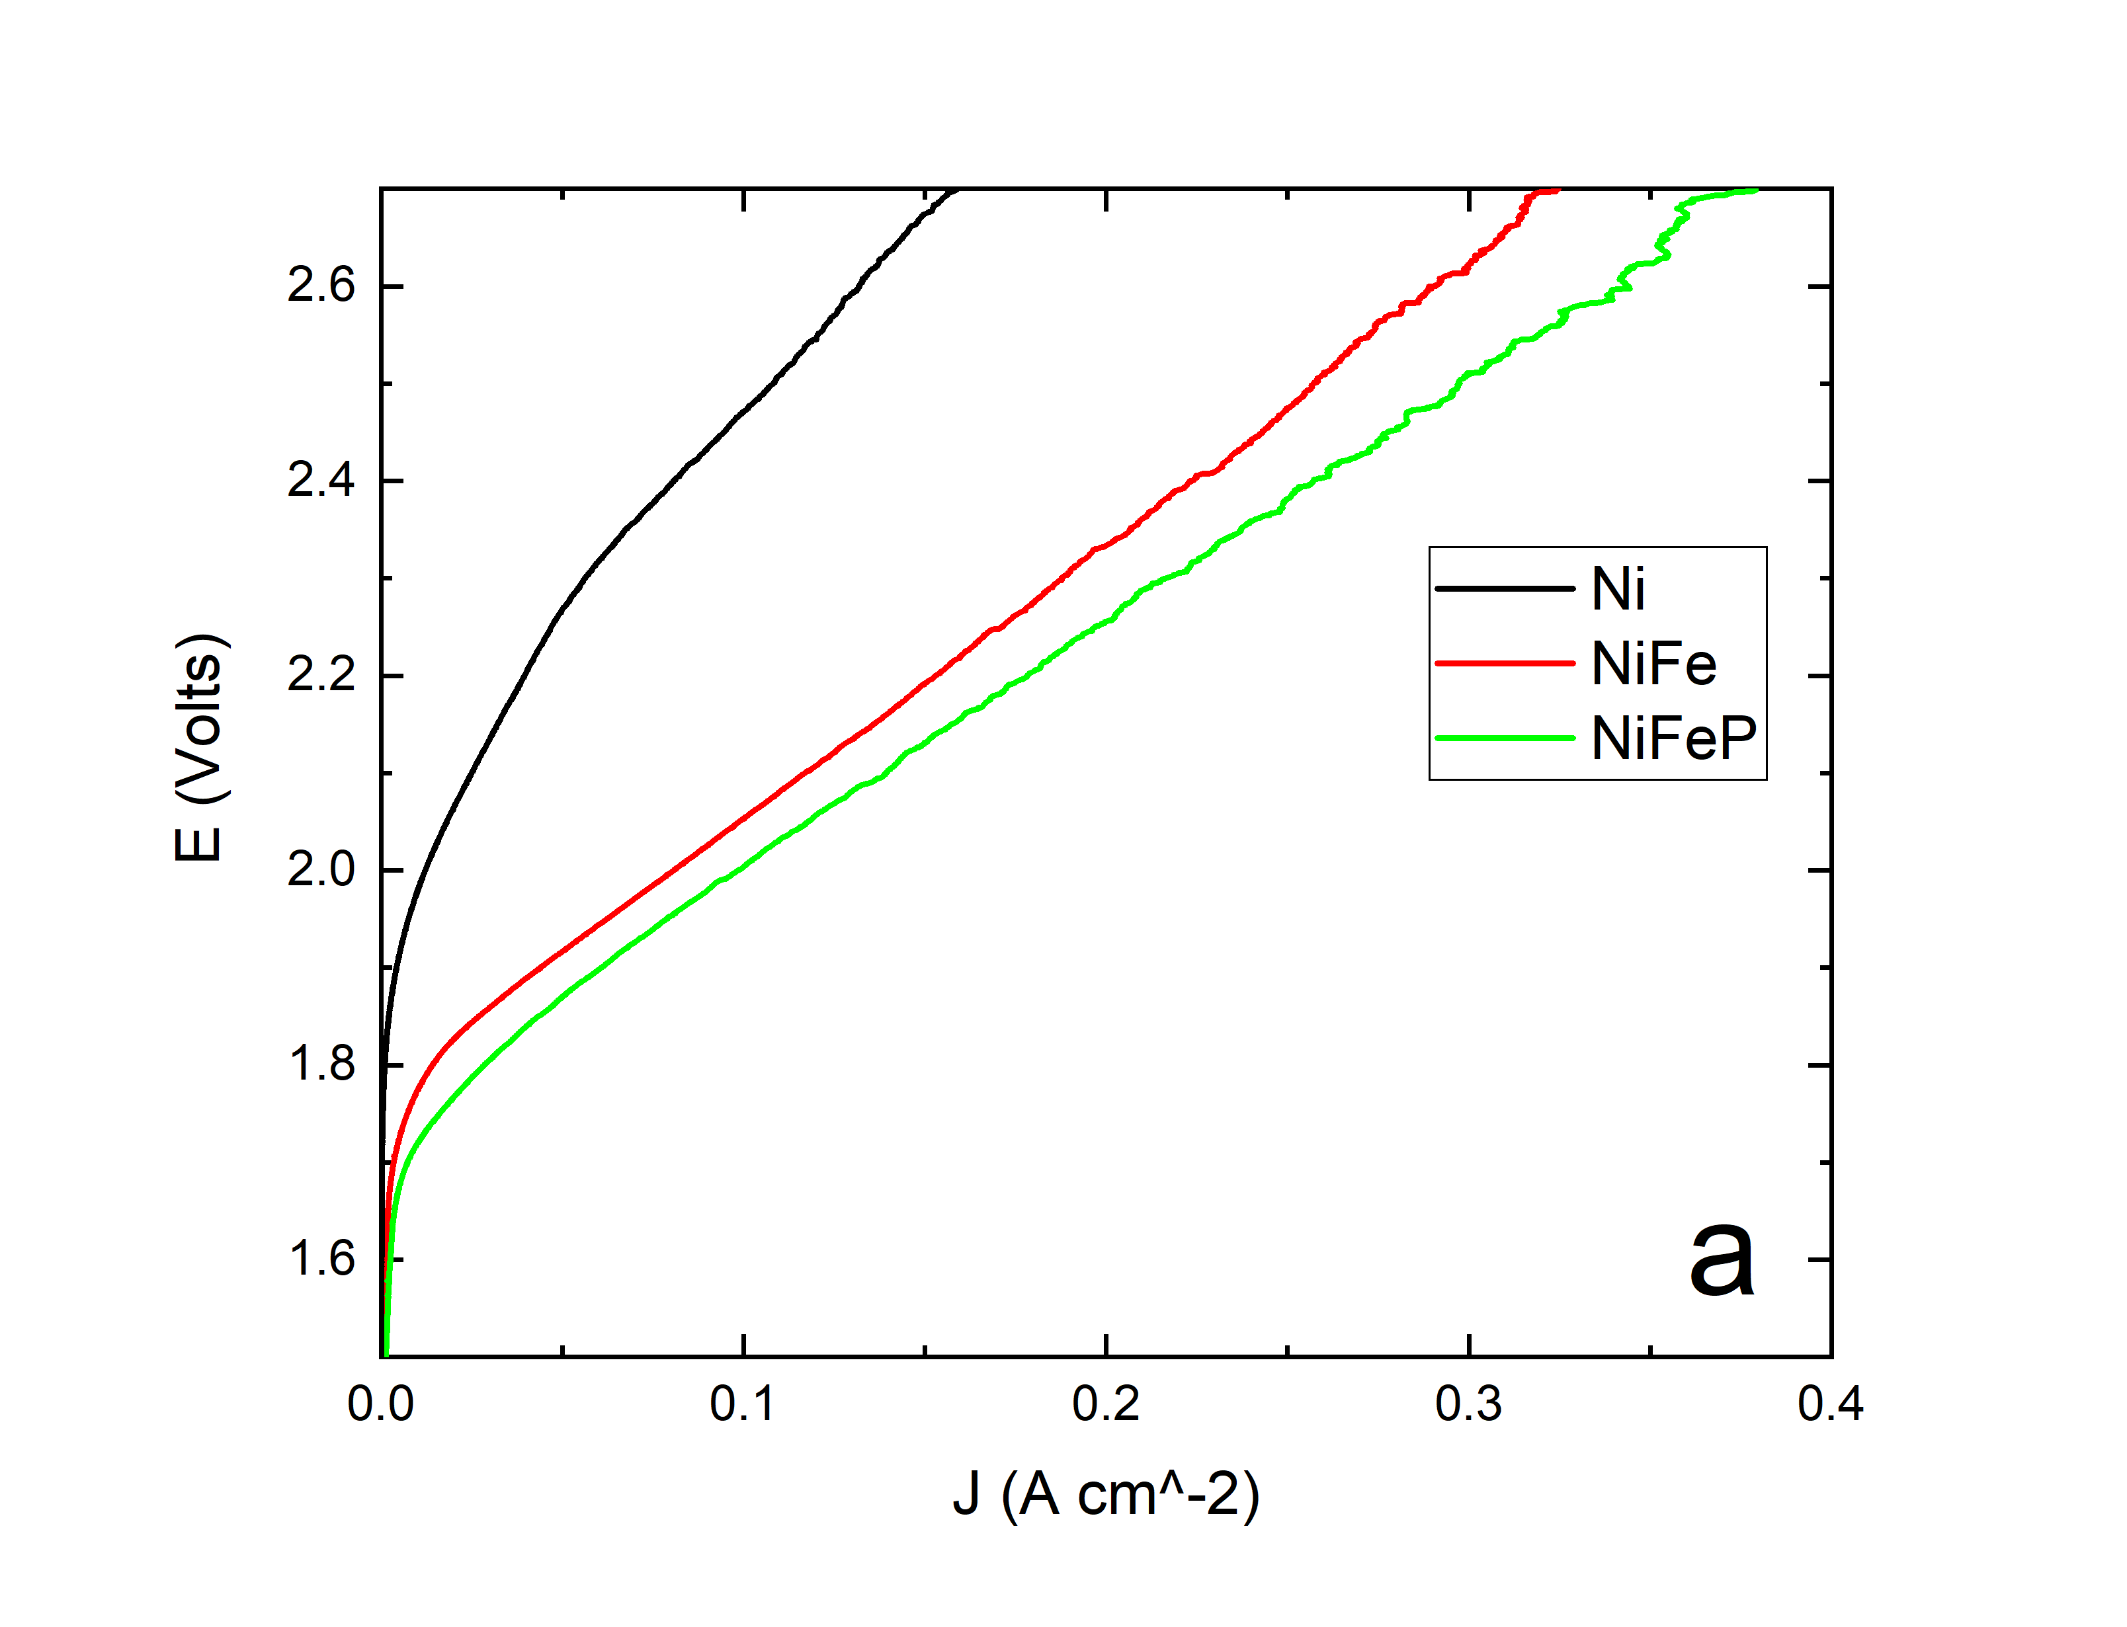
Subsequently, an alkaline electrolyzer (AWE) was constructed. The NWs and sheet were assembled into a small AWE, with an effective electrolysis area of 4 cm². The electrolyte was pumped through the cells at a constant flow rate with the assistance of a peristaltic pump. Figure 5 illustrates the current-potential response of the electrolyser in question. For sheet to attain a current density of 100 mA cm⁻², the electrolyzer requires a potential of only 2 V, which is smaller than that required for NiFe sheet, and only 1.94V for NWs. After the OER and HER tests EDS mapping, and SEM characterization are performed to examine the chemical composition changes in the structures and the morphology variation. In all cases the nanostructures remained perfectly preserved.

Figure 5. LSV polarization curves of a) sheet and b) NWs in the AWE cell

It is evident that the use of nanostructures, due to their greater electrically active area, improves cell performance, regardless of the presence of a catalyst. Indeed, the use of nanowires in place of sheets reduces the cell overvoltage with the same current density, which results in a reduction in the energy required to operate the cell. This provides an economic advantage due to the lower cost of the electrolyser.
For LCA, the inventory was obtained by examining the manufacturing process of the cell, which includes the lab-scale production of the Ni alloy electrodes, electrolyte, cell walls, gaskets, pump and pipes. The production process of the electrodes consists of three main phases, initially, a polycarbonate track-etched membrane is subjected to sputtering process that deposits a thin layer of gold. Subsequently, electrodeposition forms the Ni alloy layer, and finally chloroform etching dissolves the polycarbonate membrane. The other components were obtained through a direct analysis of the cell. Specifically, the pump was derived from a proxy, the pipes and connectors are made of polypropylene, the gaskets are composed by polymethyl methacrylate, and then the 30% solution of KOH is prepared using potassium hydroxide and deionized water.
The results, referred to the functional unit, show that the electrodeposition causes the largest impact only for Acidification, Particulate matter and Water use, moreover, the contribution analysis conducted on the electrodeposition process of the three electrodes, show that nickel sulphate and nickel chloride are identified as materials with the largest impact in the electrodeposition process, so the iron and phosphorous precursor had a minimal effect on results. In general, their contribution on the electrodeposition stage is lower than 14% in all categories. The contribution analysis applied to the sputtering process identifies gold as the material characterized by the largest impact for all impact categories, on the other hand, however, this material can be replaced with a lower impact as nickel.
Conclusions
In this work, we presented nanostructured Ni-based electrodes fabrication and characterization. Nanostructured electrodes were obtained by electrodeposition inside the channels of a polycarbonate membrane acting as a template. The aim was to provide an electrode with high electrocatalytic activity for water splitting. In this scenario, Ni sheet electrodes and Ni nanostructured functionalized with Fe and P for kinetically enhancing HER and OER were prepared. After fabrication, the electrodes were characterized by SEM, EDS, and electrochemical tests. The electrochemical tests conducted under hydrogen and oxygen evolution in 30% w/w KOH solution, showed better performance of the nanostructured electrodes in comparison to sheet electrodes. The AW electrolyzer realized with Sheet and NWs confirmed the best performance of the NWs and the presence of different catalyst improve the current density obtained with the same voltage applied. Catalyst can also be easily scaled for industrial use. The results of LCA study can help eco-design practices for electrodes in electrolysers and represents a step towards greater environmental responsibility and awareness in industrial products. These types of assessments, by providing eco-profiles, allow the identification of improvement opportunities from an environmental perspective.
Acknowledgments
This work was partially financed by the project "SiciliAn MicronanOTecH Research And Innovation CEnter "SAMOTHRACE" (MUR, PNRR-M4C2, ECS_00000022), spoke 3 - Università degli Studi di Palermo "S2-COMMs - Micro and Nanotechnologies for Smart & Sustainable Communities".
References
Amores, E.; Rodríguez, J.; Carreras, C. Influence of operation parameters in the modeling of alkaline water electrolyzers for hydrogen production. Int. J. Hydrogen Energy 2014, 39, 13063–13078.
Buccheri, B., Ganci, F., Patella, B., Aiello, G., Mandin, P., Inguanta, R., 2021. Ni-Fe alloy nanostructured electrodes for water splitting in alkaline electrolyser. Electrochimica Acta 388, 138588.
Carbone S., Caruso A.G.M., Patella B., Miceli R.., Pellitteri F., Caruso M., Mandin P., Aiello G., Inguanta R., Nanostructured Ni-Fe-P Alloy for Alkaline Electrolyzer. Chemical Engeneering Transactions 2023, 100, 649.
Carbone S., Proietto F., Bonafede F., Oliveri R.L., Patella B., Ganci F., Aiello G., Mandin P., Kim M., Scopelliti M., Inguanta R., Behavior of a forest of NiFe nanowires in KOH and NaCl solution for water electrolysis Electrochimica Acta 2023, 467, 143120.
Chandrasekaran S, Ma D, Ge Y, Deng L, Bowen C, Roscow J, et al. Electronic structure engineering on two-dimensional (2D) electrocatalytic materials for oxygen reduction, oxygen evolution, and hydrogen evolution reactions Nanomater Energy 2020;77:105080.
Ganci, F.; Cusumano, V.; Livreri, P.; Aiello, G.; Sunseri, C.; Inguanta, R. Nanostructured Ni–Co alloy electrodes for both hydrogen and oxygen evolution reaction in alkaline electrolyzer. Int. J. Hydrogen Energy 2021, 46, 10082–10092.
Li G, Wang X, Seo MH, Hemmati S, Yu A, Chen Z. Design of ultralong single-crystal nanowire-based bifunctional electrodes for efficient oxygen and hydrogen evolution in a mild alkaline electrolyte. J Mater Chem 2017;5:10895e901
Lopez-Fernandez E, Gil-Rostra J, Espinos JP, Gonzalez- Elipe AR, de Lucas Consuegra A, Yubero F. Chemistry and electrocatalytic activity of nanostructured nickel electrodes for water electrolysis. ACS Catal 2020;10:6159e70.
Nairan A, Zou P, Liang C, Liu J, Wu D, Liu P, et al. NiMo solid solution nanowire array electrodes for highly efficient hydrogen evolution reaction. Adv Funct Mater 2019;29:1903747.
UNI EN ISO 14040 (2006). Environmental Management – Life Cycle Assessment –Principles and Framework,
UNI EN ISO 14044 (2006). Environmental Management – Life Cycle Assessment –Requirements and Guidelines,
Wei Y, Ren X, Ma H, Sun X, Zhang Y, Kuang X, et al. CoC₂O₄ 2H 2 O derived CO₃O₄ nanorods array: a high-efficiency 1D electrocatalyst for alkaline oxygen evolution reaction. Chem Commun 2018;54:1533e6.
Yan Y, Thia L, Xia BY, Ge X, Liu Z, Fisher A, et al. Construction of efficient 3D gas evolution electrocatalyst for hydrogen evolution: porous FeP nanowire arrays on graphene sheets. Adv Sci 2015;2:1500120.

