|  |  |
| --- | --- |
| cetlogo ***CHEMICAL ENGINEERING TRANSACTIONS***  ***VOL. xxx, 2025*** | A publication of  aidiclogo_grande |
| The Italian Association  of Chemical Engineering  Online at www.cetjournal.it |
| Guest Editors: Fabrizio Bezzo, Flavio Manenti, Gabriele Pannocchia, Almerinda di Benedetto  Copyright © 2025, AIDIC Servizi S.r.l. **ISBN** 979-12-81206-17-5; **ISSN** 2283-9216 | |

Semi-quantitative Dust Hazard Analysis: Identification of the Ignition Sources and Quantification of the Probability

Leonardo Michele Carluccio\*; Aurora Lafiosca, Sara Perelli

DEKRA Italia s.r.l., Process Safety Business Unit, Via Fratelli Gracchi 27, 20122 Cinisello Balsamo (MI)

[leonardomichele.carluccio@dekra.com](mailto:leonardomichele.carluccio@dekra.com)

Dust Hazard Analysis (DHA) is a risk assessment technique used for identifying, managing, and mitigating the risks related to the handling, production, and storage of combustible dusts. In a previous study, the efficacy of the use of a semi-quantitative approach (i.e., leveraging a Risk Matrix to assess the risk level associated with combustible dust, through the definition of severity and likelihood levels) has been analysed. This study is intended to deepen some aspects of the methodology, exploring, in particular, the approaches used to identify the probability of ignition during a semi-quantitative DHA.

The identification of all the possible ignition sources and the consequent definition of a probability for each of these to be effective (i.e., to be able to ignite a cloud of dust, properly mixed with air inside explosibility limits) is a fundamental step to conduct a semi-quantitative DHA; for this reason, the aim of the present study is to discuss the possible scenarios related to the different ignition sources that could be present in a working environment where combustible dust is handled (e.g., electrical equipment, electrostatic discharge, etc., as described in the standard EN 1127-1), together with the approach used to determine the proper ignition probability to be used in the assessment.

The study underscores the importance of the identification of all the possible ignition sources and the suggested approaches for the determination of the ignition probability within the framework of semi-quantitative DHA, where a Risk Matrix is used to evaluate the risk levels associated with identified dust-related scenarios.

* 1. Introduction

The introduction of a semi-quantitative approach to Dust Hazard Analysis (DHA) allows the methodology to be systematically applied in different facilities (Gritti et al., 2024). The necessity to develop a more reliable and uniform methodology to perform DHA brings the need to study the application of a Risk Matrix to the DHA.

This risk assessment technique enables the creation of a more structured analysis in which the following elements of DHA are included:

* Hazardous Area Classification (HAC) – applying the zoning system supported by the International Electrotechnical Commission (IEC 60079-10-2:2015), or Class / Division system supported by the National Fire Protection Association (NFPA 70, National Electrical Code – NEC);
* Ignition Risk Assessment (IRA), including electrostatic risk assessment (Carluccio et al., 2023);
* Assessment of the consequences effects (i.e., fire, flash fire, explosion);
* Evaluation of existing Basis of Safety (BoS);
* Safety Management System for identified scenarios.

Semi-quantitative analysis of DHA provides a reliable risk assessment by conducting a structured approach, allowing prioritization of mitigation strategies, focusing on most critical high-risk scenarios and facilitating the decision-making process. The detailed steps that enable the success and effectiveness of DHA (i.e., plant visits and qualitative assessments) using the matrix in DHA are essential. Therefore, although the strength of this methodology lies in the quantification of risk, numerical values for ignition probability and risk reduction should only be considered as an indication of magnitude (Gritti et al., 2024). Nevertheless, as far as ignition sources could be present in a hazardous area, the need to assign a probability level arises.

The management of ignition sources is an important Basis of Safety (BoS) for fire and explosion hazard management. The assessment of the probability of ignition sources becoming effective can be carried out by applying the Standard UNI EN 1127-1, which identifies thirteen general types of ignitions. However, in this paper the ignition risk assessment will be covered in detail only for the most common ignition sources, such as:

* Hot surfaces;
* Electrical equipment;
* Static electricity (i.e., sparks discharge, cone discharges, static discharge due to the operator);
* Frictional ignition sources.

Actually, one of the challenges of DHA analysis is to define the probability for each ignition sources; according to the Standard UNI EN 1127-1, the potential ignition sources shall be classified according to the likelihood to become effective, in the following manner:

* Ignition sources which can occur continuously or frequently;
* Ignition sources which can occur in rare situations;
* Ignition sources which can occur in very rare situations.

The purpose of this paper is to define a methodology to attribute a probability, i.e. a number, that gives an idea of the ignition sources probability to be effective, according to the actual conditions of the plant and the explosible characteristics of the dust handled, to be used as an input data for the semi-quantitative DHA.

* 1. Methodology

The proposed methodology is described below in dependence on the various ignition sources considered.

* + 1. Hot surfaces

Combustible dust can be released and can form clouds or layers and, based on different mechanisms and temperatures, they can be ignited by hot surfaces. The capability of a heated surface to cause ignition depends on the type and concentration of the particular substance in the mixture with air, as well as the flow velocity of the explosive atmosphere around the hot surface. Furthermore, the effectiveness of the ignition source depends on the size and shape of the heated body and becomes greater with increasing temperature and increasing surface area.

Once the process has been verified and analysed (i.e., HAC has been performed, assessing the probability and the conditions in which the combustible dust can be present in the area, in form of a cloud or a layer - Perelli et al., 2023), DHA’s focus can be moved to all pieces of equipment in the hazardous area that generate heat, like no insulated steam lines, electrical motors, processing equipment, etc.

To define the safe working conditions (i.e., the maximum allowable surface temperature of equipment working in hazardous areas), the MIT and LIT of the involved combustible dust shall be available to select the maximum temperature. In particular, to define the maximum allowable temperature, several different approaches are present, as reported in the Standards IEC 60079-14, NFPA 652 and NEC (NFPA 70), as reported in Table 1.

*Table 1: Different Standards to define the maximum allowable surface temperature for the equipment*

|  |  |  |  |
| --- | --- | --- | --- |
| **Standard** | **Tmax MIT** | **Tmax LIT** | **Maximum Allowable Temperature** |
| **IEC** | 2/3 MIT | LIT5mm-75°C | Minimum value between Tmax MIT and Tmax LIT |
| **NFPA** | MIT – 50°C | LIT – 50°C | Minimum value between Tmax MIT and Tmax LIT |
| **NEC** | MIT | LIT | Minimum between MIT, LIT or 165°C |

Moreover, attention should be paid when relevant dust accumulation is noticed in the plant, since the thickness of the layer has a negative impact on the LIT, as reported in Figure 1 below (IEC 60079-14:2024).

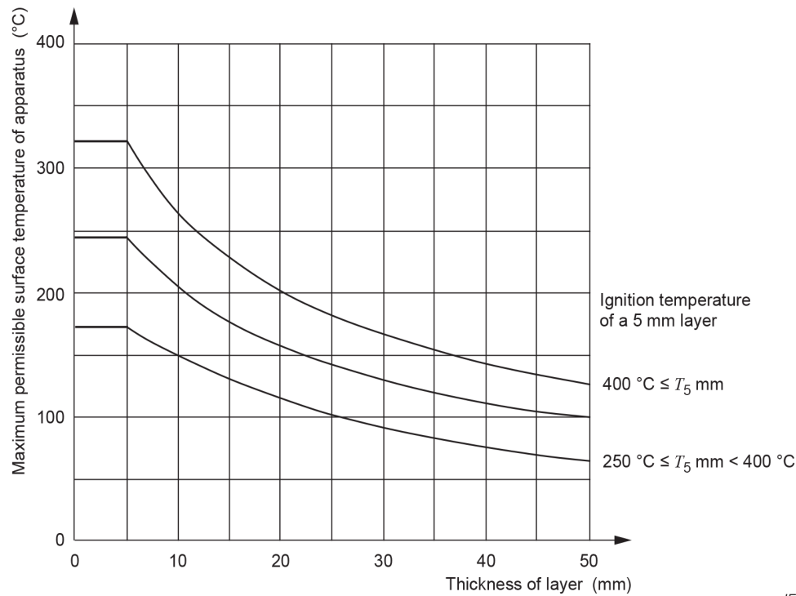

*Figure 1: Correlation between the maximum permissible surface temperature and thickness of dust layers (IEC 60079-14:2024. Figure 1)*

* + - 1. **Ignition probability evaluation**

The probability of the ignition to be effective has to be evaluated conducting a comparison between the maximum foreseeable temperature of the heated surface (e.g., electrical equipment) and the maximum allowable temperature calculated with one of the approaches reported in the Table 1. It is possible to identify three classes, as follow:

* High impact: if the Max T of the equipment ≥ Max allowable T, then the probability assigned is P = 1;
* Medium-high impact: if the Max T of the equipment is between 80% of Max allowable T and Max allowable T, then the probability assigned is P = 0.1;
* Low impact: if the Max T of the equipment < 80% of Max allowable T, then the probability assigned is P = 0.01.
  + 1. Electrical equipment

If electrical equipment and components are installed in a hazardous area, electrical sparks can appear as ignition sources leading to a possible fire / flash fire or explosion scenario. Electric sparks can be generated, for example:

* When electric circuits are opened and closed;
* By loose connections;
* By stray currents;
* By overload or insufficient cooling;
* By short circuits.

However, voltages lower than 50V can still produce sufficient energy to ignite an explosive atmosphere.

* + - 1. **Ignition probability evaluation**

The main method of dealing with sources of ignition due to electrical equipment is to verify the correct marking of the equipment. Therefore, during the plant visit it is advisable to verify that process equipment, installed in the hazardous area, is ATEX marked as specified in the Directive 1999/92/CE, EN 60079-0 (Electric) and EN ISO 80079-36 (Not Electric).

* If the equipment is generally ATEX marked, then the probability assigned is P = 0.1;
* If the equipment is generally not ATEX marked, then the probability assigned is P = 1.

It is worth emphasizing that, during field visit, the verification of the compliance of the equipment with the hazardous area of installation is usually conducted just for some equipment, randomly; for this reason, to maintain a cautionary approach, it is preferrable to use P = 0.1 as a lowest probability value, avoiding to assign a probability equal to P = 0.01 that could potentially lead to underestimation of the ignition risk.

* + 1. Static electricity

Under certain conditions, when charges can be generated and accumulated, the possible discharge can lead to incendive sparks. There are primarily three types of electrostatic discharges that may be encountered during processing and material handling that may pose an ignition hazard: Cone discharge, Spark discharge, Static discharge due to operator (brush discharge will not be considered in this assessment; as reported in the Standard IEC 60079-32-1:2017, “the present state of knowledge indicates however, that independent of their MIE combustible powders cannot be ignited by brush discharges, providing there are no flammable gases or vapours”).

The main three static discharges are as follow:

* Cone discharge: when highly charged insulating powder is filled into silos or large containers, it generates a region of very high space charge density within the heap of bulked powder. This leads to high electrical fields at the top of the heap. Under those circumstances large discharges running (radially, in the case of cylindrical containers) along the surface have been observed. Based on several and extensive experiments performed in earthed conductive silos, the energy released from a cone discharge depends on the silo diameter and the particle size (mass median) of the dust creating the powder heap, as follow:

|  |  |
| --- | --- |
| $$E=5.22* D^{3.36}*d^{1.462}$$ | (1) |

Where:

* + E = upper limit of the energy of the cone discharge in mJ;
  + D = diameter of the earthed conductive silo in metres (valid for 0.5 m < D < 3 m);
  + d = mass median of the particle size distribution of the powder forming the cone in mm (valid for 0.1 mm < d < 3 mm).
* Sparks discharge: it can occur due to the charging of electrically isolated conductive parts of equipment or accumulations of low resistivity powders. In most cases, virtually all the stored electrostatic energy is dissipated in the spark. The stored energy that could be released in the spark can be evaluated using the following equation:

|  |  |
| --- | --- |
| $$W=\frac{1}{2} Q V=\frac{1}{2} C V^{2}$$ | (2) |

Where:

* + W = is the energy dissipated in Joules;
  + Q = is the quantity of charge on the conductor in Coulombs;
  + V = is its potential in Volts;
  + C = is its capacitance in Farads.
* Static discharge due to operator may occur when the operator is not correctly grounded (e.g., not wearing antistatic PPE – e.g., gloves, shoes – insulative painting on the floor, use of insulative tools to perform manual operations). According to the Standard IEC 60079-32-1:2017, the worst-case voltage which may commonly be acquired by people is about 20 kV. With the typical capacitance of the human body being about 150 pF, the resulting maximum stored energy is about 30 mJ.
  + - 1. **Ignition probability evaluation**

The probability of the ignition to be effective has to be selected from the comparison between the maximum foreseeable energy that could be released from the specific static discharge and the MIE of the dust under evaluation, as follow:

* High impact: if the value it’s ≥ MIE, then the probability assigned is P = 1;
* Medium-high impact: if the value is between 80% of MIE and MIE, then the probability assigned is P = 0.1;
* Low impact: if the value is < 80% of MIE, then the probability assigned is P = 0.01.

It is worth emphasizing that the most relevant value of MIE to evaluate the electrostatic hazard is the MIE determined using a capacitive circuit without an additional inductance (as described in ISO/IEC 80079-20-2 and ASTM E2019-03).

* + 1. Frictional ignition sources

Friction, impact, or abrasion processes, such as grinding, can cause particles to detach from solid materials and become hot due to the energy involved. If these particles are oxidizable, like iron or steel, they can oxidize, increasing their temperature further. These hot particles, or sparks, can ignite flammable gases and dust/air mixtures, particularly metal dust/air mixtures. In deposited dust, these sparks can cause smouldering, potentially igniting an explosive atmosphere. When stainless steel undergoes impact, friction, or grinding, it can easily produce hot surfaces, serving as an effective ignition source. High contact pressure during friction or grinding can generate a burst of sparks, enhancing the ignition risk.

As reported in the Standard ISO EN 80079-36:2016, a relative contact speed of 1 m/s is often used as the limit value below which friction ignition sources are not capable to ignite an explosive atmosphere.

To this regard, analysis of incidents has led to the following values for the relationship between the ignition ability of rotating parts and their relative speed v (ISSA Prevention Series No, 2033, 2004):

🡪 no ignition hazard (low relative speed);

🡪 each case must be considered on its own merits taking into account data for the specific dust and construction material (medium relative speed);

🡪 an ignition hazard exists in all cases (high relative speed).

* + - 1. **Ignition probability evaluation**

According to the specification reported above, it is possible to assign the probability of ignition according to the three classes reported below:

* High relative speed: the probability assigned is P = 1;
* Medium relative speed: the probability assigned is P = 0.1;
* Low relative speed: the probability assigned is P = 0.01.

It is worth emphasizing that the knowledge of MITcloud and MIE (with inductance) is required to evaluate the ignition risk due to friction, since the effectiveness of ignition source is influenced by both the MITcloud and the MIE. From the following Figure 2 (ISSA Prevention Series No, 2033, 2004) it is possible to evaluate the effectiveness of a mechanical spark for a specific dust: in particular, the ignition of a dust cloud is possible if the MIE lies below the Equivalent Electrical Energy EQ.

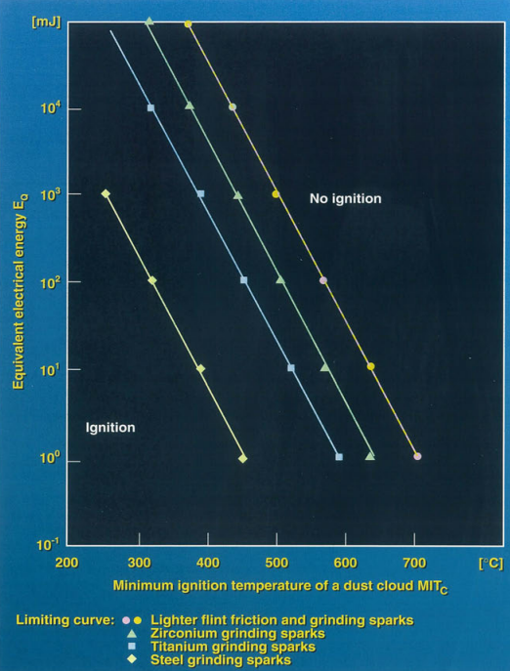

*Figure 2. Grinding sparks: relationship between Equivalent Electrical Energy EQ and MITCloud (ISSA Prevention Series No, 2033, 2004, Figure 7)*

* 1. Conclusions and Next steps

The Ignition Risk Assessment is a fundamental stage during a DHA, and therefore the quantification of the probability is a crucial step in the semi-quantitative DHA to exploit the potential of the Risk Matrix.

According to the outcomes of this paper, it has emerged that further studies are necessary to identify a model capable to increase the safety margins when the specific dust is characterized by high ignition sensitivity, i.e., by low MIE or MIT (e.g., expanding ‘Medium-high impact’ zone, assigning a probability equal to 0.1 in a wider range of values).

Moreover, with respect to the electrical equipment, deeper studies should be conducted to evaluate the possible correlation between the reliability of the equipment suitable to be installed in a specific hazardous area (i.e., Category 1 / 2 / 3 equipment according to ATEX Directives 1999/92/CE and 2014/34/EU) and the probability for those pieces of equipment to give rise to ignition. To this regard, reference could be done to Standards IEC 61508 and 61511 and VDI/VDE 2180 Blatt 6.

To conclude, in this paper, a structure is proposed to adopt a systematic approach in the definition of the ignition probability; nevertheless, the field visit are of paramount importance to collect the necessary information to conduct DHA and IRA (e.g., adequacy of the grounding and bonding, compliance of electrical equipment to the zone of installation, inspection of manual operations): to this regard, the qualitative evaluations are and remain essential, and this methodology is intended to provide a framework to translate them into numbers, allowing the adoption of a semi-quantitative approach.

Nomenclature

ASTM – American Society for Testing and Materials

BoS – Basis of Safety

DHA – Dust Hazard Analysis

EQ – Equivalent Electrical Energy

HAC – Hazardous Area Classification

IEC – International Electrotechnical Commission

IRA – Ignition Risk Assessment

ISSA – International Social Security Association

ISO – International Organization for Standardization

NEC – National Electrical Code

NFPA – National Fire Protection Association

ATEX – ATmosphere EXplosive

MIT – Minimum Ignition Temperature

LIT – Layer Ignition Temperature

MIE – Minimum Ignition Energy

PPE – Personal Protective Equipment

SIL – Safety

References

American Society for Testing and Materials, 2019, ASTM E2019-03, Standard Test Mehod for Minimum Ignition Energy of a Dust Cloud in Air.

Carluccio L.M., Perelli S., 2023, Electrostatic Risk Assessment for Combustible Dust Atmospheres, Chemical Engineering Transactions, 104, 61 – 66.

European Committee for Standardization / European Committee for Electrotechnical Standardization, CEN / CENELEC, 2019, EN 1127-1 Explosive atmospheres - Explosion prevention and protection - Part 1: Basic concepts and methodology.

European Parliament and Council of the European Union, 1999, Directive 1999/92/CE of the European Parliament and of the Council on minimum requirements for improving the safety and health protection of workers potentially at risk from explosive atmospheres.

European Parliament and Council of the European Union, 2014, Directive 20114/34/EU of the European Parliament and of the Council on the harmonisation of the laws of the Member States relating to equipment and protective systems intended for use in potentially explosive atmospheres.

European Committee for Standardization, 2016, EN ISO 80079-36 – Part: 36: Non-electrical equipment for explosive atmospheres – Basic method and requirements.

Gritti A., Carluccio L.M., Pellegrini L., 2024, Semi-quantitative Dust Hazard Analysis: Advantages and Limitations of Using a Risk Matrix in DHA, Chemical Engineering Transactions, 111, 265 – 270.

International Electrotechnical Commission, 2015, IEC 60079-10-2 Explosive atmospheres - Part 10-2: Classification of areas - Explosive dust atmospheres, Geneva, Switzerland.

International Electrotechnical Commission, 2024, IEC 60079-14 Explosive atmospheres - Part 14: Electrical installation design, selection and installation of equipment, including initial inspection, Geneva, Switzerland.

International Electrotechnical Commission, 2017, Technical Report, CLC/TR 60079-32-1 Explosive atmospheres - Part 32-1: Electrostatic hazards, guidance, Geneva, Switzerland.

International Electrotechnical Commission, 2017, IEC 60079-0 Explosive atmospheres - Part 0: General requirements, Geneva, Switzerland.

International Electrotechnical Commission, 2016, ISO/IEC 80079-20-2 Explosive atmospheres - Part 20-2: Material characteristics - Combustible dust methods.

International Electrotechnical Commission, IEC 61508, Functional safety of electrical/electronic/programmable electronic safety-related systems, Geneva, Switzerland

International Electrotechnical Commission, IEC 61511, Functional safety – Safety instrumented systems for the process industry sector, Geneva, Switzerland

International Section of the ISSA for Machine and System Safety, 2004, ISSA Prevention Series No. 2033 (E), Dust Explosion Prevention and Protection for Machines and Equipment, Basic Principles, 19 – 23, Mannheim, Germany.

National Fire Protection Association, NFPA 70, 2023, National Electrical Code.

National Fire Protection Association, NFPA 652, 2019, National Electrical Code.

Perelli S., Carluccio L.M., 2023, Hazardous Area Classification Due to Combustible Dust Atmospheres and Layers: Avoiding Common Mistakes, Chemical Engineering Transactions, 99, 211 – 216.

VDI/VDE 2180 Blatt 6, 2013-06, Safeguarding of industrial process plants by means of process control engineering (PCE). Application of functional safety in the context of explosion protection (original title: Sicherung von Anlagen der Verfahrenstechnik mit Mitteln der Prozessleittechnik (PLT) Anwendung der funktionalen Sicherheit im Rahmen von Explosionsschutzmaßnahmen). Berlin: Beuth Verlag