|  |  |
| --- | --- |
| cetlogo ***CHEMICAL ENGINEERING TRANSACTIONS***  ***VOL. xxx, 2025*** | A publication of  aidiclogo_grande |
| The Italian Association  of Chemical Engineering  Online at www.cetjournal.it |
| Guest Editors: Fabrizio Bezzo, Flavio Manenti, Gabriele Pannocchia, Almerinda di Benedetto  Copyright © 2025, AIDIC Servizi S.r.l. **ISBN** 979-12-81206-17-5; **ISSN** 2283-9216 | |

A compressor - system digital twin for performance prediction under a wide range of flow and operating conditions

Alberto Serena\*, Lars E. Bakken

Norwegian University of Science and Technology, Department of Energy and Process Engineering, N-7491 Trondheim

\* alberser@ntnu.no

Turbomachines are essential equipment in propulsion, energy conversion and process engineering; their efficiency and optimization require the exploration of tailored designs and the exploitation of the full machine capability. The compressor behaviour in the overall system under design and off-design conditions needs to be adequately modelled and integrated. A blend of theory, laboratory experiments, operational experience, data analysis and process simulation have been employed for an accurate description of the machine behaviour. Testing benefits from a responsive rig, allowing modification of layout and key parameters. The model under study is vital in the definition of the actual surge margin and of a suitable recovery strategy; an early detection is needed to safeguard stable operation and avoid unnecessary stresses. The main focus is the validation of the system model at the boundary of the operating envelope, and, in particular, the study and prediction of the trip trajectory, caused by disturbances in the power input, or variations in inlet composition, or downstream equipment pressure build-up. The experimental campaigns, data processing and model validation are presented; a wide test matrix covers the parameters of specific interest for chemical and process engineering plants; sensitivity studies are performed on molar weight and mixture composition, exploring not only machine capabilities in terms of stability range and performance degradation, but also the software real gas models and the influence of real operating conditions and machine aerodynamic design.

* 1. Introduction

Turbomachines in chemical and process engineering plants are required to handle with variable operating conditions and increased rangeability to allow a more favourable return of investment. Whether a specifically designed machine or a model already available from a Manufacturer catalogue, such equipment shall withstand a wide range of scenarios, such as start-up and shut-down, severe transients and unexpected faults, varying mixture compositions, degradation and fouling over time. All these entail severe stresses on the machine and the risk of entering the unstable operation area. Downsizing, variable pitch stages and power electronics add further complexity; integration in an overall system model is needed to predict the response and performance.

The approach presented entails accurate flow phenomena characterization, thanks to a responsive test rig, which allows a quick modification of layout and key parameters, and the validation of system modelling, performed through the Dynamic suite of the commercial software ASPEN HYSYS, and a specific routine developed ad hoc, to account for performance degradation outside of the nominal operating envelope.

Depending on the field of application, characteristic values of rotational speeds range between 7 000 and 20 000 rpm; the machines feature various designs (axial vs radial flow), and the reservoir volumes, number of stages, the presence of a vaned or vaneless diffuser, all contribute to the complex interaction with the system and evolution under transient conditions. At the lower flow boundary, the complex phenomenon of surge occurs, involving not only the machine design (with positive effects by the adoption of IGVs and improvements in aerofoil tip clearance, casing geometry, other equipment), but also the interaction with the surrounding system. When the discharge is connected to a large volume, in case of a sudden deceleration, as in a power dip, the operating point moves towards the surge line as the flow rate drops faster than the reservoir pressure; changes in gas composition might adversely affect stability too. Detection shall be performed through responsive sensors and actuators, with short time constants and delays, and, possibly, non-intrusive instrumentation, recovery by valves providing flow recirculation from outlet to inlet. The currently set surge margins safeguard the machine integrity but might unduly restrict the useful operating range, close to the peak efficiency area. In addition, uncertainties in the detection of flow conditions, transients in the flow rate, the occurrence of secondary flows, high-frequency pressure fluctuations, delays, shall be considered too. The surge margin is usually overcome in transients with fixed loads, or during start-ups and shut-downs. Detection and protection systems benefit from improved prediction methods, usually based on analytical or numerical representations of the compressor characteristics linked to the surrounding stable zones, as steady-state measurements cannot be performed in the unstable flow region and limited data are available, as their reliability is highly affected by the test setup and approach.

Tveit et al. (2005) and Bakken et al. (2002, 2016) have performed key sensitivity studies to determine the main parameters related to risk of surge during a trip; these were: initial operating point, capabilities of the system to provide recirculation, polar inertia, head rise to surge, driver power decay rate, pipe and equipment volumes. A high inertia driver makes the system more resilient with easier protection; in parallel, a slow driver power decay and possibility of power loss delay. The system dynamics are expressed in Eq.(1), as a variation of kinetic energy, with the main terms related to the train inertia, the drive and compressor power, and the frictional losses.

|  |  |
| --- | --- |
|  | (1) |

Another possible scenario in multi-casing machines, is the trip of a following stage causing a sudden discharge pressure-rise for the first compressor, ref. Figure 1. This pressure-rise may overcome the first stage capability. It should be noted that a careful process design as the installation of large, suitable fast acting anti-surge systems and check valves, is successful only if fully reliable.

Figure 1 Compressor system configuration; a) Large discharge volume b) Compressors in series

This paper focuses on the digital twin methodology capability in modelling behaviour at surge, starting from closely matching the characteristics in the design operating range, and then exposing the system to transients. Under such conditions, a characteristic system oscillation behaviour is established, and the occurrence of such behaviour depends on the machine design, while its features are strongly related to system parameters, as presented by Greitzer (1976a, 1976b) and validated by others (e.g., Hansen et al., 1981).

* + 1. System and machine instabilities

The operating point is typically found at the intersection of the machine (drive) and system (load) characteristic curves. Different instabilities and surge phenomena occur when approaching severe part-load conditions. The flow in the compressor, away from the nominal conditions, is intrinsically unsteady; however, how the pipes, valves and other devices dampen and respond to the flow field variations plays a key role in the evolution of machine instabilities. An analytical model by Greitzer (1976a), assimilating the system to a Helmholtz resonator, allows to simplify the oscillatory behaviour of the system at fully closed discharge; characteristic values for the system are the volume between the compressor outlet and the control valve (often referred to as the surge volume), for the machine the length of the blade passage, and outlet cross-section. Threshold values determine the resulting instability: rotating stall, mild surge or deep surge.

Previous investigations

A deeper study of the underlying flow fundamentals has allowed to identify the key factors through the following analyses, in preparation of the system full Digital-Twin validation (Serena et. al, 2024):

- description of the unsteady flow phenomena onset and evolution, aided by optical access to a real-scale, industrial compressor stage, this includes injection of droplets as tracers and multiphase flow

- evaluation of sensors capabilities, correlation of multiple parameters which help detecting the phenomenon under real plant conditions, in view of a recovery strategy,

- modeling and validation of the system response, and sensitivity study of the key parameters, as the interaction with the surrounding system, with special regards to the discharge setup

- a full characteristic curve, as in Figure 3a, in both average path and oscillations, to evaluate the resulting stresses; it shall be noted that the pressure peak in the second quadrant will never exceed the compressor capability, but it is rather related to system conditions

- advanced analysis techniques as time-frequency analysis, CFD and transient system modeling

* 1. Digital twin methodology

The current work focus is the exploration of the modelling capabilities and its experimental validation.

A full system Digital-Twin, as the virtual representation of the physical asset, shall allow to faithfully replicate – and accurately predict - the components behaviour and their interaction. It requires a deep knowledge of the fundamentals, a reliable, wide set of experimental data, and a thorough tuning of the model setting.

Aiming at system modelling, a unique model is not able to effectively describe a complex environment, involving unsteady and very different time and spatial scales; the main goal then becomes a reliable modelling of the flow phenomena. The instrumentation placement, responsiveness and synchronization are of the utmost importance.

A CFD investigation needs to account for local effects as curvatures and obstructions, the unsteady contribution of the flows through gaps and seals; the domain should reasonably extend upstream and downstream, in order to include the effect of the auxiliary components and let the flow develop, adding further complexity. A system model, in alternative, employs a set of ordinary differential equations in a lumped system, with properties equal in space. Pressure and flow are specified on all boundary material streams; resistance equations and conductance operations require a calculation of a pressure drop and the isolation of boundary streams. Unit operations with significant holdup volumes are pressure nodes in a dynamic simulation, as separators and tanks. A degrees of freedom analysis determines if the appropriate number of inputs are in place.

The model is implemented with the compressor performance curves (for each rotational speed, VIGV angle, MW) and anti-surge margin, and tuning the valves response and delays. Through dedicated valves and setting of scenarios, ref. Figure 2, different configurations as open, semi-closed or closed loops are the available alternatives. An event scheduler allows to set a sequence of commands which replicate the actions performed to recover from a transient, with ramps set according to their actual trend.

* 1. Experimental facility

A detailed overview of the test rig setup and experimental capabilities are given by Hundseid and Bakken (2015).

The experimental campaigns, data processing and model validation were presented in (Serena and Bakken, 2024), with a test matrix covering a wide range of parameters, including system layout and surge volume size, rotational speeds, flow rate, molar weight and mixture composition. These data are vital for system modelling validation, essential for full condition monitoring and preservation of equipment integrity, and the results indicate the potential of such model, relying on accurate data acquisition and analysis. The test rig allows full adjustment of the loop layout, optical access to the impeller inlet and outlet, and the injection of water droplets.

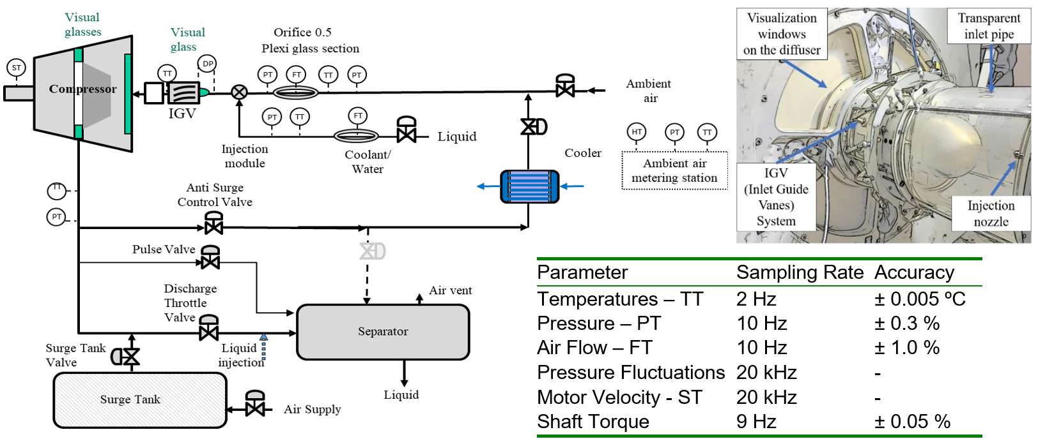

Figure 2: Test rig setup with logged parameters with sampling rate and accuracy of the instrumentation

The single-stage, centrifugal compressor, specifically designed for conventional natural gas process applications, features a shrouded impeller with 18 blades, 400 mm outlet diameter and a vaneless diffuser and volute, a 450 kW electric motor and a maximum rotational speed of 11 000 rpm. In the range of design operating conditions, the impeller stage and system are under full compressibility effects. The design machine Mach number is 0.68 at 11 000 rpm with peak polytropic head 28.1 kJ/kg, equivalent to a static pressure ratio of 1.36. Focus is given to the correlation among readily available, real-plant measurements, possibly involving soft-sensors and probability to account for the uncertainties in flow detection.

* 1. Performance shift and key operating cases

Test methodology and results obtained in previous studies (Pronk and Bakken, 2024a/b; Serena et al., 2024) are extended to broader operating conditions, with a test matrix comprising several combinations of system layout, rotational speeds, surge volume size, flow rate, molar weight and mixture composition. The inlet volume flow rate may be varied from max capacity to zero flow, and into the second quadrant of the map with fully reversed flow. By excluding or including a 3 m3 surge tank and connecting hosing (see Figure 2), tests can be conducted with either a small (0.23 m3) or large (3.32 m3) surge volume, respectively, to vary the transient response and instability behaviour of the system. While ambient air is used as test fluid in the rig, simulations are performed using real performance curves for alternative fluids such as heavier hydrocarbon gases.

The following cases highlight the revised dynamic model behaviour (Pronk et al., 2025) compared against detailed transient experimental data. Further analyses are reported in Pronk and Bakken (2024a).

Positive slope performance characteristics and related impact on trip trajectory

Compressor manufacturers usually provide the right side of the curve, till the surge line. Performance testing in the positive slope area of the characteristics reveals the compressor system response. Figure 3a shows a progressively increasing unsteadiness when further closing the discharge valve after surge inception: showing flow fluctuations and related hysteresis. It should be noted that the actual tested positive slope behaviour is in contradiction to a generalized dynamic modelling approach utilizing a linear increase in head rise towards zero flow. The compressor system response in the positive slope area will be significantly affected.

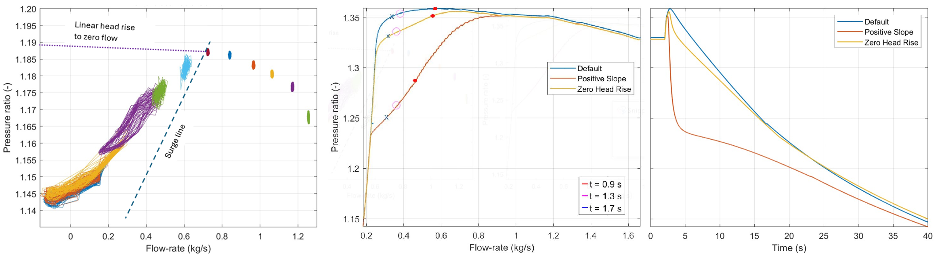

Figure 3a Performance test at 9 000 rpm covering the positive slope area. Figure 3b: Trip trajectory at 11 000 rpm according to different positive slope performance characteristics. Figure 3c: Time evolution of 3b

The impact of different positive slope models is documented in Figure 3b. As a default, a limited head rise towards zero flow is considered. More realistic representations are a zero head rise from surge initiation to zero flow, and the actual positive slope, with a head characteristics according to tested slope given in Figure 3a.

This choice affects the ability to recover from a light surge condition and related impact on time in surge (TIS).

Molecular weight impact on performance and transient response.

An important aspect to ensure stable and reliable behaviour is the anti-surge margin location and related shape of the characteristics, a key stage in safety systems sizing. As testing with the actual mixture might not always be performed before the compressor is installed in the real site, such effect shall therefore be included. Shifts in suction pressure and/or temperature do normally have limited impact on the head and efficiency characteristics. However, shifts in gas composition/molecular weight may alter the performance characteristic considerably. Figure 4 represents such impact with MW ranging from 35 to 44 kg/kmol, and the resulting shift in trip trajectory. Each fluid presents a different performance shape, time to surge, and related surge severity, as shown in Figure 4b. Please note that the three separate curves are at the same speeds for the different MW.

Model validation of time to surge (TTS), combined with compressor driver trip (Trip)

Typical process transients may involve sudden drop in flow rate, power supply (voltage dips) and/or rotational speed. In the current analyses these have been performed by scheduling the discharge throttle valve stroke, and a combined discharge valve stroke schedule and drive trip (sudden loss in power supply). The time throughout the experimental trip is validated. Model prediction versus experimental test data are documented in Figure 5a. A very important validation aspect upfront detailed trip trajectory analysis is a confirmation that the model represents a drive trip from a normal operating point, without any valve interactions. This ensures directly that the compressor train polar inertia, valve and piping frictional losses and drive interactions (residual torque) represent the actual plant process design and behaviour.

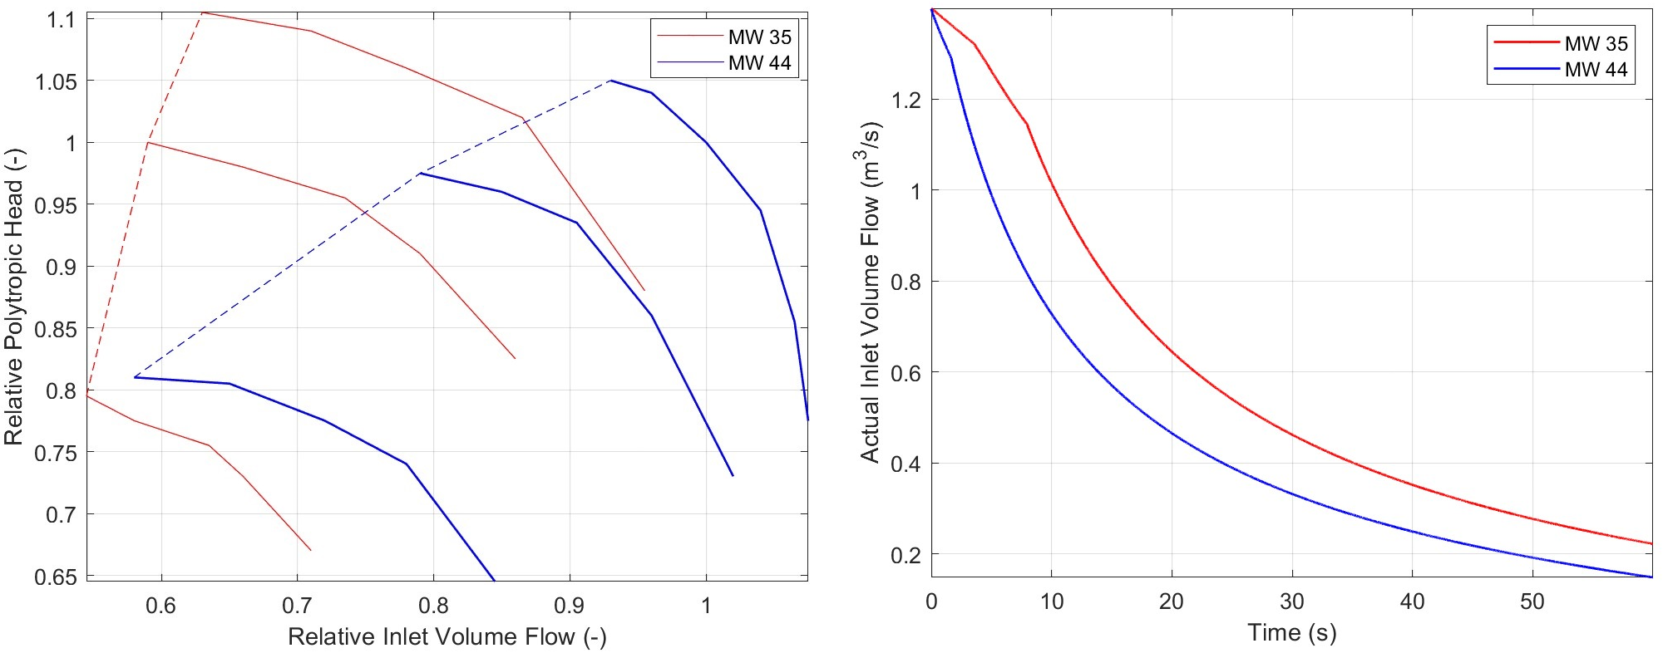

Figure 4a: Performance curves. Figure 4b: Performance shift and trip trajectory at different gas composition

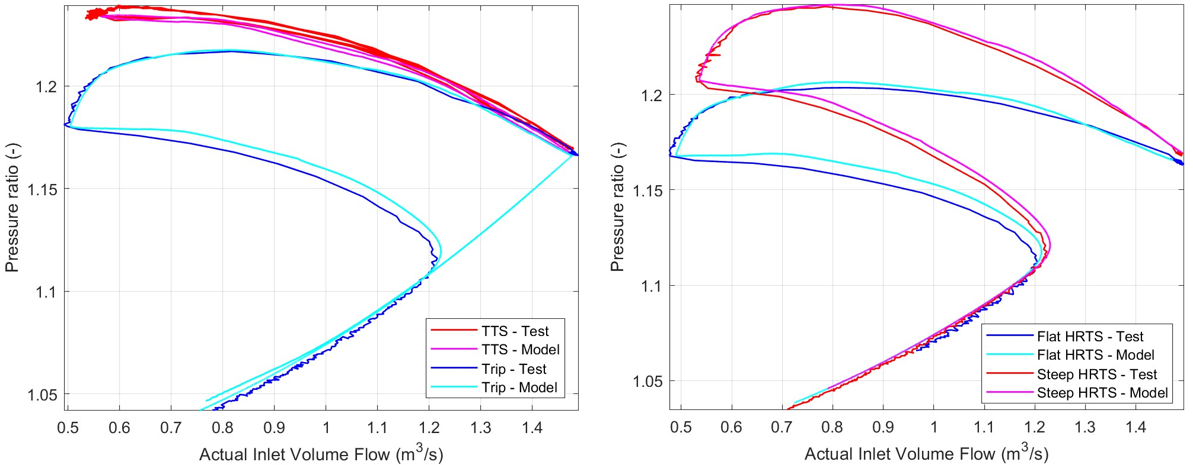

Figure 5a: Model transient response versus experimental data. Figure 5b: Pressure rise to surge impact on trip trajectory, test versus model

“Head rise to surge” impact on stability.

Vital to ensure stable operation and surge protection, the head rise to surge requirements are incorporated in the international compressor specification and test standards like ISO5389 (ISO, 2005) and ASME PTC10 (ASME, 1997). The performance characteristic shape dictates directly the operating point sensitivity related to a shift in pressure ratio; a flat characteristic entails a larger and more sudden shift in inlet volume flow-rate at given speed. The requirement is essential in any stability, anti-surge and process interaction analysis as it affects the TTS and TIS. The HRTS impact on trip trajectory has been tested and validated, ref Figure 5b.

Further cases can be set and modelled, to explore a suitable recovery strategy and sequence of actions. Realistic capabilities of anti-surge devices, as the acceleration rate by variable speed drives considering motor and train inertia, the action of IGV, the intervention of anti-surge recirculation valve, etc, shall be considered.

* 1. Conclusions

The experimental data are vital for system modelling validation for a full compressor-system digital twin, essential for full condition monitoring and preservation of equipment integrity. The results document the potential of such model, relying on accurate data acquisition and analysis. The target is the description of a full combination of input variations and compensating regulation, e.g. trip trajectory resulting from variations in power dips and inlet composition,which might encounter downstream pressure and flow instabilities.

A series of normal operation cases are presented and validated, given key guidelines and important relationships between real compressor behaviour and system dynamics. These reveal:

* Importance of establishing a realistic “positive slope characteristics”;
* Molecular weight impact on performance and transient response as it entails a shift in compressor characteristics, performance steepness towards surge initiation and surge point location.
* Time interval before surge initiation, especially in combination with compressor drive trip.
* Impact of different performance “head rise to surge” on system stability. The shift in head rise to surge varies according to compressor design, operating conditions and compressor deterioration.
* Importance of surge model fidelity to represent actual compressor behaviour over the full range.

Nomenclature

f – frequency, Hz

m – flow rate, kg/s

MW – molar weight, g/mol

n – rotational speed, rpm

pi – suction pressure, bar(a)

pd – discharge pressure, bar(a)

Q – volumetric flow rate, m3/s

CFD – Computational Fluid Dynamics

HRTS – Head Rise to Surge

LSV – large surge volume

Ma – Mach Number

SSV – small surge volume

TIS – time in surge

TTS – time to surge

VIGV – variable inlet guide vanes

VSD – variable speed drive, -

Acknowledgments

The Authors would like to kindly thank Equinor and Gassco for their professional support. A special thanks to Ola Ilseth Pronk for his precious collaboration and key contribution, and Erik Langørgen for his expertise regarding test rig operation and modifications.

References

American Society of Mechanical Engineers, 1997, Performance Test Code on Compressors, ASME PTC10

Bakken, L. E., Bjørge, T., Bradley, T. M, Smith, N., 2002, Validation of Compressor Transient Behaviour, Proceedings of the ASME Turbo Expo 2002, ASME GT2002-30279

Bakken, L. E., Lunde, E., Loes, M., 2016, Power Dip Impact on Compressor System Stability, Proceedings of ASME Turbo Expo 2016, GT2016-56950

De Jager, B., 1995, Rotating Stall and Surge Control: a Survey, Proceedings of the 34th Conference on Decision & Control, New Orleans, La

Gravdahl, J.T., Egeland, O., 1998,Speed and Surge Control for a Low Order Centrifugal Compressor Model, Modeling, Identification and Control 19(1), 13-29

Greitzer, E. M, 1976a/b, Surge and Rotating Stall in Axial Flow Compressors: I: Theoretical Compression System Model, II: Experimental Results and Comparison with Theory, J, Engineering for Power 98, 190-211

Greitzer, E. M., Moore, F. K., 1986, A Theory of Post-Stall Transients in a Axial Compressor Systems: Part II-Application,, Journal of Engineering for Gas Turbines and Power 108, 231-239

Hansen, K. E., Jørgensen, P., Larsen, P. S., 1981, Experimental and Theoretical Study of Surge in a Small Centrifugal Compressor, Journal of Fluids Engineering 103, 391-395

Hundseid, Ø. and Bakken, L. E., 2015, Integrated Wet Gas Compressor Test Facility, Proceedings of ASME Turbo Expo 2015, ASME GT2015-43004

International Organization for Standardization, 2005, Turbocompressors – Performance Test Code, ISO 5389

Pronk, O. I., Bakken, L. E, 2024a, Experimental Characterisation of Surge Cycles and Second Quadrant Operation for a Centrifugal Compressor, Proceedings of ASME Turbo Expo 2024, ASME GT2024-121338

Pronk, O. I., Serena, A., Bakken, L. E., Validation of Compressor Surge Rundown Trajectories: Comparative Analysis of Transient Model Predictions and Test Rig Measurements, ASME Proceedings GT2025-151663

Pronk, O. I., Serena, A., Bakken, L. E., Compressor Surge and Positive-Slope Performance Modelling. 2025, Proceedings of the 16th European Turbomachinery Conference (ETC16), ETC2025-142

Serena, A., Pronk, O. I. and Bakken, L. E, 2024, A Centrifugal Compressor - System Transient Digital Twin, Proceedings of ASME IMECE 2024, ASME IMECE2024-142703

Serena, A., Bakken, L. E., 2024, Transient Analysis of Flow Unsteadiness And Machine Instabilities In a Centrifugal Compressor at Surge and Second Quadrant Operation, ASME *J. Eng. Gas Turbines Power*. 1-33, doi.org/10.1115/1.4066988

Tveit, G. B., Bjørge, T., Bakken, L. E., 2005, Impact of Compressor Protection System on Rundown Characteristics”, Proceedings of ASME Turbo Expo 2005, GT2005-68436