|  |  |
| --- | --- |
| cetlogo ***CHEMICAL ENGINEERING TRANSACTIONS***  ***VOL. xxx, 2025*** | A publication of  aidiclogo_grande |
| The Italian Association  of Chemical Engineering  Online at www.cetjournal.it |
| Guest Editors: Fabrizio Bezzo, Flavio Manenti, Gabriele Pannocchia, Almerinda di Benedetto  Copyright © 2025, AIDIC Servizi S.r.l. **ISBN** 979-12-81206-17-5; **ISSN** 2283-9216 | |

Validation of Gas-Liquid Flow Maps using  
Chemical Thermodynamic Simulation

Luigi Raimondi

Process Simulation Services srl

luigi.raimondi@xpsimworld.com

The transport of liquid and vapor phases in pipes is a more complex engineering problem than that of separate phases. Two-phase transport can be found in chemical plants, production of oil and gas from wells, and reinjection of gas-oil mixtures into depleted reservoirs. Two-phase flow models were initially based on empirical correlations and the search for adimensional groups for the calculation of liquid holdup and friction factors for pressure evaluations. Later the analysis of gas-liquid interactions turned to the search for mechanistic models based on fundamental physical principles. The initial development of this topic occurred in the 1980s and 1990s. The seminal study titled “A Model for Predicting Flow Regime Transitions in Horizontal and near Horizontal Gas-Liquid Flow” was published by Taitel and Dukler in 1976. The flow types are represented by diagrams showing the gas and liquid flow rates using superficial velocities of the liquid USL and vapor USG. These maps, widely reproduced in textbooks and design manuals, are often considered cornerstones in the two-phase flow subject but have never been discussed. The results obtained in developing a mathematical model for the dynamic compositional simulation of two-phase flows, allowed the author to highlight the lack of thermodynamic bases and other approximations in calculating classical two-phase flow maps. They represent reality in a very approximate way, especially when used by chemical engineers to design two-phase transport of multicomponent mixtures. The failure to consider the vapor-liquid equilibrium in the cases of oil and gas transport is perhaps the greatest error, probably generated by the initial consideration of air-water systems only. The frequent reproduction of these flow maps in textbooks and design manuals is also a problem in the correct teaching of two-phase flow topics. The article highlights the inconsistencies introduced in the generation of two-phase flow maps presented by Taitel and Dukler in their historical study. This analysis is based on a rigorous 1D fluid dynamic simulation implemented by the author.

* 1. Introduction

Thus gas-liquid two-phase flows represent an essential topic in chemical engineering and for the design of mass transport in chemical plants. The main characteristic of two-phase flow is the formation of different flow configurations or patterns depending on the relative flow rates of the two phases. The main flow patterns are: stratified, annular, dispersed, bubble, and slug flows. The 'slug' flow, being the most complex one, shows dynamic instabilities and has been the subject of numerous studies

To introduce this study, we may start from the description in Perry’s Chemical Engineers’ Handbook of the gas-liquid two-phase flow. For co-current flow for liquid and gases in horizontal and inclined pipes, a very large literature of experimental and theoretical work has been published, with less work on co-current and counter-current vertical downflow. Much of the effort has been devoted to predicting flow patterns, pressure drop, and volume fractions of the phases, with emphasis on fully developed flow. In practice, many two-phase flows in process plants are not fully developed. The most reliable methods for fully developed gas-liquid flows use mechanistic models to predict flow patterns, (stratified, annular, dispersed, bubble, and slug) and use different pressure drop and void fraction estimation procedures for each flow pattern. One image of the most common classification of horizontal flow patterns is shown in Figure 1. A key reference for mechanistic methods for flow pattern predictions and flow regime-specific pressure drop methods is that of Taitel and Dukler (TD,1976). These flow maps, widely reproduced in textbooks and design manuals, are often considered cornerstones in the two-phase flow subject but have never been discussed in detail.

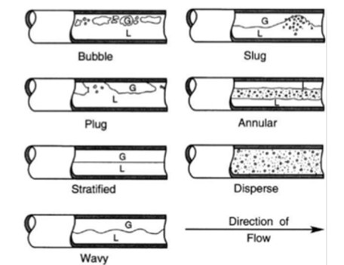

*Figure 1. Flow patterns of horizontal gas-liquid flow.*

In this context, we may also quote the book “Applied Multiphase Flow in Pipes and Flow Assurance, Oil and Gas Production” by E.M Al-Safran and J. Brill (2017). The flow patterns are represented by diagrams showing the pattern areas as functions of the gas and liquid flow rates using the superficial velocities of the liquid USL (on the Y-axis) and vapor USG (usually on the X-axis). Assuming the general validity of a flow map for different fluid mixtures may bring gross errors in the engineering design of pipelines. These maps have been built based on limited data (either experimental or calculated) for one specific pipe diameter and extended to ranges of the gas superficial velocity never tested or even calculated. In most cases, the vapor-liquid equilibrium is never considered, and the temperature and pressure changes bringing the density and viscosity properties to new regions are not properly considered. This study develops the comparison between the flow map published in the classical paper of Taitel and Dukler (TD, 1976), reproduced in Figure 2, and the results obtained using the dynamic simulation of vapor-liquid flows in pipes.



*Figure 2. Crude oil - natural gas, 38°C, 68 atm, horizontal. Reproduced from TD*

The example selected by TD is an industrial fluid transport case in the oil and gas industry. A horizontal pipeline of 0.30 m diameter transports a mixture of crude oil and natural gas at 38 °C and 68 atm. The fluid properties used to calculate the flow-pattern boundaries are reproduced in Table 1.

Table 1. TD case – crude oil and natural gas properties

|  |  |  |
| --- | --- | --- |
| Fluid | Crude oil | Natural gas |
| Temperature, °C | 38 | 38 |
| Pressure, atm | 68.0 | 68.0 |
| Density, kg/m3 | 650 | 50.0 |
| Viscosity, cp | 0.5 | 0.015 |

* 1. Compositional simulation

In a recent study (Raimondi, 2022) the published TD map was considered in the analysis of slug flow. The map shows that the point characterized by liquid and gas flows at the superficial velocity of 1 m/s should belong to the slug flow region. So, an analysis of the TD map has been initially performed using this value of the liquid flow rate. For a compositional simulation, natural gas is assumed to be methane, and the crude oil, whose density should be 650 kg/m3, is defined as a mixture of n-heptane, n-octane, and n-nonane with molar composition: nC7 0.25, nC8 0.50, nC9 0.25. Vapor-liquid equilibrium is calculated using the Peng-Robinson (1976) equation of state while enthalpy, entropy, and density are calculated with the Lee-Kesler equation. The properties of crude oil and natural gas are calculated as shown in Table 2.

Table 2 – Compositional simulation fluid properties

|  |  |  |
| --- | --- | --- |
| Fluid | Crude oil | Natural Gas (CH4) |
| Temperature, °C | 38 | 38 |
| Pressure, atm | 68.0 | 68.0 |
| Density, kg/m3 | 684.0 | 46.9 |
| Viscosity, cp | 0.444 | 0.013 |

When a compositional calculation is applied for this case, vapor-liquid equilibrium must be calculated to define the fluid inlet conditions into the pipe: the first finding to be remarked is the high solubility of methane in the liquid crude oil. The methane molar fraction in the liquid is about 27%, corresponding to a weight fraction of around 5%. So, when the methane flow rate, as measured by its superficial velocity, is below a certain amount it completely dissolves into the liquid and a single liquid phase is obtained. For such conditions, a two-phase flow cannot exist. For each 1000 kg of crude oil, 50 kg of methane is dissolved into the liquid lowering its density and viscosity. Vice versa the fraction of liquid dissolved into the gas is less than 1% molar and has small effects on the gas properties as illustrated in Table 3.

Table 3 – Fluid properties from vapor-liquid equilibrium

|  |  |  |
| --- | --- | --- |
| Fluid | Saturated Crude oil | Saturated natural gas |
| Temperature, °C | 38 | 38 |
| Pressure, atm | 68.0 | 68.0 |
| Density, kg/m3 | 655.0 | 48.2 |
| Viscosity, cp | 0.238 | 0.013 |

To obtain a liquid flow rate with a superficial velocity of 1 m/s, a crude oil feed of 254 m3/h is required. With this liquid flow rate, at the inlet conditions of 38 °C and 68.9 bar, the minimum gas flow rate to have a separate gas phase results in 9100 kg/h of methane corresponding to a superficial gas velocity of 0.76 m/s. So, the gas-liquid flow patterns on the line defined by USL equal 1.0 m/s do not exist for gas superficial velocities lower than 0.76 m/s. Therefore, a homogenous liquid phase is found for all points where $U_{SG}<0.76U_{SL}$. Table 4 shows the vapor and liquid equilibrium compositions of methane and crude oil at 38 °C and 68 atm.

Table 4 – Gas and liquid equilibrium compositions at 38°C and 68 atm.

|  |  |  |
| --- | --- | --- |
| Component | Liq. molar fract. | Gas molar fract. |
| Methane | 0.265577 | 0.996153 |
| n-Heptane | 0.183606 | 0.001868 |
| n-Octane | 0.367211 | 0.001618 |
| n-Nonane | 0.183606 | 0.000360 |

* 1. Dynamic simulation

The fluid dynamic equations are based on a VOF (Volume of Fluid) method and, as implemented in the simulation software program (XPSIM, 2024), have been presented by the author in previous studies (Raimondi, 2017 and Raimondi, 2022). One of the interesting features is their ability to calculate pressure instabilities and oscillations such as those generated by the slug flow without any need for ad-hoc models and external initializations or perturbations. To set a simulation case of industrial interest, the pipe is considered to be 1,000 m long. At the pipe inlet, the gas and liquid flow rates are fixed and have the same velocity (i.e. no-slip flow is assumed). Due to the high liquid velocity, an initial pipe section is required to balance the gas and liquid mechanical momentum. All the simulations are calculated by setting the outlet pressure at 68.0 bar. The inlet pressure is varied by the solution algorithm and the outlet gas-liquid flow rate is calculated. The simulation, which uses pipe segments 5 m long, is carried along a minimum period of 20 minutes allowing the liquid and vapor initial holdup, generated by the initialization, to reach a different steady state when existing. The integration time step is adjusted by the solution algorithm between a minimum of 0.001 s and a maximum value of 0.1 s. Flow parameters (pressure, temperature, liquid and vapor velocities, liquid holdup, and liquid wave height) are obtained by virtual instruments positioned every 200 m. Using these values, the flow pattern can be easily identified. The flow pattern types, to be compared with the classical TD flow map, are taken at a station located 800 m from the pipeline inlet. In the following chapters, two calculation sets each at a constant liquid superficial velocity, are presented. The results obtained are quite different from what TD presented in their flow map shown in Figure 2.

* + 1. Case 1 - USL 1.0 m/s

The first case is defined by the superficial velocity of the liquid equal to 1 m/s, and the results obtained are listed in Table 5.

Table 5. TD flow map. Liquid superficial velocity 1.0 m/s.

|  |  |  |  |  |  |  |  |
| --- | --- | --- | --- | --- | --- | --- | --- |
| Case | UoM | 1 | 2 | 3 | 4 | 5 | 6 |
| Liquid vol. flow | m3/h | 217 | 217 | 217 | 217 | 217 | 217 |
| Gas mass flow | kg/h | 20000 | 30000 | 40000 | 50000 | 60000 | 80000 |
| Liquid super. vel. | m/s | 1.00 | 1.00 | 1.01 | 1.01 | 1.02 | 1.03 |
| Gas super. vel. | m/s | 1.00 | 1.84 | 2.66 | 3.51 | 4.36 | 6.14 |
| Total super. vel. | m/s | 2.00 | 2.84 | 3.67 | 4.52 | 5.38 | 7.17 |
| Flow pattern |  | strat | strat- wav | slug | strat | strat | strat-wav |

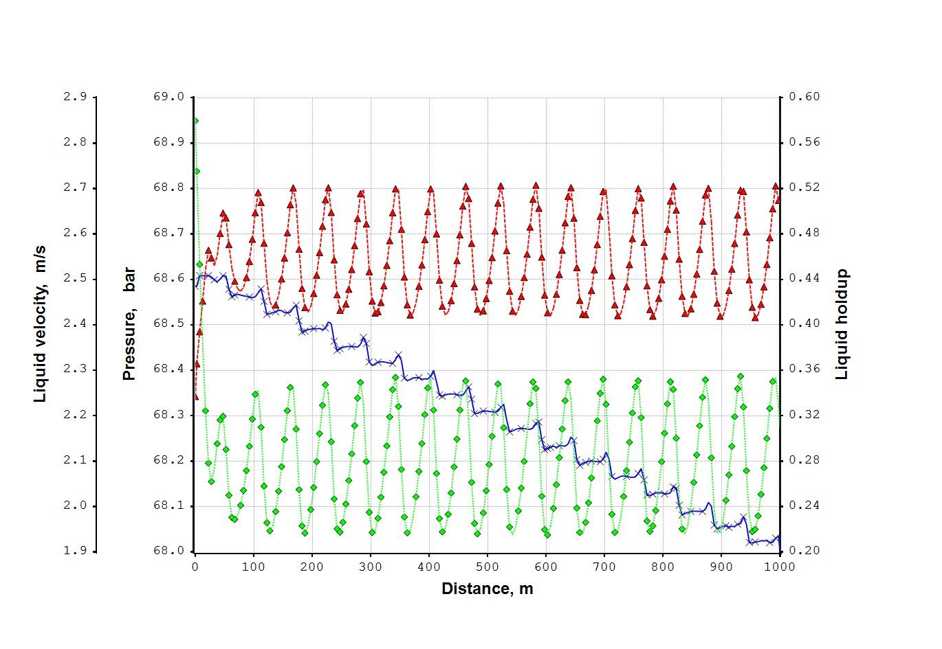As previously discussed, there is no two-phase flow for gas flow rates below 9100 kg/h.

Figure 3. Case 1, USL 1 m/s, WG 30000 kg/h. Pressure (x), liquid holdup (∆), liquid velocity (**◊**)

The first calculation with gas flow at 20000 kg/h generates a stratified flow and no intermittent flow pattern is found. With a higher gas flow rate of 30000 kg/h, the stratified flow becomes wavy, as shown in Figure 3, where the pressure, holdup, and liquid velocity profiles are plotted along the pipe length. Only with a gas flow rate of 40000 kg/h, corresponding to a gas superficial velocity of 2.66 m/s, the intermittent flow appears, and a slug-type structure can be identified as shown in Figure 4.

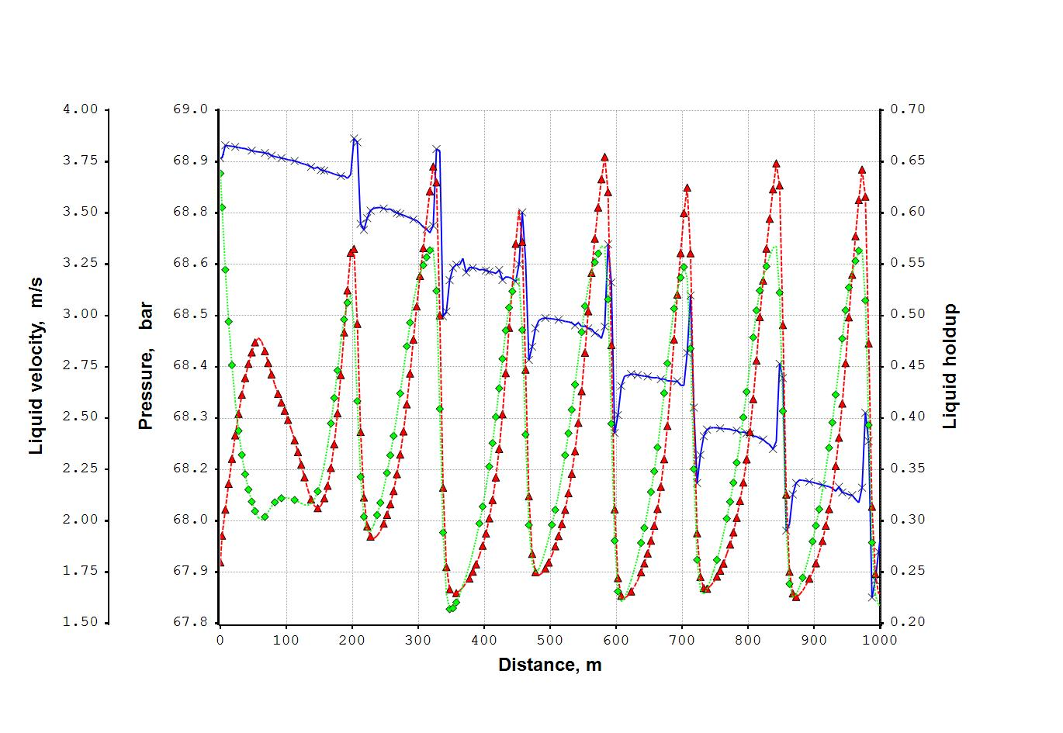

Figure 4. USL 1 m/s, WG 40000 kg/h. Pressure (x), liquid holdup (∆), liquid velocity (◊)

* + 1. Case 2 - USL 2 m/s

Calculations made with a liquid superficial velocity of 2 m/s are summarized in Table 6. Up to a gas flow rate of 40000 kg/h, the two-phase flow shows the characteristic of a bubble flow with no formation of sections with stratified flow. It is only with a higher gas flow rate that an intermittent flow pattern begins to appear.

Table 6. TD flow map. Liquid superficial velocity 2.0 m/s

|  |  |  |  |  |  |  |  |  |  |  |
| --- | --- | --- | --- | --- | --- | --- | --- | --- | --- | --- |
| Case | UoM | 1 | 2 | 3 | 4 | 5 | 6 | 7 | 8 | 9 |
| Liquid vol flow | m3/h | 434 | 434 | 434 | 434 | 434 | 434 | 434 | 434 | 434 |
| Gas mass flow | Kg/h | 20000 | 30000 | 40000 | 50000 | 60000 | 70000 | 80000 | 85000 | 90000 |
| Liquid sup. vel. | m/s | 1.99 | 1.99 | 2.00 | 2.00 | 2.02 | 2.02 | 2.03 | 2.03 | 2.03 |
| Gas sup. vel. | m/s | 0.427 | 1.3 | 2.17 | 3.04 | 3.88 | 4.71 | 5.59 | 6.02 | 6.51 |
| Flow pattern |  | Bubbl | Bubbl | Bubbl | Plug | Slug | Slug | Slug | Slug | Strat |

The results obtained by the dynamic simulation are very different from the flow pattern boundaries of the original TD flow map.

* 1. Conclusion

We have shown that figures currently used to show the flow pattern of gas-liquid two-phase flow lack verification. They are too generic mainly in the limit of one phase (gas or liquid) approaching zero. In most cases, the thermodynamic equilibrium between phases is not considered as well as the extent of solubility of one phase into the other. The case considered is taken from a fundamental study in the field of two-phase flow in pipes. It shows many incongruencies when analyzed from the chemical engineering thermodynamic point of view. The main point is that the real case presents a large section of the graph where the gas is completely soluble in the liquid phase producing a single liquid phase flow. This fact is completely ignored. The correct map should present a large part occupied by the ‘homogeneous liquid’ left to red line added, as presented in Figure 6

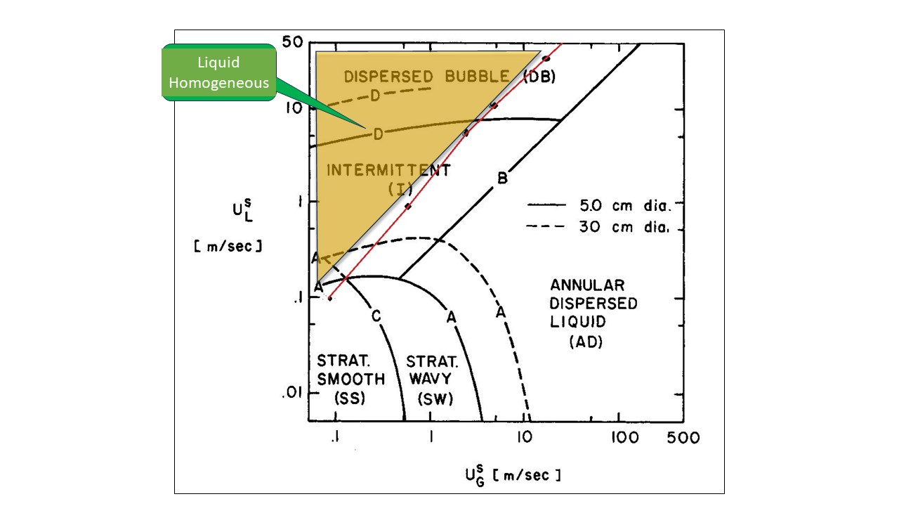

Figure 6. TD flow map corrected with single liquid phase boundaries

References

Al-Safran E.M., Brill J., 2017, Applied Multiphase Flow in Pipes and Flow Assurance - Oil and Gas Production”, Society of Petroleum Engineers.

Lee B.I., Kesler M.G., 1975, A generalized thermodynamic correlation based on three-parameter corresponding states, AIChE J.,21, 510-527.

Peng D.Y., Robinson D.B., 1976, A new two-constant equation of state, Industrial Engineering Chemistry Fundamentals, 15, 59–64.

Perry R.H., Green D.W., 1998, Perry’s Chemical Engineers’ Handbook, 7th Edition, McGraw – Hill International Editions.

Raimondi, L., 2017, Compositional Simulation of Two-Phase Flows for Pipeline Depressurization. SPE J., 22 (4) 1242–1253.

Raimondi L., 2022, Gas/Liquid Two-Phase Flow in Pipes: Slugs, Classical Flow-Map, and 1D Compositional Simulation, SPE J., 27 (1) 532-551

Taitel Y., Dukler A.E., 1976, A Model for Predicting Flow Regime Transitions in Horizontal and near Horizontal Gas-Liquid Flow”. AIChE Journal, 22 (1) 47-55.

XPSIM (eXtended Process SIMulator), 2024, Reference Manual, Version 3.02., Process Simulation Services, [www.xpsimworld.com](http://www.xpsimworld.com).