 CHEMICAL ENGINEERING TRANSACTIONS  VOL. xxx, 2025 | A publication of  
The Italian Association
of Chemical Engineering
Online at www.cetjournal.it

Guest Editors: Fabrizio Bezzo, Flavio Manenti, Gabriele Pannocchia, Almerinda di Benedetto
Copyright © 2025, AIDIC Servizi S.r.l.
ISBN 979-12-81206-17-5; ISSN 2283-9216

Modelling a Gasification Process for Agricultural Waste using GasDS and Validation with Experimental Data
Muhammad S. Manshaª*, Francesco Negri^{b,c}, Cristina E. Molinerª, Flavio Manenti^{b}, Elisabetta Aratoª
ªDipartimento di Ingegneria Civile, Chimica e Ambientale (DICCA), Università degli Studi di Genova, Genova (Italy)
^{b}Politecnico di Milano, Dipartimento di Chimica, Materiali e Ingegneria Chimica “Giulio Natta”, Milano (Italy)
^{c}Itelyum Regeneration S.p.A., Via Tavernelle 19, Pieve Fissiraga 26854, Lodi, Italy
muhammad.saadmansha@edu.unige.it

Abstract
Gasification is a highly efficient thermochemical process that can transform biomass into syngas—a mixture of hydrogen, carbon monoxide—through partial oxidation at elevated temperatures, making it an attractive waste recovery solution with reduced emissions. This study examines the gasification of prunings of apple trees (PAT) and wood pellets (WP), selected for their abundance and renewable potential. The GasDS simulation tool was used to analyse the influence of varying equivalence ratio (ER) on temperature, syngas yield and composition, and calorific values and the outputs were compared to experimental results using a spouted bed reactor. The results demonstrates that GasDS reliably predicts key gasification products trends validating the model’s accuracy. By refining the model and incorporating diverse feedstocks, its predictive accuracy might be enhanced, thereby optimizing waste conversion for improved energy efficiency. These findings underscore gasification's promise in sustainable waste management, offering a pathway to efficient, cleaner energy production and demonstrating the critical role of simulation tools in advancing waste valorisation technologies.
  - Introduction
Waste management has advanced with recycling, composting, and waste-to-energy technologies, yet landfilling remains prevalent, causing environmental issues like groundwater contamination and greenhouse gas emissions (Suryawan and Lee, 2024). The EU Landfill Directive targets a reduction of landfilled waste to 10% by 2035 (“Economic instruments and separate collection systems — key strategies to increase recycling,” 2023). To further reduce waste, techniques such as lignocellulosic biomass fractionation, incineration, anaerobic digestion, pyrolysis, and gasification are being employed for resource recovery and energy production (Santos et al., 2022). Gasification is a widely studied, commercially viable process for producing synthetic gas (syngas: H₂, CO). It involves thermochemical conversion of waste at temperatures above 700°C, using oxidation agents like air, oxygen, steam, or CO₂ (Hanchate et al., 2021). Biomass, as a renewable resource, supports sustainable production of heat, electricity, and biofuels. Different gasifier types (fixed bed, fluidized bed, spouted bed, entrained-flow, plasma) enable diverse outputs such as electricity, chemicals, fuels, and hydrogen, making it a versatile industrial process (Tezer et al., 2022). In current work, the exploitation of Pruning of Apple Tree (PAT) and Wood Pellets (WP) for syngas production is investigated via a Spouted Bed Pilot Gasification Plant based in Biella (Italy). The Spouted Bed Reactor (SBR) is designed to operate with capacity of 200 g/min of biomass able to provide 20kWth. The pyramidal reactor has 0.2 m length of its square base, 1.3 m height and 21 mm spouting orifice diameter with 60° inclination of side at spouted base (Bove et al., 2019). SBR are an innovative technology with applications in drying, coating, desulfurization, and thermo-chemical reactions (Moliner et al., 2017). Unlike traditional fluidized bed reactors (FBR), SBR employ a single orifice inlet instead of a distributor plate, enhancing solid recirculation and establishing a distinct multiphase flow regime. This design improves solid-gas interactions, making SBRs efficient for various industrial processes (Carozzo et al., 2024). During gasification of biomass, a series of homogeneous and heterogeneous reactions occurs, described in literature through a complex kinetic framework, which includes drying, pyrolysis, char conversion, and homogeneous reactions. Initially, moisture is released through drying, followed by pyrolysis, which produces gases such as CO₂, CO, CH₄, and H₂. Subsequently, the char reacts with gasifying agents at elevated temperatures to facilitate further conversion (Fan et al., 2020).
Advanced simulation tools are increasingly employed for modeling, optimizing, and analysing complex processes, including biomass gasification. Widely used software includes ChemCAD, MATLAB, GWSIM, Aspen Plus, and computational fluid dynamics platforms such as GAMBIT, FLUENT, and OPENFOAM, offering robust capabilities for process evaluation (Ajorloo et al., 2022). Conventional software like Aspen Plus (Moliner et al., 2016; Mutlu and Zeng, 2020), COCO (Moliner et al., 2018) and DWSIM (Moliner et al., 2024; Ullah et al., 2024), widely used for biomass gasification modeling, relies on equilibrium assumptions, excluding reaction kinetics. This simplification often omits dynamic process behaviour, leading to deviations between simulated and experimental results. Accurate modeling requires incorporating kinetic details for reliable process predictions (Marchelli et al., 2019). The GasDS offers precise modeling of chemical kinetics and transport in gas-solid systems through validated reaction kinetics for accurate biomass gasification, using a lignocellulosic composition-based kinetics scheme (Negri Francesco et al., 2022). This approach is different from the commonly applied proximate and ultimate analysis-based simulations that have been proved not sufficient to describe the devolatilization process. A reliable structural analysis of biomass samples, giving significant information on the relative content of carbohydrates (glucose, xylose, galactose, arabinose, and mannose), lignin, extractives, protein, and ash, is key to analyse the successive biomass decomposition steps. (Ranzi et al., 2017). GasDS has been widely validated for biomass and has been recently used to model the sewage sludge decomposition by optimizing kinetic parameters to align with experimental data. The model provided effluent properties, including flowrate (0.03–0.07 kg/s), temperature (950–1150 K), and composition, aiding in the design of waste-to-energy systems (Gallo Francesco and Manenti Flavio, 2023).
The paper aims to validate the use of GasDS for gasification of PAT and WP biomass feeds at varying equivalence ratios (ER) by comparison with the experimental data by (Bove et al., 2019). Our work on GasDS reliably predicts gasification trends, aiding in process optimization for better energy efficiency. Refining the model and adding diverse feedstocks can further enhance biomass conversion and support sustainable energy.
  - Materials and Methods
The chemical composition and thermo-physical properties of commercial wood pellets (WP) and apple tree prunings (PAT), as determined by (Bove et al., 2019) through proximate, ultimate, and calorimetric analyses, were applied in the GasDS for detailed kinetic modelling. PAT was evaluated for equivalent ratios (ER) 0.42 and 0.65 while WP was evaluated for series of ER between 0.21 and 0.89. The ER represents the ratio of the actual oxygen supplied to the system to the oxygen needed for full stoichiometric combustion (Zhu et al., 2024).
The gas-solid kinetic model is integrated with a comprehensive gas-phase kinetic scheme, encompassing over 200 species and more than 2,000 reactions. The detailed gasification model within GasDS leverages chemical-physical data, kinetic behaviour, and mass-transfer characteristics of various biomass (Ranzi et al., 2014) and coal (Corbetta et al., 2015) types. GasDS applies a detailed kinetic scheme across particle, reactor layer, and gasifier reactor scales. Initially governed by partial differential equations (PDEs), it is reduced to ordinary differential equations (ODEs) through approximations, focusing on time-dependent gradients. Axial plug-flow behaviour is represented by reactor layers with assumed perfect gas-phase mixing, while intra-particle gradients are approximated via radial discretization (Lorenzo Cabianca et al., 2016).
  - Application of GasDS Suite
As described in Section 2, the initial input to define the feedstock (WP, PAT) for GasDS is the lignocellulosic composition. The reference work (Bove et al., 2019) did not provide this composition and its calculation was done with Microsoft Excel based program based on the Proximate and Ultimate Analysis (Table 1).
Table 1. Inputs in MS Excel program for calculation of lignocellulosic percentage composition
Inputs |  |  | Outputs
Fractions | WP | PAT | Component | WP | PAT
Carbon | 50.06 ± 0.70% | 48.88 ± 0.39% | CELL | 55.4% | 59%
Hydrogen | 6.23 ± 0.08% | 5.71 ± 0.09% | LIG | - | 18.1%
Oxygen | 43.38 ± 0.68% | 42.15 ± 0.53% | LIGH | 35.2% | 19.6%
Nitrogen | 0.06 ± 0.05% | 0.26 ± 0.05% | ASH | 0.3% | 3.3%
Sulphur | 0.01 ± 0.16% | 0.13 ± 0.07% | HECELL | 9.1% | -
Ash content | 0.26 ± 0.10% | 2.87 ± 0.11%
The obtained lignocellulosic composition was used as input along with air inflow rates in GasDS suite (Table 2).The input values for particle properties, equipment properties and operating conditions were obtained from (Bove et al., 2019) while the information about components, reactions and output components are coded in GasDS. Output values include solid and gaseous products along with temperature profiles and heating values.
Table 2. Inputs for Gasification WP & PAT in GasDS program
Input Description | WP | PAT
Number of reactions | 50 | 50
Number of Particles | 1 | 1
Number of Particle sectors | 1 | 1
Uniform Particles initial Temperature (K) | 300 | 300
Uniform initial Pressure (Ata) | 1 | 1
Equipment surface (m2) | 2.12 | 2.12
Equipment Height (m) | 1.3 | 1.3
Number of Volume Elements | 2 | 2
Feed Flow (Nm3/h) | 17 | 17
Particle Diameter (m) | 0.006 | 0.01
Humidity | 5.07 | 8
Lignocellulosic Composition | Outputs from Table 1 | Outputs from Table 1
Total Analysis Time (s) | 500000 | 500000
Temperature for Gasification | 1225.15 | 1225.15
Reactor Model | Continuous | Continuous
Fresh Solid Feed Top Up (g/min) | As per ER | As per ER
  - Gasification Results
Figure 1 and 2 compare gaseous outputs and Figure 3 and 4 the temperatures for PAT and WP, respectively. The air inflow was maintained constant (17 Nm³/h) and the biomass feed was varied to match all ER.
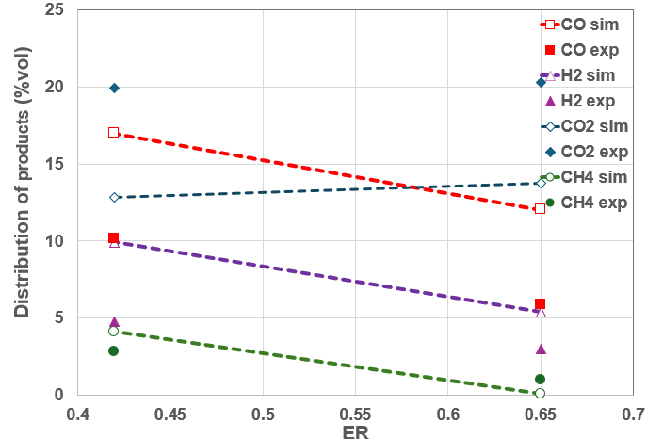  Figure 1: Trend for gaseous outputs from GasDS and Experimental values for PAT | 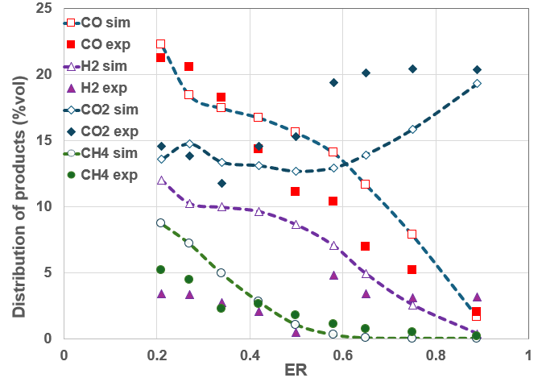  Figure 2: Trend for gaseous outputs from GasDS and Experimental values for WP
For PAT, at ER = 0.65, while some discrepancies are observed, the overall trends in component concentrations are consistent between the experimental and simulated datasets. Specifically, the simulated methane (CH₄) concentration (0.06% v/v) is lower than experimental values (0.99% v/v). Despite this, both datasets show a minimal presence of CH₄ at this ER. The simulated carbon monoxide (CO) concentration (12.01% v/v) exceeds the experimental value (5.88% v/v) as well as the hydrogen (H₂) concentration (5.4% v/v vs. 3.01% v/v) whereas the simulated carbon dioxide (CO₂) concentration (13.78% v/v) is lower than the experimental value (20.32% v/v). At ER = 0.65, the system is closer to combustion conditions, where oxidation reactions lead to higher CO₂ production than CO, as it is the case. At ER = 0.42, simulation results show improved agreement with experimental data. Concentrations of CH₄ (4.12% v/v vs. 2.83% v/v), CO (16.98% v/v vs. 10.16% v/v), H₂ (9.3% v/v vs. 4.75% v/v) and CO₂ (12.85% v/v vs. 19.94% v/v) exhibit similar trends, with simulations overestimating CO and H₂ and underestimating CO₂. These results are also in agreement with other works, where an ER in the range of 0.2–0.34 favours the production of hydrogen-rich syngas with yields while higher ER promote increased CO₂ formation at the expense of CO and H₂ concentrations due to enhanced oxidation reactions (Sidek et al., 2020) Similar trend of output gases has been seen by (He et al., 2019) by varying the equivalence ratio ER for gasification processes.
Similarly for WP, Figure 2 shows the distribution of products for WP in the outlet gas and compares the result with experimental data. When conditions are run at higher ER (e.g., 0.89), both the experimental data and the simulation show similar CO concentrations (1.99% v/v vs. 1.59% v/v), with a consistent trend of increasing CO as ER decreases. The CO₂ concentrations show a similar decreasing trend in both datasets, though GasDS slightly underpredicts CO₂ at lower ER. CH₄ concentrations are generally low in both cases, and while the simulation slightly underestimates CH₄, the trend of increasing methane with decreasing ER is effectively captured by the model. Hydrogen (H₂) concentrations exhibit a larger discrepancy, particularly at ER 0.50, where the experimental data (0.46% v/v) deviates significantly from the expected trend, likely due to experimental error or measurement uncertainty. Beyond this point, both the experimental and simulated results show a similar upward trend in H₂ concentration as ER decreases. This indicates that the overall behaviour of H₂ production is well represented by the simulation, despite the anomaly at ER 0.50. The comparison between GasDS and experimental results show better agreement at lower equivalence ratios (ER), where deviations are minimal. At higher ER values, significant discrepancies were observed. Interestingly, the temperature of reaction for WP (Figure 4) was better described at lower ER whereas at higher ER temperature was highly underestimated. This could be the motivation for the observed differences in the corresponding gas composition, as a different gasification system might be obtained due to the different considered temperature. This fact could be related to difficulties encountered in the experimental reactor where isolation or expected combustion reactions might not be performing as expected, and this also indicates that there is room for optimisation in the experimental system.
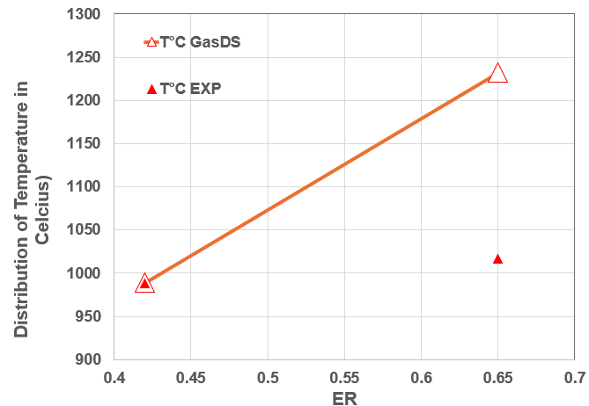  Figure 3: Trend for Temperature Output from GasDS and Experimental values for PAT | 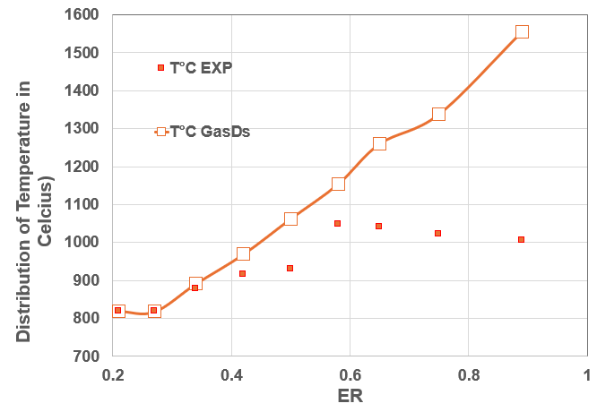  Figure 4: Trend for Temperature Output from GasDS and Experimental values for WP

Table 3 shows the comparison between experimental and simulated LHVs, together with the associated error values. Lower heating values (LHV) were calculated by using an equation provided by (Gai and Dong, 2012):
LHV = (0.126*x) + (0.108*y) + (0.358*z) [MJ/Nm³] (1)
Where x, y and z are percentages of volume fraction of combustible compounds CH₄, CO and H₂ respectively
Table 3: LHV Outputs comparison of GasDs and Experimental data for WP & PAT at different ER
ER | Feed (g/min) | LHV MJ/Nm³  GasDS | LHV MJ/Nm³ Experimental | Error %
PAT
0.65 | 99 | 2.12 | 1.42 | +49
0.42 | 150 | 4.12 | 2.80 | +47
WP
0.89 | 67 | 0.24 | 0.65 | -0.63
0.75 | 81 | 1.26 | 1.15 | +9.5
0.65 | 93 | 2.01 | 1.48 | +35
0.58 | 405 | 2.63 | 2.20 | +19
0.5 | 120 | 3.26 | 2.07 | +57
0.42 | 145 | 4.13 | 2.95 | +40
0.34 | 176 | 5.02 | 3.40 | +47
0.27 | 223 | 5.99 | 5.16 | +16
0.21 | 286 | 7.21 | 4.53 | +58
The predicted LHV are consistently higher than the experimental values in all cases due to the discussed variations in gas composition, and the trend of increasing LHV with decreasing ER is similarly captured in both datasets. Lower ER create fuel-rich conditions with limited oxygen, favouring partial oxidation and reactions like gasification and water-gas shift. This increases CO and H₂ production while reducing CO₂, enhancing syngas energy content and process efficiency (Cerone and Zimbardi, 2021). (Puig-Gamero et al., 2021) simulated biomass gasification in fluidized bed reactor using Aspen plus at varying temperatures, ER values and varying feed stocks and similar trends for output gases were observed with slight overestimation of H_{2.} Moreover, both models predicted well for ER values near 0.30.
Overall, although quantitative discrepancies are observed, the trends in gas composition and LHV are in good agreement between the simulation and experimental results. These findings validate GasDS as a valuable tool for simulating the gasification of biomass, with any observed differences likely stemming from experimental uncertainties or difficulties to effectively describe the initial feedstock through its lignocellulosic composition.
  - Conclusions
The comparison between experimental data from the gasification of biomass and the simulated GasDS results reveals that the model accurately predicts the key trends in the gasification of pruning of apple trees (PAT) and wood pellet (WP) feed. While quantitative discrepancies were observed, the overall trends in gas composition (CO, CO₂, CH₄, H₂), temperature and lower heating value (LHV) were in good agreement between the two datasets. GasDS generally captures the increasing CO and H₂ with decreasing equivalence ratio (ER) and the corresponding decrease in CO₂, albeit with slight overestimations or underestimations in certain components. These findings demonstrate that GasDS is a reliable tool for simulating biomass gasification processes, with any observed differences likely stemming from experimental uncertainties or assumptions about feedstock composition. By uniquely incorporating lignocellulosic composition-based kinetics (hemicellulose, cellulose, lignin), GasDS provides a more detailed representation of biomass feedstock and deeper insights into reaction pathways. Further enhancements, such as refining reaction kinetics and expanding the range of feedstock types, could improve its precision and applicability, supporting the advancement of biomass conversion processes and sustainable energy technologies.

Nomenclature
PAT - Prunings of Apple Trees | WP - Wood Pellets | LIG – Lignin
ER - Equivalence Ratio | EU - European Union | CELL – Cellulose
LHV - Lower heating Values | HECELL – Hemicellulose | LIGH - Lignin (Hydrolyzed)
  - Acknowledgments
EA acknowledges the project “Network 4 Energy Sustainable Transition—NEST” funded under the National Recovery and Resilience Plan (NRRP), Mission 4 Component 2 Investment 1.3—Call for Tender No. 1561 of 11.10.2022 of Ministero dell’Università e della Ricerca (MUR) and the PRIN 2022 funded by the European Union—NextGenerationEU.
  - References
Ajorloo, M., Ghodrat, M., Scott, J., Strezov, V., 2022. Recent advances in thermodynamic analysis of biomass gasification: A review on numerical modelling and simulation. Journal of the Energy Institute 102, 395–419. https://doi.org/10.1016/j.joei.2022.05.003
Bove, D., Moliner, C., Curti, M., Baratieri, M., Bosio, B., Rovero, G., Arato, E., 2019. Preliminary tests for the thermo‐chemical conversion of biomass in a spouted bed pilot plant. Can J Chem Eng 97, 59–66. https://doi.org/10.1002/cjce.23223
Carozzo, V., Arato, E., Moliner, C., 2024. Review of Experimental Activities and Recent Developments of Spouted Bed Reactors at Different Operational Scales. Energies 17, 1046. https://doi.org/10.3390/en17051046
Cerone, N., Zimbardi, F., 2021. Effects of Oxygen and Steam Equivalence Ratios on Updraft Gasification of Biomass. Energies 14, 2675. https://doi.org/10.3390/en14092675
Corbetta, M., Bassani, A., Manenti, F., Pirola, C., Maggio, E., Pettinau, A., Deiana, P., Pierucci, S., Ranzi, E., 2015. Multi-scale Kinetic Modeling and Experimental Investigation of Syngas Production from Coal Gasification in Updraft Gasifiers. Energy Fuels 29, 3972–3984. https://doi.org/10.1021/acs.energyfuels.5b00648
Economic instruments and separate collection systems — key strategies to increase recycling [WWW Document], 2023. European Environment Agency. URL https://www.eea.europa.eu/publications/economic-instruments-and-separate-collection/economic-instruments-and-separate-collection (accessed 12.9.24).
Fan, F., Wang, S., Yang, S., Hu, J., Wang, H., 2020. Numerical investigation of gas thermal property in the gasification process of a spouted bed gasifier. Applied Thermal Engineering 181, 115917. https://doi.org/10.1016/j.applthermaleng.2020.115917
Gai, C., Dong, Y., 2012. Experimental study on non-woody biomass gasification in a downdraft gasifier. International Journal of Hydrogen Energy 37, 4935–4944. https://doi.org/10.1016/j.ijhydene.2011.12.031
Gallo Francesco, Manenti Flavio, 2023. Kinetic Modeling of Sewage Sludge Combustion and Gasification for Energy Generation. Chemical Engineering Transactions 105, 283–288. https://doi.org/10.3303/CET23105048
Hanchate, N., Ramani, S., Mathpati, C.S., Dalvi, V.H., 2021. Biomass gasification using dual fluidized bed gasification systems: A review. Journal of Cleaner Production 280, 123148. https://doi.org/10.1016/j.jclepro.2020.123148
He, P., Chen, L., Shao, L., Zhang, H., Lü, F., 2019. Municipal solid waste (MSW) landfill: A source of microplastics? -Evidence of microplastics in landfill leachate. Water Research 159, 38–45. https://doi.org/10.1016/j.watres.2019.04.060
Lorenzo Cabianca, Andrea Bassani, Andre Furtado Amaral, Francesco Rossi, Giulia Bozzano, Eliseo Ranzi, Dries Telen, Filip Logist, Jan Van Impe, Flavio Manenti, 2016. Gasds: a kinetic-based package for biomass and coal gasification. Chemical Engineering Transactions 50, 247–252. https://doi.org/10.3303/CET1650042
Marchelli, F., Moliner, C., Baratieri, M., Bosio, B., Arato, E., 2019. From equilibrium to kinetic modelling: The gasification of apple pruning residues in a spouted bed reactor. Presented at the European Biomass Conference and Exhibition Proceedings, pp. 813–820.
Moliner, C., Bove, D., Bosio, B., Ribes, A., Arato, E., 2016. Simulation activities for the pseudo-equilibrium modelling of the gasification of agricultural residues. Presented at the European Biomass Conference and Exhibition Proceedings, pp. 934–940.
Moliner, C., Carozzo, V., Arato, E., 2024. MODELLING OF BIOMASS GASIFICATION: COMPARISON BETWEEN FREE-LICENSED DWSIM AND A COMMERCIAL SOFTWARE. Presented at the European Biomass Conference and Exhibition Proceedings, pp. 543–548.
Moliner, C., Marchelli, F., Bosio, B., Arato, E., 2018. Simulation of the gasification of agricultural residues using coco simulator. Presented at the European Biomass Conference and Exhibition Proceedings, pp. 764–768.
Moliner, C., Marchelli, F., Bosio, B., Arato, E., 2017. Modelling of Spouted and Spout-Fluid Beds: Key for Their Successful Scale Up. Energies 10, 1729. https://doi.org/10.3390/en10111729
Mutlu, Ö.Ç., Zeng, T., 2020. Challenges and Opportunities of Modeling Biomass Gasification in Aspen Plus: A Review. Chem Eng & Technol 43, 1674–1689. https://doi.org/10.1002/ceat.202000068
Negri Francesco, Nova Anna, Basso Daniele, Manenti Flavio, 2022. Techno-Economic Analysis of Dimethyl Ether Biofuel Production Plant Based on Sewage Sludge Gasification. Chemical Engineering Transactions 94, 1087–1092. https://doi.org/10.3303/CET2294181
Puig-Gamero, M., Pio, D.T., Tarelho, L.A.C., Sánchez, P., Sanchez-Silva, L., 2021. Simulation of biomass gasification in bubbling fluidized bed reactor using aspen plus®. Energy Conversion and Management 235, 113981. https://doi.org/10.1016/j.enconman.2021.113981
Ranzi, E., Corbetta, M., Manenti, F., Pierucci, S., 2014. Kinetic modeling of the thermal degradation and combustion of biomass. Chemical Engineering Science 110, 2–12. https://doi.org/10.1016/j.ces.2013.08.014
Ranzi, E., Debiagi, P.E.A., Frassoldati, A., 2017. Mathematical Modeling of Fast Biomass Pyrolysis and Bio-Oil Formation. Note I: Kinetic Mechanism of Biomass Pyrolysis. ACS Sustainable Chem. Eng. 5, 2867–2881. https://doi.org/10.1021/acssuschemeng.6b03096
Santos, S.M., Assis, A.C., Gomes, L., Nobre, C., Brito, P., 2022. Waste Gasification Technologies: A Brief Overview. Waste 1, 140–165. https://doi.org/10.3390/waste1010011
Sidek, F.N., Abdul Samad, N.A.F., Saleh, S., 2020. Review on effects of gasifying agents, temperature and equivalence ratio in biomass gasification process. IOP Conf. Ser.: Mater. Sci. Eng. 863, 012028. https://doi.org/10.1088/1757-899X/863/1/012028
Suryawan, I.W.K., Lee, C.-H., 2024. Achieving zero waste for landfills by employing adaptive municipal solid waste management services. Ecological Indicators 165, 112191. https://doi.org/10.1016/j.ecolind.2024.112191
Tezer, Ö., Karabağ, N., Öngen, A., Çolpan, C.Ö., Ayol, A., 2022. Biomass gasification for sustainable energy production: A review. International Journal of Hydrogen Energy 47, 15419–15433. https://doi.org/10.1016/j.ijhydene.2022.02.158
Ullah, K., Asaad, S.M., Inayat, A., 2024. Process Modelling and Optimization of Hydrogen Production from Biogas by Integrating DWSIM with Response Surface Methodology. Digital Chemical Engineering 100205. https://doi.org/10.1016/j.dche.2024.100205
Zhu, B., Jiang, X., Li, S., Zhu, M., 2024. An Overview of Recycling Phenolic Resin. Polymers 16, 1255. https://doi.org/10.3390/polym16091255

