|  |  |
| --- | --- |
| cetlogo ***CHEMICAL ENGINEERING TRANSACTIONS***  ***VOL. xxx, 2025*** | A publication of  aidiclogo_grande |
| The Italian Association  of Chemical Engineering  Online at www.cetjournal.it |
| Guest Editors: Fabrizio Bezzo, Flavio Manenti, Gabriele Pannocchia, Almerinda di Benedetto  Copyright © 2025, AIDIC Servizi S.r.l. **ISBN** 979-12-81206-17-5; **ISSN** 2283-9216 | |

Resilience Evaluation in the Montes de María Beekeeping Chain as a Tool to Improve Safety and Sustainability in the Colombian Caribbean Region

Jalelys Liceth Leones-Cerpaa, Rosalba Cabreraa, Camila Maderoa, Juan F. Restrepob, Katherine Velandiab, Eduardo Sanchez-Tuirána, Karina A. Ojeda Delgadoa,\*

aProcess Design and Biomass Utilization Research Group (IDAB). Faculty of Engineering, Universidad de Cartagena, Av. El Consulado Street 30 #48-150. Cartagena, Colombia.

bBiontessori Group. Colegio Montessori Cartagena, Av. Jiménez Calle 26 No 18-86, Cartagena, Colombia.

\*kojedad@unicartagena.edu.co

Beekeeping is an important economic activity in the Colombian Caribbean, but its sustainability and resilience face significant challenges. This study assesses the resilience of the Montes de María beekeeping chain through ecosystem characterization based on GLOBE protocols and theoretical risk identification. Surveys were conducted with beekeepers to assess their exposure to different risks, including environmental, socio-cultural, economic and physical factors, as well as bee aggressiveness. Resilience was analyzed using four components, each with specific indicators, which were consolidated into a Resilience Index (RI). Results indicate that the socio-cultural component has the greatest impact on resilience, influenced by limited government support and community awareness of bees. The promotion of beekeeping products, the promotion of teamwork ergonomics, and the establishment of robust regulations for beekeeping practices and products are critical steps in improving the resilience and competitiveness of the sector.

* 1. Introduction

Colombia, one of the most biodiverse countries in the world, is often considered an untapped treasure trove of natural wealth (Geng et al., 2020). This biodiversity supports numerous agro-industrial chains that are critical to the country's economic development and the well-being of its communities. Chain growth and sustainability depend on factors such as infrastructure and logistics, technological innovation, market dynamics, regulatory frameworks, and sustainable practices-along with Colombia's strategic geography (García, 2013). These factors support diverse production chains such as bananas, Sierra Nevada coffee, maize, sorghum, livestock, cocoa, cassava, tropical fruits, and beekeeping, fostering a balance between economic growth and environmental conservation (Cáceres, 2018). Among these industries, beekeeping has recently emerged as a growing sector in Colombia's Caribbean region. The country's honey production will increase by 21% between 2020 and 2024, from 3,851 tons to 6,599 tons, supported by approximately 163,215 beehives (Ministry of Agriculture and Rural Development - MADR, 2024). Despite the growth in beekeeping products, the Montes de María sub-region faces challenges that affect its production processes. The sensitive nature of raw material production and processing highlights the importance of addressing these challenges in a comprehensive manner. Assessing resilience within the beekeeping industry is crucial to identify and mitigate potential disruptions, while optimizing production and promoting sustainability (Salgado, 2005). Studies have been conducted on the resilience of Apis mellifera colonies, as they are an evolved species that must adapt to new environmental conditions and survive pest and virus attacks daily (Blacquière and Panziera, 2018). In this search for a resilient activity based on land use, research has also been conducted on the relationship between beekeeping and society (Malkamäki et al., 2016). However, the novelty of this research lies in the approaches taken to assess the resilience of beekeeping in this Colombian region. To achieve this, the adoption of the GLOBE protocols is proposed. This methodology integrates socio-cultural, economic, physical, and environmental considerations. It offers a holistic approach to resilience assessment that benefits both local communities and the nation as a whole.

* 1. Materials and methods
     1. Study area

This study was conducted in the Colombian Caribbean region, focusing specifically on the Montes de María subregion (Figure 1). Three sampling campaigns were carried out to collect data on key environmental parameters, including bird counts, and atmospheric measurements. The GLOBE protocols were employed for data collection across three domains:

Atmosphere: Measurements included air temperature and surface temperature. Biometry: Vegetation was assessed using 30x30 m quadrants, utilizing tools such as analog clinometers, densimeters, alcohol and infrared thermometers, and the Cloud Globe Observer application (GLOBE program, 2024). Bird counts were conducted using 2–3 observation stations per sampling site. At each station, birds were identified within a 100 m radius over a 10-minute period, following the methodology of Melles et al. (2003).

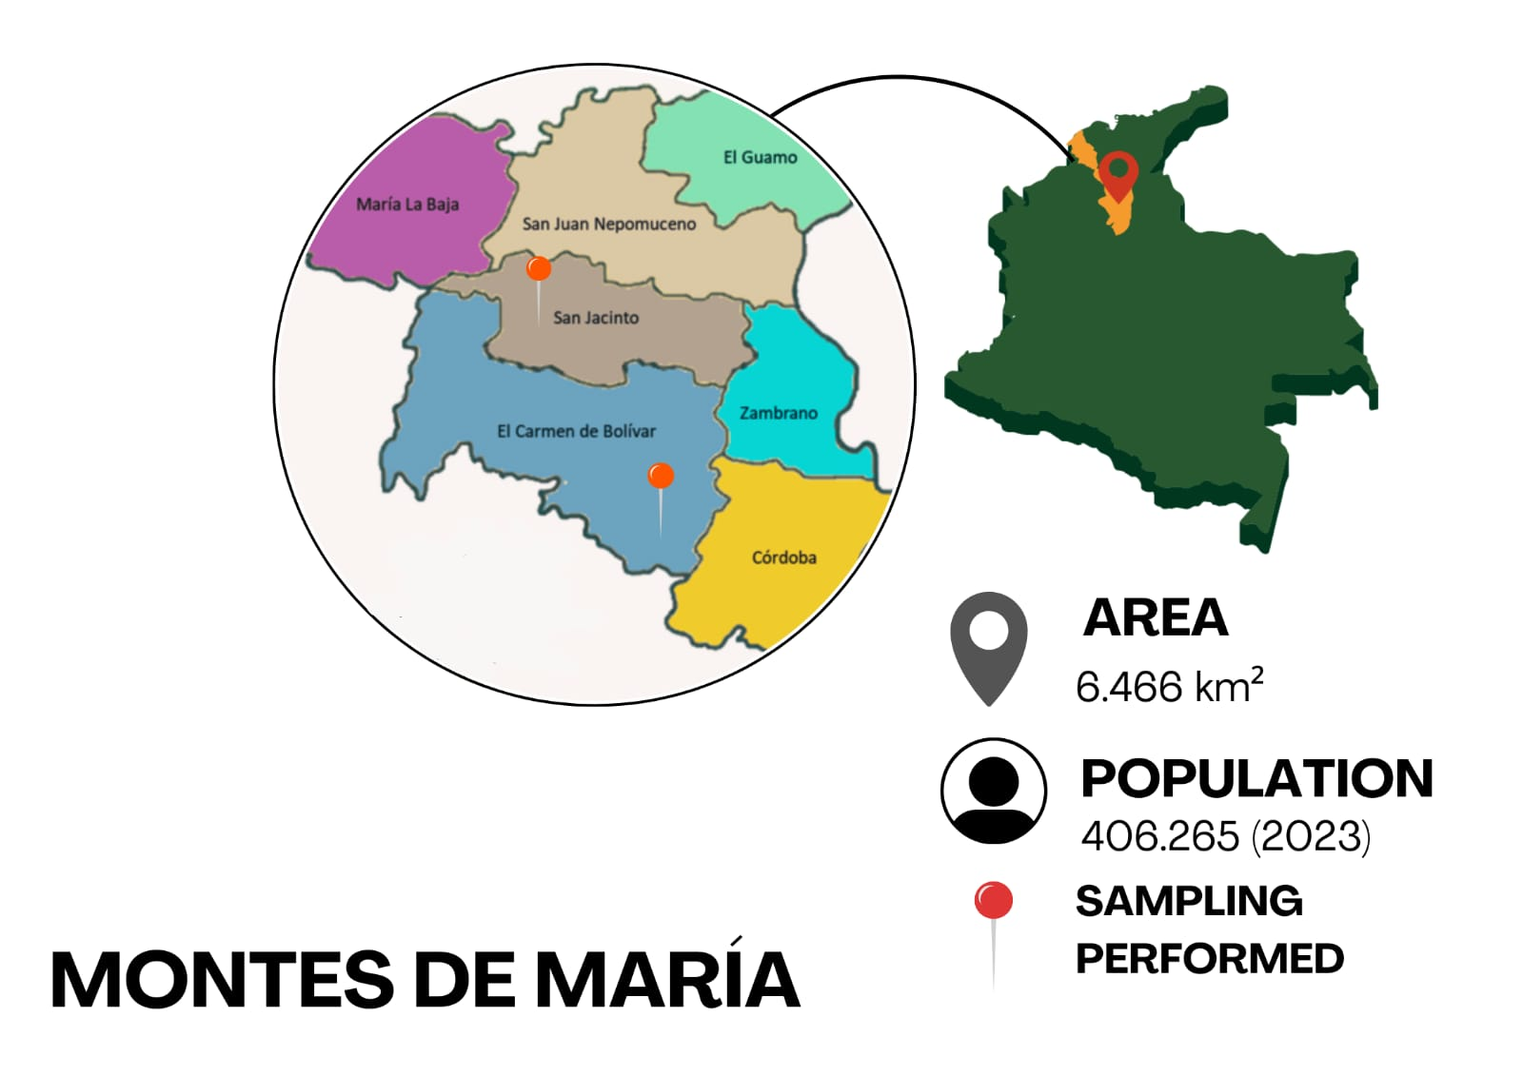

Figure 1: Study area. Colombian Caribbean region - Montes de María-.

* + 1. Theoretical and practical identification of risks during beekeeping practice

For this study, databases including Scopus, Science Direct, Google Scholar, and SciELO were consulted over a ten-year period (2014–2024). The searches were conducted during March, April, and May 2024, focusing on risks associated with beekeeping practices. These risks encompassed environmental, social, physical, and bee aggressiveness factors. The initial search targeted the dangers of beekeeping activities specifically in Colombia and the Caribbean region. The search criteria included the following combinations:

"beekeeping practice risks" AND "Colombia" AND "*Apis mellifera*"; "beekeeping practice risks" AND "Colombian Caribbean region" AND "*Apis mellifera*"; "beekeeping practice risks" AND "Colombia" AND "*Apis mellifera*" AND "environmental" OR "ergonomics" OR "sociocultural" OR "aggressiveness".

The database findings informed the design of surveys to identify the risks perceived by beekeepers in various aspects of their practice. Surveys were conducted in June 2024 with members of the Multiactive Cooperative of Organic Beekeepers Montes de María (COOAPOMIEL) using the CAWI (Computer-Assisted Web Interviewing) method. To ensure compliance with ethical standards, personal data of the participants were not collected, adhering to the guidelines of Law 1581 of 2012 and Decree 1074 of 2015. The survey was created using the Google Forms platform and consisted of four questions tailored to assess beekeeping risks based on the literature review.

* + 1. Resilience evaluation in Montes de María beekeeping chain

The resilience evaluation of the Montes de María beekeeping chain was conducted using a qualitative methodology. Experts, primarily beekeepers, were consulted to estimate risks and assess actions to mitigate them. This process included surveys and a detailed characterization of the study area across three periods in 2024. Additional information was gathered from the websites of government entities such as the Information and Communication Network for the Agricultural Sector (Agronet), the Colombian Agricultural Institute (ICA), and the Ministry of Agriculture and Rural Development (MADR). The evaluation considered four main components: environmental (EC), sociocultural (SCC), economic (ECC), and physical/aggressiveness of *Apis mellifera* (FAC). Each component included a set of indicators assessed on a scale from 0 to 4, with 4 representing a highly resilient system. These indicators were used to calculate the resilience index (RI), as expressed in Eq. (1):

|  |  |
| --- | --- |
| $$RI=(EI + SCI + ECI + FAI)/4$$ | (1) |

Equation (1) is a modified version of the framework proposed by Altieri and Nicholls (2013) in their work on agroecology and resilience to climate change. Each indicator was normalized to a scale ranging from 0 to 4, using data from Latin American countries with notable advancements in beekeeping.

* 1. Results and Discussion
     1. Characterization of the study area

The Montes de María subregion, located within the Colombian Caribbean region, is one of the six economic and social development zones (ZODES) in the Department of Bolívar. This diverse territory, rich in ecosystems prioritized for conservation, requires agricultural practices that emulate natural biogeochemical cycles to ensure the sustainable use of resources while supporting the development of peasant communities. Citizen science serves as an effective tool for educating the public on scientific topics, including Life and Earth Sciences. This research yielded valuable insights into bird populations and environmental parameters associated with the biosphere, atmosphere, and hydrosphere as outlined in GLOBE program protocols. A total of 24 bird species, spanning seven families and ten functional groups, were identified in the study area. Among these, frugivorous species (five) and nectarivorous species (one) were particularly notable, as their shared ecological needs with bees underscore the richness of this ecosystem in supporting a thriving beekeeping industry. Regarding land characteristics, the terrain was classified according to the MUC guide (GLOBE program, 2024) as Herbaceous Vegetation with Short Graminoid and 10–40% tree cover. The trees are broad-leaved, semi-evergreen, characteristic of the Tropical Dry Forest Biome, making the land cover highly suitable for beekeeping activities. The recorded air temperature of 33°C exceeds the March monthly 2-meter height temperature average for 2016–2022, which was 30.4°C (NASA Power, 2024), by nearly 2°C. If this warming trend continues, it could pose challenges for the beekeeping industry. The study also observed abundant running water across the terrain, a favorable condition for beekeeping.

* + 1. Beekeeping risk in the Montes de María subregion

The review revealed that beekeepers primarily face risks of an environmental nature (Steinhauer et al., 2021) and physical risks. However, additional challenges related to the characteristics of bees, social contributions, and opportunities to enhance beekeeping practices (Ministry of Agriculture and Rural Development - MADR (Colombia), 2021) were also identified. Thus, the diversity of healthy birds is an indicator of the good state of the surrounding ecosystem (Leones et al., 2023), as is the presence of fruit and flower trees, which are essential for the collection of nectar and pollen. Based on these findings, a four-question multiple-choice survey was designed and administered to 35 beekeepers affiliated with COOAPOMIEL. The survey questions were as follows:

Environmental factors: Which of the following situations do you experience during beekeeping practices?

Social factors: Which of the following options do you consider essential for the effective development of beekeeping?

Physical/ergonomic factors: Which of the following conditions do you encounter during beekeeping practices?

*Apis mellifera* characteristics: Considering the aggressiveness of *Apis mellifera*, do you believe more frequent management practices are necessary?

Survey responses are illustrated in Figure 2. Among the environmental risks, beekeepers identified all three queried items as high-risk. Notably, 100% of respondents reported exposure to attacks by other animal or plant species, a concern justified by the biodiversity of the Montes de María ecosystem. This region hosts numerous species, including snakes and insects, thriving in over 75 species of tropical dry forest (Luna-Blanco et al., 2022). In addition, exposure to high temperatures was a prominent issue, consistent with the characterization of the study area. Apiary temperatures were reported to increase by up to 20% (El Agrebi et al., 2021). In terms of social considerations, respondents highlighted the lack of government support for beekeeper associations. This lack of support hinders the development of beekeeping products and the establishment of initiatives to secure funding and resources essential for sustainable beekeeping practices. A significant concern in beekeeping is the limited understanding among communities regarding the broader benefits and care of bees. This issue could be addressed through targeted training programs. In terms of physical risks, the activity that poses the greatest danger to beekeepers is the lifting of heavy hive boxes.

|  |  |
| --- | --- |
| **(a)** | **(b)** |
| **(c)** | **(d)** |

Figure 2: Results of surveys applied to beekeepers. (a) Environmental items, (b) Social items, (c) Physical items, (d) Characteristics of bees.

Consequently, there is a pressing need for the development of practical and ergonomic equipment designed for use in apiaries. Apis mellifera exhibit a range of defensive behaviors, varying in their level of aggressiveness. To manage these behaviors effectively, beekeepers generally agree that the proper use of personal protective equipment is essential in preventing bee attacks. While there is a noticeable trend toward genetic modification of bees (35.6%), a lack of awareness and the absence of adequate regulatory frameworks in Colombia hinder its potential as a viable option. Despite the many areas of beekeeping that require improvement, beekeepers contend that the implementation of stricter regulations could significantly enhance the quality and promotion of the practice. Additionally, the thorough application of good beekeeping and manufacturing practices would further contribute to the sector's development.

* + 1. Resilience in the Montes de María beekeeping chain

The resilience index (RI) of the Montes de María beekeeping chain was calculated by selecting key indicators that influence the development of beekeeping activities. This analysis was based on data from the Ministry of Agriculture and Rural Development (MADR) of Colombia (2024), the Information and Communication Network of the Colombian Agricultural Sector (Agronet) (2021), and the Colombian Agricultural Research Corporation (Agrosavia) (2022). The selected indicators for each component, along with their respective scores, are presented in Figure 3. The components of the Resilience Index (RI) revealed significant differences when examined closely. Notably, the socio-cultural aspect received the lowest score. This can be explained by the communities' lack of knowledge about beekeeping, the various products derived from it, the vital role bees play in maintaining ecological balance, and the insufficient support from government authorities in creating a structured framework to aid beekeepers’ associations.

|  |  |
| --- | --- |
| **(a)** | **(b)** |
| **(c)** | **(d)** |

Figure 3: Components of the resilience index with their indicators (a) Environmental, (b) Sociocultural, (c) Economic, (c) Physical and aggressiveness.

The environmental component was notably impacted by the challenges faced by apiaries, which are highly dependent on the specific ecosystem in which they are located. The economic dimension reflected the limited commercialization of bee products in the Colombian Caribbean region, where value-added products and opportunities are scarce. The physical efforts of beekeepers, along with the inherent characteristics of bees, are intertwined with the socio-cultural and economic dimensions, as progress in these areas is crucial for advancing beekeeping practices. From a local policy perspective, government support for beekeeping through the provision of personal protective equipment and education through courses to improve its practices. Beekeeping, with its complex ecosystem of social, cultural, economic, environmental, physical, and behavioral interactions, has the potential to become a significant economic sector in the Colombian Caribbean region. If strategically organized, it could contribute to local development and sustainability. Additionally, beekeeping is not only sustainable but can also complement traditional crops in the region. Despite the numerous challenges and difficulties faced by beekeepers, they demonstrate remarkable resilience and determination in maintaining their apiaries and surrounding habitats. They continuously strive to improve the quality of hive products and are always seeking new opportunities for collaboration to enhance their practices and success.

* 1. Conclusions

The Montes de María region is home to rich biodiversity that supports bee cultivation. During the characterization of the area, 24 bird species were identified across seven families, primarily consisting of frugivorous and nectarivorous species. These birds play an important ecological role through their interactions with bee populations, highlighting the region's favorable environmental conditions. Additionally, herbaceous and grassy plant species essential for creating natural barriers around apiaries were identified. Temperature data indicated a nearly 2°C increase compared to measurements taken two years ago, while water quality remained good. Survey results revealed that beekeepers are aware of the potential risks associated with their activities, such as the threat of predation by local wildlife and exposure to high temperatures. From both an environmental and social perspective, government support is seen as crucial. Moreover, the physical demands of beekeeping, particularly lifting heavy hive boxes, highlight the need for ergonomically designed equipment. Beekeepers also recognize the importance of using personal protective equipment to manage the behavior of *Apis mellifera*. The socio-cultural component of beekeeping has emerged as a key challenge, reflected in its low score of 1.9, which negatively impacts the overall Resilience Index (RI) of 2.5. This underscores the need for significant change, including government intervention and a shift in community attitudes toward the importance of bees. This socio-cultural transformation must be paired with economic improvements, particularly in sales and the development of value-added bee products. Overall, beekeeping is a highly sustainable activity that plays a critical role in regional development. The efforts of beekeepers, who continually strive to improve hive management, are central to this potential.

Acknowledgments

The authors acknowledge to the *Colegio Montessori de Cartagena*, *Technical Agricultural Educational Institution (IETA) –* San Jacinto (Bolívar)*, and Julio César Turbay Educational Institution* – El Carmen de Bolívar (Bolívar), and the *Universidad de Cartagena* for their support with the development of this research project (Act 066-2022).

References

Agronet, 2021, Information and communication network of the Colombian agricultural sector (Agronet). <agronet.gov.co/estadistica/Paginas/home.aspx?cod=1/> accessed 09.07.2024.

Altieri, M., Nicholls, C. I., 2013, Agroecology and resilience to climate change: principles and methodological considerations (Spanish), Agroecología, 8(1), 7–20.

Malkamäki, A., Toppinen, A., Kanninen, M., 2016, Impacts of land use and land use changes on the resilience of beekeeping in Uruguay, Forest Policy and Economics, 70, 113-123, DOI:10.1016/j.forpol.2016.06.002.

Blacquière, T., Panziera, D., 2018, A Plea for Use of Honey Bees’ Natural Resilience in Beekeeping, Bee World, 95(2), 34–38, DOI: 10.1080/0005772X.2018.1430999

Colombian Agricultural Research Corporation (Agrosavia), 2022, Good Beekeeping Practices Protocol and genetic improvement BPAp - *Apis mellifera*. <agrosavia.co/> accessed 09.07.2024.

El Agrebi, N., Steinhauer, N., Tosi, S., Leinartz, L., de Graaf, D. C., Saegerman, C., 2021, Risk and protective indicators of beekeeping management practices, Science of the Total Environment, 799, 1–10, DOI: 10.1016/j.scitotenv.2021.149381

García, R., Núñez, A., Jaimes, S., 2013, Characterization of the upstream phase of the value and supply chain of the palm oil agroindustry in Colombia (Spanish), Dyna, 80 (179), 79-89.

Geng, Z., Song, G., Han, Y., Chu, C., 2020, Static and dynamic energy structure analysis in the world for resource optimization using total factor productivity method based on slacks-based measure integrating data envelopment analysis, Energy Conversion and Management, 228, 113713, DOI: 10.1016/j.enconman.2020.113713

GLOBE program, 2024, Globe program and protocols, <globe.gov/> accessed 15.03.2024.

Leones, J. L., Restrepo, J. F., Velandia, K., Sanchez, E., & Ojeda, K. A., 2023, Sustainability Assessment of Water Ecosystems based on Modified Water Poverty Index (WPI) with Birds’ Biodiversity Parameters. Case study: Juan Angola Creek- Cartagena, Colombia, Chemical Engineering Transactions, 98, 147–152, DOI: 10.3303/CET2398025

Luna-Blanco, C. P., Álvarez-Pérez, P. J., Gómez, J. M., 2022, Diversity and physiognomic structure in two fragments of riparian forests associated with dry ecosystems in the Colombian Caribbean (Montes de María -Sucre) (Spanish), Ciencia En Desarrollo, 13(2), 11–24.

Melles, S., Glenn, S., Martin, K, 2003, Conservation Ecology: Urban bird diversity and landscape complexity: Species–environment associations along a multiscale habitat gradient <ecologyandsociety.org/vol7/iss1/art5/main.html > accessed 18.09.2024.

Ministry of Agriculture and Rural Development - MADR (Colombia), 2024, Minagricultura launches the ninth Regional Committee of Bees and Beekeeping in Magdalena. Ministry of Agriculture and Rural Development (Spanish) <minagricultura.gov.co/ /> accessed 16.09.2024.

NASA Power, 2024, Predictions of Worldwide Energy Resources <power.larc.nasa.gov/> accessed 01.11.2024.

Salgado A.,2005, Methods and instruments to measure resilience: a peruvian alternative (Spanish), Liberabit,11 (11), 41-48

Steinhauer, N., VanEngelsdorp, D., Saegerman, C., 2021, Prioritizing changes in management practices associated with reduced winter honey bee colony losses for US beekeepers, Science of the Total Environment, 753, 1–16, DOI: 10.1016/j.scitotenv.2020.141629.