|  |  |
| --- | --- |
| cetlogo ***CHEMICAL ENGINEERING TRANSACTIONS***  ***VOL. xxx, 2025*** | A publication of  aidiclogo_grande |
| The Italian Association  of Chemical Engineering  Online at www.cetjournal.it |
| Guest Editors: Fabrizio Bezzo, Flavio Manenti, Gabriele Pannocchia, Almerinda di Benedetto  Copyright © 2025, AIDIC Servizi S.r.l. **ISBN** 979-12-81206-17-5; **ISSN** 2283-9216 | |

Safety Production of Fermented Beverages Made with Beekeeping by-products in the Colombian Caribbean Region

Jalelys Liceth Leones-Cerpaa, Gabriella Santandera, Inés Arroyoa, Martha Cuenca Quicazánb, Eduardo Sanchez-Tuirána, Karina A. Ojeda Delgadoa,\*

aProcess Design and Biomass Utilization Research Group (IDAB). Faculty of Engineering, Universidad de Cartagena, Av. El Consulado Street 30 #48-150. Cartagena, Colombia.

bTransformation of Industrial and Agro-industrial Matrixes research group (ITMIA). Faculty of Engineering, Universidad de Cartagena, Cartagena, Colombia.

\*kojedad@unicartagena.edu.co

Currently, the search for developing food products that meet the nutritional and qualitative expectations of consumers has intensified. In this research, fermented beverages were prepared using hawthorn yam (*Dioscorea rotundata*) and beekeeping products (pollen and honey as a sweetener) from the Colombian Caribbean region. Initially, an enzymatic hydrolysis of hawthorn yam with pretreated pollen (Antioquia and Montes de María) was carried out until the mixtures reached a concentration ranging from 8.5°Bx to 12°Bx. The fermentation processes were carried out for 8 hours, monitoring pH and titratable acidity. Once the fermentation period was over, honey was added to the beverages, and they were stored at 4°C, after which microbiological analyses were performed, and the Food Safety Assessment (FSA) was conducted. Among the results, a notable decrease in pH was evident in the samples containing Montes de María pollen (between 4.12 and 4.32), together with an increase in acidity (0.96 and 1.36 %w/w lactic acid). The percentage compliance with FSA was considerably high in the two selected samples, although it is necessary to improve the pretreatment processes of pollen and honey, as well as adjust the duration of one of the fermentations (M2). The beverages produced represent a promising value-added product and an opportunity to strengthen the beekeeping chain in the Colombian Caribbean region.

* 1. Introduction

Beekeeping is important for the sustainability of agriculture and the environment (FAO, 2023). Evaluating the context of the Colombian Caribbean region, beekeeping is an opportunity for communities composed of people displaced by the armed conflict, who have found in beekeeping a sustainable and economically profitable practice (Gardana et al., 2018). However, beekeeping practices lack standardization of product generation processes, innovation, regulation, and traceability of their products (Mora-Adames et al., 2021).

One of the most widely used methods for obtaining new products is lactic acid fermentation. It's a sustainable and economical method that improves the nutritional profile of products and extends the shelf life of foods (Ruiz et al., 2020). In recent years, beverages obtained by lactic acid fermentation have gained popularity due to their ability to combine different ingredients. Among them, different combinations of inputs, probiotics, and antioxidants have been evaluated (Albuquerque et al., 2018). The physicochemical, sensory, and nutritional aspects of fermented beverages have been studied in various investigations and have contributed to a wide range of knowledge in this field (Mărgăoan and Topal, 2020).

Honey and bee pollen have aroused a growing interest in the development of food products, such that recent research highlights the property of bee honey to promote the growth of lactic bacteria and improve parameters such as pH, acidity, phenolic content and antioxidant activity of fermented products, which also increases their sensory acceptance by consumers (Gomes et al., 2017). On the other hand, the Institute of Food Science and Technology (ICTA) of the National University of Colombia (UNAL) has highlighted the nutritional and bioactive importance of bee pollen (Mora-Adames et al., 2021). Although little research has been done on the relationship between honey and pollen in fermented beverages, studies suggest that adequate concentrations of both ingredients significantly improve physicochemical properties, promote bacterial growth and lactic acid production, which also optimizes the organoleptic characteristics of the product (Llumiquinga, 2022).

The diversity of fruits and vegetables in Colombia has allowed studies to evaluate the possibility of producing fermented beverages from these raw materials and their combinations. Various investigations have used different fruits, achieving products with high concentrations of probiotics and showing the influence of fermentation in preserving the quality of the mixtures (Benavides, 2019). Also noteworthy is the production of fermented beverages using different substrates, from fruits such as apples and melons to beekeeping by-products such as honey (Ruiz et al., 2020). By using tubers, vegetables, fruits, and others to produce fermented lactic beverages, producers could add value to their crops, improve the sustainability of their businesses, and access new markets, both nationally and internationally, generating additional sources of income and promoting the development of more sustainable agricultural practices in the region (Leones-Cerpa et al., 2024). In turn, the use of pollen and honey in the production of fermented beverages offers additional benefits. These include improving the nutritional and sensory profile. Incorporating pollen and honey enriches the final product, promotes local beekeeping, and creates new opportunities for small regional producers by offering high-value-added products. The objective of this research was to evaluate the percentage of compliance in the bromatological, and microbiological parameters of fermented lactic beverages based on yam (*Dioscorea rotundata*), honey, and pollen as a strategy for the valorization of beekeeping by-products, taking into account the safety of the production process.

* 1. Materials and methods
     1. Raw Materials and Microorganisms

In this research, hawthorn yam (*Dioscorea rotundata*) from the Colombian Caribbean region was used, acquired directly from farmers, honey from the municipality of San Jacinto, Bolivar, and two types of bee pollen, from Antioquia (An) and Montes de Maria (MM). Two commercial mixed cultures were used for lactic fermentations, culture 1 composed of *Streptococcus thermophilus, Lactobacillus delbrueckii ssp. lactis,* and *Lactobacillus delbrueckii ssp. bulgaricus*, and culture 2 composed of *Streptococcus thermophilus, Lactobacillus delbrueckii ssp. bulgaricus, Lactobacillus delbrueckii ssp. lactis, Lactobacillus acidophilus, Bifidobacterium lactis;* α-amylase and glucoamylase enzymes from the LD Carlson Company brand were also used.

* + 1. Substrate preparation, monitoring, and characterization during lactic fermentation

First, the hawthorn yam was pretreated as shown in Figure 1. It was washed, peeled, cut into small pieces, and washed again. For the fermentations, a ratio of hawthorn yam and water was used (1:4.5 wt%), for which each mixture was subjected to a precooking at 100 °C for 0.5 h to facilitate the grinding process and obtain a homogeneous mixture. As for the bee pollen, it was pretreated by a humid thermal pretreatment with water: pollen ratio of 2:1, initial pH adjusted to 5.8, with a 0.5 N NaOH solution, subjected to sterilization, 115 °C for 0.16 h at 80 kPa (Mora-Adames et al., 2021).

Then, enzymatic hydrolysis was performed using the enzymes α-amylase and glucoamylase, the use of these allows the degradation of granular starch at a temperature lower than that of gelatinization (Uthumporn et al., 2012). In this process, the pollen, previously pretreated, was added in 4 g/ 1000 g of mixture, to the homogeneous mixture of hawthorn yam. The mixture was heated to 90°C and the enzyme α-amylase was added according to the manufacturer's instructions. Then, measurements of the soluble solids (°Bx) were made every 15 minutes until a value of approximately 10 °Bx. When this approximate value was reached, the temperature was lowered to 60°C, the glucoamylase enzyme was added and allowed to react for 1 h. For lactic fermentation, the hawthorn yam and water ratios mentioned above were used, and triplicate assays were performed for each mixed culture, hawthorn yam: water ratio, and pollen type. The mixtures were placed in an electric incubator model SNJ-159B preheated to 42°C. Fermentations were performed for 8 hours (with two mixed cultures), during which time the samples reached pH between 4.5 and 4.6., and then, honey was added for flavoring (approximately 40 g/kg of beverage), and then the samples were stored at 4°C.

Fermentation monitoring was performed by taking 10 g of sample every hour, to measure pH and titratable acidity (wt% lactic acid). The pH meter model HI9813-6 brand Hanna was used. Titratable acidity was measured with the official potentiometric method AOAC 937.05, adding 10 g of distilled water and shaking at 500 rpm for 1 minute. The titration was carried out with a BRIXCO brand glass burette, using a 0.1 N NaOH solution and 5% phenolphthalein as an indicator, considering a color change in the samples at a pH of 8.2 ± 0.1. Soluble solids were measured using a Hanna brand digital refractometer model HI96811.

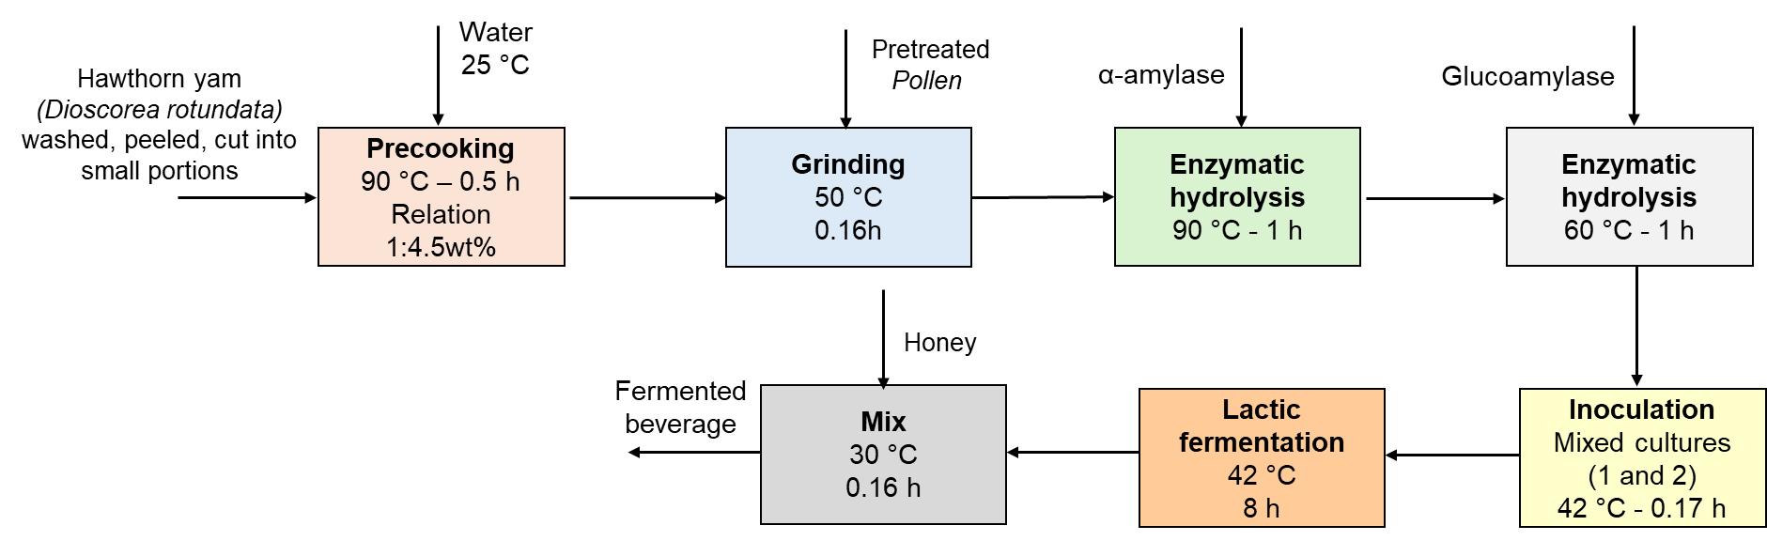

Figure 1: Diagram of the lactic fermentation process of beverages based on hawthorn yam, pollen, and honey

* + 1. Food safety assessment of fermented beverages

The Food Safety Assessment (FSA) of fermented beverages characterizations was performed on the fermented beverages at 4 °C. The characterizations included the physicochemical determinations mentioned in section 2.2, and microbiological analysis to estimate the *E. coli* count (according to ISO 9308-1:2014), total Coliform count (according to ISO 4832:2006), lactic acid bacteria count (according to NTC 5034:2002), and mold and yeast count (according to ISO 21527-2:2008). In this research, all beverages were yogurt-like; they are not dairy products. The limits established in the Colombian Technical Standard (CTS) 805 for dairy products and fermented milks (Colombian Institute of Technical Standards and Certification (ICONTEC), 2005), and the Colombian Resolution Number 1407 (2022) (Minsalud -Ministry of Health and Social Protection, 2022), which establishes the microbiological criteria that food and beverages for human consumption in Colombia must meet were taken into account when determining the percentage of compliance with the physicochemical and microbiological parameters (Gómez-Rave et al., 2022). Thus, the percentage of Compliance with the Food Safety Assessment (FSA) is established as shown in Eq. 1:

|  |  |
| --- | --- |
|  | (1) |

* 1. Results and Discussion
     1. Analysis of the parameters during lactic fermentation

The preparation of the mixtures composed of hawthorn yam and bee pollen from two different regions (Antioquia and Montes de María) began with the enzymatic hydrolysis process, during which monitoring of °Bx revealed an elevation from 3.3 °Bx to 8.5 °Bx for the mixtures containing pollen from Antioquia, and from 4.2 °Bx to 12 °Bx for the mixtures incorporating pollen from Montes de María. Consequently, the importance of enzymatic hydrolysis in pollen is highlighted as an approach for the release of compounds in the mixture before fermentation (Zuluaga-Domínguez et al., 2019); therefore, it is possible to mention that pollen from Montes de María, unlike that from Antioquia, showed a greater release of sugars and proteins (Thakur and Nanda, 2020), which increased the soluble solids composition of the mixture.

The pH variation in the fermented beverages is shown in Figure 2. In this research, triplicate tests were performed for each hawthorn yam mixture with Pollen, as follows: A1: hawthorn yam fermentations with Pollen from Antioquia and culture 1, A2: hawthorn yam fermentations with Pollen from Antioquia and culture 2, M1: hawthorn yam fermentations with Pollen from Montes de María and culture 1, and M1: hawthorn yam fermentations with Pollen from Montes de María and culture 2.

As illustrated in Figure 2, all experimental trials showed a decrease in pH within the range of 4.12 to 4.32; however, samples with Montes de María pollen showed lower pH values ​​than those with Antioquia pollen. It is important to emphasize that hawthorn yam contains mainly water (approximately 69.6%), carbohydrates (approximately 27.88%), proteins (approximately 1.53%), and sugars (approximately 0.5%), in addition to other components such as fiber, vitamins and traces of magnesium and calcium (Salgado-Ordosgoitia et al., 2018). Consequently, the main contribution of soluble solids in the fermented mixtures was pollen, which contains proteins, carbohydrates, vitamins, minerals, dietary fiber, lipids, and other components (Basso et al., 2019). Therefore, the type of pollen had a significant influence on the decrease in pH.

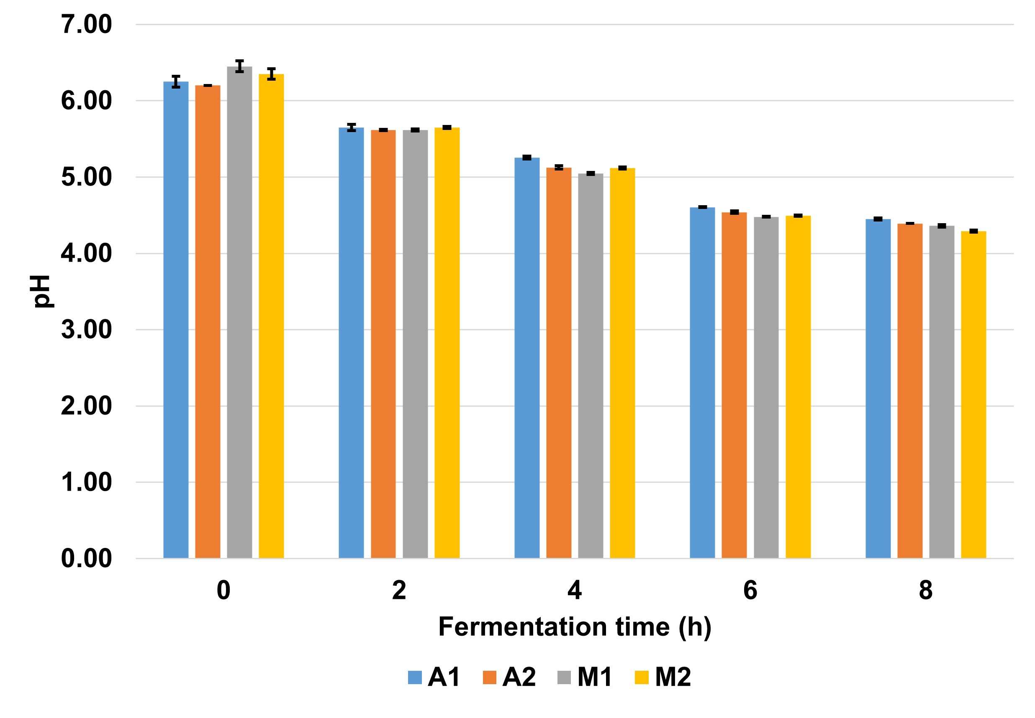

Figure 2: Monitoring of pH in fermentative process of hawthorn yam with Pollen-Antioquia with culture 1 (A1), and culture 2 (A2), Pollen-Montes De María with culture 1 (M1), and culture 2 (M2).

During the lactic acid fermentation process, titratable acidity, expressed as wt% lactic acid, was monitored, as shown in Figure 3, in which higher acidity is observed in the mixtures with hawthorn yam and pollen from Montes de María (M1 and M2), especially in combination with culture 2. This is due to the higher consumption of sugars over time by the lactic acid bacteria of culture 2 in A2 and M2 (0.96 and 1.36 % wt lactic acid, respectively) under the same fermentation conditions, whose main characteristic is that most lactic acid bacteria are homofermentative, and their ability to synthesize lactic acid as a primary metabolite (Gänzle, 2015). The sample acidity correlates with the percentage of lactic acid, mainly because the presence of lactic acid in the beverage increases its shelf life, inhibits the proliferation of microorganisms that spoil the products, and contributes to the sensory attributes like aroma and flavor (Anumudu et al., 2024).

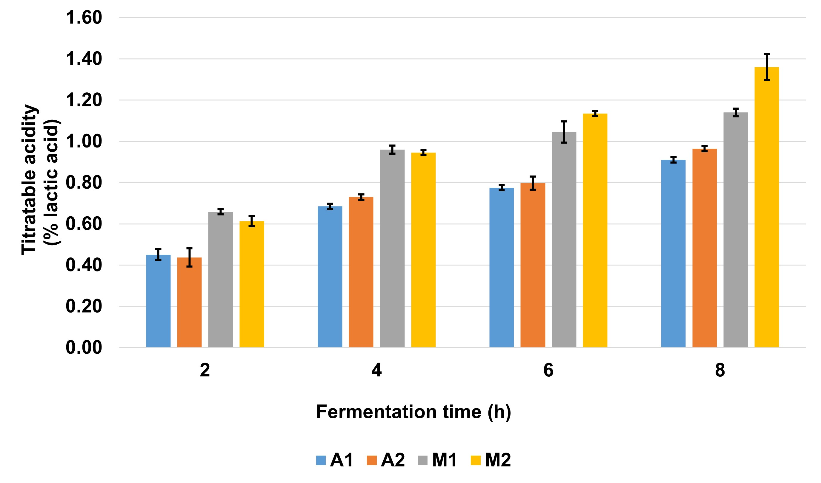

Figure 3: Monitoring of titratable acidity in the fermentative process of hawthorn yam with Pollen-Antioquia with culture 1 (A1), and culture 2 (A2), Pollen-Montes De María with culture 1 (M1), and culture 2 (M2).

Fermentations reaffirm the importance of identifying pollen composition about its geographical origin, as variations in color, aroma, and texture are evident even among samples collected in the same country, differences attributed to the extensive biodiversity between Colombia's regions (Gardana et al., 2018). Consequently, it is imperative to determine the specific components that facilitate fermentation and investigate the nutritional properties potentialization (Zuluaga-Domínguez et al., 2023).

* + 1. Analysis of the Food Safety Assessment (FSA) of Fermented Beverages

To quantify the Food Safety Assessment (FSA) of Fermented Beverage, the maximum and/or minimum values ​​established in Colombian regulations for fermented foods, and dairy products were consulted, considering the physicochemical and microbiological parameters quantified in this research. As a result of the fermentations, samples A2 and M2 were characterized to compare the parameters using two types of pollen and the same culture (culture 2), by the results of the quantification of pH, titratable acidity, and appearance like traditional yogurt. The results of the physicochemical and microbiological criteria evaluated in the two samples of fermented beverages and % FSA compliance are shown in Table 1. The fermented beverages obtained presented different characteristics, in addition to the known properties of the components of the fermented mixture (Lorusso et al., 2018). Table 1 shows the results for the samples with pollen from Antioquia (A2) and Montes de María (M2), where for the first, 83.33% of the measured parameters are within acceptable limits. The elevated concentration of total coliforms detected in sample A2 can be attributed to contamination originating from pollen, which is susceptible to exposure during the collection phase and subsequent processes of drying, freezing, and lyophilization (Végh et al., 2021). Numerous studies have reported the presence of total and fecal coliforms in desiccated pollen samples, with a predominant recommendation to change the drying methodology to include freezing of pollen constants monitoring (Vargas-Abella et al., 2020).

Table 1: Results of physicochemical and microbiological parameters of fermented beverage samples, and % FSA Compliance

|  |  |  |  |
| --- | --- | --- | --- |
| Parameter | Limit values ​​(Units) | Sample A2 | Sample M2 |
| pH | 4.2 – 4.5 | 4.24 | 4.12 |
| Titratable acidity  (wt% lactic acid) | > 0.6 (%wt) | 0.96 (%wt) | 1.36 (%wt) |
| *E. coli* | < 10 (CFU/g) | < 10 (CFU/g) | < 10 (CFU/g) |
| Total Coliform count | < 100 (CFU/g) | 860 (CFU/g) | 81 (CFU/g) |
| Lactic acid bacteria | 106 (CFU/g) | > 3x105 (CFU/g) | > 3x105 (CFU/g) |
| Molds and yeast | 200 – 500 CFU/g | < 10 (CFU/g) | < 10 (CFU/g) |
| % Compliance FSA | | 83.33 % | 83.33 % |

Regarding sample M2, a compliance percentage of 83.33% was obtained, in which it did not reach the required pH range; however, in this case, to comply with the pH requirement, it is advisable to stop the fermentation process two (2) hours earlier, leaving a fermentation duration of six (6) hours, during which the pH was measured at 4.5 ± 0.2, and to repeat the microbiological analyses.

* 1. Conclusions

In recent years, fermented foods with high nutritional value and quality have been developed. In the present study, fermented beverages were prepared using combinations of hawthorn yam and bee pollen from two regions of Colombia (Antioquia and Montes de María). Enzymatic hydrolysis applied to the mixtures was crucial to increase the total soluble solids (°Bx) due to the release of pollen components. The monitoring of the lactic fermentations facilitated the quantification of the physicochemical parameters essential for the evaluation of the beverage quality. The reduction in pH was more pronounced in the mixtures containing Montes de María pollen (M1 and M2), due to the release of nutrients that favored the growth of lactic acid bacteria. Similarly, the titratable acidity was also high in the samples containing Montes de María pollen, especially with culture 2, which is characterized by the presence of homofermentative lactic acid bacteria that mainly produce lactic acid as a primary metabolite. The determination of the Food Safety Assessment (FSA) was based on the comparison of the values obtained from the physicochemical and microbiological characterization of the fermented beverage samples with the limits established in the Colombian regulations for said food products, followed by the quantification of the percentage of compliance (% FSA compliance). The results on the % FSA compliance were favorable for the two samples analyzed, although in one of them (A2) there is a need to improve the pretreatment process to reduce total coliforms (presumably present in pollen), while in the other sample (M2) it is necessary to adjust the duration of fermentation and repeat microbiological analyses.

Acknowledgments

The authors thank the University of Cartagena for its support in the development of this research project entitled “Evaluation of routes for the integrated use of yam (*Dioscorea Rotundata*) and beekeeping by-products using a biorefinery approach as a contribution to the bioeconomy of the Montes de María” (Act 008-2024).

References

Albuquerque, L., Alves, É., Ribeiro, A., Rocha, V., Antunes, A., Dos Reis, A., Espinosa, R., 2018, Viability of probiotic bacteria in bioyogurt with the addition of honey from Jataí and Africanized bees, Pesquisa Agropecuaria Brasileira, 53(2), 206–211, DOI: 10.1590/S0100-204X2018000200009

Anumudu, C. K., Miri, T., Onyeaka, H., 2024, Multifunctional Applications of Lactic Acid Bacteria: Enhancing Safety, Quality, and Nutritional Value in Foods and Fermented Beverages, Foods, 13(23), 3714, DOI: 10.3390/foods13233714

Basso, I., Lorenzo, D., Mouteira, M., Custo, G., 2019, Mineral analysis of pollen by Total Reflection X-Ray Fluorescence, Applied Radiation and Isotopes, 152, 168-171, DOI: 10.1016/j.apradiso.2019.06.015

Benavides, M. A., 2019, Application of lactic fermentation as a strategy for transformation and evaluation of plant matrices (Spanish), PhD Thesis, Universidad Nacional de Colombia, Bogotá, Colombia.

Colombian Institute of Technical Standards and Certification (ICONTEC), 2005, Colombian Technical Standard (CTS) 805: Dairy products. Fermented milk <tienda.icontec.org/> accessed 24.09.2024.

Gänzle, M., 2015, Lactic metabolism revisited: metabolism of lactic acid bacteria in food fermentations and food spoilage, Current Opinion in Food Science, 2, 106-117, DOI: 10.1016/j.cofs.2015.03.001

Gardana, C., Del Bo’, C., Quicazán, M., Corrrea, A., Simonetti, P., 2018, Nutrients, phytochemicals and botanical origin of commercial bee pollen from different geographical areas, Journal of Food Composition and Analysis, 73, 29-38, DOI: 10.1016/j.jfca.2018.07.009

Gomes Machado, T., Gomes de Oliveira, M., Ferreira Campos, M. I., Antonio de Assis, P., Leite de Souza, E., Madruga, M. S., Ramos do Egypto, R., 2017, Impact of honey on quality characteristics of goat yogurt containing probiotic Lactobacillus acidophilus, LWT - Food Science and Technology, 80, 221229, DOI: 10.1016/j.lwt.2017.02.013

Gómez-Rave, N. A., Gil Uribe, M. A., Luján-Roldán, B. D., López-Cadena, Y. S., Marín-Pareja, N., Valencia-García, F. E., 2022, Microbiological hazards related to artisanal fermented foods marketed in Tunja, Nariño and Cauca, Colombian Journal of Biotechnology, 24(2), 4–15, DOI: 10.15446/rev.colomb.biote.v24n2.97013

FAO, 2023, The importance of bees and other pollinators (Spanish). <fao.org/publications/home/news-archive/detail/the-importance-of-bee-ing-pollinators/es> accessed 24.09.2024.

Leones-Cerpa, J. L., Quicazán, M. C., Sanchez Tuirán, E., Ojeda Delgado, K. A., 2024, Application of lactic fermentation processes for the use of vegetable matrices and apiculture products as a contribution to the Colombian caribbean region economy, Chemical Engineering Transactions, 109, 655–660, DOI: 10.3303/CET24109110

Llumiquinga P. K., 2022, Effect of the addition of honey and bee pollen on the levels of lactic fermentation and the microbiological quality of a natural yogurt (Spanish), PhD Thesis, Universidad de las Fuerzas Armadas, Sangolquí, Ecuador.

Lorusso, A., Coda, R., Montemurro, M., Rizzello, C. G., 2018, Use of Selected Lactic Acid Bacteria and Quinoa Flour for Manufacturing Novel Yogurt-Like Beverages, Foods, 7(4), 51, DOI: 10.3390/foods7040051

Mărgăoan, R., Cornea-Cipcigan, M., Topal, E., Kösoğlu, M., 2020, Impact of Fermentation Processes on the Bioactive Profile and Health-Promoting Properties of Bee Bread, Mead and Honey Vinegar, Processes, 8(9):1081, DOI: 10.3390/pr8091081

Mora-Adames, W. I., Fuenmayor, C. A., Benavides-Martín, M. A., Algecira-Enciso, N. A., Quicazán, M. C., 2021, Bee pollen as a novel substrate in pilot-scale probiotic-mediated lactic fermentation processes, Lwt, 141, 1–9, DOI: 10.1016/j.lwt.2021.110868.

Minsalud -Ministry of Health and Social Protection, 2022, Colombian Resolution Number 1407 of 2022, <minsalud.gov.co/Normatividad\_Nuevo/Resoluci%C3%B3n%20No.%201407%20de%202022.pd> accessed 24.09.2024.

Salgado-Ordosgoitia, R., Rodríguez-Manrique, J., Cohen-Manrique, C., Mendoza-Ortega, G., 2018, Characterization of the techno-functional properties of starch from purple yam (Dioscorea alata), Hawthorn yam (Dioscorea rotundata) and Diamante 22-type yam, Dyna, 85(207), 143-152, DOI: 10.15446/dyna.v85n207.72869

Thakur, M., Nanda, V., 2020, Composition and functionality of bee pollen: A review, Trends in Food Science & Technology, 98, 82-106, DOI: 10.1016/j.tifs.2020.02.001

Uthumporn, U., Shariffa, Y.N., Karim, A.A., 2012, Hydrolysis of native and heat-treated starches at sub-gelatinization temperature using granular starch hydrolyzing enzyme, Applied Biochemistry and Biotechnology, 166(5):11-82, DOI: 10.1007/s12010-011-9502-x

Vargas-Abella, J., Tarazona-Manrique, L., Andrade-Becerra, R., 2020, Microbiological characterization of dried and frozen pollen in Viracachá-Colombia (Spanish), Journal MVZ Córdoba, 25(3), 57-64, DOI: 10.21897/rmvz.1854

Végh, R., Csóka, M., Sörös, C., Sipos, L., 2021, Food safety hazards of bee pollen – A review, Trends in Food Science & Technology, 114, 490-509, DOI: 10.1016/j.tifs.2021.06.016

Zuluaga-Domínguez, C., Castro-Mercado, L., Quicazán M., 2019, Effect of enzymatic hydrolysis on structural characteristics and bioactive composition of bee-pollen, Journal of Food Processing and Preservation, 4, 2-5, DOI: 10.1111/jfpp.13983

Zuluaga-Domínguez, C. M., Fuenmayor, C. A., Quicazán, M. C., 2023, Bioactive Attributes and Analysis of Electronic Nose Feature Signals of Colombian Stingless Bees Propolis, Chemistry & Biodiversity, 20 (1), 1-9, DOI: 10.1002/cbdv.202200952