|  |  |
| --- | --- |
| cetlogo ***CHEMICAL ENGINEERING TRANSACTIONS***  ***VOL. xxx, 2025*** | A publication of  aidiclogo_grande |
| The Italian Association  of Chemical Engineering  Online at [www.cetjournal.it](http://www.cetjournal.it) |
| Guest Editors: Fabrizio Bezzo, Flavio Manenti, Gabriele Pannocchia, Almerinda di Benedetto  Copyright © 2025, AIDIC Servizi S.r.l. **ISBN** 979-12-81206-17-5; **ISSN** 2283-9216 | |

Optimization of energy consumption of a microwave-assisted continuous pilot plant for the processing of shelled almonds

Antonia Tamborrinoa, Alessandro Leonea, Roberto Romaniellob, Claudio Peroneb, Cosimo Damiano Dellisantia, Domenico Tarantinoa, Biagio Bianchia, Antonio Berardia,\*

aDepartment of Agricultural and Environmental Science, University of Bari Aldo Moro, Via Amendola 165/A – 70126 Bari, ITALY

bDepartment of the Science of Agriculture, Food and Environment, University of Foggia, Via Napoli, 25 – 71100 Foggia, ITALY

corresponding. [antonio.berardi@uniba.it](mailto:antonio.berardi@uniba.it)

Energy efficiency is nowadays an essential requirement for sustainable food processing. This article introduces a numerical model for the optimization of electricity consumption of the prototype built for the disinfestation of shelled almonds.

Previous studies have investigated the use of microwave technology, as an alternative physical process to the traditional chemical processes, for the disinfestation of almonds during the post-harvest storage phase. They defined the operating parameters of the machine to guarantee 100 % mortality of the insect at different life stages, without affecting the quality parameters of the product.

In this study, experimental tests were carried out on the pilot plant to determine the electrical consumption of the prototype, by varying of discrete quantities the overall power of the prototype (range 2.25-7.50 kW) and the residence time in the treatment chamber (range 82-202 s). The results of the experimental tests were used to build the energy model in order to predict the energy consumption as a function of the main operating parameters and therefore to define the optimal operating conditions.

The proposed mathematical model made it possible to map the optimal operating conditions and to adjust the pilot plant according to the type of treatment, highlighting the possibility of reducing electricity consumption by up to approximately 10%.

* 1. Introduction

The contamination of seeds, legumes, cereals, dried fruits, and other types of stored products by insects and parasites remains a persistent issue, particularly during the storage and distribution phases (Gutam et al., 2018; Chenlo et al., 2009; Wang et al., 2010). For almonds, in particular, common pests such as the Indian meal moth (Plodia interpunctella), the navel orangeworm (Amyelois transitella), the red flour beetle (Tribolium castaneum) (Patil et al., 2020; Gao et al., 2010), and the Mediterranean flour moth (Ephestia kuehniella Zeller) (Tamborrino et al., 2023) can cause extensive damage, leading to significant economic losses for producers and distributors (Heather et al., 2008).

Traditional methods to control insect infestations typically involve the use of chemical agents, such as pesticides and fumigants, which can leave harmful residues on food products. While effective, these methods have raised concerns about food safety, environmental sustainability, and consumer health, in fact administrations have been limited and in some cases specific products have also been banned. Numerous studies involving the use of alternative, non-chemical treatments, including hot air, controlled atmospheres, low pressure conditions and cold storage, have been performed over the years. These innovative treatments, although they present practicable solutions, often involve high investments and operating costs (Wang et al., 2001), biological control (Grieshop et al. 2006) and batch and not continuous use, therefore not allowing industrial scale-up.

In recent years, microwave (MW) technology has gained attention as an effective and sustainable alternative for post-harvest disinfestation of food products, including almonds. Research has shown that MW treatment can achieve 100% mortality of target pests without leaving any chemical residues (Mescia et al., 2022), preserving the nutritional quality of the treated products, and meeting international environmental standards (Mescia et al., 2024). Microwave systems offer additional advantages, such as ease of automation, a compact footprint, and shorter processing times with reduced energy consumption (Tamborrino et al., 2021).

Given these advantages, this study focuses on the development and optimization of a microwave-assisted pilot plant designed for almond processing. The primary goal is to create an energy model that accurately predicts electricity consumption based on key operating parameters (Perone et al., 2023), allowing for more efficient, sustainable processing (Romaniello et al., 2024). By optimizing the energy usage of this MW technology, the study aims to demonstrate its applicability not only as a disinfestation method but also as a commercially viable solution for sustainable food processing (Moirangthem and Baik, 2021).

The pilot plant and the calculation model can be used for an industrial scale-up.

* 1. Materials and methods
     1. MW PILOT PLANT

The pilot plant for seeds develops linearly andconsists of a loading hopper with a capacity of 40l which introduces the product via a microwave filter , appropriately sized, into the treatment chamber where the product is processed and subsequently downloaded. The treatment chamber is composed of a polyethylene (PE) tube of 3000 mm length with inner diameter of 91 mm; inside the pipe there is a metal spiral of circular section for the mixing and extraction of the product driven by an electric motor of 0.37 kW coupled with a reducer gear (reduction ratio 1/46). Along PE pipe, there are installed five magnetrons provided with a power generator of 1.5 kW each (overall electrical power 7.5 kW). The pilot plant is controlled by a PLC (Programmable Logic Controller) that can regulate the total electrical power supplied by the magnetron, switch ON/OFF each magnetron and regulate the residence time depending on the frequency of the electric motor (adjustment of rotation speed of the spiral inside the PE tube). For the correct use of the process machine and for safety reason, there are two product detection sensors (one on the loading hopper and the other one in the final part of the treatment chamber), ensured that the treatment chamber was filled with almonds before the magnetrons were switched on.

On the pilot plant in order to measure and monitor the electrical power consumption it had been installed a current and voltage datalogger branch Yokogawa, model CW121 with capacity up to 450V and 1000A in order to measure in real time, with a frequency of 1s the electrical parameter during the MW treatment in the different test conditions.

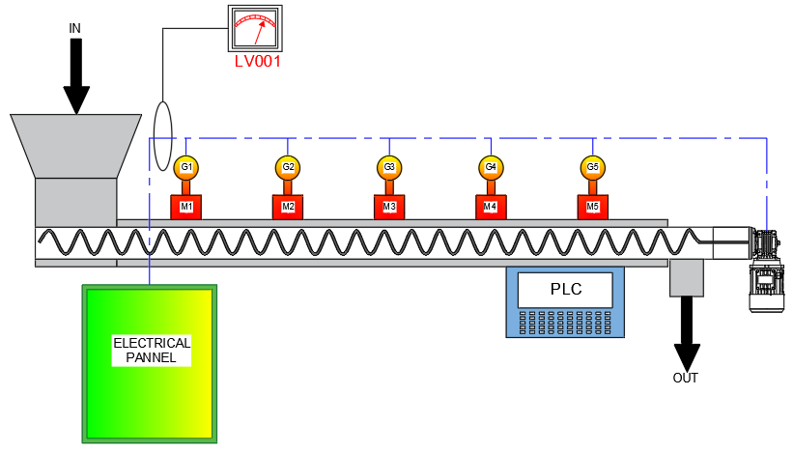

Figure 1: MW pilot plant longitudinal section

* + 1. Raw material

Almonds (Prunus dulcis) of the Tuono variety, harvested in 2023, were used for the experimental assays. After harvesting, the almonds were hulled, sun dried, shelled and stored at controlled temperature (18°C) at Bari, Apulia, Italy.

* + 1. Experimental procedure to investigate operative and electrical parameters

The operating parameters (Table 1) characterize the behavior of the continuous MW pilot plant and were measured experimentally in Tamborrino et al, 2023 and the machine operating curves for mass flow rate and residence time were defined.

*Table 1 – Operating parameters of the continuous microwave pilot plant*

|  |  |  |
| --- | --- | --- |
| Electric motor frequency [Hz] | Mass flow rate [kg min-1] | Residence time [s] |
| 30 | 1.91±0.13 | 202.2±21.4 |
| 40 | 2.76±0.11 | 148.9±18.7 |
| 45 | 3.00±0.11 | 135.4±17.5 |
| 50 | 3.28±0.10 | 121.3±15.6 |
| 60 | 4.2320.11 | 100.7±13.2 |
| 80 | 5.39±0.11 | 82.2±10.1 |

Mean ± standard deviation (SD)

An experimental test plan was defined taking into consideration the six different operating configurations of the machine, function of the frequency value of the electric motor that powers the metal spiral, (residence time and mass flow rate) at different electrical power values ​​of the MW magnetron.

The eight different electrical power configurations have values ​​of 2.25 - 3.00 - 3.75 - 4.50 - 5.25 - 6.00 - 6.75 - 7.50 kW.

The combination of operating parameters (six conditions) and electrical powers (eight configurations) generates forty-eight operating conditions. Each test is characterized by a Specific Energy value supplied to the product inside the treatment chamber and by an electrical consumption that was monitored for five minutes, recording the electrical energy consumption every 5 s of the functioning MW system.

In the measurement of electrical consumption, both the variable consumption attributable to the electrical power set for the operation of the magnetrons and the constant consumption of the system attributable to the electric motor which drives the metal spiral for mixing and advancing the product and to all the auxiliary systems with which the plant is equipped.

The recorded data were statistically analyzed for the creation of a mathematical model for the analysis and prediction of the system's energy consumption and for the identification of the optimal electricity consumption curve.

The model is specific for the plant and for the product treated (almonds).

* 1. Results and discussion
     1. Operating curves of microwaves pilot system

The overall electrical consumption values ​​detected during the system operation tests, with predefined conditions, were correlated to the specific energy values ​​that the system is able to administer to the product, thus generating eight different operating curves (2nd order polynomials) that overlap.

As can be seen from Fig. 2, the trend of the operating curves allows the possibility of providing, for a specific defined energy value, different configurations of electrical consumption of the machine, allowing the operator to choose and define the best operating condition of the system to obtain the same treatment result.

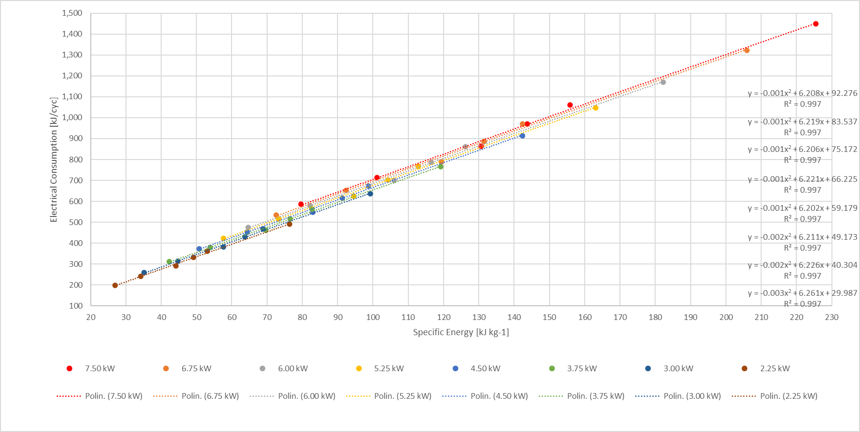

Figure 2: Trend of Specific Energy and Electrical Consumption

Therefore, since the operating curves and the equation that regulates their trend are known (second order polynomials with R2 values ​​close to 1), it is easy to predict the energy behavior of the machine at constant values ​​of specific energy required by the user for a specific behavior and draw an energy graph (Figure 3) highlighting the percentage of electricity savings of up to 10%.



Figure 3: Energy saving graph of microwaves pilot system

By selecting the optimal operating values ​​of the microwaves pilot system with the lowest electrical consumption for each Specific Energy value, a linear operating curve is generated with R2 close to 1.

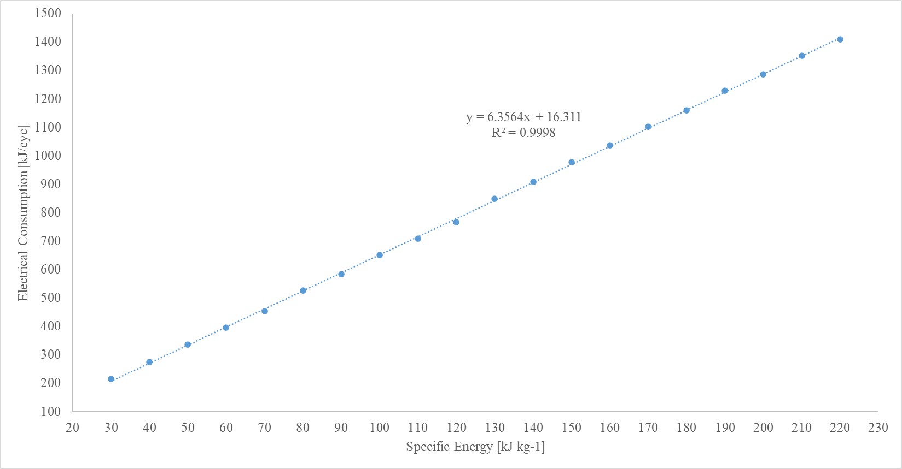

Figure 4: Trend of Specific Energy and optimal Electrical Consumption

* 1. Conclusions

This study highlights the potential of microwave-assisted technology and how to optimize energy consumption in almond processing, especially for disinfestation of shelled almonds.

Through the development of a numerical model, it was possible to calculate, predict and regulate the operating parameters of a pilot plant, obtaining energy savings of up to 10%. Experimental tests varying the electrical power (from 2.25 kW to 7.50 kW) and treatment time (from 82 to 202 seconds) allowed the creation of precise operating curves, which informed the optimal settings for energy efficiency.

Microwave disinfestation, as an alternative to chemical treatments, has significant advantages. This approach not only eliminates the presence of chemical residues on the products, but also preserves the nutritional quality of the almonds, respecting international environmental standards. Additionally, the technology facilitates a more sustainable and user-friendly process, given the lower energy requirements and compact design.

The results presented in this study highlight the feasibility of integrating microwave technology into almond processing, potentially setting a new standard for sustainable food processing practices. Further research could explore the possibility of extending the use of this model and adapting it to other types of agricultural products, broadening its application and impact and making the system more versatile.

The scale-up of the pilot plant designed for MW treatment is easy to be implemented in the industrial sector considering the excellent results while respecting the environment.

The numerical model for optimizing the energy consumption of the plant requires, if it is to be implemented at an industrial level, suitable systems for continuously measuring and monitoring the process parameters in order to be able to identify in real time the optimal operating parameters for the plant.

Acknowledgments

The authors have contributed to the same extent to the present study

References

Gautam, C.; Islam, S.M.; Sadistap, S.; Sarma, U. Effect of Microwave Heat on the Nutritional Properties of Infected Red Kidney Beans. IEEE Access 2018, 6, 57137–57143.

Chenlo, F.; Moreira, R.; Chaguri, L.; Torres, M.D. Note. Sugar, moisture contents, and color of chestnuts during different storage regimes. Food Sci. Technol. Int. 2009, 15, 169–178.

Wang, S.; Tiwari, G.; Jiao, S.; Johnson, J.; Tang, J. Developing postharvest disinfestation treatments for legumes using radio frequency energy. Biosyst. Eng. 2010, 105, 341–349.

Patil, H.; Shejale, K.P.; Jabaraj, R.; Shah, N.; Kumar, G. Disinfestation of red flour beetle (Tribolium castaneum) present in almonds (Prunus dulcis) using microwave heating and evaluation of quality and shelf life of almonds. J. Stored Prod. Res. 2020, 87, 101616.

Gao, M.; Tang, J.; Wang, Y.; Powers, J.; Wang, S. Almond quality as influenced by radio frequency heat treatments for disinfestation. Postharvest Biol. Technol. 2010, 58, 225–231.

Heather, N.W., Hallman, G.J., 2008, Pest Management and Phytosanitary Trade Barriers. Columns Design Ltd. Readind, UK. 226 pp.

Tamborrino, A., Summo, C., Berardi, A., De Angelis, D., Ragone, G., Leone, A., 2023, Use of a Microwave Pilot Plant for Almond Disinfestation: Study on the Thermal Uniformity of the Treatment and Effect on Volatile Composition, Chemical Engineering Transactions, Vol. 102, ISSN 2283-9216, doi: <https://doi.org/10.3303/CET23102014.>

Tamborrino, A., Berardi, A., de Lillo, E., Ragone, G., De Benedictis, M., Tufariello, M., Santino, A., Leone, A., 2023, Using a continuous microwave system for postharvest almond disinfestation, Postharvest Biology and Technology, Volume 201, 112369, ISSN 0925-5214, <https://doi.org/10.1016/j.postharvbio.2023.112369>.

Wang, S.; Tang, J., 2001, Radio frequency and microwave alternative treatments for nut insect control: A review. Agric. Eng. J., 10, 105–120.

Grieshop, M.J., Flinn, P.W., Nechols, J.R., 2006. Biological control of indianmeal moth (lepidoptera: Pyralidae) on finished stored products using egg and larval parasitoids. J. Econ. Entomol. 99 (4), 1080–1084. https://doi.org/10.1093/jee/99.4.1080.

Mescia, L., Lamacchia, C., Berardi, A., Leone, A., Tamborrino, A., 2022. Continuous microwave pilot plant for almond disinfestation: preliminary tests. Mediterranean Microwave Symposium. 1-4. 10.1109/MMS55062.2022.9825556.

Mescia, L., Leone, A., Lamacchia, C.M., Ferraris, A., Caggiano, D., Berardi, A., Tamborrino, A., 2024, Numerical Simulation and Development of a Continuous Microwave-Assisted Pilot Plant for Shelled Almond Processing. Appl. Syst. Innov., 7, 43. https://doi.org/10.3390/asi7030043.

Tamborrino, A., Catalano, F., Berardi, A., Bianchi, B., 2021, New Modelling Approach for the Energy and Steam Consumption Evaluation in a Fresh Pasta Industry, Chemical Engineering Transactions, 87, 409-414.

Perone, C., Berardi, A., Dellisanti, C.D., Tamborrino, A., Leone, A., 2023, Investigation of an Energy-Saving System to Reduce the Energy Consumption of Decanter Machine, Chemical Engineering Transactions, Vol. 102, ISSN 2283-9216, doi: <https://doi.org/10.3303/CET23102027>.

Romaniello R., Perone C., Berardi A., Leone A., Tamborrino A., 2024, Biomass Recovery from Olive Oil Extraction Line: Opportunities for Reuse of By-products and Energy Saving, Chemical Engineering Transactions, 109, 25-30.

Moirangthem, T.T., Baik, O.D., 2021. Disinfestation of stored grains using non-chemical technologies. A review. ISSN 0924-2244 Trends Food Sci. Technol. 107, 299–308. <https://doi.org/10.1016/j.tifs.2020.11.002>.