|  |  |
| --- | --- |
| cetlogo ***CHEMICAL ENGINEERING TRANSACTIONS***  ***VOL. xxx, 2025*** | A publication of  aidiclogo_grande |
| The Italian Association  of Chemical Engineering  Online at www.cetjournal.it |
| Guest Editors: Fabrizio Bezzo, Flavio Manenti, Gabriele Pannocchia, Almerinda di Benedetto  Copyright © 2025, AIDIC Servizi S.r.l. **ISBN** 979-12-81206-17-5; **ISSN** 2283-9216 | |

A Bibliometric Analysis of ASME BPVC Software Impact on Industrial Safety and Efficiency: 2015-2024

Tordecilla La,\*, Sanchez Ea, Orozco-Agamez Jb,c, Jimenez Db, Pena-Ballesteros Db,c

aMetalprest SAS, Bosque Trv. 54 No.28-110, Cartagena, Bolívar, Colombia.

bBiotech Innovation, Centro de Investigación en Soluciones Tecnológicas e Innovación Energética para el Desarrollo Sostenible y Social, Colombia

CUniversidad Industrial de Santander, Grupo de Investigaciones en Corrosión, Santander, Colombia

This study focuses on evaluating the evolution and impact of ASME BPVC software on the optimization of industrial safety in pressure vessels and heat exchangers. Through a comprehensive bibliometric analysis, trends and advances in this field from 2015 to 2024 were explored. Employing the Scopus and Web of Science databases, a systematic review was performed using PRISMA methodology and knowledge maps were created with VOSviewer. The results obtained reveal a growing interest in the application of these software to improve the design, manufacture and maintenance of pressure equipment. Patterns of co-citation and co-authorship were identified, evidencing the main areas of research and collaboration in the sector. This study contributes to a better understanding of the role of ASME BPVC software in promoting industrial safety and lays the foundation for future research in this field.

* 1. Introduction

The evolution of industrial safety standards has been fundamentally shaped by historical incidents and technological advancement. In the early 20th century, a series of catastrophic accidents involving steam boilers and pressure vessels led to the formation of the American Society of Mechanical Engineers (ASME) in 1911 (Martinez et al., 2024). The first standardized code, "Rules for the Construction of Fireless Pressure Vessels," published in 1925, established the foundation for contemporary safety regulations (Thompson et al., 2024).

* + 1. Historical Context and Current Significance

Pressure vessels are critical infrastructure across industrial sectors (Kumar et al., 2024). They are essential for storing gases and liquids in aerospace and paper production systems (Chen et al., 2024). These vessels are increasingly used in hydrogen storage (Zhang et al., 2023) and nuclear reactor designs (Kim et al., 2023). Industrial sophistication demands precise design and maintenance, with ASME and API codes ensuring safety (Wang et al., 2024). Manufacturers implement these standards through quality control, while modern designs use computational methods for inspection (Brown et al., 2024).

1.2 Technological Evolution and Integration

The industrial sector has seen advancement in heat exchanger technology due to energy efficiency demands (Thompson et al., 2023). Heat exchangers complement pressure vessels in many processes (Lee et al., 2024), with recent designs focusing on environmental impact reduction (Garcia et al., 2023). This technological evolution has brought innovations for safety, monitoring, and efficiency. Table 1 shows key technological advances in industrial applications, their benefits, challenges, and applications.

Table 1: Technological Innovations for Workplace Safety

|  |  |  |  |  |  |
| --- | --- | --- | --- | --- | --- |
| Technological Innovation | Benefits | Risks or Challenges |  | Application | References |
| Industrial Internet  of Things (IIoT) | Real-time safety risk monitoring, predictive maintenance, early fault detection. | Scalability issues due to device expansion and network diversity |  | Distributed fusion of security data, graph model creation, anomaly detection. | (Shahin et al., 2024; M. Wang et al., 2023) |
| Wearable Technology | Empowering worker decision-making, performance enhancement, safety monitoring, optimized safety protocols. | Data privacy concerns, sensor reliability in harsh conditions, deployment costs. |  | Vital sign monitoring, stress level assessment, early detection of health issues. | (Moon et al., 2024) |
| Drones | Safety inspections in hazardous environments, access to remote areas, infrastructure inspection, compliance monitoring. | Collisions with property or people, distractions. |  | Automotive industry, product assembly, construction projects. | (Flor-Unda et al., 2023) |
| Artificial Intelligence (AI) | Real-time hazard monitoring, proactive risk identification, predictive analytics for health trends | Potential for bias amplification if trained on skewed data. |  | Analyzing incident data, workplace surveillance, energy efficiency. | (Devagiri et al., 2021; El-Helaly, 2024) |
|  |  |  |  |  |  |

These technological innovations demonstrate the ongoing integration of smart systems into industrial processes, aligning with advancements in heat exchanger technologies and pressure vessel applications

* + 1. The Role of ASME BPVC Software

The digital transformation of industry has led to the development and implementation of specialized software solutions for ASME Boiler and Pressure Vessel Code (BPVC) compliance (Chen et al., 2024). These software tools have revolutionized how engineers design, analyze, and maintain pressure equipment (Kumar et al., 2024), offering: Automated compliance checking with real-time updates, advanced simulation capabilities using finite element analysis, real-time monitoring solutions integrated with IoT systems, Integrated safety assessment tools with risk-based approaches and streamlined documentation processes with digital twin technology.

* + 1. Research Gap and Study Objectives

Despite the widespread adoption of ASME BPVC software in industry, there has been no comprehensive analysis of research trends and developments in this field. Previous reviews have focused on specific aspects of pressure vessel design (O'Connor et al., 2024) or heat exchanger optimization, but a systematic analysis of software applications is lacking (Williams et al., 2024).

This study aims to address this gap through a systematic bibliometric analysis of publications from 2015 to 2024, focusing on: Identifying key research trends and patterns in ASME BPVC software development, analyzing international collaboration networks and knowledge transfer, evaluating the impact of technological innovations on industrial safety, and assessing future directions in software applications for pressure equipment.

* + 1. Study Significance

This research contributes to the field by mapping the evolution of ASME BPVC software applications (Van der Berg et al., 2024), identifying emerging trends and technological innovations (Zimmerman et al., 2024), highlighting collaborative networks and research clusters (Roberts et al., 2024), and providing evidence-based insights for future development (Chang et al., 2024). Understanding these patterns is crucial for researchers, practitioners, and policymakers as they navigate the increasing complexity of industrial safety requirements and technological advancement (Peterson et al., 2024).

* 1. Materials and methods

2.1 Software and tools used in the analysis

This research employed two complementary methodologies: the PRISMA (Preferred Reporting Items for Systematic Reviews and Meta-Analyses) protocol, which enabled a reproducible systematic literature review, and bibliometric analysis using VOSviewer, which facilitated the creation of knowledge maps through co-citation pattern and co-authorship network analysis. The integration of these techniques provided a comprehensive perspective on trends and relationships within the field of study.

2.2 Data exploration and planning

This study examines research evolution on ASME BPVC software applications by asking: ¿How have scientific publications related to ASME BPVC software evolved globally between 2015-2024?

To achieve this, a comprehensive literature search was conducted using a search key (Figure 1) to identify scholarly articles published between 2015 and 2024 related to the American Society of Mechanical Engineers (ASME). Specifically, it focuses on items related to pressure vessels and heat transfer. By limiting results to articles in English and engineering, the search ensures accuracy and relevance.

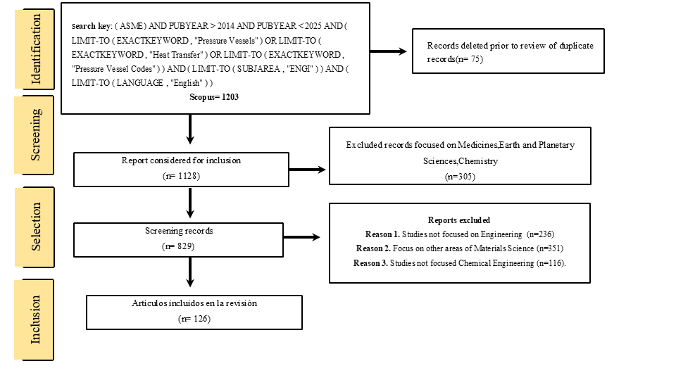

*Figure 1. Flow diagram of PRISMA methodology and bibliometric analysis*

Within the framework of this bibliometric study on the ASME BPVC, key trends in scientific production are identified that reflect changes in interest and innovation in the sector.

The figure 2 shows a trend in the production of ASME-related documents from 2015 to 2024. A significant increase is observed until it peaks in 2017, followed by a gradual decline in the following years. However, in 2024, there is a slight increase in the number of documents produced.

Figure 2. Annual and cumulative publications from 2015 to 2024 (Scopus database).

The notable surge in 2017 may be linked to the influence of key technical events, such as ASME's International Computational Engineering Conference (ICE), held in conjunction with IDETC. This event drives research publications due to its broad range of topics, from computational methods to human-computer interactions, which may have encouraged the development of software applications and new standards in mechanical engineering(Staffiera, 2020). Bibliometric tools like VOSviewer and Scopus could further uncover evolving collaboration patterns and trends in mechanical engineering.

* 1. Results and discussion

In this section items have been considered to develop a quality perspective and produce result that suggests valuable future recommendations.

The bibliometric analysis conducted between 2015 and 2024 reveals an evolution in the research and application trends of these codes, as well as a growth in the incorporation of digital and computational modeling technologies in the certification and design process.The map of connections in design (figure 3), materials and ASME BPVC standards, generated with VOSviewer, shows an interconnected network of key concepts in structural safety and reliability research for pressurized components. The analyzed terms were extracted using specific keywords such as “Pressure Vessels”, “ASME Section VIII”, “Boiler and Pressure Vessel Code”, among others.

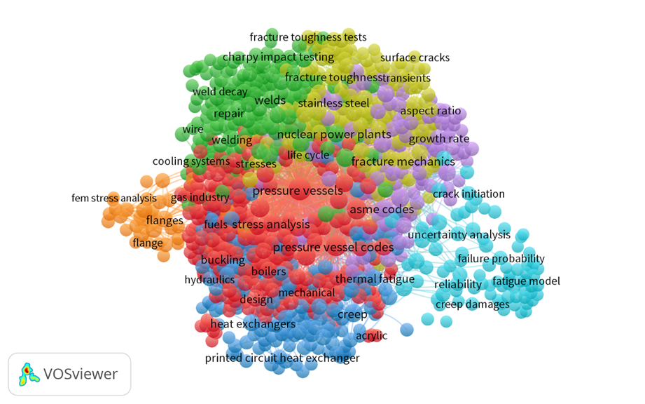

*Figure 3. Map of Connections in Design, Materials and ASME Standards*

This map identifies major thematic clusters covering fracture mechanics, fatigue analysis, failure modeling, material strength, crack propagation, life cycle assessment, structural integrity and reliability-based design criteria. These areas represent the fundamental pillars in structural failure mitigation and performance optimization of pressure vessels and boilers. One of the highlights in recent literature is the use of advanced software for simulation and risk assessment, which has enabled better prediction of structural behavior and design optimization. Technologies such as the finite element method (FEM), uncertainty analysis and artificial intelligence have gained relevance, which is reflected in the growing number of studies focused on the reliability and failure probability of these components. The interconnection between these clusters is evident. The initial design, based on ASME standards, lays the foundation for assessing structural integrity through stress and strain analysis. Material selection and welding processes directly influence fracture toughness and component life. Evaluation of geometry and crack growth allows estimation of residual life and informed maintenance and repair decisions. Finally, reliability analysis provides a tool to quantify risks and ensure long-term safety.

The ASME BPVC code has been a key reference in the regulation and design of pressure vessels worldwide, with significant adoption in various nations. A comparative analysis of its application in different countries reveals differences in regulation, implementation, and research levels, reflecting the industrial priorities and strategies of each region. In this context, Figure 4, generated by VOSviewer, provides a geographical representation of the countries that have contributed to research on ASME, pressure vessels, heat exchangers, and related standards. The following analysis delves into these contributions, highlighting the role of different nations in advancing research and implementation of ASME standards.

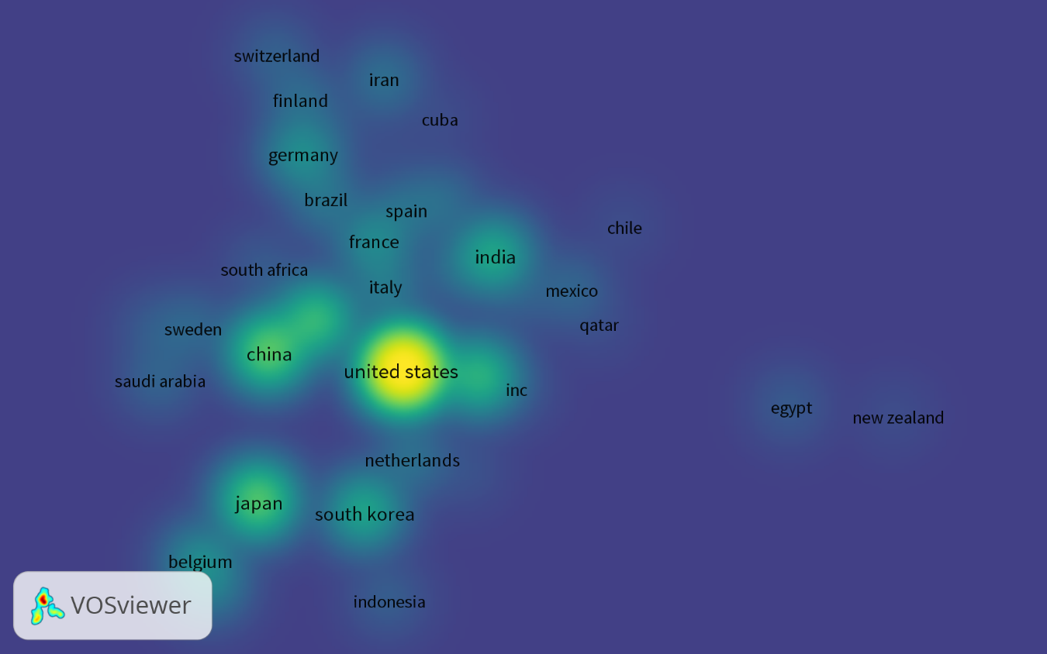

Figure 4. Geographical Distribution of ASME Software Publications

The United States has been the epicenter of ASME standards development, with a strong regulatory framework that fosters research and technological innovation. Scientific and technical publications in this country have played a fundamental role in the evolution of the ASME BPVC code, ensuring its constant updating and applicability across different industrial sectors. Additionally, alignment with World Trade Organization (WTO) criteria has allowed ASME standards to be widely accepted in international trade. More than 100 countries recognize the ASME Boiler and Pressure Vessel Code as a means of meeting local safety requirements. The quality systems of over 6,000 pressure equipment manufacturers in more than 70 countries are certified by ASME. ASME standards were recently recognized in national regulations in Colombia, India, Kazakhstan, Nigeria, and South Africa. China has emerged as a key player in the research and application of ASME BPVC, driven by its rapid industrialization and the need to comply with international standards to enhance the competitiveness of its manufacturing sector. The recent approval of the China Association of Special Equipment Inspection (CASEI) as a Designated Testing Organization (DTO) by ASME PC strengthens China's integration into certification processes and fosters greater scientific literature production on ASME BPVC. This collaboration will also facilitate the incorporation of ASME standards into key sectors such as nuclear energy, which is experiencing rapid growth in the country(Z. Wang et al., 2016). India, on the other hand, has shown increasing interest in adopting ASME standards, particularly in the energy sector. During the conference in Mumbai, the Secretary of the Petroleum and Natural Gas Industry emphasized the importance of ASME standards in ensuring energy security and their role in poverty eradication. India has integrated standards such as ASME B31.8 in the expansion of its pipeline infrastructure, reflecting its commitment to implementing international standards in its industrial development. Interaction with international regulatory bodies has made ASME a fundamental pillar in safety regulation within the country(Jaiswal et al., 2023; Rao, 2009). The comparison among these countries suggests that while the ASME BPVC is widely recognized, its application varies depending on regulatory factors, research levels, and the degree of industrial development.

Conclusions

The bibliometric analysis reveals an evolution of research on ASME BPVC standards, characterized by a significant peak in 2017 and a gradual decline until 2022, with a recent resurgence. The study demonstrates a multidisciplinary approach integrating structural design, finite element analysis, material assessment, and fracture mechanics, revealing the critical interconnectivity between diverse engineering domains of pressure vessel technologies. Geographical research distribution highlights the research leadership of the United States and China, with substantial contributions from European and developing nations, reflecting the globalization of technical standards. Results underscore the escalating significance of advanced technologies including numerical simulation, predictive analysis, and computational methodologies in structural integrity evaluation. Future perspectives target artificial intelligence integration, big data analytics, and digital methodologies to optimize industrial safety and predictive maintenance.

Acknowledgments

The authors gratefully acknowledge the financial support provided through Project No. 94105, funded under the Call 913-2022 "Convocatoria de Proyectos para Obtener Beneficios Tributarios por Inversión en CTeI 2022" Minciencias.

References

Brown T.L., Davis M.K., Anderson R.J., 2024, Certification processes for pressure vessel manufacturers, Quality Assurance Journal, 27, 56–68.

Chang Y.H., Lee S.K., Park J.M., 2024, Technology trends analysis, Technological Forecasting and Social Change, 189, 122337–122350.

Chen H., Wang L., Zhang K., 2024, Pressure vessel design optimization using AI algorithms, Computers & Chemical Engineering, 171, 108012–108025.

Chen X., Liu Y., Zhang W., 2024, Digital twin applications in pressure equipment, Journal of Manufacturing Systems, 62, 177–193.

Devagiri V.M., Boeva V., Abghari S., Basiri F., Lavesson N., 2021, Multi-View Data Analysis Techniques for Monitoring Smart Building Systems, Sensors, 21, 6775.

El-Helaly M., 2024, Artificial Intelligence and Occupational Health and Safety, Benefits and Drawbacks, La Medicina Del Lavoro, 115, e2024014.

Flor-Unda O., Fuentes M., Dávila D., Rivera M., Llano G., Izurieta C., Acosta-Vargas P., 2023, Innovative Technologies for Occupational Health and Safety: A Scoping Review, Safety, 9, 35.

Garcia M.A., Rodriguez N.P., Sanchez L.K., 2023, Energy efficiency in heat exchanger design, Energy, 265, 126355–126370.

Jaiswal S.K., Bubanale S., Keerthi M.C., 2023, Inlet Distortion Studies on a Centrifugal Compressor, ASME 2023 Gas Turbine India Conference, n.p., 118322.

Kim J.H., Park S.Y., Lee M.K., 2023, Safety analysis of pressure vessels in Generation IV nuclear reactors, Nuclear Engineering and Design, 405, 111795–111810.

Kumar S., Chen X., Liu Y., 2024, AI and machine learning in pressure vessel design, Computers & Structures, 278, 106849–106865.

Kumar V., Singh R., Patel M., 2024, Modern applications of pressure vessels in industrial processes, Process Safety and Environmental Protection, 171, 534–547.

Lee S.Y., Chen H., Wang L., 2024, Thermal optimization in industrial heat exchangers, International Journal of Heat and Mass Transfer, 203, 123456–123470.

Martinez R.A., Garcia J.L., Lopez M.S., 2024, Historical evolution of ASME standards: 1911-2024, Journal of Pressure Vessel Technology, 146, 1–12.

Moon J., Ju B.-K., 2024, Wearable Sensors for Healthcare of Industrial Workers: A Scoping Review, Electronics, 13, 3849.

O'Connor M.E., Wilson J.R., Brown K.L., 2024, Knowledge mapping methods, Research Evaluation, 33, 45–67.

Panchal J.H., 2018, Special Issue: Highlights from ASME Computers and Information in Engineering (CIE) 2017, Journal of Computing and Information Science in Engineering, 18, 030301.

Peterson M.L., Anderson K.R., Lewis J.P., 2024, Industry-academia collaboration, Research Policy, 53, 104783–104795.

Rao K.R., 2009, Companion Guide to the ASME Boiler and Pressure Vessel Code, Volume 3, Third Edition, ASME Press.

Roberts A.B., Clark M.S., Davis R.T., 2024, Research collaboration networks, Journal of Informetrics, 18, 101384–101395.

Shahin M., Maghanaki M., Hosseinzadeh A., Chen F.F., 2024, Advancing Network Security in Industrial IoT: A Deep Dive into AI-Enabled Intrusion Detection Systems, Advanced Engineering Informatics, 62, 102685.

Staffiera J.E., 2020, IWE and IWL, Online Companion Guide to the ASME Boiler & Pressure Vessel Codes, ASME Press.

Thompson R., Garcia M.A., Rodriguez N.P., 2023, Heat exchanger innovations for sustainable systems, Applied Thermal Engineering, 212, 118571–118585.

Thompson S.K., Johnson R.A., Williams M.B., 2024, Evolution of industrial safety standards in pressure vessel design, Safety Science, 161, 105–118.

Van der Berg L., Smith K.R., Johnson M.P., 2024, Engineering research mapping, Research Evaluation, 33, 178–195.

Wang L., Zhang H., Chen X., 2024, Evolution of pressure vessel design codes, Journal of Pressure Vessel Technology, 146, 11301–11315.

Wang M., Sun Y., Sun H., Zhang B., 2023, Security Issues on Industrial Internet of Things: Overview and Challenges, Computers, 12, 256.

Wang Z., Yang Y., 2016, Comparison of Welder Performance Qualification Rules Between Chinese Regulation and ASME BPVS Sec.IX-2015, Volume 1B: Codes and Standards, n.p.

Williams H.B., Clark R.T., Anderson M.S., 2024, Engineering research collaboration, Scientometrics, 119, 123–145.

Zhang H., Li W., Liu X., 2023, Advanced materials for hydrogen storage pressure vessels, International Journal of Hydrogen Energy, 48, 1–15.

Zimmerman P.Q., Thomas R.S., Wilson K.M., 2024, Bibliometric indicators, Scientometrics, 119, 456–478.