Sustainability Evaluation of Biorefineries in tropical countries. Macro and micro-scale possibilities

Karina Angélica Ojeda-Delgado
Process Design and Biomass Utilization Research Group (IDAB). University of Cartagena, Department of Engineering, Cartagena, Colombia

Tropical countries have a wide biodiversity where agriculture practices represent an important role in their economies and environmental sustainability. Many research are focused on tropical agro-industrial crops and waste valorization oriented on the potential use of these by-products through integrative biorefineries. However, large-scale biorefineries from one-crop feedstock could promote unsustainable farming practices leading to deforestation, and monocropping, and could not be the sustainable alternative for minor farmers located in areas of difficult access where there are high costs of biomass or waste collection limiting their participation in the strengthening of regional bioeconomies. Therefore, decentralized small-scale biorefining represents a suitable alternative due to the economic, ecological, and social benefits. In this talk, biorefineries and micro-biorefineries in tropical countries are discussed through case study analysis. Perspectives in the area are presented and existing challenges are identified, which may focus research into sustainable agricultural chains to empower local communities by promoting self-reliance.
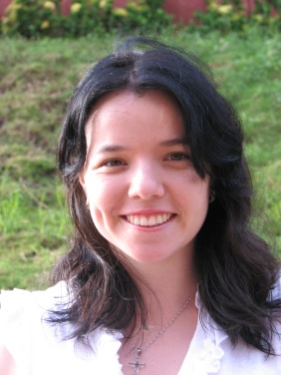
SHORT CV
Ph.D. in Chemical Engineering. Full Professor at the Chemical Engineering Program – College of Engineering – Universidad de Cartagena (Colombia). Head of the Process Design and Biomass Utilization Research Group (IDAB). Senior Researcher at the Ministry of Science, Technology and Innovation in Colombia (MINCIENCIAS). Head of the Research Department of the College Engineering– Universidad de Cartagena (2018-2021), Academic Vice-dean of the College Engineering– Universidad de Cartagena (2021-2022)

