Prof. Dr. Ing. Flavio Manenti

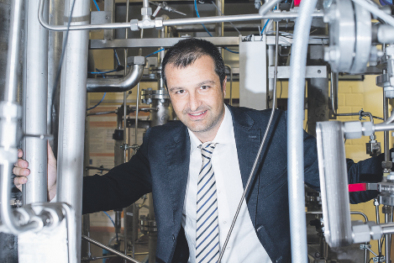

He is Full Professor of Chemical Plants at Politecnico di Milano, CMIC Dept. “Giulio Natta”, where he is the Director of the Centre for Sustainable Process Engineering Research (SuPER) with 12 permanent staff, 15+ researchers and 20+ collaborators and Coordinator of the Master of Science Degree in Food Engineering. He is also Member of the Bio-Fuel Committee for the Ministry of Energy and Environment (MASE).
He has served for two terms the European Federation of Chemical Engineering (EFCE) as elected Charity Trustee (2016-2019). Currently, he is the President of the Computer Aided Process Engineering (CAPE), EFCE’s Working Party (based in UK), for the second term and Member of the Executive Board of worldwide Process Systems Engineering community (based in US).
He is the coordinator of Double PhD and MSc bilateral agreement with Institutions from all continents. He published more than 350 papers indexed by Scopus along with a series of 5 books titled “… for the Chemical Engineer” edited by Wiley-VCH (Weinheim, Germany) on process digitalization and chemical engineering. He co-authored a chapter of Kirk-Othmer Encyclopedia by John Wiley and Sons (NY, USA) on big data analytics in chemical processes. He has been invited at 20+ plenary lectures in Europe, America, Africa and Asia.
Research consultant for national and international companies on Process and Process Systems Engineering, H₂ production and CO₂ Utilization with 22 filed patents and 6 trademarks. 6 technologies have been scaled up to TRL 9 in 2019-2023, with 9-16kt/y operating plants. Other 6 patents are at the industrial implementation phase with turnaround of investment for 42M€ in the last 5y.
For his research activities, he received some recognitions such as the “Excellence in Simulation” Award (Los Angeles, USA, 2007), the “Zdenec Burianec Memorial” Award (Prague, CZ, 2008), the “Alexander von Humboldt” Senior Research Award (Berlin, GER, 2014) and the Mashelkar Golden Medal (New Delhi, IN, 2019).
In free time, he is active UEFA-licensed soccer coach with two national championships (scudetto) and 6 regional championships awarded; he is Federal soccer coach and he acted for the U15W and U13 National Team (SGS FIGC Nazionale Italia, Centro Federale Tecnico) in 2017-2019.

