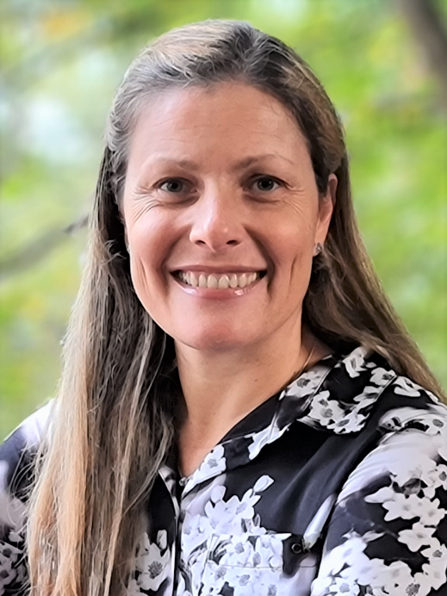

Solange I. Mussatto

Tentative title:

New trends in biomass pretreatment and strain development to advance the fermentation of biomass hydrolysates.

SHORT CV

Solange I. Mussatto is Professor and Head of the Research Group "Biomass Conversion and Bioprocess Technology" at the Technical University of Denmark. Her group conducts research in interdisciplinary areas including biotechnology, chemical engineering and sustainability, with the aim of creating innovative processes able to accelerate the development of a bioeconomy, with potential environmental, economic, and social benefits (see more at: www.bcbtgroup.com). The importance of her research is highlighted in more than 600 publications including more than 250 full papers published in high quality peer-reviewed journals, 4 patents, 2 books, several book chapters, and many international awards. She is a reference person in the areas of Bioeconomy and Biorefinery, being the Danish representative in IEA Bioenergy Task 42 – Biorefining in a Future Bioeconomy, and vice-chair of the Bioenergy and Bioeconomy section in the European Society of Biochemical Engineering Sciences. She is/has been Editor of several scientific journals in her areas of specialization. Since 2020 she has been ranked in the top 2% of scientists in the world (no. 1 in Denmark within the sub-field of biotechnology).

