CHEMICAL ENGINEERING TRANSACTIONS  VOL. , 2023 | A publication of
The Italian Association
of Chemical Engineering
Online at www.cetjournal.it

Guest Editors: Leonardo Tognotti, Rubens Maciel Filho, Viatcheslav Kafarov
Copyright © 2024, AIDIC Servizi S.r.l.
ISBN 979-12-81206-10-1; ISSN 2283-9216

Effect of pH and applied bias on H₂ and HVA products through photoelectrocatalytic glycerol oxidation
Claudio M. Pecoraro*, Francesco Di Franco, Vittorio Loddo, Marianna Bellardita, Monica Santamaria
Dipartimento di Ingegneria, Università degli Studi di Palermo, Viale delle Scienze Edificio 6, 90128 Palermo, Italy
*claudiomaria.pecoraro@unipa.it
This study explores how pH and applied bias influence the generation of H₂ and high-value-added products resulting from glycerol photooxidation, specifically targeting 1,3-dihydroxyacetone (DHA) and glyceraldehyde (GA), within a photoelectrochemical cell. TiO₂ NTs with a length of 760 nm were utilized as the photoanode, while Ni foam served as the cathode. The experiments were carried out under acidic, neutral, and alkaline pH conditions, with applied biases ranging from 0.1 to 1 V vs. Ag/AgCl reference electrode.
The findings demonstrated that the highest faradaic efficiency towards high-value-added products, namely DHA and GA, was achieved at pH 7 with an applied bias of 0.5 V vs. Ag/AgCl, and this efficiency remained stable at higher bias values. Notably, at pH levels of 2 and 7, both glycerol mineralization into CO₂ and H₂, and glycerol photooxidation into DHA and GA were more pronounced. Conversely, at higher pH, the faradaic efficiency towards DHA, GA, and CO₂ decreased, while the photocurrent increased. This observed trend suggests a heightened water splitting effect at higher pH, leading to a reduction in faradaic efficiency towards H₂ due to subsequent reactions with O₂ in the gas phase.

Keywords: Glycerol partial oxidation, H₂ production, Photoelectrocatalysis, TiO₂ nanotubes, Pt-free cathode
  - Introduction
In recent years, the increasing energy demands, and subsequent CO₂ emissions have led to significant efforts towards renewable and low-carbon energy sources. In this context, an emerging opportunity involves harnessing biomasses to simultaneously produce hydrogen and valuable products (Pecoraro et al., 2024).
Among the available biomasses, glycerol, a biodiesel production byproduct, has obtained increasing attention for its ability to yield hydrogen and valuable compounds like 1-3 dihydroxyacetone (DHA) and glyceraldehyde (GA) (Pecoraro et al., 2023), fundamental in industries such as cosmetics, pharmaceuticals, fine chemicals, and food production (Kong et al., 2016). Consequently, the production of DHA and GA from glycerol represents an economically attractive option (Luo et al., 2022).
Traditional methods of producing DHA and GA from glycerol involve thermo-catalysis under harsh conditions, needing costly noble-metal catalysts (e.g., Pt, Au, Pd), and external oxidants like O₂ or H₂O₂ (Verma et al., 2022). To minimize energy consumption, light-based approaches like photoelectrocatalysis (PEC) have emerged, offering a sustainable pathway to oxidize organic compounds, generate valuable chemicals, and promote cathodic H₂ production. This technique couples photocatalysis and electrocatalysis, using semiconductor photoelectrodes irradiated with light having energy higher than their band gap, while the exposition to an electric potential effectively separates the photo-produced species (Yao et al., 2018). In PEC systems, photo-produced electrons (e⁻) and holes (h⁺) migrate to the cathode and the photocatalyst surfaces respectively, triggering reduction and oxidation reactions at these spots (Pitchaimuthu et al., 2022). Although PEC research primarily focuses on water splitting and breaking down pollutants, it is a sustainable way to oxidize organic compounds, producing valuable chemicals and encouraging cathodic H₂ production (Dey et al., 2021). Notably, in PEC oxidation of glycerol to DHA and GA, the achievement of high FE remains an actual challenge.
In this work, the effect of pH and applied bias on hydrogen production by glycerol photoreforming and water splitting was studied to enhance both the hydrogen evolution rate and the FE towards DHA and GA. A special attention was paid to the development of a photoelectrochemical cell employing both PGM-free cathode and photoanode to point towards low-cost alternative materials compared to the noble metal-based catalysts and to overcome possible poisoning effects due to the presence of organic species. As supplied commercial Ni foam was used as cathode. The photoanode was prepared by anodizing Ti foils in a fluoride containing electrolyte to induce the growth of large arrays of well aligned TiO₂ nanotubes in the attempt to widen the active surface of the electrode. Photoelectrochemical tests were carried out to assess the formation of a n-type semiconducting material, while electrochemical impedance measurements allowed to study the behavior of the photoanode/electrolyte interface under irradiation. The concentration of H₂ in the gas phase was monitored by gas chromatography (GC), while high performance liquid chromatography (HPLC) was used to determine the concentration of DHA and GA in the liquid phase.
  - Experimental
TiO₂ NTs were grown on Ti foil (purity > 99.7 % and 0.127 mm thickness, Sigma Aldrich). Ti foil was cut and etched in a solution containing hydrofluoric acid (Sigma Aldrich, 39.5 %), nitric acid (Sigma Aldrich, 69 %), and deionized water in 1:1:3 volume ratios for 15 seconds. Then, it was cleaned in acetone and ethanol through ultrasonic treatment for 5 minutes each and rinsed with deionized water before being dried in air. The TiO₂ nanotubes were formed in an ethylene glycol (Sigma Aldrich, 99.8 % anhydrous) solution containing 0.25 %wt NH₄F (Sigma Aldrich, ≥ 98 %) and 0.75 %wt deionized water. The anodization of 25 cm² of immersed surface was performed using a two-electrode configuration with aluminum foil as the cathode and maintaining a constant potential of 45 V for 10 minutes. Post-anodizing, annealing at 450°C for 3 hours under air exposure was carried out to induce crystallization in the TiO₂ nanotubes. The cathode employed in the process was 6 cm² of commercial Ni foam (Goodfellow).
SEM images were captured using an FEI Quanta 200 ESEM microscope operating at 30 kV. XRD patterns of the photoanodes were obtained at room temperature using a PANalytical Empyrean diffractometer equipped with a PIXcel1D detector. The diffractometer operated at 40 kV and 40 mA using CuKα radiation, with a 2θ scan rate set at 3°/min. Raman spectra were carried out using a Raman Microscope coupled with a Leica DMLM microscope.
Photocurrent transients were carried out by using TiO₂ NTs as the working electrode within a three-electrode setup. A Pt wire was used as the counter electrode, while an Ag/AgCl/saturated KCl setup was the reference electrode. The electrolyte consisted of a 0.5 M Na₂SO₄ aqueous solution. Current transients were recorded using monochromatic irradiation at different constant potentials. The photocurrent (I_{ph}) was quantified by manually stopping the irradiation while maintaining the applied potentials steady, ranging from 0.5 V to -0.5 V vs Ag/AgCl.

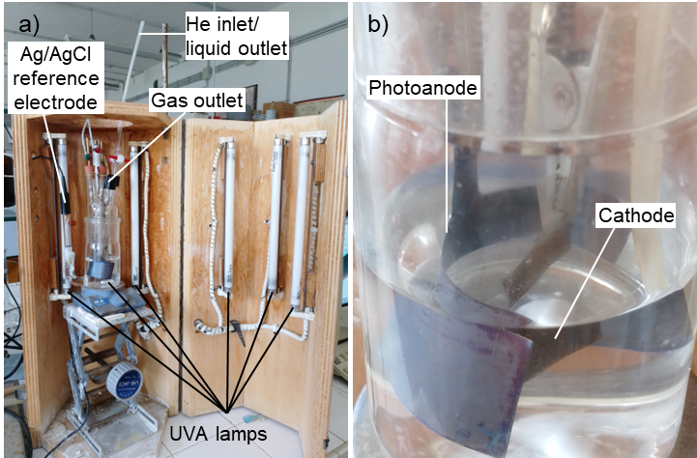
Figure 1: a) overview of the experimental setup and b) magnification of photoanode and cathode

EIS measurements were carried out in 0.5 M Na₂SO₄ aqueous solution employing a Parstat 2263 potentiostat featuring an Impedance Analyzer connected to the cell setup. The impedance spectra were obtained in a frequency range of 10 kHz to 0.1 Hz at 25 °C, using an AC amplitude of 10 mV. Before each measurement, the cell underwent a stabilization period of at least 15 minutes under irradiation. Subsequently, data analysis and fitting of the equivalent circuit were performed utilizing Power Suite and ZSimpleWin software.
Photoelectrocatalytic experiments were carried out in a 450 ml undivided glass cell by using three electrodes as shown in Figure 1. The setup used Ni foam as the counter electrode and an Ag/AgCl electrode as the reference. The solution underwent external illumination from six UVA fluorescent lamps emitting light at a maximum wavelength of 365 nm (8 W). Before each test, Helium was bubbled through a 150 ml aqueous solution for approximately 30 minutes. The control over the cell potential was maintained by using a CH Instrument 630B Series potentiostat. A 0.5 M Na₂SO₄ solution was used as the electrolyte (pH ~ 7), the glycerol starting concentration was 0.1 M, and an applied potential up to 1 V vs Ag/AgCl was employed. To study the effect of the pH, H₂SO₄ was added dropwise, or a KOH solution was used as the electrolyte. The quantification of glycerol and the concentration of reaction intermediates was performed by using a Thermo Scientific Dionex UltiMate 3000 HPLC, equipped with a Diode Array detector and a REZEK ROA Organic acid H⁺ column. The analysis of gaseous species accumulated in the reactor headspace was carried out by using an HP 6890 Series GC system equipped with a Supelco GC 60/80 CarboxenTM-1000 packed column and a thermal conductivity detector. The FE towards the products was calculated using Eq. (1).

$${Faradic efficiency}_{i} \left[\%\right]= \frac{Amount of product i formed [mol]}{\frac{Q [Coulomb]}{z F \left[{Coulomb}/{mol}\right]}} x 100$$ | (1)
where:
- i is the formed product
- Q is the circulated charge
- z are the electrons exchanged, equal to 2 for H₂, DHA, and GA and 14/3 for CO₂ according to the anodic and cathodic semi-reactions in Eqs. (2-4)
- F is the Faraday constant of 96485 [Coulomb/mol]

$$Photoanode: C_{3}H_{8}O_{3}+2h^{+} → C_{3}H_{6}O_{3}+2H^{+}$$ | (2)
$${Photoanode: C}_{3}H_{8}O_{3}+3H_{2}O + 14h^{+} → 3CO_{2}+14H^{+}$$ | (3)
$$Cathode: 2H^{+} + 2e^{-} → H_{2}$$ | (4)
where C₃H₆O₃ is DHA or GA.
  - Results and discussion
Figure 2a shows the SEM image of TiO₂ NTs after the anodization and annealing steps. The micrograph distinctly exhibits the successful growth of a large array of TiO₂ NTs, showing an average length of 760 nm approximately, in line with previous results (Santamaria et al., 2017). The XRD pattern presented in Figure 2b shows distinct peaks corresponding to bare titanium (Reyes-Coronado et al., 2008), whereas the Raman spectra depicted in Figure 2c exhibits distinctive peaks corresponding to anatase at 144 cm⁻¹, 196 cm⁻¹, 397 cm⁻¹, 513 cm⁻¹, and 639 cm⁻¹ (Balachandran et al. 1982). According to previous findings, the annealing process involves two concurrent phenomena. Firstly, the amorphous TiO₂ within the nanotubes transforms into anatase, while the underlying layer at the interface between titanium and the nanotubes to rutile. This formation of rutile promotes a strong adhesion between the nanotubes and the metallic substrates. When the system is subjected to a thermal treatment at 450°C in an air environment for 3 hours, it results in a 140 nm thick rutile layer. Furthermore, the nanotube wall primarily consists of anatase crystals with a cylindrical morphology, extending several hundred nanometers along the nanotube axis (Albu et al., 2010).

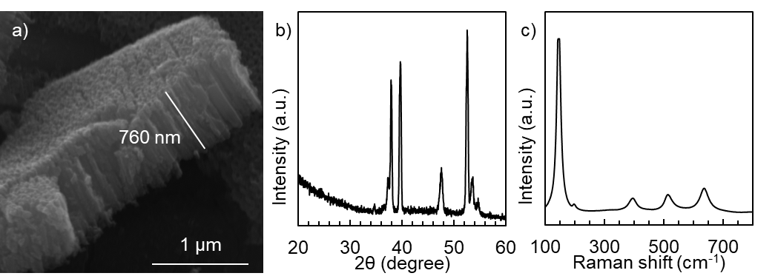
Figure 2: a) SEM picture, b) XRD pattern, and c) Raman spectra of TiO₂ NTs

Photocurrent transients reported in Figure 3 show an anodic photocurrent, confirming the n-type semiconductor characteristics of the oxide. At approximately -0.5 V vs Ag/AgCl the photocurrent registered was close to zero, this value, as an estimate for the flat band potential, is in line with others documented in the literature (Pecoraro et al., 2024).
Figure 4 shows the EIS spectra obtained in a 0.5 M Na₂SO₄ solution at 0.5 V vs. Ag/AgCl. The setup involved employed TiO₂ NTs as the working electrode, Ni foam as the counter electrode and an Ag/AgCl reference electrode. The EIS spectra were carried out both in the absence and in the presence of 0.1 M glycerol, with and without UV irradiation. All the spectra were fitted by using the equivalent circuit in Figure 4. This circuit includes elements representing different parameters: R_{s} represents solution resistance, R_{CT} the charge transfer resistance, and Q_{SC,el} the capacitance of TiO₂. The charge transfer resistance is related to the exchange current density that takes into account the kinetic constants (i.e., rate constants, k) of the oxidation reactions, in agreement with the specific reaction mechanism. The best fitting parameters are reported in Table 1.

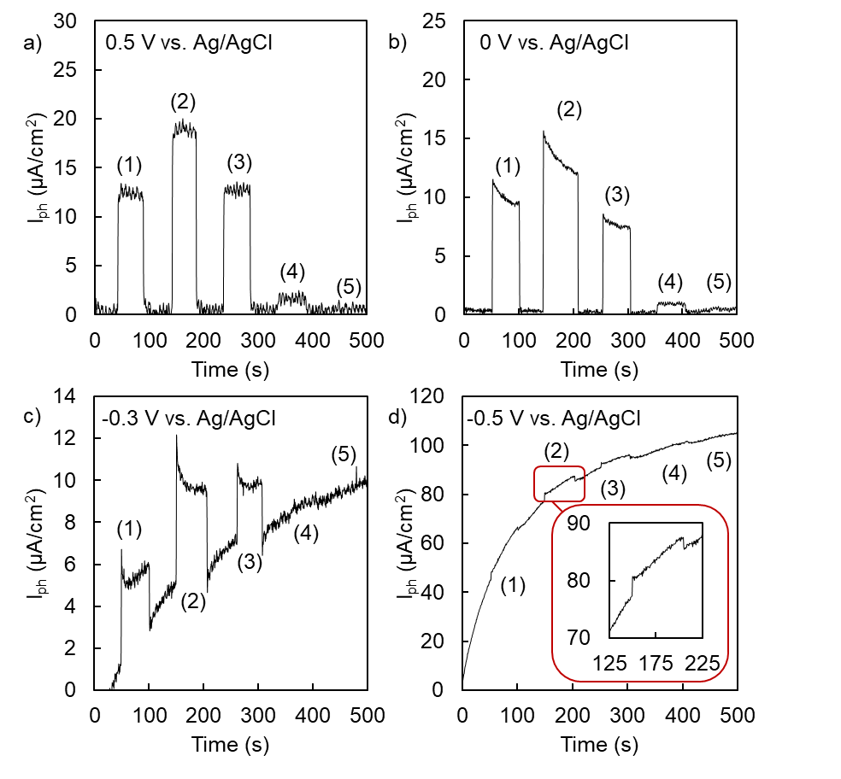
Figure 3: photocurrent transient executed at pH 7 and a) 0.5 V, b) 0 V, c) -0.3 V, and d) -0.5 V vs. Ag/AgCl using monochromatic light at various wavelength: (1) 300 nm, (2) 330 nm, (3) 350 nm, (4) 380 nm and (5) 400 nm.

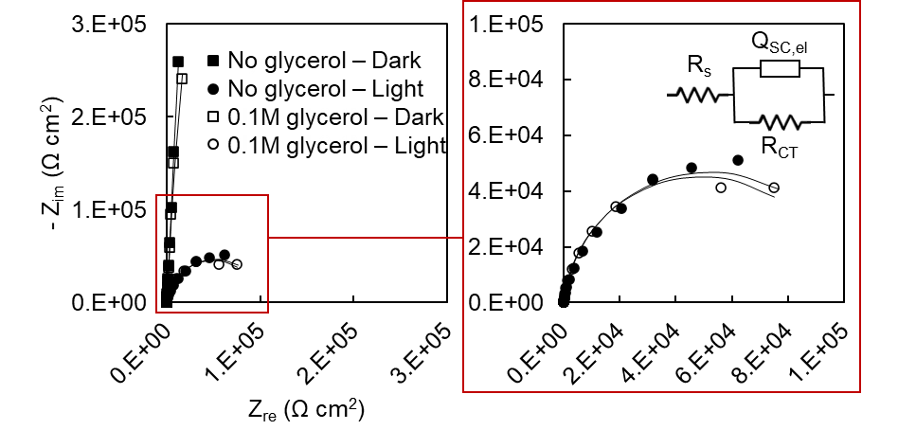
Figure 4: EIS spectra carried out at pH 7 and 0.5 V vs Ag/AgCl without and in the presence of glycerol and irradiation.
Table 1: Best fitting parameters of EIS spectra carried out at pH 7 and 0.5 V vs Ag/AgCl without and in the presence of glycerol and irradiation.
 |  | No glycerol  Dark | No glycerol  Light | 0.1 M Glycerol  Dark | 0.1 M Glycerol  Light
R_{s} | (Ω cm²) | 96 | 86 | 73 | 73
R_{CT} | (Ω cm²) | 4.4·10⁶ | 1.1·10⁵ | 4.0·10⁶ | 9.8·10⁴
Q_{sc,el} | (S s^{n} cm⁻²) | 6.0·10⁻⁶ | 7.8·10⁻⁶ | 6.4·10⁻⁶ | 8.3·10⁻⁶
n | (adm) | 0.974 | 0.945 | 0.975 | 0.946

The influence of light irradiation on the electrode/electrolyte interface is notably evident except for R_{s} which shows a minor impact from both the irradiation and the presence of glycerol. Under dark conditions, the recorded R_{CT} is notably high. Additionally, the optimal fitting exponent 'n' for Q_{sc,el} approximates 1, consistent with the expected behavior of an almost perfect n-type semiconductor. During post-irradiation, a substantial reduction in R_{CT} occurs, closely linked to the amplified concentration of photocarriers and in agreement with the increased capacitance. However, during illumination, lower R_{CT} are recorded in a 0.1 M glycerol-containing solution compared to estimates in a glycerol-free solution. This confirms that, from a kinetic point of view, the overall reaction is less demanding under irradiation in the glycerol-containing solution.
Photoelectrocatalytic results are detailed in Table 2. Generally, under constant pH conditions, an increase in the applied bias results in an increase of the cell potential. Notably, at fixed applied bias, the cell potential increases as the pH increases. The same trends are observed for the photocurrent and thus for the reaction rates. This is consistent with the increased driving force, i.e., cell potential, caused by an increase of the applied bias, and a more favorable kinetic for OER at higher pH values.
Table 2: Photoelectrocatalytic results varying pH and applied bias.
pH | Applied bias  (V vs. Ag/AgCl) | Cell potential  (V) | Photocurrent  (mA) | FE DHA  (%) | FE GA  (%) | FE CO₂  (%) | FE H₂  (%)
2 | 0.5 | 0.90 | 2.3 | 8.4 | 6.2 | 26 | 85
7 | 0.1 | 1.00 | 3.0 | 15.0 | 6.4 | 13 | 100
7 | 0.2 | 1.12 | 3.5 | 6.8 | 11.7 | 11 | 91
7 | 0.3 | 1.26 | 4.1 | 6.7 | 11.8 | 8 | 100
7 | 0.4 | 1.34 | 4.0 | 6.5 | 13.8 | 9 | 100
7 | 0.5 | 1.35 | 4.0 | 7.4 | 16.9 | 12 | 84
7 | 1.0 | 1.85 | 5.4 | 9.5 | 15.2 | 6 | 85
14 | 0.1 | 1.20 | 4.7 | 1.1 | 0 | 0 | 96
14 | 0.3 | 1.39 | 4.8 | 1.7 | 0 | 0 | 51
14 | 0.5 | 1.57 | 5.0 | 3.8 | 0 | 0 | 41

The partial oxidation products, specifically DHA and GA, show different FEs depending on the pH of the reaction mixture. Significantly, the highest FE for DHA and GA was obtained at pH 7 with an applied bias of 0.1 V and 0.5 V vs Ag/AgCl respectively. Moreover, at higher pH, the DHA production is reduced, and it drops to 0 for GA. This may be due to the increased OER at higher pH values, thanks to its favorable kinetic, which in turn hinders the production of HVA products derived by glycerol photooxidation.
CO₂ production, indicative of glycerol mineralization, is strongly affected by the pH of the reaction mixture rather than the cell potential. Notably, FE towards CO₂ stands at 26 % at pH 2, approximately 10 % at pH 7, and drops to 0 at pH 14. This trend aligns with the hypothesis that the applied bias mainly serves to minimize recombination between photoinduced holes and electrons, rather than affecting their potential. Conversely, the pH influences the redox potential of species within the reaction mixture as well as the kinetic toward the OER, affecting the glycerol mineralization to CO₂ and H₂.
The FE towards H₂ diminishes as both the pH and the applied bias increase. This observation aligns with findings in the literature and is likely linked to higher O₂ production, which interacts with the generated H₂, thereby reducing its FE (Hunsom et al., 2013; Karimi Estahbanati et al., 2019). A higher bias as well as a higher pH favours the kinetic of oxygen evolution. Indeed, this reaction is kinetically sluggish and thus more sensitive to the electric field at across the space charge region of the semiconductor (namely TiO₂). The electric field in turn raises by raising the potential with respect to the flat band potential. Since O₂ can diffuse to the cathode its reduction becomes competitive with respect to H₂ evolution thus explain the experimental findings.
  - Conclusions
This study investigates the influence of pH and applied bias for H₂ production and HVA products from glycerol photooxidation in a photoelectrochemical cell. TiO₂ NTs measuring 760 nm length over 24 cm² as the surface area were used as the photoanode and PGM-free Ni foam of 6 cm² as the cathode.
Photoelectrocatalytic tests were carried out across acidic, neutral, and basic pH, employing applied bias ranging from 0.1 and 1 V vs Ag/AgCl. The results show the highest FE towards HVA products, i.e., DHA and GA at pH 7 and applied bias of 0.5 V and 0.1 V vs. Ag/AgCl respectively, remaining stable at higher applied bias. The highest glycerol photoreforming level was obtained at lower pH. Conversely, at higher pH, both the glycerol photooxidation and photoreforming, i.e., FE towards DHA, GA, and CO₂, decreased, and I_{ph} increased. This suggest that water splitting is more pronounced at higher pH, resulting in a lower FE towards H₂ because of the subsequent reaction with the O₂ in the gas phase.
As final remark, it is important to stress that these results are encouraging considering the high chemical and physical stability of the employed PGM free electrodes, offering interesting perspectives for future developments in targeted applications (i.e., H₂ production and/or HVA products) and opens up new routes for sustainable technologies.
Nomenclature

EIS – Electrochemical Impedance Spectroscopy
FE – faradaic efficiency
HVA – High Value Added
NTs – Nanotubes
OER – Oxygen Evolution Reaction
PGM – Platinum metal group

Acknowledgments
C.M.P. acknowledges support from the University of Palermo.
References
Albu, S. P., Tsuchiya, H., Fujimoto, S., & Schmuki, P. (2010). TiO₂ Nanotubes – Annealing Effects on Detailed Morphology and Structure. European Journal of Inorganic Chemistry, 2010(27), 4351–4356. https://doi.org/10.1002/ejic.201000608
Balachandran, U., & Eror, N. G. (1982). Raman spectra of titanium dioxide. Journal of Solid State Chemistry, 42(3), 276–282. https://doi.org/10.1016/0022-4596(82)90006-8
Dey, A., Houle, F. A., Lubner, C. E., Sevilla, M., & Shaw, W. J. (2021). Introduction to (photo)electrocatalysis for renewable energy. Chemical Communications, 57(13), 1540–1542. https://doi.org/10.1039/D0CC90530E
Hunsom, M., & Saila, P. (2013). Product Distribution of Electrochemical Conversion of Glycerol via Pt Electrode: Effect of Initial pH. Int. J. Electrochem. Sci, 8, 11288–11300. www.electrochemsci.org
Karimi Estahbanati, M. R., Mahinpey, N., Feilizadeh, M., Attar, F., & Iliuta, M. C. (2019). Kinetic study of the effects of pH on the photocatalytic hydrogen production from alcohols. International Journal of Hydrogen Energy, 44(60), 32030–32041. https://doi.org/10.1016/J.IJHYDENE.2019.10.114
Kong, P. S., Aroua, M. K., & Daud, W. M. A. W. (2016). Conversion of crude and pure glycerol into derivatives: A feasibility evaluation. Renewable and Sustainable Energy Reviews, 63, 533–555. https://doi.org/10.1016/j.rser.2016.05.054
Luo, L., Chen, W., Xu, S.-M., Yang, J., Li, M., Zhou, H., Xu, M., Shao, M., Kong, X., Li, Z., & Duan, H. (2022). Selective Photoelectrocatalytic Glycerol Oxidation to Dihydroxyacetone via Enhanced Middle Hydroxyl Adsorption over a Bi₂O₃ -Incorporated Catalyst. Journal of the American Chemical Society, 144(17), 7720–7730. https://doi.org/10.1021/jacs.2c00465
Pecoraro, C. M., Bellardita, M., Loddo, V., Di Franco, F., Palmisano, L., & Santamaria, M. (2023). A facile way to synthesize noble metal free TiO₂ based catalysts for glycerol photoreforming. Journal of Industrial and Engineering Chemistry, 118, 247–258. https://doi.org/10.1016/j.jiec.2022.11.010
Pecoraro, C. M., Bellardita, M., Loddo, V., Virtù, D., Di Franco, F., & Santamaria, M. (2023). Photocatalytic and photoelectrocatalytic H₂ evolution combined with valuable furfural production. Applied Catalysis A: General, 650, 118987. https://doi.org/10.1016/j.apcata.2022.118987
Pecoraro, C. M., Di Franco, F., Bellardita, M., Loddo, V., & Santamaria, M. (2024). Enhancing H₂ production rate in PGM-free photoelectrochemical cells by glycerol photo-oxidation. International Journal of Hydrogen Energy, 49, 322–336. https://doi.org/10.1016/j.ijhydene.2023.08.011
Pitchaimuthu, S., Sridharan, K., Nagarajan, S., Ananthraj, S., Robertson, P., Kuehnel, M. F., Irabien, Á., & Maroto-Valer, M. (2022). Solar Hydrogen Fuel Generation from Wastewater—Beyond Photoelectrochemical Water Splitting: A Perspective. Energies, 15(19). https://doi.org/10.3390/EN15197399
Reyes-Coronado, D., Rodríguez-Gattorno, G., Espinosa-Pesqueira, M. E., Cab, C., de Coss, R., & Oskam, G. (2008). Phase-pure TiO₂ nanoparticles: anatase, brookite and rutile. Nanotechnology, 19(14), 145605. https://doi.org/10.1088/0957-4484/19/14/145605
Santamaria, M., Conigliaro, G., Franco, F. Di, Megna, B., & Quarto, F. Di. (2017). Electronic Properties of Thermal Oxides on Ti and Their Influence on Impedance and Photoelectrochemical Behavior of TiO₂ Nanotubes. Journal of The Electrochemical Society, 164(4), C113–C120. https://doi.org/10.1149/2.0601704jes
Verma, A. M., Laverdure, L., Melander, M. M., & Honkala, K. (2022). Mechanistic Origins of the pH Dependency in Au-Catalyzed Glycerol Electro-oxidation: Insight from First-Principles Calculations. ACS Catalysis, 12(1), 662–675. https://doi.org/10.1021/ACSCATAL.1C03788/ASSET/IMAGES/LARGE/CS1C03788_0006.JPEG
Yao, T., An, X., Han, H., Chen, J. Q., & Li, C. (2018). Photoelectrocatalytic Materials for Solar Water Splitting. Advanced Energy Materials, 8(21), 1800210. https://doi.org/10.1002/AENM.201800210

