CHEMICAL ENGINEERING TRANSACTIONS  VOL. , 2024 | A publication of
The Italian Association
of Chemical Engineering
Online at www.cetjournal.it

Guest Editors: Leonardo Tognotti, Rubens Maciel Filho, Viatcheslav Kafarov
Copyright © 2024, AIDIC Servizi S.r.l.
ISBN 979-12-81206-09-0; ISSN 2283-9216

Thermal Performance of Hydrogenated Palm Stearin as Phase Change Material in a Pilot Solar Thermal Energy Storage System
Víctor A. Lizcano-Gonzálezª, Viatcheslav Kafarov^{a,}*, Khamid Mahkamov^{b}
ªDepartment of Chemical Engineering, Universidad Industrial de Santander, Carrera 27 Calle 9, Bucaramanga, Colombia
^{b}Department of Mechanical and Construction Engineering, Northumbria University, Sutherland Building Newcastle-upon-Tyne NE1 8ST, United Kingdom and Address
kafarov@uis.edu.co
The search for new phase change materials (PCM) of renewable origin and low cost, as an alternative to the use of paraffin wax, contributes to the environmental resilience of solar thermal energy systems. An important source of PCMs of renewable origin are vegetable oils and fats, especially those with established agro-industrial chains. Globally, palm oil has positioned as an indispensable product in many industrial sectors. One of the main by-products of palm oil refining is palm stearin, which can be hydrogenated to improve its thermal properties. This paper presents the results of the performance of a Solar thermal energy storage system (STESS) located in a Colombian paramo area with an altitude of 3,200 m.a.s.l. The system store heat in 550 kg of Hydrogenated Palm Stearin (HPS), contained in a rectangular vessel, which allow to supply hot water and space heating for a country house. The average ambient temperature is 12 °C during the day and 7 °C at night. This experimental station implements a robust measurement and control system including 39 PT-100 type temperature sensors, and different actuators connected to a control system based on Arduino and Raspberry Pi devices. This configuration permit also to implement a remote monitoring system. The constructed STESS employs 140 collector tubes, running at a maximum temperature of 95 °C. According to the energy load tests during a period of 7 hours of operation, approximately 40.0 MJ were stored as heat in the hydrogenated palm stearin. For the same period, the heat transfer fluid received approximately 170 MJ of energy. In subsequent discharge tests, the heat stored in the HPS allowed the ambient temperature inside the room to be maintained 8 °C above the external ambient temperature for up to 8 hours during the night, demonstrating the technical feasibility of using this new PCM from renewable sources.

  - Introduction
Low and medium temperature Solar Thermal Energy Storage Systems (STESS) are equipment used to supply hot water and/or heating or steam. These systems are generally composed of solar thermal energy collectors, a control system and instruments, an energy storage tank, and an auxiliary system for heat supply (Mahkamov et al., 2018). Materials that accumulate energy as sensible heat or latent heat are used in heat storage tanks. In general, energy storage as latent heat is preferred because it provides greater energy density, using different phase change materials (PCM). PCMs are used to store energy during the fusion process and release it during the crystallization process (Pielichowska & Pielichowski, 2014). PCMs are classified based on the phase transition they make and the chemical nature of the substance. This transition can be Gas-Liquid, Solid-Gas, Solid-Liquid and Solid-Solid, although for technical and safety considerations, most applications focus on Solid-Liquid transition (Riffat, Mempouo, & Fang, 2015). PCMs offer the advantage of a high energy storage to mass ratio and a quasi-isothermal operating process. Although the amount of energy stored depends on the material used, the rate of transfer with the surrounding medium also depends on the operating conditions and system design. Among the different applications reported in the literature, there are important differences in device configuration and performance efficiency. For the desalination of seawater, a solar still was used made up of a glass box, whose black bottom served as a collector and storage tank for the PCM, in this case paraffin wax. This configuration, tested under conditions of the Egyptian desert over the Mediterranean Sea, allowed the production of up to 3.8 kg of water per square meter of collector area (Yousef & Hassan, 2019). A second work compares the performance of a heat exchanger for the supply of domestic hot water, using paraffin wax or a mixture of fatty alcohols. The exchanger constructed with a heat sink configuration with copper tubing and heat-conducting baffles was immersed in 94 kg of PCM and was capable of heating 164 l of water from 5 °C to over 40 °C at a rate of 8 l/min (Dogkas et al., 2019). The construction of a mobile system for the supply of hot water, using 2.5 kg of phase change material, has also been reported. A vacuum tube collector with a total area of 0.29 m² was used to charge the PCM. Under the conditions of the city of Mesa, Arizona, USA, this configuration was capable of storing up to 1.21 MJ of energy during an 8-hour charging cycle, when stearic acid and palmitic acid were used as PCM (Prakash et al., 2019). In the present work, the performance of hydrogenated palm stearin as a phase change material in a pilot system for the storage of solar thermal energy located in a high mountain area is evaluated. Palm stearin (PS) is the main by-product in palm oil refining, representing up to 30% of the total content of crude palm oil (Tan & Nehdi, 2012) and can be hydrogenated (HPS) in order to increase its temperature value and enthalpy of fusion, as well as improve chemical stability (Patterson, 2011). HPS is a renewable PCM of agro-industrial origin and whose production can take place on a large scale. To the authors' knowledge, this is the first solar thermal energy harnessing system that uses hydrogenated palm stearin as PCM.
  - Methods
A brief description of the device used and the method of calculating the heat exchanged is given below.
    - Experimental setup
The heat storage tank consists of a rectangular stainless-steel vessel with internal dimensions of 0.76 m x 0.76 m x 1.2 m as shown in Figure 1. Inside the storage tank, 27 temperature sensors were located inside the PCM, distributed in three groups of nine units, called sections A, B and C. The sensors are distributed following the nine vertical guides shown in Figure 1, located at the bottom, middle, and top of the PCM. Two coils, called the large coil and the small coil, made of copper and with a rectangular profile, were placed inside the tank. The total capacity of the tank is 550 kg of hydrogenated palm stearin.
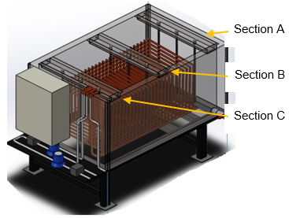
Figure 1: Schematic of the heat storage tank. In sections A and C, only the large coil exchanges heat with the PCM.

The solar radiation is captured by vacuum tubes. A total of 140 tubes were installed, separated into two circuits. The first group of 60 tubes is connected to the small coil, while the second group is connected to the large coil. According to the manufacturer, the collectors have a solar radiation capture efficiency of 76%. During charging cycles, a hot water recirculation pump drives the water from the solar collectors to the storage tank in a closed circuit. During the discharge cycles, water is recirculated between the storage tank and radiators located inside a house. The start and end of each cycle is determined automatically depending on the availability of solar radiation and the need for heating during the night. The solar thermal energy storage system is located in a rural house in a Colombian paramo area with an altitude of 3,200 m.a.s.l.
    - Calculation of energy stored and transferred by hydrogenated palm stearin
The energy absorbed and delivered by the hydrogenated palm stearin during the charging and discharging cycles was calculated from the sensible heat exchanged by the water, according to the following equation:
$$\dot{Q}=\dot{v}{⋅ρ}_{(T)}⋅Cp(T)⋅∆T$$ | (1)
W$here \dot{v}$ represents the volumetric flow, $ρ_{(T)}$ the density, C_{p(T)} the heat capacity and ΔT the temperature difference between the fluid inlet and outlet. The calculation was made for each coil, considering the flow rate and the recorded inlet and outlet water temperature. The calculation of the heat exchanged by the heat transfer fluid makes it possible to establish the energy effectively used, implicitly considering the heat losses present.
  - Results
    - Temperature profiles during charge and discharge cycles
To determine the heat transferred to and from the heat transfer fluid it is necessary to identify the start and end time of the charging and discharging cycles. Table 1 shows the start and end time of each cycle and its duration. Both the start and end times of each cycle were very similar during the two tests with durations of approximately 7 hours for the heat charging cycles and 8 hours for the discharge cycles. The selected days correspond to an example of operation during the beginning of the cold season. Although there is no winter period in the area where the system was located, every year, from the end of November to mid-January, the lowest temperatures of the year are recorded.
Table 1 Starting date, end date and duration of two charge/discharge cycles of hydrogenated palm stearin.
Cycle type | Start date  (y/m/d h:min) | End Date  (y/m/d h:min) | Duration  (h:min)
Charge | 2023/12/11 9:22 | 2023/12/11 16:07 | 6:45
Discharge | 2023/12/11 22:27 | 2023/12/12 6:42 | 8:15
Charge | 2023/12/12 9:16 | 2023/12/12 16:15 | 6:59
Discharge | 2023/12/12 22:30 | 2023/12/13 6:55 | 8:25

Figure 2 shows the temperature variation of both inlet and outlet water in the coils during the charging and discharging cycles. The volumetric water flow profile obtained is also shown. During the load cycles, the water temperature at the inlet of the coils was always above 60 °C, reaching maximums of 75 °C around 2:00 pm. The temperature of the water varied as a function of the incident solar radiation.
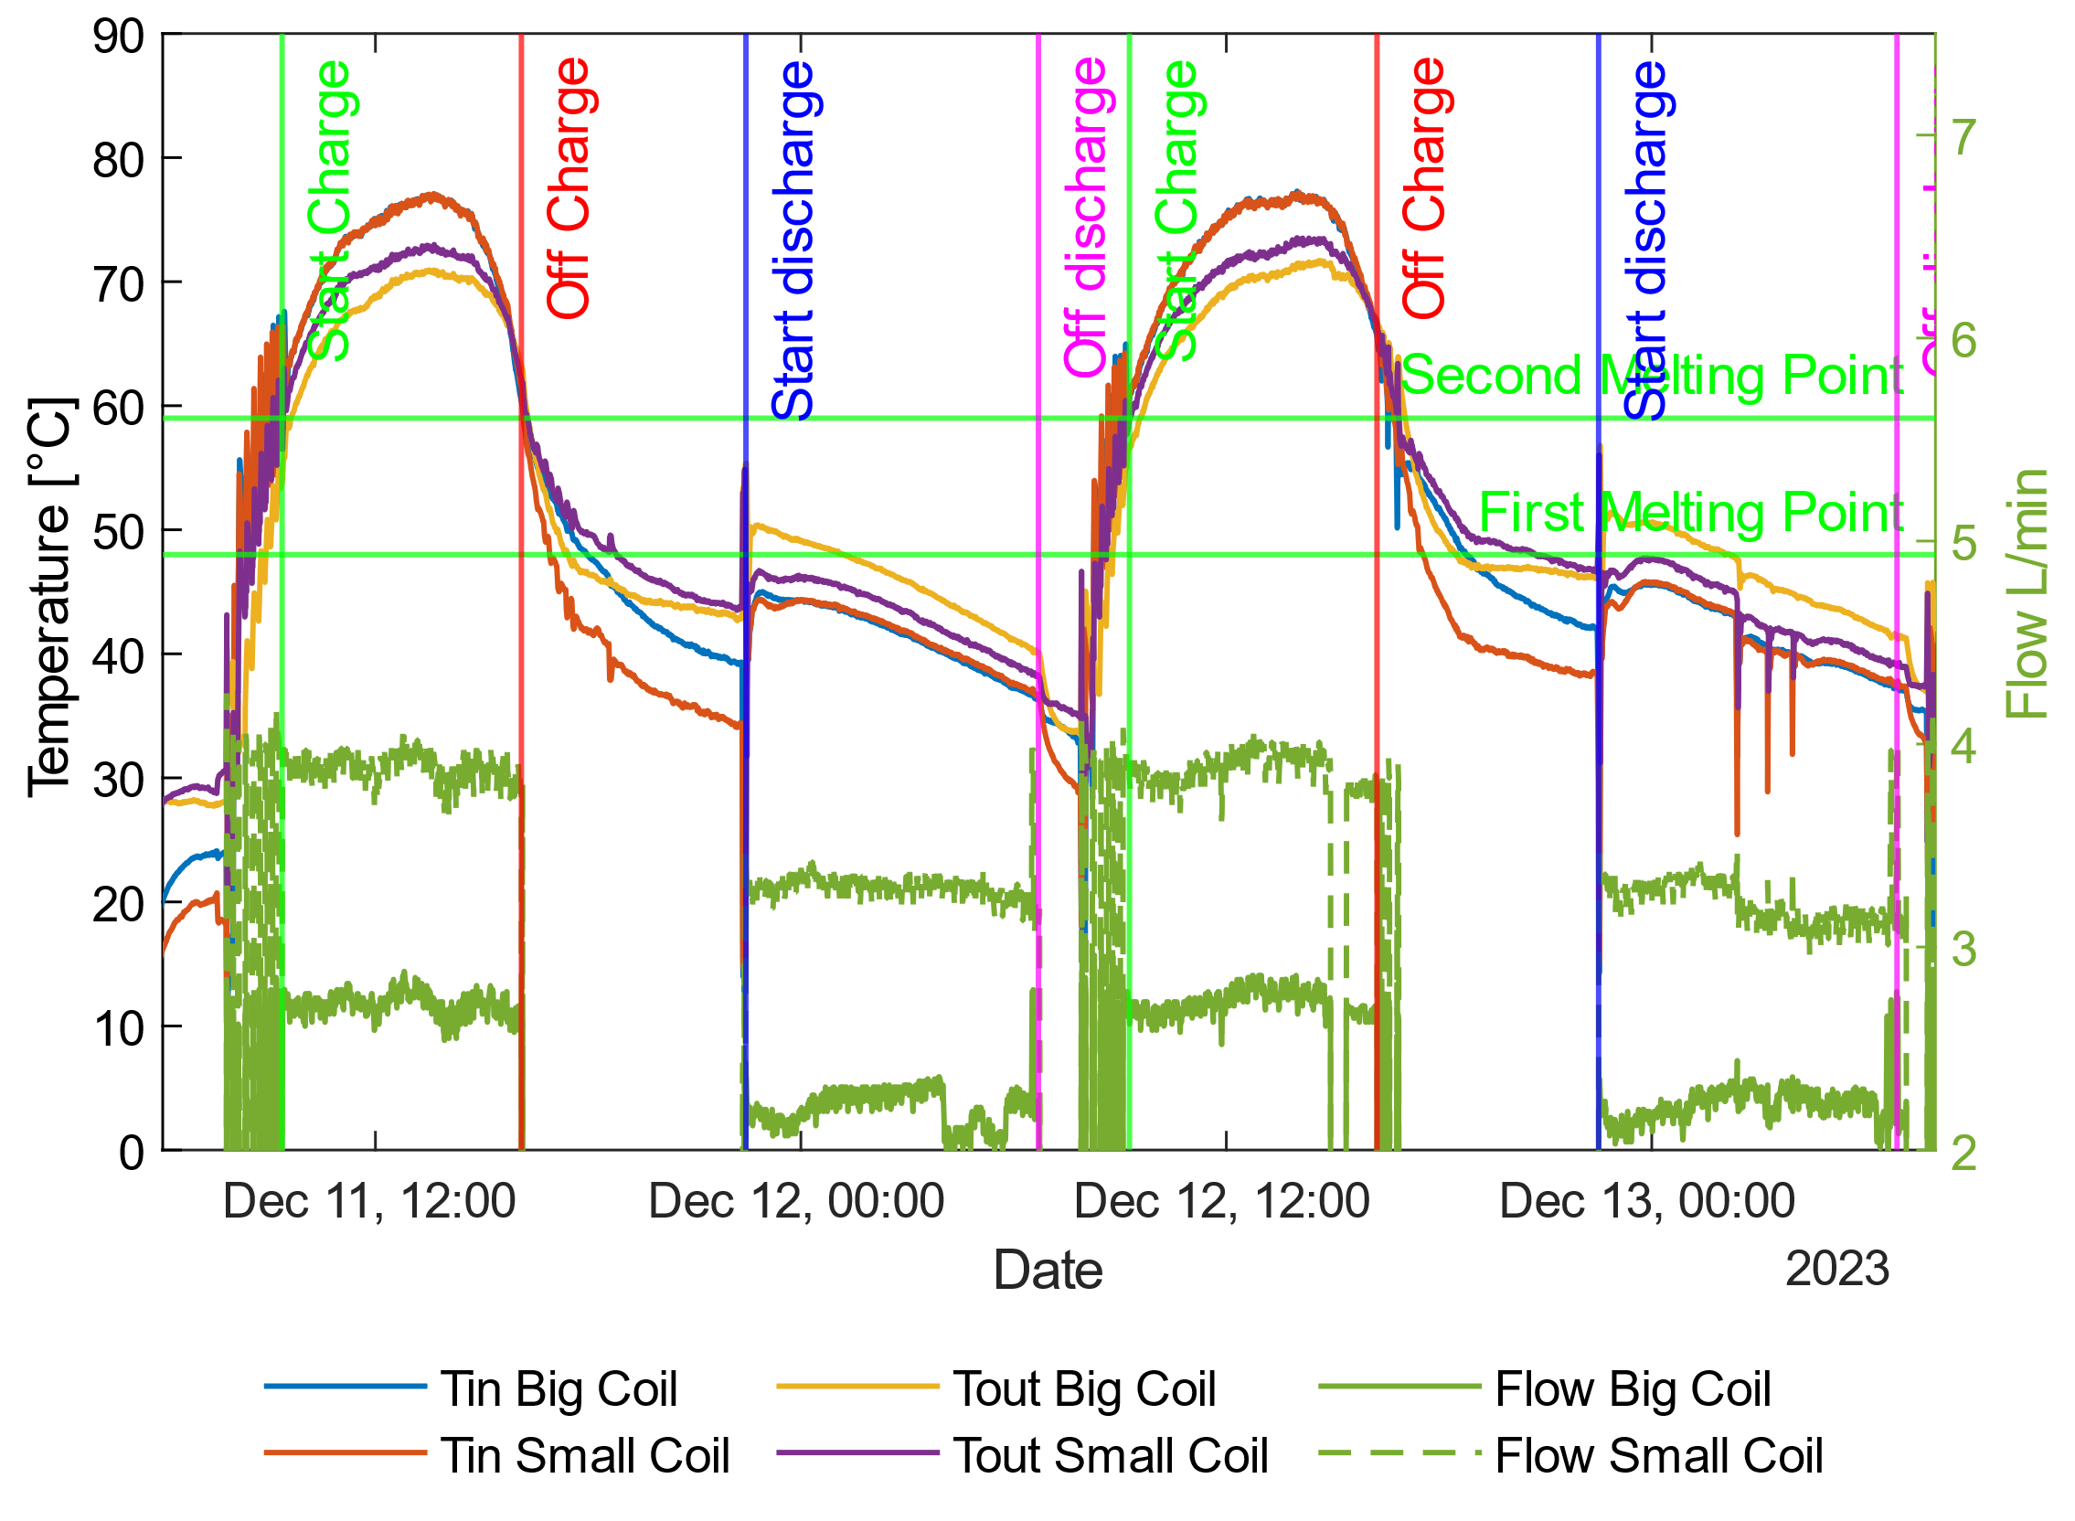
Figure 2: Volumetric flow and water temperature profiles at the inlet and outlet of the coils during two charging and discharging cycles. The horizontal green lines indicate the temperature range in which the HPS melts. During the charging cycles, the water coming from the collectors reached temperatures of up to 77 °C. Notably, the outlet water temperature decreased slowly during the discharge cycles, losing only 10 °C in about 8 hours.
The values recorded by the temperature sensors for sections A, B and C are presented in Figure 3, Figure 4 and Figure 5.
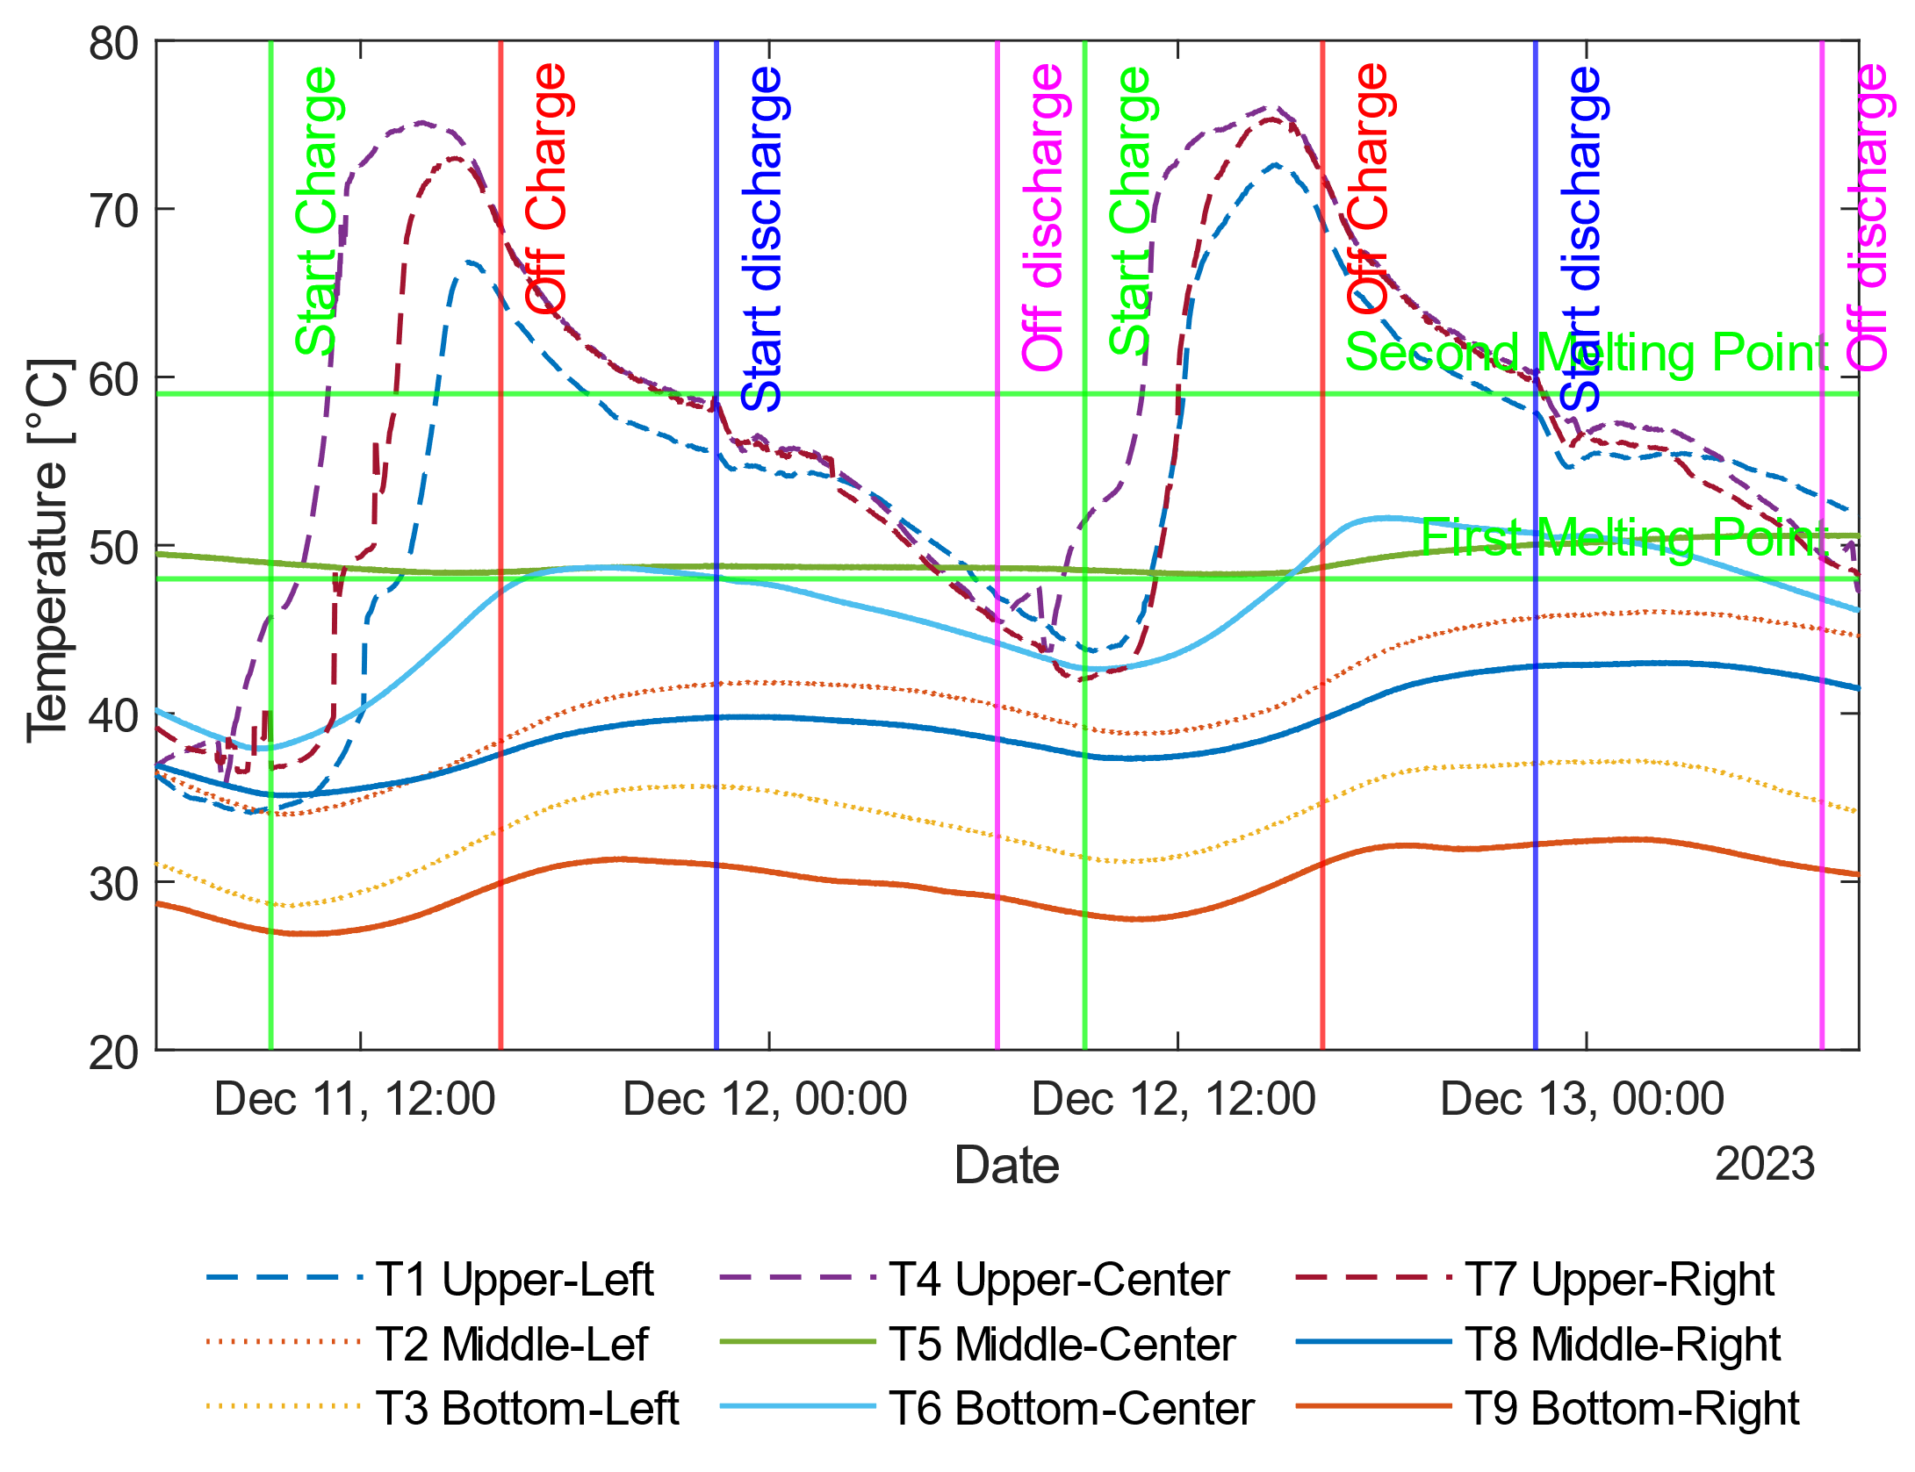
Figure 3: Temperature profile in section A of the PCM. The three sensors located at the top of the section record temperatures above the melting point of the material during a charging cycle, and then record the largest temperature decrease during the discharging cycle. The other sensors indicate the presence of solid material, with small temperature variations.

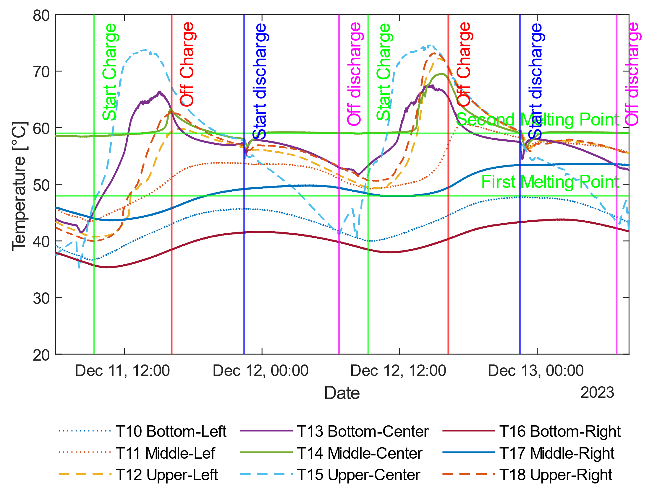
Figure 4: Temperature profile in section B of the PCM. Five sessions showed temperatures above the melting point of the HPS during the first charging cycle, increasing to six in the second cycle. A complete melting of the PCM is deduced in this section, except for the lower corners.

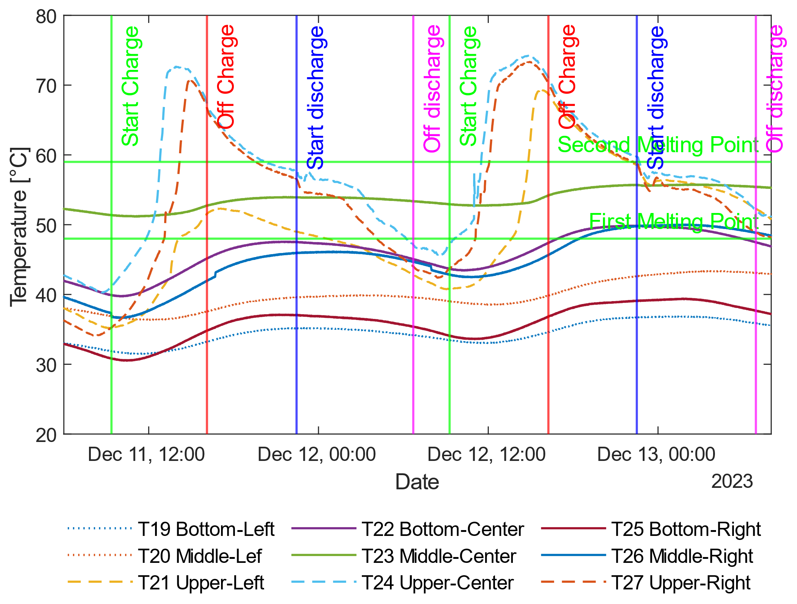
Figure 5: Temperature profile in section C of the PCM. Similar behaviour to that recorded in section A is observed. It should be noted that in sections A and B only the large coil is present. The fact that the largest temperature variations are recorded at the top indicates that the molten PCM flows there as the charging cycle progresses.

The temperature difference between water inlet and outlet was up to 8 °C. This behavior allows us to deduce that it is still possible to propose improvements in the design of the heat exchanger or increase the amount of PCM to be used in order to increase the efficiency of the system. In each section, the 9 sensors were arranged equidistantly inside the HPS, with three sensors at the top, three in the middle and three at the bottom. For sections A and C, during the load cycles, it is observed that the temperatures measured at the top of the PCM increase rapidly from approximately 40 °C to 75 °C. The other sensors indicate the presence of solid PCM, except for the center of each section where the material was in the phase change range during the tests. During the discharge tests, all sensors again registered values below the melting temperature of the material, indicating that it had fully crystallized. For section B, up to five sensors recorded temperatures above 59°C, indicating complete melting of the material. Up to five of the sensors remain at temperatures in the phase change range, even after the end of a discharge cycle. As in sections A and C, the lower corners of section B are the areas of lowest heat transfer, presenting slight temperature variations. Similar behavior has been reported for others PCMs, and is attributed to the phenomenon of natural convection in which the molten material with a higher temperature and lower density tends to be located at the top of the system, generating a temperature difference between the top and the bottom of the storage tank. (Mahdi et al., 2021).
    - Energy stored and transferred by hydrogenated palm stearin
The amount of energy transferred from the hot water to the PCM during the charge cycles and vice versa during the discharge cycles is shown in Table 2.
Table 2: Energy absorbed and released by the HPS during charge/discharge cycles
Cycle type | Start date  (y/m/d h:min) | Energy exchanged by the large coil (MJ) | Energy exchanged by the small coil (MJ) | Total Energy  (MJ)
Charge | 2023/12/11 9:22 | 22.4 | 19.8 | 42.2
Discharge | 2023/12/11 22:27 | 20.7 | 11.7 | 32.4
Charge | 2023/12/12 9:16 | 21.1 | 18.8 | 39.9
Discharge | 2023/12/12 22:30 | 23.7 | 13.3 | 37.0
The energy exchanged by each coil and the total energy are detailed. The energy released during a discharge cycle corresponds to between 76% and 92% of the energy absorbed during the day. This lower proportion is due to energy losses to the environment and to the characteristics of the crystallization process where, as the PCM becomes a solid state, the layer that forms around the coils forms a barrier that limits heat transfer. This, however, allows hot water to be delivered for longer, where in the 8 hours of discharge tests, the water outlet temperature decreased only 10 °C.
  - Conclusions
Hydrogenated palm stearin showed satisfactory performance as a phase change material allowing up to 37 MJ of heat to be delivered during a discharge cycle. Being a material of renewable and biodegradable origin, it is presented as a viable alternative to replace the use of paraffin of petrochemical origin, which is currently the most widely used PCM. In addition, this would make it possible to diversify the oil palm production chain where palm stearin is seen as an unwanted product by most companies. It is necessary to continue with the design and implementation of improvements in solar thermal energy storage systems to increase the overall efficiency of this type of technologies, guaranteeing the fusion of the entire PCM and minimizing energy losses heat to the environment. Likewise, it is necessary to establish the behavior of the system over longer periods of time, in order to estimate a more accurate efficiency, which includes the climatic variations of the area.

Acknowledgments
Authors would like to thank The Royal Society for supporting this research through the Enabling Harvesting of Solar Energy for Remote Applications in the Andes Region (LA-SOLAR ENHANCE- ICA\R1\191201) project. Also special thanks to the Ministerio de Ciencia Tecnología e Innovación of Colombia for the support of the project entitled Desarrollo de una herramienta metodológica computacional y tecnologías de energías renovables para la transición energética en zonas de alta montaña en condiciones de post- pandemia, CD 82605 CT ICETEX 2022-0644. Special thanks to the Vice-Rectory of Research and Extension of the Universidad Industrial de Santander for their support to the project "Estudio de la Convección Natural Durante la Fusión de Materiales de Cambio de Fase para el Almacenamiento de Energía Solar Térmica en Sistemas Carcasa-Serpentín" (Study of Natural Convection During the Fusion of Phase Change Materials for the Storage of Solar Thermal Energy in Casing-Serpentin Systems), code VIE 3732.
References
Dogkas G., Konstantaras J., Koukou M.K., Stathopoulos V.N., Coelho L., Rebola, A., 2019, Evaluating a prototype compact thermal energy storage tank using paraffin-based phase change material for domestic hot water production, Chapter In: M. A. Sayegh, J. Danielewicz, H. Jouhara, B. Kaźmierczak, M. Kutyłowska, K. Piekarska, (Eds.), E3S Web of Conferences, 116: 00016.
Mahdi M.S., Mahood H.B., Campbell A.N., Khadom, A.A., 2021, Natural convection improvement of PCM melting in partition latent heat energy storage: Numerical study with experimental validation, International Communications in Heat and Mass Transfer, 126: 105463.
Mahkamov K., Pili P., Manca R., Leroux A., Mintsa A.C., Lynn K., Mullen D., Halimic E., Bartolini C., Pirro M., Costa S.C., Cabeza L.F., de Gracia Cuesto A., Kenisarin M., & Makhkamova I. 2018. Development of a Small Solar Thermal Power Plant for Heat and Power Supply to Domestic and Small Business Buildings, In: Volume 1: Fuels, Combustion, and Material Handling; Combustion Turbines Combined Cycles; Boilers and Heat Recovery Steam Generators; Virtual Plant and Cyber-Physical Systems; Plant Development and Construction; Renewable Energy Systems. American Society of Mechanical Engineers.
Patterson H.B.W., 2011, Hydrogenation Methods. In: Hydrogenation of Fats and Oils. Elsevier: pp. 189–278.
Pielichowska K., & Pielichowski K. 2014. Phase change materials for thermal energy storage, Progress in Materials Science, 65: 67–123.
Prakash J., Roan D., Tauqir W., Nazir H., Ali M., & Kannan A., 2019, Off-grid solar thermal water heating system using phase-change materials: design, integration and real environment investigation, Applied Energy, 240, 73–83.
Riffat S., Mempouo B., Fang, W, 2015, Phase change material developments: a review, International Journal of Ambient Energy, 36, 102–115.
Tan C.P., Nehdi I. A., 2012, The Physicochemical Properties of Palm Oil and Its Components. In: Palm Oil. Elsevier: pp. 377–391.
Yousef M.S., Hassan H, 2019, Energetic and exergetic performance assessment of the inclusion of phase change materials (PCM) in a solar distillation system, Energy Conversion and Management, 179: 349–361.

