CHEMICAL ENGINEERING TRANSACTIONS  VOL. , 2024 | A publication of
The Italian Association
of Chemical Engineering
Online at www.cetjournal.it

Guest Editors: Leonardo Tognotti, Rubens Maciel Filho, Viatcheslav Kafarov
Copyright © 2024, AIDIC Servizi S.r.l.
ISBN 979-12-81206-09-0; ISSN 2283-9216

Decarbonisation Strategies for Sustainable Agricultural Development in Kazakhstan
Marzhan A. Sadenova^{a,}*, Nail A. Beisekenovª, Natalya A. Kulenovaª, Dinmukhammed Ye. Ualiyev^{b}, Yuri S. Kamenev^{c}, Serik Khamzin^{c}
ªPriority Department Centre «Veritas», D. Serikbayev East Kazakhstan technical university, Ust-Kamenogorsk, Kazakhstan
^{b}International School of Economics, Maqsut Narikbayev University, Astana, Kazakhstan
^{с}Experimental farm of oilseeds (EFoO), Ust-Kamenogorsk, Kazakhstan
MSadenova@edu.ektu.kz
In this study on the example of 2 agro-ecosystems located on opposite banks of the Irtysh River the content of organic carbon in soil and dynamics of its change for the period from 2001 to 2020 were studied. According to the results of the study, the estimated amount of organic carbon losses for the period from 2001 to 2020 from arable chernozem soils on both banks of the Irtysh River averaged 96×10³ kg C per year-¹ at Site 1 (right bank) and 87×10³ kg C per year-¹ at Site 2 (left bank). It was found that differential fertiliser application, use of organic topdressing and compost, mulching and introduction of 10-field crop rotation promoted soil organic carbon (SOC) conservation. Correlation between SOC value and soil resistance to drought, erosion and other unfavourable conditions was revealed. The possibility of effective forecasting and regulation of crop yields by using a combination of geographic information systems (GIS), SOC-modelling in the form of RothC and remote sensing data with the Trends.Earth tool has been substantiated. The proposed approach allows operational monitoring of SOC content and contributes to the successful implementation of a decarbonisation strategy for sustainable crop agriculture development
  - Introduction
Low-carbon development is a prerequisite for sustainable development and aims to prevent the catastrophic effects of global climate change. Kazakhstan has announced a new goal of achieving carbon neutrality by 2060, reaffirming its commitments under the Paris Agreement to prevent global temperature rise of more than 1.5-2oC. For Kazakhstan, the transition to low-carbon development and decarbonisation of the economy is a serious and responsible challenge, requiring large-scale measures in all areas of technological modernisation of the national economy and, above all, its extractive sectors. In February 2023, the Strategy for Achieving Carbon Neutrality of the Republic of Kazakhstan until 2060 was adopted (Adilet-zan, 2023). The medium-term goal is to reduce greenhouse gas emissions by 2030 by 15% relative to the 1990 level and by 25% subject to international support for decarbonisation of the economy. One of the important areas of decarbonisation is agriculture. Interactions between soil and atmospheric carbon, especially in greenhouse gas dynamics, are becoming increasingly important in environmental research. The diverse agricultural areas of Kazakhstan, especially in the foothills, are not well suited for traditional soil analysis methods. Digital soil mapping (DSM), which combines limited environmental samples with covariates, has become an effective solution for estimating SOC, a vital component in carbon flux management, as noted by Su et al. (2021). The success of DSM depends largely on the relationship between SOC and environmental variables such as vegetation density. In pristine ecosystems, this relationship is particularly strong and can be monitored using remote sensing technologies, a method detailed in Zeraatpisheh et al. (2022). Satellite imagery, such as the 4-metre IKONOS highlighted by Peteri et al. (2021), is crucial for mapping SOC on homogeneous soil types or agricultural land. These methods aim to reduce the influence of vegetation on reflectance data and improve the accuracy of SOC predictions. The study of soil CO2 fluxes, reflecting the exchange of carbon dioxide between soil and atmosphere, is an integral part of understanding the global carbon cycle. This aspect is attracting increasing attention because of its potential impact on crop yields, given the significant contribution of agricultural practices to global greenhouse gas emissions. The dichotomy of the role of CO2 in photosynthesis versus its possible adverse effects on soil pH, plant health and microbial activity highlights the complexity of this area (Lozbenev et al., 2022). In foothill regions, DSM often uses topographic data from digital elevation models (DEMs) (Lee et al., 2020), emphasising the influence of landscape on SOC. The difficulty lies in directly correlating image data with SOC levels, which can greatly simplify DSM processes. Traditional linear regression models in soil studies are limited by their inability to capture non-linear relationships between soil attributes and predictors. An alternative, regression trees, offers finer modelling but fails to cope with the variability of the data. More sophisticated are extended branch regression models, which combine several simple models to improve prediction accuracy and reliability (Sadenova et al., 2023). Improving soil health and fertility can increase crop yields and provide economic benefits to farmers (Sadenova et al., 2022). Improving soil fertility, conserving soil cover, minimising agronomic practices that degrade soil health are important steps to promote effective land use management strategies (Beisekenov et al., 2021). The relevance of the study lies in the need to find ways to reduce CO2 emissions and improve the manageability of non-irrigated agriculture in the sharply continental climate of eastern Kazakhstan. The novelty lies in the development of new approaches for operational monitoring of the state of vegetation, soil cover using modern digital technologies in order to implement the decarbonisation strategy for sustainable agricultural development in Kazakhstan.
  - Materials and methods
This study was conducted at two experimental sites located in East Kazakhstan. Figure 1 shows the location of these sites relative to the Irtysh River: site 1 is on the right bank of the river, and site 2 is on the left bank. The dominant soil type in these sites, according to soil systematics, is chernozem (black soil). This region of Kazakhstan is characterised by a sharply continental climate, with extreme temperatures ranging from maximums of 45°C in summer to minimums of -40°C in winter. The experimental part of this study utilised the Trends.Earth tool, a standalone module specifically designed for the QGIS GIS platform. This tool, developed by Gonzalez et al. (2019), plays an important role in assessing the neutrality of land degradation. Trends.Earth uses a combination of remote sensing and machine learning algorithms to assess the condition and productivity of pasture and cropland. Although it does not measure soil carbon content directly, it uses modelling techniques to estimate it, as described in Pham et al. (2018). Trends.Earth synthesises data from satellite imagery, weather stations and other sources to gather comprehensive information on land cover, land use and soil characteristics of specific areas. Using these data, the model estimates the amount of carbon stored in the soil, taking into account various existing environmental factors. The study used the Trends.Earth model, based on the RothC model, to calculate soil carbon sequestration, taking into account factors such as soil type, land use and climate. The RothC model includes various components representing different forms of organic matter and their decomposition rates. Process-based models such as RothC provide insight into changes in soil organic C stocks, but their regional and national application is limited by the need for extensive, high-quality data. The main objective of this study was to develop a data collection methodology for modelling soil organic C losses in arable soils of eastern Kazakhstan. Trends.Earth supplements its estimates with ground-based measurements such as soil sampling when possible. Calculating soil C using Trends.Earth involves combining remote sensing, soil and climate data, and measurements to estimate soil C stocks. The tool's algorithm provides information on land degradation indicators and is part of the United Nations global monitoring system to combat desertification. Trends.Earth provides statistical and cartographic data on land degradation indicators at a spatial resolution of 250-300 metres per pixel. It estimates land cover changes by comparing current and baseline data, with land cover types grouped into seven classes for analysis. Estimating changes in soil organic C stocks is challenging because of the variability of soil properties and the need for intensive soil surveys. Trends.Earth uses data from the SoilGrid database, which provides soil data at 250 m resolution, but only offers regional averages that require adjustment for specific local applications. Whilst there are other improved free databases available, SoilGrid stands out for its affordability and ease of integration with our analytical tools such as Trends.Earth and the RothC model. This allows for more efficient data manipulation and simplifies the modelling process. SOC content data were collected during field studies at two pilot plots in East Kazakhstan. Soil sampling points were selected for each site that were representative of land use types and agro-ecological conditions. Soil samples were collected at different depths using standardised methods to ensure accuracy and comparability of data. The samples were analysed for SOC content under laboratory conditions using wet oxidation and spectrophotometric techniques to obtain accurate soil organic carbon values. The resulting laboratory data were analysed and integrated with information from Trends.Earth to calculate SOC stock changes at the experimental sites. Trends.Earth, using satellite monitoring data, allowed the estimation of changes in cover and land use, which are key drivers of SOC dynamics. The RothC model integrated into Trends.Earth was used to simulate changes in SOC as a function of soil type, land use and climatic conditions. The integration of field data with the modelling in Trends.Earth allowed a comprehensive analysis of SOC changes and an evaluation of the effectiveness of different land management practices. Data from independent studies and literature sources were used to validate the modelling results.
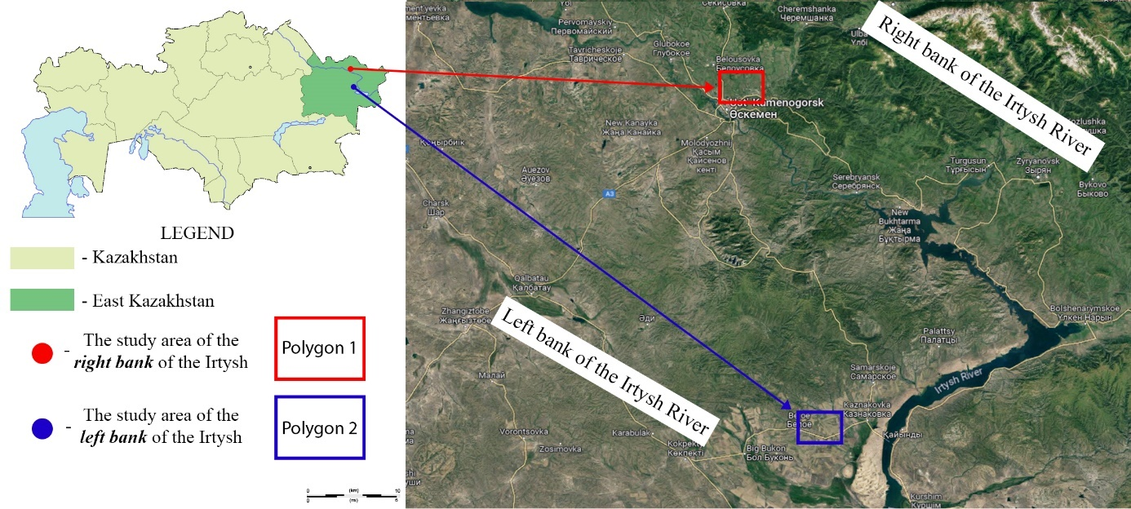
Figure 1: Experimental polygons
Special attention is given to analysing different land cover types and their influence on soil organic carbon (SOC) content. The description of land cover types and their characterisation is a key aspect for understanding the conditions and opportunities for carbon balance in different ecosystems. Below is a definition of each land cover type used in our study: Tree-covered areas: These are land areas covered with tree and shrub vegetation capable of reaching a height of more than 5 metres and a crown cover of more than 30%; Grasslands: Land covered with herbaceous vegetation, including natural pastures and fallow lands; Croplands: Land areas used for growing crops. These areas are cultivated for planting, growing and harvesting crops, including fields of cereals, vegetables, fruit and other agricultural products; Wetlands: Lands saturated with standing or flowing water, including bogs, marshes, lakes, peatlands and mud flats; Artificial areas: Land areas that have been modified by humans, including urban areas, roads and other structures.
  - Results
The method for estimating land degradation trends using the Trends.Earth computational module, is not calculated as a function of changes in soil organic C stocks, but rather as a function of changes in soil cover. "Negative" changes in soil cover lead to a decrease in soil organic C and vice versa. This condition is characteristic of arable land, where dehumidification occurs through ploughing of the area and erosion of the topsoil. There may also be positive dynamics within a single land class, e.g., with good land management and fertiliser application. The estimation of soil organic C resulted in the change in soil organic C composition over the period 2001-2020, shown in Figure 2. Using the Trends.Earth tool, the change in soil organic C from the baseline from 2001 to 2020 was calculated, the units of imported raster: metric tonnes of organic C per hectare (Table 1, 2). According to the data presented in Table 1, the percentage change in soil organic carbon accumulation from the baseline to the target level was 0.08%. In addition, the change in soil organic matter content from the baseline for the study period was calculated. The choice of the value of 0.08% as a measure of change in SOC content was due to several factors (Wu et al., 2022). Firstly, this value corresponds to the average percentage change in SOC calculated from time series analyses of land use and cover change data derived from satellite imagery and the SoilGrid database. Secondly, this value was adjusted to the results of in-situ SOC measurements to refine the model calculations and ensure their greater accuracy. This section describes the results of a study we conducted to examine changes in soil organic carbon (SOC) content in experimental plots. We analysed several key indicators that helped us to assess changes in SOC content. One of these indicators is the target soil organic carbon content, expressed in tonnes. This indicator represents the projected amount of SOC by the end of the study period, 2020, based on model projections. These projections take into account current trends in land use change and agroecosystem management. Another important indicator is the change in soil organic carbon, also expressed in tonnes. It represents the difference between target and baseline SOC values for the period from 2001 to 2020, which allows us to estimate the total increase or decrease in SOC stocks over the study period. In addition, we considered the percentage change in soil organic C content, which allows us to assess the dynamics of change in the context of reference stocks and allows comparison between different sites or management practices. This calculation is presented in Table 2. Based on the simulation data presented in Tables 1, 2, and 3, it was determined that from 2001 to 2020, SOC stocks diminished at an average rate of 96×10³ kg C ha⁻¹ year⁻¹ in Polygon 1 and 87×10³ kg C ha⁻¹ year⁻¹ in Polygon 2.
Table 1: Change in soil organic C in Polygon 1, from baseline over the period 2001-2020
 | Baseline area  (sq. km) | Baseline soil organic carbon (tonnes) | Target soil organic carbon (tonnes) | Change in soil organic carbon (tonnes) | Change in soil organic carbon
Tree-covered areas | 156.75 | 292177.31 | 292487.05 | 310.70 | 0.11%
Grasslands | 1108.02 | 1570894.80 | 1551393.41 | -19474.38 | -1.24%
Croplands | 283.84 | 443230.06 | 465372.8 | 22121.94 | 5.00%
Wetlands | 5.24 | 10843.31 | 10808.70 | -34.53 | -0.32%
Artificial areas | 1.33 | 1721.95 | 2044.64 | 322.36 | 18.74%
Other lands | 17.45 | 21023.75 | 19614.31 | -1407.90 | -6.70%
Total: | 1572.66 | 2339891.22 | 2341721 | 1838.19
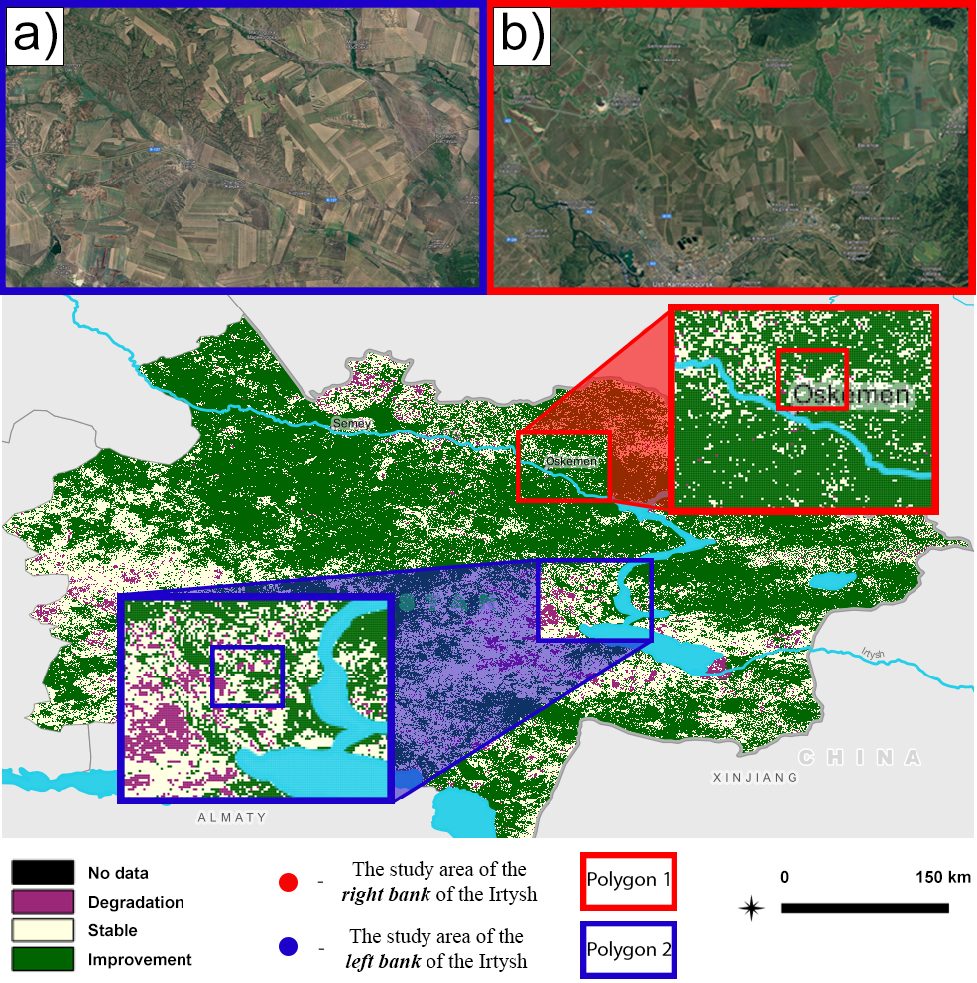
Figure 2: Change in soil organic carbon composition over the period 2001-2020 (a) Polygon 2; (b) Polygon 1
This translates to a reduction of organic carbon by 1838.19 tonnes in Polygon 1 and by 1655.22 tonnes in Polygon 2 over the two decades, with the latter representing an 11% smaller loss than the former. The substantial difference in organic carbon loss is attributed to the divergent agro-ecological conditions of the Irtysh River's right bank compared to its left, including variations in temperature, precipitation, and soil content and quality. Consequently, the study proposes methods to augment organic carbon in the soil of Polygon 1, including the implementation of soil conservation practices such as mulching, green manuring, and reduced tillage. These methods are designed to preserve and increase the organic material in the soil, thereby significantly reducing carbon emissions into the atmosphere. Table 3 provides a comprehensive view of the changes in SOC content in different land cover types from initial to target levels, expressed as a percentage of the initial stock. Here is a detailed breakdown of SOC changes: see note. Table 3 offers a thorough overview of the shifts in SOC content across different types of land cover from the initial to the target level, showcasing these changes as a percentage of the initial stock. It details that there is no change in SOC when tree-covered areas transition to other tree-covered areas, grasslands, or wetlands. However, a 3.80% reduction in SOC is noted when shifting to croplands, with more significant losses observed when moving to artificial areas (18.53% decrease) and other lands (12.92% decrease). Grasslands exhibit a similar pattern where no SOC change is noted within the same category, but shifting from grasslands to croplands results in a 3.15% loss. Transitioning to artificial areas and other lands from grasslands leads to decreases of 14.94% and 16.80%, respectively. Conversely, when tree-covered areas and grasslands are converted into croplands, there is an increase in SOC by 4.62% and 5.29%, respectively, and croplands maintain their SOC stock if no land cover change occurs.
Table 2: Change in soil organic C in Polygon 2, from baseline over the period 2001-2020
 | Baseline area  (sq. km) | Baseline soil organic carbon (tonnes) | Target soil organic carbon (tonnes) | Change in soil organic carbon (tonnes) | Change in soil organic carbon
Tree-covered areas | 174.21 | 263234.27 | 263541.66 | 279.77 | 0.106%
Grasslands | 1231.45 | 1415282.15 | 1397862.88 | -17535.94 | -1.25%
Croplands | 315.46 | 399323.75 | 419318.17 | 19919.96 | 4.75%
Wetlands | 5.83 | 9769.17 | 9739.04 | -31.09 | -0.31%
Artificial areas | 1.48 | 1551.37 | 1842.30 | 290.28 | 15.75%
Other lands | 19.40 | 18941.14 | 17673.22 | -1267.76 | -7.17%
Total: | 1747.86 | 2108101.89 | 2109977.28 | 1655.22
Table 3: Change in soil organic C from the initial level to the target level depending on the type of land cover transition (percentage of initial stock)
 | Tree-covered areas | Grasslands | Croplands | Wetlands | Artificial areas | Other lands
Tree-covered areas | 0.00% | 0.00% | -3.80% | 0.00% | -18.53% | -12.92%
Grasslands | 0.00% | 0.00% | -3.15% | - | -14.94% | -16.80%
Croplands | 4.62% | 5.29% | 0.00% | - | -14.08% | -23.08%
Wetlands | 0.00% | - | - | 0.00% | - | -
Artificial areas | - | - | - | - | 0.00% | -
Other lands | 18.64% | 10.63% | 20.76% | - | 0.00% | 0.00%

However, significant SOC losses are recorded when croplands transition to artificial areas (14.08% decrease) and other lands (23.08% decrease). Wetlands show stability within their category with no data available for transitions to other land cover types. In the case of artificial areas, no SOC change is observed when transitioning within the same category, and no data is available for transitions from artificial areas to other types. Interestingly, substantial increases in SOC are seen when other lands transition to tree-covered areas (18.64% increase), grasslands (10.63% increase), and croplands (20.76% increase), indicating that converting these lands to more vegetative states could be beneficial for SOC accumulation. The change in SOC content for each land category over the study period (2001-2020) was calculated using data from the SoilGrid database and satellite imagery to estimate the changes in the coverage and utilization of these lands. The SOC changes were estimated using a RothC model, adapted for each land type based on their specific agro-ecological and climatic conditions. This table points to the importance of land cover type in SOC dynamics. For example, the significant increase in SOC when other lands transition to more vegetative states could imply that reforestation or revegetation of degraded lands could be a potent strategy for carbon sequestration. Conversely, the losses noted when agricultural lands transition to artificial areas may reflect the impact of urbanization on SOC stocks. The absence of change within certain categories indicates a stable SOC stock, which is a good sign of equilibrium in the carbon cycle of those ecosystems. However, the losses in SOC with certain transitions underscore the need for careful land management practices to prevent soil degradation and promote carbon sequestration. In summary, the data from Table 3 highlight the complex interactions between land cover change and SOC levels, emphasizing the critical role of sustainable land management in maintaining and enhancing soil carbon stocks.
  - Conclusions
The findings from this investigation suggest that the land degradation neutrality approach, employing the computational module Trends.Earth, is a viable method for assessing land degradation in areas with conditions analogous to Eastern Kazakhstan. The module successfully captures key trends in land cover and productivity, aligning with the United Nations Sustainable Development Goals (UN SDGs). It enables the calculation of the proportion of degraded land relative to the total land area, which is crucial for the formulation of land management strategies and decision-making processes aimed at sustainable regional development. Moreover, the application of the Trends.Earth module, founded on the RothC model, has proven effective for the quantitative assessment of SOC stocks. The research indicates that SOC in the eastern part of Kazakhstan has undergone significant changes from 2001 to 2020, with a decrease in SOC stocks at an average rate of 96×10³ kg C ha⁻¹ year⁻¹ in Polygon 1, and 87×10³ kg C ha⁻¹ year⁻¹ in Polygon 2. It is noteworthy that Polygon 1 exhibited an 11% greater reduction in organic carbon than Polygon 2, a discrepancy likely attributable to the different agro-ecological conditions on the right bank of the Irtysh River. The study's data, showing changes in SOC across different land cover types, underscores the potential of improving SOC through targeted land management practices. By increasing soil organic carbon, we can substantially mitigate CO₂ emissions to the atmosphere. The analysis showed that implementing sustainable land management practices can reduce CO2 emissions by 0.08-0.1 per cent per year per unit area, depending on land type and regional conditions. While these values may seem small, they have a significant impact on the global carbon balance when scaled to large areas. Enhancing SOC not only contributes to the reduction of atmospheric carbon dioxide but also bolsters soil fertility, structural integrity, and biodiversity conservation. In summary, the land degradation neutrality methodology and the insights provided by the Trends.Earth module constitute valuable tools in advancing sustainable land management and combating climate change. The adoption of these tools and the implementation of conservation-oriented agricultural practices, such as mulching, green manuring, and reduced tillage, are recommended to preserve and enrich the soil's organic matter, thereby contributing significantly to the region's sustainable development and ecological stability.
References
Adilet-zan, 2023, U2300000121 On Approval of the Strategy for Achieving Carbon Neutrality of the Republic of Kazakhstan until 2060. Decree of the President of the Republic of Kazakhstan dated 2 February 2023 No. 121. <https://adilet.zan.kz/rus/docs/U2300000121 >, accessed 11.03.2024
Beisekenov N.A., Sadenova М.А., Kulenova N.A., Mukhtarkanovna M.A., 2021. Development of a preliminary version of a model for machine learning in predicting yield on the example of wheat in the conditions of East Kazakhstan. Conference: 2021 16th International Conference on Electronics Computer and Computation (ICECCO). https://doi.org/10.1109/icecco53203.2021.9663758
González‐Roglich M., Zvoleff A., Noon M., Liniger H., Fleiner R., Harari N., García C.L., 2019. Synergizing global tools to monitor progress towards land degradation neutrality: Trends.Earth and the World Overview of Conservation Approaches and Technologies sustainable land management database. Environmental Science & Policy 93, 34–42. https://doi.org/10.1016/j.envsci.2018.12.019
Lee S.-H., Han K.-J., Lee K., Lee K.-J., Oh K.-Y., Lee M.-J., 2020. Classification of landscape affected by deforestation using High-Resolution Remote sensing data and Deep-Learning techniques. Remote Sensing 12, 3372. https://doi.org/10.3390/rs12203372
Liu F., Zhang G., Song X., Li D., Zhao Y.-G., Yang J.-L., Wu H., Yang F., 2020. High-resolution and three-dimensional mapping of soil texture of China. Geoderma 361, 114061. https://doi.org/10.1016/j.geoderma.2019.114061
Lozbenev N., Komissarov M., Zhidkin A.P., Gusarov A.V., Fomicheva D., 2022. Comparative assessment of digital and conventional soil mapping: a case study of the Southern Cis-Ural Region, Russia. Soil Systems 6, 14. https://doi.org/10.3390/soilsystems6010014
Péteri R., Ranchin T., Couloigner I., 2001. A multiresolution modelling approach for semi-automatic extraction of streets: application to high resolution images from the IKONOS satellite. HAL (Le Centre Pour La Communication Scientifique Directe).
Pham T.G., Degener J., Kappas M., 2018. Integrated universal soil loss equation (USLE) and Geographical Information System (GIS) for soil erosion estimation in A Sap basin: Central Vietnam. International Soil and Water Conservation Research 6, 99–110. https://doi.org/10.1016/j.iswcr.2018.01.001
Sadenova M., Beisekenov N.A., Varbanov P.S., Pan T., 2023. Application of machine learning and neural networks to predict the yield of cereals, legumes, oilseeds and forage crops in Kazakhstan. Agriculture 13, 1195. https://doi.org/10.3390/agriculture13061195
Sadenova M.A., Beisekenov N.A., Ualiyev Y.T., Kulenova N.A., Varbanov P.S., 2022, Modelling of Forecasting Crop Yields Based on Earth Remote Sensing Data and Remote Sensing Methods, Chemical Engineering Transactions, 94, 19-24.
Su F., Xu S., Sayer E.J., Chen W., Du Y., Lu X., 2021. Distinct storage mechanisms of soil organic carbon in coniferous forest and evergreen broadleaf forest in tropical China. Journal of Environmental Management 295, 113142. https://doi.org/10.1016/j.jenvman.2021.113142
Wu X., Wang L., An J., Wang Y., Song H., Wu Y., Liu Q., 2022. Relationship between soil organic carbon, soil nutrients, and land use in Linyi city (east China). Sustainability, 14(20), 13585.
Zeraatpisheh M., Garosi Y., Owliaie H., Ayoubi S., Taghizadeh–Mehrjardi R., Scholten T., Xu M., 2022. Improving the spatial prediction of soil organic carbon using environmental covariates selection: A comparison of a group of environmental covariates. CATENA 208, 105723.

