CHEMICAL ENGINEERING TRANSACTIONS  VOL. , 2023 | A publication of
The Italian Association
of Chemical Engineering
Online at www.cetjournal.it

Guest Editors: Leonardo Tognotti, Rubens Maciel Filho, Viatcheslav Kafarov
Copyright © 2024, AIDIC Servizi S.r.l.
ISBN 979-12-81206-10-1; ISSN 2283-9216

Development of Biochar-based Composites Electrodes from Pyrolysis of Coffee Silverskin: Microbial Fuel Cells

for Wastewater Treatment
Stefania Marzorati^{a*}, Mirko Magniª, Sebastiano Campisi^{b}, Giorgia Ghiaraª, Gabriele Angelo Valtorta^{b}, Antonella Gervasini^{b}, Stefano P.M. Trasattiª
ªDepartment of Environmental Science and Policy, Università degli Studi di Milano, via Celoria 2, 20133, Milan, Italy
^{b}Dipartimento di Chimica, Università degli Studi di Milano, via Golgi 19, 20133, Milan, Italy
stefania.marzorati@unimi.it
Addressing the need for cost-efficient and environmentally friendly electrode materials for large-scale applications of bioelectrochemical systems, this study implemented the principles of circular economy to produce biochar- and hydroxyapatite/biochar-based conductive cathodes to be employed in clean and green technologies for wastewater treatment. Silverskin, the byproduct of coffee roasting responsible for generating significant waste worldwide, was subjected to a pyrolysis process to produce conductive biochar, then characterized in terms of physico-chemical properties. Biochar-based inks were formulated and employed to produce microporous layers on carbon cloth, finally used as cathodic materials in microbial fuel cells systems. The presence of hydroxyapatite in biochar-based composites was also evaluated with the goal of combining the remediation activity of biochar towards dissolved organic compounds, with that of hydroxyapatite towards inorganic ionic pollutants (such as Cd(II) and Zn(II)). Despite underperforming compared to other more technological and optimized materials, waste-derived biochar and its composite with hydroxyapatite were demonstrated to open novel frontiers in design and architecture of “multi-pollutants targeted” smarter bioelectrochemical systems, where not only microcurrent production, but a broader range of wastewater treatment can be addressed.
  - Introduction
Among bioelectrochemical systems, microbial fuel cells (MFCs) are investigated as promising technologies due to their dual capability of effectively treating wastewater, while simultaneously yielding energy (Roy et al., 2017).
The core principle of MFCs involves the presence of mixed bacterial cultures, naturally found in wastewater, able to adhere to one or both of the anodic and cathodic electrodes, where they catalyse electrochemical reactions. At the anode (i.e., negative electrode), microorganisms perform the oxidation of biodegradable dissolved organic compounds, resulting in a Chemical Oxygen Demand (COD) reduction in the wastewater. Simultaneously, this oxidation process generates electrons, which are conveyed through an external electrical circuit to an air-exposed cathode (i.e., positive electrode), where the oxygen reduction reaction takes place. This combination of electrochemical processes in MFCs leads to the production of micro-electrical power, all the while effectively remediating the wastewater (Williams et al., 2010). Although systematic studies on bioelectrochemical systems date back to the 1990s, the practical large-scale implementation of this technology still waits to overcome the challenge of finding an optimal balance between process efficiency and cost-effectiveness (Logan and Regan, 2006). MFCs architectures and materials frequently draw inspiration from conventional engineered electrochemical cells (i.e., electrolysers, electrodialysis systems, electroplating plants). Nevertheless, when considering applications on a larger scale for environmental purposes, like wastewater treatment, employing these materials and architectures could pose significant challenges due to their relatively high economic and environmental fabrication costs, as well as their limited sustainability at the end of their lifecycle (Marzorati et al., 2018; Schievano et al., 2019). In this context, following the guiding principles of circular economy, this study aims to produce sustainable biochar-based conductive cathodes, derived from biomass wastes, to be employed in MFCs, assisting the need to innovate and develop the palette of materials that are both low-cost and environmentally compatible for the fabrication of electrodes on a scale suitable for industrial applications. Specifically, silverskin, the outer layer of coffee beans that is typically discarded during the coffee roasting process and responsible of the generation of 2400 tons of waste produced per year only in Italy, was subjected to a pyrolysis procedure at 900°C, yielding a conductive biochar (Kumar et al., 2021). Biochar-based inks were then formulated and utilized to fabricate microporous layers on carbon cloth, subsequently employed as the cathodic materials within MFCs, operated in the presence of simulated brewery wastewater. Simultaneously, to broaden the spectrum of pollutants that can be removed efficiently by a wastewater, the development of hydroxyapatite/biochar composites was carried out with the goal of combining the electrocatalytic properties of biochar with the remediation activity of hydroxyapatite towards inorganic pollutants. Hydroxyapatite, a biocompatible material of general formula Ca₁₀(PO₄)₆(OH)₂, can be sourced from waste materials (animal bones, eggshells, seafood shells, agricultural residues, ashes) or synthesized from readily available, low-cost feedstock, with an estimated production cost of approximately $1.25 per kilogram (Ferri et al., 2021; Ibrahim et al., 2020). It has been compellingly demonstrated that the combination of hydroxyapatite with few amount of different carbon-based materials is able to provide electrically conductive composites that can be used to simultaneously remove and detect inorganic pollutants, even when crafted as self-standing electrodes (Magni et al., 2023). Moreover, in combination with biochar, hydroxyapatite yields versatile composites serving for an array of applications, spanning from water remediation (targeting both organic and inorganic pollutants) to cutting-edge sensor technology, and from electrocatalytic CO₂ reduction reactions to power-to-gas systems (Ferri et al., 2022; Ghiara et al., 2023).
In this work, waste-derived biochar and the novel biochar/hydroxyapatite composite materials, the latter obtained by the precipitation of hydroxyapatite within a dispersion of silverskin-derived biochar in water, were demonstrated to serve as pioneering electrode materials in the design and architecture of next-generation bioelectrochemical systems. Here the primary focus extends beyond microcurrent production, with wastewater treatment emerging as the real objective towards organic and inorganic pollutants at the same time. Results here reported could contribute significantly to the ongoing evolution of sustainable and efficient technologies that address the dual challenges of environmental remediation and clean energy generation.
  - Materials and Methods
2.1 Biochar Production and characterization
Silverskin, provided by Caffè Verderio S.r.l, was ground into powder using a knife mill (Fritsch, Pulverisette 11, Italy) at 10,000 RPM for 5 seconds and then dried in an oven for two days at 85°C. Before pyrolysis, the biomass was introduced into a quartz reactor positioned in a furnace and nitrogen was fluxed at 0.5 L h⁻¹ for 2 hours to completely remove the oxygen present. Subsequently, a thermal ramp was set, which included an increase from room temperature to 900°C at a rate of 10°C min⁻¹, followed by a static phase at 900°C for 1 hour, under nitrogen flow. The furnace was then turned off, and the nitrogen flow was maintained until the temperature dropped below 50°C.
2.2 MFC components and set-up
Cathodes: each cathode was made of carbon cloth (SAATI C1, Appiano Gentile, Italy) by cutting a circular piece, 9 cm in diameter, keeping a lateral strip (ca. 5 cm in length) for allowing the external electrical connection through a thin titanium wire. The central area was covered with a conductive ink, the latter prepared by mixing 1.00 gram of carbon source (biochar for the experiment or activated carbon Timcal-ENSACO for control), 4.56 mL of milli-Q water, 0.95 mL of a 60% suspension of PTFE (Merck) and 0.41 mL of Triton® (Merck). The resulting ink, homogenized by manual stirring, was spread using a spatula over the surface of the previously prepared carbon cloth, limited to a circular area of ca. 38 cm². The coated carbon cloth was then placed in an oven for 30 minutes at a temperature of 340°C. The ink was applied, layer by layer, three times. A polystyrene ring (1.5 cm thick, external diameter of 9 cm, internal void diameter of 7 cm), working as a floater, was attached to each cathode by an inert sealing glue (Gomma Nera Bostik).
MFC Set up: two types of MFCs, differing only in the cathodic material, were operated in duplicate, yielding four MFCs in total:
- SK-MFCs, operated in the presence of silverskin-based biochar cathode
- CTRL-MFCs, operated in the presence of commercial carbon cathode.
Each MFC (Figure 1A) was assembled using a cylindrical polypropylene container, approximately 12 cm tall and with an internal diameter of about 10 cm on the top. About 175 g of graphite granules were introduced at the bottom of the cell, covering about one-third of its height. To maximize contact with the graphite granules, a current collector made of 10x10 cm carbon cloth was inserted within graphite, connected to a thin titanium wire exiting from the top of the container. After the introduction of wastewater, the cathode was positioned in a way that it could freely float on the surface of the liquid in order to maintain the contact with wastewater even in the case of a certain liquid evaporation. Milli-Q water was carefully added when the level of liquid was found lower than the original one. The anode and cathode of the MFC were connected through insulated copper wires with an external load of 100 Ω.
For the acclimation phase, MFCs were filled with 400 mL of a solution composed of: i) a bacterial inoculum from a biological methanation plant, ii) non-pasteurized beer, and iii) tap water (volume ratio 300:7:693). After the acclimation, a first cycle (CYCLE 1) and a second cycle (CYCLE 2) were run filling each MFC with 400 mL of a solution of diluted non-pasteurized beer in tap water at a concentration of 14 mg/L and 30 mg/L, respectively.
2.3 MFC monitoring
Chemical parameters: the Chemical Oxygen Demand (COD) was periodically measured by a spectrophotometric method. An aliquot of solution sampled from each MFC was carefully added to HT-COD cuvette test (Hach Lange Gmbh) and digested at 175 °C for 15 min (Lange HT 200 S). Upon cooling, the COD value was read with a spectrophotometer (Lange DR 3900).
Electrochemical parameters: the cell potential (E_{cell}) of each device was monitored over time through the potential drop generated across a 100 Ω resistance (R), used as electrical load and shunt resistance, by acquiring a value every 20 min with a multichannel Data Logger (Graphtech midi Logger GL820). The generated current (I) was calculated by the Ohm law equation I = E_{cell} R⁻¹.
Power curve of each device was obtained from potentiodynamic polarization curves recorded by varying the cell potential, at a fixed scan rate of 10 mV min⁻¹, from open circuit potential to short circuit using potentiostats/galvanostats (Interface 1000, Gamry) connected to a personal computer.
2.4 Hydroxyapatite/biochar composite production
Composites were prepared via a wet deposition method at 80°C in an excess of phosphate. Initially, 1.00 g of silverskin-based biochar was dispersed in 250 mL a 0.07 M (NH₄)₂HPO₄ solution in a five-necked round flask and maintained under stirring and inert atmosphere (N₂ flux) for 30 minutes. The pH was adjusted to ca. 10 (±0.2) by adding around 10 mL of a 28–30 wt% NH₄OH solution. Subsequently, 100 mL of 0.11 M Ca(NO₃)₂.4H₂O solution was added dropwise via a peristaltic pump (1.65 mL min⁻¹). To maintain a constant basic pH, periodic additions of ammonia solution were made. After completing the addition of the Ca(II) precursor solution, the suspension was stirred for 5 minutes, followed by vacuum filtration. The obtained powders were washed with MilliQ water until the washing waters reached neutrality, then dried for 16 hours at 50 °C under vacuum. Finally, the dried powders were thermally treated for 8 hours at 120 °C under air, obtaining around 1.18 g of composite. The formation of HAP was verified by X-Ray diffraction by comparison with reference pattern (JCPDS 00-064-0738).
2.5 Adsorption tests on composite
The sorption ability of biochar and composite was evaluated ex situ, by means of static batch adsorption tests. Sorbent (typically ca. 100 mg) was placed in test tubes, equipped with magnetic stirrers and contacted with aqueous solutions containing 1 mg L⁻¹ Cd(II) and 5 mg L⁻¹ Zn(II). Tests were carried out with a constant solid to liquid ratio of 4 g_{sorbent} L⁻¹, at 30.0 ± 0.1 °C. Adsorption kinetics in binary Cd(II)-Zn(II) mixtures was studied monitoring the supernatant Cd(II) and Zn(II) concentration at successive intervals of contact time, up to 4 days, by ICP-AES (Perkin-Elmer, Optical Emission Spectrofotometer, Model Optima 8000 DV).
  - Results and Discussion
3.1 Biochar production
The temperature at which pyrolysis occurs strongly influences the characteristics of biochar, such as the surface area and pore surface distribution, which increase with pyrolisis temperature (Cantrell et al., 2012; Li et al., 2019). Above 500°C, biochar is more stable and resistant to microbial degradation compared to that produced at lower temperatures (Cui et al., 2022). Pyrolisis temperature also affects the electrochemical behaviour, enabling the production of more conductive and electrocatalytically active biochar, when the temperature is set between 900 and 1100°C (Park et al., 2021). Furthermore, in a study by Yuan and colleagues in 2013, the electrical power of devices crafted with a cathode made of biochar derived from sewage sludge and pyrolyzed at 900°C, was found to be five times higher than that of biochar produced at 500°C and three times higher than that produced at 700°C (Deng et al., 2016). Based on these literature findings, the pyrolysis temperature was therefore set at 900°C. By pyrolysis, silverskin-based biochar was produced, resulting in weight loss of 74% (pyrolysis yield of 26%).
3.2 MFC operation
Duplicates of the device coded as SK-MFC were operated in the presence of a simulated brewery wastewater, using a cathode made from the silverskin-based biochar, as above described. At the same time, two replicates called CTRL-MFC were operated in the presence of a cathode made of a commercial activated carbon.
Current trends of the four MFCs were measured over 45 days monitoring an initial acclimation cycle followed by two remediation cycles, by removing each time the treated wastewater through a valve placed in the bottom of the cells and replacing it with fresh wastewater. Results are reported in Figure 1B, with error bars for each displayed data. The current trends showed a percentage standard deviation between the duplicates of about 5%. During the first acclimation period, the system took around 48 hours before assuming the correct polarization, with the floating electrode being the positive one of the bioelectrochemical device. This polarization switch is common in MFCs and is mainly related to the creation of an oxygen gradient along the depth of the solution that decreases from the surface to the bottom of the device as a consequence of the resting condition of the solution and of the natural aerobic processes occurring in the wastewater. Maximum current densities (currents normalized by the cathodic geometrical area), detected after ca. four days from the beginning, was up to about 370 mA m⁻² and 220 mA m⁻² for SK-MFC and CTRL-MFC, respectively.
After the acclimation phase, the real operational period began with cycle 1, followed by cycle 2, both of them started with a replacement of the whole wastewater content of each MFC. Cycle 1 was characterized by current densities reaching a maximum of 150 mA m⁻² and 95 mA m⁻² for SK-MFC and CTRL-MFC, respectively. Cycle 2 was characterized by slightly higher currents, for both cell types. SK-MFC, throughout the monitoring operational period, was always performing better in terms of current production, if compared to the control cell CTRL-MFC, thus evidencing the beneficial presence of silverskin-derived biochar on the cathodic performance.
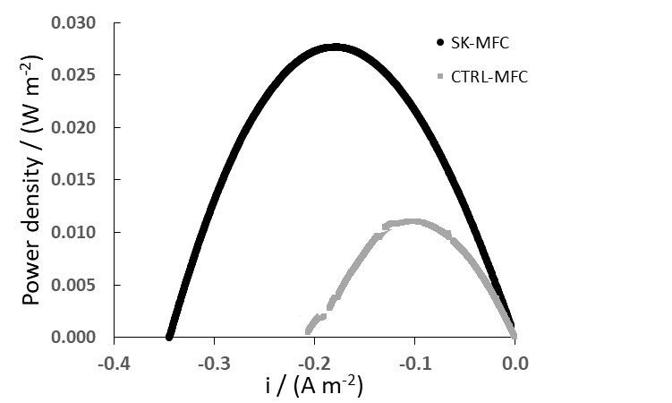
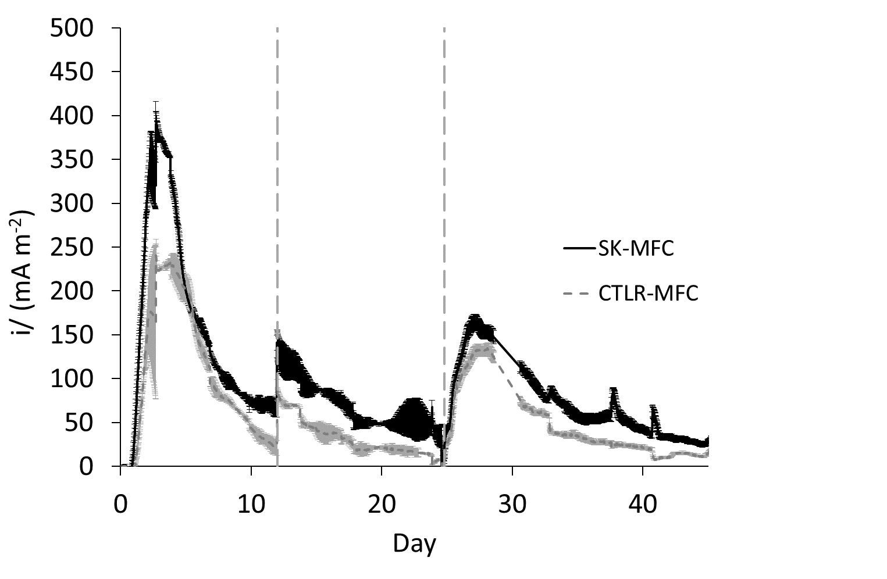
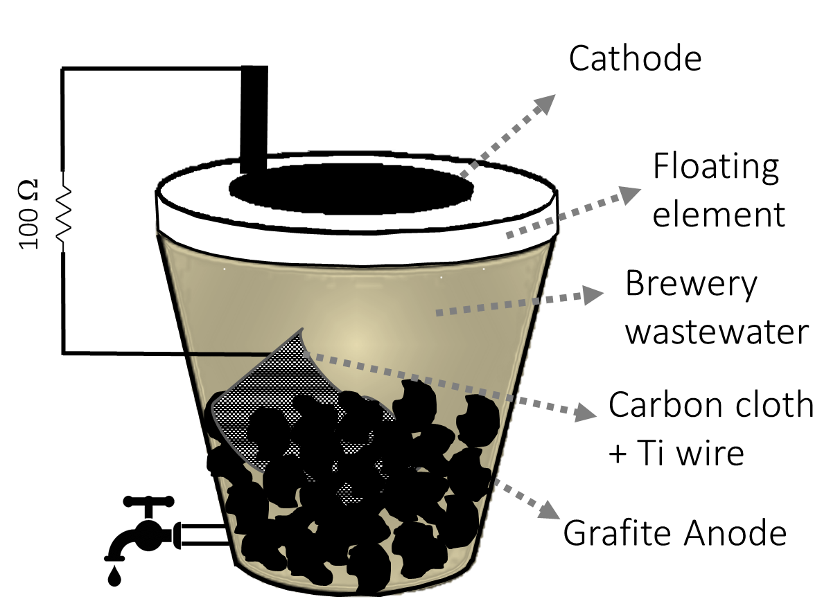
B)
C)
ACCLIM.
CYCLE 1
CYCLE 2
A)

Figure 1: A) Schematic representation of MFC set-up; B) Current densities trends, reported as average values of duplicates (error bars are reported for each point); C) Power curves (measured on the peak of current production during cycle 2).

In order to better assess any difference in the electrochemical performance among the two types of devices, the polarization curves were recorded during the best operative period of cycle 2 (i.e., when the highest current was detected for both cells). The derived power curves (Figure 1C and Table 1) detected a maximum power density of about 27.7 mW m⁻² for SK-MFC, a value almost 3 times higher than the maximum power density recorded for CTRL-MFC (Table 1). Interestingly, cells equipped with a silverskin-based cathode are able to efficiently work at current densities neatly higher than those of control MFCs, evidencing a faster electrode kinetics, more efficient mass transportation and, hence, lower overpotentials that result in lower energy dissipation and loose in performance. Despite the enhanced performance of silverskin-based MFCs, with respect to the control MFCs, they invariably resulted underperforming compared to other literature optimized systems (Li et al., 2021). According to Li and co-workers, significant challenges still need to overcome the poor electrocatalytic properties of biochars, as the very high energy barrier of the oxygen reduction reaction hinders the overall current production of the devices. However, through a wider viewpoint, an optimal electrode catalyst must possess not only electrocatalytic activity and electrical conductivity but also exhibit recyclable or reusable traits. Achieving these attributes means minimizing material cost and energy consumption during the manufacturing process (Li et al., 2021).
In order to characterize the organics remediation properties of each system, the real focus of this work, COD values were determined at the beginning and at the end of each operational stage.
Table 1 displays the COD removal for both cells in each cycle, demonstrating that the consumption of organic substrate occurred with high efficiency, in all cycles within about 10 days. At the end of cycle 2, COD removal resulted of 97±3 for SK-MFC and 99±2 for CTRL-MFC, respectively, with no significant differences among systems, contrary to the evident differences detected for the electrochemical key features of the devices. It could be inferred that a parallel pathway (bulk microbial degradation processes. i.e., fermentation) competes in yielding an almost complete organic removal together with the surface-mediated processes triggered by the electrophilic consortia of bacteria grown on the electrodes, in turn the only responsible for the current production.

Table 1: Results of monitored chemical and electrochemical parameters
MFC | COD REMOVAL (%) |  |  | POWER DENSITY (mW m⁻²)
 | ACCLIMATION | CYCLE 1 | CYCLE 2
SK-MFC | 100±2 | 69±5 | 97±3 | 27.7
CTRL-MFC | 100±3 | 72±2 | 99±2 | 10.9

HAP/biochar composites production
As a preliminary study, under the perspective view of a second generation MFCs, where the organics removal occurs parallel to inorganics remediation, silverskin-derived biochar had also served as the scaffold for fabricating biochar/hydroxyapatite composite materials with a 10 wt.% HAP content. The hydroxyapatite was precipitated from an aqueous solution containing Ca and P precursors, with biochar suspension serving as the medium for this process. The attachment and growth of hydroxyapatite onto the biochar surface were corroborated through X-Ray Powder Diffraction (XRPD) analysis. Indeed, the XRPD pattern of the composite material (Figure 2A) revealed distinctive reflections characteristic of crystalline HAP (JCPDS 00-064-0738). Additionally, the broad signal corresponding to biochar in the 2theta range of 20˚–30˚ was distinctly observed.
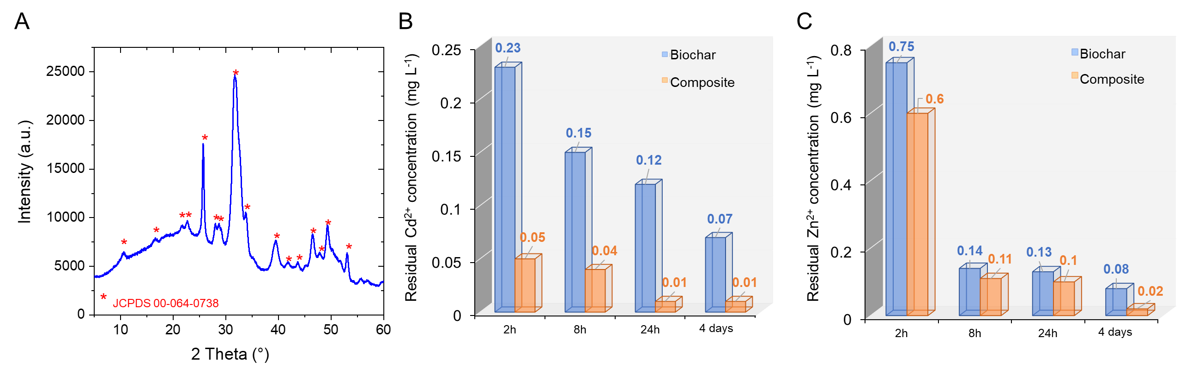
Figure 2: A) XRPD pattern of HAP/biochar composite. Results of adsorption tests on biochar- and composite-based sorbents for B) Cd(II) (initial concentration 1 mg L⁻¹) and C) Zn(II) (initial concentration 5 mg L⁻¹)
Before studying the performance of the composite as cathode in MFCs for the hybrid remediation of wastewater, the sorption ability of the composite toward Cd(II) and Zn(II) ions was evaluated ex situ, by means of static batch adsorption tests as a function of time. For comparative purpose, the sorption capacity of the silverskin-biochar was also studied independently, aiming to discern the potential added value brought by the inclusion of HAP in the composite. The obtained results on residual elements concentration in solution (Figure 2B and 2C) evidence that the presence of HAP in the composite material imparts significant improvements, especially in the case of Cd(II) contamination, as the heavy metal cations are almost entirely adsorbed (residual concentration < 10 ppb, Figure 2B) by the composite within just 24 hours. This outcome can be attributed to the fact that the Ca(II) ion, the constituent cation of HAP, has an ion radius very similar to that of Cd(II) (0.1nm and 0.095nm, respectively). The resemblance in their ionic radii facilitates the exchange of Ca(II) ions with Cd(II) ions, making the adsorption process thermodynamically favorable. For both ions, it is observed that, at the end of the 4-day period, the quantity of ions adsorbed by the composite material neatly surpasses that of biochar alone. After four days, biochar had adsorbed 98.4% of Zn(II) and 93% of Cd(II), while the composite with HAP adsorbed 99.6% and 99.9%, respectively. Based on these data, it is legitimate to assert that composites comprising silverskin-derived biochar and hydroxyapatite deserve in-depth investigation as cathodic materials in the field of microbial fuel cells, particularly for their application in the treatment of wastewater containing (potential) inorganic pollutants besides organic contaminants.
Conclusions
In summary, microbial fuel cell experiments revealed satisfying electrochemical performance, with the silverskin-based MFC consistently outperforming the control MFCs both in term of maximum power and current output, because of a reduction of undesired overpotentials. The observed high chemical oxygen demand (COD) removal efficiencies in both systems affirm their effectiveness in organic substrate consumption. Additionally, a very preliminary study disclosed the remarkable sorption capacities of silverskin-derived biochar/hydroxyapatite composites towards both Cd(II) and Zn(II) ions, a proof-of-concept for the development of a novel generation of MFC aimed at the simultaneous remediation of wastewater polluted by both inorganics and inorganics.
Acknowledgments
This study was carried out within the Agritech National Research Center and received funding from the European Union Next-GenerationEU (PIANO NAZIONALE DI RIPRESA E RESILIENZA (PNRR) – MISSIONE 4 COMPONENTE 2, INVESTIMENTO 1.4 – D.D. 1032 17/06/2022, CN00000022). This article reflects only the authors’ views and opinions, neither the European Union nor the European Commission can be considered responsible for them. M.M. e S.C. acknowledge the Italian Ministry of Education, University and Research (MIUR) and European Social Fund (ESF) for the PON 2014-2020 program, action IV.6 ‘Research contracts on green issues’ PON (DM 10/08/2021 n. 1062). The authors thank Ideal Caffè snc (Verderio) for providing the biomass.
References
Cantrell K.B., Hunt P.G., Uchimiya M., Novak J.M., Ro K.S., 2012, Impact of pyrolysis temperature and manure source on physicochemical characteristics of biochar, Bioresour. Technol., 107, 419–428.
Cui X.L., Zhong J., Li H.X., Jin R.Z., Liu Y., Che X.K., Yuan X.T., Zhang Q.D., Fu H., 2022, Influence of pyrolysis temperature on tea waste-based biochar property and function as a heavy metal sorbent in aqueous solution, J. Phys. Conf. Ser., 2256, 2501–2510.
Deng L., Yuan H., Cai X., Ruan Y., Zhou S., Chen Y., Yuan Y., 2016, Honeycomb-like hierarchical carbon derived from livestock sewage sludge as oxygen reduction reaction catalysts in microbial fuel cells, Int. J. Hydrogen Energy, 41, 22328–22336.
Ferri M., Campisi S., Polito L., Shen J., Gervasini A., 2021, Tuning the sorption ability of hydroxyapatite/carbon composites for the simultaneous remediation of wastewaters containing organic-inorganic pollutants, J. Hazard. Mater., 420, 126656.
Ferri M., Delafontaine L., Guo S., Asset T., Cristiani P., Campisi S., Gervasini A., Atanassov P., 2022, Steering Cu-Based CO2RR Electrocatalysts’ Selectivity: Effect of Hydroxyapatite Acid/Base Moieties in Promoting Formate Production, ACS Energy Lett., 7, 2304–2310.
Ghiara G., Campisi S., Goglio A., Formicola F., Balordi M., Gervasini A., Trasatti S.P.M., Adani F., Franzetti A., Cristiani P., 2023, Biochar based cathode enriched with hydroxyapatite and Cu nanoparticles boosting electromethanogenesis, Sustain. Energy Technol., Assessments 57, 103274.
Ibrahim M., Labaki M., Giraudon J.M., Lamonier J.F., 2020, Hydroxyapatite, a multifunctional material for air, water and soil pollution control: A review, J. Hazard. Mater., 383, 121139.
Kumar N., Weldon R., Lynam J.G., 2021, Hydrothermal carbonization of coffee silverskins, Biocatal. Agric. Biotechnol., 36, 102145.
Li S., Harris S., Anandhi A., Chen G., 2019, Predicting biochar properties and functions based on feedstock and pyrolysis temperature: A review and data syntheses, J. Clean. Prod., 215, 890–902.
Li S., Ho S.H., Hua T., Zhou Q., Li F., Tang J., 2021, Sustainable biochar as an electrocatalysts for the oxygen reduction reaction in microbial fuel cells, Green Energy Environ., 6, 644–659.
Logan B.E., Regan J.M., 2006, Electricity-producing bacterial communities in microbial fuel cells, Trends Microbiol., 14, 512–8.
Magni M., Sironi D., Ferri M., Trasatti S., Campisi S., Gervasini A., Papacchini M., Cristiani P., 2023, High-Content Hydroxyapatite Carbon Composites for the Electrochemical Detection of Heavy Metal Cations in Water, ChemElectroChem, 10, 1–10.
Marzorati S., Schievano A., Colombo A., Lucchini G., Cristiani P., 2018, Ligno-cellulosic materials as air-water separators in low-tech microbial fuel cells for nutrients recovery, J. Clean. Prod., 170.
Park W., Kim H., Park H., Choi S., Hong S.J., Bahk Y.M., 2021, Biochar as a low-cost, eco-friendly, and electrically conductive material for terahertz applications, Sci. Rep., 11, 1–8.
Roy S., Marzorati S., Schievano A., Pant D., 2017, Microbial Fuel Cells, in: Encyclopedia of Sustainable Technologies, Elsevier Inc., pp. 245–259.
Schievano A., Berenguer R., Goglio A., Bocchi S., Marzorati S., Rago L., Louro R.O., Paquete C.M., Esteve-Núñez A., 2019, Electroactive Biochar for Large-Scale Environmental Applications of Microbial Electrochemistry, ACS Sustain. Chem. Eng., 7, 18198–18212.
Williams K.H., Nevin K.P., Franks Englert, Long P.E., Lovley, D.R., 2010, Electrode-based approach for monitoring in situ microbial activity during subsurface bioremediation, Environ. Sci. Technol., 44, 47–54.

