CHEMICAL ENGINEERING TRANSACTIONS  VOL. , 2023 | A publication of
The Italian Association
of Chemical Engineering
Online at www.cetjournal.it

Guest Editors: Leonardo Tognotti, Rubens Maciel Filho, Viatcheslav Kafarov
Copyright © 2024, AIDIC Servizi S.r.l.
ISBN 979-12-81206-10-1; ISSN 2283-9216

Comprehensive Evaluation of Soursop Spirit Drinks: Distillation Conditions, Volatiles Compounds and Process Simulation
Luis J. López-Giraldo*, Hernando Amaya, Johana A. Alvarez, Javier H. Bedoya, Laura S. Sánchez.
Food Science and Technology Research Group- CICTA, School of Chemical Engineering- Industrial University of Santander, Bucaramanga, CO.
*ljlopez@uis.edu.co
In recent years, tropical fruit spirits, particularly those made from soursop, some fruit widely produced in Colombia, have gained popularity due to their exotic character and unique sweet and sour flavours. However, there is a lack of information on the operational conditions of distillation and the volatile compounds following fermentation and distillation at low temperatures. In addition, there is no record of process simulations that provide a comprehensive understanding of the process. Therefore, the objective of this study was to evaluate the distillation conditions of soursop ferments, specifically the influence of vacuum pressure and turning speed, in terms of productivity, alcohol content and volatile compounds, together with a simulation of the process using SuperPro Designer software. For this purpose, response surfaces obtained for each variable were used, which allowed studying the effects over each one. The presence of ethanol, methyl butane among others, was also found, highlighting compliance with the regulations for maximum limits of methanol in national regulations, analysed by solid phase microextraction (SPME) and later analysed by gas chromatography and liquid chromatography. Additionally, as an integral part of this study, a process simulation was developed, ranging from pretreatment to packaging, demonstrating the feasibility starting to NPV break point in 649 kg soursop/batch, producing distilled beverages with volatile compounds that add significant value, this thanks to the crucial inclusion of the yeast recovery process. These findings shed light on beverage development from both a quality and economic profitability perspective, providing valuable information for the tropical spirits industry.
  - Introduction
Soursop (Annona mirucata) is an amazon fruit unique flavour and aroma, rich volatile compounds, offered sensorial attractive and therapeutics (Santos et al., 2023). It fruits with shape defects, impact-related stains on the stylar tips, and sun-induced cracks exceeding 25% are categorized as second grade according to the quality standards outlined in the NTC 5208 standard. This grade is deemed suitable for both human consumption and as raw material in the agro-industrial sector. A significant challenge in soursop production is the imperative to minimize waste, with reports indicating that 30% of soursop goes unused during the post-harvest stage, as highlighted by the Ministry of Agriculture and DANE. Biotechnological processes have gained traction across various sectors of the food market, particularly due to their potential to achieve zero waste. Notably, the beverage sector is witnessing a sustained demand for sustainability and innovation (Rodriguez-Sanchez & Sellers-Rubio, 2021).

Despite its potential, research on the production process of distilled beverages from soursop remains limited. In 2022, Agudelo & Cancino focused on evaluating ethanol production using soursop juices, identifying juices as a substantial source of carbon due to the abundance of sugars, such as glucose and fructose. (Chacón & Robayo, 2023) further identified ammonium chloride as the inorganic nitrogen source favouring the growth of native yeast in soursop juices, defining the optimal C:N ratio for the fermentation process. Although various authors such as (Jagessar & Douglas, 2020) have successfully distilled ferments from soursop fruits, the operational conditions that ensure the quality of the distillates remain undetermined. In addition, studies characterising the volatile compounds of the distillates obtained are scarce. There is a notable lack of reports on studies simulating the production of such beverages to assess the technical-economic viability of the process. Considering these gaps, this work proposes to evaluate the distillation conditions suitable to produce soursop spirits from ferments produced with native yeasts in the Santander region. At the same time, a comprehensive study of the whole process will be carried out through simulation using SuperPro Designer.
  - Materials and methods
    - Preparation of Soursop and Fermentation conditions
Fruits were sourced from Lebrija, Santander, Colombia, with only fresh fruits meeting the technical standards outlined in NTC 5208 being selected. Under aseptic conditions, the pulp was separated, and subsequently, the juice was extracted by manually pressing canvas-type fabrics. The average yield of juice extraction was quantified for both processes. The juice underwent centrifugation at 7,000 rpm for 7 minutes to remove insoluble fiber and was subsequently sterilized at 121 °C for 15 minutes. Fermentable sugar content was analyzed using high-performance liquid chromatography (HPLC) with a Thermo Dionex Ultimate 3000 system equipped with an automatic injector, a refractive index detector, a degasser, and a COREGEL 107H column of 7.8 x 300 mm (8 μm) maintained in an oven at a constant temperature of 30 °C. Then the juice was diluted to 65 g/L with sterile water.

Native ethanol-producing yeast from the region were employed in the fermentation process, they registered under the access agreement to genetic resources and derivatives from Colombia, 303, were obtained from the cocoa fermentation boxes at the Experimental Farm Villa Mónica of Fedecacao. These strains are maintained in the culture collection of the Laboratory of Microbiology and Environmental Mutagenesis at the Industrial University of Santander, Colombia. Fermentations were conducted with a working volume of 0.5 L in 12 runs. Exhaustive inoculations were performed at 30°C for 48 hours, followed by inoculum utilization in a 1/10 ratio with volumes of 0.005 and 0.05 L, maintained at 30°C with agitation at 150 rpm for 12 h. Microbial growth was quantified using a Thermo Scientific Multiskan Go Spectrophotometer, and quantification of fermentable sugars and ethanol was performed through HPLC as previously mentioned at hours 0 and 12. Once ferments were obtained, they underwent a 10-minute ultrasonic bath treatment and were then subjected to a centrifugation process under the same conditions as described in section 2.1. This was done to preserve the properties present in the ferments.
    - Distillation Conditions and Characterization
An experimental design 2² was used in which each of the factors has two levels. Also, replicates of each of the combinations of the design with central point were applied to guarantee the linearity of the results. The factors used were vacuum pressure and rotational speed, with respective levels of 90 - 120 mbar and 0 – 6 RRU (Relative Rotary Units). Distillation processes were conducted using a Buchi Rotary evaporator R-210, controlling vacuum pressure, heat temperature, and cold bath. The operating temperature was set at 60°C, resulting in a volume of 50 mL. Alcoholic percentage (%ABV) was determined in accordance with NTC 5113. Both alcoholic content and productivity were considered as response variables. Productivity was calculated as the distilled volume over distillation time (L/h). ANOVA analysis was performed, and response surface methodology (RSM) was obtained for each variable using the statistical software Statistica 12.

The volatile compounds present in the distillate produced under optimal conditions were evaluated using solid-phase microextraction (SPME-HS). A silica fibber coated with 65 μm PDMS/DVB was utilized under the following conditions: 10 minutes of balance time, 30 minutes of extraction time at 60°C, 10 minutes of desorption time in the injection port at 250°C. Gas Chromatography with Mass Spectrometry detection (GC-MS) was performed using an Agilent 6890 coupled to a selective detector (MSD, AT 5973N) operating in full scan mode with a Split/Splitless SPME device. A DB-5MS (J & W Scientific, Folsom, CA, USA) column with 5%-Ph-PDMS, 60 m x 0.25 mm x 0.25 m dimensions was employed. The Adams, Wiley, and NIST databases were utilized for presumptive identification, and mass spectra (EI, 70 eV) of fragmentation patterns were acquired. Liquid chromatography equipment, as described in Section 2.1, was also employed to determine the concentrations of ethanol, methanol, and remaining fermentable sugars.
    - Simulation Process and Evaluation Economic
The process was simulated using SuperPro Designer ® 12 and was divided into three main phases as shown in Figure 1. The first phase is the extraction and conditioning of the must, where the fruit enters a storage tank, passes through the SP-101 press filter to separate the juice from the solids (approximately 60%), and the resulting liquid is mixed with an ammonium chloride solution at a 15:1 carbon to nitrogen ratio. It is then heat sterilized in ST-101. The second stage is fermentation and distillation, where the sterilized juice enters the FR-101 fermenter, is inoculated with native yeast, filtered to recover the yeast, and then dried with the RDR-101 rotary dryer to achieve a moisture content of less than 5%. Approximately 2.8% is recycled back into the process while the remainder is sold as a finished product. The filtered ferment is fed to the C-101 distiller, which is operated under the conditions selected in section 2.2. The distillate contains unused salts and minor compounds that could be used as a supplement for crops. The final stage is packaging and wrapping to produce a spirit. It passes through bottling in a standard 750ml presentation, followed by labelling and packing in cartons of 12 bottles.

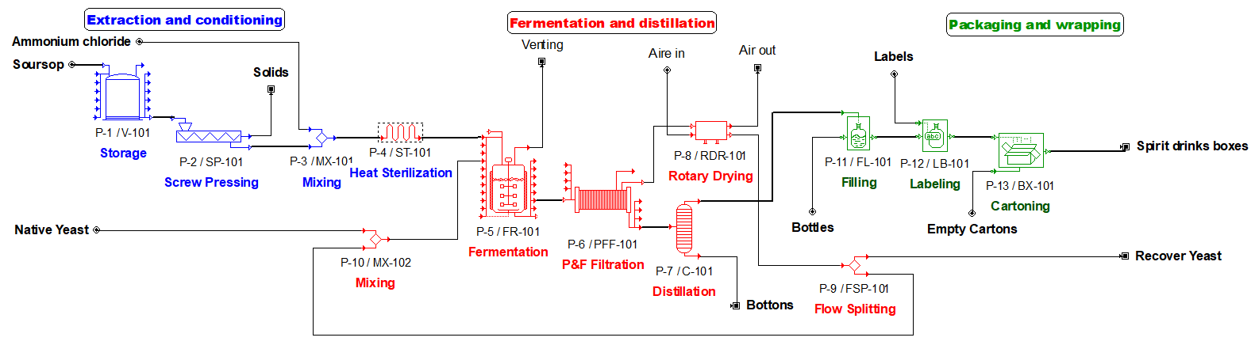
Figure 1: Simulation Process Flow Diagram using SuperPro Designer®.
Initially, one ton per batch of soursop with a sugar content of 150 g/L was used as the starting feedstock. The mass composition of soursop was simulated according to bromatological analysis (Agudelo & Cancino, 2022), as shown in Table 1 on the left. Processes and operating conditions (temperature, pressure, residence time, ratios, etc.) were considered based on the small-scale details outlined in sections 2.1 and 2.2. The results obtained from the simulator in terms of composition and concentrations were validated by experimental data, ensuring an error of less than 5%. The costs of raw materials and labor, as well as prices of sale products, taken for the simulation are shown in Table 1 on the right, it was adjusted to suppose production and sale in Colombia. The economic evaluation was conducted using SuperPro Designer's cost model (Petrides et al., 2008). Unit purchase costs were estimated based on cost correlations within the system by 2023-year. Capital investment was derived from total equipment acquisition costs using a distributed set of factors by default for direct, indirect, contractor, and contingency costs. Operative costs were calculated for each equipment piece. Profitability analysis, considered a 15-year project life and 30-month construction period, included NPV calculation at an 8% interest rate with income taxes. Economic parameters like Internal Rate of Return (IRR) and Payback Period (PRI) were also estimated simulator. Sensitivity analysis determined the breakeven point (BP) by varying feedstock quantity in the simulation and drawing key economic parameters.
Table 1: Composition feedstock and simulation prices evaluated.
Composition feedstock | % | Classification | Description | Cost [USD$/kg]
Seed | 1.74 | Raw material | Soursop | 0.5
Insoluble fiber | 31.26 | Raw material | Ammonium Chloride | 65.57
Water | 51.15 | Raw material | Native yeast | 155
Glucose | 9.38 | Products | Dry yeast recovered | 77.5
Protein | 0.38 | Products | Solids (fiber, seeds) | 0.04
Minerals | 0.25 | Products | Spirit drink x12 | 247.5*
Soluble fiber | 0.84 | Others Cost | Labor-Dependent | Cost [USD$/h]
Total | 100 | Others Cost | Labor | 2.52
*Price per cartons with 12 bottles of 750 mL, standard presentation.
  - Results
    - Fermentation conditions
The average composition of soursop revealed the following distribution: 59.8% juice, 27.8% insoluble fiber, 10.6% shell, 1.6% seed, with an average yield extraction of 34 L/100 kg. The concentration of fermentable sugars averaged 150.64 ± 13.03 g/L. In the fermentation process, the yield of the product relative to the substrate (Yps) was determined to be 29.9 ± 2.8 g/g, slightly lower than the 31.3% reported by (Chacón & Robayo, 2023) under similar conditions. The yield of biomass relative to the substrate (Yxs) was found to be 26.2 ± 2.2% g/g. These results, along with the C:N ratio, were utilized to estimate stoichiometric coefficients describing the fermentation with native yeast, as represented by Equation 1. The fermented must achieved an alcohol by volume (ABV) content of 10.7%, comparable to the 11% ABV obtained by Okigbo & Obire (2009) using the same carbon source and commercial yeast over a 10-day period.

$C_{6}H_{12}O_{6}+0,4NH_{4}→ {2CH}_{1,8}O_{0,5}N_{0,2}+1,65CO_{2}+0,52H_{2}O+1,18C_{2}H_{5}OH$ (1)
    - Distillation Conditions and Characterization
Table 2 illustrates an average alcohol by volume of 15 %ABV, accompanied by a productivity of 0.15 L/h. This productivity is markedly lower than the 52 % ABV reported by Vasquez & Sánchez (2019), achieved through simple distillation at 78.4°C from soursop fermented at 7.1 %ABV. The difference can be attributed to varying conditions. The primary aim of employing reduced pressure conditions was to retain the maximum number of volatile compounds in the final beverage.
Table 2: Results experimental design.
Reduced pression [mBar] | Rotation speed [RRU] | %ABV | Productivity [L/h].
90 | 0 | 15.8 | 0.0539
90 | 6 | 12.5 | 0.2765
120 | 0 | 18.7 | 0.0246
120 | 6 | 14.5 | 0.1743
105 | 4 | 13.3 | 0.1997

Moreover, both response variables displayed an inverse relationship, as depicted in Figure 2. In general, higher rotation rates and pressures positively impacted productivity, while a higher %ABV was favored under lower pressure conditions without rotation. This phenomenon is likely explained by the phase balance diagram, where maintaining a consistent temperature while reducing pressure results in a lower boiling point of water. This facilitates vaporization, leading to increased productivity but decreased %ABV.
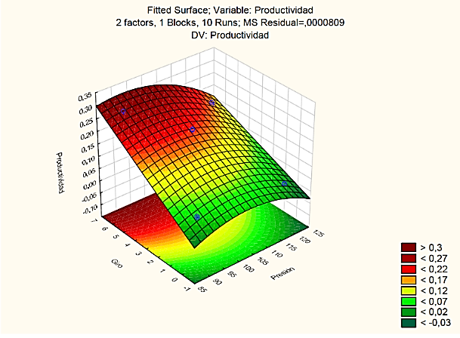
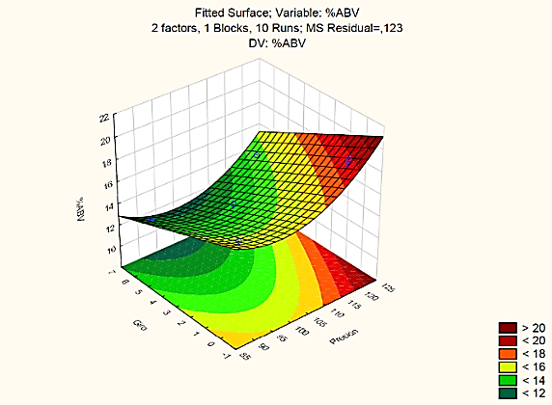
However, maximizing these variables posed a challenge due to the low %ABV obtained. The conditions necessary for achieving distillation and a productivity of 0.1743 L/h were identified as 120 mbar and 6 RRU, meeting the minimum requirement for classification as a spirit beverage (15 %ABV) in compliance with CE regulations.
a.
b.
Figure 2: Response surface for a) Productivity and b) %ABV.
The volatile profile of duplicated samples under the selected distillation conditions was determined. Table 3 presents the compounds identified using the chromatographic conditions. Ethanol was the predominant component, constituting 97.4% of the total. Methyl butanol followed with 2.4%, a compound previously identified in various distilled beverages such as mezcals (Vera et al., 2009), tequilas (Ceballos, 2007), and piscos (Garrido et al., 2008). Additionally, 2,4-di-tert-butylphenol was identified at 0.2%, a compound utilized in fragrance and pharmaceutical manufacturing (Delgado, 2016). It is noteworthy that this compound was identified as the most abundant among phenols in various wines by Minig (2015).

The chromatogram revealed four minor peaks that could not be identified; these may include isopropanol, n-propanol, and amyl alcohol, as previously found by Vasquez & Sanchez (2019) in soursop distillates. Regarding methanol content, the distilled product exhibited a concentration of 41.53 ± 3.06 mg/dm³, well within the maximum permissible limit of 300 mg/dm³ according to NTC 410, NTC 305, and CE regulations for spirit drinks and vodkas.
Table 3: Identify compounds on the volatile fraction of soursop distilled.
Tentative identification | t_{R}, min | Relative quantity
Ethanol | 3.6 | 97.4
Methyl-butanol | 7.0 | 2.4
2,4-di-di-tert-butylphenol | 36.8 | 0.2
    - Simulation Process and Economic Evaluation
Given the high sugar content in soursop, an initial concentration of 150 g/L was chosen for simulation, utilizing Equation (1) for the fermenter. According to stoichiometry, a 31.1 % ABV was achieved after undergoing the distillation process, leading to a higher market value. Based on the simulation outcomes, the BP for NPV was identified at 649 kg/batch of feedstock, marking the threshold for potential profitability, as illustrated in Figure 3 (a). In this case, the executive summary and economic parameters estimated by the system were taken, as detailed in Table 4, revealing a total capital investment close to 8 million USD, a gross margin of 69.98%, a PRI of 9.11 years, and an IRR of 6.99%.

It is noteworthy that, revenues from the main product, spirit drink, closely align with those obtained from other products such as native yeast recovery, fiber, and seeds. Additionally, the system provided a breakdown of operating costs, as shown in Figure 3 (b), where raw material costs are the predominant annual operating expense, constituting 77% of the total. Specifically, costs associated with native yeast and ammonium chloride play a significant role. To enhance the process's profitability, it is crucial to recover and treat yeast for sale and explore alternative uses for distilled funds containing unused salts.

Figure 3: a) Sensitivity analysis reached break point NVP and other economic parameters; b) Annual operating cost breakdown (%). Note: Total Revenues (TR), Annual Operating Cost (AOC), Capital Investment (Invest.).
Table 4: Executive summary and economic parameters for case in NPV = 0.
Executive Summary | Value | Economic Parameters | Value
Total Capital Investment | 7’794,000 $ | Net Unit Production Cost | 145.43 $/ MP Entity
Operating Cost | 408,000 $/year | Unit Production Revenues | 484.47 $/ MP Entity
Main Revenues | 694,000 $/year | Gross Margin | 69.98 %
Other Revenues | 664,000 $/year | Return On Investment | 10.98%
Total Revenues | 1’359,000 $/year | Payback Time | 9.11 years
Batch Size | 6.64 MP Entities | IRR (After Taxes) | 6.99 %
Cost Basis Annual Rate | 2,804 MP Entities/year | NPV (at 7%, Interest) | 0 $
MP = Flow of discrete entity main product (Boxes with 12 bottles).
  - Conclusions
A remarkable inverse relationship between productivity and % ABV was observed in the distillation process. Optimal conditions were identified at 6 RRU and 120 mbar, resulting in 0.18 L/h and 15% ABV, meeting the minimum requirements for classification as a spirit drink with acceptable productivity. Volatile compound characterization of the distilled product revealed the presence of methyl butane and 2,4-di-tert-butylphenol, substances also identified in other alcoholic beverages such as tequilas, mezcals, wines and piscos, contributing to their aromatic profiles. Methanol levels were well below safe limits for human consumption.
The simulation process carried out by SuperPro Designer used a starting concentration of 150g/l, which resulted in an alcoholic beverage of 31.1% ABV after processing. The breakeven point, where the net present value is zero, was determined to be 649 kg/batch of soursop feedstock. Economically, the recovery of native yeast proved to be critical, highlighting the potential for multiple product streams to make the whole process economically viable, especially given the high cost of the feedstock. These results provide valuable insights for the tropical spirits industry.
Nomenclature
NPV - Net Present Value
IRR - Internal Rate of Return
PRI - Payback Period
MP - Main Product
AOC - Annual Operating Cost
TR - Total Revenues
BP - Breakeven Point
Invest. - Capital Investment
Acknowledgments
The authors express them sincerely to Centre for Research in Food Science and Technology (CICTA) for technical support in chemical analyses. Likewise, for the farmers of Vereda Puyana, Lebrija, Santander, Colombia, for providing the fruits used.
Referencies
Agudelo Forero, J. S., & Cancino Laguado, K. D. 2022. Evaluation of ethanol production using Santander native yeasts from soursop leachate (in Spanish). Degree Thesis. Industrial University of Santander. Bucaramanga, CO.
Ceballos, S. G., 2007. Analytical characterization of Agave Tequilana distillates using multivariate analysis techniques (in Spanish). Dissertation, Sevilla University, Sevilla, ES.
Chacón, B. S., & Robayo, J. V., 2023. Identification of the Effect of Scale Change in the Soursop Leachate Fermentation Process on the Ethanol Yield using Santander Native Yeasts (in Spanish). Industrial University of Santander. Bucaramanga, CO.
Delgado, I. S., 2016. Analysis of fragrances in water by advanced chromatography techniques. Dissertation, Sevilla University, Sevilla, ES.
Garrido, A., Linares, T., & Cárdenas, L., 2008. Study of the composition of pisco from different varieties of pisco grapes from the must to the product (in Spanish). Peruvian Journal of Chemical Engineering, 11, 58–60. PE
Jagessar, R. C., & Douglas, L., 2020. The Fermentation of Sugar Rich Fruits: jamun (Syzigium Cumini), soursop (Annona Muricata), and papaya (Carica Papaya), with and without additives, to produce optimum ethanol yield for commercial purposes, Vol. 8, Issue 3, Georgetown, GF, 1–37.
Minig, P. M., 2015. Microbial Enzyme Eystems with Application in Industrial Food Biotransformation, Dissertation, National University of Río Cuarto, Río Cuarto, AR.
Okigbo, R. N., & Obire, O., 2009. Mycoflora and production of wine from fruits of soursop (Annona muricata L.). International Journal of Wine Research, 1, 1–9. Anambra, NG.
Petrides, D., Siletti, C., & Pal, N. 2008. SuperPro Designer: An Interactive Software Tool for Designing and Evaluating Integrated Chemical, Biochemical, and Environmental Processes.
Rodriguez-Sanchez, C., & Sellers-Rubio, R., 2021. Sustainability in the beverage industry: A research agenda from the demand side. Sustainability,13, 1–10. Alicante, ES.
Santos, I. L., Rodrigues, A. M. da C., Amante, E. R., & Silva, L. H. M. da., 2023. Soursop (Annona muricata) Properties and Perspectives for Integral Valorisation. Foods, 12, 14-48. Pará, BR.
Vera, A. M., Santiago, P. A., & López, M. G., 2009. Volatile aromatic compounds generated during the production of mezcal from Agave angustifolia and Agave potatorum (in Spanish). Fitotec, 32, 273-279. Irapuato, MX.
Vasquez, J. W., & Sanchez, M. E., 2019. Evaluation of the yield and quality of ethyl alcohol produced from the fermentation of soursop (Annona Muricata l.) with saccharomyces cerevisiae (in Spanish). University of Guayaquil Faculty of Chemical Engineering, Guayaquil, EC.

