CHEMICAL ENGINEERING TRANSACTIONS  VOL. , 2023 | A publication of
The Italian Association
of Chemical Engineering
Online at www.cetjournal.it

Guest Editors:
Copyright © 2023, AIDIC Servizi S.r.l.
ISBN 979-12-81206-XX-X; ISSN 2283-9216

Novel High Performance Catalyst for Complete and Energy- Efficient Tar Reforming in Biomass Derived Syngas
Manfred Nackenª*, Alessandro A. Papa^{b}, Andrea Di Carlo^{b}
ªC&CS catalysts and chemical specialties GmbH, Georg-Wimmer-Ring 25, D-85604 Zorneding, Germany
^{b}Dipartimento di Ingegneria Industriale dell’Informazione e di Economia, Università degli Studi dell’Aquila, Piazzale E.
Pontieri 1, Monteluco di Roio, 67,100 L’Aquila, Italy]
manfred.nacken@candcs.de
In hot gas cleaning of biomass gasification gas conversion results of a fixed bed MgO-NiO catalyst tested in a simulated biomass gasification gas at a naphthalene inlet content of 5 g / Nm³ in the presence of 100 ppmv H₂S have shown so far, that catalytic filtration is feasible, if a temperature of 800°C and a space velocity of 3054 or 3207 h⁻¹, respectively, is applied by integrating the catalyst in the cylindrical hollow space of a hot gas filter candle. In this work a novel patented tar reforming catalyst C&CS #1050 B is presented that exhibits a distinctly superior catalytic performance in direct comparison at a total model tar content of 13 g / Nm³. Complete conversion at a space velocity of 6000 h⁻¹ from 750°C down to 650°C was measured because of its more than 4-fold higher NiO density in a fixed bed compared to the MgO-NiO catalyst and its approx. 3.5 – 4.5 times higher BET surface area compared to typical commercial steam reforming catalysts. Due to its 21-fold higher NiO density compared to a catalyst integrated in a filter candle as catalytic layer, fixed bed based catalytic filter candles are superior to candles of catalytic layer design. Based on the evidence of 99% model tar conversion at 750°C also at a content of 4.9 g / Nm³ naphthalene and 9.3 g / Nm³ toluene of a C&CS #1050 B filled candle of 60 mm outer diameter complete real tar abatement with a capacity of 13 g / Nm³ is estimated at this temperature allowing a more energy-efficient hot gas filtration and enlarging the applicability of catalytic hot gas filters to higher tar inlet contents.
  - Introduction
According to the European Green Deal (European Commission, 2019) CO₂ emissions are to be reduced by 50-55% up to 2030 compared to 1990 and zero netto CO₂ emissions are to be achieved up to 2050. To meet these climate protection targets the use of locally available biomass for the production of energy and fuels is necessary. Gasification of biomass is the most important thermo-chemical route to convert the renewable source into syngas. For a commercial breakthrough of this thermo-chemical process reduction of tar formation in the gasification process and highly efficient tar abatement in the syngas is a prerequisite to use the syngas in downstream applications and to prevent pipeline fouling and catalyst deactivation (Cortazar et al., 2023), e.g. in fuel cells. Catalytic filtration was indicated as a promising hot gas cleaning method to eliminate tars and particles as it allows process intensification (Aravind and de Jong, 2012). The use of a catalytic filter, where the reforming catalyst is integrated downstream of the particle separating membrane in the hot gas filter element, allows a more energy efficient process by directly using the high temperature of the gasification gas for the endothermic tar steam reforming reaction leading to an increased gas yield. An increase of the gas yield due to the conversion of the tar compounds was already found in catalytic tar steam reforming tests of different Nickel based commercial steam reforming catalysts by use of a fixed bed reactor placed after a guard bed of dolomite downstream of a BFB gasifier (Caballero et al., 1997). For operation of a catalytic tar reforming fixed bed reactor it was recommended to reduce the inlet content of tars to a content below 2 g/Nm³ and to operate the fixed bed reactor in the temperature frame between 780 – 830 °C to prevent its deactivation by carbon deposition [Aznar et al., 1998 ]. A detailed examination of the catalytic activity of a developed fixed bed Nickel based reforming catalyst in model tar reforming in a simulated biomass gasification gas with a naphthalene inlet content of 5 g / Nm³ in the presence of 100 ppmv H₂S has shown the feasibility of catalytic filtration, if the fixed bed catalyst is integrated in the cylindrical hollow space of a hot gas filter candle with an outer diameter / inner diameter of 40/20 mm (Nacken et al., 2007) or 50/30 mm (Nacken et al., 2010), respectively. In these catalytic filter candles the integrated fixed bed catalyst is to be operated at a relatively high temperature of 800°C at a space velocity of 3054 or 3207 h⁻¹, respectively. In this work a novel tar reforming catalyst C&CS #1050 B with a distinctly superior catalytic performance for use as fixed bed catalyst in a hot gas filter element is presented to enlarge the applicability of a distinctly improved tar reforming catalytic filter for a multiplicity of different gasification processes using different feedstocks, bed materials and gasifying agents.
  - Experimental
The novel tar reforming catalyst C&CS #1050 B was prepared based on an inventive catalyst production method that was developed at C&CS catalysts and chemical specialties GmbH within the scope of the European project “Advanced membranes and membrane assisted processes for pre- and post-combustion CO₂ capturre (CE project MEMBER, 2022) to provide a highly active fluidizable steam reforming catalyst for the sorption enhanced steam reforming process (SER) of natural gas or methane, respectively. Accordingly, a suitable MgO-Al₂O₃ hydroxy carbonate precursor was chemically modified by an Al₂O₃ precursor to obtain after dyring and calcination a high surface area mixed oxide raw support material of which a suitable grain fraction was sieved out to obtain after catalytic activation by incipient wetness impregnation by a NiO precursor the MgO-Al₂O₃-NiO catalyst raw material. A more detailed description of the preparation process is given in the corresponding granted European patent EP 3805149. From the catalyst raw material a 0.25 – 0.5 mm fraction was sieved out to obtain the fixed bed catalyst C&CS #1050 B with a MgO content of > 40 %, an Al₂O₃ content of < 30 % and a NiO content of 31% (s. Figure 1, right), that is mechanically stable and, therefore, is suitable to be used as catalyst filling in the hollow cylindrical space of a hot gas filter candle of the two fixed bed types FB60 and FB70 sketched in Figure 1. For direct comparison, an alternative catalytic layer based catalytic filter element type denoted CL60, that was already described and tested (Rapagnà et al., 2012), is also displayed in Figure 1.

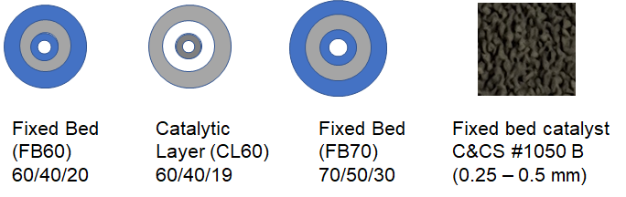
Figure 1: Cross section of two fixed bed (FB) types and one catalytic layer (CL) type of cylindrical catalytic filter elements (blue: ceramic filter element support, grey: catalyst filling / catalytic layer on filter support, white: empty space; 60/40/20: candle outer diameter / candle inner diameter / inner tube outer diameter in mm) as well as high-resolution picture of the catalyst C&CS #1050 B
Using the novel catalyst C&CS #1050 B as fixed bed catalyst filling in the filter candles of fixed bed design FB60 and FB70, the novel catalytic filter candles FB60N and FB70N are obtained (s. Table 1). The exact dimensions of these novel catalytic filter candles concerning their structure, chemical composition of the catalyst filling, their filtration characteristics, operating conditions, total catalyst surface areas and NiO densities are listed in Table 1. For direct comparison, a catalytic filter candle of the design FB60 filled with a MgO-NiO based fixed bed catalyst already described and tested (Nacken et al., 2007) as well as a catalytic filter candle of the design CL60 with two MgO-Al₂O₃-NiO based catalytic layers already described and tested by Rapagnà et al, 2012 are also characterized. In case of the integrated MgO-NiO based fixed bed catalyst a shipping density of 1 g / ml was assumed. The catalyst C&CS #1050 B exhibits a shipping density of 0.7985 g / ml.
The catalytic performance of the novel catalyst C&CS #1050 B in steam reforming of the model tars naphthalene and toluene with a content of 3.60 g / Nm³ or 9.69 g / Nm³, respectively, was measured in the temperature range between 650°C - 750°C in a fixed bed reactor of 16 mm inner diameter and 0.5 m height at the University of l’ Aquila. A mass flow controller was used to feed N₂ as carrier gas mixed with steam and a tar solution of naphthalene in toluene vaporized at 220°C. In addition, an appropriate amount of thiophene was added to N₂ containing 30% steam to adjust after complete conversion a content of 100 ppmv H₂S in order to simulate a model biomass gasification gas. A glass double pipe condenser was used to condense water and the condensable hydrocarbons at 0°C from the product stream using ethylene glycol as cooling liquid. The overall mass flow rate of the dried outlet stream stream was measured by a mass flow controller. An online gas analyzer from ABB was used to determine the percentage of CO, CO₂, CH₄ and H₂ in the outlet stream. Further details about the experimental apparatus are reported by Savuto et al., 2019. From the knowledge of the molar flowrates of CO and CO₂ in the outlet stream the value of the tar conversion was obtained as result of the sum of these flow rates divided by the molar flow rate of the carbons of the injected tar compounds at the inlet.
  - Results and discussion
In a BET surface area examination of the novel C&CS #1050 B a specific surface area of 58.3 m²/g was found that is 3.9 fold higher compared to the average value of surface areas of typical MgO-Al₂O₃ or CaO-Al₂O₃ supported Nickel steam reforming catalysts of 10 – 20 m²g (Lloyd, 2011).
Naphthalene conversion tests of the MgO-Al₂O₃-NiO based catalyst C&CS #1050 B in a N₂ carrier gas containing 30 vol % H₂O in the presence of 100 ppmv H₂S and at a naphthalene inlet content of 3.60 g / Nm³ as well as a toluene inlet content of 9.69 g / Nm³ have shown that also in the lower temperature range at 750 °C, 700 °C and rather at 650 °C complete naphthalene conversion is achieved (Figure 2 and Table 2). In addition, toluene is also completely converted. In contrast to that, the described MgO-NiO fixed bed catalyst used as reference catalyst in Figure 2 exhibited at a naphthalene content of 5 g / Nm³ at 750°C and 700°C in the presence of 100 ppmv H₂S only a conversion of 85 % and 40 %, respectively, in a simulated biomass gasification (Nacken et al, 2007).
Table 1: Characterisation of catalytic filter candles of different design
Design | Fixed bed | Catalytic  layer | Fixed bed | Fixed bed
Notation | FB60_MgNi | CL60_  MgAlNi  (2 CL) | FB60N | FB70N
OD/ID  candle / | 60/40/20 | 60/40/16 | 60/40/20 | 70/50/30
OD tube

Catalyst  filling /  layer  Catalyst  name | MgO-NiO  - – 0.3  mm)  n. a. | MgO-Al₂O₃-NiO + MgO-Al₂O₃-NiO  n. a. | MgO- Al₂O₃-NiO (0.25 – 0.5 mm)  C&CS  # 1050 B | MgO- Al₂O₃-NiO (0.25 – 0.5 mm)  C&CS  # 1050 B
Effective  filtration  length [mm] | 398  (Rapagnà  et al., 2010) | 381  (Rapagnà  et al., 2012) | 398 | 398
ID of tube | 10 - 12 | 9 | 10 - 12 | 20 - 22
[mm] | assumed |  | assumed | assumed
Filter area  [m²] | 0.0750 | 0.0718 | 0.0750 | 0.0875
Operating  temperature  [°C] | 811.8 | 811.3 | 650 – 800  (tar content dependent) | 650 – 800  (tar content dependent)
NiO density  [g/ml] | 0.0566  (based on Nacken et  al., 2007) | 0.0118  (based on Nacken et  al., 2012) | 0.2509 | 0.2509
Total catalyst | 732 | 807 | 17461 | 23282
surface area
/ candle [m²]
Moreover, the achieved complete naphthalene conversions of C&CS #1050 B were measured at a distinctly higher GHSV value of 6000 h⁻¹. The naphthalene conversions of the MgO supported NiO catalyst were measured at a GHSV value of only 2080 h⁻¹. This substantial improvement in the catalytic tar reforming performance is due to the more than fourfold higher NiO density of C&CS #1050 B compared to the density of only 0.0566 g/ml of the MgO supported NiO catalyst (s. Table 1). In addition, the novel tar reforming catalyst C&CS #1050 B exhibits a 29.9 fold higher BET surface area than the measured BET surface area of the MgO-NiO catalyst. The high surtace area of C&CS #1050 was generated on the basis of a synthesized high surface area support by impregnating the porous support with a high NiO amount at a high dispersion to still maintain a relatively high surface area at high temperature responsible for the observed high performance of this catalyst.

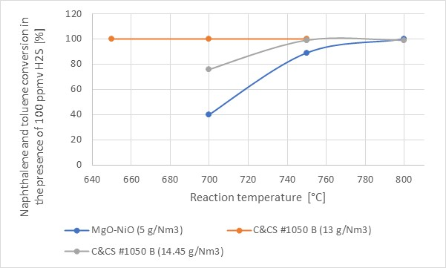
Figure 2: Catalytic performance of C&CS #1050 B at a content of 3.60 g / Nm³ naphthalene, 9.69 g / Nm³ toluene and 0.406 g / Nm³ thiophene as well as at a content of 4.87 g / Nm³ naphthalene, 9.25 g / Nm³ toluene and 0.383 g / Nm³ thiophene versus a MgO-NiO catalyst at a naphthalene content of 5 g/Nm³ (Nacken et al., 2007)
Table 2: Gas composition after tar reforming with C&CS #1050 B at two tar inlet contents
Tempe-  rature [°C] | 650 | 700 | 750 | 650 | 750 | 800
C-inlet flow  [10⁻⁴ mol/min] | 5.1909 | 5.1909 | 5.1909 | 3.087 | 3.087 | 5.7309
C-outlet flow  [10⁻⁴ mol/min]  CO₂ content  In outlet [%] | 5.1970  97.360 | 5.2112  98.440 | 5.1920  97.285 | 2.3330  58.310 | 3.0440  77.100 | 5.6800  78.760
CO content  In outlet [%] | 2.640 | 1.560 | 2.735 | 17.270 | 21.510 | 21.240

The obtained novel catalytic filter candle FB60N after filling of the hollow-cylindrical space of a hot gas filter candle of design FB60 with an effective filtration length of 398 mm exhibits a total catalyst surface area of 17691 m² being 23.9 fold higher than that of the tested catalytic filter candle FB60 with the MgO-NiO catalyst (Rapagnà et al., 2010) and 21.6 fold higher than a catalytic filter candle of catalytic layer design CL60 described by Rapagnà et al., 2012 (s. Figure 3). Based on the surface area value of this type of catalytic filter candle with a filtration length of 381 mm (s. Table 1) the appropriate surface area of a candle with a filtration length of 398 mm would exhibit a value of 843 m². Compared to this catalytic layer based candle the novel catalytic filter candle FB60N would exhibit a 20.7 fold higher surface area. This large increase in the catalyst surface area of the novel catalytic filter candle FB60N indicates that the catalytic performance of a fixed bed candle with the integrated catalyst C&CS #1050 B is superior to the catalytic filter candle of catalytic layer design. Moreover, due to the measured complete tar conversions at a total tar model compound content of 13.3 g / Nm³ in the relatively low temperature range from 750 °C over 700 °C down to 650 °C and at a relatively high gas hourly space velocity of 6000 h⁻¹, low temperature tar steam reforming is potentially feasible, even if the complete conversions were measured on model tar compounds. The high content of CO₂ in the product gas after complete tar steam reforming also indicates a high water gas shift activity of the catalyst (Table 2). Furthermore, the applied gas hourly space velocity allows a higher filtration velocity of 112.4 m/h at 750 °C instead of the filtration velocity of 87 m/h adjusted at the catalytic filter candle CL60 (s. Figure 3). This distinct improvement versus the gained results in real biomass tar steam reforming so far (Rapagnà et al. 2010 and 2012) would lead to a more energy-efficient catalytic filtration and would lead to reduced costs for a catalytic filter, as the filter size can be reduced by 22.6 %. If the novel catalyst C&CS #1050 B is filled in the filter candle of the design FB70 the catalytic performance of the obtained novel catalytic filter candle FB70N can be further improved by an 33.3 % increase of the total catalyst surface area to 23282 m².

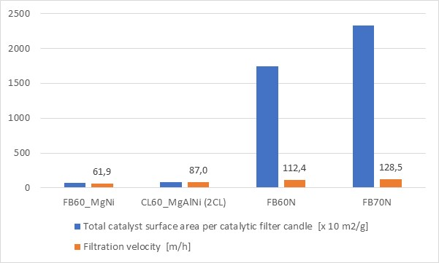
Figure 3: Total catalyst surface area of FB60_MgNi, CL60_MgAlNi (2 CL) and of the two novel C&CS #1050 B filled catalytic filter candles FB60N and FB70N and the corresponding filtration velocities at 750 °C
Due to the higher catalyst volume in this candle and applying the same gas hourly space velocity of 6000 h⁻¹, an even higher filtration velocity of 128.5 m/h at 750°C can be realized with this novel catalytic filter candle design that is recommended to disctinctly reduce the size and costs of an energy-efficient catalytic filter.

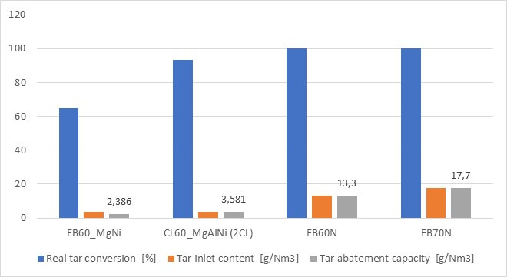
Figure 4: Estimated real tar conversion at 750°C at different tar inlet contents and the tar abatement capacity of FB60N and FB70N compared to the corresponding of FB60_MgNi and CL60_MgAlNi (2 CL)
For an estimation of the real tar conversions of the novel catalytic filter candles FB60N and FB70N in comparison to the tested candles FB60 and CL60 in the freeboard of a biomass fluidized bed gasifier that have shown real tar conversions of 65 % or 90%, respectively (Rapagnà et al. 2010 and 2012), the appropriate total model tar conversion at a naphthalene content of 3.60 g / Nm³ and toluene content of 9.69 g / Nm³ in the temperature range from 650 – 750°C as well as at a naphthalene content of 4.87 g / Nm³ and a toluene content of 9.25 g / Nm³ at 750°C (s. Figure 2 and Table 2) were used as basis. In addition, the total catalyst surface area of candle FB60N and FB70N (s. Figure 3) were considered in this estimation (Figure 4). Accordingly, based on the found complete tar conversion at a tar inlet content of 13.3 g / Nm³ and the measured 99 % tar conversion at a higher tar inlet content of 14.1 g / Nm³ using the catalyst C&CS #1050 B at 750°C, in a conservative approximation, it is assumed that due to the 23.9 fold higher catalyst surface area of FB60N compared to FB60 the real tar abatement capacity is at least as high as the measured complete total model tar conversion of 13.3 g / Nm³ at 750°C. In case of the recommended novel catalytic filter candle FB70N with a further increased catalyst surface area by 33.3 %, the maximum real tar abatement capacity of FB70 N was estimated to be 17.7 g / Nm³ at 750 °C, if the candle is operated at a filtration velocity of 96.4 m/h corresponding to a 25% lower GHSV value compared to the catalytic filter candle FB60N. The estimated real tar abatement capacity of the novel catalytic filter candle FB60N with a standard outer diameter of 60 mm presents already a 3.7 fold increase compared to the tar abatement capacity of the tested most active catalytic filter CL60 so far. This distinct increase in the real tar abatement capacity of a catalytic filter candle with the novel catalyst C&CS #1050 B needs to be confirmed by future real tar conversion tests in biomass gasification test rigs for a further enlargement of the applicability of catalytic hot gas filter cleaning to more different gasification processes with higher tar inlet contents. Furthermore, appropriate model tar examinations in the lower temperature range of 700 and 650°C at a higher naphthalene content than 3.60 g / Nm³ and a comparable toluene content of 9.69 g / Nm³ are to be performed at a lower gas hourly space velocity in future work to estimate the corresponding real tar abatement capacity at 700°C and 650°C with respect to the potential of realizing low temperature tar reforming.
  - Conclusions
Complete model tar conversions of the novel Nickel catalyst C&CS #1050 B in the temperature range between 650 – 750 °C at a gas hourly space velocity of 6000 h⁻¹ in the presence of 13 g / Nm³ model tars and 100 ppmv H₂S in a simulated biomass gasification gas have shown its suitability to be used as highly active fixed bed catalyst in the hollow-cylindrical space of hot filter candles with 60 mm outer diameter to allow complete real tar reforming at 750 °C, being more than 50 °C lower than realized so far. If a catalytic filter candle of 70 mm outer is filled with the catalyst C&CS #1050 B the catalytic filter size can be additionally reduced by 22.6 %. This substantial progress in distinctly increasing the real tar abatement capacity from the recommended 2 g / Nm³ by a factor of 6.5 and rather lowering the typical tar steam reforming temperature opens new possibilities in providing a more energy-efficient catalytic filter solution with reduced size and an applicability to biomass gasification feed gases with higher tar inlet contents. Future work needs to be focused on real tar steam reforming campaigns in pilot-scale biomass gasifiers with an integrated catalytic filter of this novel type to confirm these forecasted tar abatement capacities with respect to a breakthrough in the commercialisation of biomass gasification plants for energy and fuel production.

References
Aravind P.V., de Jong W., 2012, Evaluation of high temperature gas cleaning options for biomass gasification product gas for Solid Oxide Fuel Cells, Progress in Energy and Combustion Science, 38, 737-764.
Aznar M.P., Caballero M.A., Gil J., Martin J.A., Corella J., 1998, Commercial steam reforming catalysts to improve biomass gasification with steam-oxygen mixtures. 2. Catalytic Tar Removal, Industrial Engineering Chemistry Research, 37, 2668-2680.
Caballero M.A., Aznar M.P., Gil J., Martin J.A., Francés E., Corella J., 1997, Commercial steam reforming catalysts to improve biomass gasification with steam-oxygen mixtures. 1. Hot gas upgrading by the catalytic reactor, Industrial Engineering Chemistry Research, 36, 5227-5239.
CE project MEMBER, 2022, cordis.europa.eu/project/id/760944.
Cortazar M.,Santamaria L., Lopez L., Alvarez J., Zhang L., Wang R., Bi X., 2023, A comprehensive review of primary strategies for tar removal in biomass gasification, Energy Conversion and Management, 276,
European Commission, 2019, Communication from the commission to the European parliament, the European council, the council, the European economic and social committee and the committee of the regions - The European Green Deal.
Lloyd, L., 2011, Handbook of Industrial Catalysts, Springer, New York.
Nacken M., Ma L., Engelen K., Heidenreich S., Baron G.V., 2007, Development of a tar reforming catalyst for integration in a ceramic filter element and use in hot gas cleaning, 46, Industrial Engineering Chemistry Research, 1945-1951.
Nacken M., Ma L., Heidenreich S., Baron G.V., 2010, Catalytic activity in naphthalene reforming of two types of catalytic filters for hot gas cleaning of biomass-derived syngas, Industrial Engineering Chemistry. Research, 49, 5536–5542.
Nacken M, Ma L., Heidenreich S., Verpoort F., Baron G.V., 2012, Development of a catalytic ceramic foam for efficient tar reforming of a catalytic filter for hot gas cleaning of biomass-derived syngas, Applied Catalysis B: Environmental 125, 111-119.
Rapagnà S., Gallucci K., Di Marcello M., Matt M, Nacken M., Heidenreich S., Foscolo P.U., 2010, Gas cleaning, gas conditioning and tar abatement by means of a catalytic filter candle in a biomass fluidized-bed gasifier, Bioresource Technology, 101, 7134-7141.
Rapagnà S., Gallucci K., Di Marcello M. Foscolo P.U., Nacken M., Heidenreich S. Matt M., 2012, First Al₂O₃ based catalytic filter candles operating in the fluidized bed gasifier freeboard , Fuel, 97, 718-724.
Savuto E., Di Carlo A., Steele A., Heidenreich S., Gallucci K., Rapagnà S., 2019, Syngas conditioning by ceramic filter candles filled with catalyst pellets and placed inside the freeboard of a fluidized bed steam gasifier, Fuel Processing Technology, 191, 44-53.

