CHEMICAL ENGINEERING TRANSACTIONS  VOL. , 2024 | A publication of
The Italian Association
of Chemical Engineering
Online at www.cetjournal.it

Guest Editors: Leonardo Tognotti, Rubens Maciel Filho, Viatcheslav Kafarov
Copyright © 2024, AIDIC Servizi S.r.l.
ISBN 979-12-81206-09-0; ISSN 2283-9216

Kinetics and Adsorption Equilibrium of Copper and Manganese with Olive Endocarp for the Remediation of Acidic Waters
Eusterio H. Acosta Suasnabar*, Jessica E. Palomares Ulloa, Danny A. Lizarzaburu Aguinaga, Elmer Benites-Alfaro, Carlos A. Castañeda Olivera, Sixto S. Mendoza Vilca.
Universidad César Vallejo, Escuela de Ingeniería Ambiental, Av. Alfredo Mendiola 6232 Los Olivos, Lima Perú.
Coresponding: eacostas@ucv.edu.pe

Acidic waters represent an environmental issue that adversely impacts aquatic life and disrupts the quality of surface and groundwater, leading to significant consequences for nearby communities, which are the most affected. This research aimed to study the kinetics and equilibrium adsorption of Cu (II) and Mn (II) using olive endocarp to treat acidic waters from a mining unit. In the study, adsorption tests were conducted by varying the pH of the initial samples to values of 3 and 5. Additionally, the amount of adsorbent was adjusted from 0.5 g to 2 g, and the contact time ranged from 30 minutes to 120 minutes. The results of the adsorption tests revealed that, at pH 3 and 5, the removal efficiency of Cu (II) was 61.20% and 73.08%, respectively, and Mn (II) was 99.14% and 89.44%, respectively. Both metals were treated with 1 g of adsorbent and a 90-minute contact time. Furthermore, the adsorption kinetics of Cu (II) and Mn (II) were evaluated, determining that the first-order reaction kinetics best fit the study. The correlation values obtained were R²=0.8252 for Cu (II) and R²=0.966 for Mn (II). Concerning equilibrium, it was determined that the Freundlich isotherm best represented the adsorption process of Cu (II) and Mn (II), with correlation values of R²=0.9618 and R²=0.9709, respectively. This approach successfully achieved metal adsorption and improved the quality of the acidic effluent.
  - Introduction
Worldwide, environmental concern is linked to water pollution caused by various unwanted compounds, such as active pharmaceutical ingredients (APIs), industrial and chemical additives, pesticides, herbicides, steroids, hormones, personal care products, surfactants, gasoline additives, heavy metal ions, and microplastics (UN, 2017). The presence of these pollutants poses serious health risks. Most heavy metals, including chromium, cadmium, arsenic, mercury, and lead, found in drinking water supplies, can cause organ damage, metabolic disorders, and other diseases such as anemia, skin lesions, and vascular problems (Balali-Mood et al., 2021). Like other metals, manganese is resistant to biodegradation and tends to accumulate in the food chain (Fu, Wang, 2011). Managing water contaminated with manganese poses a significant environmental threat due to its harmful effects on living organisms (Alvarez-Bastida et al., 2013).
Water contamination from mining activities usually originates primarily from the leachate emitted by acid mine drainage (AMD). This process occurs through the oxidation of sulfide minerals, enhanced by the action of chemotrophic acidophilic microorganisms. These effluents consist of acidic waters with a low pH that ultimately settle in a tailings dam (Yadollahi et al., 2021). Various conventional methods are employed to neutralize and remediate Acid Mine Drainage (AMD) to comply with permissible discharge limits for environmental sustainability. However, these techniques are costly and are mostly associated with various ecological challenges (Mang and Ntushelo, 2020).
To achieve higher sorption efficiency, it is recommended to consider a fluidized bed column with effective absorbent agents. The proper choice of material is essential for the removal of solid particles and the simultaneous adsorption of ions and organic compounds. Various sorbents and types of installations exist, such as activated carbon (Pruss et al., 2009), zeolites (Ursini et al., 2006), clays (Lazaratou et al., 2020), and other natural minerals. Activated carbon encompasses various types of absorbents characterized by their high sorption capacity and well-developed surface. However, it is susceptible to colonization by microorganisms due to the lack of bacteriostatic properties (Holc et al., 2016).
The olive pit charcoal is used as a bioadsorbent for metal ions, as it contains functional groups from cellulose, hemicellulose, and lignin (Driss S., 2010). The process involves the binding of metal ions to negatively charged functional groups present on the cell surface, followed by their accumulation inside the vacuole (Kaur Brar et al., 2022). The research provides significant insights into the efficacy and potential application of activated carbon derived from olive endocarp in treating acidic mine waters, as well as the identification of suitable kinetic and equilibrium models to understand and predict the adsorption process of metals such as Cu (II) and Mn (II) in these acidic waters originating from the mining unit. Currently, it is critical to mitigate the negative environmental impacts associated with the discharge of acidic mine waters.

  - Methodology
2.1 Preparation of activated carbon using olive endocarp (Olea europaea)
The raw material (Olea europaea) was collected to produce activated carbon. The process began with the removal of impurities and extraction of olive endocarp, which was subsequently ground and sieved with an opening of 0.0098 inches. This material was placed in a muffle furnace at a temperature of 80 °C for 20 hours, following the standards (ASTM D-1105-96). Subsequently, a 50% H₃PO₄ activating agent was prepared (Bohli, Ouederni, Villaescusa, 2013), and the olive endocarp was impregnated with this activating agent in a ratio of 1:3. Finally, the charcoal was activated at a temperature of 600 °C for 1 hour.

2.2 Characterization of Acid Mine Drainage (AMD)
The AMD sample with pH 2.9, was collected from the acidic waters originating from discharges directed towards the Water Treatment Plant of the Yauricocha Mining Unit. This procedure followed the water monitoring protocol established by MINEM (MINEM, 2010).

2.3 Initial pH Effect on the Adsorption of Mn (II) and Cu (II)
A treatment process was carried out to remove Cu (II) and Mn (II) from acidic waters, using 1 g of activated carbon and 200 mL of acidic water for each test in three replicates. As a first step, the pH of the collected samples from mine acidic waters, which had an initial value of 2.9, was adjusted to values of 3 and 5 by adding an alkaline substance, 1 M lime, according to the experimental design.

2.4 Kinetics and Adsorption Equilibrium of Mn (II) and Cu (II)
The experimentation was carried out at room temperature, at 20°C, with an agitation of 100 rpm, using olive endocarp activated carbon as the adsorbent with the capacity to simultaneously adsorb metals from acidic waters. To develop the kinetic models of adsorption of Mn (II) and Cu (II) based on the concentration-time relationship (C/t), 1 g of activated carbon was employed. Contact times of 30, 60, 90, and 120 minutes were established, with a pH of 5. To develop the equilibrium adsorption models based on the concentration-mass relationship of the adsorbent (C/m), quantities of 0.5 g, 1 g, 1.5 g, and 2 g of activated carbon were used, with a pH of 5, and a contact time of 90 minutes to achieve reasonable adsorption equilibrium.
After evaluating the Langmuir and Freundlich isotherms, it was determined that the most effective was the Freundlich Isotherm, which describes heterogeneous surface energies due to multilayer adsorption. It is expressed as follows:
$qe=KfC_{e}^{1/n}$ (1)
Linearly.
$qe=\operatorname{Log}{Kf+ }\frac{1}{n}Log Ce$ (2)
where:
𝐶𝑒 (𝑚𝑔/𝐿) = concentration at equilibrium,
𝑞𝑒 (𝑚𝑔/𝐿) = amount adsorbed at equilibrium per unit sorbent,
𝐾𝑓 (𝑚𝑔/𝑔) 𝑦 𝑛 = Freundlich constants related to adsorption capacity and intensity of adsorption (Aziz et al., 2004).

  - Results
In Table 1, the initial and final concentrations of the metals under investigation were determined in three replicas (R-I, R-II y R-III). In the treatment, variations in the pH of the solutions were carried out at 3 and 5.

Table 1: Concentrations of Cu (II) and Mn (II) before and after treatment with activated olive endocarp charcoal.
Replicas. | Before treatment |  | After treatment |  |  |  | Removal
 | Cu  (ppm) | Mn  (ppm) | Cu  (ppm) |  | Mn  (ppm) |  | Cu  (%) |  | Mn  (%)
 | pH |  |  |  |  |  | pH
 | 2.9 |  | 3 | 5 | 3 | 5 | 3 | 5 | 3 | 5
R-I | 12.51 | 9.28 | 4.83 | 3.36 | 0.09 | 0.99 | 60.95 | 72.84 | 99.03 | 89.33
R-II |  |  | 4.80 | 3.33 | 0.08 | 1.01 | 61.20 | 73.08 | 99.14 | 89.12
R-III |  |  | 4.87 | 3.40 | 0.10 | 0.98 | 60.63 | 72.51 | 98.92 | 89.44

Minimum concentration values were obtained for copper (Cu), reaching 3.33 ppm at a pH of 5 in R-II. In the case of manganese (Mn), a minimum concentration of 0.08 ppm was recorded when the treatment was performed at a pH of 3 in R-II. In Table 1, the percentage of Cu removal concerning pH, the minimum values obtained ranged from 60% to 62% at a pH of 3, while the maximum values fluctuated between 72% and 74% at a pH of 5. Regarding Mn removal concerning pH, the minimum values obtained were in the range of 88% to 90% at a pH of 5, while the maximum values varied between 98% and 100% at a pH of 3. In acidic water environments, manganese is typically found predominantly in dissolved forms, such as Mn (II). However, at higher pH levels, manganese can precipitate as insoluble manganese hydroxides. Additionally, other ions present in the water may compete with manganese to be adsorbed by activated carbon, reducing the amount of manganese available to be captured by the activated carbon (Calderón J. M., Tuiro M. C., 2021).

3.1 Kinetic Adsorption Model of Cu (II) and Mn (II)
The study of the adsorption kinetics of Cu and Mn in acidic waters was conducted using a natural adsorbent made from olive endocarp. Experiments were conducted at time intervals of 30, 60, 90, and 120 minutes.

Table 2: Results of the Adsorption Kinetics Study of Cu (II) and Mn (II).
Adsorption Time (minutes) | Cu Concentration |  | Kinetic Adsorption Parameters for Cu |  | Mn Concentration |  | Kinetic Adsorption Parameters for Mn
 | Initial (mg/L) | Final (Ct)  (mg/L) | Ln Ct | 1/Ct | Initial (mg/L) | Final (Ct)  (mg/L) | Ln Ct | 1/Ct
0 | 12.37 | 12.37 | 2.515 | .0.81 | 9.28 | 9.28 | 2.228 | 0.108
30 |  | 5.17 | 1.643 | 0.193 |  | 4.61 | 1.528 | 0.217
60 |  | 4.33 | 1.466 | 0.231 |  | 2.79 | 1.026 | 0.358
90 |  | 3.34 | 1.206 | 0.299 |  | 0.88 | -0.128 | 1.136
120 |  | 0.41 | -0.892 | 2.439 |  | 0.24 | -1.427 | 4.167

The results were presented in Table 2, detailing the initial and final concentrations of Cu and Mn over the contact time. It is observed that, in both cases, as time progresses, more favorable results are obtained, reaching minimum final concentrations of Cu at 0.41 ppm at 120 minutes and a minimum Mn concentration of 0.24 ppm in the same evaluation period. Additionally, kinetic adsorption parameters were included, which were utilized to graphically represent the first-order adsorption kinetics for Cu and Mn, respectively.

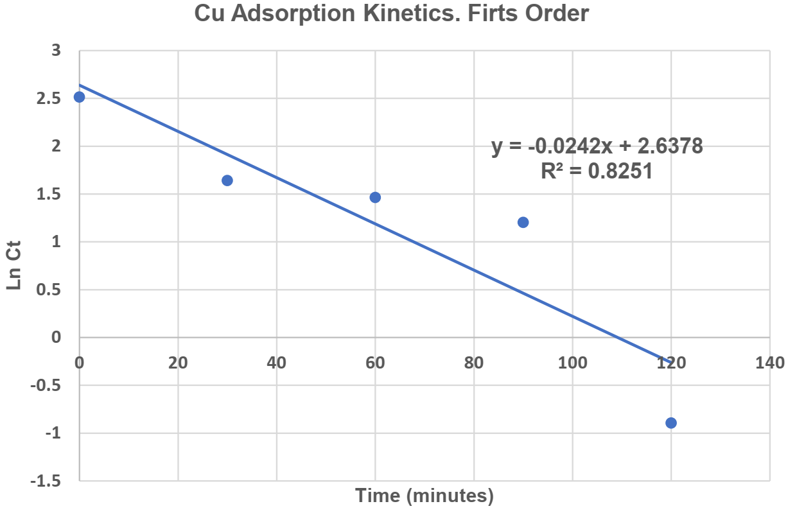 | 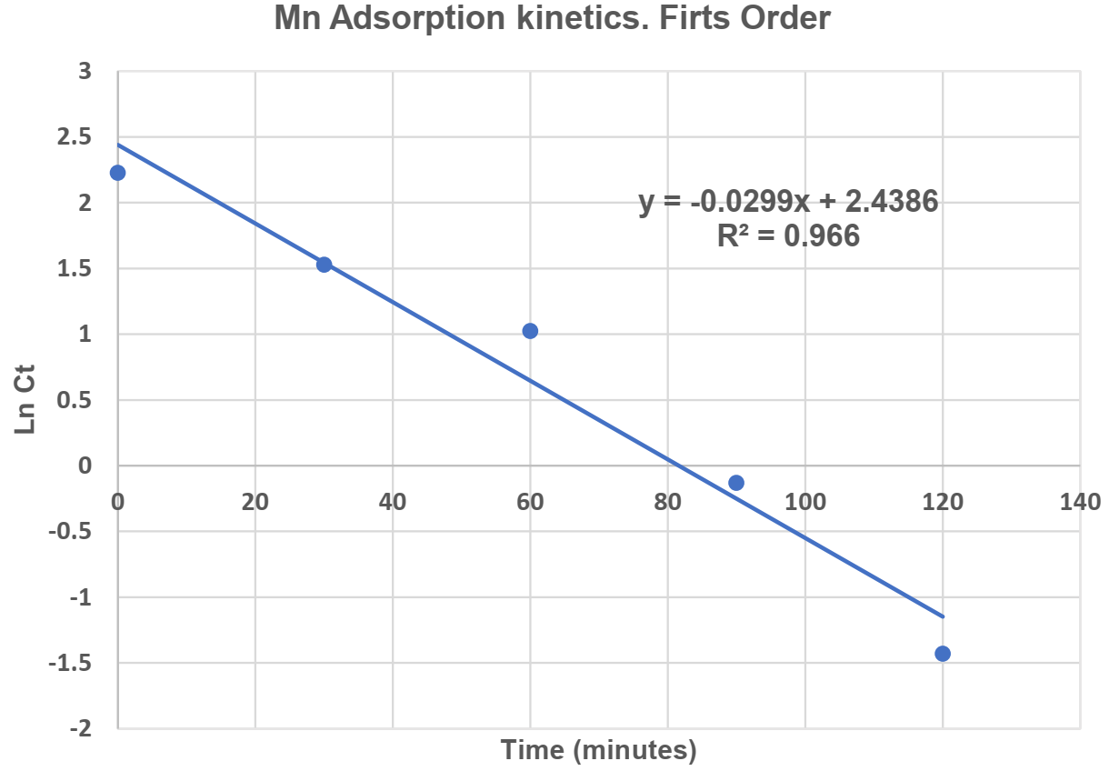
Figure 1. Copper Adsorption Kinetics | Figure 2. Manganese Adsorption Kinetics
In Table 3, the values of the rate constants obtained for the first-order kinetics of both Cu and Mn were presented.
Table 3: Kinetic Adsorption Constants for Cu (II) and Mn (II)
Metallic Element | Initial Concentration (mg/L) | First Order
 |  | qe  (mg/L) | K  (min⁻¹) | R²
Cu | 12.37 | 0.970 | -0.0242 | 0.8251
Mn | 9.28 | 0.891 | -0.0299 | 0.9660

The qe values in the adsorption kinetics of Cu (II) and Mn (II) were obtained from the previously described Equation 2.

3.2 Adsorption Equilibrium of Cu (II) and Mn (II)
In the adsorption equilibrium study, the quantity of adsorbent, which was olive endocarp charcoal, was varied over a period of 90 minutes at a pH of 5, using amounts of 0.5 g, 1 g, 1.5 g, and 2 g. The results of the removal behavior of Cu and Mn are shown in Table 4.

Table 4: Adsorption Equilibrium Study Results for Cu (II) and Mn (II)
Adsorbent Quantity  (g) | Cu Concentration |  | Mn Concentration
 | Initial  (ppm) | Final  (ppm) | Initial  (ppm) | Final  (ppm)
0.5 | 12.37 | 6.18 | 9.28 | 2.14
1.0 |  | 3.34 |  | 0.88
1.5 |  | 1.15 |  | 0.45
2.0 |  | 0.46 |  | 0.18

In both cases, it was observed that with an optimal adsorbent dose of 2 g, minimum final concentrations of 0.46 ppm of Cu (II) and 0.18 ppm of Mn (II) were obtained, allowing for a better observation of the removal behavior of these metals.

3.3 Parameters Used in the Freundlich Isotherm for Cu (II) and Mn (II)
To graphically represent the Freundlich isotherm in the Cu and Mn adsorption study, the parameters used for the investigation were presented in Table 5.
Table 5: Parameters Used in the Freundlich Isotherm for Cu and Mn
Mass  (g) | Cu |  |  |  | Mn
 | C_{e}  (mg/L) | q_{e}  (mg/g) | Log C_{e} | Log q_{e} | C_{e}  (mg/L) | q_{e}  (mg/g) | Log C_{e} | Log q_{e}
0.5 | 6.18 | 2.292 | 0.791 | 0.360 | 2.14 | 2.856 | 0.330 | 0.456
1.0 | 3.34 | 1.714 | 0.524 | 0.234 | 0.88 | 1.680 | -0.056 | 0.225
1.5 | 1.15 | 1.435 | 0.061 | 0.157 | 0.45 | 1.177 | -0.347 | 0.071
2.0 | 0.46 | 1.145 | -0.337 | 0.059 | 0.18 | 0.910 | -0.745 | -0.041

The data from Table 5, specifically the values of Log Ce and Log q_{e}, were used for the graphical representation of the Freundlich isotherm, as shown in Figures 3 and 4.

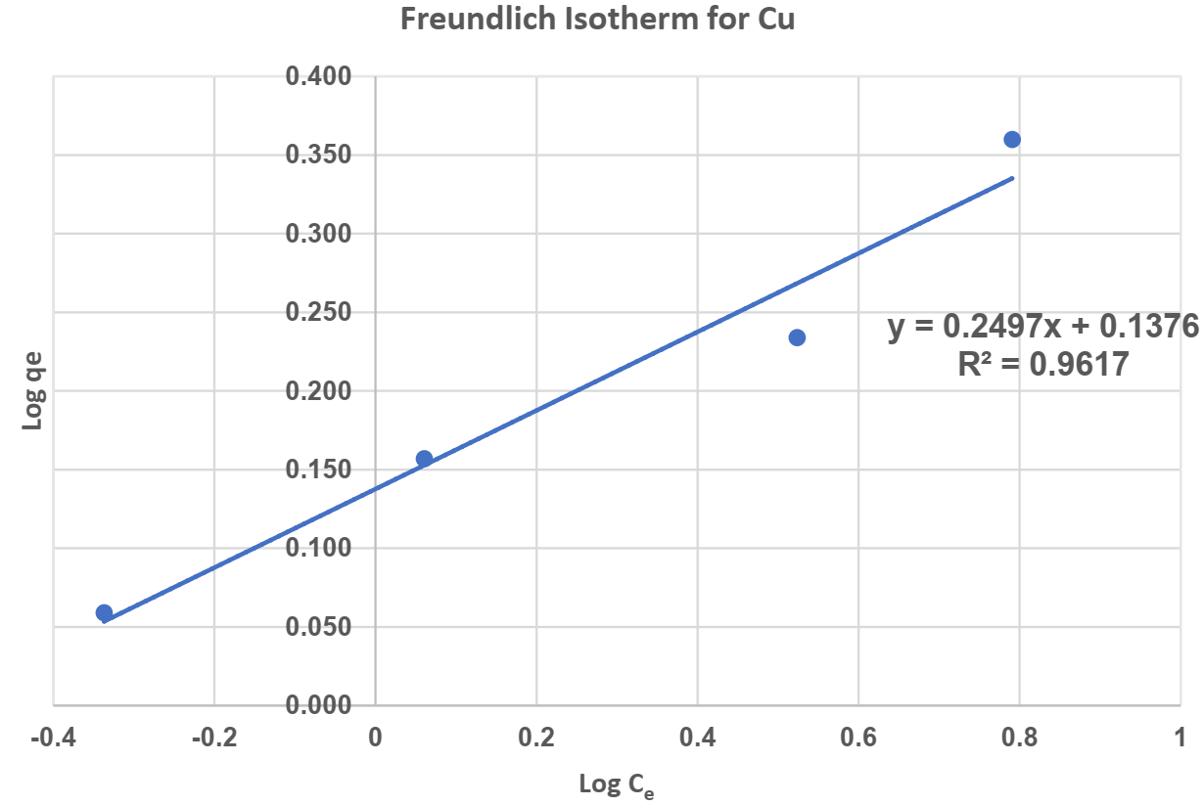 | 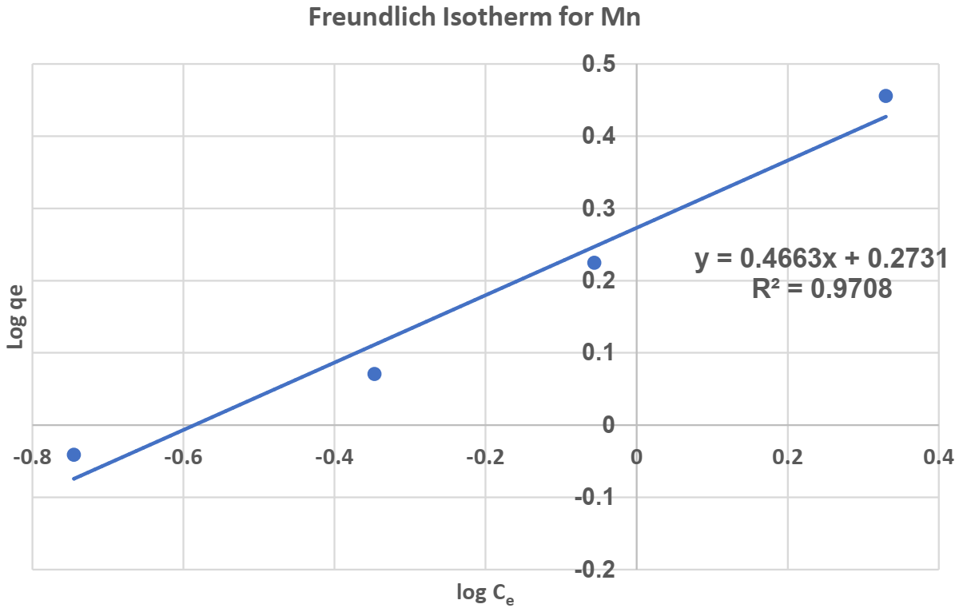
Figure 3. Freundlich Isotherm for Cu | Figure 4. Freundlich Isotherm for Mn

Table 6 presented the constants determined from the graphs of the Freundlich isotherms for Cu and Mn.

Table 6: Freundlich Isotherm Constants
Metallic Element | Isotherm Equation | R² | ordinate (1/q_{max}) | Slope (1/q_{max.b}) | q_{max} | b
Cu | y = 0.2497x+0.1376 | 0.9617 | 0.1367 | 0.2497 | 1.36994 | 4
Mn | y = 0.4663x+0.2731 | 0.9708 | 0.2731 | 0.4663 | 1.87456 | 2.14546
  - Discussion
According to Zhang, Y., and Luo, W. (2014), the adsorption capacity of Cu²+ on AD-char increased as the pH increased up to < 8.6, indicating that the presence of alkaline functional groups on the surface could be responsible for the adsorption capacity of metals with biochar. In the research, the influence of initial pH on Cu (II) adsorption, with pH values of 3 and 5, determined removal rates of 61.20% and 73.08%, respectively. These results are consistent with the findings of Luna et al. (2007) in their research on Cu (II) removal within a pH range of 4 to 5. They also pointed out that at a pH of 3, the removal of Cu (II) was inhibited due to the possible prevalence of hydrogen ions, limiting the approach of metal cations due to repulsive forces. Regarding Mn (II), the removal was 99.14% at pH 3, while at pH 5, it was 89.44%. This result differs from the study by Akl et al. (2013), who investigated Mn (II) removal using activated carbon from organic waste and obtained better results within a pH range of 3 to 5.
The assessment of Cu (II) adsorption is presented in Figure 3, where Freundlich constants (Kf and n) were calculated and recorded, as detailed in Table 6. The Freundlich isotherm fits remarkably well, with a coefficient of determination (R²) of 0.9618. These results are like those reported by Tapia et al. (2017) using peach pit, who achieved an R² of 0.978 when evaluating at pH 5. In their study, they concluded that the Freundlich isotherm best modeled their results. Additionally, the value of 1/n, which is 0.25 according to Table 6, indicates favorable adsorption. This value serves as an indicator of adsorption intensity or surface heterogeneity, being more heterogeneous as its value approaches zero (Adamson, Gast, 2001).
In the adsorption of Mn (II), Freundlich constants (Kf and n) were calculated and recorded from Figure 4, as detailed in Table 6. Figure 4 shows a relatively better fit (R² = 0.9709), results that are consistent with those obtained by Li et al. (2020). In their study on Mn (II) adsorption in acidic mine waters with red mud, they concluded that the Freundlich isotherm best modeled their results, achieved under conditions of pH=6 and a temperature of 28 °C. Additionally, the value of 1/n, which is 0.4661 according to Table 6, indicates favorable adsorption, according to the interpretation of Adamson and Gast (2001).

  - Conclusions
The adsorption of Cu (II) and Mn (II) was evaluated at pH 3 and 5, achieving a removal of 61.20% for Cu (II) (Cf=4.80 ppm) and 99.14% for Mn (II) (Cf=0.08 ppm) at pH 3. Similarly, at pH 5, higher removal was achieved for Cu (II) at 73.08% (Cf=3.33 ppm) and for Mn (II) at 89.44% (Cf=0.98 ppm), albeit lower than that obtained at pH 3. The first-order kinetic model was identified for the adsorption of both Cu (II) and Mn (II). Tests were conducted with contact times of 30, 60, 90, and 120 minutes, yielding correlation coefficients of R²=0.8252 for Cu (II) and R²=0.966 for Mn (II). Adsorption equilibrium was determined through the Freundlich isotherm, which proved to be the model that best fit both Cu (II) and Mn (II) adsorption. Tests were conducted with quantities of 0.5 g, 1 g, 1.5 g, and 2 g of activated olive endocarp charcoal. The most notable correlation coefficient values obtained were R²=0.9618 for the Freundlich isotherm in the Cu (II) study and R²=0.9709 for the Freundlich isotherm in the Mn (II) study. Adjusting the pH to a higher level can enhance the effectiveness of metal removal through adsorption using activated carbon from olive endocarp, which is essential in the management and cleaning of waters contaminated by heavy metals.

Acknowledgments
The authors express their gratitude to the Vice Chancellor's Office for Research at Cesar Vallejo University and the Fund for Support of Teaching Research for the financial support provided for the publication of this research.

References
Adamson, A.W., Gast A. P., 1997, Physical Chemistry of Surfaces. 5th Edition. New York, USA.: Wiley,
Akl M. A., Yousef A. M., AbdElnasser S., 2013, Removal of Iron and Manganese in Water Samples Using Activated Carbon Derived from Local Agro-Residues. Journal of Chemical Engineering & Process Technology, 4, 4.
Alvarez-Bastida C., Martínez-Miranda V., Vázquez-Mejía G., Solache-Ríos M., Fonseca-Montes de Oca G., Trujillo-Flores E., 2013, The corrosive nature of manganese in drinking water, Science of The Total Environment, 447, 10-16.
Aziz H. A., Yusoff M. S., Adlan M. N., Adnan N. H., Alias S., 2004, Physico-chemical removal of iron from semiaerobic landfill leachate by limestone filter. Waste Management, 24, 4, 353-358.
Balali-Mood M., Naseri K., Tahergorabi Z., Khazdair M.R., Sadeghi, M., 2021, Toxic Mechanisms of Five Heavy Metals: Mercury, Lead, Chromium, Cadmium, and Arsenic. Front. Pharmacol. 2021, 12, 643972.
Bohli T., Ouederni A., Villaescusa., 2013, Evaluation of an activated carbon from olive stones used as an adsorbent for heavy metal removal from aqueous phases. Comptes Rendus Chimie, 89-101.
Calderon J. M., Tuiro M. C., 2021, Precipitation of iron and sequential manganese of drain effluents, Journal of the Research Institute, Faculty. Mines Metallurgy, Geographical Sciences, 24, 47, 41 - 46. Spain
Driss Alami S. B., 2010, Exploitation of olive pit for the BIOSORPTION of metal ions, doctoral thesis, University of Granada, Granada, Spain.
Fu F., Wang Q, 2011, Removal of heavy metal ions from wastewaters: A review, Journal of Environmental Management, 92, 3, 407-418.
Holc D., Pruss A., Michałkiewicz M., Cybulski Z., 2016, Effectiveness of organic compounds removing during water treatment by filtration through a biologically active carbon filter with the identification of microorganisms. Annu. Set Environ. Prot., 18, 235–246.
Kaur Brar K., Etteieb S., Magdouli S., Calugaru L., Kaur Brar S., 2022, Novel approach for the management of acid mine drainage (AMD) for the recovery of heavy metals along with lipid production by Chlorella vulgaris, Journal of Environmental Management, 308, 114507.
Lazaratou C.V., Vayenas D.V., Papoulis D., 2020, The role of clays, clay minerals and clay-based materials for nitrate removal from water systems: A review. Appl. Clay Sci, 185, 105377.
Li Y., Huang H., Xu Z., Ma H., Guo Y., 2020, Mechanism study on manganese (II) removal from acid mine wastewater using red mud and its application to a lab-scale column. Journal of Cleaner Production, 253, 119955.
Luna A. S., da Costa A. C. A., Henriques C. A., Herbst M.H., 2007, Electron Paramagnetic Resonance and Atomic Absorption Spectrometry as tools for the investigation of Cu (II) biosorption by Sargassum filipendula, Hydrometallurgy, 86, 1–2, 105-113.
Mang K.C., Ntushelo K., 2020, Algae based heavy metal remediation in acid mine drainage: a review Appl. Ecol. Environ. Res., 18, pp. 2499-2512.
MINISTRY OF ENERGY AND MINES (MINEM), 2010. Water Quality Monitoring Protocol, Lima. Retrieved from: <www.minem.gob.pe/minem/archivos/anexo5.pdf> Spain.
Pruss A., Maciolek A., Lasocka-Gomula I., 2009, Effect of the biological activity of carbon filter beds on organic matter removal from water. Environ. Pollut. Control, 31, 31–34.
Tapia P., Pavez O., Santander M., Sepúlveda B., 2017. Removal of copper ions with organic sorbents. Holos, 8, 42–55. Spain
Tejada-Tovar C.N., Villabona-Ortiz Á., Garcés-Jaraba L., 2015, Adsorption of heavy metals in wastewater using biological materials. Tecno Lógicas, 18, 34, 109-123.
United Nations World Water Development Report 2017. Wastewater: The Untapped Resource. In United Nations World Water Assessment; UN: New York, NY, USA, 2017.
Ursini O., Lilla E., Montanari R., 2006, The investigation on cationic exchange ca-pacity of zeolites: The use as selective ion trappers in the electrokinetic soil technique. J. Hazard. Mater, 137, 1079 – 1088.
Yadollahi A., Abdollahi H., Ardejani F.D., Mirmohammadi M, Magdouli S., 2021, Bio-oxidation behavior of pyrite, marcasite, pyrrhotite, and arsenopyrite by sulfur- and iron-oxidizing acidophiles Bioresour. Technol. Rep., 15, Article 100699.
Zhang, Y., Luo, W., 2014, Adsorptive Removal of Heavy Metal from Acidic Wastewater with Biochar Produced from Anaerobically Digested Residues: Kinetics and Surface Complexation Modeling, BioResources, 9, 2, 2484-2499.

