|  |  |
| --- | --- |
| cetlogo ***CHEMICAL ENGINEERING TRANSACTIONS***  ***VOL. , 2024*** | A publication of  aidiclogo_grande |
| The Italian Association  of Chemical Engineering  Online at www.cetjournal.it |
| Guest Editors: Leonardo Tognotti, Rubens Maciel Filho, Viatcheslav Kafarov  Copyright © 2024, AIDIC Servizi S.r.l. **ISBN** 979-12-81206-09-0; **ISSN** 2283-9216 | |

Impact of Biomass Harvest-to-Processing Time on Protein Extraction in a Green Biorefinery Demonstration Plant

Thalles A. Andrade\*, Natália H. M. dos Passos, Damian E. L. Fetzer, Morten Ambye-Jensen

Aarhus University, Department of Biological and Chemical Engineering, 8200 Aarhus N, Denmark

CBIO, Aarhus University Centre for Circular Bioeconomy, 8830 Tjele, Denmark

\*thal@bce.au.dk

Given the increasing demand for sustainable and alternative protein sources, exploring and replacing traditional monogastric animal feeds, such as soybean meal, with protein extracted from green biorefineries is necessary. The present study explored the influence of the time interval between biomass harvesting and processing in a green biorefinery demonstration facility established at Aarhus University, Denmark. The study utilized grass-clover mixtures as feedstock over two seasons (August 2021 and August 2022) to extract protein concentrate. The investigation evaluated the impact of varying durations between biomass harvest and processing on protein extraction yield and the quality of the leaf protein concentrate. The findings indicate that protein degradation rises with longer harvest-to-processing intervals. This reinforces the importance of implementing the biorefinery close to the harvesting field to reduce this time and optimize logistics. This research aimed to contribute valuable insights for implementing efficient and sustainable processes in green biorefineries to maximize protein yields from fresh biomass.

* 1. Introduction

The increasing global population and economic prosperity have led to an escalating demand for protein worldwide. Concurrently, the need to address climate change and promote sustainable food production requires developing solutions within the food and feed system. These solutions aim to facilitate the local sourcing of high-quality protein with enhanced land productivity and minimized environmental impacts (Chan et al., 2024). One promising technology is green biorefinery, which offers a holistic solution to enable sustainable local production of a leaf protein concentrate (LPC) from green forage, such as grasses and legumes. The LPC offers a compelling substitute for soybean meals in monogastric animal nutrition, such as pigs and poultry, mitigating the European Union's reliance on soybean imports (Andersen and Kiel, 2000; Ravindran et al., 2021).

The initial stage of a sustainable green biorefinery involves mechanical fractionation of harvested biomass into two fractions: a fiber press cake containing abundant lignocellulosic materials, and a liquid green juice (GJ) with high protein content. The GJ is submitted to a protein precipitation process, including heat coagulation, fermentation, or chemical treatment methods. Subsequently, the resulting LPC is separated from the residual brown juice (BJ) through centrifugation and finally subjected to a drying process (Kamm et al., 2016).

The fiber fraction is suitable for serving as feed for ruminant animals due to its slightly disrupted fiber structure and remaining protein content, fulfilling the requisite nutritional feed requirements (Hansen et al., 2023). Furthermore, the fiber fraction finds applications in various areas, including energy production through methods such as anaerobic digestion and pyrolysis. Additionally, it can be refined into biomaterials and biochemicals (Hansen et al., 2023; Ravenni et al., 2023; Sharma et al., 2011). The BJ exhibits richness in organic compounds, including sugars and amino acids. Notable applications of BJ encompass biogas production, ferti-irrigation, and its utility as a substrate for the fermentation of diverse substances such as single-cell protein, astaxanthin, and bioethanol (Andrade et al., 2023; Kisvarga et al., 2020; Martinez et al., 2018).

Studies have shown that the LPC presents an amino acid profile compared to the ones utilized as feed for monogastric animals and can be used without compromising the feed efficiency and meat sensory profile (Bals et al., 2012; Stødkilde et al., 2021a). To implement a sustainable and profitable green biorefinery, it is crucial to guarantee an efficient process and maximize the protein yield extracted from the fresh biomass. The interval between grass harvesting and processing holds significant relevance in mitigating protein degradation and unfavorable biological interactions (Stødkilde et al., 2021b). Therefore, it is advisable to position the field in proximity to the biorefinery to minimize such time for transport and planning. However, determining the suitable time for transportation, as well as the appropriate handling of biomass during transit, remains unresolved.

A green biorefinery demonstration facility was established at Aarhus University, in Foulum, Denmark, to generate a rich protein concentrate from green biomasses. This study focuses on the use of a grass-clover mixture as feedstock throughout two consecutive seasons (August 2021 and August 2022). Biomass was processed to assess the impact of the duration between harvest and processing on protein extraction yield and LPC quality, along with determining optimal conditions for biomass handling during transportation. The investigated period ranged from immediate processing to a delay of up to 12 hours after biomass harvest.

* 1. Materials and methods

Two different demonstration-scale experiments were conducted for this study, in late August 2021 and late August 2022. Both experiments aimed to investigate the effect of harvest method and time between harvest and processing, but both grass-clover mixtures and time intervals differed between the two experiments. In 2021, a ForageMax 45, including 7 % white clover, 11 % red clover, 3 % ryegrass, and 45 % festulolium was the green biorefinery feedstock. In 2022, the biomass was a ForageMax 55, with a seed mixture of 10 % white clover, 65 % ryegrass, and 25 % red fescue.

* + 1. Process description

Figure 1 illustrates the green biorefinery demonstration platform located at Aarhus University Viborg. The fresh biomass processed averaged 4-4.8 tonnes per trial. Two distinct harvesting and cutting methods were assessed. In the first scenario, referred to as "in-field cutting", both biomass harvesting and cutting occurred in the field, employing a JF-STOLL FCT 900 cutter set to a 30 mm cutting length. In the second scenario, named "stationary cutting", the grass-clover was harvested intact using a GrassTech GT140 harvester, ensuring a minimum biomass length of 30 cm. In this case, biomass cutting took place after harvesting at the demonstration plant just before the wet fractionation using a custom-built stationary cutter configured to a theoretical length of 40-50 mm.



*Figure 1: Green biorefinery demonstration plant.*

Following the harvest and cutting of the grass-clover mixture, the cut biomass was submitted to wet fractionation using a Cir-Tech P25 Twin Screw Press, facilitating the separation of the fiber fraction from the GJ. The GJ was filtered in a 50 µm-filter bow screen to retain residual solid particles intended for recirculation to the screw press and eventual recovery in the fiber press cake.

The GJ was directly heated to 85 °C for protein precipitation using Alfa Laval WideGap 100 gasketed plate exchangers. This heating process was conducted in two stages: initially, the GJ was heated to 65 °C by exchanging heat with the BJ, followed by the application of additional heat with hot pressurized water to achieve the target temperature. A GEA CF 4000 Decanter Centrifuge was employed to separate the precipitated protein fraction from the BJ as a protein-rich LPC. Lastly, the LPC was subjected to drying in a vacuum dryer to reach a dry matter (DM) concentration of 95 %.

* + 1. Process set-up

Table 1 provides a summary of the experimental trials. The minimum time duration of 30 minutes corresponds to the time required for harvesting the biomass in the field, transporting it to the biorefinery, and initiating the fractionation process.

Table 1: Experimental set-up at the green biorefinery demonstration platform

|  |  |  |  |  |
| --- | --- | --- | --- | --- |
| Period | Grass-clover mixture | Harvest and cutting type |  | Time between harvesting and processing |
| August 2021 | ForageMax 45 | In-field |  | 0.5, 6, 12 h |
|  |  | Standard |  | 0.5, 6, 12 h |
| August 2022 | ForageMax 55 | In-field |  | 0.5, 2, 4, 6 h |
|  |  | Standard |  | 0.5, 2, 4, 6 h |

* + 1. Sampling and analysis

Upon reaching a steady state in the process, samples of all fractions (biomass, fiber, GJ, BJ, LPC) were collected in duplicate. The pH and degrees Brix of the GJ and BJ were promptly measured. Samples from all fractions were subjected to overnight drying at 105 °C for analysis of DM concentration. The determination of ash concentration involved exposing the samples to a high-temperature muffle furnace at 550 °C for 3 h.

The total organic carbon (TOC) and total nitrogen (TN) concentrations in both GJ and BJ were determined using a scalar FORMACS HT-I TOC/TN analyzer, employing the Kjeldahl method. Fresh biomass, fiber, and LPC, were sent to carbon, hydrogen, nitrogen, and sulfur elemental analysis (CHNS) using an Elementar vario MACRO cube elemental analyzer (Langenselbold, Germany). Nitrogen values were converted to crude protein (CP) concentration by multiplying the nitrogen concentration by a factor of 6.25, a common practice in the standard feed industry (Petersen et al., 2022). The CP concentration was reported on a DM basis.

* 1. Results and discussion

Table 2 depicts the CP and ash concentrations within the LPC fraction. In the context of the 2021 processing season, when the stationary cutting approach was employed, it was observed that the CP concentration exhibited minimal fluctuation over an extended interval between harvest and processing. This is attributable to the preservation of the fresh biomass in an uncut state before starting the process, thereby maintaining the stability of component properties, and resulting in limited observable variations. A similar pattern emerged in the case of CP concentration during the 2022 stationary-cutting scenario, indicating a consistent trend.

Table 2: CP and ash concentrations in the LPC fraction when processing grass-clover in 2021 and 2022.

|  |  |  |  |  |  |
| --- | --- | --- | --- | --- | --- |
| Year | Time after harvest (h) | CP (%DM) | | Ash (%DM) | |
| In-field | Stationary | In-field | Stationary |
| 2021 | 0.5 | 54.0 | 53.7 | 4.4 | 4.4 |
| 6 | 50.4 | 53.5 | 6.0 | 4.8 |
| 12 | 49.0 | 54.7 | 5.6 | 5.3 |
|  |  |  |  |  |  |
| 2022 | 0.5 | 52.3 | 49.9 | 5.4 | 5.8 |
| 2 | 52.8 | 48.3 | 5.2 | 8.5 |
| 4 | 50.5 | 50.3 | 5.9 | 6.1 |
| 6 | 47.9 | 49.5 | 6.3 | 6.4 |

In the context of the in-field cutting scenario, the CP concentration in LPC declines in both experiments (2021 and 2022) after 6 h, with the 2022 experiment exhibiting a more pronounced reduction evident as early as 4 h. For the stationary cutting at the biorefinery, the CP concentration does not seem to decline in any of the experiments. The decrease in CP concentration for the in-field harvesting can be attributed to the biomass being cut to a shorter length in this scenario as well as the fact that the cutting takes place before the time intervals. With an extended post-harvest time before processing, the likelihood of protein degradation increases when the biomass is disrupted to a larger extent, leading to a reduction in its content within the LPC fraction. This aligns with the observed trend in ash concentration, which, overall, demonstrates an increase after a prolonged period between harvest and process.

Overall, the CP concentration was higher in the LPC fractions in 2021 than in 2022. This difference is attributed to the composition of the biomass utilized in 2021, which featured a higher clover content than the mixture used in 2022. This could be seen in the seed mixtures with 18 % clover content in 2021 versus 10 % in 2022. Both white and red clover have a higher leaf-to-stem ratio than grass forage biomasses, and therefore, are acknowledged for their more elevated CP concentrations, thus explaining the observed variation in CP levels between the two years (Gaffey et al., 2023; Stødkilde et al., 2021b).

Figure 2 illustrates the DM and CP yields within the LPC fraction for the 2021 and 2022 seasons. The yields are presented relative to the total DM and CP contents in the fresh biomass. In both years, higher DM and CP yields were achieved when employing stationary cutting as opposed to in-field cutting. This observation suggests enhanced stability of protein and other solid components when the biomass remained uncut, in contrast to being cut in the field.

Both DM and CP yields tended to decrease with a prolonged time before starting the process. In the 2021 experiment, the DM yield reduced from 7.8 to 5.5 % in the in-field scenario, and from 8.1 to 6.7 % in the stationary scenario when the biomass standing time increased to 12 h. In the 2022 experiment, the DM yield decreased from 3.9 to 2.4 % in the in-field scenario and from 4.6 to 3.9 % in the stationary scenario when the time between harvest and processing was extended to 6 h. Regarding the CP, an unexpected rise in CP yield was noted with extended biomass standing time in the initial period, specifically under stationary cutting conditions in both experimental years. When using in-field cutting, the CP yield decreased from 21.0 to 14.0 % in 2021, and from 9.2 to 5.5 % in 2022. The increase in the CP yield under stationary cutting conditions is probably due to the potential enzymatic oxidation of the biomass throughout its processing and storage. These reactions lead to the browning of the biomass, due to the formation of reactive quinones, that can form a protein–quinone complex. This event diminishes the solubility and digestibility of proteins, causing increased CP precipitation, although with reduced quality (Amer et al., 2021). An increase in the CP precipitation continues while this effect is more predominant than protein degradation. Further investigation is required to elucidate the fundamental mechanisms that contribute to this phenomenon and assess its reproducibility. Overall, these findings underline the importance of minimizing the time between harvest and process to optimize DM and CP yields, with stationary cutting demonstrating a more favorable impact on overall yield compared to in-field cutting in both experimental years.

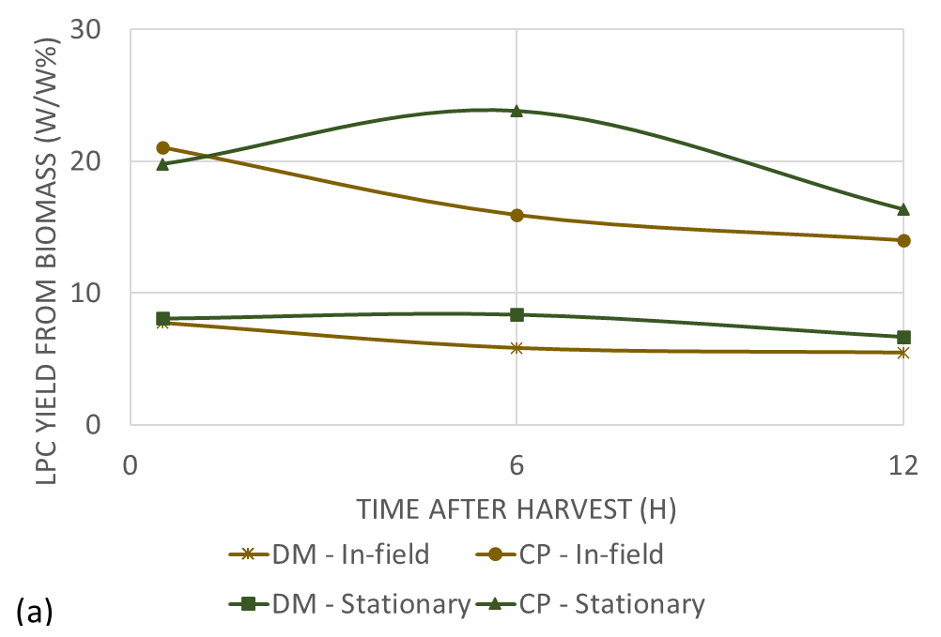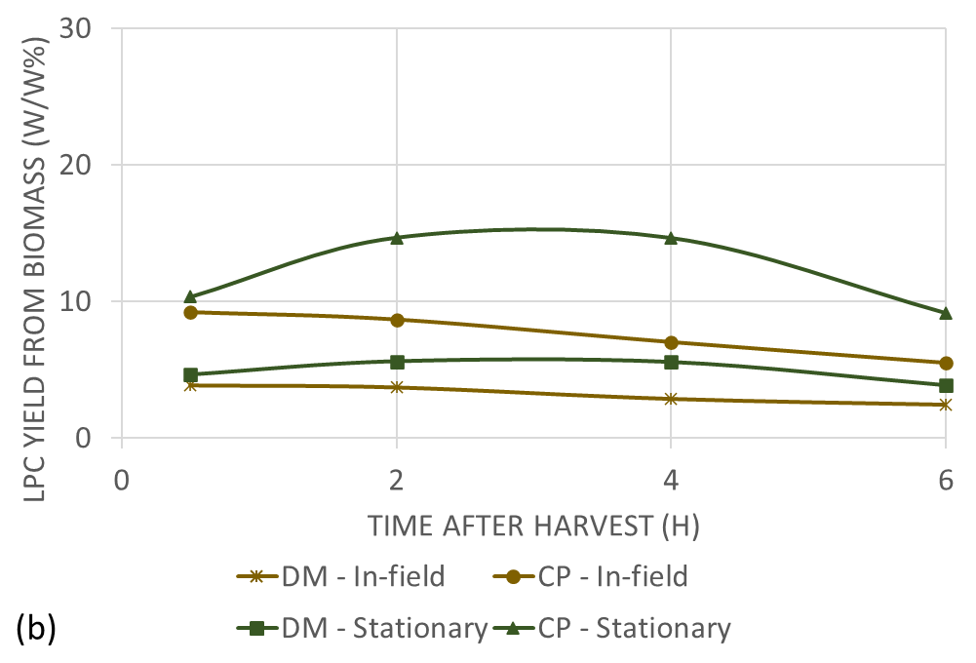

*Figure 2: DM and CP yield in the LPC concerning their content in the biomass in (a) 2021 and (b) 2022.*

The DM yield in the LPC fraction was higher in 2021 compared to 2022 across all scenarios. This disparity is attributed to the utilization of ForageMax 55 feedstock in 2022, which contains a higher proportion of grass relative to ForageMax 45 feedstock used in 2021. The elevated stem content in grasses, as opposed to the higher leaf content in legumes like clovers, suggests that the DM content in grass comprises a richer source of lignocellulosic materials, which are subsequently allocated to the fiber fraction following wet fractionation. This pattern is evident in Figure 3, which shows the distribution of DM content from the biomass across fiber, BJ, and LPC fractions. The figure indicates that a greater proportion of DM was allocated to the fiber fraction in the 2022 trials due to feedstock quality. Additionally, Figure 3 illustrates a trend, particularly noticeable in the 2022 experiment, where the DM yield in the fiber fraction reduces with prolonged biomass standing time, associated with a continuous increase in solid particles allocated to the BJ fraction. This observation is linked to the potential degradation of biomass components over time after harvesting, including protein molecules that undergo proteolysis, breaking down into smaller peptides and amino acids, and that will be incorporated into the composition of the GJ. Apart from proteins, various other plant constituents may be more readily extracted into the juice during pressing. Further analysis to quantify the amino acid content in the GJ and BJ is necessary to validate this observation.

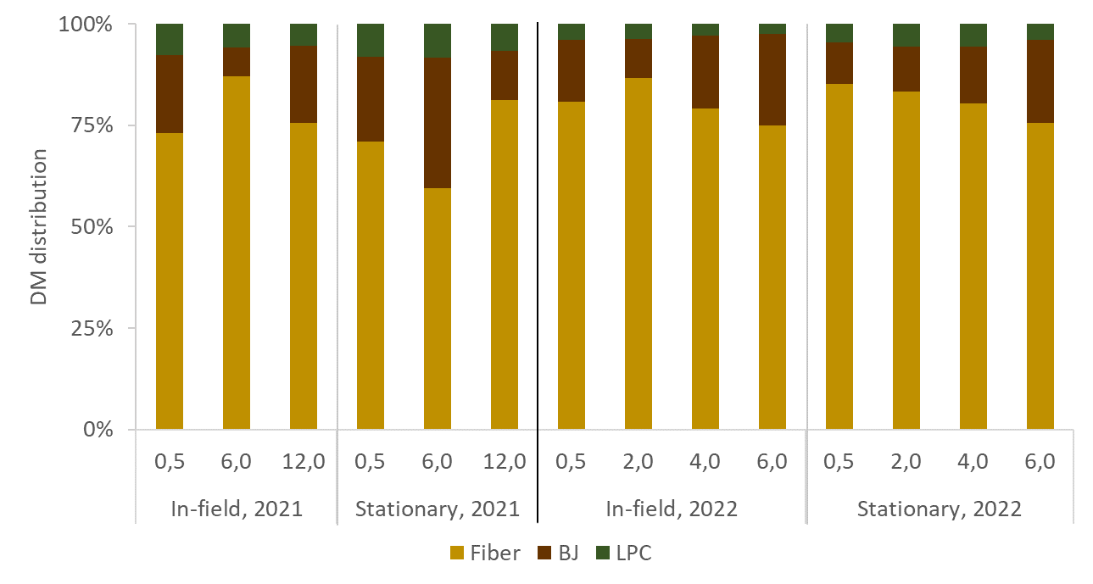

*Figure 3: Distribution of the DM biomass into fiber, BJ, and LPC fractions.*

Figure 4 presents the DM and CP yields within the LPC fraction relative to the total DM and CP contents in the GJ for the 2021 and 2022 seasons. The remaining DM and CP contents not recovered in the LPC fraction were retained in the BJ. In 2021, the GJ exhibited a DM yield ranging from 20 % to 25 %, with a CP yield averaging between 21 % and 28 %. Both DM and CP yields showed a reduction of approximately 15 % when extending the biomass standing period. In contrast, for the 2022 season, the GJ displayed a DM yield of 14.5 %, with a CP yield averaging 15.5 %. Those yields in the GJ are lower than the DM and CP yields in 2021 since a higher DM content was retained in the fiber fraction. The DM and CP yields decreased by 8 % and 15 %, respectively, for a longer time between harvesting and processing the biomass. The reduction in the CP yield within the LPC is linked to the protein degradation resulting from the extended standing period preceding the biomass processing. This longer time intensifies proteolysis and proteins break down into free amino acids, peptides, and ammonia. Consequently, these components do not precipitate during the heat coagulation step, persisting instead in BJ. Intriguingly, under the stationary cutting scenario in 2022, the highest DM and CP yields were observed when processing the biomass after 4 h of harvest. This phenomenon requires further investigation to establish if it is attributable to experimental errors or measurement variations.

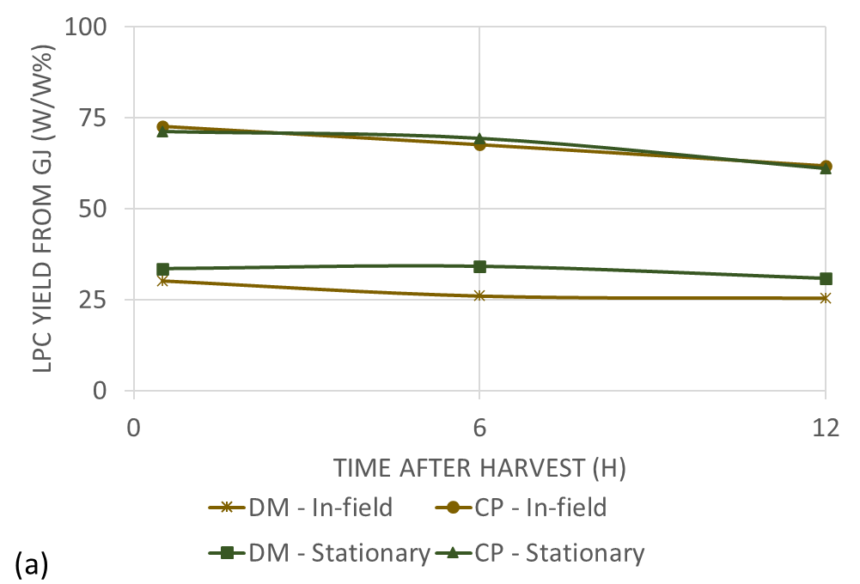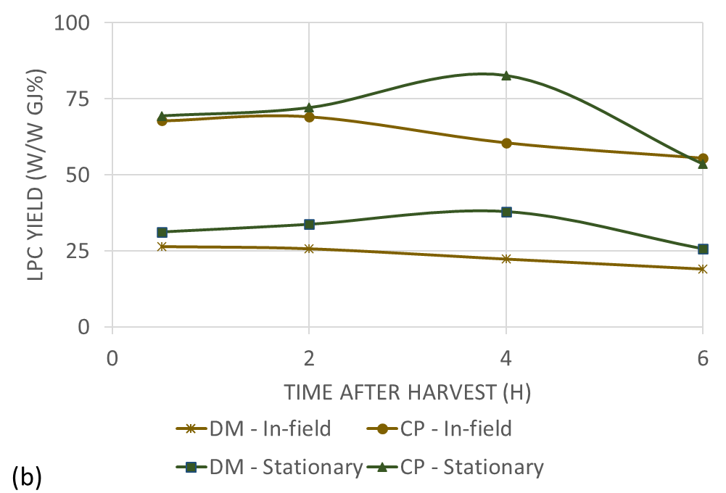

*Figure 4: DM and CP yield in the LPC concerning their content in the GJ in (a) 2021 and (b) 2022.*

* 1. Conclusions

In this investigation covering two consecutive experiments in the seasons 2021 and 2022, the impact of the time interval between biomass harvesting and processing in a green biorefinery for the extraction of LPC was assessed, utilizing two distinct grass-clover mixtures. A notable higher CP yield was observed in 2021, attributed to a higher clover content in the grass-clover mixture of that specific year. The study highlights that an extended period before processing intensifies protein and other solid compound degradation, reducing the LPC yields by up to 33.5 % in 2021, and 40.5 % in 2022. Additionally, two harvest and cutting combinations were assessed, with stationary cutting, where the biomass remained uncut before utilization, resulting in less decline of yields over time, especially within the first 6 hours.

Acknowledgments

The authors acknowledge the financial support from GO-GRASS (European Union’s Horizon 2020 Research and Innovation program, grant agreement No 862674), and Græs-Prof – Value creation with grass protein (GUDP Danish National funding, grant agreement No 34009-19-1591).

References

Amer, B., Juul, L., Møller, A.H., Møller, H.S., Dalsgaard, T.K., 2021. Improved solubility of proteins from white and red clover – inhibition of redox enzymes. International Journal of Food Science & Technology 56, 302–311.

Andersen, M., Kiel, P., 2000. Integrated utilisation of green biomass in the green biorefinery. Industrial Crops and Products 11, 129–137.

Andrade, T.A., Ramírez-Márquez, C., Ambye-Jensen, M., 2023. Process simulation of an integrated green protein biorefinery using nanofiltration membrane and ethanol fermentation. Separation and Purification Technology 327, 124887.

Bals, B.D., Dale, B.E., Balan, V., 2012. Recovery of Leaf Protein for Animal Feed and High-Value Uses, in: Biorefinery Co-Products. John Wiley & Sons, Ltd, pp. 179–197.

Chan, S.W.S., Marami, H., Tayo, L.L., Fog, E., Andrade, T.A., Ambye-Jensen, M., Birkved, M., Khoshnevisan, B., 2024. Environmental impacts of a novel biorefinery platform integrated with power-to-protein technology to decrease dependencies on soybean imports. Science of The Total Environment 907, 167943.

Gaffey, J., Rajauria, G., McMahon, H., Ravindran, R., Dominguez, C., Ambye-Jensen, M., Souza, M.F., Meers, E., Aragonés, M.M., Skunca, D., Sanders, J.P.M., 2023. Green Biorefinery systems for the production of climate-smart sustainable products from grasses, legumes and green crop residues. Biotechnology Advances 66, 108168.

Hansen, N.P., Jensen, S.K., Johansen, M., Hellwing, A.L.F., Ambye-Jensen, M., Larsen, M., Weisbjerg, M.R., 2023. Fiber digestibility and protein value of pulp silage for lactating dairy cows: Effects of wet fractionation by screw pressing of perennial ryegrass. Journal of Dairy Science 106, 937–953.

Kamm, B., Schönicke, P., Hille, Ch., 2016. Green biorefinery – Industrial implementation. Food Chemistry 197, 1341–1345.

Kisvarga, S., Barna, D., Kovács, S., Csatári, G., O. Tóth, I., Fári, M.G., Makleit, P., Veres, S., Alshaal, T., Bákonyi, N., 2020. Fermented Alfalfa Brown Juice Significantly Stimulates the Growth and Development of Sweet Basil (Ocimum basilicum L.) Plants. Agronomy 10, 657.

Martinez, E.J., Micolucci, F., Gomez, X., Molinuevo-Salces, B., Uellendahl, H., 2018. Anaerobic digestion of residual liquid effluent (brown juice) from a green biorefinery. Int. J. Environ. Sci. Technol. 15, 2615–2624.

Petersen, A.M., Annoh-Quarshie, J., Van Rensburg, E., Görgens, J.F., 2022. Optimizing the processes of extracting proteins from yellow peas and ethanol production from spent pea residues. Biomass Conv. Bioref. 12, 2913–2924.

Ravenni, G., Thomsen, T.P., Smith, A.M., Ambye-Jensen, M., Rohde-Nielsen, K.T., Henriksen, U.B., 2023. Integration of a drying and pyrolysis system in a green biorefinery: biochar product quality and impacts on the overall energy balance and climate footprint. Biomass Conv. Bioref.

Ravindran, R., Koopmans, S., Sanders, J.P.M., McMahon, H., Gaffey, J., 2021. Production of Green Biorefinery Protein Concentrate Derived from Perennial Ryegrass as an Alternative Feed for Pigs. Clean Technol. 3, 656–669.

Sharma, H.S.S., Lyons, G., McRoberts, C., 2011. Biorefining of perennial grasses: A potential sustainable option for Northern Ireland grassland production. Chemical Engineering Research and Design 89, 2309–2321.

Stødkilde, L., Ambye-Jensen, M., Jensen, S.K., 2021a. Biorefined organic grass-clover protein concentrate for growing pigs: Effect on growth performance and meat fatty acid profile. Animal Feed Science and Technology 276, 114943.

Stødkilde, L., Lashkari, S., Eriksen, J., Jensen, S.K., 2021b. Enhancing protein recovery in green biorefineries through selection of plant species and time of harvest. Animal Feed Science and Technology 278, 115016.