CHEMICAL ENGINEERING TRANSACTIONS  VOL. , 2024 | A publication of
The Italian Association
of Chemical Engineering
Online at www.cetjournal.it

Guest Editors: Leonardo Tognotti, Rubens Maciel Filho, Viatcheslav Kafarov
Copyright © 2024, AIDIC Servizi S.r.l.
ISBN 979-12-81206-09-0; ISSN 2283-9216

Hydrothermal Carbonization of Aquatic Biomass: a Promising Solution for the Invasive Species Myriophyllum Aquaticum
Federica Barontini^{a,}*, Marco Landi^{b}, Nicola Silvestri^{b}, Monica Pucciniª
ªDipartimento di Ingegneria Civile e Industriale, Università di Pisa, Largo Lucio Lazzarino 2, 56122 Pisa, Italy.
^{b} Dipartimento di Scienze Agrarie, Alimentari e Agro-ambientali, Università di Pisa, via del Borghetto 80, 56124 Pisa, Italy.
federica.barontini@unipi.it
Myriophyllum aquaticum (Vell.) Verdc., an invasive aquatic plant from South America, is to date worldwide distributed. In Tuscany M. aquaticum has colonized much of the surface water network of reclamation channels, forcing the reclamation authority to its removal, with the consequent production of a huge amount of wet biomass to be disposed as a biological waste. In the present study the hydrothermal carbonization (HTC) process was proposed and investigated as a path for the valorisation of this waste biomass. Performed in aqueous conditions at moderate temperatures, HTC does not require energy-intensive pre-drying steps, making HTC applicable to biomass feedstocks with high moisture contents. HTC leads to a carbonaceous solid product, referred as to hydrochar, with different potential applications, such as solid biofuel, or soil amendment. An experimental investigation was carried out performing HTC tests in a laboratory-scale reactor. The combined effect of operating parameters (temperature, residence time and solid load) on process yields and hydrochar properties was investigated by Design of Experiments – Response Surface Methodology (DoE-RSM), a statistical and mathematical approach for process analysis, prediction, and optimization. The results obtained demonstrated the feasibility of HTC for M. aquaticum, suggesting HTC as a promising treatment path for the production of hydrochar with multiple applications. Beyond the use as a biofuel, the suitability of the hydrochar produced from M. aquaticum as an organic growth medium for vegetable/seedlings in horticulture and gardening or soil amendment was evaluated. Potential phytotoxic effects of M. aquaticum hydrochar were evaluated through bioassays using Lepidium sativum L. as a model species.
  - Introduction
Myriophyllum aquaticum (Vell.) Verdc. (Parrot’s Feather) is an amphibious aquatic macrophyte native to South America, which is nowadays distributed worldwide. It was firstly found in Italy in the early 90s and afterwards the sightings concerned many regions of central and northern Italy. In 2004, M. aquaticum was recorded in Tuscany where colonized much of the surface water network of reclamation channels, thereby significantly hindering the normal water outflow. The north-Tuscany reclamation authority has been forced to remove M. aquaticum from reclamation channels, producing a huge amount of wet biomass to be disposed as a biological waste. Conversely, it could be usefully allocated to virtuous processes of biomass reuse (according to Agenda 2030 prerogatives, e.g. SDG 12).
In this context, the authors aim to propose and explore a pathway for enhancing the value of this biomass. Hydrothermal carbonization (HTC) has emerged as a promising sustainable thermochemical process for exploiting waste biomass with high moisture content. Operating under aqueous conditions at moderate temperatures (ranging from 180 to 300 °C) and autogenous pressure, HTC transforms biomass into a carbonaceous solid product known as hydrochar (Wang et al., 2018). The versatility of hydrochar has led to various proposed applications, including as solid biofuel, electrode material in energy storage devices, adsorbent for wastewater treatment, and soil amendment (Sharma et al., 2020). Notably, HTC stands out from other thermochemical processes as it eliminates the need for energy-intensive pre-drying of feedstock, making it applicable to a wide array of high-moisture biomasses. Researchers have explored HTC for treating a range of substrates such as agricultural residues, agro-industrial and food wastes, organic fractions of municipal solid waste, and sewage sludges (Cavali et al., 2023). However, there is no systematic investigation regarding the application of HTC to M. aquaticum biomass.
Within this framework, the present study pursues several interconnected aims: i) to demonstrate the feasibility of HTC for M. aquaticum; ii) to investigate the combined effect of operating parameters on process yields and hydrochar properties; iii) to assess potential applications of hydrochar derived from M. aquaticum.
Experimental HTC tests were conducted using a laboratory-scale reactor. The combined effect of process parameters was explored using Design of Experiments – Response Surface Methodology (DoE-RSM), a statistical and mathematical approach suitable for analyzing, predicting, and optimizing various experimental systems. Given the complexity of HTC reactions that limit the scope of process simulation, DoE-RSM proves particularly valuable for HTC process study and optimization. Among the potential applications of hydrochar, there is a growing interest in its utilization as an organic growth medium for vegetable/seedlings in horticulture and gardening (as a substitute for peat in potting mix) or as a soil amendment (Islam et al., 2021). The suitability of hydrochar derived from M. aquaticum was evaluated in terms of potential phytotoxicity through germination and growth tests conducted in microcosms.
  - Materials and Methods
    - Feedstock
M. aquaticum biomass was collected from Barra channel in the catchment of Lake Massaciuccoli (Tuscany, Italy) in March 2023. Harvested biomass was washed with tap water to remove adhering matter. For HTC experiments, the biomass was dried at 105 °C and ground to size < 1 mm. Table 1 summarizes the results of feedstock characterization, i.e., Volatile Matter (VM), Fixed Carbon (FC) and Ash content, Carbon (C), Hydrogen (H), Nitrogen (N) and Oxygen (O) content, and Higher Heating Value (HHV).
Table 1: Results of biomass characterization (on a dry basis)
VM [wt %] | FC [wt %] | Ash [wt %] | C [wt %] | H [wt %] | N [wt %] | O [wt %] | HHV [MJ/kg]
54.56 | 12.37 | 33.07 | 32.09 | 4.08 | 2.14 | 28.62 | 12.20

    - Design of Experiments – Response Surface Methodology
HTC tests were planned using the DoE-RSM approach. Temperature (A), reaction time (B), and solid content (C) were identified as independent variables (factors). Table 2 illustrates the chosen levels for these process variables. To explore potential non-linear interactions among the factors, a face-centered central composite design was implemented. The experimental design matrix comprised 20 runs, including 8 runs at factorial points, 6 runs at axial points, and 6 replicates at the central point. Randomization of the experimental sequence was conducted to mitigate the influence of uncontrolled factors. To evaluate the process yields and the properties of the resulting hydrochars, the following responses were selected: hydrochar yield (Y), carbon yield (C yield), hydrochar H/C and O/C atomic ratios, hydrochar ash content, hydrochar higher heating value (HHV), energy densification (ED), and energy yield (EY). The definitions of hydrochar yield, carbon yield, energy densification, and energy yield are outlined in Eqs (1)–(4).
$$Y=\frac{mass of dry hydrochar}{mass of dry biomass}∙100$$ | (1)
$$C yield=Y∙\frac{C content of dry hydrochar}{C content of dry biomass}∙100$$ | (2)
$$ED=\frac{{HHV}_{dry hydrochar}}{{HHV}_{dry biomass}}$$ | (3)
$$EY=Y∙\frac{{HHV}_{dry hydrochar}}{{HHV}_{dry biomass}}$$ | (4)
The analysis of variance (ANOVA) was used to assess suitable models for each response. The Design Expert® 13 (Stat-Ease) software was employed to carry out DoE/RSM trials.
Table 2: Independent variables in HTC experiments: name, units and levels
Factor | Low level (-1) | High level (+1)
A: Temperature [°C] | 200 | 260
B: Time [min] | 30 | 210
C: Solid content [wt %] | 5 | 25
    - Hydrothermal Carbonization experiments
HTC experiments were conducted using a 300 mL stainless-steel PARR reactor. Additional specifics regarding the experimental setup can be found elsewhere (Barontini et al., 2023). Tests were carried out at varying reaction temperatures, reaction times, and solid contents, as per the randomized design matrix derived from DoE-RSM. Each experiment involved the reactor loading with M. aquaticum and distilled water to attain the desired solid content. Following the HTC process, the obtained slurry was retrieved from the reaction vessel, and the solid fraction was separated via vacuum filtration. The resulting solid product, known as hydrochar, underwent washing with distilled water, drying at 105 °C for 12 hours, followed by weighing and storage at 4 °C before subsequent characterization and phytotoxicity assessments.
    - Feedstock and hydrochar characterization
The physicochemical characterization of M. aquaticum and hydrochar samples was performed following the methodologies briefly reported herein. Proximate analysis was performed by thermogravimetric analysis using a TA Instruments Q-500 analyzer. Ultimate analysis was carried out with a LECO TruSpec CHN Elemental Analyzer, the oxygen content was evaluated by difference. A LECO AC-500 Calorimeter was employed for heating value determination.
    - Phytotoxicity test
Hydrochar phytotoxicity was assessed through bioassays using cress seeds (Lepidium sativum L.), as a model species, according to the Italian regulation (D.Lgs. n. 75/2010) and the methodology reported by APAT (APAT 20/2003).
Hydrochar water extract
For the germination test, water extracts from hydrochar with elemental composition similar to peat (HC peat) and lignite (HC lignite) were obtained as it follows. Hydrochar samples (20 g) were watered up to 85% humidity with Milli-Q water and shaken for two hours (MR-12 Rocker-Shaker, Biosan) at the maximum speed. Subsequently, samples were centrifuged for 15 min at 5000 rpm (MPW med. instruments, Warsaw, Poland), and the obtained supernatants were filtered using a vacuum pump (Delchimica Scientific Glassware Srl, Naples, Italy). Due to the high water-retention ability of HC peat, no water extract was obtained from this treatment. The water extract of HC lignite was diluted to 30% (v/v) with Milli-Q water.
Germination test
For the germination test, 1.5 mL of 30% (v/v) diluted aqueous hydrochar extract was added to 9-cm diameter Petri dishes (n = 3) containing filter paper and 10 seeds of L. sativum previously soaked for 60 min in distilled water. As a control, 1.5 mL Milli-Q water was used replacing the aqueous hydrochar extract. Finally, the Petri dishes were incubated in the dark for 48 hours at 25 °C.
After incubation, the germination index (I_{g}) was determined using the following formula:
$$I_{g} (\%)=\frac{Gt×Lt }{Gc×Lc }×100$$ | (5)
where Gt and Gc were the average number of germinated seeds in the treated and the control Petri dishes, respectively, while Lt and Lc were the average root lengths of the treated and control samples.
Growth test
A growth test was performed in 0.55-L pots (n = 5) filled with a layer of expanded clay at the bottom, followed by a substrate consisting of sand and peat 1:1 (v/v) with the addition of 75 g L^{‒1} of hydrochar, and finally by a layer of sand on the top. Control pots were made up to final volume with sand and peat. In each pot, 20 seeds were sown and covered with a perlite layer.
Aboveground biomasses were collected after 21 days from the sowing to determine the plant fresh weights. To determine their dry weight, samples were dried in a ventilated oven (Memmert GmbH Co., KG Universal Oven UN30, Schwabach, Germany) at 105 °C until a constant weight was reached.
The growth index (G_{m}) was calculated according to the following formula:
$$G_{m} (\%)=\frac{Gt}{Gc}×100$$ | (6)
where Gt and Gc represents the average plant dry weight in treated and in the control pots, respectively.
Statistical analysis
After checking the normality of distribution (Shapiro-Wilk test, 95% confidence interval), the difference between the treatment and the control in the germination test was analyzed by unpaired t-test. On the growth test results, a non-parametric Kruskal-Wallis test was performed and significant differences among treatments were determined by Dunn's multiple comparisons post-hoc test (p ≤ 0.05). GraphPad software (GraphPad, La Jolla, CA, USA) was used for the statistical analysis of the bioassays.
  - Results and Discussion
    - Results of HTC tests
The HTC treatment transformed the M. aquaticum biomass into a carbonaceous solid product enriched in total and fixed carbon, exhibiting lower atomic ratios of hydrogen to carbon (H/C) and oxygen to carbon (O/C) compared to the initial feedstock (Figure 1). Throughout the HTC process, the biomass undergoes a sequence of reactions including hydrolysis, dehydration, decarboxylation, condensation, polymerization, and aromatization, resulting in decreased atomic H/C and O/C ratios (Reza et al., 2014). The extent of these reactions depends on the feedstock and reaction conditions such as temperature, residence time, and solid content (Sharma et al., 2020). The degree of carbonization can be visualized using the Van Krevelen diagram (Figure 1), aiding in the assessment of the carbonization extent while juxtaposing it with other fossil fuels like peat, lignite, and coal (Reza et al., 2014). Results for hydrochars produced under varied process conditions are shown in Figure 1. To characterize HTC operating conditions and compare hydrochars derived from different temperature and residence time settings, the severity factor f was employed, defined as:
$$f=50∙t^{0.2}∙e^{-\frac{3500}{T}}$$ | (7)
where t is the residence time (s) and T is the temperature (K) (Funke and Ziegler, 2010). Enhanced process severity correlates with higher temperature and/or prolonged residence time. The results in Figure 1 evidence that the HTC process applied to M. aquaticum yields hydrochars with elemental composition close to that of peat and lignite. As expected, increasing process severity leads to a greater degree of carbonization.
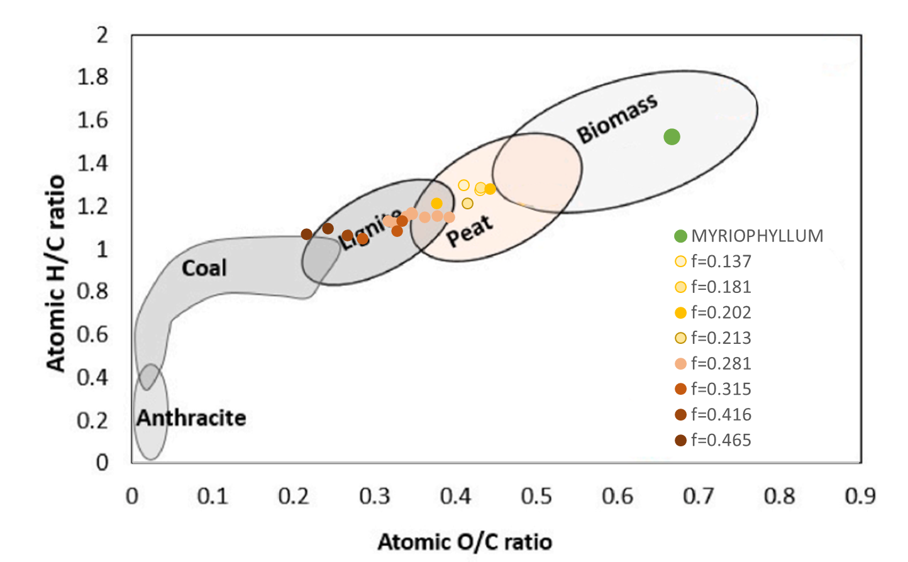
Figure 1: Atomic H/C versus O/C ratio (Van Krevelen diagram) of Myriophyllum aquaticum and hydrochars obtained in different process severity (f factor) conditions.
The RSM approach was employed to analyze the impact of temperature, time, and solid content on the process yields and properties of the resulting hydrochar. This involved investigating the effects of the key operational parameters on the target responses and their interactions to determine the optimal operating conditions for the intended application. Polynomial models were fitted to the selected responses through regression calculations. The effects, including main and interaction effects, were computed for all model terms, along with statistical values such as p-values, lack of fit, and adjusted and predicted R². The software recommended statistically significant models with high values for adjusted and predicted R² for each response. A reduced cubic model was derived for hydrochar yield, and the parametric model in terms of coded values is presented in Eq (8):
$$Y=58.13-4.99A-3.28B+1.69C+0.0399AB+0.1438AC+0.7284A^{2}-1.45C^{2}+2.34A^{2}B+0.7064A^{2}C$$ | (8)
The correlation between process parameters and responses can be visually depicted through three-dimensional response surface plots. Figure 2 displays the response surfaces of the hydrochar yield as a function of temperature and time for different solid content values. It is worth noting that the hydrochar yield increases with increasing solid content and decreasing temperature and residence time. It is evident that temperature has a significant impact on solid yield, aligning with expectations as the temperature enhances the decomposition reactions of lignocellulosic biomass components. A decrease in the solid yield with increasing temperature is mainly expected from the solubilisation of reaction intermediates into the aqueous phase. These findings align with previous studies on HTC of diverse feedstocks (Nizamuddin et al., 2017). The observed increase in hydrochar yield with increasing solid load could be attributed to secondary char formation, indicating that higher solid content induces polymerization of chemical species from the liquid phase.
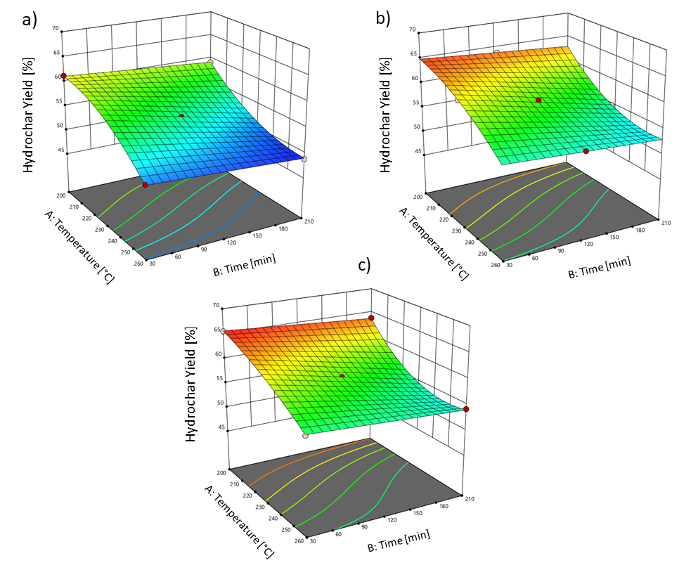
Figure 2: 3D response surface graphs for hydrochar yield as a function of temperature and time; (a) 5 wt % solid content, (b) 15 wt % solid content, (c) 25 wt % solid content.
    - Results of germination and phytotoxicity test
Hydrochars obtained from a range of raw material might contain some potentially phytotoxic compounds which usually are water soluble and are part of the dissolved organic carbon fraction, thus posing a threat for seed germination and plant growth (Bargmann et al., 2013; Lang et al., 2023). In the present experiment, the use of hydrochar with an elemental composition similar to lignite (HC lignite) did not reveal any significant phytotoxicity effect on the germination efficiency within 48 h after sowing nor in germination index after 21 days (Figure 3a,b), thus suggesting that HC lignite has low content in phytotoxic compounds. Moreover, Luutu et al. (2023) reported that a product from high-temperature HTC (260 °C) has no effect on seedlings emergence. Despite data on germination index on HC peat were not available, the growth index revealed a possible phytotoxicity after chronic seedlings exposure (Figure 3b).
Figure 3: Gemination index (I_{g}; a) of Lepidium sativum in control (CTRL) or treated with water extract of hydrochar with an elemental composition similar to lignite (HC lignite). Means (n =3 ± SD) were subjected to an unpaired t-test. ns, non-significative difference. Growth index (G_{m}; b) of Lepidium sativum in control (CTRL) condition and after treatment with hydrochars with elemental composition similar to lignite (HC lignite) or peat (HC peat). Means (n =5 ± SD) were subjected to a non-parametric Kruskal-Wallis test and significant differences among treatments were determined by Dunn's multiple comparisons post-hoc test (p ≤ 0.05) and indicated with different letters.
These results contrast with previous experiments which evidenced that higher HTC temperatures are most likely to increase its phytotoxic compound content (Celletti et al., 2021; Luutu et al., 2023). Anyway, these tests represent only a preliminary screening to disentangle the possible phytotoxicity of hydrochar obtained from M. aquaticum and further agronomic studies must be performed.
  - Conclusions
Results of the present study offer the clear evidence that HTC of M. aquaticum can be a win-win strategy to a wise and sustainable reuse of this biomass derived from an alien invasive species, allowing to produce a product (hydrochar) which can be proficiently used as a substrate for plant cultivation. Further investigation is recommended, as the produced hydrochar offers promising potential for agronomic applications.
Acknowledgments
The study has been funded under the National Recovery and Resilience Plan (NRRP), Mission 4 Component 2 Investment 1.3 - Call for tender No. 1561 of 11.10.2022 of Ministero dell’Università e della Ricerca (MUR); funded by the European Union – NextGenerationEU; Project code PE0000021, Concession Decree No. 1561 of 11.10.2022 adopted by Ministero dell’Università e della Ricerca (MUR), CUP I53C22001450006, Project title “Network 4 Energy Sustainable Transition – NEST”.
References
APAT (Italian Environmental Agency), 2003. Metodi microbiologici di analisi del compost. www.isprambiente.gov.it/contentfiles/00003500/3544-manuali-2003-20.pdf/
Bargmann I., Rillig M.C., Buss W., Kruse A., Kuecke, M., 2013, Hydrochar and biochar effects on germination of spring barley, Journal of agronomy and crop science, 199, 360-373.
Barontini F., Vitolo S., Gori R., Trivelli L., Puccini M., 2023, The Hydrothermal Carbonization Process for Waste Valorisation: a Study on the Effect of Process Conditions on the Yield and Properties of Hydrochars from Municipal Solid Waste, Chemical Engineering Transactions, 99, 181-186.
Cavali M., Libardi J.N., Dutra de Sena J., Woiciechowski A.L., Soccol C.R., Filho P.B., Bayard R., Benbelkacem H., Borges de Castilhos J.A., 2023, A review on hydrothermal carbonization of potential biomass wastes, characterization and environmental applications of hydrochar, and biorefinery perspectives of the process, Science of the Total Environment, 857, 159627.
Celletti S., Bergamo A., Benedetti V., Pecchi M., Patuzzi F., Basso D., Baratieri M., Cesco S., Mimmo T., 2021, Phytotoxicity of hydrochars obtained by hydrothermal carbonization of manure-based digestate, Journal of Environmental Management, 280, 111635.
D.Lgs 29 April 2010 n°75, 2009. Riordino e revisione della disciplina in materia di fertilizzanti, a norma dell’articolo 13 della legge 7 luglio 2009. vol. 88. www.gazzettaufficiale.it/eli/id/2010/05/26/010G0096/sg
Funke A., Ziegler F., 2010, Hydrothermal carbonization of biomass: a summary and discussion of chemical mechanisms for process engineering, Biofuels, Bioproducts and Biorefining, 4, 160–177.
Islam Md.A., Limon Md.S.H., Romić M., Islam Md.A., 2021, Hydrochar-based soil amendments for agriculture: a review of recent progress, Arabian Journal of Geosciences, 14, 102.
Lang Q., Guo X., Wang C., Li L., Li Y., Xu J., Zhao X., Li J., Liu B., Sun Q., Zou G., 2023, Characteristics and phytotoxicity of hydrochar-derived dissolved organic matter: Effects of feedstock type and hydrothermal temperature, Journal of Environmental Sciences. doi.org/10.1016/j.jes.2023.10.007
Luutu H., Rose M.T., McIntosh S., Van Zwieten L., Weng H.H., Pocock M., Rose T.J., 2023, Phytotoxicity induced by soil-applied hydrothermally-carbonised waste amendments: effect of reaction temperature, feedstock and soil nutrition, Plant and soil, 1-15.
Nizamuddin S., Baloch H.A., Griffin G.J., Mubarak N.M., Bhutto A.W., Abro R., Mazari S.A., Ali B.S., 2017, An overview of effect of process parameters on hydrothermal carbonization of biomass, Renewable and Sustainable Energy Reviews, 73, 1289-1299.
Reza M.T., Andert J., Wirth B., Busch D., Pielert J., Lynam J.G., Mumme J., 2014, Hydrothermal carbonization of biomass for energy and crop production. Applied Bioenergy, 1, 11-29.
Sharma H.B., Sarmah A.K., Dubey B., 2020, Hydrothermal carbonization of renewable waste biomass for solid biofuel production: A discussion on process mechanism, the influence of process parameters, environmental performance and fuel properties of hydrochar, Renewable and Sustainable Energy Reviews, 123, 109761.
Wang T., Zhai Y., Zhu Y., Li C., Zeng G., 2018, A review of the hydrothermal carbonization of biomass waste for hydrochar formation: Process conditions, fundamentals, and physicochemical properties, Renewable and Sustainable Energy Reviews, 90, 223-247.

