CHEMICAL ENGINEERING PROCEEDINGS  VOL. , 2024 | a publication of
The Italian association
of Chemical Engineering
Online at www.cetjournal.it

Guest editors: Leonardo Tognotti, Rubens Maciel Filho , Viatcheslav Kafarov
Copyright © 2024, AIDIC Services srl .
ISBN 979-12-81206-09- 0 ; ISSN 2283-9216

Immobilization of Peruvian Chlorella Microalgae for the Elimination of Nitrates and Phosphates in Municipal Wastewater
Junior A. Morales Zorrilla, Eusterio H. Acosta Suasnabar*, Elmer Benites-Alfaro, Carlos A. Castañeda Olivera, Verónica Tello Mendívil, Danny Lizarzaburu-Aguinaga

Universidad César Vallejo, School of Environmental Engineering, Av. Alfredo Mendiola 6232 Los Olivos, Lima-Peru.
Universidad César Vallejo, Formative Research Program, Av. Argentina 1795, Callao-Peru
Correspondent: eacostas@ucv.edu.pe

Microalgae are microscopic organisms found in marine and freshwater environments. They can carry out photosynthesis in a similar way to land plants, allowing them to use nitrogen (N) and phosphorus (P) as nutrients for their growth. In conventional wastewater treatment (tertiary treatment), Chlorella peruviana, a relatively understudied native species, is used for the removal of nutrients such as phosphates and nitrates to prevent pollution of water bodies. The objective of the study was to evaluate the immobilization of the microalga Chlorella peruviana for the elimination of nitrates and phosphates in the wastewater of the main collector of the San Gabriel neighborhood (AA.HH. San Gabriel), in the district of Comas, Lima. Eleven liters of wastewater were used to analyze its physical and chemical properties. To eliminate nitrates and phosphates, 1 liter of the wastewater sample was poured into 9 one-liter bioreactors and three different doses of microalgae immobilized in calcium alginate were added: 50, 100, and 150 g/L. After 5 days, the results were the following: at a dose of 150 g/L, 83.14% of the nitrates and 85.58% of the phosphates were removed. Finally, the effects of different doses of Chlorella peruviana microalgae immobilized on calcium alginate beads for the removal of nitrates and phosphates in wastewater were explained.

- Introduction
The rapid growth of both the human population and the global economy has caused a shortage of water resources suitable for direct consumption. Therefore, water remediation inevitably becomes a central objective globally (Abdelfattah et al., 2022). Water is an essential resource and a fundamental raw material in various industries and for domestic purposes (Morseletto et al., 2022). Wastewater contains various toxic compounds harmful to organisms and releases organic and inorganic nutrients into the environment, increasing chemical oxygen demand (COD) and biological oxygen demand (BOD). Aquatic eutrophication, caused by phosphorus (P) and nitrogen (N) loads, generates environmental impacts, solid waste production, and air emissions (Chen et al., 2020; Wang et al., 2022). There are various mechanisms to treat wastewater loaded with nitrate and phosphate ions; smoke dust from industrial waste has been used, removing more than 52.74% of nitrate and 92.38% of phosphate (Ali et al., 2021); The electrosorption process has been applied to remove phosphates and nitrates from wastewater with good possibilities, however, there are reserves for higher concentrations (Krishnamurthy et al., 2022) ; The sustainable removal of nitrates has also been sought by combining biological treatment with the use of membranes, with results of up to 98% removal efficiency (Pietrelli et al., 2022) . All these contributions gave rise to the question: What would the results be like with the use of microorganisms to treat these waters?
Microalgae can be cultivated in various type of wastewater and show great potential to remove pollutants from industrial and urban effluents (Abdelfattah et al., 2022). Several species of microalgae including Scenedesmus, Chlorella, Botryococcus, Phormidium, Limnospira (formerly Arthrospira, Spirulina), and Chlamydomonas, have been shown to exhibit outstanding capacity in wastewater bioremediation, removing nutrients, heavy metals, emerging contaminants, and pathogens. (López-Sánchez et al., 2022, and Ahmad et al., 2021). The presence of microalgae can reduce the risk of eutrophication by removing phosphorus (P) and nitrogen (N) components (Priyadharshini et al., 2021).
A promising strategy to improve the efficiency of Wastewater Treatment Plants (WWTP) is the co-culture of microalgae with other microorganisms. In this approach, microalgae collaborate symbiotically with heterotrophic microorganisms such as yeast, bacteria, and fungi. This process results in the exchange of nutrients and metabolites, which increases algal biomass yield and improves bioremediation (Chia et al., 2020; Li et al., 2022). The nitrogen absorption process in microalgae begins at the plasma membrane, where ${NO}_{3}^{-}$ it is reduced to ${NO}_{2}^{-}$. A part of ${NO}_{2}^{-}$ was produced is released into the aquatic environment, while another fraction of ${NO}_{2}^{-}$ is further reduced in the chloroplast, forming ${NH}_{4}^{+}$. This ammonium is then incorporated into the synthesis of amino acids (Burhenne and Tischner, 2000; Wang et al., 2010; Umamaheswari and Shanthakumar, 2016). During metabolism, the phosphate ion (${PO}_{4}^{3-}$) is assimilated into forms ${H_{2}PO}_{4}^{-}$ and ${HPO}_{4}^{2-}$ subsequently incorporated into organic compounds through the process of phosphorylation. At this stage, an important part of ${PO}_{4}^{3-}$is used for the synthesis of adenosine triphosphate (ATP) from adenosine diphosphate (ADP), providing the energy necessary for cellular functions (Martínez et al., 1999, Cai et al., 2013).
Microalgae are used in wastewater treatment not only for their effectiveness in removing nitrogen and phosphorus but also for their ability to eradicate pathogenic organisms. This is attributed to the generation of extreme pH levels and the production of substances with antibacterial effects that can be secreted by these microalgae (Ramírez-Mérida et al., 2015).
Wastewater treatment using microalgae has become a serious alternative to conventional technology. The objective of the study was to use the immobilized Chlorella peruviana microalgae for the elimination of nitrates and phosphates in wastewater from the main collector of the Comas district, Lima.

- Methodology
2.1. Preparation of Chlorella peruviana Microalgae
A 200 mL sample of Chlorella peruviana was used. This species was selected because it is considered a native microalga that is easily accessible in the region, so it can be used at a low cost. The microalgae culture was developed in 1.5 L of salt water obtained from the Peruvian Sea Institute (IMARPE).
The cultivation of Chlorella peruviana involved introducing the entire sample into a 1000 mL capacity bioreactor. 800 ml of seawater was added, resulting in 1 liter of solution. Subsequently, 5 g of Nitrofert 20-20-20 foliar fertilizer was added. Throughout the growth process, the Chlorella peruviana culture was subjected to constant aeration, with a photoperiod of 16 hours of light and 8 hours of darkness, at a light intensity of 1060 lumens and a temperature of 20 °C. This process was carried out during a cultivation period of 2 and a half months, without altering the conditions.

  - Monitoring Point Selection
The appropriate sampling point for the investigation was defined as the effluent from the sewer pipes of the community of San Gabriel, located in the district of Comas, province and department of Lima.

  - water sampling
The water sample was collected using a pick to lift the well cover. Since the stream was at a height of 2 meters, a bucket and rope were used to collect the water sample. It was then poured into a 20 L volume drum. Once the required volume was reached, the manhole was closed and finally, the water samples were transported to the laboratory for initial analysis and subsequent treatment.

  - Microalgae cell count
The cell count was carried out in the laboratory using the Neubauer chamber, allowing the number of Chlorella peruviana cells in the culture to be quantified. The counting was carried out under a microscope with 10x and 40x lenses for better appreciation.

  - Preparation of calcium alginate beads with microalgae.
To the Chlorella peruviana culture with 1 L volume, 15 g of sodium alginate was added. It was stirred continuously until a homogeneous and dense solution was obtained. Then, using a syringe, it was slowly dripped into a 2% calcium chloride solution, which was stirred gently, until small green spheres formed (see Figure 1). These spheres were immersed for 1 minute in the calcium chloride solution and then rinsed with distilled water.

  - Dose
50, 100, and 150 g of microalgae immobilized on calcium alginate beads were obtained for triplicate using a balance. These quantities were added to the wastewater samples, carrying out the treatment in triplicate, resulting in a total of 9 experimental units.

  - Treatment
The immobilized microalgae were subjected to the same growth conditions, as mentioned in the previous section on cultivation. This involved providing constant aeration with photoperiods of 16 hours of light and 8 hours of darkness, a light intensity of 1060 lumens, and an ambient temperature of 20 °C (see Figure 2). This growth period lasted 5 days.

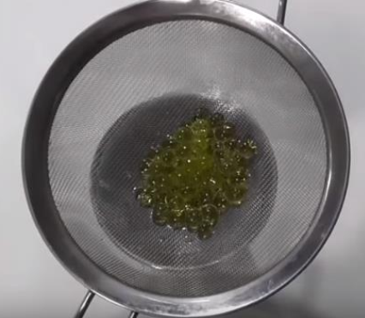 | 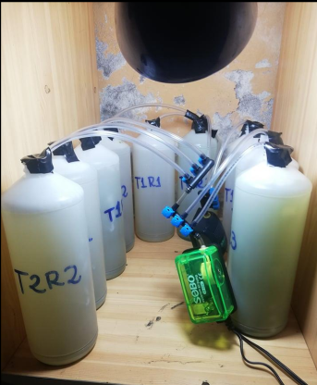
Figure 1. Chlorella peruviana immobilized in calcium alginate. | Figure 2. Wastewater treatment process.

  - Final parameter analysis
The microalgae beads were removed, and the water was poured into a clean flask. Subsequently, 50 mL of the sample was taken and transferred to a 250 mL beaker to measure the pH. Finally, samples from the 9 experimental units were sent to the laboratory for analysis of nitrate (${NO}_{3}^{-}$) and phosphate (${PO}_{4}^{3-}$) levels.

- Results
3.1 Characterization of Microalgae
In Table 1 it was observed that the Chlorella peruviana microalgae culture exhibited the typical characteristics of microalgae.

Table 1: Characteristics of microalgae cultivation
Cell concentration (Number of cells/mL) | pH | Length  (mm) | Temperature  (ºC)
30.1x106 | 8.8 | 5 | 19.5

3.2 Initial Water Characterization
Table 2 presents the results of the initial water analysis, showing the initial concentrations of nitrates and phosphates, as well as the pH and temperature values.

Table 2: Wastewater characteristics
Nitrate concentration (mg/L) | Phosphate concentration (mg/L) | pH | Temperature (°C)
23.9 | 22.4 | 8.2 | twenty

3.3 Final results
Table 3 shows the concentrations of nitrates, phosphates, and pH after applying doses of Chlorella peruviana immobilized in calcium alginate to wastewater, using three doses and the average of the three treatments.

Table 3: Nitrate concentration, phosphate concentration, and pH after applying the doses.
Dose  (g/L) | Nitrate concentration (mg/L) | Elimination  (%) | Phosphate concentration  (mg/L) | Elimination  (%) | pH
Make = Initial Sample | 23.90 |  | 22.4 |  | 8.20
D1 = 50 | 18.23 | 23.72 | 13.54 | 39.55 | 8.33
D2 = 100 | 10.50 | 56.07 | 7.97 | 64.42 | 8.50
D3 = 150 | 4.03 | 83.14 | 3.23 | 85.58 | 8.70

According to Table 3, it was observed that with higher doses of Chlorella peruviana immobilized in calcium alginate applied to wastewater, average values were obtained that reduced the concentration of nitrates and phosphates, while the pH showed an increase.

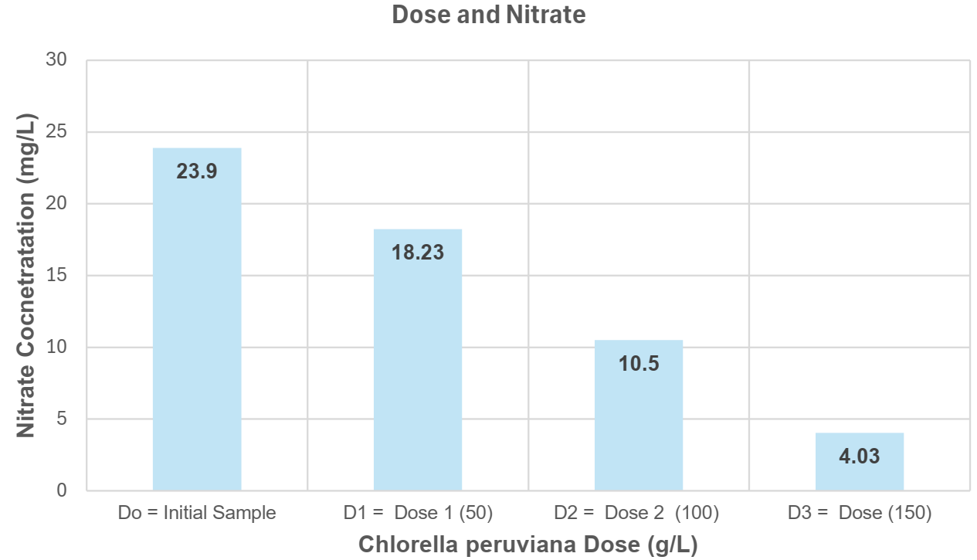 | 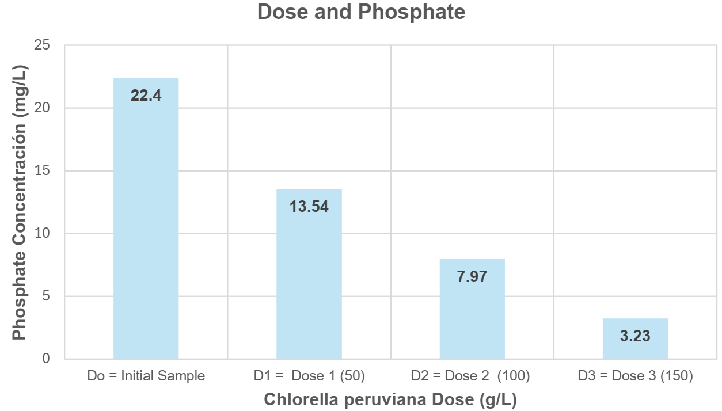
Figure 3. Dosage and Final Nitrate | Figure 4. Dosage and Final Phosphate

In Figure 3, the average nitrate concentration values ranged from 18.23 mg/L to 4.03 mg/L. Similarly, in Figure 4, the average phosphate concentration values varied between 13.54 mg/L and 3.23 mg/L. The microalgae were immobilized in 2% calcium alginate. According to Table 3, the maximum percentage removal of ${N-NO}_{3}^{-}$ was recorded in 83.14%, and the highest elimination value of ${PO}_{4}^{3-}$ was observed in 85.58%. In the most algae cultures it was observed that more than 50% and 70% of ${N-NO}_{3}^{-}$ and ${PO}_{4}^{3-}$, respectively, were eliminated during dose 2. Although immobilization had a negative impact on nutrient removal, the values obtained exceeded or fell within the high elimination ranges reported in previous studies. In this context, it is worth noting that both strains, whether freely grown or immobilized, show significant potential for use in the removal of inorganic nutrients in municipal wastewater, especially in the case of ${PO}_{4}^{3-}$(Ávila et al., 2018).

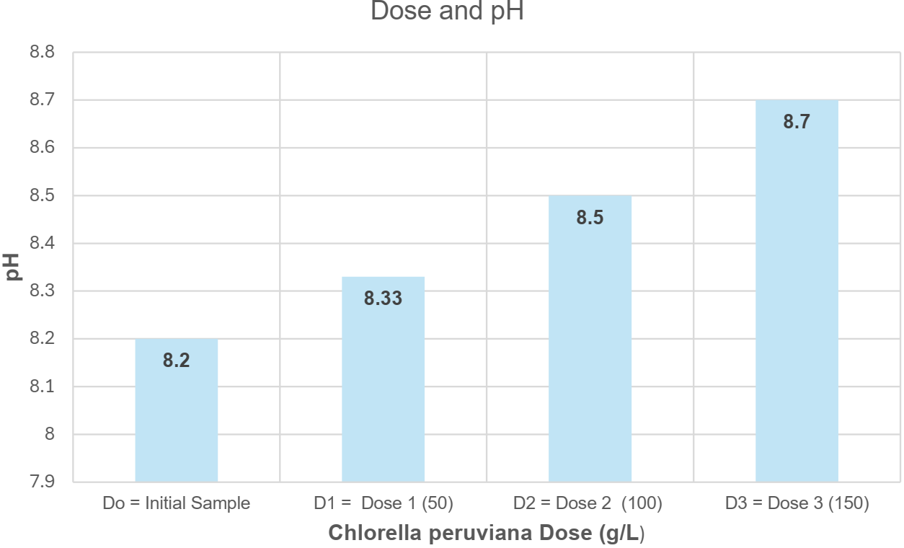
Figure 5. Dose and pH
In Figure 5 the pH obtained average values that ranged between 8.33 and 8.70. When increasing the dose of Chlorella peruviana there was a slight average increase up to 8.7 with dose 3. This increase is attributed to the photosynthesis process carried out by Chlorella, where the inorganic carbon present in the water is consumed (Bobadilla and Alvarez, 2018).

- Discussion
In the research, a significant decrease in nitrate and phosphate concentrations was observed when adding doses of immobilized Chlorella peruviana microalgae as detailed in Table 3. These results support the effectiveness of the application of microalgae for the removal of nutrients in wastewater. Comparing our results with previous research, Acevedo et al. (2017) achieved 65% phosphorus and 80% nitrogen removal using the microalgae Scenedesmus sp. This suggests that different microalgae species may have variations in their nutrient removal capacity, highlighting the importance of carefully selecting microalgae species for each specific application. Furthermore, Sayadi et al. (2016) used several species of microalgae in their study. Spirulina platensis achieved a removal of 81.49% of phosphate with a treatment of 0.45 g/L, while Chlorella vulgaris achieved a removal of 88% with the same treatment. It was also found that in the case of pearls in Chlorella minutissima (CM) and dairy wastewater algae (DWA) showed a nitrate removal efficiency of 94 % and 77% in that order; In the case of phosphate removal, CM removed 67.5% and DWA 100%, demonstrating outstanding efficiency for this contaminant (Kumar Singh et al., 2011). These results suggest that the effectiveness of different microalgae species may vary, and Chlorella peruviana used in our study demonstrates notable performance in removing nitrates and phosphates.
Compared with the results of Ávila et al. (2018), we noted some differences in nitrate and phosphate removal rates using microalgae. In their study, the free-form microalgae Chlamydomonas sp. reported a nitrate removal of 75.08%, while Chlorella sp. In its free form, it achieved the highest removal of phosphates, with an impressive 83.69%. These results suggest that different strains of microalgae may present variations in their nutrient removal capacity. In our study, with immobilized Chlorella peruviana, we observed notable effectiveness in reducing nitrate and phosphate concentrations in wastewater. Immobilization of microalgae could have a positive impact by improving the retention and removal capacity of inorganic nutrients, as demonstrated in our research.
Regarding pH, it is important to consider that the growth and development of microalgae are linked to temperature, so determining the optimal temperature for adequate development and growth is essential, considering the species of microalgae used (Bholase, 2004).

- Conclusions
Immobilized microalgae in the form of beads, with an approximate dimension of 5 mm and a concentration of 30.1x10 ⁶ cells per milliliter, can eliminate nitrates and phosphates present in wastewater. The microalga Chlorella peruviana successfully removed nitrates and phosphates from the wastewater of the collector by applying doses 1, 2, and 3. For nitrates, removals of 23.72%, 56.07%, and 83.14% were achieved, while for phosphates, removals of 39.55%, 64.42% and 85.58% were achieved. With dose 3, the removal of 83.14% and 85.58% of nitrates and phosphates, respectively, showed a good performance. These results demonstrate the reducing capacity of nitrates and phosphates can be used in water treatment industries, distilleries, sugar factories, textile industries, and fertilizer industries (Gizaw et al., 2021). The final pH increased slightly from 8.20 to 8.70. Thus, the immobilized Chlorella peruviana microalgae emerges as a promising alternative for the removal of nutrients in wastewater.

Recognition
The authors and GIGATRE thank “Investiga UCV” of the César Vallejo University for the financial support for the publication of this research.

References
Abdelfattah A., Ali SS, Ramadan H., El-Aswar EI, Eltawab R., Ho SH, Elsamahy T., Li S., El-Sheekh MM, Schagerl M., Kornaros M., Sun J., 2022, Microalgae-based wastewater treatment: mechanisms, challenges, recent advances and future perspectives. Environment Science Ecotecnol . 8, 13, 100205.
Acevedo S., Pino NJ, Peñuela GA, 2017, Nitrogen and phosphorus removal and biomass production of Scenedesmus sp in domestic wastewater. Spanish.
Ahmad I., Abdullah N., Koji I., Yuzir A., Mohamad SE, 2021, Potential of microalgae in wastewater bioremediation. Bull. Chemistry. React. Catal Eng, 16, 413–429.
Ali DA, Al-Mansi NM, Sadek MA, and Aboelnasr AW., 2021, Simultaneous Removal of Nitrate and Phosphate Ions from Aqueous Solutions Using Fume Dust from Electric Arc Furnace Industrial Waste. Chemical Engineering Transactions, 88 (June), 25–30. <doi.org/10.3303/CET2188004˃ accessed 28.03.2024.
Ávila, J., Laos, A., Verano, R., 2018, Removal of nitrates and phosphates by native strains of Chlorella sp. (Chlorellaceae) and Chlamydomonas sp. (Chlamydomonadaceae) in free and immobilized form in municipal wastewater. Arnaldoa . 25, 2, 499-514. Spanish.
Bholase P., 2004, Environmental and cultural stimulants in carotenoid production from microorganisms. Applied Microbiology and Biotechnology, 63, 4, 351 – 361.
Bobadilla A., Alvarez P., 2018, Evaluation of the use of Chlorella vulgaris in the removal of hexavalent chromium, chemical oxygen demand in wastewater from paper industries at laboratory level. Bachelor's Thesis, University of Guayaquil, Guayaquil, Ecuador. Spanish.
Burhenne N., Tischner R., 2000. Isolation and characterization of nitrite-reductase-deficient mutants of Chlorella sorokiniana (strain 211-8k). Plant 211: 440-445.
Cai T., SY Park SY, Li Y., 2013. Nutrient recovery from wastewater streams by microalgae: status and prospects. Renewable and Sustainable Energy Reviews 19: 360-369.
Chen M., Chang L., Zhang J., Guo F., Vymazal J., He Q., Chen Y., 2020, Global nitrogen input in wetland ecosystem: the driving mechanism of labile carbon and nitrogen soil in greenhouse gas emissions. Reign. Science. Ecotecnol, 4.
Chia WY, Tang DY, Khoo KS, Lup AN, Chew KW, 2020, Nature's fight against plastic pollution: algae for plastic biodegradation and bioplastic production. Reign. Science. Ecotecnol ., 4.
Gizaw A., Zewge F., Kumar A., Mekonnen A., and Tesfaye M., 2021, A comprehensive review on nitrate and phosphate removal and recovery from aqueous solutions by adsorption. Aqua Water Infrastructure, Ecosystems and Society, 70 (7), 921–947. <doi.org/10.2166/aqua.2021.146˃ accessed 03.28.2024.
Krishnamurthy S., Jayasayee K., Eide TAE, McKay K., Tschentscher R., Stensrød RE, and Sundig MF., 2022, Evaluation of Electrosorption Process for Phosphate and Nitrate Removal from Wastewater. Chemical Engineering Transactions, 96 (3), 79–84. <doi.org/10.3303/CET2296014˃ accessed 03.27.2024.
Kumar Singh S., Bansal A., Jha MK and Dey A., 2011, Comparative Studies on Uptake of Wastewater Nutrients by Immobilized Cells of Chlorella minutissima and Dairy Waste Isolated Algae. Indian Chemical Engineer, 53(4), 211–219. < doi.org/10.1080/00194506.2011.70644> accessed 03.27.2024.
Li S., Show PL, Ngo HH, Ho SH, 2022, Algal-mediated antibiotic wastewater treatment: a critical review. Reign. Science. Ecotecnol, 9.
López-Sánchez A., Silva-Gálvez AL, Aguilar-Juárez Ó., Senés-Guerrero C., Orozco-Nunnelly DA, Carrillo-Nieves D., Gradilla-Hernández MS, 2022, Treatment of livestock wastewater based on microalgae (MbWT) as a circular bioeconomy approach: improving biomass productivity, removing contaminants, and producing high-value compounds. J. Environment. Manager, 308
Martinez ME, Jiménez JM, El Yousfi E., 1999, Influence of phosphorus concentration and temperature on the growth and absorption of phosphorus by the microalgae Scenedesmus obliquus. Biological Resources Technology 67(3): 233-240.
Morseletto P., Mooren CE, Munaretto S., 2022, Circular water economy: definition, strategies and challenges, Circ. Economy. Hold, 1–5.
Pietrelli L., Ferro S., Reverberi A.P., and Vocciante M., 2022, Sustainable Removal of Nitrates from Wastewater using Membrane Bioreactors. Chemical Engineering Transactions, 91 (3), 217–222. <doi.org/10.3303/CET2291037˃ accessed 03/27/2024.
Priyadharshini SD, Babu PS, Manikandan S., Subbaiya R., Govarthanan M., Karmegam N., 2021, Wastewater Phytoremediation for Pollutant Removal: An Ecological Approach for Long-Term Environmental Protection and Remediation. Reign. Pollution., 290.
Ramírez-Mérida LG, Zepka LQ, Menezes CR, Jacob-Lopes E. 2015, Microalgae as a nanofactory for the production of antimicrobial molecules. Nanomedicine and Nanotechnology Magazine, S6-004.
Sayadi, M., Ahmadpour, N., Fallahi CM, Rezaei M., 2016, Removal of nitrate and phosphate from aqueous solutions by microalgae: an experimental study. Global Journal of Environmental Science and Management., 2, 3, 357 – 364.
Umamaheswari J., Shanthakumar S., 2016, Efficacy of microalgae for industrial wastewater treatment: a review of operating conditions, treatment efficiency and biomass productivity. Reviews in Environmental Sciences and Bio/Technology 15(2): 265-284.
Wang C., Luo D., Zhang X., Huang R., Cao Y., Liu G., Zhang Y., Wang H., 2022, Biochar-based slow release fertilizers for sustainable agriculture: a mini review. Reign. Science. Ecotecnol, 10
Wang L., Min M., Li y., Chen P., Chen Y., Liu Y., Wang Y., Ruan R., 2010. Cultivation of green algae Chlorella sp. in different wastewater from the municipal wastewater treatment plant. Applied Biochemistry and Biotechnology, 162(4),1174-1186.

