CHEMICAL ENGINEERING TRANSACTIONS  VOL. , 2024 | A publication of
The Italian Association
of Chemical Engineering
Online at www.cetjournal.it

Guest Editors: Leonardo Tognotti, Rubens Maciel Filho, Viatcheslav Kafarov
Copyright © 2024, AIDIC Servizi S.r.l.
ISBN 979-12-81206-09-0; ISSN 83-9216

Evaluation of Hydrogen utilization for Catalytic Hydrodeoxygenation of residual Biomass Pyrolysis oil at atmospheric pressure
Lorenzo Bartolucciª, Stefano Cordinerª, Massimiliano Materazzi^{b}, Pietro Mele^{a,}*, Vincenzo Mulone ª, Hualun Zhu^{b},
ª University of Rome Tor Vergata, Department of Industrial Engineering, via del Politecnico 1, 00133 Rome, Italy
^{b} University College London, Department of Chemical Engineering, London WC1E 7JE, United Kingdom
*Pietro.Mele@uniroma2.it
Biomass is an abundant renewable energy resource that can be converted into carbon-based biofuels. Pyrolysis is a thermochemical process that allows the rapid conversion of residual biomass and biowaste into bio-oil, a liquid biofuel with a high energy density. Hydrodeoxygenation (HDO) is a catalytic process in which typically high-pressure hydrogen is used to remove oxygen mainly through dehydration, decarboxylation and decarbonylation reactions from the oxygenated compounds of bio-oil. The objective of this work is to evaluate the process of hydrodeoxygenation under mild conditions, i.e. atmospheric pressure, quantifying the hydrogen consumption and the degree of deoxygenation. The organic fraction of the pyrolysis oil of spent coffee grounds has been processed in a packed-bed reactor in a semi-continuous regime. The performance of two different MoO₃/NiO alumina-supported catalysts were evaluated at 350°C and LHSV of 0.5. The results showed a high upgraded oil yield (72-87 w/w %), limited gas production (up to 1 w/w%) and a limited coking (12-26 % w/w). GC-MS analysis of upgraded oil showed a significant reduction of hydrocarbons molecular weight, as well as caffeine, fatty acids and furans relative concentration, while pyridines, phenolics and ketones were still very abundant. The measured hydrogen consumption was very limited (up to 1g/L bio-oil), suggesting that increasing pressure would be beneficial for higher degree of deoxygenation.
  - Introduction

Recent extraordinary weather events, linked to the effect of climate change, underline the need to limit the increase in the global average temperature below 1.5 ° C. IEA in the last energy report stresses the importance of reaching net zero CO₂ emissions by 2050, to meet the objectives set (IEA 2023). In this context, bioenergy will be a key-driver in the renewable energy mix in various energy-intensive sectors such as industry, transportation and heating. In detail, bioenergy demand is expected to increase from 55 EJ (2019) to more than 150 EJ by 2050 and will represent 25% of the total energy supply (IRENA 2023).
In this context, thermochemical processes allow the efficient conversion of the energy potential of residual biomass into valuable bioenergy carriers for different utilization, i.e. combined heat and power generation, heat generation for the industry and production of liquid biofuels for sectors difficult to be decarbonized (Fytili and Zabaniotou 2018; Silveira Junior et al. 2021).
Pyrolysis is a the thermal depolymerization process for the conversion of feedstock into bio-oil, biochar and non-condensable gas, carried out in total absence of oxidating agents (Volpe et al. 2014) . Operating conditions such as temperature, residence time and inert atmosphere play a crucial role to determining process performances and product characteristics (Zhang et al. 2011; Salehi et al. 2011). In fast pyrolysis, the rapid heating of feedstocks with short vapors residence time (up to 5 s) at the temperature of 400-500°C maximizes the bio-oil yield.
Pyrolysis oil is a viscous dark-brown liquid biofuel with HHV of 16-19 MJ/kg (A. Bridgwater 2012). Bio-oil finds application as a fuel for heating generation in industrial processes. However, due to the high water content, acidity and chemical instability, pyrolysis oil cannot be directly used as transportation fuel (Han et al. 2019). Most of its undesirable properties are attributed to the high presence of oxygenated compounds such as acids, aldehydes, ketones and oxygenated aromatics. Therefore, pyrolysis oils must be upgraded to remove oxygenated compounds and high-molecular weight hydrocarbons (Stummann et al. 2021).
Among the upgrading strategies, catalytic hydrotreatment is considered the most beneficial for optimum bio-oil quality (Bartolucci et al. 2023). The main advantage of catalytic hydrotreatment is that oxygen can be removed by reactions with hydrogen, generating an aqueous layer that can be easily separated from upgraded oil. In catalytic fast pyrolysis, oxygen is removed mainly through CO₂/CO molecules, resulting in significant carbon losses (Eschenbacher et al. 2021). Therefore, hydrodeoxygenation (HDO) is considered a process the maximizes both the degree of deoxygenation and the carbon conversion.
Several studies have already investigated the catalytic HDO process under mild operating conditions, that is, moderate temperature (375°C-450°C) and near-atmospheric pressure (1-4 bar). Eschenbacher et al. (2020) demonstrated that atmospheric HDO in line with fast pyrolysis process was able to reduce the oxygen content of the wheat straw bio-oil up to 7-12 wt. %. They used a TiO₂-supported-Pt (0.5 wt%) and MoO₃ (10 wt%) in and an hydrogen atmosphere up to 50% H2 in volume. R. Cross et al. (2020) demonstrated that reactive catalytic hydropyrolysis of pine sawdust using MoO₃-based catalyst was able to reduce the oxygen content of bio-oil up to 5 wt.%, considering a maximum operating pressure of 4 bar.
In view of the above, this study aims at contributing to the development of near-atmospheric HDO, providing data on the effectiveness of the process for spent coffee grounds (SCG) pyrolysis oil. A packed-bed reactor in downflow operation was employed for HDO in semicontinuous regime. Two different MoO₃-NiO catalysts, alumina-supported, differentiated by acid and basic impregnation process, were tested and compared for the deoxygenation performance of the SCG pyrolysis oil. GC-MS analysis of the upgraded oil was carried out to compare the chemical composition of the upgraded oil with that of the thermal processed oil (without catalyst). Finally, hydrogen consumption was calculated to understand the economic competitiveness of the process.

  - Materials and Methods

    - Feedstock
Spent coffee grounds (SCG), a blend of arabica/robusta 40:60 by weight, as specified by the producers, were collected from the coffee shop of the Department of Engineering of the University of Rome ‘Tor Vergata’. The feedstock was dried for 12 h in a static oven at 105 ∓ 1 °C before each test, sieved to obtain a uniform particle size with a mesh between the 500-850 μm. After that, dried SCG were pyrolyzed at 500°C employing a laboratory scale screw-type reactor, operated in semi-continuous mode. The solid residence time of the feedstock was about 10 s. and the test was conducted under inert atmosphere. After condensation, SCG pyrolysis oil spontaneously fractionated into heavy organic fraction and aqueous residue. The two bio-oil fraction were collected separately and the product yield calculated gravimetrically. For the catalytic upgrading only the organic fraction was considered. Further details about the pyrolysis set-up can be found elsewhere (Bartolucci et al. 2023).
    - Catalyst
Two catalysts for hydrotreatment were produced by Catal International Ltd. Both catalysts had the same composition (16.2% MoO₃, 1-8% NiO on alumina support), but the first was impregnated in acid (CT_A) and the second one in basic solution (CT_B). CT_A and CT_B were dispatched in 1.8-mm spheres. Before the test, all the catalysts were reduced in a hydrogen atmosphere employing the same procedure. As indicated by the catalysts supplier, catalyst activation started at 300°C, introducing hydrogen up to 10 % (vol/vol) in the nitrogen atmosphere for 10 min. After that, temperature was increased to 350°C and hydrogen was progressively introduced at a step of 10% (vol / vol) and up to 50% (vol/vol) in the nitrogen atmosphere. The total activation time was about 2 hours.
2.3 Experimental Set-up
A packed-bed reactor was employed for the catalytic upgrading of the organic fraction of SCG pyrolysis oil. Briefly, a LEGATO ® 180 syringe pump (KD Scientific Inc.) fed the pyrolysis oil through a 1 mm needle in the top section of a reactor at the volumetric flow rate of 30 ml/h. The reactor consisted of a 200 mm long AISI 304 vertical tube with internal diameter of 25.4 mm. The supplied gas (nitrogen/hydrogen mixture) was preheated before entering contact with oil up to 300°C. Gas flow was controlled through two mass flow controllers (Bronkhorst, F-201CZ). A wire mesh supported the catalyst in the central part of the reactor. Before each test, 20 g of clay/catalyst were loaded into the reactor. Downstream of the reaction zone, a two-stage condensation system was composed by impinger bottles, immersed in a water-ice solution. To clean the gas for uncondensed vapors, a bubbler filled with 100 mL of isopropanol was employed. A Rapidox 7100 multigas analyser (Cambridge Sensotec) was used for the online gas analysis, determination of gas yield and calculation of hydrogen consumption during the test. Based on the gas analyzer measurement, the gas yield was calculated. The coke yields were calculated by difference. A heating tape was used to heat up the reactor. Four K-type thermocouples measured the temperature every 50 mm of the reactor. Before each test, the reactor was heated to 300 ° C under nitrogen conditions, with a constant flow of 0.6 L/min, keeping a GHSV of 1000. After that, the catalyst activation procedure started. After activation, the temperature was kept at 350 ° C and the gas flow rate adjusted to 1.5 L/min with H₂/N₂ (10:90 vol/vol). An LHSV of 0.5 and a vapors nominal residence time of 0.8 seconds were selected. At the end of each test, the condensing bottles were weighted to measure the oil yield, and the samples were kept in the refrigerator for further analysis.
2.4 Analytical Methods
A Shimadzu QP2020 NX, equipped with a SH-Rxi-5ms column (30 m × 0.25 mm × 0.25 μm) was employed for GC-MS analysis of the samples. The GC was programmed by maintaining 40 °C for 1 min, followed by heating to 325 °C at a heating rate of 15 °C/min and held at the final temperature for 30 mins. The injection took place at 200 °C in a split mode, injecting 1μL sample. The flow rate of the carrier gas (He) was adjusted at 1.99 mL/min. The ion source temperature was 200 °C and the interface temperature 280°C for the mass selective detector. Data were acquired in 50 –300 m/z scan mode. The solvent cut time was 5 min.

  - Results
    - Product Yields
In Figure 1 the yields of atmospheric HDO process are reported. As shown, liquid recovery was in the range of 72 to 95 wt. % and was lower in the case of catalytic upgrading. The condensed liquid resulted in a single phase. Similar studies on atmospheric deoxygenation reported the appearance of two phases in the condensed products (Eschenbacher et al. 2020; Koike et al. 2016). However, in this study the atmospheric HDO was a separated step and not integrated with the pyrolysis process. Therefore, the aqueous fraction of SCG pyrolysis oil was previously removed and the upgrading regarded only the heavy organic fraction. Liquid yield for packed-bed reactor with down-flow operation are generally in the range of 30-68 wt. % (Han et al. 2019); however, generally HDO is operated under more severe pressure conditions (50-200 bar) and the degree of deoxygenation is very high (Han et al. 2019). For SCG heavy fraction of pyrolysis oil upgrading, Waheed et al. reported that liquid yields of the upgraded oil fraction are in the range of 50-97 wt.%, (Waheed et al. 2024). In the case of catalytic upgrading the gas yield remained stable, increasing up to 1% in the case of CAT_B. Table 1 expresses the volumetric composition of the gas produced in the tests. As clearly shown, CO and CO₂ were the major species measured as expected, since the main hydrodeoxygenation reactions produces CO₂, CO and H₂O by decarbonylation/decarboxylation and ketonization reactions of the oxygenated compounds with hydrogen (Han et al. 2019) (Dabros et al. 2018). As evident, a higher CO₂/CO ratio obtained in the case of catalytic upgrading, suggesting how the catalysts employed are active to remove oxygen at mild pressure conditions. More in detail, the highest CO₂/CO ratio was obtained by CAT_B. Hydrogen consumption of the HDO process is shown in Table 1. At mild pressure conditions, in this study the hydrogen required for the HDO reaction is very low, under 1 g/L of pyrolysis oil. In this case, the CAT_A catalyst consumed more hydrogen for the atmospheric conversion of oxygenated compounds.
J. Peters (2017) reported a value of hydrogen consumption of approximately 4.1 g H₂ / kg of the oil for a first stage of HDO process with residual 30 wt. % of oxygen of the condensate. R. French et al. (2011) reported a value of 50 g H₂/kg bio-oil for hydrogen consumption to obtain an almost complete degree of deoxygenation.
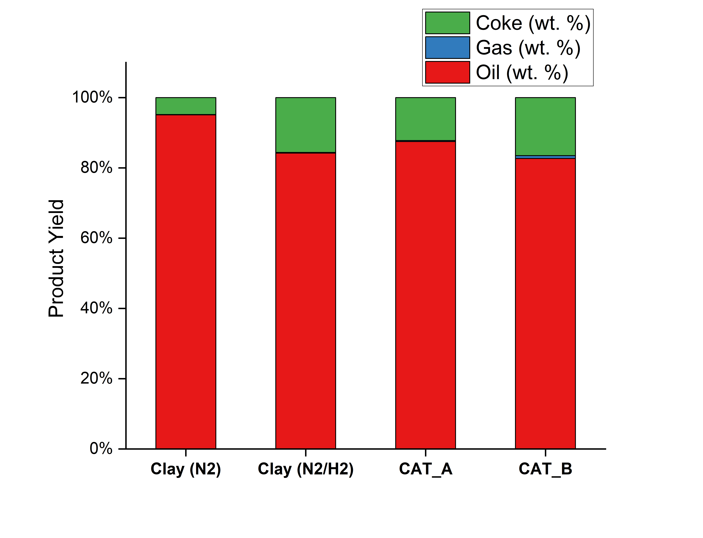
Figure 1 Product yields of thermal and catalytic upgrading of SCG pyrolysis oil

Table 1 Gas composition of thermal upgrading and atmospheric HDO of SCG pyrolysis oil
Sample | CH₄(vol/vol %) | CO₂(vol/vol %) | CO (col/vol %) | H₂ Consumed (g/L oil)
Clay (N₂) | 0.2 | 32.4 | 67.4 | -
Clay (N₂/H₂) | 0.9 | .7 | 76.4 | -
CAT_A | 1 | 18.3 | 80.7 | 0.9
CAT_B | 0.9 | 24.2 | 74.9 | 0.4

    - Pyrolysis oil characterization

The chromatograms of GC-MS analysis of pyrolysis oil and upgraded oil are presented in Figure 2. The chromatogram is very similar in the case of pyrolysis oil and thermal upgraded samples, both in the case with nitrogen and nitrogen/hydrogen atmosphere. This is an interesting result and demonstrates that thermal processing does not alter the composition of the oil. However, some modifications of the chromatogram are noticed in the case of atmospheric HDO.
More in detail, the catalytic upgrading reduces the relative peak area of the caffeine (the high peak on the right) and the regions of oxygenated compounds/fatty acids identified in the central region of the chromatogram.
Table 2 reports the results of GC-MS analysis, where the organic compounds were classified by component groups. As evident, caffeine relative concentration significantly drops, while the relative concentration of pyridines (N-containing compounds) increases. Thus, is possible to conclude that caffeine undergoes a decomposition to N-containing compounds characterized by lower molecular weight. Similar results were obtained by Waheed et al. (2024) who investigated the catalytic upgrading of the SCG heavy fraction of pyrolysis oi under supercritical ethanol conditions. The concentration of fatty acids decreases significantly, attributable to cracking to shorter chains by decarbonylation and decarboxylations reactions. Phenolics concentrations increases in the case of catalytic upgrading. A similar results regarding the phenolics enrichment of the oil was reported by A. Eschenbacher et al. (2020) in atmospheric HDO of wheat straw employing MoO₃ catalyst. Phenolics are the most persistent oxygen species and require particularly severe hydrotreatment conditions to be deoxygenated (Cross et al. 2020). Ketones relative abundance is also subjected to a rise, attributable to a ketonizations reactions carboxylic acids, that are difficult to deoxygenize (Eschenbacher et al. 2020). A similar ketones enrichment was obtained by Parthasarathy and Narayanan (2014) in the hydrotreatment of various lignocellulosic pyrolysis oil under severe process conditions.
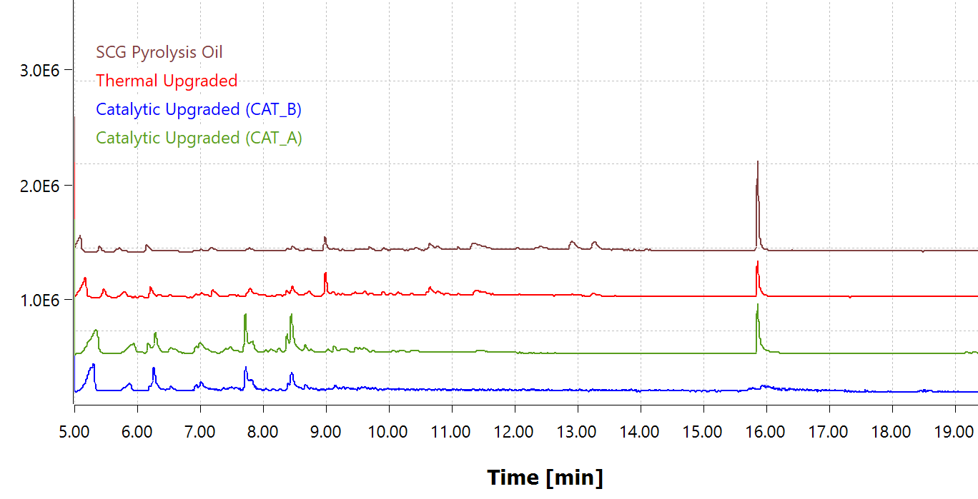
Figure 2 Chromatograms of GC-MS analysis of pyrolysis oil, thermal upgraded (clay) and catalytic upgraded (CAT_A and CAT_B)
Table 2 GC-MS analysis of raw and upgraded SCG oil
Component Group (Peak Area %) | SCG Pyrolysis Oil | CAT_A Upgraded | CAT_B Upgraded
Caffeine | 40.8% | .1% | 4.4%
Fatty Acids/Esters | 35.4% | 13.3% | 19.5%
Pyridines | 5.6% | 20.5% | 31.4%
Furans | 3.7% | 0.0% | 0.0%
Ketones | 10.2% | 24.6% | 29.0%
Phenolics | 4.4% | 19.5% | 15.7%

  - Conclusions
The objective of this work was to understand the performance of atmospheric HDO as a cost-effective pyrolysis oil upgrading strategy. The results illustrated moderate changes in the chemical composition of the upgraded SCG oil, which highlighted acceptable activity of MoO₃-supported catalysts at ambient pressure and 350°C. Moreover, the high yield of upgraded oil and the reduced hydrogen consumption suggested the high potential of packed-bed reactor configuration for semicontinuous operations. Further analyses are required to assess the effective degree of deoxygenation and hydrogen uptake of the process. In the further development of this work, the experimental set-up will be adapted for hydro-processing of pyrolysis oil exploring different operating condition sets.
Acknowledgments
The authors would like to thank Dr. Xiangyi Long from the Department of Chemical Engineering at the Imperial College of London for the GC-MS analysis of the pyrolysis oil and upgraded oils.

References
Bartolucci, L., S. Cordiner, P. Mele, and V. Mulone. 2023. Defatted Spent Coffee Grounds Fast Pyrolysis Polygeneration System: Lipid Extraction Effect on Energy Yield and Products Characteristics. Biomass and Bioenergy 179 (December 20): 106974. https://doi.org/10.1016/j.biombioe.2023.106974.
Bridgwater, A.V. 2012. Review of Fast Pyrolysis of Biomass and Product Upgrading. Biomass and Bioenergy 38: 68–94. https://doi.org/10.1016/j.biombioe.2011.01.048.
Cross, P., K. Wang, J. Weiner, E. Reid, J. Peters, O. Mante and D.C. Dayton. 2020. Reactive Catalytic Fast Pyrolysis of Biomass over Molybdenum Oxide Catalysts: A Parametric Study. Energy and Fuels 34 (4): 4678–84. https://doi.org/10.1021/acs.energyfuels.0c00320.
Dabros, T.M.H., M.Z. Stummann, M. Høj, P. A. Jensen, J.D. Grunwaldt, J. Gabrielsen, P.M. Mortensen and A.D. Jensen. 2018. Transportation Fuels from Biomass Fast Pyrolysis, Catalytic Hydrodeoxygenation, and Catalytic Fast Hydropyrolysis. Progress in Energy and Combustion Science 68: 268–309. https://doi.org/10.1016/j.pecs.2018.05.002.
Eschenbacher, A., P. Fennell and A.D. Jensen. 2021. A Review of Recent Research on Catalytic Biomass Pyrolysis and Low-Pressure Hydropyrolysis. Energy and Fuels 35 (): 18333–69. https://doi.org/10.1021/acs.energyfuels.1c02793.
Eschenbacher, A., A. Saraeian, B. H. Shanks, P. A. Jensen, C. Li, J. Øllgaard Duus, A. B. Hansen. 2020. Enhancing Bio-Oil Quality and Energy Recovery by Atmospheric Hydrodeoxygenation of Wheat Straw Pyrolysis Vapors Using Pt and Mo-Based Catalysts. Sustainable Energy and Fuels 4 (4): 1991–2008. https://doi.org/10.1039/c9se01254k.
French, R. J., J. Stunkel and R. M. Baldwin. 2011. Mild Hydrotreating of Bio-Oil: Effect of Reaction Severity and Fate of Oxygenated Species. Energy and Fuels 25 (7): 3266–74. https://doi.org/10.1021/ef200462v.
Fytili, D. and A. Zabaniotou. 2018. Circular Economy Synergistic Opportunities of Decentralized Thermochemical Systems for Bioenergy and Biochar Production Fueled with Agro-Industrial Wastes with Environmental Sustainability and Social Acceptance: A Review. Current Sustainable/Renewable Energy Reports 5 (2): 150–55. https://doi.org/10.1007/s40518-018-0109-5.
Han, Y., M. Gholizadeh, C. Cong Tran, S. Kaliaguine, C. Z. Li, M. Olarte and M. Garcia-Perez. 2019. Hydrotreatment of Pyrolysis Bio-Oil: A Review. Fuel Processing Technology 195 (May). https://doi.org/10.1016/j.fuproc.2019.106140.
IEA. 2023. World Energy Outlook, 23–28.
IRENA. 2023. World Energy Transitions Outlook 2023: 11.5°C Pathway, Volume 2. International Renewable Energy Agency (IRENA). https://irena.org/Digital-Report/World-Energy-Transitions-Outlook-20%0Ahttps://irena.org/publications/2021/March/World-Energy-Transitions-Outlook.
Koike, N., S. Hosokai, A. Takagaki, S. Nishimura, R. Kikuchi, K. Ebitani, Y. Suzuki, and S. Ted Oyama. 2016. Upgrading of Pyrolysis Bio-Oil Using Nickel Phosphide Catalysts. Journal of Catalysis 333: 115–26. https://doi.org/10.1016/j.jcat.2015.10.0.
Parthasarathy, P. and S. K. Narayanan. 2014. Effect of Hydrothermal Carbonization Reaction Parameters On. Environmental Progress & Sustainable Energy 33 (3): 676–80. https://doi.org/10.1002/ep.
Peters, J.F. 2017. Pyrolysis for Biofuels or Biochar? - A Thermodynamic, Environmental and Economic Assessment. https://doi.org/10.13140/RG.2.2.34448.30721.
Salehi, E., J. Abedi and T. Harding. 2011. Bio-Oil from Sawdust: Effect of Operating Parameters on the Yield and Quality of Pyrolysis Products. Energy and Fuels 25 (9): 4145–54. https://doi.org/10.1021/ef200688y.
Silveira J., E. G., Nathalia R.F. da Silva, V.H. Perez, G. F. David, F.L. Olivares, S. A. Fernandes, O.R. Justo and E. Simionatto, 2021, Fast Pyrolysis of Peanut Husk Agroindustrial Waste: Intensification of Anhydro Sugar (Levoglucosan) Production. Waste and Biomass Valorization 12 (10): 5573–85. https://doi.org/10.1007/s12649-021-01403-3.
Stummann, M.Z., H. Martin, J. Gabrielsen, R. Lasse, P. Arendt and A. Degn. 2021. A Perspective on Catalytic Hydropyrolysis of Biomass 143 (January). https://doi.org/10.1016/j.rser.2021.110960.
Volpe, M., C. D’Anna, S. Messineo, R. Volpe and A. Messineo. 2014. Sustainable Production of Bio-Combustibles from Pyrolysis of Agro-Industrial Wastes. Sustainability (Switzerland) 6 (11): 7866–82. https://doi.org/10.3390/su6117866.
Waheed, W., G. Amini, J.Y. Park, and I.G. Lee. 2024. Catalytic Upgrading of the Heavy Fraction of Waste Coffee Grounds Pyrolysis Bio-Oil Using Supercritical Ethanol as a Hydrogen Source to Produce Marine Biofuel. Chemical Engineering Science 287 (January): 119761. https://doi.org/10.1016/j.ces.2024.119761.
Zhang, H., Rui X. , D. Wang, G. He, S. Shao, J. Zhang and Z. Zhong. 2011. Biomass Fast Pyrolysis in a Fluidized Bed Reactor under N 2, CO 2, CO, CH 4 and H 2 Atmospheres. Bioresource Technology 102 (5): 4258–64. https://doi.org/10.1016/j.biortech.2010.12.075.

