CHEMICAL ENGINEERING TRANSACTIONS  VOL. , 2024 | A publication of
The Italian Association
of Chemical Engineering
Online at www.cetjournal.it

Guest Editors: : Leonardo Tognotti, Rubens Maciel Filho, Viatcheslav Kafarov
Copyright © 2024, AIDIC Servizi S.r.l.
ISBN 979-12-81206-09-0; ISSN 2283-9216

Thermodynamic Equilibrium of Hydrate Formation in Multiphase and Multicomponent Systems
Isabela T. Hilario, Reginaldo Guirardello*
School of Chemical Engineering, University of Campinas, Av. Albert Einstein 500, 13083-852, Campinas – SP, Brazil.
*guira@feq.unicamp.br

Hydrates are crystalline structures composed of water molecules and low molecular weight compounds, formed under appropriate conditions of pressure and temperature. Depending on the circumstances, these crystalline solids can be seen as a problem or a solution. In a negative context, gas hydrates tend to cause serious flow assurance problems in the petroleum industry. On the other hand, these hydrates can be used in the separation, transport and storage of gas, playing an important role in reducing the impacts caused by greenhouse gases (GHG). In this context, there is a need for a consistent assessment of the thermodynamic equilibrium of systems with a tendency to form hydrates in order to solve the problems and enable their large-scale use. Therefore, this study presents a rigorous analysis of hydrate phase equilibrium in systems composed of carbon dioxide (CO₂), methane (CH₄), propane (C₃H₈) and glycerol (C₃H₈O₃). For this, the isofugacity and Gibbs energy minimization methodologies were used. With this work, it was possible to develop a rigorous evaluation of the phase equilibrium of hydrate-forming systems, investigate the use of C₃H₈ as a promoter and C₃H₈O₃ as a hydrate inhibitor, and the influence of thermodynamic conditions on the occupation of hydrate cavities by molecules CO₂ and CH₄. The results obtained in this study were compared with experimental data available in the literature, enabling the conclusion about the satisfactory prediction of the phase equilibrium behavior of the investigated systems.
  - Introduction
Hydrates are crystalline structures made up of water and low molecular weight molecules, formed under conditions specific thermodynamics, generally of high pressures and low temperatures. Water molecules come together through hydrogen bonds, forming cavities responsible for keeping one or more compounds inside. The presence of these compounds inside the hydrates provides stability to the crystalline structure through van der Waals interactions (Sloan and Koh, 2008).
In the energy industry, the spontaneous formation of hydrates in gas pipelines and equipment can result in obstructions that compromise efficient operation, which can lead to explosions and consequent economic losses, safety risks and environmental damage. Furthermore, the sudden release of gas in natural gas hydrate reserves, whether through environmental changes or human intervention, also poses a significant challenge due to the high concentration of CH₄ present in these deposits (Shahnazar and Hasan, 2014).
On the other hand, hydrates can have beneficial applications when used in carbon capture and storage (CCS) processes, contributing to the mitigation of impacts caused by greenhouse gases (GHG). Capturing CO₂ through hydrates can reduce its concentration in the atmosphere, since the captured CO₂ can be used in the process, stored in the oceans or injected into reserves of natural gas hydrates, replacing CH₄. In this case, it is a method of CO₂ sequestration and CH₄ recovery simultaneously (Wang, Zhang and Lipiński, 2020).
The use of thermodynamic inhibitors and promoters is essential due to their ability to control the formation and stability of hydrates, playing different roles in this process. While thermodynamic inhibitors act to prevent the formation of hydrates in pipes and equipment, promoters act by attenuating the thermodynamic conditions for the formation of these hydrates, which results in a reduction in energy costs (Sloan and Koh, 2008).
Thus, a comprehensive understanding of the formation and behavior of hydrates under various conditions of pressure, temperature and composition is essential for the advancement of technologies related to these materials. Therefore, the motivation of this work was to carry out a rigorous analysis of the thermodynamic equilibrium of the systems CH₄ + CO₂ + C₃H₈ + H₂O and CH₄ + C₃H₈O₃ + H₂O. For this, Gibbs isofugacity and energy minimization methodologies were used, since the combination of these methods allows the determination of the compositions of a multiphase and multicomponent system in a solid and stable manner. The cubic Soave-Redlich-Kwong (SRK) equation was used to calculate the liquid and gaseous phases, since it is suitable for a wide variety of systems, especially nonpolar components (Ghanbari et al., 2017). Furthermore, the Van Der Waals and Platteeuw models were used to describe the solid phase of the hydrate.
  - Methodology
This work represents an extension of our previous research (Bicalho and Guirardello, 2022). In this study, thermodynamic equilibrium was investigated for the multicomponent systems CH₄ + CO₂ + C₃H₈ + H₂O and CH₄ + C₃H₈O₃ + H₂O, considering the presence of a promoter and a thermodynamic inhibitor.
    - Isofugacity
The methodology used in this study to describe the behavior of the liquid and vapor phases of the systems was based on the use of the Soave-Redlich-Kwong (SRK) cubic equation, expressed explicitly by Eq(1).
$$P=\frac{RT}{V-b}-\frac{a\left(T\right)}{V\left(V+b\right)}$$ | (1)
The fugacity coefficients of component $i$ in the liquid and vapor phases of the mixture were calculated using Eq(2), presented in its generalized form, as described by Prausnitz et al. (1999).
$$\ln{{\hat{φ}}_{i}}=\frac{1}{RT}\int_{V}^{∞}{\left[{\left(\frac{∂P}{∂n_{i}}\right)}_{T,V,n_{j≠i}}-\frac{RT}{V}\right]}dV-lnZ i=1, … ,NC$$ | (2)
In this work, a phi-phi approach was used to determine the fugacity of the $i$-component in the liquid and vapor phases of the mixture, according to Eq(3).
$${\hat{f}}_{i}={\hat{φ}}_{i}∙x_{i}∙P$$ | (3)
The model adopted for the solid phase was based on the equations proposed by Waals and Platteeuw (1959). Thus, the water fugacity in the crystalline structure of the hydrate was determined by applying Eq(4).
$${\hat{f}}_{w}^{H}=f_{w}^{0}∙exp\left[\sum_{m=1}^{NCAV}{ϑ_{m}∙ln\left(1-\sum_{i=1}^{NC-1}{θ_{i}^{H,m}}\right)+\frac{∆μ_{0}}{RT_{0}}+\frac{∆H_{0}}{R}}\left(\frac{1}{T}-\frac{1}{T_{0}}\right)-\frac{∆c_{P}}{R}\left[ln\left(\frac{T}{T_{0}}\right)+\frac{T_{0}}{T}-1\right]+\frac{P∆V_{0}}{R\overline{T}}\right]$$ | (4)
When formulating this equation, the different types of cavities (NCAV) that can be formed by the non-aqueous components present in the system are taken into account. The values of the parameters of the state transition properties of water ($∆μ_{0}, ∆V_{0}, ∆H_{0}$ and $∆c_{P}$), ranging from the aggregation state of pure liquid water to structures I, II and H, which are possible to be formed by the system, still corresponding to a metastable intermediate phase, were obtained through studies conducted by Pedersen et al. (2014) and Parrish and Prausnitz (1972). The term $\overline{T}$ is responsible for accounting for the temperature dependence on the PV/T term and can be calculated from the average between the system temperature $T$ and the reference temperature $T_{0}$ which is 273.15 K in Eq(4). The term $ϑ_{m}$, which corresponds to the number of cavities of type $m$ per water molecule, was also obtained by Pedersen et al. (2014). The occupancy fraction of molecule $i$ in cavity $m$ ($θ_{i_{m}}$) was calculated using Eq(5).
$$θ_{i_{m}}=\frac{C_{i_{m}}{\hat{f}}_{i}}{1+\sum_{j=1}^{NC}{C_{j_{m}}}{\hat{f}}_{j}} i=1, …, NC-1$$ | (5)
From Eq(6), based on the Langmuir model of gas adsorption, it was determined the constant for $i$-component in a cavity of type $m$, which was proposed by Munck et al. (1988).
$$C_{i_{m}}=\frac{A_{i_{m}}}{T}∙exp\left(\frac{B_{i_{m}}}{T}\right) i=1, …, NC-1$$ | (6)
The values of parameters A and B were obtained from studies by Pedersen et al. (2014) and Parrish and Prausnitz (1972). The iterative numerical procedure used to equalize the fugacity for the same components in different phases (solid, liquid and vapor), satisfying the isofugacity criterion, was carried out with the help of Microsoft Office Excel 2019.
    - Gibbs Energy Minimization
Eq(7) corresponds to the integration the partial molar Gibbs energy equation over the entire gas or vapor phase (V), liquid phase (L) and stable crystalline phase for solid hydrate (H) and also over all NC components of the system, considering isothermal and isobaric conditions.
$$G=\sum_{i=1}^{NC}{\left(n_{i}^{V}μ_{i}^{V}+n_{i}^{L}μ_{i}^{L}\right)+\sum_{i=1}^{NC-1}{\sum_{m=1}^{NCAV}{\left(n_{i}^{H,m}μ_{i}^{H,m}\right)+\left(n_{w}^{H}μ_{w}^{H}\right)}}}$$ | (7)
For the liquid and vapor phases, the chemical potential for the $i$-component in the mixture can be calculated from a convenient reference state (ideal gas at 1 atm and $T$) to the chemical potential under system conditions $T$ and $P$, as presented by Eq(8):
$$μ_{i}\left(T,P\right)- μ_{i}^{0}\left(T,P_{0}\right)=RTln\left(\frac{{\hat{φ}}_{i}∙x_{i}∙P}{P_{0}}\right)$$ | (8)
where $P_{0}$ is 1 atm (1.013 bar). From Eq(9) it was possible to calculate the chemical potentials of the guest molecules of each $i$-component hosted in each type $m$ cavity in the crystalline structure of the hydrates.
$$μ_{i}^{H,m}=μ_{i}^{0}(T,P_{0})+{∆G}_{i}^{m^{0}}+RTln\left(\frac{θ_{i}^{H,m}}{1-\sum_{i=1}^{NC-1}{θ_{i}^{H,m}}}\right)$$ | (9)
The chemical potentials for all $i$ in the standard state ($μ_{i}^{0}$), at $T$ and $P_{0}$, were calculated from Atkins and Paula (2006), using as reference the pure state at 298.15 K and $P_{0}$. The term ${∆G}_{i}^{m^{0}}$ was calculated using Eq(10):
$${∆G}_{i}^{m^{0}}=-RT\left[ln\left(\frac{A_{i_{m}}}{T}\right)+\frac{B_{i_{m}}}{T}\right]$$ | (10)
The occupation fraction of $i$-molecule in cavity $m$ is defined by Eq(11):
$$θ_{i}^{H,m}=\frac{n_{i}^{H,m}}{ϑ_{m}∙n_{w}^{H}} i=1,…, NC-1$$ | (11)
The determination of the chemical potential of water in the crystalline structure of the hydrate was based on the equation proposed by Waals and Platteeuw (1959), as presented in Eq(12):
$$μ_{w}^{H}=μ_{w}^{β}+RT\sum_{m=1}^{NCAV}{ϑ_{m}\ln\left(1-\sum_{i}{θ_{i}^{H,m}}\right)}$$ | (12)
with Eq(13) determining the chemical potential of water in the metastable intermediate crystalline phase ($μ_{w}^{β}$):
$$μ_{w}^{β}=μ_{w}^{L}+∆μ_{0}\left(\frac{T}{T_{0}}\right)+{∆H}_{0}\left(1-\frac{T}{T_{0}}\right)-T{∆c}_{P}\left[ln\left(\frac{T}{T_{0}}\right)+\frac{T_{0}}{T}-1\right]+\frac{PT∆V_{0}}{R\overline{T}}$$ | (13)
where $μ_{w}^{L}$ is the chemical potential of pure liquid water at $T$, and $T_{0}$ is 273.15 K in Eq(13). By replacing Eq(8), Eq(9) and Eq(12) in Eq(7), it is possible to obtain the objective function of the minimization problem as Eq(14):
$$G\left(T, P,n_{i}^{k}\right) = \sum_{i=1}^{NC}{n_{i}^{L}\left[μ_{i}^{0}+RTln\left(\frac{{\hat{φ}}_{i}^{L}∙x_{i}∙P}{P_{0}}\right)\right]} + \sum_{i=1}^{NC}{n_{i}^{V}\left[μ_{i}^{0}+RTln\left(\frac{{\hat{φ}}_{i}^{V}∙y_{i}∙P}{P_{0}}\right)\right] }$$  $$+ \sum_{i=1}^{NC-1}{\sum_{m=1}^{NCAV}{n_{i}^{H,m}}}\left[μ_{i}^{0}+{∆G}_{i}^{m^{0}}+RTln\left(\frac{θ_{i}^{H,m}}{1-\sum_{i=1}^{NC-1}{θ_{i}^{H,m}}}\right)\right]+n_{w}^{H}\left[μ_{w}^{β}+RT\sum_{m=1}^{NCAV}{ϑ_{m}\ln\left(1-\sum_{i}{θ_{i}^{H,m}}\right)}\right]$$ | (14)
The Gibbs energy minimization problem is subject to the molar balance constraints for water in all phases of the system, the molar balance constraints for the non-aqueous $i$-components also in all phases, and the non-negativity of the number of moles of any component in any phase, according to Eq(15), Eq(16) and (17).
$$n_{w}^{V}+n_{w}^{L}+n_{w}^{H}=n_{w}^{T}$$ | (15)
$$n_{i}^{V}+n_{i}^{L}+n_{i}^{H,s}+n_{i}^{H,l}=n_{i}^{T} i=1,…,NC-1$$ | (16)
$$n_{i}^{k}≥0$$ | (17)
The solution to the nonlinear programming (NLP) problem, given by minimizing Eq(14), and subject to Eq(11) and restrictions (15)-(17), was carried out using version 23.9.5 of the GAMS software, using CONOPT4, which is a robust solver based on the Generalized Reduced Gradient algorithm (GRG) for solving NLP problems.
  - Results and Discussion
In Figures 1a and 1b, the phase equilibrium curves, obtained through the isofugacity methodology, are presented, together with the geometric points, determined by the Gibbs energy minimization criterion. The curves are outlined as a function of temperature and pressure. Tables 1 and 2 present the results obtained through the application of the Gibbs energy minimization criterion.

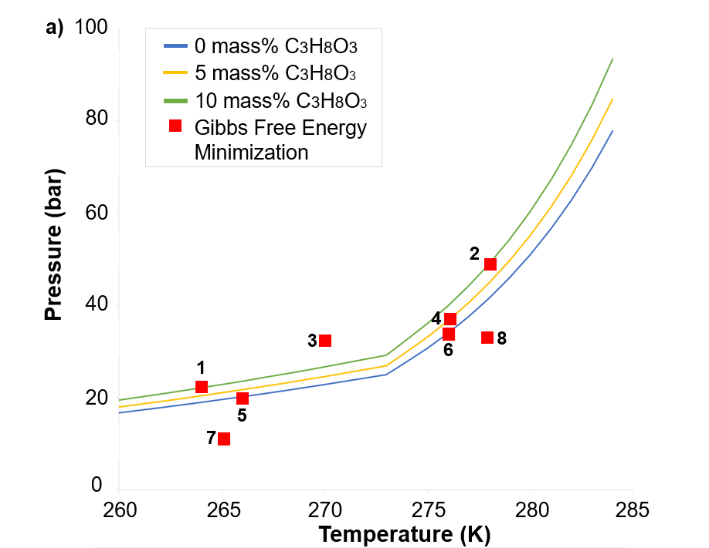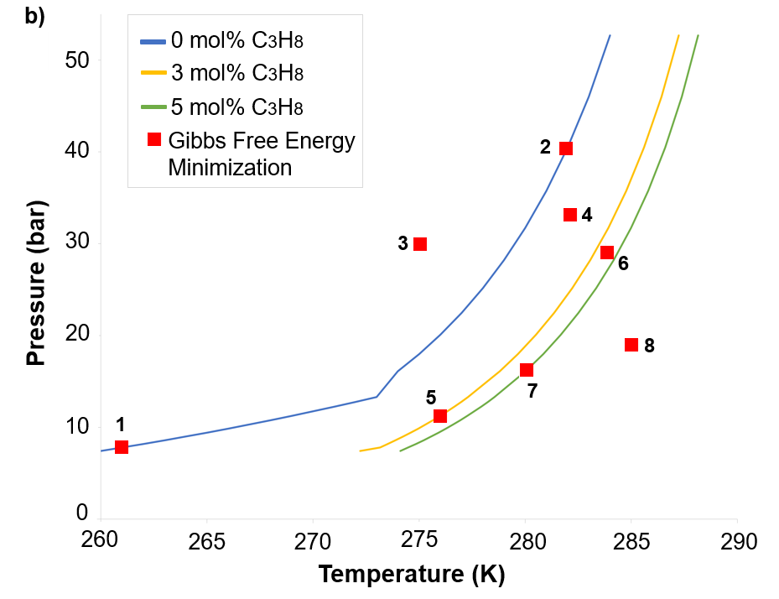
Figure 1: Results for systems a) CH₄ + C₃H₈O₃ +H₂O, in mass fraction, and (b) CH₄ + 75% CO₂ + C₃H₈ + H₂O, in mole fraction, both on a dry basis.
Table 1: Molar quantities in the hydrate structures, at the geometric points, for the CH₄ + H₂O system with a C₃H₈O₃ molar fraction of 0 mass%, 5 mass% and 10 mass% in the gas phase on a dry basis.
N. | Comp. | T (K) | P(bar) | n  initial | Gas | Liquid  or Ice | n  small | n  large | n  structural | θ  small | θ  large
1 | CH₄ | 264 | 22.118 | 2000 | 1829.192 | 7*10⁻⁷ | 29.354 | 141.455 | - | 0.6139 | 0.9861
 | H₂O |  |  | 1100 | 0.182 | 1*10⁻⁷ | - | - | 1099.818 | - | -
 | C₃H₈O₃ |  |  | 23.909 | 0 | 23.909 | - | - | - | - | -
2 | CH₄ | 278 | 48.956 | 2000 | 1806.269 | 4*10⁻⁶ | 37.097 | 156.634 | - | 0.7018 | 0.9878
 | H₂O |  |  | 1216 | 0.284 | 2*10⁻⁷ | - | - | 1215.716 | - | -
 | C₃H₈O₃ |  |  | 26.430 | 0 | 26.430 | - | - | - | - | -
3 | CH₄ | 270 | 32.000 | 2000 | 1842.644 | 0 | 28.607 | 128.748 | - | 0.6580 | 0.9870
 | H₂O |  |  | 1000 | 0 | 1*10⁻⁷ | - | - | 1000 | - | -
 | C₃H₈O₃ |  |  | 21.735 | 0 | 21.735 | - | - | - | - | -
4 | CH₄ | 280 | 55.137 | 2000 | 1745.731 | 2*10⁻⁶ | 49.385 | 204.884 | - | 0.7145 | 0.9881
 | H₂O |  |  | 1590 | 0.295 | 1*10⁻⁷ | - | - | 1589.705 | - | -
 | C₃H₈O₃ |  |  | 16.370 | 0 | 16.370 | - | - | - | - | -
5 | CH₄ | 266 | 20.200 | 130 | 114.653 | 0 | 2.522 | 12.825 | - | 0.5803 | 0.9834
 | H₂O |  |  | 100 | 0.015 | 2*10⁻⁷ | - | - | 99.985 | - | -
6 | CH₄ | 276 | 33.955 | 300 | 257.859 | 0 | 7.483 | 34.657 | - | 0.6376 | 0.9843
 | H₂O |  |  | 270 | 0.047 | 4*10⁻⁷ | - | - | 269.953
7 | CH₄ | 265 | 11.000 | 100 | 100 | 0 | 0 | 0 | - | 0 | 0
 | H₂O |  |  | 100 | 0 | 100 | - | - | 0 | - | -
8 | CH₄ | 278 | 33.000 | 100 | 100 | 0 | 0 | 0 | - | 0 | 0
 | H₂O |  |  | 100 | 0 | 100 | - | - | 0 | - | -

Table 2: Molar quantities in the hydrate structures, at the geometric points, for the CH₄ + 75 mol% CO₂ + H₂O system with a C₃H₈ molar fraction of 0 mol%, 3 mol% and 5 mol% in the gas phase on a dry basis.
N. | Comp. | T (K) | P(bar) | n  initial | Gas | Liquid  or Ice | n  small | n  large | n  structural | θ  small | θ  large
1 | CO₂ | 261.0 | 7.807 | 32.022 | 28.497 | 0 | 0.789 | 2.736 | - | 0.7267 | 0.8392
 | CH₄ |  |  | 10.000 | 9.496 | 0 | 0.041 | 0.463 | - | 0.0375 | 0.1419
 | H₂O |  |  | 25.000 | 0.008 | 6*10⁻⁶ | - | - | 24.992 | - | -
2 | CO₂ | 282.0 | 40.476 | 32.392 | 23.286 | 0 | 0.893 | 8.213 | - | 0.2739 | 0.8397
 | CH₄ |  |  | 10.000 | 7.760 | 0 | 0.767 | 1.472 | - | 0.2353 | 0.1505
 | H₂O |  |  | 75.000 | 0.010 | 1*10⁻⁵ | - | - | 74.990 | - | -
3 | CO₂ | 275.0 | 30.0 | 36.497 | 35.104 | 0 | 0.183 | 1.210 | - | 0.3825 | 0.8431
 | CH₄ |  |  | 12.000 | 11.701 | 0 | 0.087 | 0.211 | - | 0.1827 | 0.1472
 | H₂O |  |  | 11.000 | 0.000 | 0 | - | - | 11.000 | - | -
4 | CO₂ | 282.0 | 33.0 | 30.000 | 30.000 | 0 | 0 | 0 | - | 0 | 0
 | CH₄ |  |  | 10.000 | 10.000 | 0 | 0 | 0 | - | 0 | 0
 | H₂O |  |  | 16.000 | 0 | 16.000 | - | - | 0 | - | -
5 | CO₂ | 275.993 | 11.255 | 30.604 | 28.856 | 0 | 1.261 | 0.487 | - | 0.4291 | 0.3315
 | CH₄ |  |  | 9.000 | 8.445 | 0 | 0.545 | 0.010 | - | 0.1854 | 0.0067
 | H₂O |  |  | 25.000 | 0.020 | 6*10⁻⁶ | - | - | 24.980 | - | -
 | C₃H₈ |  |  | 2.118 | 1.154 | 0 | 0 | 0.964 | - | 0 | 0.6560
6 | CO₂ | 284.0 | 29.0 | 28.800 | 28.800 | 0 | 0 | 0 | - | 0 | 0
 | CH₄ |  |  | 10.000 | 10.000 | 0 | 0 | 0 | - | 0 | 0
 | H₂O |  |  | 16.000 | 0 | 16.000 | - | - | 0 | - | -
 | C₃H₈ |  |  | 1.200 | 1.200 | 0 |  |  | - | 0 | 0
7 | CO₂ | 280.018 | 16.121 | 36.112 | 30.322 | 0 | 4.513 | 1.277 | - | 0.4514 | 0.2556
 | CH₄ |  |  | 10.000 | 8.067 | 0 | 1.907 | 0.026 | - | 0.1908 | 0.0051
 | H₂O |  |  | 85.000 | 0.021 | 1.1*10⁻⁵ | - | - | 84.979 | - | -
 | C₃H₈ |  |  | 5.699 | 2.022 | 0 | 0 | 3.677 | - | 0 | 0.7356
8 | CO₂ | 285.0 | 19.0 | 28.000 | 28.000 | 0 | 0 | 0 | - | 0 | 0
 | CH₄ |  |  | 10.000 | 10.000 | 0 | 0 | 0 | - | 0 | 0
 | H₂O |  |  | 16.00 | 0 | 16.000 | - | - | 0 | - | -
 | C₃H₈ |  |  | 2.000 | 2.000 | 0 | 0 | 0 | - | 0 | 0

The thermodynamic equilibrium curves, calculated using the isofugacity criterion, show the coexistence of the vapor, water (solid or liquid) and hydrate phases. The region above the three-phase equilibrium curves corresponds to the two-phase region of hydrate stability, while the region below the curves does not form hydrate crystals. Validation of the results was carried out by comparing the results obtained in this work with experimental phase equilibrium studies available in the literature. Using the work of Mohammadi et al. (2008), Chapoy et al. (2014), Adisasmito and Sloan (1971), Yousefi et al. (2023) and Robinson and Mehta (1971) the largest deviations from the experimental values found were 3.10 % and 4.30 % for the systems CH₄ + CO₂ + C₃H₈ + H₂O and CH₄ + C₃H₈O₃ + H₂O, respectively. According to Lu and Sultan (2008), deviations below 5 % are considered acceptable. From this perspective, the comparative results mentioned allow us to conclude that thermodynamic modeling was sufficient and accurate in predicting the thermodynamic equilibrium for the systems studied.
In the Gibbs energy minimization methodology, for each numbered geometric point in the phase diagrams, the molar quantities of the components in all equilibrium phases were determined, together with the occupancy fractions of the gaseous components in the large and small cavities of the hydrates. Although systems composed of CH₄, CO₂ and H₂O form type I structures, the presence of C₃H₈ induces a change in structure, favoring the formation of type II structures.
Analysis of these results leads to the conclusion that the number of moles of non-aqueous components and water in the structure is zero when the geometric points are located below the three-phase equilibrium curve. This means that, under these conditions, the formation of hydrates does not occur, with only the non-aqueous components in the vapor phase and water in the liquid or solid phase being in equilibrium. These results were expected, given that this region is located outside the region of hydrate stability.
On the other hand, the geometric points positioned above the three-phase equilibrium curve indicate the presence of the solid phase (hydrate) and non-aqueous components in the vapor phase. This condition reiterates that this region represents the biphasic region of hydrate stability. Additionally, it is possible to observe that the occupancy fractions are zero when hydrate formation does not occur. However, when the geometric points are located in the hydrate stability region, the hydrate cavities are occupied by non-aqueous components present in the system.
Finally, the results also highlight the non-stoichiometric nature of the hydrates, as all the water was used in the formation of the hydrate, while the surplus of non-aqueous components remained in the vapor phase.
  - Conclusions
A thermodynamic equilibrium analysis was developed for the systems CH₄ + CO₂ + C₃H₈ + H₂O and CH₄ + C₃H₈O₃ + H₂O. The stable equilibrium was outlined based on Gibbs isofugacity and energy minimization criteria, with a detailed description of all equations used. The validation of the results showed that the intrinsic limitations associated with the equation of state and the statistical models used did not significantly influence the results of this study, presenting maximum deviations of 3.10% and 4.30%, respectively. These deviations, less than 5%, indicate that the thermodynamic modeling used was effective in predicting the thermodynamic equilibrium in the investigated systems. Furthermore, it is worth highlighting that, in the Gibbs energy minimization methodology, the conditions necessary for thermodynamic equilibrium lead to the isofugacity equations and Eq(5), which is naturally satisfied. Finally, it is important to highlight that the algorithms developed for both methodologies are not restricted to the results presented, being capable of describing the phase equilibrium of different systems under different conditions of temperature, pressure and/or composition.
References
Adisasmito S., Sloan E.D., 1971, Hydrates of Hydrocarbon Gases Containing Carbon Dioxide, Journal of Chemical & Engineering Data, 37, 343 – 349.
Atkins P.W., Paula J. (Eds), 2006, Physical Chemistry, W.H. Freeman and Company, New York, NY.
Bicalho I.T., Guirardello R., 2022, Thermodynamic Calculation for the Formation of Methane and Carbon Dioxide Hydrates, Chemical Engineering Transactions, 92, 379 – 384.
Chapoy A., Burgass R.W., Kalorazi B. T., 2014, Hydrate inhibition in propylene glycol and glycerol systems, Paper presented at 8th International Conference on Gas Hydrates 2014, Beijing, China.
Ghanbari M., Ahmadi M., Lashanizadegan A., 2017, A comparison between Peng-Robinson and Soave-Redlich-Kwong cubic equations of state from modification perspective, Cryogenics, 84, 13 –19.
Lu Z., Sultan N., 2008, Empirical expressions for gas hydrate stability law, its volume fraction and mass-density at temperatures 273.15 K to 290.15 K, Geochemical Journal, 42, 163 – 175.
Mohammadi A.H., Kraouti I., Richon D., 2008, Experimental Data and Predictions of Dissociation Conditions for Methane, Ethane, Propane, and Carbon Dioxide Simple Hydrates in the Presence of Glycerol Aqueous Solutions, Industrial & Engineering Chemistry Research, 21, 8492 – 8495.
Munck J., Jorgensen S.S., Rasmussen P., 1988, Computations of the Formation of Gas Hydrates, Chemical Engineering Science, 43, 2661 – 2672.
Parrish W.R., Prausnitz J.M., 1972, Dissociation Pressures of Gas Hydrates Formed by Gas Mixtures, Industrial & Engineering Chemistry Process Design and Development, 11, 26 – 35.
Pedersen K.S., Christensen P.L., Shaikh J.A. (Eds), 2014, Phase Behavior of Petroleum Reservoir Fluids, Taylor & Francis Group, Boca Raton, FL.
Prausnitz J.M., Lichtenthaler R.N., Azevedo E.G. (Eds), 1999, Molecular Thermodynamics of Fluid-Phase Equilibria, Prentice Hall PTR, Upper Saddle River, NJ.
Robinson D. B., Mehta B. R., 1971, Hydrates in the Propane – Carbon Dioxide – Water System, Journal of Canadian Petroleum Technology, 10, 33 – 35.
Shahnazar S., Hasan N., 2014, Gas hydrate formation condition: Review on experimental and modeling approaches, Fluid Phase Equilibria, 379, 72 – 85.
Sloan E.D., Koh C.A. (Eds), 2008, Clathrate Hydrates of Natural Gases, CRC Press, New York, NY.
Waals J.H.V., Platteeuw J.C., 1959, Clathrate Solutions, In: I. Prigogine (Ed), Advances in Chemical Physics, Vol 2, Interscience Publishers, New York, NY, 1 – 58.
Wang X., Zhang F., Lipiński W., 2020, Research progress and challenges in hydrate-based carbon dioxide capture applications, Applied Energy, 269, 114928.
Yousefi S., Bahrami M., Najibi S. H., 2023, Hydrate phase equilibria of carbon dioxide/propane gas mixture in concentrated aqueous sodium chloride solutions: Experimental data and prediction, 376, 121417.

