CHEMICAL ENGINEERING TRANSACTIONS  VOL. , 2023 | A publication of
The Italian Association
of Chemical Engineering
Online at www.cetjournal.it

Guest Editors: Leonardo Tognotti, Rubens Maciel Filho, Viatcheslav Kafarov
Copyright © 2024, AIDIC Servizi S.r.l.
ISBN 979-12-81206-10-1; ISSN 2283-9216

Bioprocessing of Industrial Wastewater for Removal of Heavy Metal ions by Ulva Lactuca (Seaweed) Biomass
Abiola Ezekiel Taiwo^{a,}*, Paul Musongeª, Oladoyin D. Jegede^{b}
ªFaculty of Engineering, Mangosuthu University of Technology, Durban 4026, South Africa
^{b}Department of Chemical Engineering, Landmark University, Omu-Aran Kwara State, Nigeria
taiwo.abiola@mut.ac.za; taiwoabiolaezekiel@gmail.com
Pollution from industrial effluents is a major concern because of their toxicity and threat to human life and the environment. The discharge of industrial effluents into water bodies has sparked widespread concern due to the potential health risks associated with toxic components entering the human and animal food chains. This study aims at the removal of selected heavy metal ions from industrial wastewater using Ulva lactuca (seaweed) biomass. A batch reactor study was carried out to remove selected heavy metal ions from industrial wastewater. Atomic absorption spectroscopy and Fourier Transform Infrared Spectroscopy (FTIR) were used to quantify heavy metal ions and adsorbent characterization. The maximum removal efficiency was 55.00% and 81.71%, respectively, for chromium and lead at pH 4, 60 mins contact time, temperature of 40 ºC, 1 mg absorbent dosage, and agitating speed of 200 rpm. Absorption behaviour was described using the Langmuir and Freundlich isotherm models. Freundlich isotherm model (R²≈1) was in good agreement with the experimental data and best described the studies based on data fitness. Kinetics data were best modeled by a Pseudo second-order equation. The study demonstrated that the Ulva lactuca (seaweed) biomass is a promising, biodegradable, eco-friendly adsorbent. The data obtained from the study would be useful to industry stakeholders for proper waste management plans.
  - Introduction
Water is a natural resource vital to human life and the environment's health, but the availability of a safe supply is difficult due to climate change and human interference (Scanlon et al., 2023). The release of industrial wastewater into the environment significantly negatively influences the receiving water bodies, making it one of the main sources of environmental contamination (Okey-Onyesolu et al., 2022). It is necessary to investigate whether the wastewater discharged by industrial operations meets regulatory requirements. The discharge of wastes into the water bodies by humans has brought about modiﬁcation of the environmental water quality, hence making substantial quantities of water unsuitable for various uses (Lin et al., 2022). Heavy metals are not biodegradable and tend to accumulate in organisms and cause numerous diseases and disorders, heavy metals are a member of a loosely defined subset of elements that exhibit metallic properties, which mainly includes transition metals, some metalloids, lanthanides, and actinides (Lin et al., 2022). Heavy metal's detrimental health impacts are well-known worldwide; metals and semimetals (metalloids) that have been linked to contamination and possible toxicity or ecotoxicity are commonly referred to as metalloids (Oladipo et al., 2021). For the adsorption of Ulva lactuca (seaweed), there is currently a growing interest in utilizing low-cost adsorbent that are eco-friendly and sustainable rather than the use of synthetic chemicals as biosorbents, which are generally expensive and lead to incomplete metal removal, high energy consumption and generation of toxic sludge after adsorption process. The use of low-cost adsorbents to remove toxic heavy metals was classified and reported in recent years as agricultural waste, domestic waste, industrial waste and forest trees (Liza et al., 2022). These adsorbents were reported to be efficient, abundant, and cost-effective.
Previous studies have reported the potential of seaweed as an adsorbent on various waste from different sources owing to its eco-friendly nature and the availability and low cost of raw materials. Biosorption via seaweed has become a viable alternative to existing technologies for removing pollutants such as dyes from textiles, paper, the printing industry, nitrogen and phosphorus, phenolic compounds, and heavy metals from various sources (Mathew et al., 2016). Seaweed is primarily constituted of brown or green macroalgae, which are recognized for their high quantity of alginate material, which might potentially bind metallic ions (Yang et al., 2021). Marine algae possess good metal biosorption capabilities due to active functional groups on the surface of their cell walls. The application of marine macroalgae as activated carbon materials has numerous advantages, including low cost, extensive availability, and high metal binding efficiency (El-Naggar and Rabei, 2020). Marine algae (seaweeds) are renewable natural biomass, and they are extremely efficient biosorbents with a high binding capacity to various metals and dye pollutants in aqueous effluents. Studies have shown that synthetic or simulated industrial wastewater treatment with seaweed has drawbacks in that it does not depict the actual characteristics of wastewater, which are relatively complex (Arumugam et al., 2018). The industrial wastewater used in this project was collected from the paint industry at the endpoint of release to the river. In addition, the results of simulated paint wastewater treatment plants might not be comparable to real-world industrial wastewater treatment plants. The aim of this study is to use Ulva lactuca (seaweed) biomass, a low-cost adsorbent, to remove chromium and lead from industrial wastewater effluent. The removal of chromium and lead metal ions was examined, as well as the effects of solution pH, contact time, and adsorbent doses.
  - Materials and methods
    - Materials
Ulva lactuca (seaweed biomass) was collected from the university teaching and research farm in Omu-Aran, Kwara State, Nigeria, and the wastewater was sourced from a paint factory in Lagos State, Nigeria. Ulva lactuca seaweed was washed with distilled water and dried in a heating drying oven (model DHG-9053A) for 2h at a temperature of 60°C (Marungrueng and Pavasant, 2007). The dried seaweed was sieved (1.60 mm) to a powdering form. The samples were stored for further use. All the chemicals used were of analytical grade.
    - Batch adsorption study
Batch adsorption experiments were carried out by agitating a series of conical flasks containing different amounts of the adsorbents (0.25 to 1.25 g) with the adsorbate (industrial wastewater). The pH of the solution was adjusted with 0.1 N of HCl or 0.1 N of NaOH to obtain the set point pH ranging from 2 to 10, and a working volume of 200 ml of adsorbate was taken into a 250 ml conical flask. The flask was stirred at a constant speed of 200 rpm in an incubator shaker (model S1500) at 30 °C. Test samples were collected at regular time intervals between 5-120 mins. The supernatant portion of the solution was filtered using Whatman filter paper and syringe filters of 0.45 μm. The samples were then analysed using an atomic emission spectrophotometer (PerkinElmer, Melville, NY, USA). The percentage removal and the adsorption capacity of Cr²⁺ and Pb²⁺ were calculated using the equations below. The quantity adsorbed of Cr²⁺ or Pb²⁺ ions (mg/g) at any time t, q_{t}, was calculated using Equation (1):

$q_{t}=\frac{(c_{0}-c_{t})}{V/M}$ (1)
Where c_{t} is the concentration of metal ions adsorbed at any time (mg/l); c_{o} is the initial concentration (mg/l); V is adsorbate volume (L); M is the weight (g) of the seaweed biomass and q_{t} is adsorbed metal ions (mg/g) at different time intervals. The quantity of Cr²⁺ or Pb²⁺ ions concentration adsorbed at equilibrium was determined using Equation (2): Where q_{e} is adsorbed metal ions (mg/g) at equilibrium:
$q_{e}=\frac{(c_{0}-c_{e})×V}{M}$ (2)
The percentage of metal ion removal (R) from the solution was calculated as follows:
$R(\%)=\frac{(c_{0}-c_{e})×100}{c_{0}}$ (3)
    - Analytical analysis
Atomic absorption spectroscopy (AAS) was used to determine the concentration of metal ions before and after adsorption. Analytical-grade reagents were used for all analyses. All reagents were standardized against primary standards to confirm their actual concentrations. All glassware and plastic containers used were soaked in 10% HNO₃ solution overnight and rinsed thoroughly with distilled water before use. Wastewater samples were digested by nitric acid, and the digest was analyzed using AAS (AAS, Perkinelmer, Melville, NY, USA). Fourier-transform infrared spectroscopy (FTIR) analysis was conducted to detect the changes in the functional groups of the seaweed biomass. Samples were prepared by mixing each sample with potassium bromide (the ratio of sample to KBr was 1:100) before analysis. The spectra were recorded within the frequency range of 4000 cm⁻¹ to 500 cm⁻¹ using an FTIR spectrometer (Infrared spectrometer Varian 660 MidIR Dual MCT/DTGS Bundle with ATR) with a detector at 4 cm⁻¹ resolution and 200 scans per sample. The refractogram obtained from FTIR spectroscopy between wave number and absorption is recorded. IR solution software is employed to get the spectrum.
    - Adsorption Isotherms
An isotherm study was performed to determine the extent of adsorption at equilibrium as well as the relationship between adsorbate and adsorbent (Nasri et al., 2017). Irvin Langmuir developed the Langmuir isotherm model, and the model is based on the assumption that there is a monolayer or single-layer binding of molecules onto the surface of the adsorbent with even distribution sites leading to the surface being chemically saturated (Wang and Guo, 2020). The model also assumes that the surface of the solid is homogenous such that the sites on the surface have equal active sites with no movement or migration of adsorbate molecules on the surface.
The Langmuir equation is written as follows:
$q_{E}$=$\frac{q_{m}K_{L}C_{∈}}{1+K_{L}C_{∈}}$ (4)
The linearization of (4) gives the following form:
$\frac{C_{e}}{q_{e}}=\frac{1}{q_{m}K_{L}}+\frac{C_{e}}{q_{m}}$ (5)
Where C_{e}, equilibrium metal concentration, $q_{m}$and $K_{L}$ are the Langmuir constants related to maximum adsorption capacity (mg/g) and the relative energy of adsorption (l/mg).
Freundlich (1907) equation is written as stated below:
$q_{e}=K_{f}{c_{e}}^{\frac{1}{n}}$ (6)
where K_{f} is Freundlich constant; n is adsorption intensity. The linearized form of Freundlich isotherm is written thus:
$lnq_{e}=ln{KP}_{f}+\frac{1}{n}lnc_{e}$ (7)
The value of K_{f and} n can be calculated by plotting ln qe against ln c_{e}, the straight line slope obtained equal 1/n, and the intercept on K_{f}.
  - Results and discussion
    - Characterization of adsorbents
Fourier transform infrared spectral analysis was carried out to identify the different functional groups present in the given samples, as shown in Figure 1. The different functional groups in the given samples are stretching of OH, CH, C=C, and C-O. The spectrum of the dried seaweed shows a broad and intense peak at 3500.27 cm^{-1,} which can be attributed to the stretching of the O-H group due to inter- and intramolecular hydrogen bonding of polymeric compounds such as alcohols or phenols. Most often, the functional groups responsible for surface activity are carboxyl, phenolic, hydroxyl, carbonyl, and lactones (Demiral et al., 2021). The peak observed at 3002.72cm-1 was associated with the stretching vibrations of the C-H bond of methyl, methylene, and methoxy groups. The peaks around 1750.24 cm⁻¹ corresponded to the C=C stretching, which might be attributed to the presence of aromatic or, olefinic or N-H bending bands (Figure 1a). FTIR spectrum of the given raw Seaweed loaded with different metals shows that the peaks at 3500.27 cm⁻¹, 3002.72 cm⁻¹, 1750.24 cm⁻¹ (before adsorption) had shifted lightly 3625.27 cm⁻¹, 2611.08 cm⁻¹, 1877.40 cm⁻¹ after binding (after adsorption) with metals as shown in the Figure 1b. This was due to the participation of these functional groups in the binding of metal ions. It was also noted that the shifting of wave number depends on the concentration of the metal present (Zeneli and Daci-Ajvazi, 2019). Biosorption by biomass of algae has mainly been occurring through interactions with cell walls. This is attributed to various cell wall functional groups like sulfate, carboxyl hydroxyl, and amino groups that can act as cell surface binding sites for pollutants (Wu et al., 2023). The primary binding mechanisms include adsorption, ion exchange, complex formation between ligands on the surface of the seaweeds and pollutant cations. These mechanisms include chelation, surface precipitation or diffusion in the cells, bioaccumulation inside cells, and binding to proteins and other intracellular components (El-Naggar and Rabei, 2020).
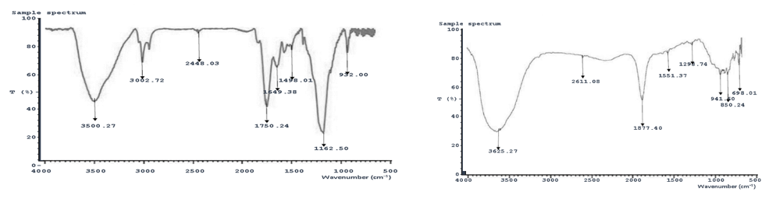
Figure 1: FTIR monograms of seaweed biomass (a) before and (b) after adsorption
    - Adsorption process parameters
Figure 2 shows that chromium and lead percentage uptake increases with time and decreases before reaching equilibrium. The equivalent equilibrium time for the two metal ions to reach this condition of balance is 60 minutes. The amount of metal ion adsorbed at equilibrium indicates the adsorbent's maximum adsorption capability under specific conditions. This study used one variable at a time (OVAT) method. The results revealed that metal ion adsorption is at equilibrium after 1 hour and that the adsorbent's active adsorption sites become involved in metal complexation as soon as the adsorbent is introduced into the system (Fu et al., 2012). Therefore, the optimum contact time was 60 min for further experiments. The percentage removal of metal ions was plotted against adsorbent dosage (Ulva lactuca seaweed) in Figure 2b. The graph shows that the percentage removal of metal ions from the aqueous phase increases as the adsorbent dosage increases for lead ion. In contrast, chromium metal ion increases in adsorbent dosage peaked at 0.25 g and 1 g for chromium. The number of active sites available for metal removal grows as the dosage of adsorbent increases (Saifuddin M and Kumaran, 2005). The removal efficiency of dosages usually improves with a dosage of 0.5 g if the lead metal ion is used to study the pattern of a dosage effect. Hence, generally, the larger the dose of adsorbents in the solution, the more exchangeable sites for the active sites of the ions available (Ezeh et al., 2017).
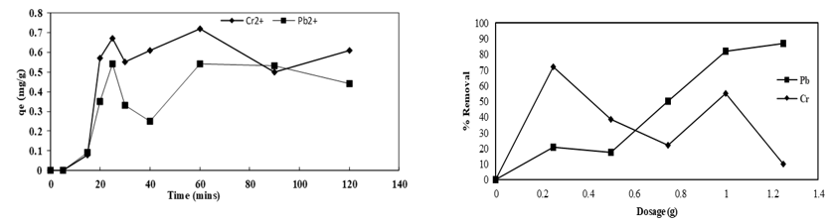
Figure 2: (a) Effect of absorbed metal ions concentration (Cr²⁺ and Pb²⁺) against time at 200rpm, 40°C, 0.25g dosage (b) Effect of adsorbent dosage against percentage removal of (Cr2+ and Pb2+) at 200rpm, 40°C, 60 min
The removal efficiency of metal ions in industrial wastewater solution was influenced by pH, as shown in Figure 3. There was an increase in percentage metal ion removal at low pH value with a peak at 4, the H+ concentration was high, and protons could compete with metal ions for surface sites. When pH rises, the positive surface charge of the sorbent functional groups decreases due to deprotonation, resulting in less electrostatic repulsion between the positively charged metal ion and the adsorbent surface (Ambaye et al., 2021). The decrease in the adsorption capacity at pH values (6.0–12.0) could be related to the repulsion between the negative charge of anionic species in solution and the negative surface charge of the sorbents (Ezeh et al., 2017).
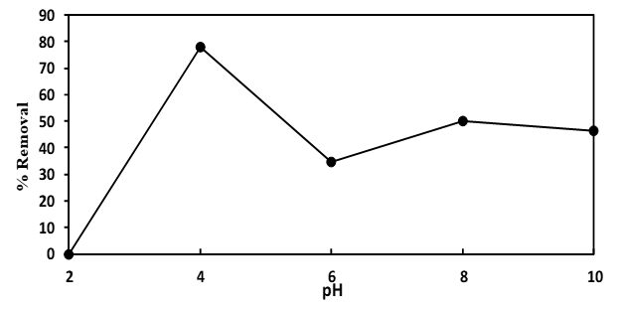
Figure 3: Effect of adsorbent dosage against percentage removal of wastewater solution at 200rpm, 40°C, 60 min
    - Adsorption isotherms
Two models (Langmuir and Freundlich) were used to model heavy metal adsorption from industrial wastewater. These models have essential data sources to design, understand, and optimize biosorption. The data express the intrinsic properties of the biosorbent and the interaction between adsorbate and adsorbent. The data can be used to compare the biosorptive capacities of the biosorbent for different pollutants (Rahman and Sathasivam, 2015). By comparing the correlation coefficients, it was shown (Figure 4a) that the Langmuir isotherm provides a good description of the adsorption system, which is based on monolayer sorption onto the surface restricting a finite number of identical sorption sites (Jahan et al., 2022). This study studied Langmuir adsorption isotherms by assuming that the surface adsorbate is saturated, and that adsorption energy is constant. The Freundlich isotherm model is one of the most widely used mathematical models for fitting experimental data over a range of concentrations. This isotherm model is based on a heterogeneous surface, active site distribution and energies, and logarithmic enthalpy changes (Pathania et al., 2017). The obtained Freundlich adsorption isotherm is shown in Figure 4b with the values of linear regression coefficients. In view of the values of the linear regression coefficients, the chromium and lead have a coefficient of determination (R²) close to unity.
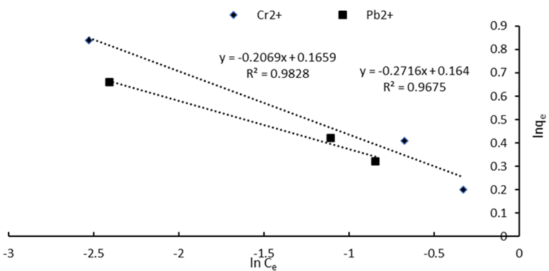
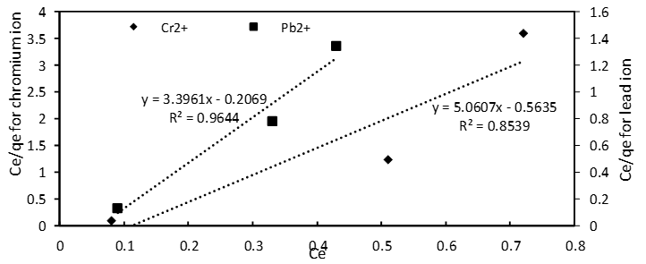

Figure 4: Isotherm for chromium and lead ion using (a) Langmuir (b)Freundlich adsorption isotherm
    - Adsorption kinetics
Preliminary studies were carried out earlier to fit first-order adsorption, but data was not fitting (data not shown). Hence, data fitting was tried on the second-order adsorption kinetic (Figure 5). Kinetics of adsorption were investigated for contact times of up to 120 minutes, which yielded the best R ² and was the most suitable. As a result, the adsorption of chromium and lead at 323 K appears to be more pseudo-second order than at other temperatures.
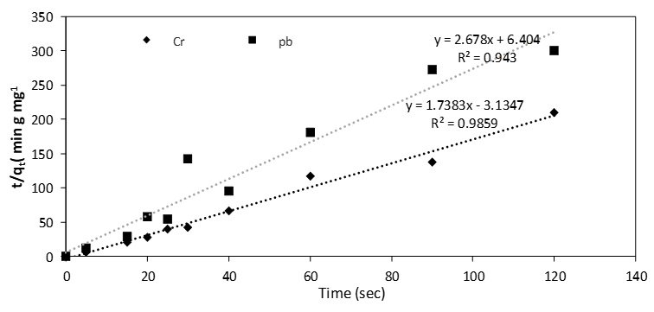

Figure 5: Pseudo-second-order kinetic adsorption
  - Conclusions
Ulva lactuca seaweed biomass was prepared and characterized for the sorption of chromium and lead metal ions. FTIR illustrated the presence of functional groups on both adsorbents. The optimum adsorption condition was found to occur at around pH 4.0, contact time 60 min, adsorbent dose 1 g/L, temperature 40 °C, and agitation speed of 200 rpm. Seaweed biomass is a low-cost, sustainable adsorbent for removing metal ions from contaminated environments. Freundlich isotherm model (R²≈1) agreed with the experimental data and best described the studies. Kinetics data were fitted and modeled with a Pseudo second-order equation. The results obtained from the study shows that seaweed, usually a microalga that grows in the river area is readily available in the environment and can be used to solve the industrial effluent that flows to the same river. Hence, the study's results could assist industrial stakeholders and waste management personnel in designing and integrating pollution control processes for proper waste management plans. Optimization studies of the obtained results is recommended in future research work.
References
Ambaye T., Vaccari M., Van Hullebusch E. D., Amrane A., Rtimi S., 2021, Mechanisms and adsorption capacities of biochar for the removal of organic and inorganic pollutants from industrial wastewater. International Journal of Environmental Science and Technology, 1-22.
Arumugam N., Chelliapan S., Kamyab H., Thirugnana S., Othman N., Nasri N. S., 2018, Treatment of wastewater using seaweed: a review. International journal of environmental research and public health, 15, 2851.
Demiral İ., Samdan C., Demiral H., 2021, Enrichment of the surface functional groups of activated carbon by modification method. Surfaces and Interfaces, 22, 100873.
El-Naggar N. E.-A., Rabei N. H., 2020, Bioprocessing optimization for efficient simultaneous removal of methylene blue and nickel by Gracilaria seaweed biomass. Scientific Reports, 10, 17439.
Ezeh K., Ogbu I., Akpomie K., Ojukwu N., Ibe J., 2017, Utilizing the sorption capacity of local Nigerian sawdust for attenuation of heavy metals from solution: isotherm, kinetic, and thermodynamic investigations. The Pacific Journal of Science and Technology,18, 251-264.
Freundlich H., 1907, Über die adsorption in lösungen. Zeitschrift für physikalische Chemie, 57, 385-470.
Fu F., Xie L., Tang B., Wang Q., Jiang S., 2012, Application of a novel strategy—Advanced Fenton-chemical precipitation to the treatment of strong stability chelated heavy metal containing wastewater. Chemical Engineering Journal, 189, 283-287.
Jahan N., Roy H., Reaz A. H., Arshi S., Rahman E., Firoz S. H., Islam M. S., 2022, A comparative study on sorption behavior of graphene oxide and reduced graphene oxide towards methylene blue. Case Studies in Chemical and Environmental Engineering, 6, 100239.
Lin L., Yang H., Xu X., 2022, Effects of water pollution on human health and disease heterogeneity: a review. Frontiers in Environmental Science, 10, 880246.
Liza Y. F. A., Gutierrez K. M. S., Espinoza R. F. R., Escobedo A. E. G., Cespedes A. R. M., Arevalo R. O., Vasquez T. V., 2022, Removal of Color and Turbidity in Runoff Water using Coconut (Cocos Nucifera) Endocarp Activated Carbon. Chemical Engineering Transactions, 93, 355-360.
Marungrueng K., Pavasant P., 2007, High performance biosorbent (Caulerpa lentillifera) for basic dye removal. Bioresource Technology, 98, 1567-1572.
Mathew B. B., Jaishankar M., Biju V. G., Beeregowda K. N., 2016, Role of bioadsorbents in reducing toxic metals. Journal of Toxicology, 4369604.
Nasri N., Abbas I., Martel H., Abdulrasheed A., Zain H., Hayatu U., Mohsin R., Majid Z., Rashid N., Sharer Z., 2017, CO₂ Adsorption Isotherms on KOH, H₃ PO₄ and FeCl₃. 6H₂O Impregnated Palm Shell Kernel Activated Carbon. Chemical Engineering Transactions, 56, 181-186.
Okey-Onyesolu C. F., Chukwuma E. C., Okoye C. C., Taiwo A. E., 2022, Application of synthesized Fish Scale Chito-Protein (FSC) for the treatment of abattoir wastewater: Coagulation-flocculation kinetics and equilibrium modeling. Scientific African, 17, e01367.
Oladipo B., Ibrahim T.H., Ajala S.O., Akintunde A.M., Taiwo A.E., Betiku E., 2021, Synthesis of Activated Carbons for Heavy Metals Removal. In: Inamuddin, Ahamed M., Lichtfouse E., Asiri A (Ed.) Green Adsorbents to Remove Metals, Dyes and Boron from Polluted Water. Environmental Chemistry for a Sustainable World, Vol 49. Springer Cham, Switzerland,1-31.
Pathania D., Sharma S., Singh P., 2017, Removal of methylene blue by adsorption onto activated carbon developed from Ficus carica bast. Arabian Journal of Chemistry, 10, S1445-S1451.
Saifuddin M, N., Kumaran P., 2005, Removal of heavy metal from industrial wastewater using chitosan coated oil palm shell charcoal. Electronic journal of Biotechnology, 8, 43-53.
Scanlon B. R., Fakhreddine S., Rateb A., De Graaf I., Famiglietti J., Gleeson T., Grafton R. Q., Jobbagy E., Kebede S., Kolusu S. R., 2023, Global water resources and the role of groundwater in a resilient water future. Nature Reviews Earth and Environment, 4, 87-101.
Wang J., Guo X., 2020, Adsorption isotherm models: Classification, physical meaning, application and solving method. Chemosphere, 258, 127279.
Wu W., Li S., Xie P., Li X., Chang H., Ho S.-H., 2023, Algal-fungal interactions and biomass production in wastewater treatment: Current status and future perspectives. Algal Research, 103021.
Yang Y., Zhang M., Alalawy A. I., Almutairi F. M., Al-Duais M. A., Wang J., Salama E.-S., 2021, Identification and characterization of marine seaweeds for biocompounds production. Environmental Technology and Innovation, 24, 101848.
Zeneli L., Daci-Ajvazi M., 2019, Metal–metal interactions in biological system: a competitive approach. Research, 24, 123-138.

