CHEMICAL ENGINEERING TRANSACTIONS  VOL. , 2024 | A publication of
The Italian Association
of Chemical Engineering
Online at www.cetjournal.it

Guest Editors: Leonardo Tognotti, Rubens Maciel Filho, Viatcheslav Kafarov
Copyright © 2024, AIDIC Servizi S.r.l.
ISBN 979-12-81206-09-0; ISSN 2283-9216

Italian potential of residual biogenic resources for energy-driven biorefineries
Nicola Pierroª, Aristide Giulianoª*, Alessandro Giocoliª, Arianna Baldinelli^{b}, Mariangela Guastaferro^{c}, Leonardo Tognotti^{c}, Isabella De Bariª
ªENEA, Italian National Agency for New Technologies, Energy and Sustainable Economic Development, S.S. 106 Ionica, km 419+500, Rotondella, MT, Italy
^{b}Dipartimento di Ingegneria dell’Energia, dei Sistemi, del Territorio e del Costruito, Università di Pisa, Pisa, 56122, Italy
^{c}Dipartimento di Ingegneria Civile e Industriale, Università di Pisa, Pisa, 56122, Italy
aristide.giuliano@enea.it
A reliable assessment of the availability of bioresources represents the first step to defining local value chains of particular interest. More than 190 and 50 Mt/y of bioresources are currently available in Europe and Italy, respectively, even if they are not fully valorized. The best end use of these feedstocks is strictly dependent on specific territorial/regional peculiarities, that consequently affect the products' final properties. In this work, the Italian web-GIS-based tool “Atlante delle biomasse” was used to determine the availability of many bioresources in Italy at the regional level. A lump classification criterion was used to categorize the available biomasses, and, then, an optimization algorithm based on a process superstructure was applied to find out the available fraction of bioresources, the amount of biofuels potentially obtainable and, consequently, the regional fuel demand coverable by biofuels. In particular, only the energy-self-sufficient technologies with higher TRLs were considered in the mathematical model. The integration between the different selected bioresources led to three biofuels to be considered, evaluating the percentage of biofuel demand that could be covered for each Italian region. The final potential production of biofuels derived from local bioresources in Italy settles down on the range 9 10⁷ – 1.6 10⁸ GJ/y covering about 5, 50, and 100 % of methane, biodiesel and bio-LPG demand respectively. Bio-LPG demand for all regions was to be considered completely satisfied, biodiesel production was also sufficient to cover high demands, on the other hand, low values of biomethane requirements coverable were obtained.
  - Introduction
The depletion of fossil fuel reserves, escalating environmental concerns, and the rapid growth of industrialization have spurred a keen interest in the development of sustainable liquid fuels as alternatives to traditional fossil fuels. Extensive research has been conducted to identify renewable options, with a focus on creating fuels that closely emulate the properties of conventional counterparts like gasoline, diesel, and jet fuel (Blasi et al., 2023). In this overview, the quantification of the availability of biomass is fundamental for their exploitation of bioenergy and for achieving the different programmatic objectives that Europe and Italy have set themselves. Imperial College (Panoutsou and Kyriakos, 2021) estimated net biomass that can be used for biofuel production in Europe at 126-262 Mtoe for 2030 and 101 – 252 Mtoe for 2050. This corresponds to advanced and waste-based biofuel production of 46 – 97 Mtoe for 2030 and 71 – 176 Mtoe for 2050. To produce those, nevertheless, various methods for generating sustainable liquid fuels have been developed, predominantly utilizing first-generation biofuels with food-grade feedstock. Biomass conversion to biofuels generally follows two distinct paths: thermochemical and biochemical methods. Thermochemical methods yield gases (via gasification) and liquids (through pyrolysis and HTL), which require additional synthesis to obtain valuable biofuels (i.e. methanol or DME) (Bora and You, 2020). Biochemical conversion paths primarily produce liquid fuels, such as ethanol, and biogas, both of which can be upgraded to produce diesel or biomethane (Baizhumanova et al., 2022). For the latter issue, process optimization and integration based on a techno-economic analysis can help to identify the most promising pathways and increase the profitability of a feedstock. Techno-economic analyses aimed also at assessing and predicting the limit in utilizing different feedstocks to produce different target biofuels respect to the local fuel demand (Galanopoulos et al., 2018). Furthermore, only a few studies reported in the literature addressed the process optimization of the biomass allocation among alternative pathways for a biorefinery co-producing several compounds, such as butanol (Toth et al., 2022), ethanol (Giuliano et al., 2014). In this work, mathematical programming methods were used to individuate the best bioresource valorization strategies for each Italian Region in order to maximize the regional biofuel production or the biofuel demand can be covered by local bioresources.
  - Methodology
The methodology proposed in the present work is shown in Figure 1. Regional Web-GIS data for the agroindustrial wastes (e.g. manure, pruning, straw,…), civil wastes (e.g. waste cooking oil, organic fraction of municipal solid waste) and other lignocellulosic biomass (e.g. forestall residues,…) were obtained from the Italian web-GIS-based tool “Atlante delle biomasse” (Pierro et al., 2021). Those data were merged into a lump classification, dividing them into only four bioresource categories: manures, Organic Fraction of Municipal Solid Waste (OFMSW), lignocellulosic biomass and oil. A process superstructure was built by considering all high TRL and energy self-sufficient technologies (Niamboonnum Sathaporn et al., 2021). Conversion processes where main raw materials are not obtainable by other bio-based processes of the superstructure were also avoided (i.e. having hydrogen as reactant). Literature values were used to set the target product yields.
    - Bioresource data assessment
The biomass surveyed were agricultural residual biomass (cereal straws, pruning from fruit trees), residues deriving from the forestry sector, wastes and by-products (Organic Fraction of Municipal Solid Waste (OFMSW). Furthermore, the availability of Used Cooking Oil (UCO) and manure from livestock farms too were assessed. To calculate the bioenergy potential in Italy, the biomasses will be grouped into similar categories (e.g. lignocellulosics, organic wastes, etc.) and merged at a regional scale. For the agricultural residual biomass: both the theoretical and the technical potential will be evaluated. The theoretical potential will be calculated according to the following formula:
Theoretical Potential = (Harvested Production) * (Residue-to-product ratios) * (1 – (Moisture / 100) | (1)
Where Harvested Production is the mass of product harvested on the area under production, Residue-to-product ratios which is the ratio used to calculate how much unused crop residue might be left after harvesting a particular crop. The quantification of the technical potential, which represents the quantity of residues that can be collected, will be obtained by applying an availability coefficient, present in the literature. Manure deriving from livestock farms was evaluated considering the regional distribution of livestock animals (Scarlat et al., 2018).
    - Process superstructure modelling and optimization
The process superstructure proposed is shown in Figure 2, fermentable raw material was considered converted to biomethane by anaerobic digestion and biogas upgrading processes (Scarlat et al., 2018). Produced methane can be used as a feedstock for a steam reforming (SR) reactor producing syngas with a H₂/CO ratio equal to 3. Syngas with a H₂/CO/CO₂ composition of 1/1/1 can be obtained by lignocellulosic biomass gasification, that can be sent to three possible syngas conversion processes: Synthetic Natural Gas (SNG) synthesis, methanol synthesis or syngas fermentation, producing methane, methanol or ethanol respectively. Methanol was considered as reactant into the oil transesterification reactor producing Fatty Acid Methyl Esters (FAME) (Castellini et al., 2021) or to be converted to DyMethyl Ester (DME). Lignocellulosic biomass could be valorized also by the 2nd generation sugars platform (e.g. steam explosion pretreatment, enzymatic hydrolysis and alcoholic fermentation) producing ethanol. The mixed ethanol stream was considered upgraded by an Alcohol-to-Diesel (AtD) process (Restrepo-Flórez et al., 2023), obtaining a biodiesel blend by mixing with FAME.
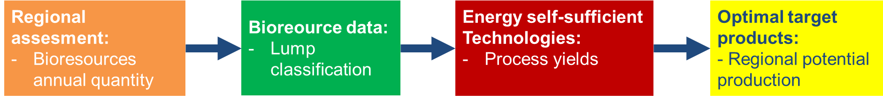
Figure 1: Data flow from input to final objective for the local valorization of bioresources
Each conversion process was modelled by linear or Non-linear equations, in order to maximize two original alternative objective functions (OF): the regional production of biofuels (in GJ/y) or the percentage of covered biofuel regional demand.
$$Max Z'=\sum_{r}{\sum_{i}{{LHV}_{tot,r,i}}}$$ | (2)
$$Max Z''=\sum_{r}{\sum_{i}{\frac{{LHV}_{tot,r,i}}{{RD}_{r,i}}}}$$ | (3)
Where Z’ and Z’’ are the objective functions to be maximized, r is the Italian region, i is the fuel (e.g. biomethane, biodiesel blend and DME), RD_{r,i} is the regional demand for each region r and fuel i in GJ/y, LHV_{tot,r,i} is the Lower Heating Value of producible biofuel i in the region r. The resulting NLP (Non-Linear Programming) was solved by Advanced Interactive Multidimensional Modelling Software (AIMMS). For both objective functions a constraint consists in limiting with an upper bound the biofuels production to not exceed the regional demand of the biofuel i:
$${LHV}_{tot,r,i}≤={RD}_{r,i} ∀ i,r$$ | (4)
    - Regional fuel demand assessment
Bioresource data were merged into a lump classification, dividing them into only three categories: fermentable materials to produce biomethane, oils to produce biodiesel (FAME), lignocellulosic biomass to produce syngas/DME/bioethanol. Target products can replace the regional demand for fossil-based fuels. In particular, the biomethane demand was estimated in terms of the natural gas replaced in the gas distribution grid. Diesel and Liquefied Petroleum Gases (LPG) were retrieved through the analysis of the Italian petroleum product consumption. The National consumption was normalized to the regional inhabitants. Furthermore, biodiesel (FAME) was assumed in blend with diesel until to 7%, while DME was considered for the LPG replacement with a volumetric blend of 12 %. From that, the regional distribution of biofuel demand can be assessed, together with the maximal regional biofuel production in order to obtain the final regional biofuel demand using local/regional bioresources.
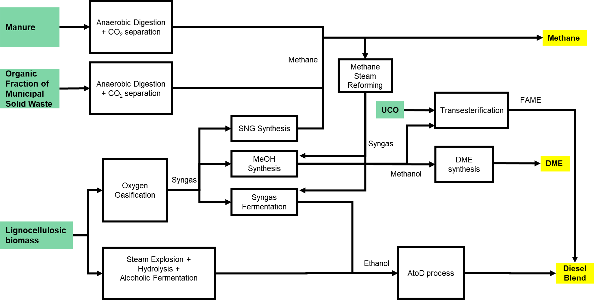Figure 2: General process superstructure converting regional bioresources to biofuels by energy self-sufficient technologies
  - Results
    - Regional bioresource assessment
The Italian regions with the greatest availability of both lignocellulosic residues and bioresources from zootechnical activities (manure) were Piemonte, Veneto and Lombardia (lignocellulosic: 883, 861 and 847 kt/y; manure: 10'814, 11’634 and 24'635 kt/y, respectively). Lombardia and Veneto can play a main role also for urban wastes as OFMSW and UCO. Further, Lazio and Campania can make available 42 and 41 kt/y of UCO, respectively.
Table 1: Bioresource availability in the Italian regions (Pierro et al., 2021)
 | Manure (kt/y) | OFMSW (kt/y) | UCO (kt/y) | Lignocellulosic biomass (kt/y)
ABRUZZO | 1'122 | 154 | 9 | 179
BASILICATA | 1'211 | 50 | 4 | 166
CALABRIA | 1'360 | 176 | 13 | 395
CAMPANIA | 4'886 | 634 | 41 | 232
EMILIA ROMAGNA | 9'070 | 797 | 32 | 690
FRIULI V. G. | 1'711 | 155 | 9 | 282
LAZIO | 3'264 | 581 | 42 | 203
LIGURIA | 129 | 150 | 11 | 19
LOMBARDIA | 24'635 | 1'147 | 73 | 847
MARCHE | 1'040 | 224 | 11 | 208
MOLISE | 803 | 26 | 2 | 65
PIEMONTE | 10'814 | 446 | 31 | 883
PUGLIA | 2'285 | 432 | 29 | 679
SARDEGNA | 4'641 | 234 | 12 | 109
SICILIA | 4'060 | 516 | 35 | 533
TOSCANA | 1'255 | 525 | 27 | 297
TRENTINO A. A. | 1'702 | 137 | 8 | 33
UMBRIA | 1'133 | 119 | 6 | 134
VALLE D'AOSTA | 311 | 12 | 1 | 1
VENETO | 11’634 | 729 | 35 | 861
    - Regional biofuel demand
The fuel Italian demand resulted in 2.27 10⁹, 1.18 10⁹ and 1.44 10⁸ GJ/y for methane, diesel and LPG respectively. Figure 3 shows the regional demand calculated as explained in the section 2.3, highlighting methane consumption is higher for Lombardia, Emilia Romagna and Piemonte, while diesel demand is higher for Lombardia, Lazio and Campania. LPG presents lower consumption for every region with a maximum demand for Lombardia (24 10⁶ GJ/y). Sardegna is the only one region without methane consumption due to absence of the methane distribution grid and a very low LPG demand (about 4 10⁶ GJ/y).
    - Regional demand coverable by locally produced biofuels
Finally, for each region the percentage of the fuel demand that could be covered by biofuel produced from regional bioresources was calculated by a NLP optimization strategy. Figure 4 shows decreasing the total biofuel demand can be covered by local bioresource valorization. By maximization of both OFs Sardegna presents the best performances with more than 70% of biofuel demand satisfied. Basilicata can reach a 18-20 % of covering, Marche and Molise attested to more than 6 %.
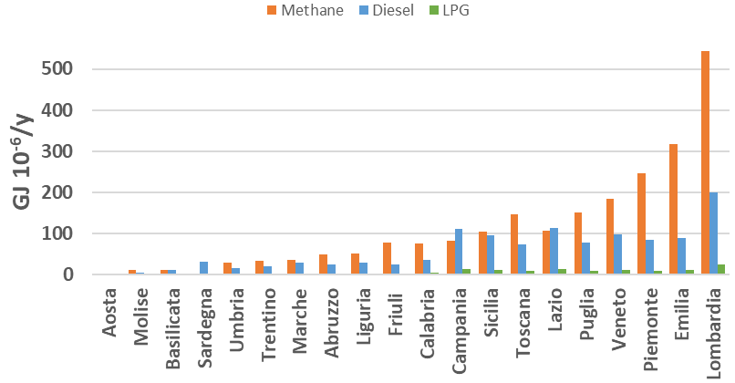
Figure 3: Regional demand of methane, diesel and LPG
These regions have low fuel consumption but consolidated rural activities producing residual biomass. Also, the big regions Campania, Sicilia and Veneto can have 5-11 % of biofuel demand satisfied. Figure 4 shows a methane demand can be covered by biomethane less than 15% everywhere. When the total biofuel production was maximized (eq. 2), higher biomethane coverages are found for Basilicata, Campania e Veneto (14.8, 9.4, 7.8 % respectively), for Basilicata region due to very low methane consumptions (Figure 3) and on the other hand a manure availability in the same range of the other regions. Campania and Veneto have high available manure and OFMSW (Table 1) with a methane consumption of 8.3 10⁷ and 1.85 10⁸ GJ/y respectively, lower than methane demand of other big regions as Piemonte (2.47 108 GJ/y), Emilia Romagna (3.18 10⁸ GJ/y) and Lombardia (5.44 10⁸ GJ/y). Considering the second OF (eq. 3) to be maximized (Figure 4.b), the methane demand covering is minimized because an increase in biomethane production corresponds to a little increase of the methane demand covering, due to two factors: the first one, higher methane consumption (as from Figure 3) and the second one biomethane can potentially cover 100 % of the demand being a drop-in fuel. However, Basilicata can reach 11.2 % of methane demand by biomethane, Molise, Piemonte e Veneto (3.5, 2.0, 1.6 % respectively). By maximizing OF (eq. 2), the biodiesel demand has higher coverable values, due to lower diesel demand (Figure 3) and also a low percentage of tolerable biofuel blending (7%). Considering that two small regions can reach very high covering by local biodiesel: Basilicata and Sardegna (73 % both). A particular case is represented by Sardegna, due to absence of methane demand, so all biomethane produced was considered to produce syngas by SR and then ethanol by SF for diesel. Basilicata (53%) thanks to lignocellulosic biomass availability and low diesel consumptions. Higher values can be found maximizing the sum of the biofuel demand covering (eq. 3) with four small regions (Basilicata, Molise, Friuli V. G., Calabria) and three big regions (Piemonte, Veneto, Emilia Romagna) reaching 100 % of covering. That is possible thanks to the high availability of lignocellulosic biomass convertible by 2nd generation sugars platform to ethanol, and then to diesel: 131, 120 and 15 kt of diesel from ethanol for Veneto, Emilia Romagna and Piemonte respectively. Considering only the FAME production, that is everywhere in the range 19-24 GJ_{FAME}/GJ_{DEMAND,BIODIESEL} due to waste cooking oil distribution and diesel consumption directly proportional to regional population. Finally, the bio-LPG demand is the simplest to cover by DME, nothing region surpasses 3 10⁶ GJ/y of consumption. By maximization of eq .2, only five regions cannot cover completely the bio-DME demand: Campania (47 %), Lazio (39 %), Trentino A. A. (32 %), Liguria (7 %) and Valle d’Aosta (0 %).
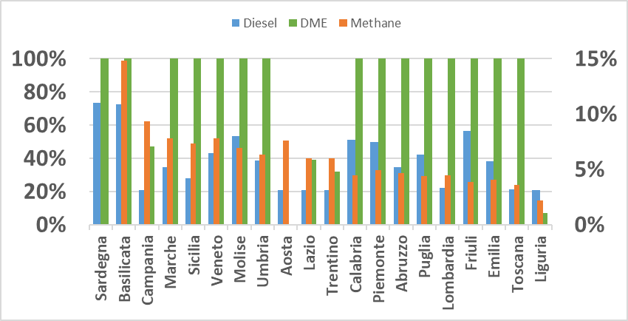
(a)
(b)
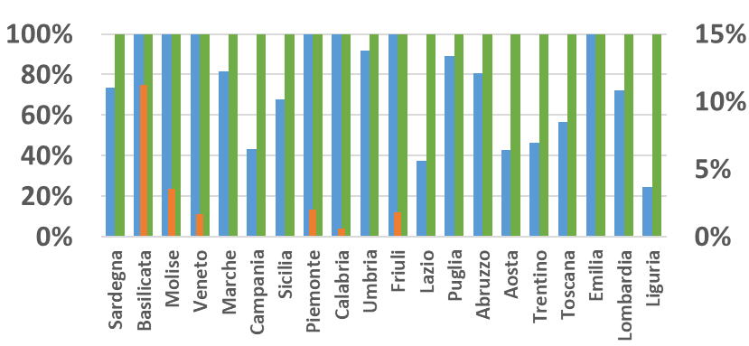
Figure 4: Biofuel regional demand covered by biomethane (on right axes), biodiesel blends and bio-DME, maximizing the production of biofuels in GJ/y (a) or the sum of covered biofuel demand (b)
These results derived by raw material valorization to produce high quantity of methane to increase the global biofuel production. On the other hand, if the percentage of demand to be covered was maximized (eq. 3) all Italian regions reach 100 % of bio-DME demand. For this case, a large ratio of biomethane was used to produce syngas and then methanol and DME.
  - Conclusions
The work highlighted a large part of the regional biofuel demand can be covered by local bioresource conversion. In particular, maximization of two objective functions led to two different bioresource allocation producing globally in Italy about 1.6 108 GJ/y maximizing the regional biofuel production and 8.9 107 GJ/y maximizing the biofuel demand covered. The main difference consists in a different allocation of fermentable raw materials (manure and OFMSW), biomethane produced was converted to methanol and diesel when the diesel demand had to be covered. Future development will be increasing the bioresource conversion processes considering also the integration with (green) hydrogen and evaluating also the capital and operating costs of the biorefineries.
.
Acknowledgments
This research was funded by PNRR PE0000021 / PE2 – Network 4 Energy Sustainable Transition (NEST). The authors deeply acknowledge the current national representatives of IEA task 42 ‘Biorefining in a Circular Economy’ from Austria, Denmark Germany, Ireland, the Netherlands and USA for useful debate and discussions. Prepared by Aristide Giuliano, Nicola Pierro, Isabella De Bari (ENEA, Italy), on behalf of IEA Bioenergy Task42.
References
Baizhumanova T.S., Zhumabek M., Kaumenova G.N., Tungatarova S.A., Talasbayeva N., Zhylkybek M., Zhang, X., Xanthopoulou G., Tolembek A.Y., 2022. Catalytic Reforming of Biogas to Produce Environmentally Friendly High Effective Fuels. Chemical Engineering Transactions 94, 985–990. https://doi.org/10.3303/CET2294164
Blasi A., Verardi A., Lopresto C.G., Siciliano S., Sangiorgio P., 2023. Lignocellulosic Agricultural Waste Valorization to Obtain Valuable Products: An Overview. Recycling 8, 61. https://doi.org/10.3390/recycling8040061
Bora R.R., You F., 2020. Techno-economic feasibility of thermochemical conversion pathways for regional agricultural waste biomass. Chemical Engineering Transactions 81, 1111–1116. https://doi.org/10.3303/CET2081186
Castellini M., Ubertini S., Barletta D., Baffo I., Buzzini P., Barbanera M., 2021. Techno-Economic Analysis of Biodiesel Production from Microbial Oil Using Cardoon Stalks as Carbon Source. Energies 14, 1473. https://doi.org/10.3390/en14051473
Galanopoulos C., Barletta D., Zondervan E., 2018. A decision support platform for a bio-based supply chain: Application to the region of Lower Saxony and Bremen (Germany). Computers and Chemical Engineering 115, 233–242. https://doi.org/10.1016/j.compchemeng.2018.03.024
Giuliano A., Cerulli R., Poletto M., Raiconi G., Barletta D., 2014. Optimization of a multiproduct lignocellulosic biorefinery using a MILP Approximation, Computer Aided Chemical Engineering. https://doi.org/10.1016/B978-0-444-63455-9.50072-6
Niamboonnum Sathaporn, Panichkittikul Nitsara, Saebea Dang, Arpornwichanop Amornchai, Patcharavorachot Yaneeporn, 2021. Thermal Self-Sufficient Operation of Hydrogen Production from Used Vegetable Oil. Chemical Engineering Transactions 88, 823–828. https://doi.org/10.3303/CET2188137
Panoutsou C., Kyriakos M., 2021. Sustainable biomass availability in the EU, to 2050.
Restrepo-Flórez J.-M., Cuello-Penaloza P., Canales E., Witkowski D., Rothamer D.A., Huber G.W., Maravelias C.T., 2023. Ethanol to diesel: a sustainable alternative for the heavy-duty transportation sector. Sustainable Energy Fuels 7, 693–707. https://doi.org/10.1039/D2SE01377K
Scarlat N., Fahl F., Dallemand J.-F., Monforti F., Motola V., 2018. A spatial analysis of biogas potential from manure in Europe. Renewable and Sustainable Energy Reviews 94, 915–930. https://doi.org/10.1016/j.rser.2018.06.035
Toth E., Mancino G., Raynal L., 2022. Isopropanol/n -Butanol/Ethanol separation from diluted fermentation broth by distillation. Process optimization using MILP techniques, in: Montastruc, L., Negny, S. (Eds.), Computer Aided Chemical Engineering, 32 European Symposium on Computer Aided Process Engineering. Elsevier, pp. 745–750. https://doi.org/10.1016/B978-0-323-95879-0.50125-9

