CHEMICAL ENGINEERING TRANSACTIONS  VOL. , 2024 | A publication of
The Italian Association
of Chemical Engineering
Online at www.cetjournal.it

Guest Editors: Leonardo Tognotti, Rubens Maciel Filho, Viatcheslav Kafarov
Copyright © 2024, AIDIC Servizi S.r.l.
ISBN 979-12-81206-09-0; ISSN 2283-9216

Energy Assessment of a Slow Pyrolysis Plant for Biochar and Heat Cogeneration
Gabriele Fambri^{a,}*, Giacomo Lombardi^{b}, Marco Badamiª, David Chiaramonti ª
ª Energy department, Politecnico di Torino, Corso Duca degli Abruzzi 24, 10129 Torino (TO), Italia
^{b} RE-CORD, Viale Kennedy 182, 50038 Scarperia e San Piero (FI), Italia
gabriele.fambri@polito.it
The production of biochar by slow pyrolysis systems is a promising technology to achieve negative emissions. In this paper, an energy analysis model for a biomass-based biochar production plant utilising the slow pyrolysis process is presented. The model was used to evaluate the energy analysis of a plant processing lignocellulosic biomass. The energy analysis considered the main technical parameters of this type of plant, including the moisture content of the biomass, the moisture after drying, the pyrolysis temperature and the characteristics of the biomass. The results showed the heat losses for each component of the plant and the recoverable useful heat from the production process, which represents about 16% of the chemical energy originally contained in the biomass. Although this is a secondary output, this aspect is important for analysing the sustainability of the biochar production chain. The energy analysis enabled by the model presented is indeed a valuable tool for the technical, economic and environmental assessment of biochar production plants.
  - Introduction
The increase in greenhouse gases, especially carbon dioxide, is a critical factor in global warming. To keep global warming below 1.5 °C, techniques to remove atmospheric CO₂ are needed (Chen and Wu, 2022). Biochar systems through pyrolysis stand out as one of the few currently effective carbon-negative solutions (Glaser et al., 2009). In addition to its carbon sequestration effect, biochar offers significant benefits as a soil amendment (Bong et al., 2021) and in other hard-to-abate sectors (Salimbeni et al. 2023).
Energy modelling is needed to evaluate biochar production processes from a techno-economic and environmental perspective by considering the energy flows and energy losses as well as possible secondary outputs such as the recovery of useful heat during the production process. Several energy models have been presented in the literature along these lines. Kliner (2016) presented a model based on a mass and energy balance of a plant processing previously dried biomass. Klinar et al. (2021) used this model to analyse a pyrolysis and subsequent gasification process. The energy yields of the pyrolysis products (biochar, pyrolysis gas and pyrolysis oil) from Cong et al. (2018). Salimbeni et al. (2023) modelled a pyrolysis plant for lignocellulosic biomass integrated into the steel production process based on experimental data.
In this paper, an energy model for a complete biochar production plant is presented, including the biomass dryer, pyrolysis reactor, pyrogas burner and recovery heat exchanger. The model presented was developed to integrate specific experimental data that can be collected in the laboratory regarding the properties of input biomass and bioproducts. In this way, the same model can be used to analyse in detail the pyrolysis process on an industrial scale from an energetic point of view based on the experimental data obtained for different types of biomasses. For these reasons, the model presented here is a valuable tool for carrying out technical, economic, and environmental analyses of biochar production facilities.
  - Material and methods
    - Slow pyrolysis plant model
The analysed model of a slow pyrolysis plant consists of four main components: the biomass dryer, the pyrolyser, the pyrolysis gas burner and the recovery heat exchanger (Figure 1). The biomass dryer reduces the moisture content of the biomass feedstock. Part of the drying process of the biomass could be done by seasoning. However, this process cannot be carried out on the shredded material because it would trigger decomposition processes. To avoid this in industrial processes, moisture is usually removed with dryers. The dried biomass is then fed into the pyrolyser where it is heated in an oxygen-free environment, resulting in the production of pyrogas and biochar. It should be noted that in this configuration there is no recovery of the bio-oil contained in the pyrogas. The condensable organic compounds are then combusted in the pyrogas burner together with the non-condensable gases. The heat generated during the combustion of the pyrogas is used to maintain the pyrolysis process and to dry the biomass, while the rest is recovered via the heat exchanger for other applications. This integrated system ensures efficient use of biomass resources while maximising energy recovery.
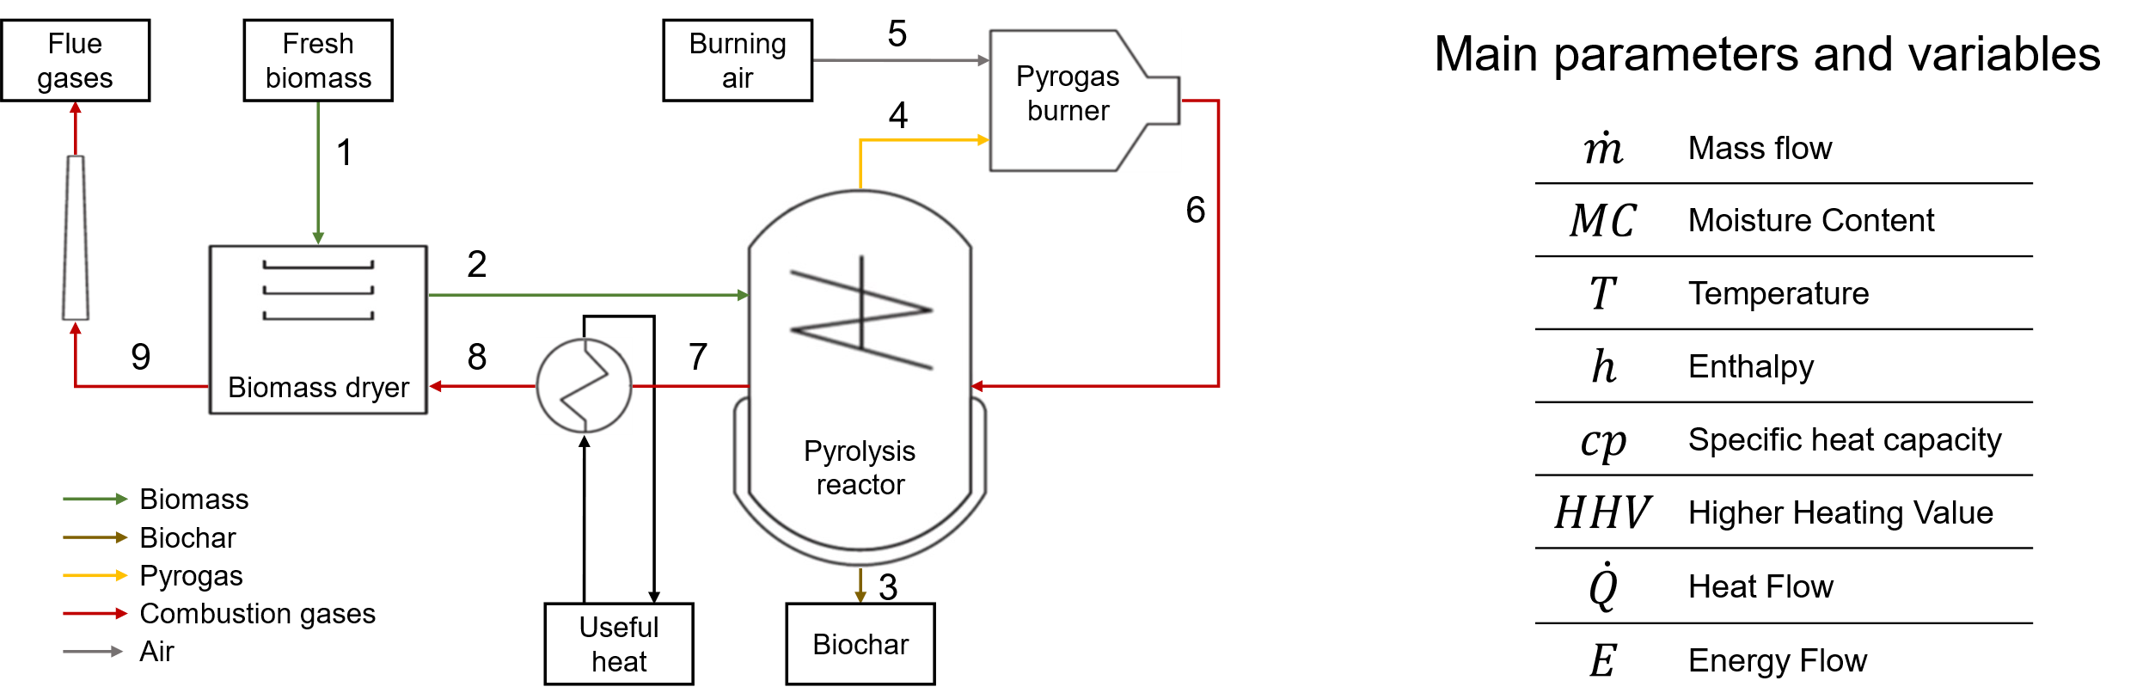
Figure 1. Integrated model schema of slow pyrolysis plant.
Biomass dryer
Fresh biomass (point 1) enters the dryer. The model assumes that the biomass leaving the dryer reaches a temperature of 100 °C (point 2) and a sufficiently low moisture content to be processed by the pyrolyser (15 %). The dryer is considered to have an efficiency of 70 % ($η_{dryer}$). The energy required to dry the biomass is equal to the heat required to bring the dry biomass and its moisture to the outlet temperature plus the heat required for evaporation. The heat required for drying comes from the combustion gases (point 8). To avoid acidic condensation, the exhaust gas temperature (point 9) is set at 120 °C.
$$\frac{{\dot{m}}_{1}∙\left[\left(1-{MC}_{1}\right)∙{cp}_{BM}∙\left(T_{2}-T_{1}\right)+{MC}_{1}∙{cp}_{H2O}∙\left(T_{2}-T_{1}\right)+\left({MC}_{1}-{MC}_{2}\right)∙{∆h}_{weva}\right]}{η_{dryer}}={\dot{m}}_{8}∙h_{8}-{\dot{m}}_{9}∙h_{9}$$ | (1)
Where the biomass specific heat capacity (${cp}_{BM}$) is estimated as function of the temperature (Simpson and TenWolde., 1999).
$${cp}_{BM}=0.1031+0.003867∙T$$ | (2)
Biomass pyrolysis
The pyrolysis process is an endothermic process. As described by Salimbeni et al., (2023)., the heat required for pyrolysis can be estimated by assuming that it is equal to the heat required to bring the dry biomass and the moisture of the biomass from the inlet temperature to the pyrolysis temperature.
$${\dot{Q}}_{py}={\dot{m}}_{2}∙\left[\left(1-{MC}_{2}\right)∙{cp}_{BM}∙\left(T_{py}-T_{2}\right)+{MC}_{2}∙{∆h}_{w \left(T_{py}-T_{2}\right)}\right]$$ | (3)
The pyrolyser is heated by the hot combustion gases (point 6). The heat extracted from the combustion gases corresponds to the heat required for the pyrolysis process plus the heat losses, which were assumed to be 33 % as an average value in the literature (Harsono, 2009).
$${\dot{m}}_{6}∙h_{6}-{\dot{m}}_{7}∙h_{7}={\dot{Q}}_{py}-{\dot{Q}}_{{py}_{TH_loss}}={\dot{Q}}_{py}∙(1+{loss}_{py})$$ | (4)
The biomass is converted into a solid phase, the biochar (point 3), and into a gas phase (point 4).
$${\dot{m}}_{2}={\dot{m}}_{3}+{\dot{m}}_{4}$$ | (5)
The gas phase consists of water vapour, which comes from the moisture in the biomass, the reaction water produced during pyrolysis, the organic vapours and the permanent gases (CO₂, CO, CH₄, C₂H₆, C₂H₄ and H₂).
The energy of the biomass is equal to its calorific value plus the latent heat of the dry biomass and the moisture.
$$E_{BM}={\dot{m}}_{2}∙\left\{\left(1-{MC}_{2}\right)∙\left[{HHV}_{BM}+{cp}_{BM}∙\left(T_{2}-T_{ref}\right)\right]+{MC}_{2}∙{cp}_{w}∙\left(T_{2}-T_{ref}\right)\right\}$$ | (6)
The energy contained in biochar is equal to its calorific value plus latent heat.
$$E_{BC}={\dot{m}}_{3}∙\left[{HHV}_{BC}+{cp}_{BC}∙\left(T_{3}-T_{ref}\right)\right]$$ | (7)
The specific heat capacity (${cp}_{BC}$) is assumed to be equal to 1.67 kJ/(kg K) (klinar, 2016).
The energy in the gas fraction can be calculated by applying an energy balance to the pyrolyser. The energy contained in the gases is equal to the energy contained in the biomass supplied plus the heat supplied from outside (minus losses) minus the energy contained in the biochar stream.
$$E_{PG}=E_{BM}+{\dot{Q}}_{py}-E_{BC}$$ | (8)
Pyrogas burner
The combustion of pyrogas takes place in the burner. The composition of the combustion gases is evaluated under the assumption of perfect oxidation. Permanent gases and organic vapours are decomposed into CO₂, H₂O and N₂. The oxidation of the permanent gases is described by the following chemical reactions:
2 CO + O₂ 2 CO₂ (${∆H}_{C}°=-283{kJ}/{{mol}_{CO}}$)
CH₄ + 2 O₂ CO₂ + 2 H₂O (${∆H}_{C}°=-891{kJ}/{{mol}_{CH_{4}}}$)
2 C₂H₆ + 7 O₂ 4 CO₂ + 6 H₂O (${∆H}_{C}°=-1561{kJ}/{{mol}_{C_{2}H_{6}}}$)
C₂H₄ + 3 O₂ 2 CO₂ + 2 H₂O (${∆H}_{C}°=-1411{kJ}/{{mol}_{C_{2}H_{4}}}$)
While the decomposition of the organic vapour is evaluated considering its ultimate composition.
$$C_{a}H_{b}N_{c}O_{d}+\left(a+\frac{b}{4}-\frac{d}{2}\right)O_{2} a{CO}_{2}+\frac{b}{2}H_{2}O+\frac{c}{2}N_{2}$$
The stoichiometric oxygen demand is calculated on the basis of these reactions. The air required for the combustion process is calculated taking into account an excess air of 140 % in order to avoid the formation of NOx (Demol et al., 2021).
The enthalpy contained in the combustion gases is calculated on the assumption that the energy of the pyrogas is transferred to the combustion gases, assuming a chemical reaction efficiency of 97 % and thermal losses of 15 % (this value includes all heat losses that occur in the path of the combustion gases).
$$H_{6}=E_{PG}∙η_{burn}-{\dot{Q}}_{{burn}_{TH_loss}}$$ | (9)
Where the thermal losses are calculated considering that they affect only the sensible heat of the combustion gases flow:
$${\dot{Q}}_{{burn}_{TH_loss}}=\left(E_{PG}∙η_{burn}-{\dot{m}}_{H2O}∙{∆h}_{weva}\right)∙{loss}_{burn}$$ | (10)
The temperature of the combustion gases at the outlet of the burner is calculated iteratively by assuming that the energy of the combustion gases is equal to the sum of the enthalpies of the individual gas types of the combustion gases (N₂, CO₂, H₂O, O₂).
$$E_{PG}={\dot{m}}_{6}∙\left(ω_{N2}∙h_{{N2}_{T6}}+ω_{H2O}∙h_{{H2O}_{T6}}+ω_{CO2}∙h_{{CO2}_{T6}}+ω_{O2}∙h_{{O2}_{T6}}\right)$$ | (11)
Where $ω_{i}$ is the mass fraction of the $i$-th gas type present in the combustion gasses.
Recovery heat exchanger
The useful heat that can be recovered corresponds to the enthalpy difference of the combustion gases between points 7 and 8.
$${\dot{Q}}_{useful}={\dot{m}}_{7}∙h_{7}-{\dot{m}}_{8}∙h_{8}$$ | (12)
The recovered heat has a temperature of around 700 °C and can be used, for example, to generate steam for industrial purposes.
    - Biomass and bioproducts and process parameters
In order to analyse the pyrolysis plant from an energy point of view, several parameters of the biomass and the pyrolysis products must be taken into account. These parameters include the higher calorific value, the moisture content and the ash content of the biomass fed in. In addition, the yield and higher calorific value of the biochar as well as the yield and composition of the pyrolysis gases are required. It is important to note that these parameters are influenced by both the type of biomass used and the specific conditions during the pyrolysis process (in particular the temperature at which pyrolysis is carried out). To demonstrate the operation of the presented model, we used data from a study by Phan et al. (2008), in which experimental data on the slow pyrolysis process of woody biomass from municipal solid waste, mainly pine but also oak and birch, are reported. The data required for the energy model are summarised in Table 1.
Table 1: Biomass and bioproducts characterization and process parameters.
Biomass
Biomass ash content (wt% dry basis, d.b.) | 1
Biomass Higher Heating Value (HHV) (MJ/kg d.b.) | 20.0
Fresh biomass moisture (wt% wet basis, w.b.) | 50
Drying process
Dry biomass moisture (wt%, w.b.) | 15
Thermal losses (%) | 30
Pyrolysis process
Operating temperature (°C) | 500
Yields (wt% d.b.) | 24.3 (Biochar); 75.7 (Pyrogas)
Condensable (wt% of Pyrogas) | 58.7
Thermal losses (%) | 33
Pyrolysis products
Biochar HHV (MJ/kg d.b.) | 32.3
Uncondensable composition (wt%) | 19.1 (CO₂); 14.8 (CO); 5.2 (CH₄); 0.9 (C₂H₆); 1.3 (C₂H₄); 0.1 (H₂)
Condensable organic phase (C_{x}H_{y}O_{w}) | 1 (x); 2.28 (y); 0.58 (w)
Condensable aqueous phase (C_{x}H_{y}O_{w}) | 1 (x); 6.23 (y); 2.46 (w)
Pyrogas burner
Excess air (%) | 140
Chemical efficiency (%) | 97
Thermal losses (%) | 15
  - Results and discussions
Table 2 shows the values for mass flow, temperature and energy content at the characteristic points of the systems shown in Figure 1. At point 1, the fresh biomass enters the dryer with an energy content that corresponds to its Higher Heating Value (HHV). At the outlet of the dryer (point 2), the biomass has lost some of its moisture and has a temperature of 100 °C. Points 3 and 4 represent the two outputs of the pyrolyser (at 500 °C), i.e. biochar and pyrogas respectively. The pyrogas is oxidised with air (point 5). The combustion gases leave the burner at a temperature of around 1020 °C (point 6). The energy of the combustion gases is transferred via heat exchangers to the pyrolyser (point 7), to the heat exchanger for useful heat recovery (point 8) and finally to the dryer (point 9). From point 6 to point 9, the combustion gases drop to 120 °C to be discharged via the chimney.
Table 2. Mass flows, temperatures and energy flows in the characteristic points of the plant.
 | 1 | 2 | 3 | 4 | 5 | 6 | 7 | 8 | 9
Mass flow (kg/h) | 1000 | 588 | 121 | 467 | 3677 | 4144 | 4144 | 4144 | 4144
Temperature (°C) | 20 | 100 | 500 | 500 | 20 | 1019 | 778 | 469 | 120
Energy Flow (MW, HHV) | 2.78 | 2.80 | 1.12 | 1.93 | 0.00 | 1.63 | 1.27 | 0.83 | 0.37
    - Mass and energy balances
Fresh biomass contains a high moisture content. The drying process reduces the moisture content of the biomass from 50 % to 15 %: around 40 % of the supplied mass is lost in the form of steam (Figure 2a). 0.30 MW, i.e. 65 % of the dryer's energy consumption of 0.46 MW, is used to evaporate the moisture. 30 % is released into the environment due to thermal losses. The remaining 5 %, which corresponds to 0.02 MW, is transferred to the biomass in the form of sensible heat. The share of sensible energy of the biomass (which comes out of the dryer at a temperature of 100 °C) corresponds to less than 1 % of the total energy of the biomass, which consists of more than 99 % chemical energy (Figure 2b).
In the pyrolyser, the biomass is converted into biochar and pyrogas (Figure 3a). It should be noted that the pyrogas flow shown in the figure also includes the residual moisture of the biomass (88 kg/h). On a dry basis, 24 % of the input is converted into biochar, the rest into pyrogas. Figure 3b shows the energy balance for this component. As the pyrolysis process is endothermic, it requires energy input. 33 % of the energy input is dissipated into the environment through thermal losses. The net energy input into the reactor is equal to the energy contained in the biomass supplied plus the energy supplied minus the thermal losses. Of this energy, 35 % is contained in the biochar and the remaining 65 % in the pyrogas.
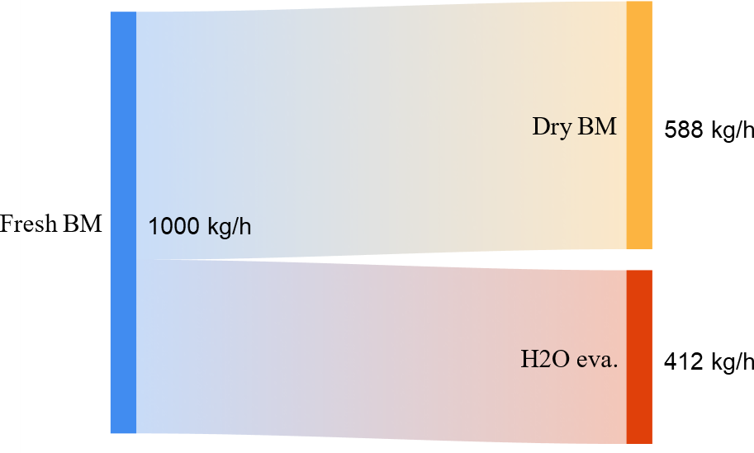  (a) | 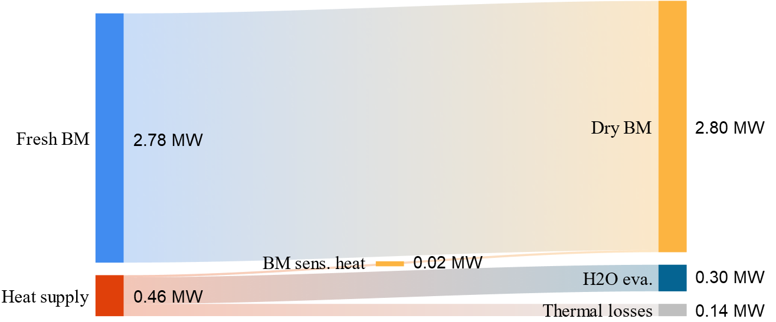  (b)
Figure 2. Dryer mass (a) and energy (b) balance.
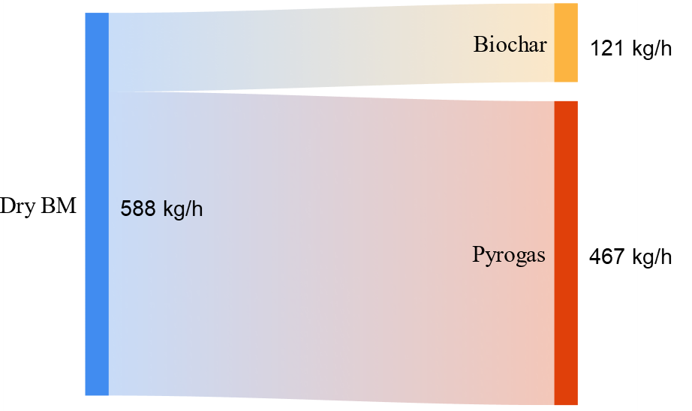  (a) | 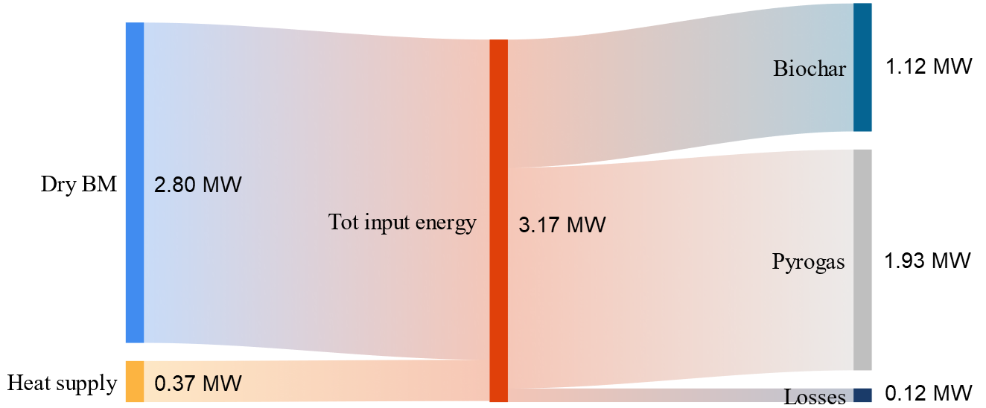  (b)
Figure 3. Pyrolyser mass (a) and energy (b) balance.
Figure 4a shows the mass balance of the burner. The pyrogas enters the burner together with the combustion air, whereby an excess air of 140% of the stoichiometric air is assumed. The weight composition of the combustion gases consists of approximately 70% N₂, 12% O₂ (due to the excess air), 11% water vapour and 7% CO₂. Figure 4b shows the energy balance of the burner: The energy contained in the pyrogas is transferred to the burnt gases except for the losses (approx. 15%).
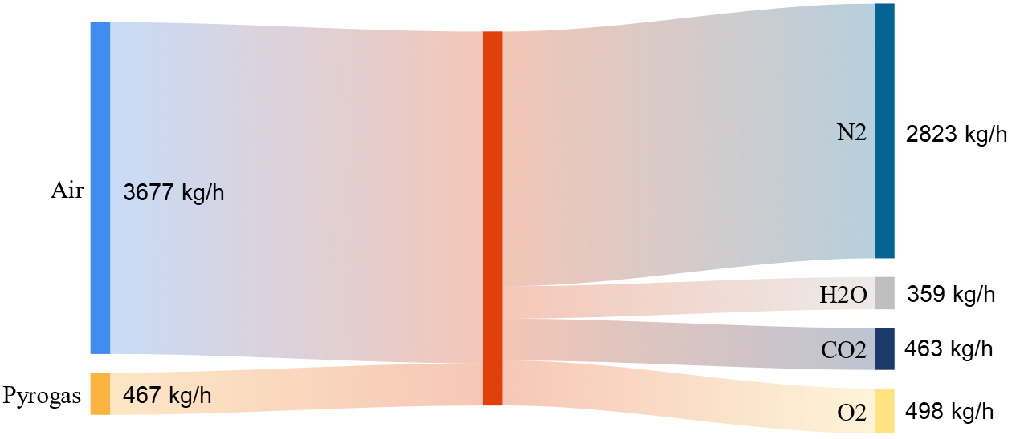  (a) | 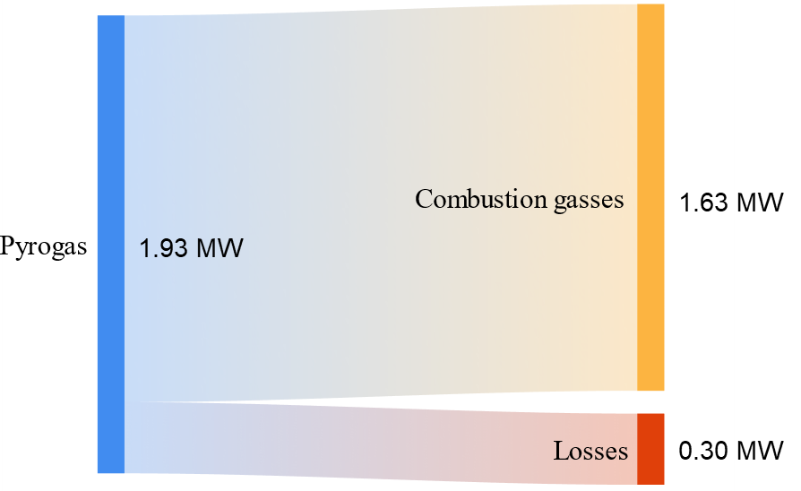  (b)
Figure 4. Burner mass (a) and energy (b) balance.
Figure 5a summarises the conversion of the biomass fed to the plant by highlighting the moisture loss during the drying process, the biochar production and the pyrogas production. The energy balance of the entire plant is summarised in Figure 5b. Almost 40 % of the chemical energy contained in the original biomass remains in the biochar in the form of chemical energy. The sensible energy of the biochar accounts for only 1 % of the energy balance of the system. 24% of the biomass energy is lost in the form of sensible and latent heat in the exhaust gases leaving the plant (more precisely 13% in the combustion gases at the chimney and 11% in the water vapour extracted in the dryer). The sensible heat of the biochar and the sensible and latent heat of the gases leaving the plant are labelled as unrecovered heat in Figure 5b, as some of this energy could be recovered with suitable systems (which would increase the investment costs of the plant). 20 % of the energy from the biomass is lost through heat losses in the dryer (5 %), in the pyrolyser (4 %) and in the burner and flue gas ducts (11 %). The remaining 16 % is useful heat, which is available at a temperature of around 700 °C and can be used for other processes, e.g. for the valuable production of pressurised steam for industrial purposes.
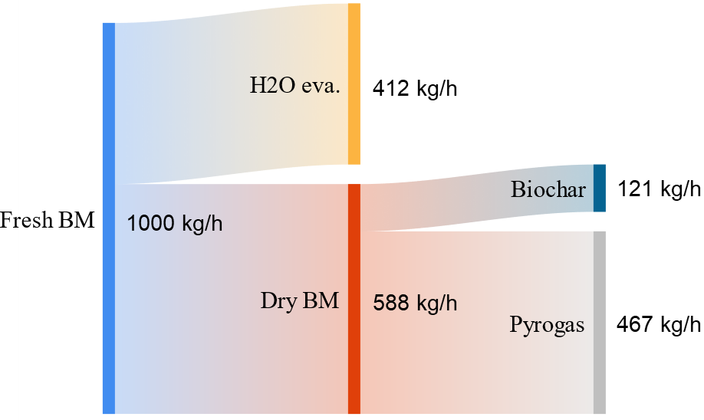  (a) | 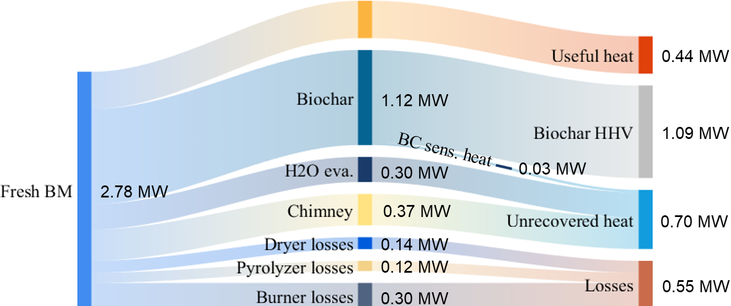  (b)
Figure 5. Plant mass (a) and energy (b) balance.
  - Conclusion
Conducting an energy analysis of the biochar production process is crucial for accurately assess the environmental impact of this well-established carbon-negative product. This study presents a comprehensive energy model specifically developed to analyse biochar production by slow pyrolysis. The model was applied to a pyrolysis plant for lignocellulosic biomass. The model effectively identified the energy losses that occur at different stages of the plant, including the dryer, pyrolyser and burner. In addition, it revealed the significant potential for heat recovery during the process, which corresponds to approximately 16% of the initial chemical energy present in the biomass. Indeed, the utilisation of this recovered heat can further improve the environmental performance of biochar production.
The versatility of the proposed model allows its adaptation to the analysis of other biomass types and makes it a valuable tool to support technical and environmental assessments. By using this model, stakeholders can gain deeper insights into the energy dynamics and optimise the sustainability of biochar production processes.
Acknowledgments
Project funded by the European Union – NextGenerationEU - National Recovery and Resilience Plan (NRRP) - Mission 4 Component 2 Investment 1.3 - Call for tender No. 341 of 15.03.2022 of Ministero dell’Università e della Ricerca (MUR). Project code PE00000021, Concession Decree No. 1561 of 11.10.2022 adopted by Ministero dell’Università e della Ricerca (MUR), CUP – E13C22001890001, according to attachment E of Decree No. 1561/2022, Project title “Network 4 Energy Sustainable Transition – NEST - Spoke 3".
References
Bong C.P.C., Lim L.Y., Lee C.T., Ong P.Y., Van Fan Y., Klemeš J.J., 2021, Integrating compost and biochar towards sustainable soil management, Chemical Engineering Transactions, 86,1345-1350.
Chen X., Wu X., 2022, The roles of carbon capture, utilization and storage in the transition to a low-carbon energy system using a stochastic optimal scheduling approach, Journal of Cleaner Production, 366,132860.
Cong H., Masek O., Zhao L., Yao Z., Meng H., Hu E., Ma T., 2018, Slow pyrolysis performance and energy balance of corn stover in continuous pyrolysis-based polygeneration systems, Energy&fuels, 32, 3743-3750.
Demol R., Dufour A., Rogaume Y., Mauviel G, 2021, Production of purified H2, heat, and biochar from wood: comparison between gasification and autothermal pyrolysis based on advanced process modelling, Energy & Fuels, 36(1), 488-501.
Glaser B., Parr M., Braun C., Kopolo, G., 2009. Biochar is carbon negative, Nature Geoscience, 2(1), 2-2.
Harsono I., Heat transfer mechanisms in an indirectly heated rotary kiln with lifters and its role in scaling, PhD Thesis, Curtin University of Technology, Perth, Australia.
Klinar D., 2016, Universal model of slow pyrolysis technology producing biochar and heat from standard biomass needed for the techno-economic assessment, Bioresource Technology, 206, 112-120.
Klinar D., Huber M., Belšak Šel N., Rižnar, K., 2021, Universal Model for the Cogeneration of Heat, Power and Char in a Decoupled Pyrolysis and Gasification Process for Techno-Economic Assessment, Processes, 9(8), 1442.
Phan A.N., Ryu C., Sharifi V.N., Swithenbank J., 2008, Characterisation of slow pyrolysis products from segregated wastes for energy production, Journal of Analytical and Applied Pyrolysis, 81(1), 65-71.
Salimbeni A., Lombardi G., Rizzo A.M., Chiaramonti D., 2023, Techno-Economic feasibility of integrating biomass slow pyrolysis in an EAF steelmaking site: A case study, Applied Energy, 339, 120991.
Simpson W., TenWolde A., 1999, Physical properties and moisture relations of wood. Wood handbook: wood as an engineering material, Madison, WI: USDA Forest Service, Forest Products Laboratory, USA.

