CHEMICAL ENGINEERING TRANSACTIONS  VOL. , 2024 | A publication of
The Italian Association
of Chemical Engineering
Online at www.cetjournal.it

Guest Editors: Leonardo Tognotti, Rubens Maciel Filho, Viatcheslav Kafarov
Copyright © 2024, AIDIC Servizi S.r.l.
ISBN 979-12-81206-09-0; ISSN 2283-9216

Sustainable Aviation Fuel Production Optimization in Colombia: An In-depth Sensitivity Analysis
Mauricio Lopez^{a,d}, Sergio Leon^{b,d}, Stender Kwakernaak^{c} , Vladimir Silva^{b} ,John Posada^{c} , Oscar Alvarezª.
ª Los Andes University, Bogotá Colombia
^{b} ECCI University, Bogotá Colombia
^{c} Department of Biotechnology, Delft University of Technology (TU Delft), Delft, the Netherlands
^{d} Colombian Air Force, Bogotá Colombia

This research explores the optimization of Sustainable Aviation Fuels (SAF) production in Colombia, emphasizing economic and environmental factors. It examines feedstock availability, production technologies Alcohol-to-Jet (ATJ), Fischer-Tropsch (FT), and geographical considerations to determine the Minimum Fuel Selling Price (MFSP) of SAF. The environmental analysis employs a Life Cycle Assessment (LCA), considering CO2 emissions at each value chain step with an energy allocation factor for equitable carbon footprint distribution. Results highlight increased SAF demand in urban centers, necessitating diverse biomass sourcing. Fischer-Tropsch proves efficient but with high energy requirements impacting costs, while Alcohol-to-Jet offers an alternative leveraging existing bioethanol facilities. The study emphasizes data sensitivity importance, addressing limitations and showcasing 0.072 USD/L change for 1% allocation change and 0.03 USD per liter for 1% conversion drop in Gas-to-Liquid Fuel, and 0.04 USD/L for allocation and 0.1 USD/L for 1% conversion drop in Alcohol-to-Jet. Compared to prior work, this research provides detailed economic and environmental insights, extending analysis depth and acknowledging limitations, thereby enhancing research comprehensiveness and applicability.
  - Introduction
This research delves into the intricacies of optimizing the production of Sustainable Aviation Fuels (SAF) production in Colombia, with a strong emphasis on economic and environmental considerations. This study seeks to identify the main variables in the value chain tailored to the unique Colombian context. An exhaustive analysis encompassed the national availability of feedstock, their corresponding production technologies, and specific geographical locations.
This evaluation of production technologies scrutinized the following technologies: alcohol-to-jet (ATJ), and Fischer-Tropsch (FT). The range of feedstocks examined includes various lignocellulosic waste sources, such as municipal solid waste, bagasse, and heart leaves from agro-industrial processes, like oil palm and corn rice residues, among others. Crucially, the study dug into economic factors, including basic economics for capital and operating costs for centralized storage processing units (CSP) and biorefineries, transport for every phase of the value chain and feedstock costs, and even the economic allocation factor to comprehensively determine the Minimum Fuel Selling Price (MFSP) of SAF, this encompassed the consideration of co-products and related services, emphasizing that the economic impact extends beyond SAF pricing. Furthermore, for environmental analysis and the life cycle assessment (LCA), a couple of factors for CO2 emissions were gathered for every step in the value chain, also, the energy allocation factor allowed to account for carbon credits and other co-products related to SAF production. This facilitated the equitable distribution of the carbon footprint across various products in the production process.

The results indicate higher SAF demand in major urban centers like Bogotá, Rionegro, Cartagena, and Cali. Biomass sourcing was geographically tailored to these urban hubs and processing centers, with materials such as sugar cane, rice, oil palm, corn, and coffee yielding essential components like bagasse, husk, shells, fiber, palm rachis, stubble, cop, basket, pulp, cisco, and stems(López Gómez et al., 2023). Notably, the technology's analysis revealed varying yields, aligning with existing literature. Fischer-Tropsch conversion of lignocellulosic feedstock emerged as the most efficient but with substantial energy requirements, which leads to a higher capital cost, and it necessarily involves rises in the MFSP; it is worth highlighting the importance of moisture content in lignocellulosic materials, which could add extra steps in the value chain. Also, the CSP location influences the transport contribution, especially when those that are far from the feedstock or biorefineries could raise the transportation prices and emissions. The ATJ route may be shown as an alternative, especially for the current technology already used in the country to produce bioethanol, despite its not being a lignocellulosic feedstock it could be made by those, this aspect is important, the already facilities could decrease the capital cost that was found and used in the literature.
Among the most relevant results is the sensitivity of data that affects the SAF at an economic and environmental level, among which the allocation factor stands out, the transportation of raw materials from the regions. On the other hand, the conversion at some point is limited by the availability of raw materials or demand. For allocation sensibility for GFT is 0.0717 USD/L for every 1% of change and 0.04 USD/L for ATJ, likewise, farmgate price and OPEX 0.00138 USD/L and 0.00131 USD/L respectively for every USD/ton for GFT, and for ATJ 0.00486 USD/L and 0.00478 USD/L. And finally for Capex 0.00271 USD/L in GFT and 0.00234 USD/L in ATJ for every million dollars of change in capex. Although logistics and value chain have been identified before, those detailed calculations are highly anticipated for SAF ecosystem in the region.
  - Methodology
    - Tool: The tool is a supply chain optimization program developed by (Kwakernaak, 2022) with the help of geolocation software, which determines the optimal supply chain for a defined demand for SAF in the major airports in Colombia, using a value chain model with four stations: feedstock production or "regions," Centralized Storage Processing (CSP), biorefinery, and airport. The model includes three phases of transport. The tool also incorporates general factors such as chemical routes, investment costs, biomass quantities in the CSP, installation levels, and environmental and economic factors. Additionally, it uses the Allocation amortization technique to distribute total costs among different co-products of the process, considering the price of the feedstock and the costs of the CSP, and biorefinery, including operating costs, capital, and productive capacities. It is important to highlight that the life cycle analysis is also present in the approach, considering the emissions per ton processed by feedstock at different stages of the supply chain, from the acquisition of the raw material to transport to the airport. This process takes into account the different regions of production of the feedstock, the transport to the CSP, which goes to the biorefinery, and finally, to the airport.
    - Factors: Factors are used to find the MFSP or LCA, this calculation has four parts as mentioned before: feedstock, CSP, biorefinery and transport, every factor is multiplied with the respective optimized facility capacity and allocation factor, and in the case of transport with the distance found for the optimization tool, the factors for MFSP are the ones related with costs, and for LCA related with eqCO2 emissions. The factors were defined after an exhaustive investigation of the literature, where the data were analyzed and used for calculations, adapted for the two technologies as mentioned above. With the selected feedstock representing the largest groups of raw materials produced in the country, the sensibility was carried out by choosing two different values—one smaller and the other greater than the original—allowing the calculation of the behavior of the MFSP or LCA when the factors could be reduced or increased. Similarly, the analyzed factors are separated into four groups: the main factor of the GFT route(Kreutz et al., 2020), the main factor for ATJ(Atsonios et al., 2015), transportation costs (taken as the base for GFT calculations), and life cycle assessment (as an example in the GFT case). The main factors for the routes mentioned before are allocation factor, a factor that reduces the total cost by distributing the cost to other by-products, conversion of the route like the mass of bio-jet that can be obtained for the mass of feedstock, farmgate price(Shahriar and Khanal, 2022), the price of the feedstock, OPEX and CAPEX operation, and capital expenditures(Capaz et al., 2020).
    - Relative Sensitivity of Factors: The relative sensitivity of each factor was found with the following equation, originally called relative sensitivity.

${Sr}_{k_{1}}^{C}=\frac{∂C^{opt}/C_{opt}}{∂k_{1}/k_{1}}=\frac{∂lnC^{opt}}{∂lnk_{1}}=\frac{lnC_{1}^{opt}-lnC_{2}^{opt} }{lnk_{1,1}-lnk_{1,2}}$ (1)

At the formula 1, C^{opt} refers to MFSP or LCA, in the original state (state 1) and the altered state (state 2) which is indicated in the subscript, and k₁ refers to the variable in case, in the same state as previously defined. It is calculated within the average range of the defined factors; this indicator will show which of the analyzed factors are the most sensible, or in other words, those factors that can have a more significant impact on MFSP or LCA with a smaller change in their value.
    - Sensitivity: The main variables are analyzed with two variations of the original factor, one increasing the factor and the other decreasing it. These changes are defined based on the information available when establishing the factors. Additionally, a sensitivity factor is calculated as follows:
$S_{k_{1}}^{C}=\frac{∂C^{opt}}{∂k_{1}}=\frac{C_{1}^{opt}-C_{2}^{opt}}{k_{1,1}-k_{1,2}}$ (2)

By systematically altering the variable, the analysis aims to discern the behavior of the result across various hypothetical values. Moreover, sensitivity analysis offers insights into the slope of the outcome, enabling a swift estimation of its value when the variable experiences minor fluctuations, whether in an upward or downward direction from its original value.
  - Results
    - Relative sensitivity: The Figures 1a and 1b show the results as following: in every label is the name of the factor that is variating in the analysis, between the brackets are three values that the variable took to run the model, the first value is the smaller value, the second is the normal value, and the third is the greater value, also, the results are shown when the factor value decreases (in blue) and when it rises (in orange) according with the values in the brackets. If the value of the relative sensitivity analysis is positive, it means a direct proportionality, indicating that an increase in the factor would lead to an increase in MFSP. Otherwise, if its value is negative, it means that an increase in the value leads to a decrease in the results. Moreover, the main Factors to analyze are, Capex or capital costs, Opex or operation costs, Farmgate process, or feedstock price, conversion in the biorefinery, and finally allocation factor.

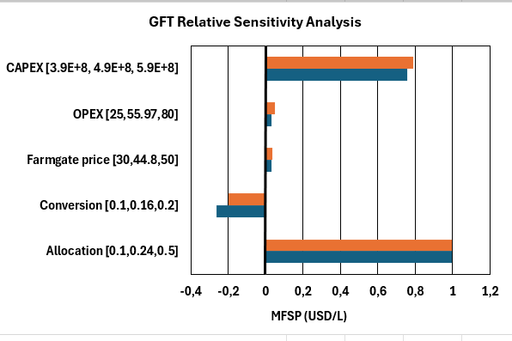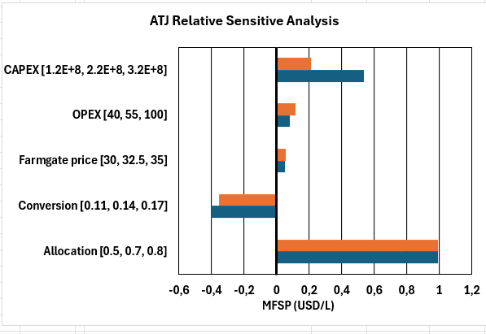
Figure 1 a) GFT Relative Sensitivity Analysis ATJ Figure 2 b) Relative Sensitivity Analysis

The most important factor in these calculations, according to these results, is the allocation factor, which exhibits the same behavior in GFT and ATJ and has the highest relative sensitivity value, this value is directly influenced by prices these co-products, like renewable diesel or naphtha, which value in Colombia is lower than kerosene, nonetheless, a rise in this prices, or a drop in jet prices should decrease the allocation factor. Besides this factor, others like OPEX and farmgate price show similar behavior. It is noteworthy that these factors have a small value of relative sensitivity. However, in ATJ, those values are greater than in GFT, which may be attributed to the effects of Capex relative sensitivity. In GFT, these factors are the second most important, and it is known that for this technology, the equipment requirements are higher due to security issues arising from the high temperatures in the gasification process(ICAO, 2023). Therefore, if this factor constitutes one of the main costs in MFSP, about 83% for GFT and 68% for ATJ, a change in this factor would result in a more significant impact in GFT(de Klerk, 2016). The last factor is conversion, which proves to be an important factor, especially if it decreases. If such an alteration occurs, the impact would be more substantial than if it increases. Therefore, careful control over this factor should be emphasized.
    - Sensitivity: In Figures 2a and 2b, the depiction of various factors is presented. Beginning with the farmgate price, it demonstrates limited variability, thereby indicating its status as the least sensitive factor. However, it is crucial to acknowledge that despite its limited variability, significant changes could potentially impact the overall optimization of this calculation (Marvin et al., 2013). The OPEX cost exhibits a similar pattern to the farmgate price, displaying comparable behavior and leading to analogous conclusions with an almost identical sensitivity factor (Yue et al., 2014). Specifically, for GFT, the farmgate price and OPEX are observed to be 0.00138 USD/L and 0.00131 USD/L respectively for every USD/ton, while for ATJ, these values are 0.00486 USD/L and 0.00478 USD/L respectively. Regarding the conversion factor, its behavior deviates from linearity. Consequently, an increase in this factor would not yield the same impact as a decrease. For instance, a 1% increase in ATJ conversion leads to a decrease of 0.061 USD/L, whereas a similar decrease could result in a rise of 0.10 USD/L. Similarly, for GFT, a 1% increase in conversion corresponds to a 0.01 USD/L decrease, while a decrease leads to a 0.037 USD/L increase. Thus, the conversion factor plays a pivotal role in this analysis (Huang et al., 2019).

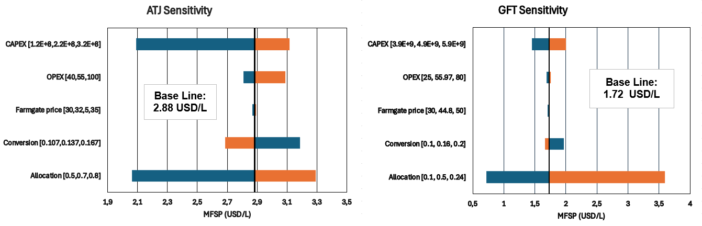
Figure 2 a) ATJ Sensitivity Figure 2 b) GFT Sensitivity

Regarding the Capex factor, it emerges as a highly significant factor according to the results. It can be observed that for GFT, changes in these high costs are not as impactful as the changes in ATJ. This is attributed to the analysis presented in the relative sensitivity analysis, since, for GFT 0.00271 USD/L, and 0.00234 USD/L in ATJ for every million dollars of change in capex.
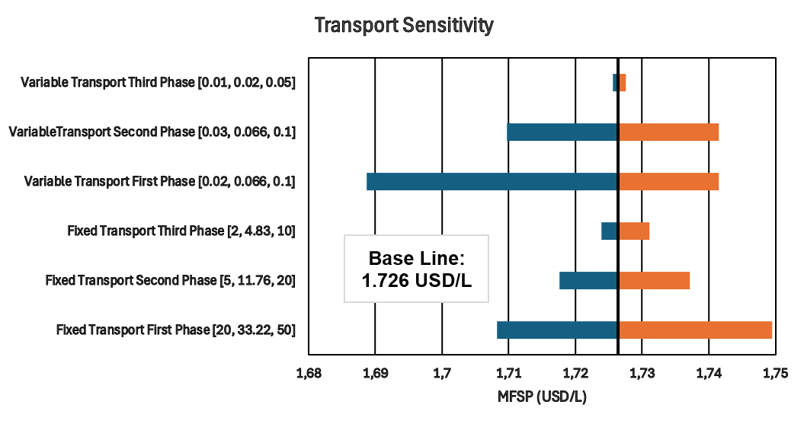
Figure 3: Transport Sensitivity

For transport costs shown in the Figure 3, three phases of transport were taken into consideration, the first is the transport from production regions of the feedstock to de CSP, the second is the transport from CSP to Biorefinery and the third is from biorefinery to airport, also, ‘variable’ factors are the ones that depends on the travel distance, and the fixed ones do not depend on it. Indeed, variable factors seem to have more impact on the final price, it is due to its nature, an increase in a variable factor will be multiplied to every kilometre of travel, so an increase in this factor equals to an increase in distance. The transport sensitivity indicates that the changes of greatest significance need to be considered, especially in the first phase of the value chain. Similarly, the third phase appears to be less important. This is attributed to the density of the material, which affects the mass capacity, particularly in the case of lignocellulosic material. This implies that the truck's capacity is reduced, resulting in the same costs for less capacity. Furthermore, it underscores the importance of having different regions of production located near the Centralized Storage Processing (CSP), as the distances are additive for every region of production. It is evident from the analysis that the first phase could be optimized, particularly in terms of variable costs. If these costs could be decreased, it would lead to a potential benefit in terms of reducing the MFSP.
In the Figure 4, the sensitivity analysis reveals that the most sensitive factor is emissions in the biorefinery, which is intuitive given its status as the primary input requirement, it could reach 0.049 gCO2eq/MJ of change with every gCO2eq/ton of feedstock of emission that is actually the lowest, In the other hand, for transport in phase three the sensibility is about 5.48 gCO2/MJ for every gCO2/tonkm in change of the factor, although, this factor is higher , a change in the factor of transport are more difficult to happen, not only in emission but also in costs, therefore the result show that for different real values found in the bibliography, the biorefinery is the one with higher impact.
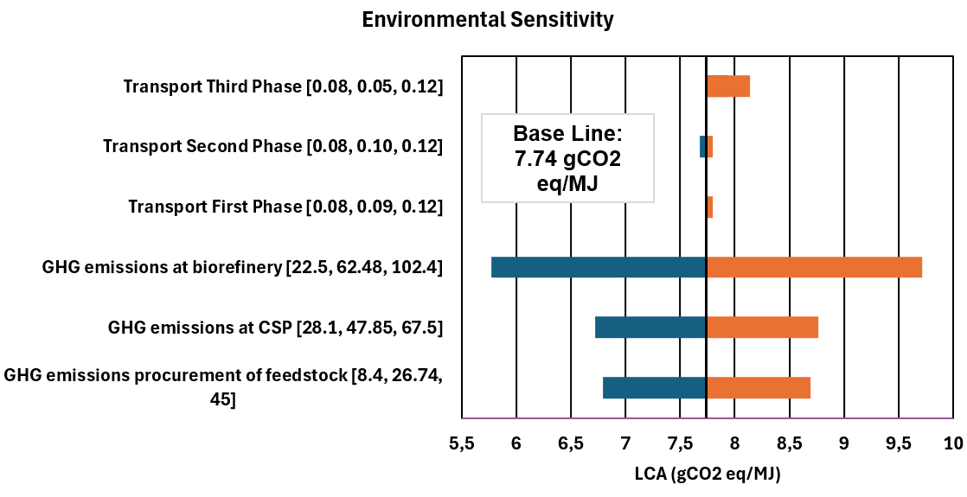
Figure 4 Environmental Sensitivity

An in-depth analysis could be conducted to explore the variables that contribute to the prominence of this factor. Given the complexity and multitude of factors involved, even with the approximations made for this research, a detailed investigation may reveal nuanced interactions.

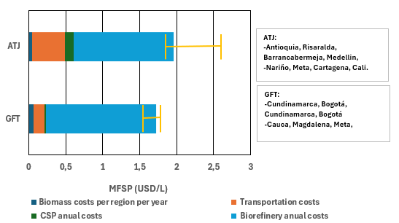

Figure 5 Location Sensitivity Figure 6 Capacity Sensitivity

For Figure 5, To analyse the sensibility for the distance, two routes were selected besides the main one; the first one was the shortest, and the other one was the largest possible, so the price for transportation could differ along with distances. The results show that a larger distance means a direct influence in the final price, however, the other cost mainly the biorefinery costs are higher than the transportation. For GFT the effect is less visible because the allocation decreases its final costs, in the case of ATJ (were the allocation used was 0,6) the initial route is very similar to the shortest, so the change is barely visible, nonetheless, the longest distance result shows that the distances could influences in a very significant way, particularly this route is very long, it goes to the most south, north and east points, and it helps to reaffirm the importance of the location of every step, and its need from it to be as nearby as possible one to another.
To analyse how the production size could affect the MFSP, three production sizes were calculated, one for reaching the 1 % integration, for 9%, and 15% of the total demand goal, which corresponds with the small, medium, and larger scales, for a reference of 300-million-gallon total demand.
The results shown in the Figure 6, display the behaviour of the economy of scales, in which, on larger scales, besides the capital cost is in accordance with this size, for a unit of product it is smaller, because the production increase as well, so for ATJ the effect could diminish the price to about 1.2 USD/L, and for GFT to about 0.5 USD/L, this value is considered very competitive if it is compared with costs of production around the world, furthermore, the capacities can be compared with the ones in the literature and it can be seen similar values, However, those capacities are much bigger than the current offer of feedstock, or the actual capacity of a possible facility, so the prices for Colombian context are shall prone to be different. Moreover, it is important to state once again that the allocation factor has an important role in diminish the overall results, it is clear in GFT results, so it is mandatory to adequate the allocation for the conditions of the context the study is carried on.
Conclusions
The economic allocation factor depends on market values of co-products such as biodiesel, gasoline, and electricity, as well as services like carbon credits. Additionally, government-generated credits, incentives, and exemptions can directly benefit the MFSP, varying from 1.7 in GFT 0.07 USD/L and from 2.88 0.1 USD/L for ATJ for every 1% of change in the allocation factor.
Among the transportation factors, the region where feedstock is generated to the CSP has the most significant influence on the overall transportation process compared to other points in the supply chain. This consideration considers displacements and capacity waste in weight due to the varying densities of the raw material.
Concerning the conversion of raw material to SAF, this factor is indispensable to optimize, its nonlinear behaviour punishes every drop in its value, even 0.03 USD/L for GFT or 0.1 USD/L in ATJ for Every 1% in drop of the conversion, besides the logistics chain faces limitations at a point where availability of raw material or demand from the final consumer becomes a deciding factor. In these scenarios, the tool can assist in decision-making.
While the farmgate price and operating costs in the biorefinery significantly impact the final SAF price, the variation across different scenarios is minimal and fails to achieve a representative effect. Therefore, government intervention in these production chains or the establishment of a hydrogen route can bring about a substantial change in the competitiveness of the final product.
Acknowledgments
The authors express their gratitude to the ECCI University, Defense Aeronautical Certification Office SECAD, Colombian Aerospace Force, Andes University, TU DELFT University, Stender Kwakernaak, Santiago Yoda, Emanuel Useche, and Laura Valderrama. This research was funded by the Ministry of Science, Technology and Innovation of Colombia MINCIENCIAS, the Colombian Air Force, and ECCI University through project 728-2020 “Evaluation of the behavior of mixtures of Colombian Biofuels in Aeronautical Turbines”.
References
Atsonios K., Kougioumtzis, M.-A., D. Panopoulos K., Kakaras, E., 2015. Alternative thermochemical routes for aviation biofuels via alcohols synthesis: Process modeling, techno-economic assessment and comparison. Appl Energy 138, 346–366. <doi.org/10.1016/j.apenergy.2014.10.056>
Capaz R.S., de Medeiros E.M., Falco D.G., Seabra J.E.A., Osseweijer P., Posada J.A., 2020. Environmental trade-offs of renewable jet fuels in Brazil: Beyond the carbon footprint. Science of The Total Environment 714, 136696. <doi.org/10.1016/j.scitotenv.2020.136696>
de Klerk A., 2016. Aviation Turbine Fuels Through the Fischer–Tropsch Process, in: Biofuels for Aviation. Elsevier, pp. 241–259. <doi.org/10.1016/B978-0-12-804568-8.00010-X>
Huang E., Zhang X., Rodriguez L., Khanna M., de Jong S., Ting K.C., Ying Y., Lin T., 2019. Multi-objective optimization for sustainable renewable jet fuel production: A case study of corn stover based supply chain system in Midwestern U.S. Renewable and Sustainable Energy Reviews 115. <doi.org/10.1016/j.rser.2019.109403>
ICAO, 2023. SAF Rules of Thumb. URL <www.icao.int/environmental-protection/Pages/SAF_RULESOFTHUMB.aspx> (accessed 9.23.23).
Kreutz T.G., Larson E.D., Elsido C., Martelli E., Greig C., Williams R.H., 2020. Techno-economic prospects for producing Fischer-Tropsch jet fuel and electricity from lignite and woody biomass with CO2 capture for EOR. Appl Energy 279, 115841. <doi.org/10.1016/j.apenergy.2020.115841>
Kwakernaak S., 2022. Spatial and temporal distribution of lignocellulosic biomass for marine & aviation biofuel production. TU DELFT.
López Gómez M., Posada J., Silva V., Martínez L., Mayorga A., Álvarez O., 2023. Diagnosis of Challenges and Uncertainties for Implementation of Sustainable Aviation Fuel (SAF) in Colombia, and Recommendations to Move Forward. Energies (Basel) 16, 5667. <doi.org/10.3390/en16155667>
Marvin W.A., Schmidt L.D., Daoutidis P., 2013. Biorefinery Location and Technology Selection Through Supply Chain Optimization. Ind Eng Chem Res 52, 3192–3208. <doi.org/10.1021/ie3010463>
Shahriar M.F., Khanal A., 2022. The current techno-economic, environmental, policy status and perspectives of sustainable aviation fuel (SAF). Fuel 325. <doi.org/10.1016/j.fuel.2022.124905>
Yue D., You, F., Snyder S.W., 2014. Biomass-to-bioenergy and biofuel supply chain optimization: Overview, key issues and challenges. Comput Chem Eng 66, 36–56. <doi.org/10.1016/j.compchemeng.2013.11.016>

