CHEMICAL ENGINEERING TRANSACTIONS  VOL. , 2024 | A publication of
The Italian Association
of Chemical Engineering
Online at www.cetjournal.it

Guest Editors: Leonardo Tognotti, Rubens Maciel Filho, Viatcheslav Kafarov
Copyright © 2024, AIDIC Servizi S.r.l.
ISBN 979-12-81206-09-0; ISSN 2283-9216

Synergistic Effects towards Hydrochar Recovery during Hydrothermal Carbonization of Ferula Communis with Process Water Recirculation
Antonio Picone, Maurizio Volpe*, Antonio Messineo
Department of Engineering and Architecture, University of Enna Kore, Cittadella Universitaria, 94100 Enna, Italy maurizio.volpe@unikore.it

Recirculation of process water (PW) from hydrothermal carbonization (HTC) has revealed as an effective strategy for the residual aqueous phase valorization in order to make the process energetically more efficient while reducing its environmental footprint. The effects of temperature, solid load and consecutive conversion phases on PW recirculation were assessed by using Ferula Communis plant residues as feedstock in HTC experiments. Recirculation of solvent promoted strong synergistic interactions between biomass and PW aimed at increasing hydrochar mass recovery. Hydrochar yield increased by 4-12 wt% on a dry basis (d.b.) according to reaction conditions. Biomass degradation was catalyzed by the reactive intermediates dissolved in the PW. The energy balance results showed that the energy recovery almost doubled by recycling PW when compared to the experiments carried out using only deionized water as HTC solvent.
  - Introduction
Hydrothermal carbonization (HTC) has proven to be an effective thermochemical technology for the conversion of residual wet biomasses into enegy-dense biofuels (Codignole et al., 2023; Messineo et al., 2012). When the feedstock is treated by HTC, a considerable amount of extra water is commonly required to obtain a biomass to solvent mass ratio (B/W) of 0.1-0.2, needed to reach a correct environment for the hydrothermal conversion. Water in subcritical conditions has the ability to catalyze the biomass decomposition, producing a solid phase product, known as hydrochar, and highly reactive organic compounds concentrated in the exhausted process water. The HTC liquid by-product is commonly referred as process water (PW) (Picone et al., 2021). Typically, during HTC of agro-waste, between 20 and 50 wt% of biomass' compounds concentrate in the PW, resulting in extensive carbon and energy losses if the compounds found in the PW are not recovered and correctly treated. In order to reach a sustainable, and thus successful, development of HTC technology, it becomes imperative to find sustainable ways to valorize the PW (Wang et al., 2020). A PW recycling strategy, as HTC conversion solvent, could significantly reduce the extra water consumption and also give the opportunity for an enhanced hydrochar recovery, improving the global process energy efficiency. Herein, the reusability of PW generated during HTC of Ferula Communis (FC) was investigated. FC is a spontaneous perennial and robust weed, abundant across the Mediterranean basin. It contains prenyl coumarins such as ferulenol and related compounds that are responsible for a lethal hemorrhagic disorder (ferulosis) mainly affecting goats, sheep, cattle, and horses. Due to its high toxicity for the livestock, FC is often weed out and thus representing a typical Mediterranean agricultural waste which should be appropriately valorized (Akaberi et al., 2015). In this study, FC was hydrothermally carbonized at different reaction conditions to assess its role during HTC with recycled solvent. Using a simplified energy balance model, it was proved that PW recirculation strategy could lead to a considerable increase of energy recovery enhancing the overall HTC process efficiency.
  - Materials and methods
    - Experimental procedure
Ferula Communis plant (FC), including stems, leaves and seeds, was collected from a suburban countryside of Enna (Sicily) and used as feedstock for all HTC conversion tests. Prior of the experiments, FC samples were ground by using a knife miller in order to provide completely homogeneous and reproducible size reduction (all samples presented a particle size of approximately 0.5 cm), and stored in sealed plastic containers in a refrigerator at 4 °C until their use. A portion of FC was dried in a ventilated oven at 105 °C until constant weight to quantify the moisture content, which resulted, on average, about 68.8 wt%. Deionized water (DW) was used as process solvent in HTC reference steps while PW was used as recycled liquid medium in the subsequent recirculation phases.
HTC experiments were carried out by using a stainless-steel batch reactor with an internal net volume of 50 mL, and charging it with approximately 9.6 g of wet FC (3.0 g d.b.) and the amount of solvent (DW or PW) required to reach the desired B/W. After the reactor sealing, it was evacuated by flushing pure nitrogen to remove residual traces of oxygen, heated up to the selected temperature and kept isothermal for the prefixed reaction time (the heating step lasted for 23-35 min according to the temperature set point). When the conversion was completed, the reactor was rapidly cooled down to room temperature by placing it on a massive stainless-steel disc at -10 °C while compressed air was blown over the reactor walls to speed up the cooling process. The hydrochar was separated from PW by vacuum filtration and dried at 55 °C until constant weight prior to mass yield determination. The recovered PW, containing the various dissolved organics, was used as a recycled process solvent for the next HTC phases.
HTC tests were performed at 180, 200 and 230 °C with a fixed reaction time of 60 min and B/W of 0.1 in order to investigate the temperature influence on the interaction between the solid treated biomass and the recycled solvent during the conversion. In addition, the effect of B/W, set at 0.1, 0.15 and 0.2, and five consecutive recirculation steps (B/W of 0.1), was studied at 180 °C and 60 min, since the highest increase of hydrochar mass yield after PW recycling was found at this reaction temperature. In order to compute the PW contribution in the hydrochar formation during recirculation steps, the recovered spent solvent was also employed as substrate (in absence of the raw solid feedstock) in HTC tests carried out at the same operating conditions used for its generation. All experiments were carried out at least three times to evaluate the deviation of data and ensure reproducibility. The results were considered valid if RSD% (Relative Standard Deviation) < 2.5.
Composition and energy content of raw feedstock and hydrochars were evaluated by proximate analysis and higher heating value (HHV) measurement, respectively. Proximate analysis was carried out by a LECO Thermogravimetric Analyser TGA 701 (ASTM D standard) to quantify volatile matter (VM), ashes (ASH) and fixed carbon (FC) of each sample. A calorimeter LECO AC500 was used to measure HHVs according to the CEN/TS 14918 standard.
    - Data analysis
The hydrochar mass yield (HY) was calculated through Eq (1), where m_{HC} is the mass of hydrochar (d.b.) collected after the conversion and m_{raw} is the mass (d.b.) of solid starting material.

$$HY=m_{HC}/m_{raw}$$ | (1)

After computing the hydrochar mass recovered from HTC of only PW (m_{onlyPW}), the hydrochar yield increase (HY_{incr}) was defined to quantify the solid yield improvement net of PW dissolved components contribution.

${HY}_{incr}= \frac{m_{HC_PW}-(m_{HC_DW}+m_{onlyPW})}{m_{raw}}$ | (2)

where m_{HC_PW} and m_{HC_DW} are the masses of hydrochars obtained from HTC with PW recirculation and DW as solvent, respectively.
The interaction occurred between the dissolved compounds in recycled PW and the treated biomass was quantified by two different coefficients in order to evaluate the strength of synergy towards hydrochar formation during HTC.

${IE}_{HC}=\frac{m_{HC_PW-}(m_{HC_DW}+m_{onlyPW})}{{(m}_{HC_DW}+m_{onlyPW})}$ | (3)

$${IE}_{fr}=1-\frac{m_{onlyPW}}{(m_{HC_PW}-m_{HC_DW})}$$ | (4)

IE_{HC} measures the strength of synergy by referring the net hydrochar surplus to the calculated value, given by the sum of hydrochar masses recovered after individual HTC of feedstock and PW while IE_{fr} quantifies the fraction of hydrochar mass surplus obtained due to the interaction of raw feedstock and recycled PW.
The hydrochar energy properties were measured through the energy yield (EY) and the energy surplus ratio (ESR), defined as follows:

$EY=\frac{{HHV}_{HC}}{{HHV}_{raw}} ∙ {MY}_{HC}$ | (5)

$ESR= \frac{E_{out}-E_{in}}{E_{in}}$ | (6)

In Eq (5), HHV_{HC} and HHV_{raw} indicate the HHV value for the hydrochar and raw feedstock, respectively. In Eq (6), E_{out} is the energy output, computed by multiplying the hydrochar mass and its HHV; E_{in} represents the energy consumption required to heat the dry solid feedstock and the solvent (DW or PW) at the HTC set point temperature.

$E_{out}=m_{HC} ∙ {HHV}_{HC}$ | (7)

$E_{in}=m_{DF}c_{p}\left(T_{HTC}-25\right)+ m_{S}\left(h_{HTC}-h_{25}\right)$ | (8)

where m_{DF} and m_{s} are the masses of dry feedstock and process solvent; T_{HTC}, h_{HTC} and h₂₅ are the HTC operating temperature, and the specific enthalpy values of water at the HTC and room (25 °C) temperatures; c_{p} is the specific heat of the dry feedstock used (1.45 kJ/kg K).
  - Results and discussion
    - Effects of PW recirculation on hydrochar recovery rates
In HTC tests carried out using DW as solvent, the increase in temperature led to a decrease in HY. As widely reported in literature, a rise of reaction severity could promote a high biomass conversion rate and dissolution with a reduced hydrochar recovery as result. Compared to B/W of 0.1, when a HY of 52.0 wt% d.b. was found, HY was increased by 4.6 and 5.8 wt% d.b. for B/W of 0.15 and 0.2, respectively (Figure 1). The reason is probably related to a less intense hydrolysis and higher degree of solid-solid conversion reactions, with a possible earlier back-polymerization of dissolved by-products, which could more easily occur at increasing solid loads (Nizamuddin et al., 2017).
When PW was recirculated, hydrochar recovery was significantly improved at 180 °C and B/W of 0.1. HY_{incr} was almost halved at 200 and 230 °C, and a progressive reduction of HY_{incr} was observed at increasing B/W values. The presence of reactive compounds in the recirculated PW could both accelerate and extend the interactions between the dissolved organics from biomass hydrolysis and those from the previous conversion step accumulated in the aqueous medium, appreciably boosting the hydrochar formation mechanism (Wang et al., 2022b). The obtained results show that low conversion severity and B/W values could increase the availability of reactive organic components in the HTC solvent and the formation of new solid carbonaceous particles precipitating on the hydrochar surface during recirculation phases. More specifically, HTC conversion intermediates such as furans and organic acids could play the main role in synergistic interactions with others soluble by-products, contributing to increase the final hydrochar yield by re-polymerization of some dissolved organics (Jia et al., 2022). However, these reactive intermediates are very unstable during HTC and can be easily converted into aromatic structures with secondary char formation yet in the conversion with DW, especially at high temperatures, thus reducing their availability in the subsequent recirculation phase (Wang et al., 2022a). The yield of hydrochar progressively increased after consecutive recirculation steps with a HY maximum value of 64.3 wt% d.b. at the fifth cycle. The HY increasing trend slowed down with the number of consecutive recirculation phases and reached a nearly stable level after two recycles. The improvement in HY during consecutive PW recirculation, could be due to the progressive accumulation in the reused solvent of soluble conversion intermediates by hydrolysis and dehydration reactions. A saturation of these organic compounds in the PW could be responsible for the HY nearly stable value reached (Arauzo et al., 2020).

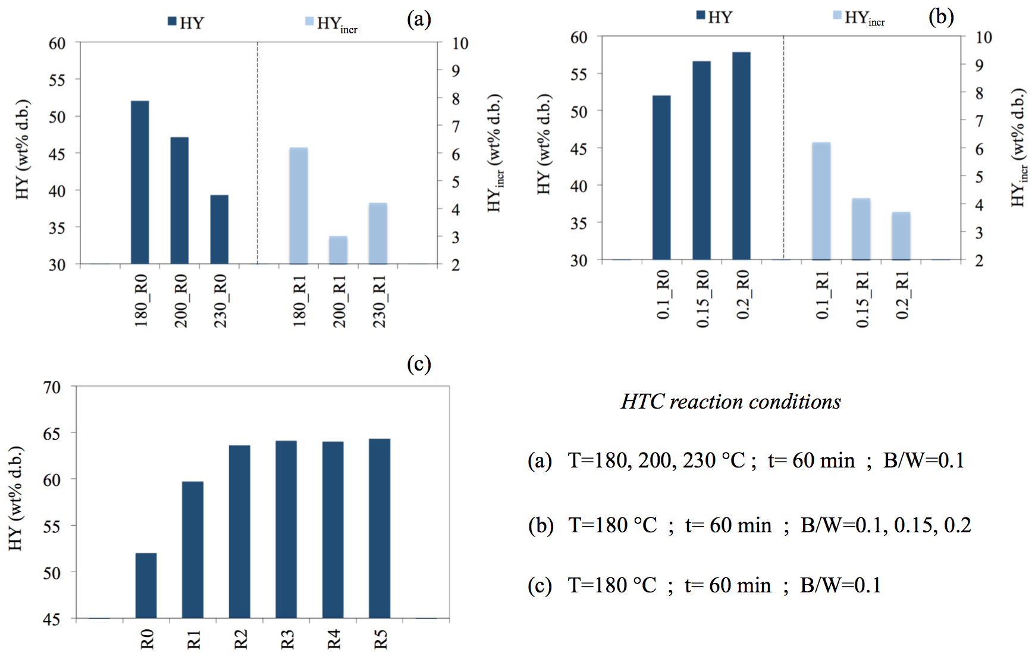

Figure 1: Effects of temperature (a), B/W (b) and consecutive PW recycling phases (c) on hydrochar recovery (RSD% ≤ 1.2). HTC runs carried out using DW as process solvent were named R0 while recirculation cycles were labelled as Rn, where n refers to the number of consecutive HTC reactions with PW as recycled aqueous phase.
As can be seen in Figure 2, the synergistic interactions occurred between the recycled solvent and the treated biomass were remarkable at all reaction conditions tested. Averagely, the 80% of the hydrochar surplus found after HTC with PW recirculation was due to the promotion effect in hydrochar formation related to the use of PW as solvent (IE_{fr} values). Compared to the calculated value (m_{HC_DW} + m_{onlyPW}), synergy led to a hydrochar yield improvement of 11.6 wt% d.b. (IE_{HC}) for the reaction carried out at 180 °C and B/W of 0.1, confirming that a low HTC temperature could strongly encourage an additional solid particles recovery. In the consecutive recirculation cycles, IE_{HC} increased from 11.6 wt% d.b. at step R1 to 19.1 wt% d.b. at step R3, remaining almost constant after the following two recycling steps.
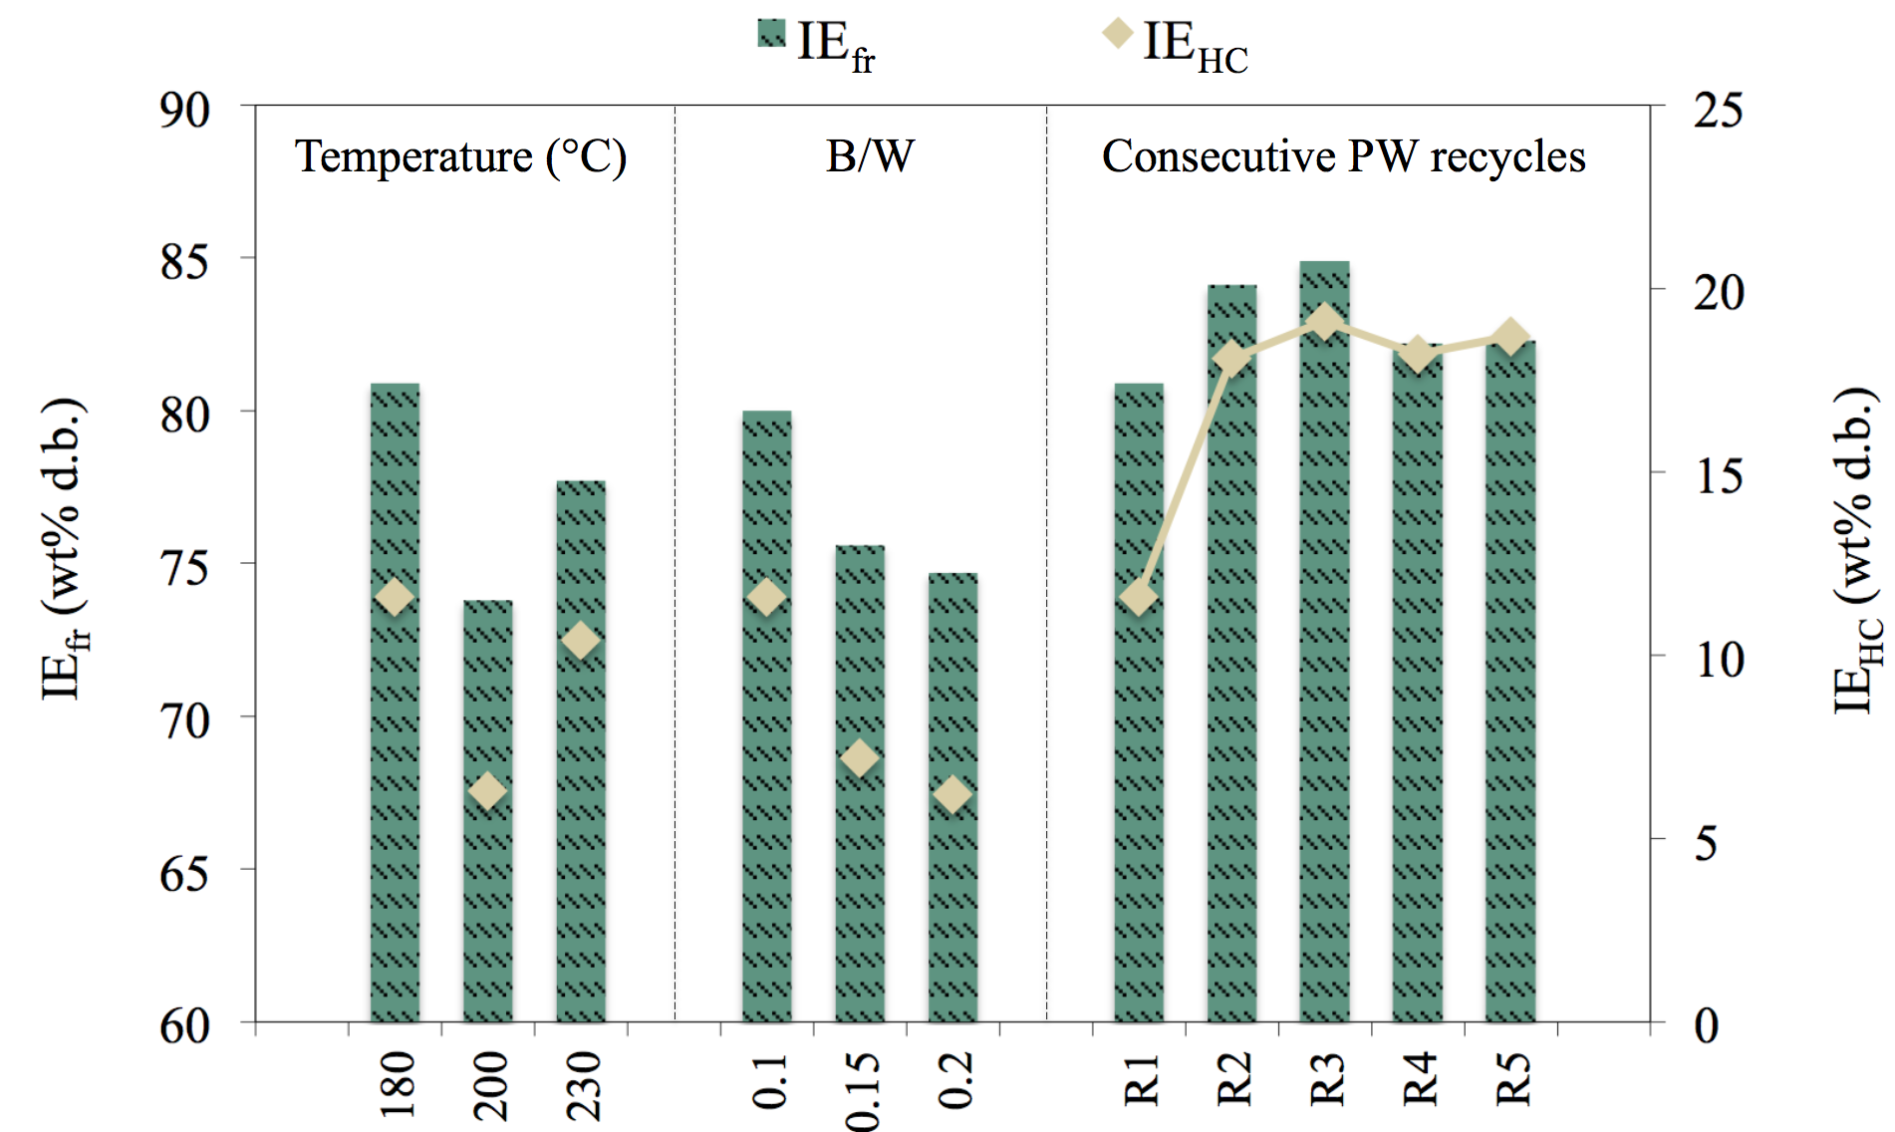

Figure 2: Synergistic effects towards hydrochar formation during HTC with PW recirculation at different reaction conditions.

    - Hydrochars characterization
Results from proximate analysis (Table 1) show that almost all hydrochars from HTC with solvent recycling, reported a decrease in VM content accompanied by an increase in FC, evidently indicating a higher conversion degree (Picone et al., 2021). The reduction in ash content after HTC must be attributed to the aqueous phase leaching effects. When PW was recycled, a slight increase in ash content was found, probably because dissolved inorganics in PW could be reabsorbed by the hydrochars and/or result on a lower leaching activity from the starting raw biomass (Mariuzza et al., 2022).
Organic acids formed by dehydration reactions involving hydrolysis products, in addition to those accumulated in the solvent from the previous conversion phases, could effectively intensify the hydrolysis itself, leading to a growing concentration of reactive organic components in PW. Among these, furfurals, phenols, aldehydes and ketones, could attend in the formation of new solid aromatics which probably led to the FC increase (Wang et al., 2022a). Simultaneously, organic acids could promote dehydration and decarboxylation dominating the devolatilization process, eventually leading to an improved hydrochars fuel quality (Wang et al., 2022b). Accordingly, HHV slightly increased for most of samples. The described effects resulted similar for all HTC reaction conditions, and no recognisable trends were observed. As direct outcome of the hydrochar increased yields, and to a less extent, the higher HHVs, EY values showed an increase of 19%, on average, reaching a maximum increase value of approximately 24% after three consecutive PW recirculations.
Energy balance results proved that a significant improvement of energy recovery was achieved by solvent recycling. All phases with DW, except that carried out at 230 °C, led to a positive energy balance (ESR value). However, when PW was recirculated, ESR was considerably enhanced and its value averagely augmented by 1.78 times, showing that PW recirculation has the potential to make HTC process energetically more efficient. These results could be improved by recirculating the exhausted solvent before its cooling down. In this way, PW could be actually employed for the feedstock pre-heating, thus strongly reducing the external heat required and positively impacting on the overall energy balance. The influence of reaction conditions on the recovery of energy is in good agreement with the results above reported. Indeed, increasing temperatures led to a decreasing ESR, which reached a stable value after three consecutive PW recycling steps. It is noteworthy that at increasing B/W values, the energy recovery increased substantially. The reason is strictly related to the energy saving obtained due to the reduction of aqueous solvent mass loaded in the reactor.
For a HTC large-scale plant, the overall energy efficiency could be further improved by reducing the conversion energy demand through an optimized heat recovery from the process, and considering a scenario in which the recycled solvent is intended as a substrate to obtain a fuel gas (methane and/or hydrogen) via biological conversion leading to an additional recovery of energy (Leng et al., 2021).
Table 1: Proximate analysis and energy properties of raw FC and hydrochars. Proximate analysis performed in duplicate; average values are showed (RSD% ≤ 1.9). Average values of three HHV measurements are reported (RSD% ≤ 0.7).
Sample | Proximate Analysis (wt% d.b.) |  |  | Energy Properties
 | VM | ASH | FC | HHV (MJ kg⁻¹) | EY (%) | ESR (%)
Raw FC | 79.0 | 7.8 | 13.2 | 16.1 | 100.0 | -
FC_180_R0 | 76.9 | 5.7 | 17.4 | 19.7 | 63.6 | 50.5
FC_180_R1 | 75.1 | 6.7 | 18.2 | 19.7 | 73.0 | 72.8
FC_180_R2 | 74.2 | 7.6 | 18.2 | 19.8 | 78.2 | 85.1
FC_180_R3 | 75.2 | 7.5 | 17.3 | 19.8 | 78.8 | 86.5
FC_180_R4 | 74.2 | 7.0 | 18.8 | 19.7 | 78.3 | 85.3
FC_180_R5 | 76.6 | 7.0 | 16.4 | 19.7 | 78.7 | 86.2
FC_200_R0 | 75.6 | 5.8 | 18.6 | 21.5 | 62.9 | 31.0
FC_200_R1 | 72.6 | 7.2 | 20.2 | 23.0 | 73.1 | 52.4
FC_230_R0 | 67.2 | 6.8 | 26.0 | 22.4 | 54.7 | -3.8
FC_230_R1 | 66.8 | 7.1 | 26.1 | 23.2 | 64.4 | 13.3
FC_0.15_R0 | 76.8 | 6.3 | 16.9 | 20.3 | 71.3 | 122.5
FC_0.15_R1 | 74.8 | 7.7 | 17.5 | 21.0 | 80.9 | 152.6
FC_0.2_R0 | 79.7 | 6.7 | 13.6 | 19.2 | 71.4 | 227.3
FC_0.2_R1 | 76.3 | 7.8 | 15.9 | 20.2 | 78.7 | 260.4

  - Conclusions
In this study, Ferula Communis plant residues were used as feedstock for HTC tests with PW recirculation in order to clarify the effect of temperature, solid load and consecutive conversion phases on hydrochar mass recovery and energy properties. Results revealed that strong synergistic effects occurred between the biomass and the recycled solvent, leading to a considerable increase of hydrochar mass yield. The impact of PW recirculation strategy on HTC was found to be remarkable in particular at 180 °C and B/W of 0.1. On average, 80% of the additional hydrochar mass recovery was due to the positive influence of reactive compounds dissolved in PW on the conversion. Hydrochar yield was increased up to 12.3 wt% d.b. after three consecutive recycles, remaining almost constant in the following two further steps probably because soluble organics reached saturation in the PW. Organic acids, accumulated in the reused solvent, may have catalyzed the biomass decomposition leading also to an increase of the fixed carbon in the hydrocars. As result, HHV slightly augmented. The energy balance calculations proved that PW recycling strategy could significantly improve the process energy efficiency. The study demonstrated that, after recirculation steps, the energy recovery averagely increased by almost twofold.

Acknowledgments
The authors gratefully acknowledge the student Vanessa Ardone for her assistance during HTC experiments. The research was carried out in the framework of the "SiciliAn MicronanOTecH Research And Innovation Center - SAMOTHRACE" project (MUR, PNRR-M4C2, ECS_00000022).
References
Akaberi M., Iranshahy M., Iranshahi M., 2015, Review of the traditional uses, phytochemistry, pharmacology and toxicology of giant fennel (Ferula communis l. subsp. communis), Iran. J. Basic Med. Sci., 18, 1050–1062.
Arauzo P.J., Olszewski M.P., Wang X., Pfersich J., Sebastian V., Manyà J., Hedin N., Kruse A., 2020, Assessment of the effects of process water recirculation on the surface chemistry and morphology of hydrochar, Renew. Energ, 155, 1173–1180.
Codignole F., Volpe M., Chiaruzzi C., Picone A., Messineo A., 2023, Bio-Crude and Bio-Char Production via Hydrothermal Carbonization of Spontaneously Grown Ricinus Communis, Chem. Eng. Trans., 98, 117–122.
Jia J., Wang R., Chen H., Xue Q., Yin Q., Zhao Z., 2022, Interaction mechanism between cellulose and hemicellulose during the hydrothermal carbonization of lignocellulosic biomas, Energy Sci. Eng., 1–12.
Leng L., Yang L., Chen J., Hu Y., Li Hailong, Li Hui, Jiang S., Peng H.,Yuan X., Huang H., 2021, Valorization of the aqueous phase produced from wet and dry thermochemical processing biomass: A review, J. Clean. Prod., 294,126238.
Mariuzza D., Lin J.C., Volpe M., Fiori L., Ceylan S., Goldfarb J.L., 2022, Impact of Co-Hydrothermal carbonization of animal and agricultural waste on hydrochars’ soil amendment and solid fuel properties, Biomass and Bioenergy, 157, 106329.
Messineo A., Volpe R., Asdrubali F., 2012, Evaluation of net energy obtainable from combustion of stabilised olive mill by-products, Energies, 5, 1384 - 1397.
Nizamuddin S., Baloch H.A., Griffin G.J., Mubarak N.M., Bhutto A.W., Abro R., Mazari S.A., Ali B.S., 2017, An overview of effect of process parameters on hydrothermal carbonization of biomass, Renew. Sustain. Energy Rev., 73, 1289–1299.
Picone A., Volpe M., Messineo A., 2021, Process water recirculation during hydrothermal carbonization of waste biomass: Current knowledge and challenges, Energies, 14, 10.
Wang R., Jia J., Jin Q., Chen H., 2022a, Forming mechanism of coke microparticles from polymerization of aqueous organics during hydrothermal carbonization process of biomass, Carbon N. Y., 192, 50–60.
Wang R., Jin Q., Ye X., Lei H., Jia J., Zhao Z., 2020, Effect of process wastewater recycling on the chemical evolution and formation mechanism of hydrochar from herbaceous biomass during hydrothermal carbonization, J. Clean. Prod., 277, 123281.
Wang R., Lin Z., Peng P., Tan S., Zhao Z., Yin Q., Wang C., 2022b, Influence mechanism of aqueous organic components on the hydrochar formation reaction during the biomass hydrothermal carbonization wastewater recycling, Fuel, 326, 125033.

