CHEMICAL ENGINEERING TRANSACTIONS  VOL. , 2024 | A publication of
The Italian Association
of Chemical Engineering
Online at www.cetjournal.it

Guest Editors: Leonardo Tognotti, Rubens Maciel Filho, Viatcheslav Kafarov
Copyright © 2024, AIDIC Servizi S.r.l.
ISBN 979-12-81206-09-0; ISSN 2283-9216

Influence of Geometrical Configuration on the Melting Process of a New Biomass Based Phase Change Material for Solar Thermal Energy Storage
Víctor A. Lizcano-Gonzálezª, Viatcheslav Kafarov^{a,}*, Valentina Aguilera-Duarteª, Anamaria Blanco-Beltránª, Khamid Mahkamov^{b}
ªDepartment of Chemical Engineering, Universidad Industrial de Santander, Carrera 27 Calle 9, Bucaramanga, Colombia
^{b}Department of Mechanical and Construction Engineering, Northumbria University, Sutherland Building Newcastle-upon-Tyne NE1 8ST, United Kingdom and Address
kafarov@uis.edu.co
There are three primary options for increasing heat transfer efficiency when working with phase change materials (PCM): additives, support matrices, and specially designed heat exchangers. But the use of components that stay solid throughout the operation results in a decrease in the specific heat storage capacity. Thus, redesigning the heat exchange systems to maximize the effects of natural convection is often the first strategy to consider. Natural convection promotes that the less dense material flows toward the upper portion of the PCM because of the different densities in the molten material related to a temperature profile. This phenomenon also depends on the physico-chemical and thermal properties of the phase change material to be studied, so experimental tests are necessary for each development. Recently, the use of hydrogenated palm stearin has been reported as a renewable PCM with good performance. Therefore, the goal of the current study was to determine how the geometry of the heat exchanger affects natural convection during the melting process of hydrogenated palm stearin. Two geometries known as the square profile and U-profile were studied. A test bench was constructed, with a 6-kilogram PCM capacity, a hot water recirculation system with flow and temperature monitoring that includes 9 temperature sensors inside the PCM. Water circulated at a temperature of 75°C and a flow rate of 2 L/min was used as heat transport fluid. Throughout the course of the 25-hour experiment, temperature and flow measurements were recorded every 4 seconds. The results of this study demonstrate a significant impact of natural convection on the melting process and provide distinctive characteristics of this phenomena. It was determined that the top portion of the PCM holds the greatest temperatures, and that there is very little heat transfer in the solid material. With each profile, the results enable us to determine which zones—due to the influence of natural convection—have relatively high heat transmission and which ones call for the addition of additives or support matrices. Therefore, it is anticipated to aid in the creation of configurations that are more cost-effective and efficient.
  - Introduction
One of the main issues concerning the development of societies worldwide is the fight against climate change by reducing the use of fossil fuels. 2023 has already been declared the hottest year in history, surpassing even the most pessimistic forecasts. (Voosen, 2024). Additionally, the increase in energy demands related with world's population suggest greater global pollution (Shen et al., 2022). Despite the implementation of renewable energies in Colombia such as hydropower (Masum, Dwivedi, & De La Torre, 2021), it continues using fossil fuels in its energy matrix, which promotes emissions and deteriorates the environment (Adebayo & Kirikkaleli, 2021). Nowadays Colombia is promoting projects in solar and wind energy in order to implement an energy transition from traditional energy sources (Zapata et al., 2022). Solar energy can be used for heat or power production (Mohammad, Iqbal, & Lone, 2022), however, natural factors such as rain, wind and day length, makes it necessary to implement storage systems (Mofijur et al., 2019). An alternative for solar thermal energy storage is the use of phase change materials (PCMs) in specially designed heat exchangers (Momeni & Fartaj, 2023). PCMs are materials that change from solid to liquid state during the heat storing and then reverse when they release energy (Shen et al., 2022). These heat exchangers should maximize the energy transfer rate, which can be done using support matrices, additives and modifications in the geometrical configuration among other alternatives (Momeni & Fartaj, 2023). Recently, the use of hydrogenated palm stearin (HPS) has been reported as a promising PCM of renewable origin (Cabrera et al., 2023), and tests are needed to study the melting process under different heat exchanger geometries. Related to geometrical configuration, the most studied variants are shell and tube exchangers, with or without fins. In one study, the objective was to increase the melting time of lauric acid to optimize its use as a phase change material (PCM). A shell-tube latent heat thermal energy storage system (LHTES) with four different arrangements was used. Convection played a key role in accelerating the melting process, resulting in a remarkable reduction of the melting time, which reached almost 70% in the configurations with tubes located at the bottom of the shell(Mahdi et al., 2021). In an experimental investigation, the behavior of palmitic acid as PCM in an energy storage tank system with circular pipe arrangement placed both vertically and horizontally was analyzed. The study concluded that placing the pipe containing PCM horizontally instead of vertically could significantly reduce the melting time (Hasan, 1994). An analysis of the paraffin wax melting process in a shell and tube latent heat storage (LHS) unit was performed. The study revealed that the process was more efficient when the system was oriented horizontal (Mahdi et al., 2019). Similarly, another study compared the effect of natural convection on the performance of a tubular shell latent heat storage (LHS) system with different tube arrangements (horizontal and vertical) and thermal fluid inlets. The results indicated that the vertical model with an HTF inlet at the bottom exhibited the highest PCM melting rate (Han et al., 2017). A study was conducted to investigate and compare the thermal behavior of a tubular shell energy storage system with vertically and horizontally arranged tube assemblies. The results indicated that, during the charging process in the horizontal orientation, convective heat transfer strongly influenced the melting of the upper half of the solid PCM. However, its impact was less significant in the lower half. This phenomenon can be attributed to the density changes that occur as the PCM melts, creating buoyancy forces that lead to upward movement of the melted PCM, i.e., natural convection, which mainly affects the upper half of the storage unit. In contrast, the vertical orientation did not show satisfactory thermal behavior during the charging process (Seddegh, Wang, & Henderson, 2016). In another study, both experimental and theoretical investigations were carried out to evaluate the natural convection heat transfer coefficient (h) in a finned tube storage system. Experimental results revealed that convective heat transfer also occurs from the surface of the tubes. In addition, it was observed that, at certain locations, convective currents from the vertical and horizontal surfaces synergistically reinforce each other, which limits the formation of convection currents in the vertical direction (Pakalka, Valančius, & Streckienė, 2021). Only a limited number of papers analyze the use of the shell-coil configuration. One such study conducted an experimental investigation on a phase change material (PCM) storage unit designed for cold storage applications. The results demonstrated that the incorporation of coils in the storage unit design is effective in facilitating heat transfer over significant areas(Castell et al., 2011). In another study, the heat transfer characteristics of a prototype system (LHTES) were investigated. This system featured a configuration consisting of a vertical cylindrical shell, a helical coil and metal inserts (MI) containing liquid gallium metal (Ga) as phase change material (PCM). The results indicated that the specific geometry and the presence of metal inserts promoted natural convection of the PCM, enabling fast charging and discharging processes(Salyan et al., 2020). An experimental investigation was carried out to evaluate the performance of an energy storage system using xylitol as a phase change material. The system incorporated a heat exchanger with a spiral coil. During the charging process, the PCM stored 450 kJ of heat in 35 min and, during discharge, released 345 kJ in 50 min(Anish et al., 2021). A limited number of studies is evident when considering individually the primary evaluation of the thermophysical properties of PCMs in analytical calculations, numerical models and design works. A notable lack of studies is also highlighted when analyzing separately the primary evaluation of PCM thermo-physical properties in analytical calculations, numerical modeling, and design work. A more accurate evaluation of PCMs could allow reducing the failures of designed LHS systems(Ali & Deshmukh, 2020). This indicates that the heat transfer process depends on both the geometry and the PCM to be used. The shell-coil configuration offers advantages in terms of construction costs due to its simplicity, smaller number of components and shorter assembly time. Its design involves determining the coil shape, pitch (number of turns per linear meter) and material of construction in a way that maximizes natural convection within the PCM. For latent heat storage, phase change materials (PCMs) must possess certain characteristics, such as a melting temperature suitable for the application, chemical stability, and high thermal conductivity, among others (Liu et al., 2021). Therefore, the main objective of this work is to experimentally evaluate the melting process of hydrogenated palm stearin for its potential use as PCM in casing-serpentine systems. Due to the above, it is necessary to understand quantitatively how the coil influence the melting process of hydrogenated palm stearin using a U and square shaped coil.
  - Methods
    - Test bench
Hydrogenated palm stearin (HPS) was used as a phase change material. HPS has a melting temperature range between 49 °C and 59 °C. For the melting tests, a test rig was constructed in the form of a casing-coil, shown in Figure 1. The casing consists of a transparent acrylic container, which has internal dimensions of 36 cm width, 34 cm height and 5 cm depth. With these dimensions, the container can hold up to 6 kg of hydrogenated palm stearin. Nine DS18B20 temperature sensors were installed in the rear lid of the vessel, which recorded the variations of this parameter inside the PCM. Two coils were designed, one with a square geometry and the other with a U-shaped geometry, made of copper pipe with a wall thickness of 1 mm and an internal diameter of 1 cm. Water at 75 °C and a flow rate of 2 L/min was used as the heat transfer fluid. The water temperature was measured at the inlet and outlet of the coils and the flow was measured at the outlet using a Hall effect sensor.

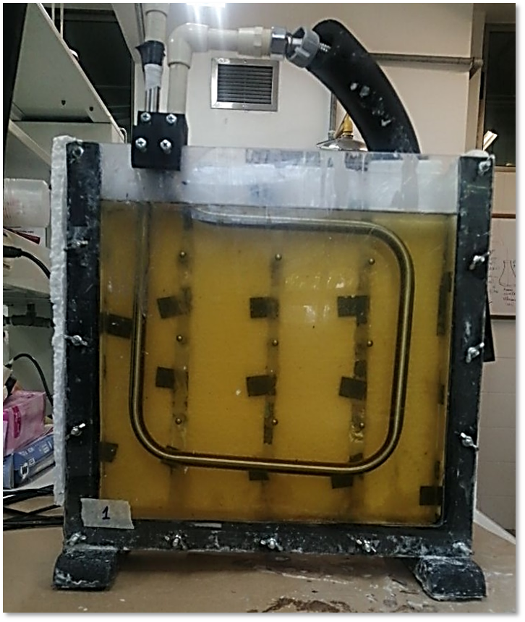
Figure 1: Photograph of the test rig used. A square coil geometry is observed and the PCM has been loaded fully melted. The 9 temperature sensors inside the housing are visible as grey dots on the back of the test bench.

An Arduino Leonardo development board was used to manage the experimental data obtained. The board was programmed to take readings every 3 seconds, generating around 28,000 readings per test for the 13 sensors, obtaining an approximate of 374,400 data per test. NodeRed software was used to store the data, in which a local server was created, allowing the information to be stored on a PC connected to the development board. The data were processed using an algorithm developed in Matlab software (Mathworks Inc.), which permitted visualisation of the data and calculations such as stored energy. For data processing, the griddata and writevideo functions of the MatLab software (MathWorks Inc.) were used as a basis.

    - Calculation of the energy transferred.
The calculation of the energy transferred from the heat transfer fluid to the hydrogenated palm stearin was made based on the energy delivered by the water during the passage of the coil. The calculation was made according to the following equation:
$$Q=\dot{m}⋅C_{pT}⋅∆T$$ | (1)
Where $\dot{m}$ represents the mass flow, $C_{pT}$ the heat capacity and $∆T$ the temperature difference between the fluid inlet and outlet of the coil.
  - Results
    - Melting process for square geometry
Figure 2 shows development of the PCM melting process for square geometry at t=5 h, t=10 h, t=15 h, and t=20 h. In general terms, it is observed that heat transfer occurs at a higher rate in the upward vertical direction. This is because the PCM becomes less dense as it melts creating buoyancy forces that generate an upward movement favouring the natural convection that affects the upper part of the test bench (Seddegh, Wang, & Henderson, 2016).
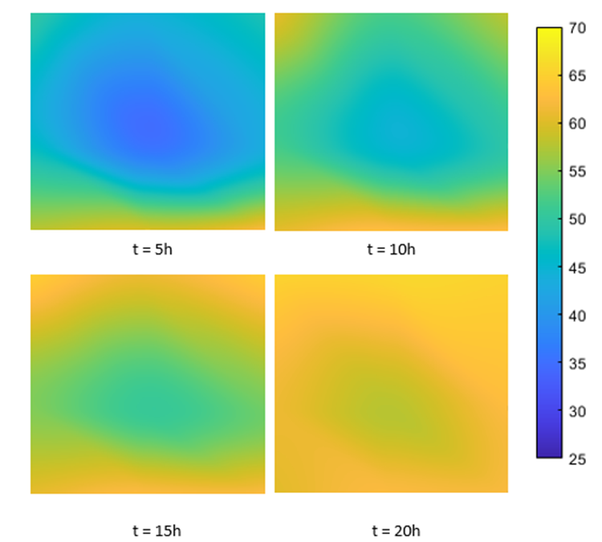
Figure 2: Development of the PCM melting process for square geometry at t=5h, t=10h, t=15h, and t=20h.

At hours 5 and 10 it can be observed how in the upper corners molten material started to accumulate, showing a typical behaviour for the presence of natural convection, where the hottest PCM rises to the top. All sensors stabilised at a maximum temperature between 60 °C and 65 °C. The first three sensors to reach a maximum temperature were those located in the third row, just above the lower section of the coil. The last sensors to reach a maximum temperature were those located in the second row, especially the central sensor which took 23 hours to reach 62°C. Finally, the total heat transferred to the PCM by the heat transfer fluid was 42.5 MJ during the 24-hour test. Most of this energy was transferred during the first 12 hours since by that time, 8 of the 9 sensors were registering temperatures above the melting temperature of the PCM which is 59 °C.
    - Melting process for square geometry
Figure 3 shows development of the PCM melting process for U geometry at t=5 h, t=10 h, t=15 h, and t=20 h. The observed temperature profiles are similar to those obtained with the square geometry, the main difference being that for the U-shaped geometry the process occurs at a lower speed and the final temperatures are slightly lower. Likewise, the sensors located in the second row and the central sensor in the top row did not reach the melting temperature of the PCM, recording a final temperature of 51 °C for the sensor located in the centre of the test bench. Regarding the temperature distribution profiles, for hours 10, 15 and 20, it is possible to observe the accumulation of molten PCM in the upper corners, which evidences the presence of strong natural convection. This behaviour leads to the conclusion that the molten PCM rises along the vertical sections of the coil and is located at the top. It is also observed that the heat transfer in the horizontal direction in the solid PCM is very low or almost zero, showing the importance of designs that favour natural convection. Considering that in the molten PCM, that which has a higher temperature will have a lower density and therefore greater buoyancy, efforts should be made to have vertical pipe sections where the heat transfer fluid flows upwards. For this experiment, the heat transferred to the PCM during the 24-hour test was 37 MJ, 12 % less than the heat transferred using the square coil. This is relevant considering that the U-shaped coil uses 25 % less material than the square coil.

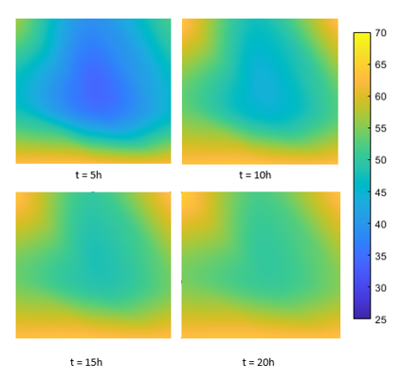
Figure 3: Development of the PCM melting process for square geometry at t=5h, t=10h, t=15h, and t=20h.
  - Conclusions
As a result of this work, the strong presence of natural convection during the melting process of hydrogenated palm stearin is verified when square and U-shaped coils are used. This PCM of renewable origin, derived from the palm oil agro industry, can be used for heat storage although it is still necessary to adjust the design of the heat exchangers to maximise natural convection and thus counteract its low thermal conductivity in the solid state. It can therefore be generally recommended to strive for vertical heat exchanger sections, ideally with the heat transfer fluid flowing in an upward direction to increase natural convection. Although the complete fusion of the PCM with the U-shaped geometry was not achieved, this configuration showed a high heat transfer value, which added to a 25% saving of the material used, could be used as a basis for the development of minimum cost heat exchangers.
Nomenclature

$C_{pT}$ Specific heat capacity at constant pressure [J kg⁻¹ K⁻¹]
$Q$ Heat transfer rate [W]
$T_{F}$ Melting temperature of hydrogenated palm stearin [°C]-
Acknowledgments
Special thanks to the Vice-Rectory of Research and Extension of the Universidad Industrial de Santander for their support to the project " Estudio de la Convección Natural Durante La Fusión de Materiales de Cambio de Fase para el Almacenamiento de Energía Solar Térmica En Sistemas Carcasa-Serpentín" (Study of Natural Convection During the Fusion of Phase Change Materials for the Storage of Solar Thermal Energy in Casing-Serpentin Systems), code VIE 3732. Also special thanks to the Ministerio de Ciencia Tecnología e Innovación of Colombia for the support of the project entitled Desarrollo de una herramienta metodológica computacional y tecnologías de energías renovables para la transición energética en zonas de alta montaña en condiciones de post- pandemia, CD 82605 CT ICETEX 2022-0644. Authors also would like to thank The Royal Society for supporting the research entitled Enabling Harvesting of Solar Energy for Remote Applications in the Andes Region (LA-SOLAR ENHANCE- ICA\R1\191201).
References
Adebayo, T. S., & Kirikkaleli, D. 2021. Impact of renewable energy consumption, globalization, and technological innovation on environmental degradation in Japan: application of wavelet tools. Environment, Development and Sustainability, 23.
Ali, S., & Deshmukh, S. P. 2020. An overview: Applications of thermal energy storage using phase change materials. Materials Today: Proceedings, 26: 1231–1237.
Anish, R., Mariappan, V., Suresh, S., Joybari, M. M., & Abdulateef, A. M. 2021. Experimental investigation on the energy storage/discharge performance of xylitol in a compact spiral coil heat exchanger. International Journal of Thermal Sciences, 159: 106633.
Castell, A., Belusko, M., Bruno, F., & Cabeza, L. F. 2011. Maximisation of heat transfer in a coil in tank PCM cold storage system. Applied Energy, 88: 4120–4127.
Han, G. S., Ding, H. S., Huang, Y., Tong, L. G., & Ding, Y. L. 2017. A comparative study on the performances of different shell-and-tube type latent heat thermal energy storage units including the effects of natural convection. International Communications in Heat and Mass Transfer, 88: 228–235.
Hasan, A. 1994. Phase change material energy storage system employing palmitic acid. Solar Energy, 52.
Liu, Y., Zheng, J., Deng, Y., Wu, F., & Wang, H. 2021. Effect of functional modification of porous medium on phase change behavior and heat storage characteristics of form-stable composite phase change materials: A critical review. Journal of Energy Storage.
Mahdi, M. S., Hasan, A. F., Mahood, H. B., Campbell, A. N., Khadom, A. A., Karim, A. M. em A., & Sharif, A. O. 2019. Numerical study and experimental validation of the effects of orientation and configuration on melting in a latent heat thermal storage unit. Journal of Energy Storage, 23.
Mahdi, M. S., Mahood, H. B., Khadom, A. A., & Campbell, A. N. 2021. Numerical simulations and experimental verification of the thermal performance of phase change materials in a tube-bundle latent heat thermal energy storage system. Applied Thermal Engineering, 194.
Masum, M. F. H., Dwivedi, P., & De La Torre, R. 2021. Assessing economic and environmental feasibility of wood-based electricity generation in South America: A case study from Colombia. Forest Policy and Economics, 124: 102381.
Mofijur, M., Mahlia, T. M. I., Silitonga, A. S., Ong, H. C., Silakhori, M., Hasan, M. H., Putra, N., & Ashrafur Rahman, S. M. 2019. Phase change materials (PCM) for solar energy usages and storage: An overview. Energies.
Mohammad, S. S., Iqbal, S. J., & Lone, R. A. 2022. Improved Utilization of Solar Energy Using Estimated Optimal Tilt Factor and Trackers. Energy Reports, 8: 175–183.
Momeni, M., & Fartaj, A. 2023. Numerical thermal performance analysis of a PCM-to-air and liquid heat exchanger implementing latent heat thermal energy storage. Journal of Energy Storage, 58: 106363.
Pakalka, S., Valančius, K., & Streckienė, G. 2021. Experimental and theoretical investigation of the natural convection heat transfer coefficient in phase change material (Pcm) based fin-and-tube heat exchanger. Energies, 14.
Salyan, S., B, P., Singh, H., Suresh, S., & Reddy, A. S. 2020. Liquid Metal Gallium in Metal Inserts for Solar Thermal Energy Storage: A Novel Heat Transfer Enhancement Technique. Solar Energy Materials and Solar Cells, 208: 110365.
Sciacovelli, A., Colella, F., & Verda, V. 2013. Melting of PCM in a thermal energy storage unit: Numerical investigation and effect of nanoparticle enhancement. International Journal of Energy Research, 37: 1610–1623.
Seddegh, S., Wang, X., & Henderson, A. D. 2016. A comparative study of thermal behaviour of a horizontal and vertical shell-and-tube energy storage using phase change materials. Applied Thermal Engineering, 93: 348–358.
Shen, R., Liu, L., Cao, Y., Zhang, L., Sheng, X., & Chen, Y. 2022. Biomass modified boron nitride/polyimide hybrid aerogel supported phase change composites with superior energy storage capacity and improved flame retardancy for solar-thermal energy storage. Solar Energy, 242: 287–297.
Voosen, P. 2024. The hottest year was even hotter than expected. Science, 383: 134–134.
Zapata, S., Castaneda, M., Aristizabal, A. J., & Dyner, I. 2022. Renewables for supporting supply adequacy in Colombia. Energy, 239: 122157.

