CHEMICAL ENGINEERING TRANSACTIONS  VOL. , 2024 | A publication of
The Italian Association
Chemical Engineering
Online at www.cetjournal.it
Guest Editors: Sauro Pierucci, Jiří Jaromír Klemeš
Copyright © 2021, AIDIC Servizi Srl .
ISBN 978-88-95608-84-6 ; ISSN 2283-9216

Biochar from wastewater treatment plant sludge: Efficiency in the removal of hydrocarbons from contaminated soil
María A. Pérez Pérez ª, Julissa A. Diaz Agüero ª, Danny Lizarzaburu-Aguinaga ^{b}, Elmer Benites-Alfaro ^{a*}
ª César Vallejo University, Av. Alfredo Mendiola 6232, Los Olivos, Lima – Peru
^{b} César Vallejo University, Av. Argentina 1795, Callao – Peru
ª*ebenitesa@ucv.edu.pe
Biochar is a carbonaceous material produced by pyrolysis of organic matter such as wood, agricultural waste, or, in this case, sewage sludge. Biochar is very porous and has a large surface area, making it very efficient at absorbing and retaining contaminants in soil, including hydrocarbons. The use of sewage sludge as biochar to remove hydrocarbons from the soil can be an interesting practice in environmental management and the remediation of contaminated soils, while at the same time, it is a sustainable solution for the management of these wastes, contributing to reducing environmental pollution. The objective of the research was to determine the efficiency of the reduction of total petroleum hydrocarbons from contaminated soil using concentrations of 5, 10, and 20 % of sewage sludge biochar. The results of hydrocarbon removal from the light fraction were 99.99 %, the medium fraction 54.59%, and the heavy fraction 54.92 %, after 45 days; In addition, the physicochemical properties of the soil improved. Therefore, the use of sewage sludge as biochar for the removal of hydrocarbons from the soil is an effective strategy, but it must be carried out with caution and following appropriate practices to ensure environmental safety and the highest remediation efficiency.
  - Introduction
On January 15, 2022, environmental alarms went off in Peru, due to a crude oil spill that occurred on the coast of Ventanilla. Nearly twelve thousand barrels affected eleven thousand hectares in 97 sites, including 62 beaches and two protected natural areas (Defensoría del Pueblo, 2023). For the International Tanker Owners Pollution Federation Limited (2023), this spill is classified as medium and contributes to the statistics of oil spills accounts for twenty-six thousand tons in the decade. This accident, like others in the country, generates the need to understand the impacts on different environments as water, soil, and ecosystems affected by the interaction of crude oil in the form of an oily stain that floats on the surface causing adverse processes on a large scale due to the wind, sea currents, and waves that transport the crude oil at high speed (Pulido Capurro et al., 2022). Low-scale diffusion processes also occur that change or modify the concentration of pollutants, causing effects on organisms (initially: fish, birds, mammals, and plankton) and due to the dispersion of crude oil, for the currents and air, are affect the bivalves, crabs, and anemones from the adjacent rocky areas (Aponte et al., 2022).

Also, the dynamics of this contaminant presents in soils generate impacts as the reduction of its oxygen exchange capacity, loss of agricultural production (Grifoni et al., 2022), low pH levels, and change in the cation exchange capacity and conductivity of the soil, in addition to reduction of the microbial community in the soil (Pulido et al., 2022). All these negative impacts lead us to think the most effective treatments to eliminate hydrocarbons in the environment, which is why arises the need to knoledge different remediation mechanisms for soils impacted by these hydrocarbons, among them we have: the use of native bacteria (Zafra et al., 2016), phytoremediation (Benítez et al., 2022), the use of bio-sludge (Lumia et al., 2020) and the use of biochar (Wei et al., 2024). The last one has been continuously used for the elimination of hydrocarbons in the environment due to its ability to be green and its economic convenience when was trying to solve the problem: What is the hydrocarbon reduction capacity using biochar in Contaminated floors?
The objective of the study was determine the efficiency of reduction of total petroleum hydrocarbons in contaminated soils using 5, 10 and 20 % of biochar from sludge from a wastewater treatment plant (WWTP), this will be necessary to determine the concentration initial and final of the light, medium and heavy fractions of hydrocarbons (MINAM, 2017) and determine if the physicochemical properties of the soil contaminated by hydrocarbons improved with the treatment with biochar.
  - Methodology
The research proposes a methodology that is developed in 5 stages: Production of biochar from waste sludge from a wastewater treatment plant, extraction of soil samples, remediation of samples contaminated by hydrocarbons, analysis, interpretation, and data processing extracted from the soil samples (see figure 1).

Figure 1: Experimental procedure diagram.

    - Production of Biochar (Sewage sludge)
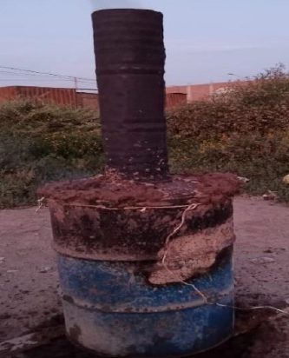
Figure 2: Pyrolysis oven heated with its chimney
50 kg were extracted from the last stage of the sludge drying process from the wastewater treatment plant located in the district of Santa Rosa, Ancón, Lima. This material was dispersed on a polyethylene surface at ambient temperature for seven days to ensure complete drying. Subsequently, the biochar was prepared by pyrolysis using an oven adapting a 1.0 m³ metal cylinder, with holes in the lower part and an airtight lid in the upper part (Condeña, 2017, pp. 66-70), this oven was designed in such a way that limits the incoming oxygen to generate the greatest amount of biochar.

Then the residual sludge was poured into the oven and dry Inga feuilleei (pacay) leaves were used as fuel. After 60 minutes, the temperature was measured with a digital pyrometer and was showing a reading of 305 ºC to confirm the background temperature was the same, the water jet technique was used (Morales et al., 2022). When the indicated temperature was reached, the cylinder was fitted into a 50 cm diameter hole and 15 cm deep, sealing around the oven with mud to prevent gas exchange (Figure 2).

Finally, after 4 hours of cooking, the lid was removed and allowed to cool for 60 minutes, and then the sludge size was decreased by crushing and sieving with a #30 mesh stainless steel strainer.

    - Soil sampling
The sample of soil contaminated with hydrocarbons was taken from an industrial area of 1000 m² that is located at kilometer 14.8 of the Huachipa district. The composite sampling technique was used following the guide for soil sampling of the Ministry of the Environment (MINAM, 2014), 25 extraction points were determined, duly referenced with their UTM coordinates, and the soil extraction was carried out through a “V”-shaped hole 10 cm deep (figure 3). All the collected samples were placed on a plastic surface on the ground in order to homogenize it and then it was obtained a unique representative sample of 20 kg that was used for the soil remediation process (figure 4).

One kilogram of the sample was used as a “control sample”. All other samples were coded and transported following the protocol and chain of custody in a cooler at 4 ºC for the analysis of total hydrocarbon concentration, texture, cation exchange capacity (CEC), pH, organic matter (OM), nitrogen (N) and phosphorus (P).

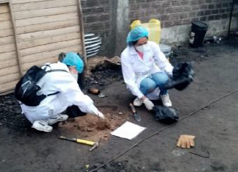  Figure 3: Sampling of contaminated soil. | 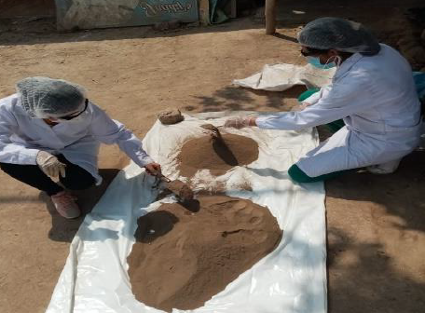  Figure 4: Homogenization of soil samples.
    - Soil remediation process
Ten buckets of 3 kg capacity were used for the treatment, each one contain 2 kg of soil contaminated with hydrocarbons: Previously, the soil was sieved with a Nº 10 mesh (2 mm ASTM 8”) to eliminate impurities (glass, concrete, plastic, etc.). The test consisted of adding three doses of biochar: 5% (100 gr), 10% (200 gr), and 20% (400 gr) to the contaminated soil. The experiment was carried out in triplicate for each dose, and one container served as a control, that is, without adding biochar (Carlini et al., 2023), the experimental units were placed in a cool and dry place for 45 days.

    - Sample Analysis
Initially, it was carried out an analysis of the hydrocarbon concentration of the control unit and then it was made the analysis of the experimental units (09 units) at 20 and 45 days after the addition of the WWTP biochar. The concentration of hydrocarbons and also the physicochemical parameters were determined. To find the efficiency of reducing the hydrocarbon concentration was used the equation (1).

$$Reduction efficiency [hydrocarbons]= \frac{{\left[hidrocarbons\right]}_{Initial}-{\left[hidrocarbons\right]}_{Final}}{{\left[hidrocarbons\right]}_{Initial}} x 100$$ | (1)
    - Data processing
Data processing consisted of an office work in which data were collected through registration forms, then the data were interpreted and coded (Table 1) to generate the results. The results are detailed in point 3, which will allow analyzing the efficiency of reducing the concentration of hydrocarbons in the samples and the improvement in the physicochemical parameters in the contaminated soils before and after treatment.
Table 1: Coding of samples according to treatment
Treatment | Fraction light | Middle Fraction | Fraction Heavy
5% Biochar | FLSB05 | FMSB05 | FPSB05
10% Biochar | FLSB10 | FMSB10 | FPSB10
20% Biochar | FLSB20 | FMSB20 | FPSB20
  - Results
The research also seeks incorporate the use of the biochar in the concept of circular economy. It is because using a common waste, such as sewage sludge from wastewater plants, to generate it. Then are added to soils contaminated with hydrocarbons to evaluate its use as an effective soil treatment alternative (Lin et al., 2022). The results are shown below.

    - Initial and final concentration of the light, medium, and heavy fractions of hydrocarbons in comparison to the ECA
The efficiency of the treatment using a proportion of 5, 10 and 20 % of biochar in soils contaminated with hydrocarbons is presented in Table 1. The results shown that after 45 days of treatment, the light fraction is reduced to 2.48, 1.03 and 0.08 mg/kg. It is also determined that for the other hydrocarbon fractions (medium and heavy) are a decrease, although not very significant. Additionally, it was possible to verify that after 45 days, the three treatments show a reduction below the standards of the Peruvian environmental standard. The same table also shows the initial concentration of hydrocarbons in the soil, along with the results obtained for each treatment and compares them with the environmental quality standard of the soil in Peru (MINAM, 2017).
Table 1: Concentration of hydrocarbons in the soil 20 and 45 days after starting the biochar treatment
Fraction of Hydrocarbons | ECA Soil (mg/kg) | Treatment code | sample (mg/kg) | Sample after 20 days (mg/kg) | Sample at 45 days (mg/kg) | Total reduction | % Efficiency in hydrocarbon reduction
Light fraction of hydrocarbons (C6-C10) | 500 | FLSB05 | 795.01 | 272.8 | 2.48 | 792.53 | 99.69%
 |  | FLSB10 |  | 206.53 | 1.03 | 793.98 | 99.87%
 |  | FLSB20 |  | 158.87 | 0.08 | 794.93 | 99.99%
Medium fraction of hydrocarbons (>C10-C28) | 5000 | FMSB05 | 7096.00 | 5582.11 | 4624.57 | 2471.43 | 34.83%
 |  | FMSB10 |  | 4862.03 | 4023.77 | 3072.23 | 43.30%
 |  | FMSB20 |  | 4027.57 | 3222.40 | 3873.60 | 54.59%
Heavy fraction of hydrocarbons (>C28-C40) | 6000 | FPSB05 | 8980.00 | 7280.70 | 6841.47 | 2138.53 | 23.81%
 |  | FPSB10 |  | 6685.17 | 5412.33 | 3567.67 | 39.73%
 |  | FPSB20 |  | 5847.00 | 4048.33 | 4931.67 | 54.92%
From the table it can be identified that in the case of the light fraction of hydrocarbons the result is 99 % regardless of the treatment. Furthermore, for the medium fraction and the heavy fraction of hydrocarbons, the treatment with 20% biochar is above 50 %.

    - Efficiency of reduction of hydrocarbon fractions in contaminated soils using various doses of biochar
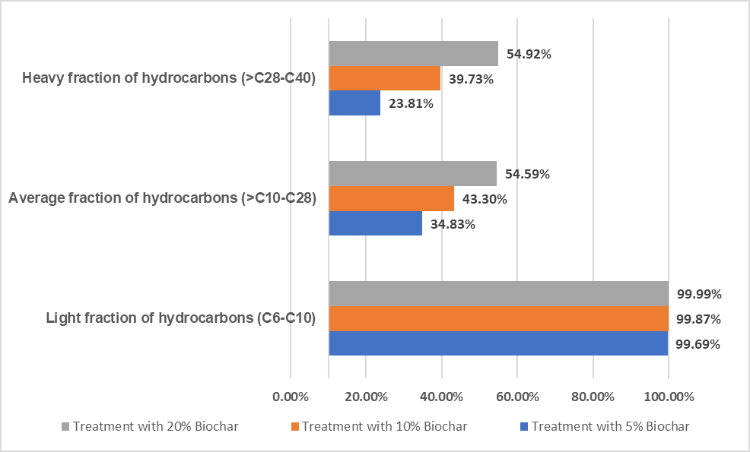

Figure 5: Percentage of efficiency according to treatment for each type of hydrocarbon fraction.
Figure 5 shows the percentage reduction in the concentration of the light, medium and heavy fractions of hydrocarbons in the soil samples during 45 days of treatment. It is confirmed that the light fraction reduces up to 99.99 % of its concentration and the heavy fraction is the one that obtains the least reduction. This is because biochar contributes to improving soil porosity, reducing apparent density and evapotranspiration; Since the light fraction is less dense, the efficiency is greater (Gul et al., 2015). Furthermore, biochar efficiently facilitates the elimination of polycyclic aromatic hydrocarbons (PAHs), stating once again that the porous structure of biochar is essential for absorption (Isaeva et al., 2021).
    - Physicochemical properties of contaminated soil after treatment with biochar
Table 2 shows the changes that each treatment (5 %, 10 %, and 20 %) exerts on the physicochemical parameters after 20 and 45 days of homogenizing the soil contaminated with biochar.
Table 2: Physicochemical parameters of the soil before and after treatment at 20 and 45 days.
Parameters physicochemical |  | Sample Control | Treatment results after 20 days |  |  | Treatment results after 45 days
 |  |  | SB05 | SB10 | SB20 | SB05 | SB10 | SB20
Organic material (%) |  | 2.36 | 3.90 | 4.19 | 4.74 | 3.99 | 4.64 | 5.10
pH (1-14) |  | 5.40 | 6.73 | 6.80 | 6.73 | 6.80 | 7.03 | 7.17
Nitrogen (mg/kg) |  | 53.60 | 68.93 | 70.87 | 72.60 | 70.07 | 72.17 | 73.90
Phosphorus (mg/kg) |  | 105.30 | 199.67 | 201.07 | 203.80 | 201.80 | 205.03 | 207.90
CIC (meq /100gr) |  | 29.50 | 45.90 | 47.20 | 46.40 | 46.63 | 52.07 | 52.60
Texture | Sand | 93.00 | 89.00 | 84.67 | 80.00 | 88.73 | 83.45 | 79.92
 | Silt | 4.00 | 8.67 | 11.67 | 16.00 | 8.69 | 11.90 | 16.50
 | Clay | 2.00 | 2.33 | 3.67 | 3.33 | 2.45 | 3.85 | 3.79
Note: SB05= Soil with 5 % Biochar, SB10= Soil with 10 % Biochar, and SB20= Soil with 20 % Biochar

It is established that the greatest change occurred in the treatment with 20% biochar in 45 days. In the case of organic matter, it increased progressively due to the porous characteristic of biochar, with the proliferation of microbiota present in the soil. The increase in pH until reaching 7.17, greater nitrogen and phosphorus fixation up to 73.90 and 207.90 mg/kg respectively was due to biochar (Allohverdi et al., 2021), the cation exchange capacity also shows a continuous increase until reaching 52.60 meq /100 g. All these values demonstrate that the soil is healthy and fertile (Freitez & Villanueva, 2019); Therefore, the incorporation of biochar into the soil can generate changes in physical and chemical properties (Puentes & Rodríguez, 2021). Finally, the texture varies with a decrease in sandiness and an increase in silt; However, more studies are still required to help conclude the benefits of biochar. (Reyes Pallazhco et al., 2023).

Biochar turns out to have an advantage due to its molecular structure and physical architecture when applied to soil, the high pyrolysis temperature allows generating a very effective biochar for the absorption of organic contaminants by increasing the surface area, hydrophobicity and microporosity (Qiu et al., 2022).
  - Conclusions
The biochar obtained from the residual sludge can reduce, significantly, the hydrocarbon concentration by 99.99% in the light fraction (C6-C10), 54.59 % in the medium fraction (> C10 – C28), and 54.92 % in the heavy fraction (> C 28 – C40), obtaining great efficiency that allows compliance with soil environmental quality standards. Likewise, it improves the physicochemical properties, such as the impact of the presence of biochar by giving it porosity, increasing the percentage of organic matter, and stabilizing the pH around 7.17. In addition, increase nitrogen, phosphorus, and cation exchange. Therefore, the use of biochar obtained under the concept of circular economy constitutes an environmentally sustainable method for treating soils contaminated by hydrocarbons.
Acknowledgments
The authors and the GIGATRE thank “Investiga UCV” of the César Vallejo University for the financial support for the publication of this research.

References
Allohverdi T., Mohanty A., Roy P., and Misra M., 2021, A review on current status of biochar uses in agriculture. Molecules, 26(18). <doi.org/10.3390/molecules26185584> accessed 11.01.2024.
Aponte H., Torrejón-Magallanes J., and Pérez A., 2022, Black Tide in Peru: Comments on an oil spill in the South American Pacific. South Sustainability, 3, 3. <doi.org/10.21142/ss-0301-2022-e044˃ accessed 06.01.2024.
Benítez L., Miranda L., and Castro., C., 2022, Phytoremediation to Remove Pollutants from Water, Leachates and Soils. Chemical Engineering Transactions, 92(April), 553–558. <doi.org/10.3303/CET2292093> accessed 07.01.2024.
Carlini C., Chaudhuri S., Mann O., Tomsik D., Hüffer T., Greggio N., Marazza D., Hofmann T., and Sigmund G., 2023, Benchmarking biochar with activated carbon for immobilizing leachable PAH and heterocyclic PAH in contaminated soils. Environmental Pollution, 325(December 2022), 121417. <doi.org/10.1016/j.envpol.2023.121417˃ accessed 09.01.2024.
Condeña Naventa, E., 2017, Recovery of soil contaminated with lead through the use of biochar from sugarcane bagasse in the Chota Park of the AA.HH Ramón Castilla – Callao 2017, Bachelor's Thesis, Universidad César Vallejo, Lima, Perú.
Defensoría del Pueblo, 2023, Oil spill in Ventanilla: One year report on the environmental and social disaster on our coast (Spanish).
Freitez N., and Villanueva S., 2019, Dissemination article: Biocarbon, an alternative to contaminated soils. Science in Revolution Magazine, 5, 97–100 (Spanish).
Grifoni M., Pedron F., Franchi E., Fusini D., Reverberi A., and Vocciante M., 2022, Green Remediation for the Sustainable Management of Oil Spills in Agricultural Areas. Chemical Engineering Transactions, 94(April), 829–834. <doi.org/10.3303/CET2294138> accessed 07.01.2024.
Gul S., Whalen J. K., Thomas B. W., Sachdeva V., and Deng H., 2015, Physico-chemical properties and microbial responses in biochar-amended soils: Mechanisms and future directions. Agriculture, Ecosystems and Environment, 206, 46–59. <doi.org/10.1016/j.agee.2015.03.015˃ accessed 11.01.2024.
International Tanker Owners Pollution Federation., 2023, Oil Tanker Spill Statistics 2022 (p. 20).
Isaeva V. I., Vedenyapina M. D., Kurmysheva A. Y., Weichgrebe D., Nair R. R., Nguyen N. P. T., and Kustov L. M., 2021, Modern carbon–based materials for adsorptive removal of organic and inorganic pollutants from water and wastewater. Molecules, 26(21), 1–95. <doi.org/10.3390/molecules26216628> accessed 04.03.2024.
Lin H., Yang Y., Shang Z., Li Q., Niu X., Ma Y., and Liu A., 2022, Study on the Enhanced Remediation of Petroleum-Contaminated Soil by Biochar/g-C3N4 Composites. International Journal of Environmental Research and Public Health, 19(14). <doi.org/10.3390/ijerph19148290˃ accessed 09.01.2024.
Lumia L., Rabbeni G., Giustra M., Giumento S., Gallo G., and Di Bella G., 2020, Treatment of contaminated sediments by bio-slurry reactors: Study on the effect of erythromycin antibiotic. Chemical Engineering Transactions, 79(September 2019), 391–396. <doi.org/10.3303/CET2079066> accessed 07.01.2024.
MINAM. (2017). Supreme Decree No 011-2017-MINAM. The Peruvian, 1–4 (Spanish).
MINAM, (2014). R. M. No 085-2014-MINAM. Guide for Soil Sampling and Guide for the Preparation of Soil Decontamination Plans, Vol. 2, (Spanish).
Pulido Capurro V, Escobar-Mamani F, Arana Bustamante C, and Olivera Carhuaz, E, 2022, Effects of the oil spill at the La Pampilla Refinery on the coast of the marine coast, Lima (Peru). Magazine of Investigations Altoandinas, 24(1), 5-8. Epub February 21, 2022, <doi.org/10.18271/ria.2022.411˃ accessed 06.01.2024.
Pulido V., Cruz J., Arana C., and Olivera E., 2022, Environmental damage to the Peruvian marine littoral caused by the oil spill (January 2022) at the La Pampilla refinery. Manglar, 19(1), 67–75. <doi.org/10.17268/manglar.2022.009> accessed 06.01.2024 (Spanish).
Qiu M., Liu L., Ling Q., Cai Y., Yu S., Wang S., Fu D., Hu B., and Wang X., 2022, Biochar for the removal of contaminants from soil and water: a review. Biochar, 4(1), 1–25. <doi.org/10.1007/s42773-022-00146-1˃ accessed 09.03.2024.
Quisquiche Morales D., Lizarzaburu Aguinaga D., Castañeda C., and Benites-Alfaro E., 2022, Solid Biofuel Spheres for the use of Residual Biomass from Polylepis (Quenual) in Rural Areas. Chemical Engineering Transactions, 92(March), 157–162. <doi.org/10.3303/CET2292027˃ accessed 09.01.2024.
Reyes Pallazhco J. M., Leon Cabrera P., and Barrezueta Unda S., 2023, Banana crop response to different proportions of microorganisms and biochar in two soil textures. Manglar, 20(2), 109–115. <doi.org/10.57188/manglar.2023.012> accessed 10.01.2024 (Spanish).
Wei Z., Wei Y., Liu Y., Niu S., Xu Y., Park J. H., and Wang J., 2024, Biochar-based materials as remediation strategy in petroleum hydrocarbon-contaminated soil and water: Performances, mechanisms, and environmental impact. Journal of Environmental Sciences (China), 138, 350–372. <doi.org/10.1016/j.jes.2023.04.008˃ accessed 07.01.2024.
Zafra G., Regino R., Agualimpia B., and Aguilar F., 2016, Molecular characterization and evaluation of oil-degrading native bacteria isolated from automotive service station oilcontaminated soils. Chemical Engineering Transactions, 49, 511–516. <doi.org/10.3303/CET1649086> accessed 07.01.2024.

