CHEMICAL ENGINEERING TRANSACTIONS  VOL. , 2024 | A publication of
The Italian Association
of Chemical Engineering
Online at www.cetjournal.it

Guest Editors: Leonardo Tognotti, Rubens Maciel Filho, Viatcheslav Kafarov
Copyright © 2024, AIDIC Servizi S.r.l.
ISBN 979-12-81206-09-0; ISSN 2283-9216

European Hazelnut Shell as a Source of Extractives and Bio-oil
Rene J. Carmona*, Alejandro A. Riquelme, Gillian Gonzalez
Forest Products Development Department, Faculty of Forest Sciences and Nature Conservation, University of Chile. Santa Rosa Avenue 11,315 Santiago, Chile
recarmon@uchile.cl

The fruit crop residues produce large volumes of agricultural lignocellulosic biomass, constituting a potential, homogeneous, concentrated and low-cost raw material. Among these, the European hazelnut (Corylus avellana) emerges as a potential source of biofuels and chemicals from its residues, of which the shell represents 42% of the total harvested biomass. In Chile, its production is relevant, and the species has adapted well, which has allowed its expansion in the country, occupying a total area in 2019 of 24,437 ha and a production of 35,000 tons/year of hazelnuts with shell. The objective of this study is to explore the feasibility of a combined extraction of polyphenols of interest with a subsequent conversion to bio-oil (biofuel) from hazelnut shells. The chemical composition of this residue was 20.1% of extractives, 49.7% of holocellulose, 37.8% alpha celullose, 30.2% of lignin and 0.7% of ash. This material presented 20.6% of fixed carbon, 68.7% of volatile and a lower 12% hemicellulose and calorific value of 4,431 Kcal/Kg. To extract tannins from ground hazelnut shells, the most effective method was to use Acetone 70% and stir for 60 minutes at 45°C. By increasing the time of extracting tannins only the biochar decreased its content. Bio-oil and pyrogenic acid showed no changes due to increased extraction time. Therefore, converting of hazelnut shells into useful chemicals, such as tannins before obtaining bio-oil, becomes a viable strategy to better exploit these residues.

  - Introduction

An important crop in south-central area of Chile, is the European hazelnut (Corylus avellana L.) with its varieties Tonda Di Giffon and Barcelona. It is a promising multipurpose species that, in addition to its great adaptation, has experienced sustained growth in the area planted in the last thirteen years, from 24,473 ha in 2019 to 42,000 ha in 2023. The production in the 2022-2023 season is expected to reach 61,500 t, transforming the country into the fifth largest world producer and the most important in the southern hemisphere (Allegrini, et al., 2022).
The shell constitutes 50 % of the total weight of the fruit and is an important residue of the processing. Its final disposition generates a problem of costs and/or contamination. The most basic way in which it is used is as a boiler fuel for heat generation. However, if you want to move from a linear economy to a green economy approaching a circular economy model, these wastes should be used for the extraction of biomolecules as active materials for other industries.
Many researchers have focused their work on the valorization of this waste, by obtaining chemical compounds for human health, functional ingredients for the production of new foods, functional ingredients for food or new materials and energy. One of the ways in which energy can be obtained from biomass is through the thermochemical path, in which pyrolysis produces biochar, gas and bio-oil. (Solis et al., 2023; Zhao et al., 2023)
The European hazelnut shell, with some differences between researchers is composed of lignin: 23-25.9%, cellulose: 26-15.4%, hemicelluloses, 30-22.4%, extractives 3.3-24.6% and ash 0.9-5% (Demirbas, 2008; Solís et al., 2023). Like other lignocellulosic biomass, given the complex polymeric nature of their components, they must be selectively fractionated into higher-value chemicals and energy in a concept known as biorefinery.

  - Materials and methods

2.1 Raw material pretreatment

The hazelnut shells were a mixture of European hazelnut cv. Barcelona and cv. Tonda di Giffoni, which are established in towns in the south-central area of Chile: Maule Region: 34°86' S, 71°18' W to 35°96' S, 71°68' W. The material was dried at room temperature, milled on a Wiley Mill and sieved to approximately 0.1-0.25 mm particles for the determination of chemical composition and energetic characteristics and 0.4 -1.25 mm particles for extractive obtaining and pyrolysis.

2.2 Chemical characterization

The chemical composition was determined according to methods reported by the US National Renewable Energy Laboratory (NREL), ASTM Standard Method. The samples were prepared for analysis of the components according to Technical report NREL/TP-510-42620. Drying at 40°C before grinding, then sieving and material selection with particle size between 20 and 60 mesh. Samples of 3.5 g were extracted in a Soxhlet apparatus according to NREL/TP-510-42619. In parallel samples were taken to determine the moisture content by drying the samples with the oven Memmert 400 to 103 ± 2°C, according to ASTM D4442-20, using Eq (1).

$Moisture Content \%=\frac{A-B }{B} x 100 \%$ (1)

where A is original mass (g) and B is oven-dry mass (g).
The measurement of ash content was conducted by weigheing the samples before they were heated in the Carbolite Chamber Furnace AAF 1100 at 580 °C for 6 h and weighing after they cooled. The ash content values were calculated according to the ASTM D-3174 2012 standard using Eq(2).
The measurement of structural components: lignin, holocellulose, α-cellulose content, was determined by using the standard method described by ASTM D 1106-96(Reap 2021), ASTM D1104-56, ASTM D1103-77. The hemicellulose was determined by the difference between holocellulose and alpha cellulose. The ash content was determined by calcination in a muffle furnace at 580±10°C using ASTM D1102-84 (Reap 2021) by Eq. (2). All analyses were performed in duplicates.

$Ash Content I \%=\frac{C}{B} x 100 \%$ (2)

where C is weight of ash (g) and B is weight of oven-dry sample (g).
The proximate analysis was conducted using the standard method described by ASTM D3173, D3174, and D3175 in 2018. This involved determining the moisture, ash and volatile matter, respectively. Samples of shells ground to a particle size between 20 and 60 meshes were dried in a stove at 103 ± 2°C. The dry mass and moisture (Eq1) were then obtained. In the same samples the volatile material was determined by heating them for 2 minutes at the muffle door (300°C) and then introduced to the interior at 950°C for 5 minutes in a reducing environment. The amount of volatile material was calculated based on the weight loss after being reduced by moisture using Eq(3) and Eq(4) formulas.

$Lost weight \%=\frac{B-D}{B} x 100 \%$ (3)

$Volatile matter \%=1-Lost weight$ (4)

where B is the oven dry mass of sample (g), D is the weight of residue after heating (g).
The ash present in the same samples is then determined by calcination in the muffle at 700°C and the percentage is calculated according to Eq (5).

$Ash Content II \%=\frac{B-E}{B} x 100 \%$ (5)

where B is weight of oven-dry sample and E is weight of ash residue al 700°C.
The fixed carbon content was determined using the data previously obtained in the proximate analysis by formula Eq(6).

$Fixed Carbon \%=100-(Ash+Volatile Matter)$ (6)

The calorific value was calculated according to ASTM-D5865-13.

2.3 Polyphenols and tannins extraction

Four extraction methods were used to obtain phenolic compounds:
(1) Five grams of sample were mixed with 50 ml of 80 % v/v methanol and placed in an orbital agitator (200 rpm) for 72 hours at 25 °C.
(2) A total of 5 g of ground hazelnut shell was mixed with 50 mL of 70% v/v acetone in 150 mL capped flasks. It was placed in an orbital agitator (200 rpm) at 45 °C for 30 minutes (Aspé et al., 2011).
(3) Five grams of sample were used to prepare an infusion in 50 mL of distilled water at a temperature of 95 °C for 10 minutes followed by immersion in an ice bath (do Prado et al., 2014).
(4) Five grams of ground hazelnut shell were extracted with 3 successive portions of 20 mL of 65 % v/v isopropyl alcohol (i-PrOH), in an orbital stirrer at 200 rpm for 20 minutes at room temperature. The three extracts were combined and measured up to 100 mL with i-PrOH-Water 65% (Isaza et al., 2007).
All extracts were filtered and stored in hermetically sealed bottles at 4 ºC.

2.4 Qualitative and quantitative analysis of tannins and polyphenols.

Tannins were detected by the ferric chloride (FeCl₃) test. 2 mL of the extract solutions were added to 1 mL of 1% FeCl₃ solution (Auwal et al., 2014). The occurrence of a blackish blue color showed the presence of gallic tannins, while a green-blackish color indicated the presence of catechol tannins (condensed tannins). Tannins were quantified by Bate Smith’s method. This assay is a colorimetric method based on the hydrolysis reaction of proanthocyanins in a heated acidic medium to produce colored anthocyanin pigments. In this procedure the sample (1 mL), water (1 mL), and hydrochloric acid (1 mL, 37%) are placed in two tubes. Tube A is placed in an ice bath (0 ºC), while tube B is placed in a warm bath (͠100ºC). After 30 minutes, 600 μL of ethanol is added to both tubes to stop the reaction. The proanthocyanidin concentration in g L⁻¹ is obtained multiplying the difference in absorbance at 550 nm between tube B and tube A by 19.33, formula Eq(7), which is the absorptivity coefficient of cyanidin after the acidic cleavage of the condensed tannins (Wilhelmy et al., 2021).

$Tannins\left(g L^{-1}\right)=\left({Tube B}_{hydrolised}-{Tube A}_{control}\right)x 19.33$ (7)

Total polyphenols content (TPC) was determined using the Folin–Ciocalteau method (Singleton & Rossi, 1965), which involves the reduction of the reagent by phenolic compounds, resulting in the formation of a blue complex. Briefly, 100 μl of extract was mixed with 6 ml of water and 250 μl of Folin–Ciocalteau reagent and allowed to stand at room temperature for 8 minutes. Then, 250 μl of Na₂CO₃ (20% w/v) was added to the mixture. After 120 minutes at room temperature, the absorbance of the blue complex was measured at 760 nm. The analysis was performed in triplicate and normalized against negative controls (distilled water). TPC was expressed as milligrams of gallic acid equivalents per gram of extract (mg GAE g⁻¹) based on a standard curve of gallic acid (50–600 mg L⁻¹; y = 0.97x + 0.0653; R² = 0.991).

2.5 Pyrolysis conditions

The slow pyrolysis experiments, on previously prepared material not extracted and extracted with acetone for times of 30, 60 and 90 min, were performed in duplicate in a 140 cc round borosilicate glass reactor with a gas outlet of 20 mm diameter and 150 mm long, closed at the top and with a side outlet of 6 mm internal diameter connected to two containers submerged in water at 6°C to condense the gases (Figure 1). The heat supply was generated in a Bunsen burner, fed by liquid petroleum gas regulated with a flow meter (Davies) to achieve a temperature of 500 ± 20°C at the base of the measured reactor with a type K thermocouple (Cr-Ni and Al-Ni). In each test, the reactor was loaded with 25 g of ground shell at a grain size of between 0, 4 and 1.25 mm, which lasted 7 minutes.
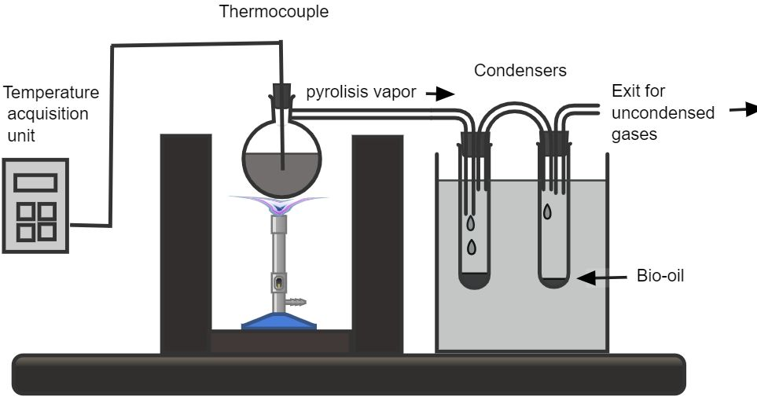
Figure 1. Schematic diagram of pyrolysis system.

3. Results and discussion
Tables 1-5 display the findings of the analyses in this study. The test of the presence of tannins is shown in Figure 2. The chemical and energy properties of European hazelnut shell as well as its ability to obtain polyphenols and bio-oil, are discussed in this research.

3.1 Chemical characteristics of biomass

The hazelnut shells exhibit a significant amount of extractables in both water (9.35%) and ethanol (10.71%) (Table 1), indicating the presence of valuable compounds that can be extracted for various purposes. These values align with findings in the literature regarding the extractability of hazelnut shells (Allegrini et al., 2022), which are known to contain bioactive compounds such as polyphenols and tannins that possess antioxidant properties (Smith et al., 2018). Moreover, the high lignin (30,2%), holocellulose (49.7%), alpha-cellulose (37.8%), and hemicellulose (12%) content suggests potential applications in biofuel production, as lignocellulosic materials are valuable feedstocks for bioenergy production due to their high carbon content and low moisture content (Table 2) (Xie et al., 2020). According to a study by Durak et al. (2018), European hazelnut shells have been reported to contain lignin in the range of 21.3% to 26.5%, which is slightly lower than the value presented in Table 1. However, the cellulose content aligns with previous findings by Hassan et al. (2015), who reported cellulose content ranging from 41.2% to 45.3%.
Regarding the energy properties (Table 2), European hazelnut shells exhibit high fixed carbon content, making them a potential candidate for bioenergy production. These findings are consistent with studies by Al-Widyan and Al-Jalil (2002) and Gupta et al. (2015), who reported fixed carbon contents ranging from 72% to 74%.

Table 1: Chemical composition of European hazelnut shells
Extractables (% of dry mass)
Water | Ethanol | Total
9.35 | 10.71 | 20.06
Structural composition (% of dry mass)
Lignin | Holocellulose | α-cellulose | Hemicellulose | Ash**
30.2 | 49.7 | 37.8 | 12.0 | 0.7
*Values are average of two repeats; ** heated to 580°C.

Table 2: Energy properties of European hazelnut shells.
Moisture (%) | Fixed Carbon (%) | Volatile Matter (%) | Ash* (%) | LCV**  (Kcal/Kg)
9.2 | 20.6 | 68.7 | 1,5 | 4,431
*heated at 700°C; **LCV: lower calorific value

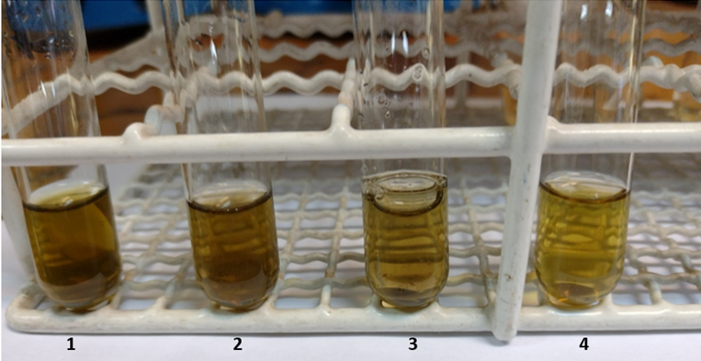
Figure 2. FeCl₃ test for tannins of European hazelnut shell using different extraction solvents: (1) 80% methanol; (2) 70% acetone; (3) water; (4) 65% isopropanol.

3.3 Phenolic compounds content

Figure 2 shows that all the extractions carried out showed a greenish coloration indicating that they correspond to condensed tannins.
The extraction of phenolic compounds from hazelnut shells using different solvents and methods reveals varying efficiencies in polyphenol and tannin extraction (Table 3). 80% methanol and 70% acetone demonstrate higher extraction yields compared to water and isopropanol, which is consistent with previous studies highlighting the superior solubility of phenolic compounds in polar solvents such as methanol and acetone (Falleh et al., 2008). Additionally, Table 4 presents that the most effective method to obtain tannins from hazelnut shells was 70% acetone and stirred for 60 min. at 45 °C. Table 4 shows that the increase in extraction time with acetone results in higher yields of both polyphenols and tannins, indicating the importance of extraction duration in optimizing phenolic compound extraction.

Table 3: Content of polyphenols and tannins in four extracts.
Extraction solvent | Total polyphenols  (mgGAE g⁻¹)* | Condensed Tannins  (mg CE g⁻¹)*
(1) Methanol 80% | 394.2 ± 15.8 | 104.7 ± 0.8
(2) Acetone 70% | 299.1 ± 22.0 | 138.0 ± 1.8
(3) Hot water | 251.4 ± 8.2 | 38.5 ± 1.0
(4) Isopropyl alcohol 65% | 138.9 ± 7.3 | 33.0 ± 0.6
* mg of gallic acid equivalents per gram (GAE g⁻¹) ; mg of catechin equivalents per gram

Table 4: Content of polyphenols and tannins from samples extracted with acetone at different times.
Extraction time  (min) | Total polyphenols  (mgGAE g⁻¹) | Condensed Tannins  (mg CE g⁻¹)
30 | 296.5 ± 6.2 | 146.0 ± 12.9
60 | 338.1 ± 3.7 | 183.4 ± 36.1
90 | 367.6 ± 5.8 | 157.8 ± 14.7

3.4 Pyrolysis products

The tests show the start of pyrolysis at 140 ± 20 °C (45 ± 5 sec) which accelerates around 200°C (60 s), along with the distillation/condensation of pyrogenic acid and tar which continues until 7 minutes when the emission of gases from biomass is stops. Table 5 shows the results obtained in the performed pyrolysis. The percentage of biochar is expressed as a percentage of the initial dry mass and the percentage of bio-oil and pyroligneous acid is expressed as a percentage of the volume recovered in the condenser tubes.

Table 5: Pyrolysis results.
Product | without extraction | acetone extraction time
 |  | 30 min | 60 min | 90 min
Biochar (%p/p) | 32,2 | 33,0 | 30,1 | 24,7
Bio-Oil (% v/v) | 12,4 | 12,8 | 13,4 | 11,2
Pyroligneous acid (%v/v) | 87,6 | 87,2 | 86,5 | 88.9

Table 5 shows that the only product affected by the previous extraction of acetone soluble extractives is the amount of biochar, which is reduced. There is a tendency for an increase in the volume of condensates. However, there are no significant differences in the relative share of bio-oil and pyrogenic acid in the volume of liquid recovered.
4. Conclusions
Hazelnut shells represent a promising biomass resource with diverse applications, including the extraction of bioactive compounds such as tannins, before obtaining bioenergy (bio-oil and biochar) through pyrolysis. The choice of solvent and extraction conditions significantly impact the yield of phenolic compounds, while solvent extraction can also influence the composition of pyrolysis products. These findings contribute to the optimization of extraction methodologies and the utilization of hazelnut shells in sustainable biorefinery processes.

References

Allegrini A., Salvaneschi P., Schirone B., Cianfaglione K., Di Michele A., 2022, Multipurpose plant species and circular economy: Corylus avellana L. as a study case. Front. Biosci. 27(1): 011
Al-Widyan, M. I., Al-Jalil, H. F., 2002, Preparation and characterization of activated carbon from olive stones and its adsorption kinetics. Energy Sources, 24(5), 491–500.
Aspé E., Fernández K., 2011, The effect of different extraction techniques on extraction yield, total phenolic, and anti-radical capacity of extracts from Pinus radiata Bark. Ind. Crop. Prod., 34, 838-844.
Auwal M.S., Saka S., Mairiga I.A., Sanda K.A., Shuaibu A., Ibrahim A., 2014, Preliminary phytochemical and elemental analysis of aqueous and fractionated pod extracts of Acacia nilotica (Thorn mimosa). Vet Res Forum. 5(2): 95-100.
Demirbaş, A., 2008, Oils from hazelnut shell and hazelnut kernel husk for biodiesel production. Energy Sources, Part A Recovery, Util. Environ. Eff., 30, 1870-1875.
do Prado A.C.P., da Silva H.S., da Silveira S.M., Barreto P.L.M., Vieira C.R.W., Maraschin M., Ferreira S.R.S., Block J.M., 2014, Effect of the extraction process on the phenolic compounds profile and the antioxidant and antimicrobial activity of extracts of pecan nut [Carya illinoinensis (Wangenh) C. Koch] shell Ind. Crop. Prod., 52, 552-561.
Durak, A., Ozgen, Y., Acar, I., 2018, Investigation of hazelnut shell as a fuel. Energy Sources, Part A: Recovery, Utilization, and Environmental Effects, 40(8), 908–913.
Falleh, H., Ksouri, R., Chaieb, K., 2008, Phenolic composition of Cynara cardunculus L. organs, and their biological activities. Comptes Rendus Biologies, 331(5), 372-379.
Gupta, N., Srinivasan, K., Jain, R., 2015, Utilization of biomass for bioenergy in Western Canada: An industry and resource assessment. Energy Conversion and Management, 99, 49–61.
Hassan, E. B., Abdelmoneim, A. A., Aggour, M. G., 2015, Extraction and Characterization of Microcrystalline Cellulose from Agricultural Wastes. Journal of Applied Sciences Research, 11(3), 1051–1060.
Isaza M., Veloza J.H., Ramírez L.S., Guevara C.A., 2007, Estimación espectrofotométrica de taninos hidrolizables y condensados en plantas melastomatáceas. Scientia Et Technica, vol. XIII, 33, 261-266.
Singleton, V. L., Rossi, J. A., 1965, Colorimetry of total phenolics with phosphomolybdic–phosphotungstic acid reagents. American Journal of Enology and Viticulture, 16, 144–158.
Smith, A., Johnson, J., & Smith, B., 2018, Bioactive compounds in nut shells: novel ingredients for food and cosmetic applications. Journal of Agricultural and Food Chemistry, 66(1), 230-238.
Solís A., Rocha S., König M., Adam R., Garcés H., Candia C., Muñoz R., Azócar L., 2023, Preliminary assessment of hazelnut shell biomass as a raw material for pellet production. Fuel, 333 (2) 126517.
Xie, H., Du, C., Zhang, Y., 2020, Utilization of lignocellulosic biomass for sustainable energy production: an overview. BioResources, 15(4), 9415-9438.
Wilhelmy C., Pavez C., Bordeu E., Brossard N., 2021, A Review of Tannin Determination Methods Using Spectro-photometric Detection in Red Wines and Their Ability to Predict Astringency. South African Journal of Enology and Viticulture, 42, (1) 1-9.
Zhao J., Wang X., Lin H., Lin Z., 2023, Hazelnut and its by-products: A comprehensive review of nutrition, phytochemical profile, extraction, bioactivities and applications. Food Chemistry, 413, 135576.

