CHEMICAL ENGINEERING TRANSACTIONS  VOL. , 2024 | A publication of
The Italian Association
of Chemical Engineering
Online at www.cetjournal.it

Guest Editors:
Copyright © 2023, AIDIC Servizi S.r.l.
ISBN 979-12-81206-XX-X; ISSN 2283-9216

Post-pandemic long-term energy demand forecasting using LEAP software in the Paramo de Santurbán: The case of Pamplona North of Santander
Álvaro E. Villamizar-Villamizar^{a,}*, Ana M. Rosso-Cerón^{b}, Julieth Becerra-Rodriguezª
ª Chemical Engineering Program, Universidad de Pamplona, Km 1 Vía Bucaramanga Ciudad Universitaria, Pamplona- Norte de Santander, Colombia
^{b} Environmental Engineering Program, Unidades Tecnológicas de Santander, Av. Los Estudiantes #9-82, Bucaramanga-Santander, Colombia.
*aevillamizar@unipamplona.edu.co

In this study, energy demand forecasts for electricity and heat consumption were made in Pamplona-Nort of Santander in the residential sector of the economy. Three different forecast scenarios (from 2018 to 2040) were simulated in the Long-Range Alternative Energy Planning model. The first scenario was calling usual trend, considered average growth rate of historical demand data. The second scenario was energy efficiency based on the energy intensity indicator agreed upon in the Program for the Rational and Efficient Use of Energy, which is a public policy guideline to promote the best use of energy resources (electric stoves, use of panels photovoltaics and other energy sources). Finally, the third scenario was post-COVID-19 trending, which was based on economic activity degree of openness of 82 %, at the end of 2020 and 100 % openness was reached in the fourth quarter of 2021. This COVID-19 projection was carried out in the absence of similar preceding events, which were accompanied by a statistical history. The results obtained in growth forecasts are the same as those that were incorporated in the energy demand projection in the national energy plan to 2050. Estimations from each of these scenarios were compared using data from a survey realized in Pamplona. The results of this study suggest a growth close to the national average. However, energy fuel mix will change, such that electricity will be the most highly consumed energy form followed by LPG, natural gas, and wood.
  - Introduction
In the Andean region, paramos, such as the Santurbán paramo in Colombia, play a crucial role in capturing water from fog and supplying it to lowlands. Nearly two million people in Colombia depend on Santurbán for their freshwater needs. This dependency is particularly significant for neighbouring sectors, including the town of Pamplona, situated at 2350 meters above sea level in the North of Santander Department of Colombia. With a population of around 55,366 inhabitants, Pamplona's economy is predominantly linked to educational and commercial activities.
The economic development of Paramo regions is essential, but the COVID-19 pandemic has posed severe challenges over time. Significant economic repercussions, including income reductions, increased unemployment, and disruptions in transportation, service, and manufacturing industries, resulted from pandemic mitigation measures in developing countries. Regarding energy, the pandemic negatively impacted monthly electricity consumption in the residential sector, while other sectors, predominantly industrial and commercial, saw decreases, signalling an overall decline in economic activities during the initial pandemic year. This shift in electricity consumption patterns may gradually elevate energy demand, given the residential sector's dominance in the country's electricity consumption, especially during prolonged crises (Bahmanyar et al., 2020).
Global attention has focused on projections of post-COVID-19 energy demand, with recent studies, including one by García-Rendon et al (2023), examining post-pandemic transformations in energy consumption patterns. Anticipated trends include the persistent impact of remote work and digital technologies on electricity demand in residential and commercial settings (Smith et al., 2021). Moreover, a growing environmental awareness may drive a preference for renewable energy sources (IEA, 2022). These analyses play a crucial role in comprehending the post-pandemic energy landscape, informing planning strategies, and guiding government policies.
Studies in Europe examined the impact of the COVID-19 pandemic on electricity usage, such as the comparative analysis by Bahmanyar et al. (2020), revealed that countries with stringent lockdowns experienced a decline in commercial and industrial electricity usage, coupled with increased residential electricity consumption. Overall, electricity consumption in the first pandemic year reduced by 1.04 % compared to rates between 2016 and 2019.
Similar studies in Latin America about electricity supply and demand forecasts, exist for countries like Ecuador (Rivera-González et al., 2019) and México (Toledo et al., 2021).
In Colombia, post-COVID-19 electricity and heat demand projections have become critical research areas. Investigations, including the study by UPME, a national reference in various studies (García-Rendon et al. 2023). Anticipated changes in demand are influenced by factors like evolving industrial processes and altered consumer behaviors related to PROURE. This program, serving as a public policy framework, aims to encourage rational and efficient energy resource use, incorporating the adoption of electric stoves, alternative energy sources like LGP, and sustainable energy solutions. Analyses by the Colombian Ministry of Mines and Energy provide insights into socio-economic aspects, such as GDP, impacting electricity and heat demand, crucial for future energy planning in the post-COVID era.
In the context of Colombian Paramos, sustainable energy is pivotal for economic development. However, these areas lack reliable energy resource data and face challenges in long-term demand forecasts, hindering effective energy policy formulation.
This study stands out for its innovative exploration of post-COVID-19 electricity and heat demand projections in Pamplona-North of Santander's residential sector from 2018 to 2040. Using the LEAP model, three scenarios were simulated: a "usual trend" with average growth rates, an "energy-efficient" behavior aligning with PROURE's energy intensity index, and a post COVID-19 tendency reflecting economic openness. Despite increased forecast uncertainty, below 15%, results indicate a growth trend mirroring the national average, shifting towards electricity as the primary source, followed by natural gas, wood, and LPG. These findings align with the national energy plan 2050, supported by comparative assessments using Pamplona survey data. The study's novelty lies in its exploration of post-COVID-19 projections, emphasizing the impact of the PROURE program and offering valuable insights for future policy formulation in the dynamic energy landscape. By scrutinizing the interplay between public policy frameworks and sustainable energy initiatives, this research not only adds a layer of uniqueness but also offers crucial insights for shaping future policy formulations in the ever-evolving energy landscape.
  - Methodology
The LEAP system, an integrated software tool, facilitates energy planning, climate change assessment, and cost analysis within a specified timeframe. This involves creating alternative scenarios, each with unique information, enabling a demand energy analysis based on demographic and macroeconomic data for the study area (Heaps, 2019). The total energy consumption demand analysis is defined through Eq (1):
$${EC}_{i}=\sum{{AL}_{i}\left(t\right)x{TE}_{i}\left(t\right)}$$ | (1)
    - Pamplona LEAP Model Framework and Base Values
Figure 1 illustrates the framework for the final energy demand module in the LEAP model, focusing on the residential sector in urban and rural areas of Pamplona.

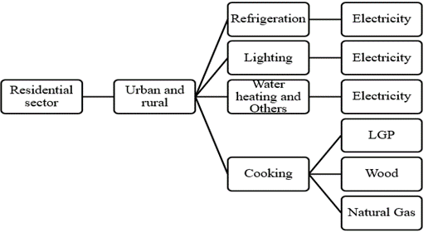
Figure 1: Final energy demand module framework for the residential sector
In the 2018–2040 period, the LEAP software system analysed the long-term energy demand forecast, incorporating historical and statistical data from 2018 as the baseline year. Input data encompassed population growth, GDP, annual and Multiannual Statistics of the Colombian Electricity Sector, annual electricity and natural gas consumption, and energy intensity index, sourced from public organizations like DANE, UPME (specifically the national energy plan 2050 and PROURE), and the SUI database. The detailed description for designing scenarios in the LEAP model is provided in section 2.2, supporting the outlook until 2040.
Table 1 shows some of the parameters, base values, and assumptions for 2018 (baseline year).
Table 1: Assumptions and base values for the baseline year (2018).
Parameter | Description
Population in 2018 | 45,521 people
Base year electricity consumption | 15,981,734 kWh (SUI, 2022)
Base year heat consumption | 52098294.19 kWh (SUI, 2022)
Energy urban share | 80.4 % (SUI, 2022)
Energy rural share | 10.60 % (SUI, 2022)

    - Key Assumptions into the LEAP Model and Scenarios Description
The first scenario, termed "usual trend" considered the average growth rate of the last ten years derived from historical demand for electricity and heat data from SUI for Pamplona, regarding heat consumption the share is 58 % firewood, 31 % natural gas and 11 % LPG.
The second scenario focused on energy efficiency, aligning with the energy intensity index established in the Program for the Rational and Efficient Use of Energy (PROURE). The energy intensity index understood as the ratio of energy consumption (heat or electricity) over GDP was used as data for the time series in LEAP. This translates into an annual increase in energy intensity between 0.35 and 0.95 in the case of electricity demand, the alternatives identified to improve energy efficiency consists of the updating refrigeration equipment and replacement of inefficient luminaires with LED 52. With respect to the demand for heat, the biggest challenge is to reduce cooking losses due to the use of firewood, so initially there is a share of heat excluding electricity that would be 58 % firewood, 31 % natural gas and 11 % LPG, which varies over time, reducing firewood consumption to 41 % in 2025 and 20 % in 2030, replacing it with LPG.
The third scenario, labeled post COVID-19 trending, was executed in the absence of similar historical events, substantiated by statistical data. Thus, energy intensity was used as a determining factor from a socioeconomic point of view. This relationship was calculated as the relationship of historical energy consumption over GDP, established from the national energy plan to 2050, where the GDP was fixed in the economic activity degree of openness, reflecting an 82 % openness level ending 2020, with the continuity of remote work and reaching 100 % openness in the fourth quarter of 2021, with a minimal part of the remote work population, just 5 %. Also, this scenario proposes improvements in the efficiency of heat demand with the replacement of incandescent luminaires with 60 % compact fluorescent lamp and 40 % LED by 2025; and 100 % LED by 2030.

    - Validation of data projected to 2022.
Demand forecasts from each scenario was compared using the city's annual energy demand data from a survey conducted by Ortiz-Flórez (2022), which used a statistical mesh to conduct tests in the residential sector of Pamplona and evaluate the final use of electricity and heat after COVID-2019. As of 2022, the average electricity consumption is 2400 GJ with an average usage of 15,213 h, and the heat consumption is 158 GJ.
  - Results and analysis
This session illustrates energy demand results for usual trend scenario that emphasizes the importance of strategic energy planning, while energy efficiency initiatives aim to counteract this trend. Finally, the post-COVID-19 scenario reflects notable changes in annual growth rates linked to GDP variations.
    - Electricity Demand forecasting
In Figure 1, the usual trend for electricity demand in both urban and rural Pamplona sectors is evident, reaching a demand of 3368.4 GJ in 2040. The annual growth rate for both sectors is approximately 1.84 %, indicating a persistent rise in residential electricity demand over the last decade. This underscores the necessity for strategic energy planning to address escalating demands, requiring infrastructure expansions, adoption of efficient technologies, and implementation of sustainability-promoting policies.
In the energy efficiency scenario for Pamplona's urban and rural areas, a distinctive approach aims to reduce electricity demand, achieving 2641.0 GJ in 2040. Applying an energy intensity index from PROURE, the trajectory shows a unique pattern with annual increases ranging from approximately 0.67 % initially to around 0.72 % later in the forecast for both rural and urban sectors. Extrapolating these rates yields an estimated cumulative growth in electricity demand of around 21.7 % for urban and 17 % for rural areas. The strategy involves upgrading refrigeration equipment and substituting inefficient luminaires with LED technology, anticipating efficiency improvements of 30 % to 40 %, similar proportions have been obtained in research like Shahzad et al. (2016). Moreover, these innovations aim to significantly decrease energy consumption, promoting a more sustainable and environmentally conscious approach in Pamplona.
The post-COVID-19 trending scenario for electricity demand shows significant dynamics, reaching 3008.8 GJ in 2040. In 2020, negative growth rates, reflecting the immediate impact of the pandemic, led to a reduction of approximately -6.9 % in both urban and rural electricity demand due to the closures of commercial and educational activities, which have a high impact on the university city of Pamplona due to remote work that caused a large part of the student population to migrate to other areas of the country. However, in 2021, there was a resilient rebound with a growth rate of about 3.7%, aligning with the post-pandemic recovery. The calculated average growth rate, derived from annual comparisons, indicates a stable metric, averaging approximately 3% until 2022, signifying the initial stages of recovery and the anticipated trend scenario. This aligns with the national UPME projections (2022), which predict an annual growth ranging between 2.21% and 3.38% for the period 2022-2036. When examining cumulative growth rates until 2030 and 2040, a comprehensive understanding of Pamplona's electricity demand trajectory emerges. This underscores the importance of implementing adaptive strategies in the face of unprecedented events, while concurrently promoting sustainability within the energy sector.

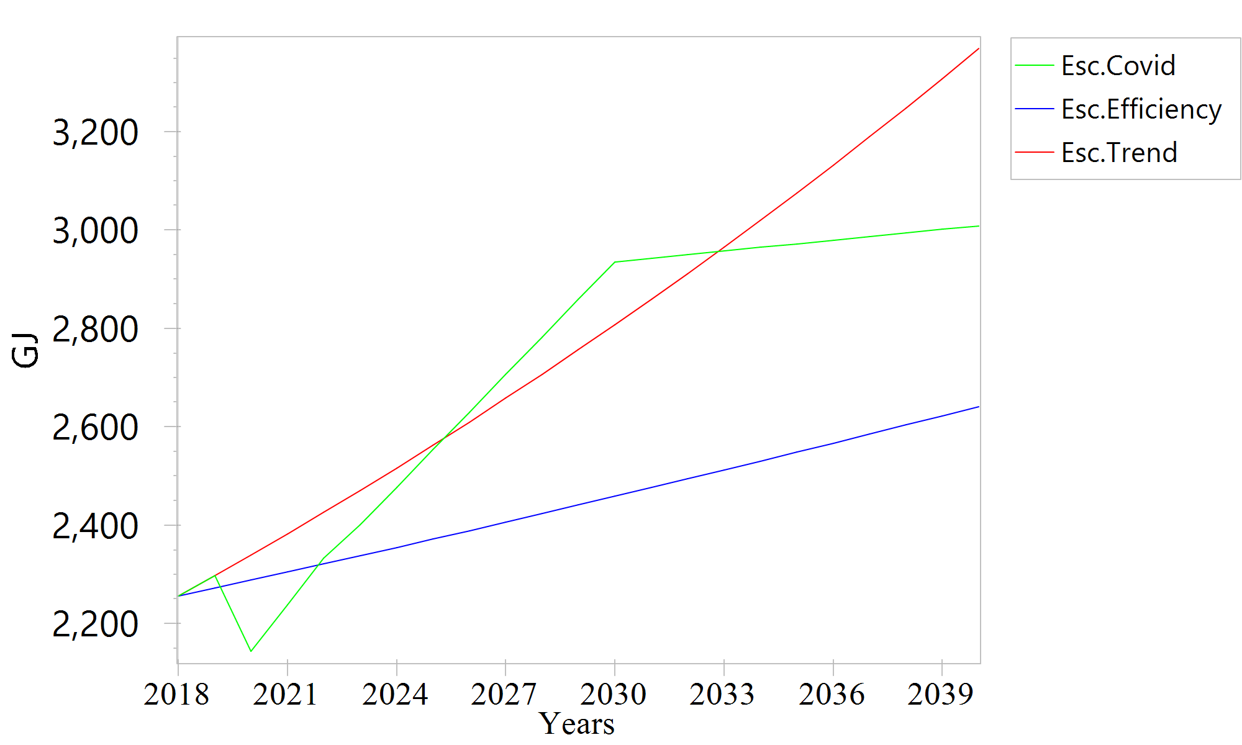

Figure 1: Electricity demand outlook for all sceneries

    - Heat Demand Forecasting
In Pamplona's trend scenario (Figure 2), the evaluation of heat consumption unveils insights, projecting 189.2 GJ in 2040. Notably, 2020 saw an increase in heat demand, with annual growth rates of 1.00 % in the rural sector and 0.99 % in the urban sector. Progressing to 2022, growth rates intensified to 2.01 % for both urban and rural areas, indicating a robust recovery. Projections until 2030 suggest sustained positive trajectories, with annual growth rates of 1.58 % for rural and 1.61 % for urban areas. By 2040, the upward trend continues, with annual growth rates reaching 1.46 % in rural and 1.49 % in urban areas.
In Pamplona's heat consumption efficiency scenario (Figure 3), with an annual energy demand of 204.6 GJ in 2040, there is a dynamic transition in energy sources. In 2020, the urban sector grew by 3.07 %, and the rural sector by 3.06 %, both relying on firewood and natural gas. However, moving forward, the influence of firewood diminishes. By 2025, the urban area sees a decline in firewood consumption to 41 %, with an increase in LPG to 28.6 %. This shift intensifies in 2030, with firewood's share reducing to 20 %, and LPG becoming the dominant energy source. These changes align with efforts to reduce cooking losses from firewood, emphasizing a strategic move towards more sustainable and efficient energy options.
The aggregate growth analysis from 2020 to 2040 highlights a significant transformation in Pamplona's energy landscape. The urban sector experiences a remarkable 85.97 % increase in heat consumption, primarily due to the shift towards LPG. Meanwhile, the rural sector exhibits a unique pattern, with a cumulative growth of 63.91 %. This increase aligns with the city's commitment to decreasing firewood dependency. The strategic reallocation of energy sources, as reflected in the evolving percentages, underscores Pamplona's commitment to environmentally conscious practices.
In the post-COVID scenario (Figure 4), Pamplona witnessed a significant decline in heat consumption in 2020, attributed to the absence of a substantial student and transient population. Movement restrictions during the pandemic led to a reduced overall heat consumption as many students were away from the city. The subsequent rebound post-COVID, indicated by positive annual growth rates of 2.79% in the urban sector and 2.80 % in the rural sector by 2029, signifies a robust recovery and resurgence in economic activities, contributing to increased heat demand.
Looking ahead to the period from 2030 to 2040, the anticipated annual growth rates continue to indicate a positive trajectory, emphasizing sustained heat demand. Expected growth rates of approximately 2.49 % in the urban sector and 2.79 % in the rural sector reflect the region's commitment to recovery and growth. The cumulative growth rates of 40.39 % in the urban sector and 40.77 % in the rural sector from 2020 to 2040 underscore the resilience and adaptability of Pamplona's energy landscape as it navigates through the challenges posed by the pandemic and charts a course toward a more sustainable and dynamic future.
At this point, it is worth mentioning that for the electricity and heat consumption projections up to 2022, the data was validated using the survey conducted by Ortiz-Florez (2022).

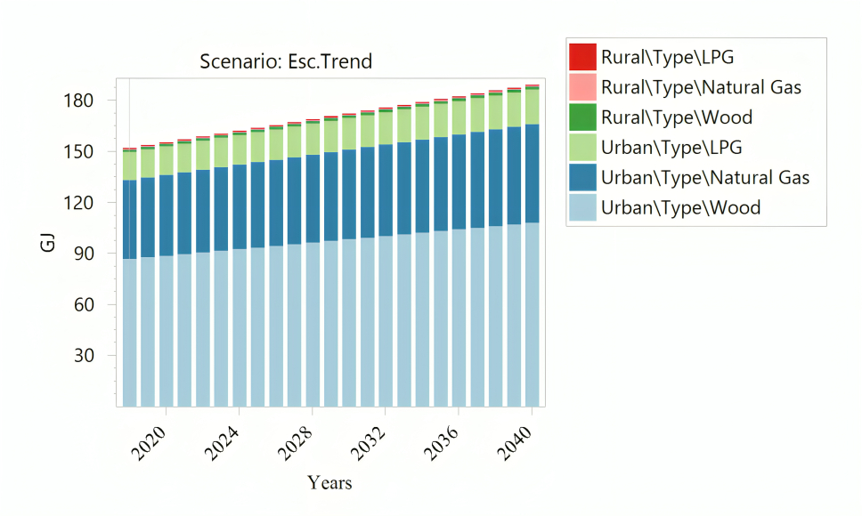
Figure 2: Heat demand outlook for usual trend scenario

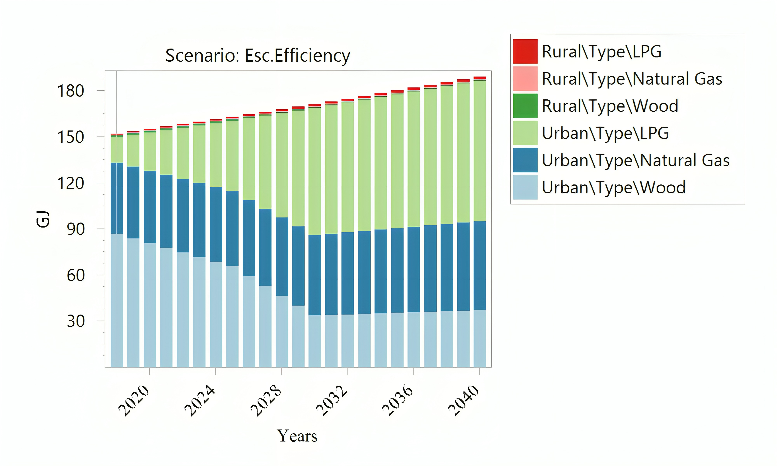
Figure 3: Heat demand outlook for efficiency scenario
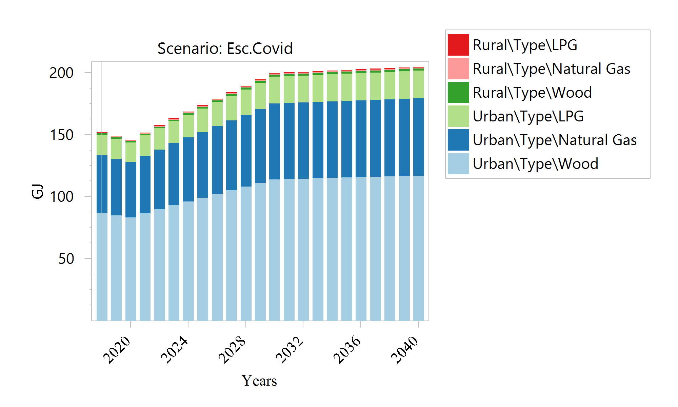

Figure 4: Heat demand outlook for post-COVID-19 scenario
  - Conclusions
Pamplona's energy demand projections unveil a consistent upward trend in both electricity and heat consumption across various scenarios. The usual trend scenario emphasizes the critical need for strategic energy planning to address the persistent rise in residential electricity demand, necessitating infrastructure expansions, technology adoption, and sustainability policies. Efforts to enhance energy efficiency through innovative measures, including equipment upgrades and LED technology adoption, aim to curb escalating electricity demand. The post-COVID-19 scenario introduces significant dynamics, with a resilient rebound in electricity demand after a pandemic-induced dip in 2020. Cumulative growth rates underscore the importance of adaptive strategies and sustainability measures to navigate uncertainties and promote a resilient energy sector.
Turning to heat demand forecasting, Pamplona's trend scenario indicates a robust increase, emphasizing the need for sustainable energy sources. The efficiency scenario showcases a strategic transition, aligning with environmental goals by reducing reliance on firewood. Post-COVID-19, the region experiences a notable decline in heat consumption in 2020, followed by a strong recovery, signalling a commitment to recovery and growth. The cumulative growth rates highlight the adaptability of Pamplona's energy landscape and its dedication to sustainability. It is noteworthy that the validation of electricity and heat consumption projections up to 2022 was ensured through a survey conducted by Ortiz-Florez (2022), adding robustness to the presented findings.
Nomenclature

AL– social or economic activity level, %
EC – total energy consumption for a sector, GJ
GDP – gross domestic product
i – specific sector
LGP – liquefied petroleum gas
LEAP – long-range energy alternatives planning
UPME – energy mining planning unit
SUI – single information system
t – period, y
TE – total final consumption of energy, GJ

References
Bahmanyar A., Estebsari A. Ernest D., 2020, The impact of different COVID-19 containment measures on electricity consumption in Europe, Energy Res. Social Sci., 68,1-4.
DANE, 2020, Population projections and retroprojections for the period 1985-2017(In Spanish) <www.dane.gov.co/index.php/estadisticas-por-tema/demografia-y-poblacion/proyecciones-de-poblacion> accessed 14.09.2022.
García-Rendon, J., Rey Londoño, F., Arango Restrepo, L. J., Bohorquez Correa, S. 2023. Sectoral analysis of electricity consumption during the COVID-19 pandemic: Evidence for unregulated and regulated markets in Colombia, Energy, 268, 126614.
Heaps, C.G., 2019, Long-range Energy Alternatives Planning (LEAP) system. Stockholm Environment Institute. <www.energycommunity.org> 25.4.2021.
International Energy Agency, 2022, <www.iea.org/reports/renewables-2022> accessed 14.09.2023
Ortiz-Flórez D.A., 2022, Estimation of the Demand for Electricity and Heat with Projection to the Year 2040 for Two Case Studies of the Páramo of Santurbán, (In Spanish), Bachelor Thesis, Universidad de Pamplona, Colombia.
PROURE <www1.upme.gov.co/DemandayEficiencia/Documents/PROURE/Documento_PROURE_2022-2030_v4.pdf> accessed 22.09.2023.
National Energy Plan, 2050. (In Spanish). <www.1upme.gov.co/DemandayEficiencia/Documents/PEN_2020_2050/Plan_Energetico_Nacional_2020_2050.pdf> accessed 10.10.2023
Rivera-González L., Bolonio D., Mazadiego L.H., Valencia-Chapi R., 2019, Long-Term Electricity Supply and Demand Forecast (2018–2040): A LEAP Model Application towards a Sustainable Power Generation System in Ecuador, Sustainability, 11,1-19.
Toledo D., Rodriguez-Martinez A., Cerezo J., Herandez G., Romero R. J., Lechon Y., 2021, Mexican Power System to 2050: Sustainability Assessment with an Energy Model, Chemical Engineering Transactions, 86, 481-486.
Shahzad K., Čuček L., Sagir M., Nizami A.S., Iqbal T., Almeelbi T., Ismail I., 2016, A Case Study for Developing Eco-efficient Street Lighting System in Saudi Arabia, Chemical Engineering Transactions, 52,1141-1146.
Smith, J., Brown, A., & Johnson, M. (2021). "Remote Work and Its Impact on Residential Energy Demand: A Case Study." Journal of Energy Economics, 33(4), 567-584.
SUI, 2022, Tool O3 (In Spanish). <bi.superservicios.gov.co/o3web/browser/showView.jsp?viewDesktop-=true&source=SUI_COMERCIAL_ENERGIA/VISTA_FACTURACION_ENERGIA%23_public> accessed 24.08.2023.
UPME, 2022, Energy Demand Projection Report 2022-2036. (In Spanish). < //www1.upme.gov.co/Demanday-Eficiencia/Documents/Informe_proyeccion_demanda_energeticos.pdf> accessed 24.01.202

