CHEMICAL ENGINEERING TRANSACTIONS  VOL. , 2024 | A publication of
The Italian Association
of Chemical Engineering
Online at www.cetjournal.it

Guest Editors: Leonardo Tognotti, Rubens Maciel Filho, Viatcheslav Kafarov
Copyright © 2024, AIDIC Servizi S.r.l.
ISBN 979-12-81206-09-0; ISSN 2283-9216

Environmental assessment of liquid hydrogen production routes
Pablo Silva Ortiz^{a,}*, Jia-Wei Linª, Adriano Pinto Mariano^{b}, Rubens Maciel Filho^{b}, Agnes Jocherª
ªTechnische Universität München, School of Engineering and Design, Boltzmannstraße 15, Garching, Germany
*pablo.silva@tum.de, jiawei.lin@tum.de, agnes.jocher@tum.de
^{b}Faculdade de Engenharia Quimica, Universidade Estadual de Campinas, Av. Albert Einstein, 500, Campinas Brazil
adpm@unicamp.br, rmaciel@unicamp.br
Recently, hydrogen has been explored as an aviation energy carrier to support various critical energy challenges for the upcoming decades. Thus, conventional and non-conventional hydrogen production methods have been developed worldwide. This paper investigates Steam Methane Reforming (SMR) and Alkaline Electrolysis (AWE) hydrogen production as primary processes from an energy requirement and life cycle perspective. Besides, It also considers hydrogen liquefaction for aviation use. In this context, an attributional, Cradle-to-Gate life cycle assessment was carried out to compare the environmental impact of SMR and AWE hydrogen production processes under four German energy mix scenarios. The assessment method selected was ReCiPe 2016, and the main impact categories were climate change and acidification potential. The results show that greenhouse gas emissions from each production method highly depend on energy sources. The CO₂ emissions from SMR and AWE processes in a base case scenario are 12 and 51 kg_{CO2eq}/kg_{H2}, respectively, and these values decrease to 7 (SMR) and 22 kg_{CO2eq.}/kg_{H2} (AWE) in a 2050 renewable energy scenario. Concerning the energy requirements, each process requires different energy amounts to produce 1 kg_{H2} (functional unit). SMR requires 11.3 kWh, AWE 61.8 kWh, and hydrogen liquefaction 5.1 kWh. In brief, hydrogen is widely promoted as an alternative energy carrier in Germany; however, depending on the production process and technical considerations, further studies are required to support and explore its applications.
  - Introduction
In 2022, around 2% of global GHG emissions were attributed to the aviation industry (Ritchie and Roser, 2023), which is expected to grow by 1.3% annually (ICAO, 2022). The International Civil Aviation Organization (ICAO) members have adopted a 2050 net-zero CO₂ objective to alleviate the projected increase in GHG emissions. Lately, several approaches for achieving this ambitious target have been suggested, including improvements in aircraft technology, operation performance, greater utilization of sustainable aviation fuels (SAF), and the introduction of market-based measures (Bergero et al., 2023). SAF can potentially reduce CO₂ emissions, as their carbon content comes from biomass or the environment instead of fossil fuels (Vardon et al., 2022). In addition, hydrogen (H₂) is increasingly recognized for its high specific energy and zero carbon emissions at the point of use, making it a promising candidate for future aviation fuel (Dawood et al., 2020). Various hydrogen routes are available and are categorized based on production processes and sources. For instance, innovative hydrogen process designs offer a zero-net carbon solution using renewable energy (Yusaf et al., 2022), including promising technologies such as steam methane reforming (SMR), alkaline water electrolysis (AWE), proton exchange membrane (PEM), and solid oxide electrolysis (SOE). They can be coupled to various H₂ liquefaction techniques, namely cascade liquefaction process and precooled liquefaction process i.e., mixed refrigerants or Joule-Brayton cycles (JBC) - the latter offers great prospects for development in the near future from a technical perspective (Yin and Ju, 2020; Son et al., 2022). Before deciding which routes should be adopted, it is necessary to assess the whole supply chain of hydrogen production and estimate the potential environmental impacts. Therefore, the life cycle assessment (LCA) of the H₂ process has been explored in recent years (Bhandari et al., 2012; Burkhardt et al., 2016; Bareiß et al., 2019) and an environmental performance review of hydrogen production technologies is given by Chelvam et al. (2024). In general, thermochemical H₂ production is the most studied technology in LCA. However, utilizing natural resources, especially solar and wind power, in the electrolysis process is an environmentally preferable solution compared to alternative production processes (Bareiß et al., 2019; Wilkinson et al., 2023). Hence, the novelty of this work is examined via the attributional LCA approach of two possible H₂ production routes covering mature technologies, SMR and AWE, integrated into a JBC liquefaction process under four German energy scenarios, reflecting both the electricity mix in 2022 and projections for 2050. Our study concentrates on the ReCiPe method, which aggregates impacts into three areas of protection, e.g., human health, ecosystem, and resource availability. Although LCA cradle-to-gate comprises various (eight) impact categories, this work focuses on global warming (GWP) and acidification potential (AP), referring to greenhouse gas emissions and acid rain effects, which are significant to determining product system environmental impacts.
  - Liquid hydrogen production technologies
This section outlines two H₂ production processes, SMR and AWE, and a subsequent JBC liquefaction process based on the technology readiness level (TRL). All processes are ranked in TRL 9 (Wilkinson et al., 2023).
    - Steam methane reforming
SMR is the most common method for H₂ production. The process consists of steam reforming, water-gas shift (WGS), and pressure swing adsorption (PSA) steps (Boyano et al., 2011). In natural gas cases, SMR requires a pretreatment stage to remove sulfur and transform non-methane hydrocarbons into methane (CH₄). It prevents the catalyst of the steam reforming stage from poisoning and avoids the correction of reactor tubes (Gangadharan et al., 2012). Our research, however, selects CH₄ as the primary input, thus excluding the need for this preliminary pretreatment. During the steam reforming stage, CH₄ reacts to produce syngas, a mixture of H₂ and carbon monoxide (CO), Eq. (1). This process requires CH₄ and steam with a nickel-based catalyst at a temperature between 700-1000°C and pressures of 5-40 bar (Barelli et al., 2008). Notably, this reaction is endothermic, requiring energy from the reformer’s furnace, as indicated by the standard enthalpies of formation $∆H$_{r} (Hajjaji et al., 2012). The WGS process is designed to increase the H₂ content by converting the mixture of CO and steam into H₂ and CO₂, Eq. (2) (Pal et al., 2018). This stage consists of high- and low-temperature subprocesses. The high-temperature WGS reactor operates between 350 and 500°C, which accelerates this chemical reaction (Chen and Chen, 2020). Subsequently, the low-temperature WGS reactor operates at 150°C. The primary outputs of the SMR processes are H₂ and CO₂, as shown in Eq. (3) (Hajjaji et al., 2012).
$$CH_{4}(g) + H_{2}O(g) ↔ CO(g) + 3H_{2}(g) ΔH_{r}= 206 kJ/mol CH_{4}$$ | (1)
$$CO(g) + H_{2}O(g) ↔ CO_{2}(g) + H_{2}(g) ΔH_{r}= -41.2 kJ/mol CO$$ | (2)
$$CH_{4}(g) + 2H_{2}O(g) ↔ CO_{2}(g) + 4H_{2}(g) ΔH_{r}= 165 kJ/mol CH_{4}$$ | (3)
    - Alkaline water electrolysis
This process requires electricity to dissociate H₂ and oxygen (O₂) ions from water. The environmental impact of water electrolysis depends on the electricity source and the use of renewable electricity targets the formation of pollutant-free hydrogen (Ursua et al., 2011). AWE consists of a nickel-based anode commonly coated with platinum and a cathode made of nickel or copper, usually coated with metal oxides, such as manganese (Mn), tungsten (W), or ruthenium (Ru) (Holladay et al., 2009). The electrolyte is a 30 wt% aqueous solution of potassium hydroxide (KOH) or sodium hydroxide (NaOH) (Sanchez et al., 2020). A key component is the porous diaphragm, which allows hydroxide ions (OH−) to travel from the cathode to the anode. AWE operates at temperatures of 70 to 140°C and pressure ranging from 1 to 200 bar (Panigrahy et al., 2022).
    - Hydrogen liquefaction
Hydrogen storage can be achieved either as a gas, requiring high-pressure tanks (350 to 700 bar) with limited volumetric efficiency (Choi and Lee, 2022), or as a liquid through liquefaction. Liquid hydrogen (LH₂) significantly reduces the volume requirements of high-pressure storage, maintaining H₂ at -253°C and a density of 70.8 kg/m³ (Colozza and Kohout, 2002), a method known as cryogenic hydrogen storage.
  - Material and methods
    - Selected energy scenarios
Four German energy scenarios were developed to evaluate their influence on LH₂ production (Fig. 1). The base scenario case represents Germany’s 2022 energy mix (Appunn et al., 2023; Ecoinvent, 2023), in which around 50% of energy was attributed to non-renewable sectors, including fossil fuels such as lignite and nuclear energy. In addition, to explore the energy transition strategies, a 2022 renewable scenario (RE 2022) was derived from the base case scenario (BC 2022) by removing the share of fossil fuels and nuclear energy.
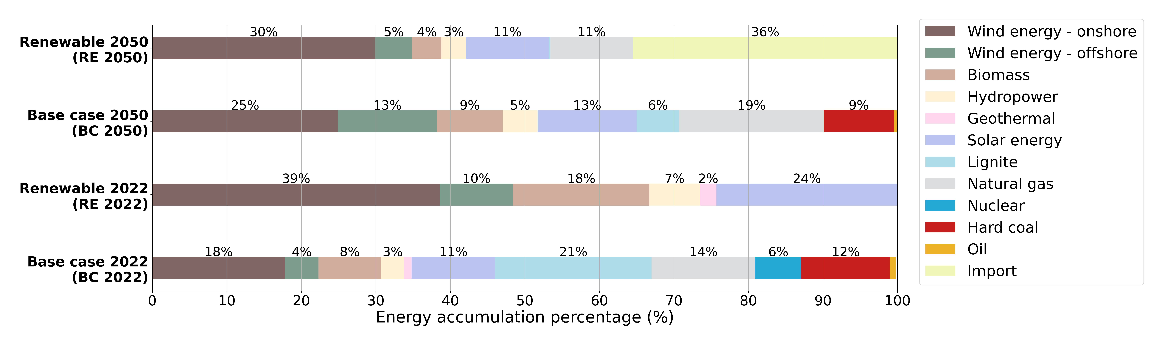
Figure 1: Overview of the investigated German energy scenarios

This study also incorporates two forecast scenarios, the 2050 base case and 2050 renewable scenario (BC and RE 2050) from Knaut et al. (2016) and Rogge et al. (2020), considering the phase-out of nuclear energy and an increase in renewable energy. Knaut’s model (the 2050 base scenario) focuses on techno-economic factors and predicts about 65% renewable energy in the mix, predominantly onshore wind energy. In the 2050 renewable scenario proposed by Rogge et al., a significant majority of energy is projected to come from renewables, with as much as 35.5% being imported energy, particularly from regions with favorable energy prices and conditions, particularly wind and solar. Despite a move away from coal, this model retains 11% natural gas to balance the intermittency of renewable sources. This strategy aligns with the International Energy Agency (IEA)’s 2050 net zero emission model, recognizing the essential role of fossil fuels in specific areas such as heavy industry, long-distance transportation, and the production of non-energy goods (IEA, 2021).
    - Life cycle assessment methodology
Two production routes for liquid hydrogen were defined: SMR with the helium JBC process and AWE with the same JBC liquefaction process. These routes include stages from power generation, feedstock sourcing, hydrogen production, liquefaction, transportation, and storage. Hence, considering the ongoing development of transportation and utilization technology in the hydrogen sector, this study employs a life cycle assessment (LCA) cradle-to-gate approach. This scope includes construction materials for SMR, AWE, and liquefaction processes, as shown in Figures 2a and 2b. The functional unit for the LCA is set at 1 kg of liquid hydrogen, and the energy supply scenarios were previously defined in Section 3.1.
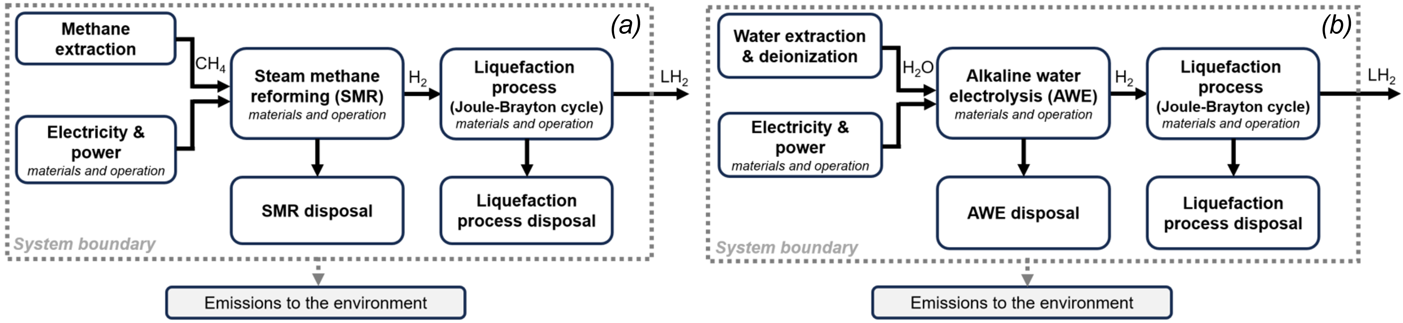
Figure 2: System boundaries adopted for liquid hydrogen production via (a) Steam methane reforming and (b) Alkaline water electrolysis adapted from Bhandari et al. (2012)

During the life cycle inventory (LCI) phase, we detailed the inputs, outputs, materials, and energy flows of these systems (ISO, 1997). The LCI data for SMR, AWE, and the helium JBC liquefaction process are presented in Table 1, based on existing literature and the Ecoinvent v3.91 database. For each process, all the LCI data were normalized to the functional unit, operational hours, lifespan, and capacity of each technology. The SMR’s LCI data, including steam reforming, WGS, and PSA stages, were taken from a process simulation study (Song et al., 2015). The SMR plant construction material data were based on Spath and Mann (2000). The LCI data for AWE processes, including water deionization and extraction, and electrolysis, are collected from Sanchez et al. (2020), with construction data for the electrolysis plant from Burkhardt et al. (2016). In addition, the helium JBC process parameters are presented in Valenti and Macchi (2008), and materials for building a liquefaction plant are listed in Stolzenburg and Mubbala (2013). While normalizing the LCI data for the functional unit allows each process to be compared, there are significant differences in production capacities and lifespan between the processes, particularly the notably higher values of the SMR. These differences play an important role in evaluating the long-term environmental sustainability of each liquid hydrogen production route. In the life cycle impact assessment (LCIA step), the ReCiPe method was selected to determine the environmental impacts and process contribution of the liquid hydrogen routes.
Table 1: LCI data for the SMR, AWE, and JBC liquefaction processes
Technology SMR AWE JBC  Process parameters  Capacity [kg/h] 8987 0.173 36000  Lifetime [Year] 20 10 20  Operating hours [h/a] 7000 7000 7000  Working fluid - - Helium  Input flows  Methane [kg] 1.61 - -  Water [kg] 5.44 - -  Deionization water [kg] - 10 -  Hydrogen [kg] - - 1  Electricity [kWh] 11.32 61.84 5.06  Output flow  Hydrogen [kg] 1 1 -  Liquid Hydrogen [kg] - - 1 | Technology SMR AWE JBC  Construction materials  Concrete [m³] 3.42e-06 - 3.89e-06  Unalloyed steel [kg] 2.60e-03 - -  Aluminium [kg] 2.15e-05 1.44e-02 2.78e-05  Cast iron [kg] 3.18e-05 3.82e-02 -  Alloyed steel [kg] - 1.24 -  Copper [kg] - 8.29e-02 2.98e-05  Nickel [kg] - 3.57e-02 -  Polymer [kg] - 2.53e-02 -  Resin [kg] - 8.82e-03 -  Zeolite [kg] - 5.86e-03 -  Electronics [kg] - 7.02e-03 -  Carbon steel [kg] - - 7.54e-05  Stainless steel [kg] - - 1.18e-04
Note: SMR parameters are based on Song et al. (2015) and Spath & Mann (2000). AWE values were defined based on Burkhardt et al. (2016) and Sanchez et al. (2020). JBC parameters were established by referencing Stolzenburg and Mubbala (2013) and Valenti and Macchi (2008).

The ReCiPe 2016 (h/hierarchist perspective) distinguishes midpoint and endpoint characterization factors (Huijbregts et al., 2017). Midpoint factors assess immediate environmental changes, while endpoint factors integrate these to evaluate effects on human health, ecosystem quality, and resource scarcity.
  - Results and discussion
    - Influence of the selected energy scenarios on GWP and AP
To assess the influence of energy supply on the environmental impact, we analyzed the GWP and AP of the introduced energy scenarios as shown in Fig. 3. The base scenario, representing Germany’s energy mix in 2022, generates the highest GWP and AP compared with transitioning to scenarios with reduced fossil fuel reliance and increased renewable energy usage. With the 2022 renewable scenario, the base case has been surpassed by a remarkable GWP decrease, accompanied by a slight reduction in the AP. The 2050 renewable scenario, with a considerable portion of energy imported from other countries, leads to a drastic decline in GWP and the lowest AP among all the scenarios. However, the results also indicate that while the scenario effectively addresses climate change concerns, its influence on reducing acidification is relatively limited.
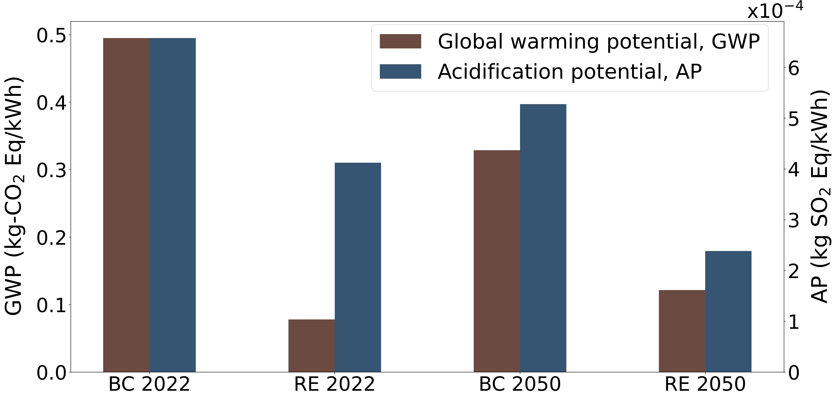 | 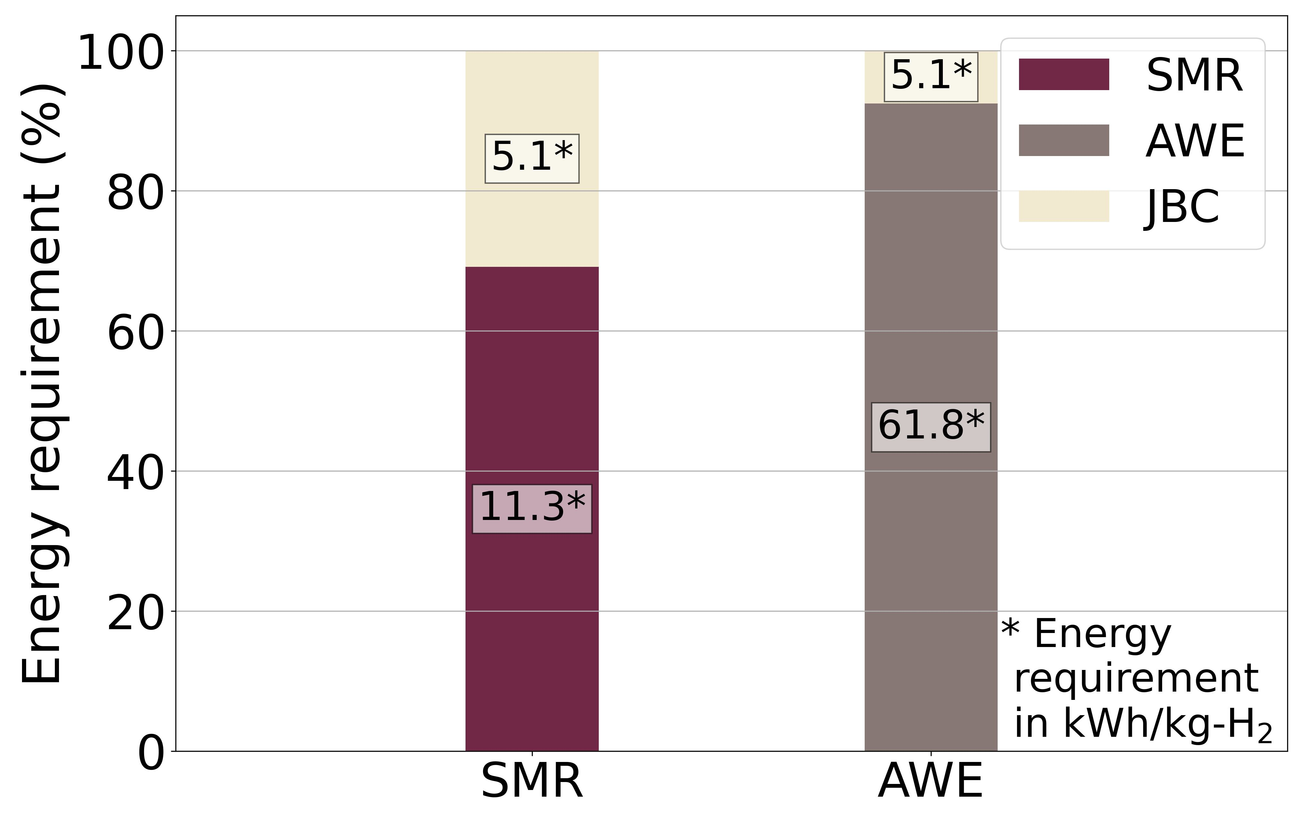
Figure 3: Results of the selected impact categories GWP  and AP for the energy scenarios analyzed | Figure 4: Resulting energy requirement for the analyzed hydrogen production routes

Figure 4 shows the energy demands for each route. The hydrogen liquefaction process consumes 5.1 kWh per kg_{H2} of the total energy requirement for the SMR and AWE routes. In brief, the SMR route requires 11.3 kWh per 1 kg of liquid hydrogen produced, while the AWE process comes to 61.8 kWh/kg_{H2}.
    - LCA interpretation of liquid hydrogen production routes
Table 2 outlines the environmental impacts of the SMR and AWE within the four energy scenarios using the ReCiPe 2016. This comprehensive evaluation includes the following impact categories: acidification (AP), climate change (GWP100), ecotoxicity (TETP), energy sources (FFP), human toxicity (HTPc and HTPnc), land use (LOP), and water use (WCP). Figure 5 shows the cradle-to-grave profile related to the impact categories of the ReCiPe method. Notably, the AWE impact is higher than that of the SMR route. The subsequent section investigates GWP and AP, which are critical in evaluating production routes within the aviation sector.
Table 2: Environmental impact for the SMR and AWE routes analyzed via ReCiPe 2016 method
Environmental  Impact | Units | BC 2022 |  | RE 2022 |  | BC 2050 |  | RE 2050
 |  | SMR | AWE | SMR | AWE | SMR | AWE | SMR | AWE
AP | kg SO₂-Eq | 0.011 | 0.126 | 0.008 | 0.110 | 0.005 | 0.092 | 0.007 | 0.103
GWP100 | kg CO₂-Eq | 11.547 | 51.956 | 8.784 | 36.873 | 6.390 | 23.803 | 5.896 | 21.106
TETP | kg 1,4-DCB-Eq | 10.231 | 117.625 | 11.067 | 122.185 | 10.765 | 120.539 | 15.635 | 147.122
FFP | kg oil-Eq | 1.695 | 12.642 | 1.126 | 9.532 | 0.535 | 6.308 | 0.255 | 4.780
HTPc | kg 1,4-DCB-Eq | 0.515 | 6.995 | 0.302 | 5.836 | 0.172 | 5.125 | 0.197 | 5.259
HTPnc | kg 1,4-DCB-Eq | 14.892 | 133.629 | 10.171 | 107.859 | 7.623 | 93.950 | 8.065 | 96.364
LOP | m²*a crop-Eq | 0.124 | 0.999 | 0.125 | 1.002 | 0.081 | 0.761 | 0.211 | 1.473
WCP | m³ | 0.027 | 0.439 | 0.019 | 0.397 | 0.026 | 0.432 | 0.018 | 0.393

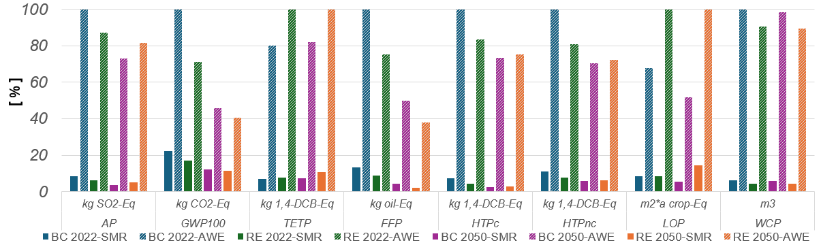
Figure 5: Cradle-to-grave profiles related to the environmental impact categories according to the ReCiPe method of the liquid hydrogen production routes

Figure 6a illustrates the GWP associated with the SMR and AWE routes under the four investigated energy scenarios per kg of hydrogen. Both production paths show a decline in GWP with an increasing share of renewable energy. Due to higher energy consumption in the AWE route, the influence of the energy mix is much more apparent than in the SMR route. However, the AWE route consistently shows a higher GWP than the SMR, even with 100% renewable energy. This higher GWP is attributed to the cradle-to-gate approach, which includes producing electronic components (global level, cutoff) and water deionization processes that consume energy from the existing electricity grid with a focus on Europe without Switzerland as a provider.
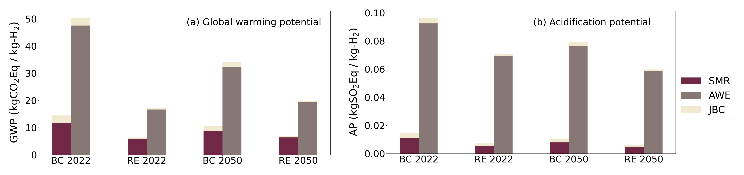
Figure 6: Environmental impact of LH₂ production routes in the investigated energy scenarios for Germany

Moreover, the liquefaction process is treated as a standalone stage, relying on electricity and H₂ as its primary inputs. This highlights that its environmental impact heavily depends on the nature of the energy supply. Fig. 6b presents the AP per kg H₂ from the SMR and AWE production route across the energy scenarios. The AWE route exhibits a much higher AP compared to the SMR counterpart. While an increase in renewable energy supply slightly narrows this difference, it barely influences acidification, as the primary contributors to AP in the AWE route are the fabrication of electronic components and the process of water deionization. The liquefaction process in the LH₂ routes requires considerably less energy than the SMR and AWE routes. As a result, changes in energy supply have a less noticeable effect on the environmental impact of liquefaction compared to the more energy-intensive SMR and AWE processes.
  - Conclusions
Based on the cradle-to-gate approach, the LCA results indicate that the electricity mix significantly influences the environmental impact of both liquid hydrogen production routes. With its substantially higher energy consumption, the AWE route is more sensitive to variations in the electricity mix than the SMR route. Increasing the proportion of renewable energy in the electricity mix effectively reduces the GWP and AP across the two liquid hydrogen production routes. It also reduces the discrepancy in these values between different production technologies. However, the AWE route exhibits a higher environmental impact than the SMR, even with a complete transition to renewable energy. This higher impact is attributed to the energy needed to deionize water and the electrolyzer construction that consumes energy from the current electricity grid. Additionally, while contributing to a considerable portion of energy in the SMR route, the liquefaction process contributes less to the total environmental impact of both production paths. Given the substantial environmental impacts of the AWE’s operation and construction, it is necessary to improve its operational efficiency and optimize construction practices. Future strategies in hydrogen production should not only accelerate the shift to renewable energy but also emphasize the use of sustainable materials and prolong the lifespan of production equipment. Such measures are crucial to achieving carbon neutrality targets in the transportation sector generally and in the aviation industry specifically.
Nomenclature
AP – Acidification potential (terrestrial)  AWE – Alkaline water electrolysis  FFP – fossil fuel potential (energy resources)  GHG – Greenhouse gas emissions  GWP – Global warming potential  HTPc – human toxicity potential (carcinogenic) | HTPnc - human toxicity potential (non-carcinogenic)  JBC – Joule Brayton cycle (helium liquefaction)  LCA – Life cycle assessment  LCI – Life cycle inventories  LCIA – Life cycle impact assessment  LOP – land use - agricultural land occupation | PEM – Proton exchange membrane  PSA – Pressure swing adsorption  SAF – Sustainable aviation fuels  SMR – Steam methane reforming  TETP – Terrestrial ecotoxicity potential  WCP – water consumption potential

References
Appunn, K., Haas, Y., and Wettengel, J. (2023). Germany’s energy consumption and power mix in charts. https://www.cleanenergywire.org/factsheets/germanys-energy-consumption-and-power-mix-charts.
Barelli, L., Bidini, G., Gallorini, F., and Servili, S. (2008). Hydrogen production through sorption-enhanced steam methane reforming and membrane technology: A review. Energy, 33(4):554–570.
Bareiß et al., 2019. LCA of H₂ from proton exchange membrane water electrolysis in future energy systems. Applied Energy (237), 862-872.
Bergero, C., Gosnell, G., Gielen, D., Kang, S., Bazilian, M., Davis, S. (2023). Pathways to net-zero emissions from aviation. Nature Sustainability, 6(4):404–414.
Bhandari, R., Trudewind, C. A., and Zapp, P. (2012). Life cycle assessment of hydrogen production methods: A review. Institut für Energie-und Klimaforschung, Systemforschung und Technologische Entwicklung.
Boyano, A., Blanco-Marigorta, A., Morosuk, T., and Tsatsaronis, G. (2011). Exergoenvironmental analysis of a steam methane reforming process for hydrogen production. Energy, 36(4):2202–2214.
Burkhardt, J., Patyk, A., Tanguy, P., and Retzke, C. (2016). Hydrogen mobility from wind energy. Applied energy, 181:54–64.
Chen, W.-H. and Chen, C.-Y. (2020). Water gas shift reaction for H₂ production and carbon dioxide capture. Applied Energy, 258:114078.
Chelvam et al., (2024). A review on the environmental performance of various hydrogen production technologies: An approach towards hydrogen economy. Energy Reports. June (11) 2024, 369-383
Choi, Y. and Lee, J. (2022). Estimation of liquid hydrogen fuels in aviation. Aerospace, 9(10):564.
Colozza, A. J. and Kohout, L. (2002). Hydrogen storage for aircraft applications overview. Technical report, NASA.
Dawood, F., Anda, M., and Shafiullah, G. (2020). Hydrogen production for energy: An overview. Int. J. Hydrogen Energy, 45(7):3847–3869.
Ecoinvent (2023). Allocation, cut-off by classification. ecoinvent database version 3.91.
Gangadharan, P., Kanchi, K., and Lou, H. (2012). Evaluation of the economic and environmental impact of combining dry reforming with steam reforming of methane. Chemical Engineering Research and Design, 90(11):1956–1968.
Hajjaji, N., Pons, M.-N., Houas, A., and Renaudin, V. (2012). Exergy analysis: An efficient tool for understanding and improving hydrogen production via the steam methane reforming process. Energy Policy, 42:392–399.
Holladay, J., Hu, J., King, D., Wang, Y. (2009). An overview of hydrogen production technologies. Catalysis, 139(4):244–260.
Huijbregts, M., Steinmann, Z., Elshout, P., Stam, G., Verones, F., Vieira, M., Zijp, M., Hollander, A., and van Zelm, R. (2017). ReCiPe2016: a harmonised LCIA method at midpoint and endpoint level. Int J Life Cycle Assess, 22(2):138–147.
ICAO (2022). Global Market Forecast 2023. Montreal: International Civil Aviation Organization.
IEA (2021). Net Zero by 2050. International Energy Agency.
ISO (1997). Environmental management: LCA – principles and framework. Technical report, International Organization for Standardization, CH.
Knaut, A., Tode, C., Lindenberger, D., Malischek, R., Paulus, S., and Wagner, J. (2016). The reference forecast of the German energy transition—an outlook on electricity markets. Energy Policy, 92:477–491.
Pal, D. B., Chand, R., Upadhyay, S., and Mishra, P. (2018). Performance of water gas shift reaction catalysts: A review. Renewable and Sustainable Energy Reviews, 93:549–565.
Panigrahy, B., Narayan, K., and Rao, B. R. (2022). Green hydrogen production by water electrolysis. Materials today, 67:1310–1314.
Ritchie, H. and Roser, M. (2023). Sector by sector: Where do global GHG emissions come from? Our World in data.
Rogge, K. S., Pfluger, B., and Geels, F. W. (2020). Transformative policy mixes in socio-technical scenarios: The case of the low-carbon transition of the German electricity system (2010–2050). Tech. Forecasting and Social Change, 151:119259.
Sanchez, M., Amores, E., Abad, D., Rodriguez, L., and Clemente, C. (2020). Aspen plus model of an alkaline electrolysis system for hydrogen production. International journal of hydrogen energy, 45(7):3916–3929.
Son et al., (2022). Simulation methodology for hydrogen liquefaction process design considering hydrogen characteristics. Int. Journal of Hydrogen Energy. V47(61), 25662-25678
Song, C., Liu, Q., Ji, N., Kansha, Y., and Tsutsumi, A. (2015). Optimization of steam methane reforming coupled with pressure swing adsorption hydrogen production process by heat integration. Applied energy, 154:392.
Spath, P. L. and Mann, M. K. (2000). LCA of hydrogen production via natural gas steam reforming. Technical report, NREL (USA).
Stolzenburg, K.; Mubbala, R. (2013). Integrated design for demonstration of efficient liquefaction of H₂. Technical report, FCH JU.
Ursua, A., Gandia, L., Sanchis, P. (2011). Hydrogen production from water electrolysis: current status and future trends. IEEE, 100(2):410–426.
Valenti, G.; Macchi, E. (2008). Proposal of an innovative, high-efficiency, large-scale H₂ liquefier. Int. J. Hydrogen Energy., 33(12):3116–3121.
Vardon, D., Sherbacow, B., Guan, K., Heyne, J., Abdullah, Z. (2022). Realizing “net-zero-carbon” sustainable aviation fuel. Joule, 6(1):16–21.
Yin, L. and Ju, Y. (2020). Review on the design and optimization of H₂ liquefaction processes. Front. in Energy, 14:530–544.
Yusaf et al. (2022). Sustainable aviation—hydrogen is the future. Sustainability 14(1):548.
Wilkinson et al. (2023), Review and meta-analysis of recent LCA of hydrogen production. Cleaner Environmental Systems 9, 100116.

