|  |  |
| --- | --- |
| pagecetlogo ***CHEMICAL ENGINEERING TRANSACTIONS***  ***VOL. , 2024*** | A publication of  aidiclogo_grande |
| The Italian Association  of Chemical Engineering  Online at www.cetjournal.it |
| Guest Editors: Leonardo Tognotti, Rubens Maciel Filho, Viatcheslav Kafarov  Copyright © 2024, AIDIC Servizi S.r.l. **ISBN** 979-12-81206-09-0; **ISSN** 2283-9216 | |

Final Upcycling of Post-Treatment Agri-Food Residues   
by Torrefaction

Michele Miccioa,\*, Michela Fraganzaa, Giovanni Casconea, Gianpiero Pataroa, b, Ervehe Rrucaja, b, Giovanna Ferraria, b, Paola Brachic, Renata Migliaccioc, Marinella Favotd, Francesca Marchid, Etienne Le Nouaillee

a Department of Industrial Engineering (DIIn), University of Salerno, via Giovanni Paolo II 132, 84084 Fisciano (SA), Italy

b ProdAl S.c.a r.l., Via Giovanni Paolo II 132, Edificio L6, 84084 Fisciano (SA), Italy

c Inst. of Sciences and Technologies for Energy and Sustainable Mobility, STEMS-CNR, P.le Tecchio 80, 80125 Napoli, Italy

d Area Science Park, Via Padriciano 99, 34149 Trieste, Italy

e Dept. of Chemical Engineering, Clermont Auvergne University, 20 ave. Blaise Pascal, 63178 AUBIERE CEDEX, France

\*Corresponding Author: mmiccio@unisa.it

Various agri-food residues were taken into consideration in this work in a dedicated experimental program centered on lab-scale fluidized bed torrefaction. They include some “difficult” feedstocks for fluidization (e.g., Industrial Cherry Cake and Coffee silverskin) or unusual ones (e.g., spent Lemon peels and Tomato seeds), for their upcycling to solid biofuels. Three different temperature levels (200, 250 and 300°C) were considered under a constant residence time (5 min) under actual torrefaction conditions of a biomass batch in the bed.

A drawback induced by the biomass torrefaction mechanism, i.e., the definitive "capture" of the small bed inert solids on the surface of the particles undergoing torrefaction, was overcome by a bed switch from fine but rather heavy solids (100-250 µm quartz sand) to coarser and lighter ones (expanded clay 1000-1400 μm). This yielded torrefied products of a better quality as solid biofuels being free of “extraneous” inert particles.

As far as the ranking of the feedstocks, Industrial Cherry Cake and Grape Marc performed better in terms of Energy Densification Index (IED even larger than 1) and Energy Yield (EY close to 100%).

* 1. Introduction

It is well-known that wastes of biogenic origin, including agri-food residues, are more and more considered valuable sources of both bioactive substances and biofuels, whatever their original moisture content is.

The authors started their work on the chemical valorization of industrial hazelnut by-products (Zainutdinova et al., 2022), thanks to the conventional lab-based Soxhlet extraction technique, for the recovery of polyphenolic compounds. Then, they focused on torrefaction as a technological stage to further valorize the spent post-extraction solid residues (Miccio et al., 2023) and upcycle them to solid biofuels, in an integrated biorefinery perspective. In fact, biomass torrefaction is perhaps the best mild thermal process to produce solid biofuels from relatively dry feedstocks (Chen et al., 2021), even under the occurrence of irregular, loose or flat particle shape.

The agri-food residues taken into consideration here are divided in two groups according to the “level of novelty” they introduced in either the type of feedstock or the lab-scale fluidized bed torrefaction adopted by the authors.

A first group of them, here referred to as “Group I”, consists of: A) Spent lemon peels; B) Dry tomato seeds; C) Industrial cherry cake. They represent potential feedstocks for fluidized bed torrefaction that are new (e.g., Spent lemon peels) or unconceivable (e.g., Dry tomato seeds) so far for such an application; in addition, they are unpractical for direct fluidized torrefaction because of the high content of liquids (e.g., Spent lemon peels and Industrial cherry cake) or the challenging shape, either irregular (e.g., Spent lemon peels) or fibrous (e.g., Industrial cherry cake), as it can be seen in Fig. 1.

Actually, tomato seeds already have a potential technological and market destination. Rossini et al. (2013) stated that the separation of components that constitute tomato pomace (mostly peels and seeds) makes sense in case of production and exploitation of oil from tomato seeds. Casa et al. (2021) simulated in AspenPlus® the biodiesel production by transesterification just starting from tomato seeds and discussed the benefits of a transition from the conventional alkaline catalyst to an inexpensive ‘green’ one.

Regarding sweet cherries for juice production, during the industrial processing of red fruits large amounts of press cakes are inevitably produced (Pataro et al., 2017). These cakes often pose environmental challenges, through landfilling or their utilization as low-value products such as animal feed and compost. Despite this, numerous studies have sought new methods to add value to red fruit press cakes. For instance, research has been conducted on extracting natural pigments and phenolic compounds with beneficial health properties (Pataro et al., 2017; Rrucaj, et al., 2023). However, a gap appears to be in the literature about the possible use of the final residue, i.e., the spent press cake left after the extraction process, for sustainable biofuel production.

The second group of feedstocks, here referred to as “Group II”, includes: D) Coffee silverskin; E) Grape marc from winemaking. In addition, Industrial cherry cake is also endorsed into Group II.

These latter agri-food residues finally proved to be good candidates for a dedicated lab torrefaction treatment for their upcycling to solid fuels, especially after a suitable tuning of the fluidization technique, which will described later in detail.

Fig. 1 reports, row by row, pictures of raw/torrefied Group I and II particles employed in this work.

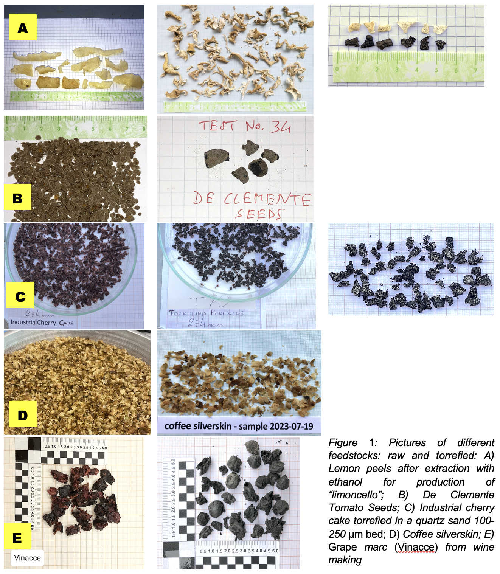

Coffee silverskin is the film wrapping the green coffee bean, which detaches from it upon heating during the roasting process and is separately collected. The research activities on this feedstock mostly concentrated on the recovery of bioactive compounds. For instance, Guglielmetti et al. (2017) conducted a comparative study between microwave and ultrasound technologies for extracting phenolic compounds and caffeine.

Despite being considered environmentally friendly, winemaking generates a substantial amount of waste materials, e.g., vine stems, grape pomace and wine lees (Maicas et al., 2020; Cascone et al., 2023). Grape pomace, which accounts for approximately 20 to 25% of the weight of grapes, is produced from white grapes before fermentation and from red grapes after fermentation (Monteiro et al., 2021; Muhlack et al., 2018). It contains a rich concentration of bioactive molecules, with around 70% of the grapes' phenolic compounds remaining in the pomace after winemaking (Cascone et al., 2023; Chiavaroli et al., 2021). Due to their proven antioxidant, anti-inflammatory and anti-aging properties, grape pomace-derived products hold great potential for incorporation into the human diet (Monteiro et al., 2021).

Almost all the above agri-food wastes become a source of valuable components through a suitable extraction process, although the mass yield is expected to be small and a costly drying pre-treatment appears necessary. On the other side, all of them deliver a spent solid residue that is worth of upcycling to a solid biofuel: this is investigated here for torrefaction.

* 1. Materials and Methods
     1. Feedstocks

The spent lemon peels were simply the residues of a lab extraction carried out in ethanol with the Soxhet apparatus for production of an experimental “limoncello”. After the test, they were dried by keeping them for more than 24 h under the lab fume hood (see Fig.1A). The resulting final equilibrium moisture was ~10% wt.

The tomato seeds were provided already separated from peels and dry (see Fig.1B) as a courtesy of the De Clemente company in Fisciano (Salerno, IT). Their moisture content was measured to be 1.84% wt.

Fresh cherry pomace was achieved from a company in the Salerno (IT) province in July 2023, following the extraction of juice from sweet cherries. The samples were promptly conveyed to the laboratory and frozen. Then, they were thawed and dried by keeping them for more than 24 h under the fume hood of the lab. The resulting final equilibrium moisture was in the range 6-9% wt. Finally, they were sieved to the prefixed size interval for the torrefaction tests, i.e., 2-4 mm (see Fig.1C).

The coffee silverskin was obtained from Area Science Park (Trieste, IT) in July 2023. Their “as received” moisture was in the range 3.8-5.2% wt. Before torrefaction, they were sieved to the 2-4 mm interval (see Fig.1D).

The grape pomace (*Vitis vinifera L*., Aglianico cultivar) was provided by the Mastroberardino winery in Atripalda (Avellino, IT) in October 2023; they were frozen on the same day as the wine was produced. They were thawed before use; then, they were dried by keeping them for more than 24 h under the fume hood of the lab; the resulting final equilibrium moisture was about 13.5% wt. Finally, they were used “as received” in torrefaction.

* + 1. Experimental technique

Torrefaction experiments were carried out in a lab-scale, nitrogen-fluidized bed apparatus consisting of a tubular steel column, 38 mm ID and 350 mm high, surrounded by an electric heating tape. For more details about the experimental apparatus and procedure please refer to Brachi et al. (2019).

Three different temperatures (i.e., 200, 250 and 300°C) were investigated while keeping constant the biomass residence time in the bed (5 min) under conditions of automatic temperature control.

The bed material was either quartz sand 100-250 µm or expanded clay 1000-1400 μm. The torrefaction tests were in *batch* mode with respect to biomass while keeping a biomass-to-inert mass ratio in the range 4-8%.

After the completion of each test, the torrefied particles were accurately separated from the inert solids by gentle sieving, weighed and safely stored for the subsequent characterization as solid fuels. This separation turned out straightforward in the case of quartz sand 100-250 µm because of the much lower size with respect to biomass (typically 2-4 mm). Vice versa, in the case of expanded clay 1000-1400 μm, some torrefied particles remained trapped within the size fraction of the inert solids (1-1.4 mm): in order to account for them and determine their mass, it was necessary to burn them in a lab muffle furnace.

The properties as a fuel of both raw and torrefied feedstocks were determined by means of proximate analysis (TGA 701 LECO thermogravimetric analyzer) and ultimate analysis (CHN 2000 LECO analyzer), hence, calculation of the Lower Heating Value (LHV) by means of the Channiwala and Parikh (2002) correlation. The results of these analyses, which were performed in triplicate at least, are not reported here for brevity.

* + 1. Equations of performance indexes

The performance of the torrefaction process is expressed through three well-known indexes.

The initial and final weights of the samples undergoing torrefaction allow for determining the mass yield MY with the equation (Brachi et al., 2019):

MY (%, db) = (mass of torrefied solids)/(mass of dry sample) $·$ 100 (1)

The knowledge of LHV values allows for determining the energy densification index IED and, hence, the energy yield EY with the equations (Brachi et al., 2019):

(2)

(3)

* 1. Results and Discussion
     1. Early tests and related issues

The Group I feedstocks were all torrefied in a bed of quartz sand 100-250 µm.

The tests with Lemon Peels and Tomato Seeds simply had a preliminary and exploratory character, basically just to assess the feasibility of fluidized bed torrefaction of such “new” feedstocks. Only two temperature levels were investigated (see Fig. 2). However, the general trends are those expected for the torrefaction performance indexes as a function of temperature (Chen et al., 2021; Brachi et al., 2019): when T is raised, MY decreases and IED increases, respectively, the first one because of the mass loss and the second one because such a loss just involves low-calorific organic compounds; quantitatively, this is explained by the fact that LHV is always referred to the unit mass of dry solids, for both raw materials and torrefied solids. The two opposite trends as a function of T do not perfectly compensate: therefore, EY decreases with T (see Fig. 2).

However, the tests with tomato seeds disclosed an undesired result, which is hard to be quantitatively determined in the performance indexes, but is documented in Fig. 1B. The contact of the fine quartz sand with the seeds undergoing torrefaction in the reactor resulted in the "capture" of numerous sand particles on the surface of the torrefied particles. This is to be considered as a "contamination", with evident and unwanted "loss of quality" as a torrefied product, i.e., as a solid biofuel.

|  |  |  |  |  |
| --- | --- | --- | --- | --- |
|   **A** |  | | |  |
| **B** |  | | |  |
| **C** | |  |  | |

*Figure* 2*: Performance indexes of different feedstocks as a function of temperature: bed material made of 100-250* μm *quartz sand: A) Lemon peels after extraction with ethanol for production of “limoncello”; B) De Clemente Tomato Seeds; C) Industrial cherry cake*

The same occurred with Lemon Peels to a minor extent and with Industrial Cherry Cake, as once more documented in Fig. 1C. In this latter case, such a "capture" is likely to be enhanced at the highest test temperature (T=300 °C): this is made evident in Fig. 2C for MY and IED. MY displays a non-monotonic pattern with an unexpected rise at T=300 °C, which is an anomalous trend; IED shows a decreasing trend, with a peak down at T=300 °C, which is contrary to expectation (Chen et al., 2021; Brachi et al., 2019).

* + 1. Effectual fluidized bed torrefaction

To overcome the above-discussed issue, the switch to another type of inert material for the bed was pursued, such as to gather the advantage of a much coarser inert particle size while maintaining the bed superficial fluidization velocity still at acceptable values to avoid particle elutriation. To achieve this goal, expanded clay in the size range of 1000-1400 μm and with a particle density of 1055.7 kg/m3 (lower than that of quartz sand: 2813.5 kg/m3) was adopted, which determined a minimum fluidization velocity of 30 cm/s at T=300 °C.

The torrefaction tests could run smoothly with such a new bed inert material at the fluidization number of 1.2 and the phenomenon of “bed particle capturing" disappeared, as documented in Fig. 1E.

The results of the Group II feedstocks are shown in Fig. 3. The torrefaction performance indexes follow the expected trends as a function of temperature (Chen et al., 2021; Brachi et al., 2019). Most of the experimental tests were carried out in duplicate and the standard deviation of the related results appears quite low (see the vertical bars on data points in Fig. 3).

It is noteworthy that IED turns out larger than 1 at whatever T for Industrial Cherry Cake and at T≳250 °C for Grape Marc. This means that the torrefied solids are more “energetic” than the raw materials, of course without considering the burden of the original moisture content in these latter, that is by referring to the unit mass on a dry basis. In turn, this determines high values of EY, which appear close enough to 100% at T= 200 °C, even at T= 250 °C in the case of Industrial Cherry Cake.

Coffee Silverskin appears to perform worse (see Fig. 2D). In particular, the IED values are quite small and, hence, determine low and almost constant values of EY as a function of T, despite appreciably good results for MY. The previous finding might be related to a different pattern of chemical decomposition during torrefaction, with a larger loss of “calorific” components from particles undergoing torrefaction to generate torgas. In any case, Coffee Silverskin particles, even though correctly torrefied, appear more problematic to be used as a solid biofuel because of their “leafy” shape, thin thickness and light weight. Vice versa, they should undergo further treatment after torrefaction, e.g., pelletization, to be upcycled to a standard-like solid fuel.

|  |  |  |
| --- | --- | --- |
| **C** |  |  |
| **D** |  |  |
| **E** |  |  |

*Figure* 3*: Performance indexes of different feedstocks as a function of temperature: bed material made of 1000-1400* μm *expanded clay: C) Industrial cherry cake;* D) *Coffee silverskin; E) Grape marc from winemaking*

* 1. Conclusions

An experimental program based on a comparative, lab-scale fluidized bed torrefaction of various agri-food residues, here referred to as Group I and Group II feedstocks, allowed to assess the feasibility of the torrefaction process in some cases, e.g., spent Lemon Peels after ethanol extraction for “limoncello” production, and to discriminate the best-performing feedstocks, i.e., Industrial Cherry Cake (after squeezing for juice) and Grape Marc (after pressing for winemaking). A change in the fluidized bed operating conditions, i.e., a switch from 100-250 µm quartz sand to 1000-1400 μm expanded clay as inert solids forming the bed, has been a decisive step in both ranking the performance of the feedstocks and producing torrefied solids of a better quality because free of “extraneous” inert particles.

The present paper, as a continuation of the authors’ previous work and in view of future activities, is a “piece” in a “mosaic composition” leading to a more thorough exploitation of the value chain of agri- and food residues. Therefore, the idea of a sequential investigation pattern will be pursued. As future work, while keeping the best performing raw feedstocks (i.e., Industrial Cherry Cake and Grape Marc) as a reference, the experimental torrefaction program will be continued on new samples of spent solid residues after recovery of bioactive compounds, e.g., an extraction treatment by means of a “green” solvent aided by pulsed electric fields (PEF) in a first stage and ultrasound (US) in a second stage, to boost the recovery yield.

References

Brachi P., Chirone R., Miccio M., Ruoppolo G., 2019, Fluidized bed torrefaction of biomass pellets: A comparison between oxidative and inert atmosphere. Powder Technology, 357, 97–107 <https://doi.org/10.1016/J.POWTEC.2019.08.058>

Casa M., Prizio C., Miccio M., 2021, Biodiesel Production from Tomato Seed by Transesterification with Alkaline and ‘green’ Catalysts: Simulation and Discussion, Chemical Engineering Transactions, 87,  451-456, DOI:10.3303/CET2187076

Cascone G., Crescente G., Petruzziello A., Bouymajane A., Volpe M. G., Russo G. L., Moccia S., 2023, A comparative study between MHG and UAE: chemical and biological characterization of polyphenol-enriched extracts from aglianico grape pomace. Foods, 12, 2678, DOI: 10.3390/foods12142678

Channiwala S. A. and Parikh P. P., 2002, A unified correlation for estimating HHV of solid, liquid and gaseous fuels. Fuel, 818), 1051–1063. <https://doi.org/10.1016/S0016-2361(01)00131-4>

Chen, W. H., Lin, B. J., Lin, Y. Y., Chu, Y. S., Ubando, A. T., Show, P. L., Ong, H. C., Chang, J. S., Ho, S. H., Culaba, A. B., Pétrissans, A., & Pétrissans, M., 2021, Progress in biomass torrefaction: Principles, applications and challenges. Progress in Energy and Combustion Science, 82, 100887. https://doi.org/10.1016/J.PECS.2020.100887

Chiavaroli A., Balaha M., Acquaviva A., Ferrante C., Cataldi A., Menghini L., Rapino M., Orlando G., Brunetti L., Leone S., Recinella L., di Giacomo V., 2021, Phenolic Characterization and Neuroprotective Properties of Grape Pomace Extracts. Molecules, 26(20), 6216.

Guglielmetti A., D'Ignoti V., Ghirardello D., Belviso S., Zeppa G., 2017, Optimisation of ultrasound and microwave-assisted extraction of caffeoylquinic acids and caffeine from coffee silverskin using response surface methodology, Italian Journal of Food Science, v.29(3), 409-423.

Maicas S. and Mateo J.J., 2020, Sustainability of wine production, Sustainability, 12(2), 559.

Miccio M., Casa M., Tauleigne B., Kostryukova N., Zainutdinova A., Fragranza M., Brachi P., Ferrari G., 2023, Valorization of roasted hazelnut cuticles supported by laboratory techniques, Detritus, 22, 41-48, DOI: 10.31025/2611-4135/2023.17256

Monteiro G.C., Minatel I.O., Junior A.P., Gomez-Gomez H.A., de Camargo J.P.C., Diamante M.S., Basílio L.S.P., Tecchio M.A., Lima G.P.P., 2021, Bioactive compounds and antioxidant capacity of grape pomace flours. LWT, 135, 110053.

Muhlack R.A., Potumarthi R., Jeffery D.W., 2018, Sustainable wineries through waste valorisation: A review of grape marc utilisation for value-added products. Waste Management, 72, 99–118.

Pataro G., Carullo D., Bobinaite R., Donsì G., Ferrari G., 2017, Improving the extraction yield of juice and bioactive compounds from sweet cherries and their by-products by pulsed electric fields. Chem. Eng. Trans. 57, 1717–1722. doi: 10.3303/CET1757287.

Rossini G., Toscano G., Duca D., Corinaldesi F., Foppa Pedretti E., Riva G., 2013, Analysis of the characteristics of the tomato manufacturing residues finalized to the energy recovery, Biomass and Bioenergy, 51, 177–182, <https://doi.org/10.1016/j.biombioe.2013.01.018>

Rrucaj E., Carpentieri S., Siano F., Ferrari G., Pataro G., 2023, Optimizing the solvent extraction process for high-value compounds from sweet cherry press cake treated with pulsed electric fields using response surface methodology, Front. Food. Sci. Technol., 3, 1273243. DOI: 10.3389/frfst.2023.1273243

Zainutdinova A.F., Kostryukova N.V., Miccio M., 2022, Извлечение Биоактивных Веществ Иззеленоголистового Покровафундукав Экстракторе cокслета (in Russian: Extraction of bioactive substances from the green leafy cover of hazelnuts in the Soxlet extractor), Molodezhnyj Vestnik UGATU (scientific journal of Ufa State Aviation Technical University), ISSN 2225-9309, 1(26), 96-99, <http://journal.ugatu.su/index.php/mvu/article/view/3337>