CHEMICAL ENGINEERING TRANSACTIONS  VOL. , 2024 | A publication of
The Italian Association
of Chemical Engineering
Online at www.cetjournal.it
Guest Editors: Leonardo Tognotti, Rubens Maciel Filho, Viatcheslav Kafarov
Copyright © 2024, AIDIC Servizi S.r.l.
ISBN 979-12-81206-09-0; ISSN 2283-9216
Investigation on Deposition of Oxide Support for Steam Reforming of Ethanol on a Microreactor
Vitória C. Poletti^{a*}, Bruna G. Floriamª, André L. Jardini Munhoz^{b}, Aulus R. R. Binelliª, Rubens Maciel Filhoª
ªVALPET, School of Chemical Engineering, Universidade Estadual de Campinas. R. Josiah Willard Gibbs, s/n, Cidade Universitária, Campinas, SP, Zip code 13417-780, Brazil
^{b}National Institute of S&T in Biomanufacturing, Av. Albert Einstein, 500, Cidade Universitária, Campinas, SP, Zip code 13083-852, Brazil
v238320@dac.unicamp.br
Numerous factors can influence the production of hydrogen by Ethanol Steam Reforming (ESR), including the homogeneity and distribution of the catalyst throughout the reaction area, as this directly affects the surface area and the catalytic sites. The aim of this work is to improve the deposition conditions of the catalytic support in a microchannel reactor in order to increase the available area for ESR. Thus, parameters such as the concentration of the support material and the concentration of the binding agent to prepare the suspension, as well as the particle size of the oxide precursor of the suspension were evaluated using a factorial design to determine the influence of these factors on the deposition thickness formed in the cross section of the microchannels of the reactor. The determination of the thickness was verified through images obtained by scanning electron microscopy and the deposition was verified by X-ray photoelectron spectroscopy. When statistically analyzing the results obtained, the factor relating to the particle size of the oxide precursor of the suspension for deposition was what generated statistical influence. Qualitatively, it was also possible to observe that the other parameters evaluated, support and binder concentration, obtained better viscosity and adhesion results at intermediate values. SEM analysis made it possible to analyze qualitatively and quantitatively (using ImageJ software) the increase in thickness and quality of the deposited layer. The XPS analysis ensured that the elements of the active and supporting phases of the catalyst were well impregnated during deposition. Therefore, the factorial design of the experiments made it possible to investigate the different effects of the independent variables to know the thickness of the deposited support.
- Introduction
Climate changes resulting from the inappropriate use of resources lead to an increase in concern for the environment and accelerate the search for efficient, low-cost, and environmentally friendly energy alternatives that can replace the use of fossil fuels (Paramati et al., 2022). In this scenario, hydrogen has been the subject of great interest (RENSSEN, 2020), since this energy vector has several advantages such as high energy density and wide availability, as it is the most present element on the planet. Its calorific value is 140.4 MJ/kg, which is around 4 times higher than that of hydrocarbon fuels such as coal and gasoline, demonstrating its high energy potential (Xu et al., 2022).
Hydrogen is obtained through various resources and technologies (Veras et al., 2017). Currently, the most widely used method is fossil fuel cracking being an economical production route for industrial use. It is estimated that 600 billion Nm³ of hydrogen is produced annually worldwide, therefore the economic factor that makes this production viable cannot be dismissed (Dawood et al., 2020). However, it is important to obtain clean and sustainable hydrogen through renewable sources that combine the high performance of hydrogen, environmental well-being and competitiveness in the market.
Ethanol Steam Reforming (ESR) is an attractive option with great potential that can be explored among numerous possibilities. Ethanol is a renewable biofuel that is easily transportable and non-toxic, and in some countries where it is used as fuel, it is already available in many places. Moreover, it reduces the carbon dioxide emitted during the biomass cultivation process (Maciel et al, 2016). The ethanol steam reforming reaction is given by the reaction Eq(1):
C₂H₅OH_{(g)} +3H₂0 _{(g)} → 6H₂ _{(g)} + 2CO₂ _{(g)} 𝛥𝐻 = +173.300 𝐽/𝑚𝑜l | (1)
This work aimed to investigate catalytic ESR in a microchannel reactor by identifying the factors that affect the
deposition of the catalyst layer on the surfaces of the microchannels since the thickness of the catalytic layer is a crucial factor that needs to be controlled to prevent significant internal diffusion limitations and ensure good accessibility for the reactants to the active sites (Laguna et al., 2016). The use of oxide suspensions can be optimized to achieve homogeneity and adhesion during deposition (Balzarotti et al., 2015).
The importance of this work lies in the objective of achieving a homogeneous coating with the catalyst and adequate adhesion in the interiors of the microchannels, in order to increase the efficiency of the reaction for
the production of hydrogen by enabling the active sites for the reforming reactions to take place.
2. Methodology
For this research, 316L stainless steel samples measuring 4 mm x 4 mm x 13 mm were utilized to examine the impact of various factors on the thickness and uniformity of a deposited layer of catalytic suspensions. The samples were printed using the EOSINT Rapid Prototyping system via laser sintering (LDMS) and cleaned with a 10% v.v. nitric acid solution. Cerium (IV) oxide (from Nanum) suspensions were deposited on the samples using the washcoating method for the support materials, followed by wet impregnation for the active phase. The experimental procedures carried out in this work were developed by Bineli (2013). CeO₂ was used as catalyst support on the walls of the microchannels.
In order to perform the experiments, a 2³ face centred factorial design was carried out to verify the influence of the factors in obtaining a catalytic support suspension, namely: the concentration of polyvinyl alcohol (PVA) in the suspension (%wt), the concentration of the support material (%wt) and the average particle size of the support oxide (μm). In this design, as shown in Table 1, the levels that were used for each variable and the results for each experiment were evaluated to identify the impact of each experimental condition on deposition.

Table 1: Variables in the statistical design of the 2³ - face central composite factorial design centred.
 | Support particle size (μm) | Support (%wt) | PVA (%wt)
Low level (-1) | 1 | 10 | 2
Central point (0) | 2 | 15 | 6
High level (+1) | 5 | 20 | 10

To carry out the washcoating method, catalytic suspensions containing cerium (IV) oxide, deionized water, and polyvinyl alcohol (PVA) binder were prepared according to the factorial design of experiments. The plates were dried at room temperature 25 ºC for 2 h and calcined for 4 h at 600 ºC in a muffle furnace. The microchannels were filled with a solution of the catalyst's active phase, containing a nickel metal precursor. Finally, the samples were calcined again for 4 h at 600 °C.
The determination of the deposition thickness was verified through images obtained by Scanning Electron Microscopy (SEM), model Leo 440i, applying an accelerating voltage of 15 kV and a beam current equal to 250 pA, with the help of ImageJ software to take measurements of the deposited layer in the cross-section of the microchannels.
The second stage of analysis was carried out by analyzing the samples using XPS K-alpha, a technique that makes it possible to quantitatively identify the chemical elements present in the walls of steel samples, as well as their oxidation states, with high precision on nanometer scales.
3. Results and discussion
Sixteen experiments were conducted by combining three independent variables - support concentration (%wt), PVA concentration (%wt), and average support particle size (μm) at three levels (high, center point, and low). The uniformity, thickness, and actual deposition of the desired material were analyzed in each experiment to determine which factors had the greatest influence on the deposition of the catalytic layer.
The images of the deposition, observed in Figure 1, showed a significant improvement in the quality of the deposition of the catalytic solution on the wall of the microchannels when compared to deposition without the use of the factorial design of experiments. In both cases the Horizontal Field Width (HFV) used was 700 $μ$m and the High Voltage (HV) was 15.00 kV. In the case of the image before factorial planning the Working Distance (WD) around 10 mm to improve visualisation of the layer.

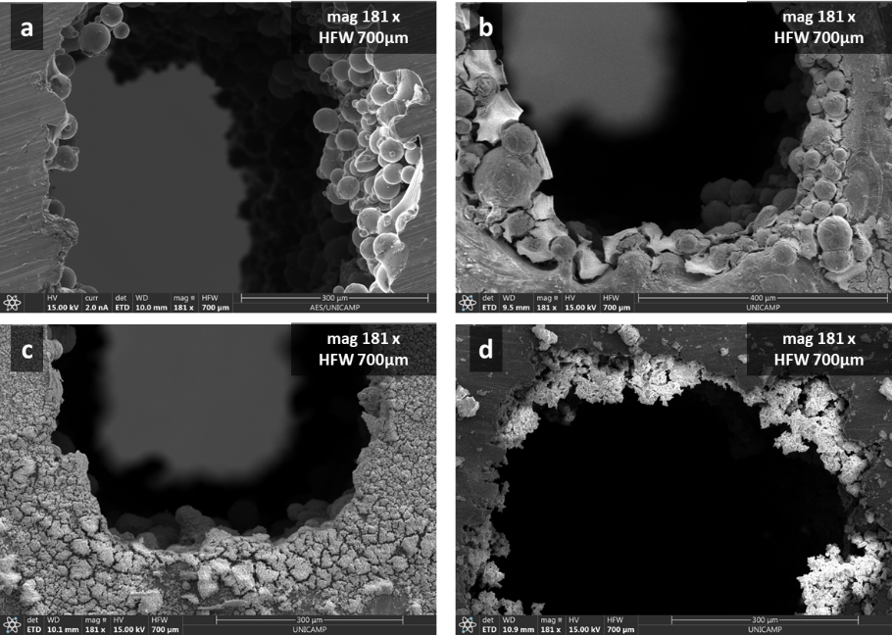
Figure 1: Images obtained by SEM analysis of the deposition on the microchannels considering (a) the initial test with irregular oxide particles of an average size of 150 um, with an oxide concentration of 10%wt. and a PVA concentration of 6%wt; (b) the condition with oxide particles of an average size of 1 um, with an oxide concentration of 20%wt. and a PVA concentration of 10%wt; (c) the condition with oxide particles of an average size of 1 um, with an oxide concentration of 20%wt. and a PVA concentration of 10%wt. and a PVA concentration of 10%wt; (c) condition with oxide particles of an average size of 1, with an oxide concentration of 15%wt. and a PVA concentration of 6%wt and (d) condition with oxide particles of an average size of 1, with an oxide concentration of 15%wt. and a PVA concentration of 10%wt.

Observing the images qualitatively, it is possible to see that for the experiment with the best conditions, a more uniform and thicker layer was obtained, while in the image before the design only the porosity of the material covered with a small and irregular layer of catalyst was seen. It means that in experimental conditions that were not as favorable for deposition, a less thick and less regular layer was formed. As a quantitative analysis, ImageJ software was used to quantify the deposition area by measuring the thickness of the support deposition. It showed that there was an improvement in the thickness of the deposition layer of approximately 8 times, reaching a maximum of 74μm. It was also possible to notice a more uniform distribution of the support between the pores of the microchannel material.
The second stage of analysis was carried out by analyzing the samples using XPS K-alpha, it shows that the depositions took place satisfactorily, with all the surfaces in the experiments showing the presence of the metals present in the stainless steel (316 L), such as carbon, manganese, chromium, phosphorus and molybdenum, as well as the metals present in the support and active phases of the catalyst, as expected, Cerium, coming from CeO₂, and Nickel, from the active phase. This was important to confirm the safety of the deposition, in addition to a regular and thick layer, the deposition guaranteed a good impregnation of the catalyst elements.
The CASA XPS software was used to process the images of the spectra obtained, as shown in Figure 2, and quantify the chemical species and their respective oxidative states, as summarized in Table 2. As expected, a large part of the deposition was composed of oxygen (58.71%), due to oxidation that occurred in the calcination process. The second element in greatest quantity is nickel (11.79% adding the oxidation states) from the active phase.

Figure 2: XPS survey scan of the samples in the CASA XPS software.

Table 2: XPS survey scan and quantification
 |  | C 1s | Ce 3d | Cr 2p | Fe 2p | Mn 2p | N 1s | Ni 2p | O 1s | Zr 3p
Atomic Concentration [%] |  | 9.17 | 3.22 | 0.88 | 8.45 | 2.62 | 1.10 | 10.69 | 58.71 | 5.16
Binding Energy [eV] |  | 285.0 | 899.5 | 576.5 | 711.0 | 642.0 | 399.0 | 855.5 | 530.5 | 333.5

Regarding the factorial design of experiments, it was found that the main factor contributing to the deposition of the catalytic suspension on the surface of the sample plate is the average size of the support oxide particle. This conclusion was reached by constructing and analyzing a Pareto Diagram, which evaluates the significance of experimental factors' interactions, as shown in Figure 3. Particle size is the only parameter with a factor p-value < 0.05, meaning that it has statistical significance greater than 95%. Therefore, it can be said that particle size is the only significant factor for improving the catalytic solution. The study showed that the size of the oxide particle and the deposition thickness are inversely proportional, this means that if particle size decreases the thickness of the deposited support increases. This suggests that the independent factor influences the result statistically and needs to be considered while making predictions.

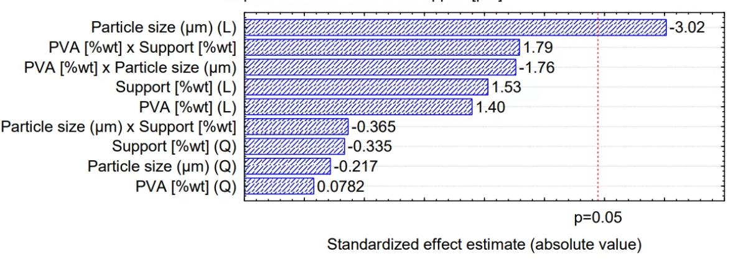
Figure 3: Pareto diagram of the factorial design of experiments carried out, showing that the only statistically relevant factor, with a p-value of less than 0.05, is the size of the support particle.

Thus, Figure 4a displays SEM images of oxide particles that served as support before being treated in a vibrating mill for 24 hours to reduce their diameter. The particles had an average size of 150 μm and an irregular morphology before the treatment. After the treatment, Figure 4b, the average particle size decreased to 1 μm, and their morphology became more uniform, resulting in the formation of spherical particles. An enhanced performance and durability of coated components are affected by the reduction of the oxide particles, which leads to uniform, adherent, and well-controlled oxide deposition in the channel walls.
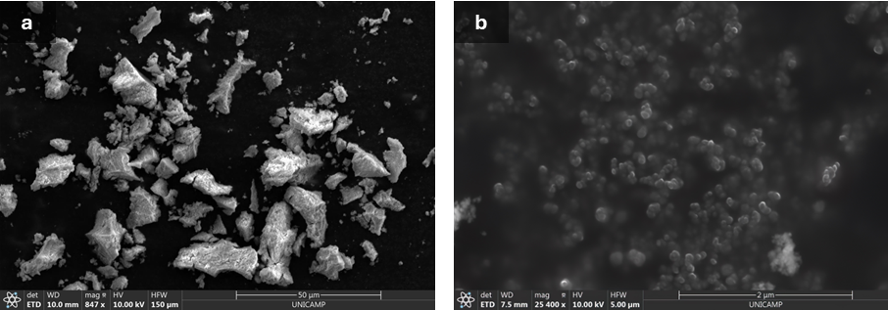
Figure 4: Comparison of morphology and particle size before treatment of the support oxide, on a scale of 50 μm, (a) and after 24 hours in the vibrating mill, on a scale of 2 μm (b).

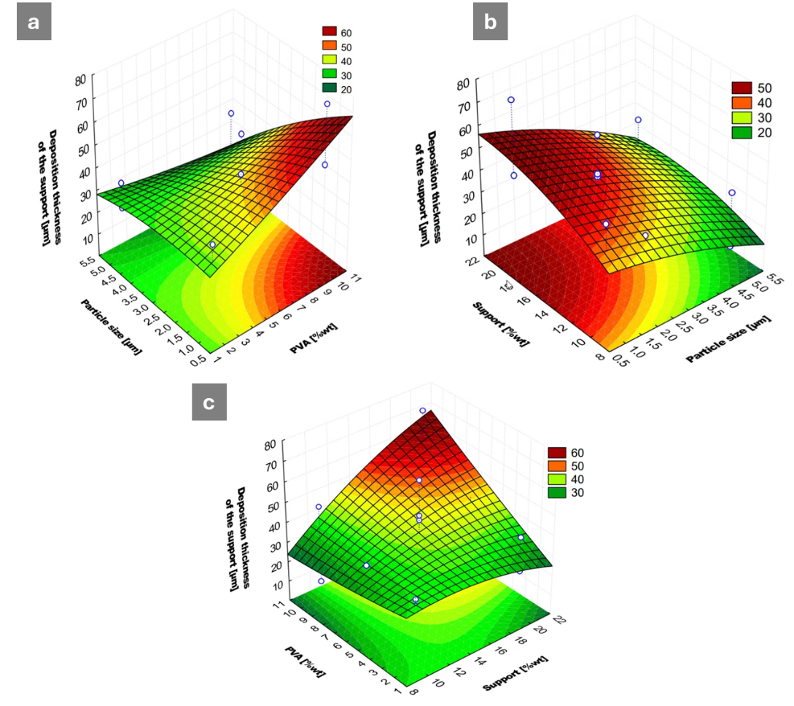
Figure 5: Deposition graph varying with the amount of PVA (wt%) and the size of the support particles (μm) (a); Deposition graph varying with the amount of support (wt%) and the size of the particles (μm) (b); Deposition graph varying with the amount of PVA (wt%) and support (wt%) (c).

The relationship between the three variables studied was analyzed using three graphs correlating deposition thickness, particle size, and the concentrations of PVA and support oxide, as shown in Figure 5. In all cases a curved response surface was obtained, showing that the relationship between the factors is non-linear and can be optimized. Looking at Figure 5a, the maximum point is close to the region with the highest concentration of PVA and the smallest particle size. As in Figure 5b, the same response can be seen for particle size and support concentration. These confirmed that the best depositions occur at the minimum values of average particle diameters. In Figure 5c, the relationship between the concentrations of PVA and support is shown, a maximum can be seen near the upper limit of the analysis. It is worth highlighting that enhancing certain factors may have adverse effects on other characteristics, such as the viscosity and wettability of the catalytic suspension. Nonetheless, as the concentration of support and PVA did not yield a statistically significant outcome with a p-value of less than 0.05, a qualitative assessment indicates that average values of 6%wt. of PVA and 15%wt. of CeO₂ can lead to an enhancement in viscosity and wettability.
4. Conclusions
This study utilized a factorial design to effectively analyse how independent variables impact the thickness of the support layer deposited within microchannels. Particle size was found to have the greatest impact on deposition thickness, while PVA concentration and support concentration played a less significant role. However, our qualitative observations highlighted the importance of optimal PVA and support concentration levels, as they can enhance viscosity and wettability, providing additional benefits beyond just deposition thickness. Our results showed that by using a particle size of around 1 μm, along with a PVA concentration of 6%wt. and a support concentration of 15%wt., a deposition thickness of approximately 70 μm on microchannel walls could be achieved. This optimized parameter combination provides valuable insights for improving support deposition processes and resulted in an eightfold increase in deposition thickness. To further characterize the depositions, we employed scanning electron microscopy (SEM) with an energy dispersive X-ray analyser and X-ray photoelectron spectroscopy (XPS). The presence of anticipated elements, including cerium from the support phase, nickel from the active phase, and the inherent constituents of the 316 L stainless steel substrate, confirmed the successful deposition of the support layer. Overall, our approach, which included factorial experimentation and thorough characterization techniques, validated the effectiveness and compositional integrity of the deposited layers within the microchannels. These findings offer valuable insights for improving support deposition processes in microchannel applications.
Acknowledgments
The authors gratefully acknowledge the support from FAPESP (the Sao Paulo Research Foundation, Project Number 2022/10644-1, Grant Numbers 2021/08940-9, 2022/02016-0 and 2023/14455-1), and to Vesta Greentech.
Nomenclature
ESR - ethanol steam reforming
EDS - energy dispersive X-ray spectroscopy
PVA - polyvinyl alcohol
SEM – scanning electron microscopy
XPS K-alpha - X-ray photoelectron spectroscopy
Wt. - weight
HFV - horizontal field width HV - high voltage
WD - working distance

References
Bineli A., 2013, Projeto, fabricação e teste de um microrreator catalítico para produção de hidrogênio a partir da reforma a vapor do etanol. PhD Thesis, Faculdade de Engenharia Química da Universidade Estadual de Campinas, Campinas, Brazil.
Balzarotti R., Ciurlia M., Cristiani C., Paparella F., Pelosato R., 2015, Low Surface Area Cerium Oxide Thin Film Deposition on Ceramic Honeycomb Monoliths, Chemical Engineering Transactions, 43, 1747-1752.
Dawood F., Anda M., Shafiullah G. M., 2020, Hydrogen production for energy: An overview. College of Science, Health, Engineering and Education, 45, 7, 3847-3869.
Laguna O.H., Domínguez M.I., Centeno M.A., Odriozola J.A., 2016, Catalysts on Metallic Surfaces: Monoliths and Microreactors, Chapter In: V. I. Parvulescu, E. Kemnitz (Ed.), New Materials for Catalytic Applications, Elsevier, 81-120.
Maciel, R.F., Bineli, A.R.R., Tasic, M. B., 2016, Catalytic steam reforming of ethanol for hydrogen production: Brief status. Association of the Chemical Engineers of Serbia, AChE. 22, 327-332.
Paramati, S. R., Shahzad, U., Dogan, B., 2022, The role of environmental technology for energy demand and energy efficiency: Evidence from OECD countries. Renewable and Sustainable Energy Reviews, 153, 111735.
Veras, T., Mozer, T. S., Dos Santos, D. C. R. M.; Cesar, A. S., 2017, Hydrogen: Trends, production, and characterization of the main process worldwide, International Journal of Hydrogen Energy, 42, 4, 2018-2033.
Xu X., Quan Z., Yub D., Zhoua Q., 2022, The future of hydrogen energy: Bio-hydrogen production technology. International Journal of Hydrogen Energy. 47, 79, 33677-33698.

