CHEMICAL ENGINEERINGTRANSACTIONS  VOL.,2024 | A publication of
The Italian Association
of Chemical Engineering
Online at www.cetjournal.it

Guest Editors:Leonardo Tognotti, Rubens Maciel Filho, Viatcheslav Kafarov
Copyright © 2024, AIDIC ServiziS.r.l.
ISBN979-12-81206-09-0;ISSN 2283-9216

Evaluation of the Impact of Catalyst Composition on Ethanol Steam Reforming in a Microchannel Reactor
Bruna G. Floriam^{a,}*, Vitória C. Polettiª, André L. Jardini Munhoz^{b}, Aulus R. R. Binelliª, Rubens Maciel Filhoª
ªVALPET, School of Chemical Engineering, Universidade Estadual de Campinas. R. Josiah Willard Gibbs, s/n, Cidade Universitária, Campinas, SP, Zip code 13417-780, Brazil
^{b}National Institute of S&T in Biomanufacturing, Av. Albert Einstein, 500, Cidade Universitária, Campinas, SP, Zip code 13083-852, Brazil
brunna.gfl@gmail.com, b219361@dac.unicamp.br
Hydrogen has the potential for storing and supplying clean energy in various sectors, but the method of obtaining hydrogen needs to be sustainable. Currently, most of the hydrogen is produced by reforming fossil fuels, with only a small portion coming from water electrolysis. However, there is an alternative method called ethanol steam reforming (ESR) that has a lot of potential and should be explored further. To make progress in this area, studies focused on process optimization are necessary to improve the efficiency of the ESR process. To this end, this investigation aims to analyse the influence of catalytic composition and temperature on hydrogen production for mobility applications, evaluating the responses of hydrogen productivity and selectivity, ethanol conversion, and reaction yield in a microchannel reactor. The results showed that the main statistical factor influencing the responses was temperature and the relevance of the response to the composition of the catalytic support and the relationship between temperature and catalytic support. The use of bimetallic active phases capable of having a positive effect on the water-gas shift reaction favours the ethanol conversion and thus provides positive results.This study suggests that to enhance onboard hydrogen production and reduce coke formation in a microchannel reactor, a catalyst consisting of ceria/zirconia support and Ni-Co active phase should be used at 700°C for steam reforming.
  - Introduction
Hydrogen is a convenient solution to the challenges of the current energy transition towards a more sustainable and carbon-neutral future, seeking alternatives to the use of fossil fuels. It has remarkable potential for storing and supplying clean energy, and its versatility extends across various sectors, from transportation and industrial applications to electricity generation and energy storage. However, the method of obtaining hydrogen is of utmost importance to deliver truly clean energy in a sustainable way. Currently, most of the hydrogen is obtained by reforming fossil fuels and some small parcel from water electrolysis (IEA, 2023). Considering the increasing demand for sustainable and renewable energy sources, ethanol steam reforming (ESR) has emerged as a promising alternative with a lot of potential to be explored. Catalytic steam reforming is a process that involves the reaction of ethanol with water vapor in the presence of a catalyst. This reaction produces hydrogen and carbon dioxide, which is represented by Eq(1). Different catalysts can be used to obtain various routes, leading to different by-products being produced. Each route has its benefits and challenges, which can be adjusted to meet specific operational requirements and resource availability. This contributes to the development of sustainable hydrogen production processes. Therefore, selecting the appropriate catalyst, synthesis method, and reaction operating conditions is a critical step (Rosha et al., 2023).
C₂H₅OH_{(g)} + H₂O ⇌ 2CO_{(g)} + 4H₂(_{g)} 𝛥𝐻 = 174 kJ/mol | (1)
There are two categories of metals that are utilized for ethanol steam reforming, namely noble metals and non-noble metals. To select more affordable and easily accessible materials, Ni, Cu, and Co-based materials have been found to exhibit promising yield and conversion outcomes(Deng et al., 2023). The study focused on the analysis of nickel-based catalysts which are known for their high yields, stability, and ability to cleavage the C-C bond in the ethanol molecule (Rosha et al., 2023). However, these catalysts have a drawback as they tend to promote coke formation, which results in a significant reduction in catalytic activity over time. To overcome this issue, bimetallic-based catalysts were explored, as they have an advantage over their single-metal counterparts in terms of activity (Bshish, 2010, Rosha et al., 2023).
Another important factor to consider is the design of the reactor, which is directly linked to its final application. Microstructured reactors with high surface area-to-volume ratios offer many advantages, including safety and scalability(Verdnik et al., 2022), making them advantageous for on-board production, particularly noted for hydrogen production in transportation.
Asthe final objective is to have high hydrogen production and yield, with low coke formation for mobility applications, catalysts composition and operating conditions that promote the reactions of ethanol dehydration and acetaldehyde decomposition, which lead to the formation of ethylene and methane respectively, and consequently coke formation, should be avoided (Liu et al., 2019). Therefore, this study helps to understand the influence of the factors reaction temperature and catalytic composition on the results of yield, selectivity, and hydrogen productivity, as well as ethanol conversion, unifying the desirability of all these dependent variables in a desirability function to select the best conditions for carrying out ethanol steam reforming in a microchannel reactor.
  - Methodology
Microchannel reactors were produced by direct laser metal sintering (DLMS) 316L stainless steel and deposited with oxide catalytic support, as well as wet impregnation of the active phase following the methodology proposed by Bineli (2013). The compositions evaluated included three different catalytic support compositions (CeO₂, Al₂O₃, CeO₂/ZrO₂) and three different active phase compositions (Ni, Ni-Cu, Ni-Co), in an attempt to evaluate the influence of bimetallic catalysts, while the reaction temperature was also evaluated at three different levels (600, 650 and 700°C). The study comprised afactorial design experiment of three distinct factors, among which two were qualitative variables (support material and active phase metal), and one was a quantitative variable (reaction temperature). It focused on the 2x2 case studies, systematically examining all possible combinations of the two qualitative variables, as outlined in Table 1.The products formed in the reactions were analyzed by gas chromatography using Agilent 7890A equipment equipped with Flame Ionization Detector (FID) and Thermal Conductivity Detector (TCD) to determine the components formed.
Table 1: Factorial Design of Experiments evaluating the influence of temperature, support, and active phase composition.
Fators | Temperature (1) (°C) | Support (2) | Active Phase (3)
Case 1 | 600-700 | CeO₂ – CeO₂/ZrO₂ | Ni – Ni/Cu
Case 2 | 600-700 | CeO₂ – CeO₂/ZrO₂ | Ni – Ni/Co
Case 3 | 600-700 | CeO₂ – Al₂O₃ | Ni – Ni/Cu
Case 4 | 600-700 | CeO₂ – Al₂O₃ | Ni – Ni/Co
Case 5 | 600-700 | CeO₂/ZrO₂– Al₂O₃ | Ni – Ni/Cu
Case 6 | 600-700 | CeO₂/ZrO₂– Al₂O₃ | Ni – Ni/Co

The results from the gas chromatography analyses were used to determine the conversion of ethanol, selectivity, yield, and productivity of the reaction using Eq (2), (3) and (4) respectively.

$$\% Coversion=100 x\frac{mol ethanol inlet-mol ethanol outlet}{mol ethanol inlet}$$ | (2)
$${Selectivity}_{H_{2}}=\frac{molH_{2}outlet}{\sum{molsubproductsoutlet}}$$ | (3)
$$\% Yield=100x\frac{mol H_{2} outlet}{mol ethanol inlet}$$ | (4)
$$Productivity=H_{2} molar fraction_{outlet} x molar flow rate_{outlet}$$ | (5)
Based on the calculations, the influence of temperature, support material, and the use of bimetallic catalyst on independent variables was analyzed statistically. Pareto charts were used to determine the statistical relevance of each case. The charts helped to identify the most significant factors in a set of variables, when associated with the p-value < 0.05, it means that it has statistical significance greater than 95%. In hypothesis testing, researchers establish a null hypothesis, usually stating that there is no effect or difference, and an alternative hypothesis.
Finally, predictions were made, and the desirability function was calculated for each case using Statisticasoftware, version 7.0 (Statsoft.Inc., 2004). The desirability function assigns a value between 0 and 1 to each response, where 0 indicates an undesirable outcome, 1 indicates a highly desirable outcome, and intermediate values represent intermediate desirability. Overall desirability is often calculated as a product or average of these individual desirability. These functions play a key role in multi-criteria decision making and optimization in various fields (Costa et al., 2011).
  - Results and discussion
The study revealed that temperature played a crucial role in determining the responses with a 95% level of confidence. The influence of each factor on the yield of hydrogen production and ethanol conversion can be seen in Figure 1 for each case. It was observed that temperature had a linear and directly proportional relationship with all the cases, indicating that higher temperatures led to better outcomes.
The catalytic response is dependent on the composition of its support. The correlation between temperature and catalytic support was also established, indicating that the temperature had a direct impact on the catalytic support and its efficiency. Indeed, temperature plays a crucial role in influencing this reaction, as it directly impacts the reaction kinetics and thermodynamics (Vasudeva et al., 1996). The reaction is endothermic, meaning it absorbs heat from the surroundings. As the temperature increases, the reaction rate accelerates due to the increased kinetic energy of the molecules, leading to more collisions and successful reactions between the reactants. Additionally, higher temperatures can thermodynamically favour the production of hydrogen. Therefore, maintaining an appropriate temperature is essential for achieving efficient ethanol steam reforming, balancing the need for a favourable reaction rate with the stability of the catalyst and selectivity towards the desired products.
Analyzing the predictions and desirability functions as depicted in Figure 2, it has been determined that selecting a reaction temperature at the highest limit of 700 °C is the most optimal choice in all cases. Additionally, it is advisable to opt for a catalytic support that consists of a 50/50 wt.% mixture of CeO₂ and ZrO₂ as the primary preference, followed by the CeO₂ support. It is justifiable to choose ceria/zirconia-supported catalysts over alumina support because they offer more alkali active sites, which are essential for the reaction to take place efficiently, while the Al₂O₃ support provides acidic active sites that promote the dehydration of ethanol, which leads to polymerization and coke formation (Llorca et al., 2002). Moreover, the addition of zirconia to the support enhances the catalyst's stability, resulting in better performance and contributes to minimizing coke formation, due to the enhanced oxygen mobility in this solid solution that oxidizes carbon residues (Llorca et al., 2013), ensuring a more efficient process. In this study, among the supports investigated, ceria and ceria/zirconia are effective in producing desirable results for the dependent variables when combined with the Ni active phase, demonstrating their applicability to microchannel reactors for ERS. Although all the comparisons result in a desirability function with a maximum selected between 0.915 and 0.844, i.e. close to 1, by comparing each case, the ceria-zirconia support prevails over the others, Figures 2b, 2e, and 2f, except in case 1, Figure 2a, where the ceria and ceria-zirconia support has similar desirability.
The desirability of bimetallic catalysts was also favored due to their better performance as shown in all the cases. This was due to its ability to favor the gas-water shift reaction, producing more favorable outcomes. The addition of another metal also helps in preventing Ni sintering, which is the agglomeration of nickel particles, thereby maintaining the catalytic surface area. Secondly, the electronic and structural properties of the bimetallic catalysts are conducive to better adsorption and activation of ethanol molecules, facilitating the desired reaction pathways leading to enhanced hydrogen production.
Observing Figure 3, coke deposition is noticeable on the reactor surface post-reforming reactions. Using ImageJ software (Schneider et al., 2012), the sections showcasing coke deposition are highlighted in red, as displayed in the figures. The use of a bimetallic active phase decreased in coke formation, as seen in Figures 3c and 3d. Examining the bimetallic composition, it is possible to note that the reactor with Ni-Co catalyst (Figure 3d) has significantly less coke deposition than the reactor with Ni-Cu catalyst (Figure 3c).While the desirability function values remain similar for the Ni-Cu and Ni-Co active phases, the qualitative evaluation of coke formation suggests the selection of the bimetallic active phase containing cobalt.
Based on the findings of this study, the conditions for enhancing ethanol conversion and maximizing hydrogen yield, productivity, and selectivity in a microchannel reactor while minimizing coke formation involve utilizing a catalyst comprised of a ceria/zirconia support and a Ni-Co active phase and at a temperature of 700°C for the steam reforming reaction.This composition seems to be effective in facilitating the desired chemical reactions and reducing undesirable by-products, thus presenting a favorable option for ethanol-to-hydrogen conversion procedures in microchannel reactors.
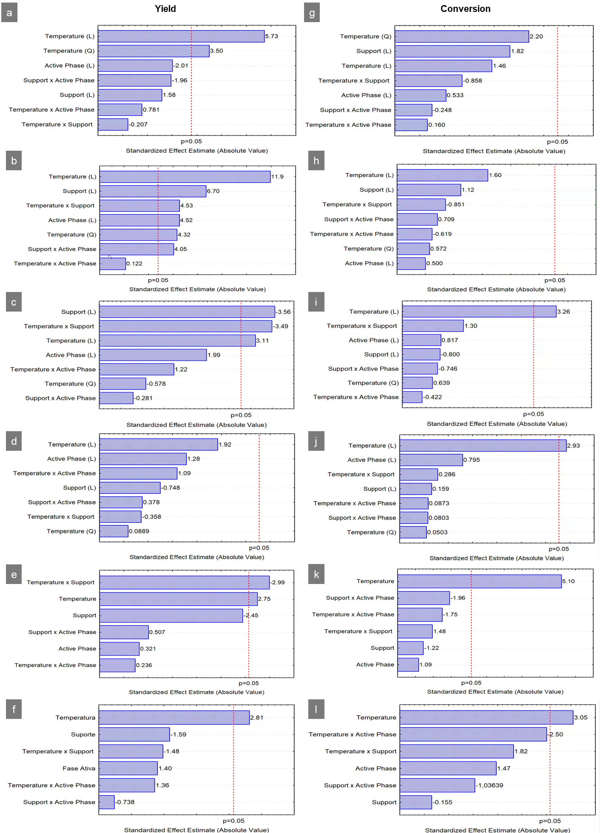
Figure 1: Pareto chart evaluating the influence of temperature, support composition and active phase composition on reaction yield (a) in case 1; (b) in case 2; (c) in case 3; (d) in case 4; (e) in case 5; (f) in case 6; and ethanol conversion (g) in case 1; (h) in case 2; (i) in case 3; (j) in case 4; (k) in case 5; (l) in case 6.
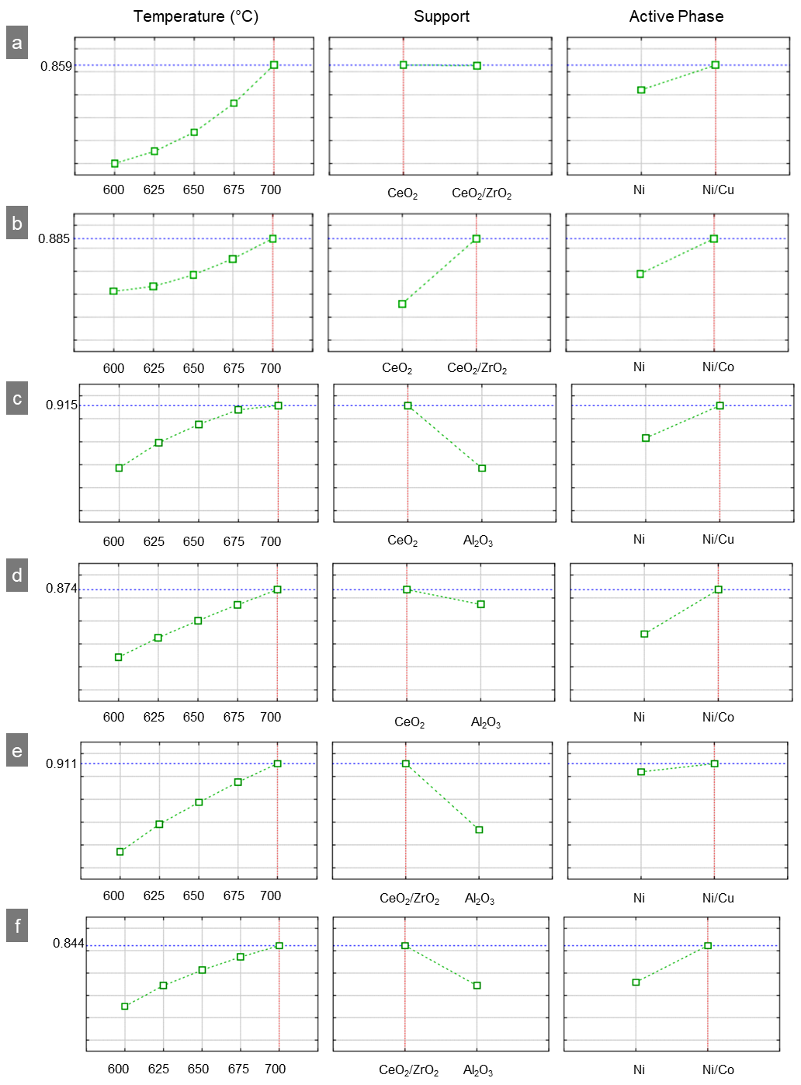
Figure 2: Desirability function for hydrogen production considering the parameters of temperature, support composition and active phase composition in the reaction yield (a) in case 1; (b) in case 2; (c) in case 3; (d) in case 4; (e) in case 5; (f) in case 6.
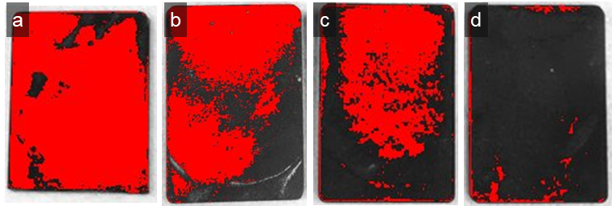
Figure 3:Surface deposition of coke in the microchannel reactor after the reforming reaction (a) reactor without catalyst; (b) reactor with Ni active phase catalyst; (c) reactor with Ni-Cu active phase catalyst; (d) reactor with Ni-Co active phase catalyst.
  - Conclusions
The results obtained in this study contribute to a greater understanding of the relationship between the variables in the procedure and the results obtained, both in terms of deposition and the effectiveness of the steam reforming reaction in microchannel reactors. Temperature has an important role in the process of ESR, demonstrating a direct relationship between temperature and outcomes. Higher temperatures led to better results, impacting hydrogen production and ethanol conversion.
The research also underscores the importance of the composition of catalytic support, finding that catalysts supported by CeO₂ and ZrO₂ are preferable over those supported by Al₂O₃ due to their alkali active sites and improved stability, ultimately minimizing coke formation. According to desirability analysis, the optimal choices for ESR are a reaction temperature of 700°C and a 50/50 wt.% mixture of CeO₂ and ZrO₂ as the primary catalytic support.
The study also explores bimetallic catalysts, with a preference for Ni-Co over Ni-Cu due to their reduced coke formation, and better gas-water shift reaction. Therefore, a ceria/zirconia and Ni-Co active phase catalyst at 700°C for ethanol steam reforming is the selected condition to enhance hydrogen production while minimizing coke formation in a microchannel reactor.
Recognizing these nuanced aspects provides valuable insights for future research, highlighting the importance of thoroughly evaluating stability under chosen conditions to ensure long-term efficiency in the steam reforming of ethanol.

Nomenclature
DLMS – Direct laser metal sintering
ESR – Ethanol steam reforming
FID – Flame Ionization Detector
TCD – Thermal Conductivity Detector
wt. – Weight
Acknowledgments
The authors gratefully acknowledge the support from FAPESP (the Sao Paulo Research Foundation, Project Number 2022/10644-1, Grant Numbers 2021/08940-9, 2022/02016-0 and 2023/14455-1), and to Vesta Greentech.
References
Bineli A., 2013, Design, Manufacture and Testing of a Catalytic Microreactor for Hydrogen Production from Ethanol Steam Reforming. PhD Thesis, Faculdade de Engenharia Química da Universidade Estadual de Campinas, Campinas, SP, Brazil.
Bshish A., Yakoob Z., Narayanan B., Ramakrishnan R., Ebshish A., 2010, Steam-reforming of Ethanol for Hydrogen Production, Chemical Papers, 65, 251–266.
Costa N. R., Lourenço J., Pereira Z.L., 2011, Desirability Function Approach: A Review and Performance Evaluation in Adverse Conditions, Chemometrics and Intelligent Laboratory Systems, 107, 234-244.
Deng Y., Li S., Apples L., Zhang H., Sweygers N., Baeyens J, Dewil R.., 2023, Steam reforming of ethanol by non-noble metal catalysts, Renewable and Sustainable Energy Reviews, 175, 113184.
IEA, 2023, Global Hydrogen Review 2023, IEA, Paris https://www.iea.org/reports/global-hydrogen-review-2023, License: CC BY 4.0
Llorca J.,Homs N., Sales J., Ramirez de la Piscina, 2002, Efficient Production of Hydrogen over Supported Cobalt Catalysts from Ethanol Steam Reforming, Journal of Catalysis, 209, 306–317.
Llorca J., Corbera V. C., Divins N. J., Fraile R. O., Taboada E., 2013, Hydrogen from Bioethanol, Chapter In: Gandia L. M., Arzamedi G., Dieguez P. M. (Ed.), Renewable Hydrogen Technologies: Production, Purification, Storage, Applications and Safety, Elsevier Science and Technology, 135-169.
Rosha P., Ali F. M., Ibrahim H., 2023, Recent advances in hydrogen production through catalytic steam reforming of ethanol: Advances in catalytic design,The Canadian Journal of Chemical Engineering, 101, 10, 5441–6044.
Schneider, C. A., Rasband, W. S., Eliceiri, K. W., 2012, NIH Image to ImageJ: 25 years of image analysis, Nature Methods, 9, 671–675.
StatSoft Inc., 2004, STATISTICA (Data Analysis Software System), Version 7.
Vasudeva K., Mitra N., Umasankar P., Dhingra S. C., 1996, Steam Reforming of Ethanol for Hydrogen Production: Thermodynamic Analysis, International Journal of Hydrogen Energy, 21, 13-18.
Verdnik A., Pintarič Z. N., Kravanja Z., 2022, Process Intensification with Microprocess Engineering, Chemical Engineering Transactions, 94, 589 – 594.

