CHEMICAL ENGINEERING TRANSACTIONS  VOL., 2024 | A publication of
The Italian Association
of Chemical Engineering
Online at www.cetjournal.it

Guest Editors: Leonardo Tognotti, Rubens Maciel Filho, Viatcheslav Kafarov
Copyright © 2024, AIDIC Servizi S.r.l.
ISBN 979-12-81206-09-0; ISSN 2283-9216

Microemulsion modeling of biodiesel to describe fuel upgrading using emulsified water
Nadia G. Khouri*, Rubens Maciel Filho
State University of Campinas (UNICAMP), School of Chemical Engineering, Av. Albert Einstein, 500, Campinas, 13083-852, Brazil.
*nadiagk@unicamp.br
Diesel is an essential energy source in heavy-duty vehicles due to its high energy density and combustion efficiency. However, its non-renewable nature and high pollution emissions are inherent challenges that are sought to be overcome. The production of biodiesel is a reality to ensure a renewable fuel source, being currently used in a mixture with conventional diesel in a percentage up to 12% in Brazil. The pollution emissions are usually settled by using catalysts. However, water/diesel (W/D) microemulsions are a potential and promising solution. Taking this into account, a populational balance model was developed and computationally implemented, in Python language, to describe W/D microemulsions formed using emulsifiers and agitation with a homogenizer. The water droplet distribution was properly determined, and the influence of parameters could be analyzed. The objective of this work is to evaluate the capability of this phenomenological model to describe the process and use it to represent a system using biodiesel. The validation of the considered assumptions was achieved by comparing the computational results with experimental data. As expected, a correction factor was used to ensure the adequate portrayal of the micrometric scale. The proposed methodology proved to be a reliable tool for determining the characteristics of biodiesel microemulsions with fewer experimental efforts.

  - Introduction

Diesel engines have the potential to withstand high compressions, resulting in durability and compatibility for heavy vehicles. Thus, the high efficiency of diesel as a fuel ensures its importance as a power source. However, the high emission of polluting gases involved in the combustion is an environmental issue that limits its usage. The combustion between nitrogen (N₂) and oxygen (O₂) at around 1300 °C produces nitrogen monoxide (NO), a lethal air pollutant (Driscoll, 1997). Lowering the required combustion temperature is a strategy that can be employed to minimize the release of polluting emissions, although it may impact the engine's performance. Enhancing diesel through the formation of water/diesel (W/D) microemulsions proves to be an efficient approach (Debnath et al., 2015). The combustion of this dispersion induces a microexplosion of the water droplets, which leads to an improvement of the engine efficiency due to the diesel atomization and the endothermic nature of water vaporization lowers the temperature, and consequently ensures a cleaner combustion (Nissar et al., 2020).

Various methods can be employed to create W/D microemulsions and the operational and physical factors exert an important influence on both engine efficiency and pollutant emissions. Limited attention has been given to the development of phenomenological models and this gap was addressed by introducing population balances to elucidate the formation of W/D microemulsions through mechanical homogenization with emulsifiers (Khouri et al., 2023). Such a model was implemented using the Python programming language and the following set of hypotheses were necessary to predict the behavior of the micro-droplets of water in diesel:

- The droplet volume is the main variable – univariate population balance (Marchisio and Fox, 2013).
- The system is time-dependent but not on spatial position – homogeneous and transient mixing.
- The momentum transfer of the breakage processes is described by discrete events.
- The coalescence of water droplets is negligible.
- Two breakage functions (Coulaloglou and Tavlarides, 1977 & Andersson and Andersson, 2006) were analyzed to determine the most suitable for the water/diesel system.
- The method of classes was used as the numerical solution.

The main results of this work showed that an adjustment of the Andersson and Andersson (2006) model was necessary to ensure the breakage of micrometric droplets, highlighting the limitation of this model in depicting micrometric scales. A correction factor (CF) was employed to obtain distributions that accurately reflect the experimental data. A CF < 1 ensures that the vortices formed in the agitation process have sufficient energy to break water droplets and produce suitable microemulsions. Thus, the adjusted model achieved reasonable results. After validating the model conditions, the influence of the operational variables was analyzed (agitation time and speed, interfacial tension, density, and dispersing element diameter). It was observed that agitation time and speed affected the final distributions, resulting in smaller and more uniform droplets.

Hence, the objective of this work is to employ the same methodology in examining water/biodiesel (W/D) microemulsions, given that this system also enables the reduction of pollutant emissions. (Heidari et al., 2018; Leng et al., 2018, 2022). Consequently, it was possible to assess the performance of the model to predict the formation of a microemulsion using a renewable fuel (biodiesel blend), being a further upgrade in the life cycle of diesel engines.

  - Methodology

This study used the computational model implemented by Khouri et al. (2023) to evaluate its performance to depict a W/B emulsion homogenization process with the operational conditions established by Table 1 (Khan et al., 2017). The dataset chosen for this study involved a blend of commercial diesel and palm oil, offering a suitable context to evaluate the effectiveness of the phenomenological model of water/diesel microemulsions in comparison to bio-oil blends. Additionally, the experimental data also highlight the significant influence of the emulsifier: a threefold increase in its quantity leads to an elevation in the system's interfacial tension, resulting in a smaller and more uniform final emulsion distribution while keeping the other conditions constant.
Table 1: Operational data and results of a W/B microemulsion formation – (Khan et al., 2017).
Variables | Dataset A (WiDE-16) | Dataset B (WiDE-24)
Base fuel composition | 95% commercial diesel + 5% palm oil
Emulsifier composition | 70% Span© 80 + 30% Tween© 85
Mixing time [min] | 15
Rotational speed [rpm] | 1500
Water volume fraction | 0.180
Emulsifier volume fraction | 0.009 | 0.027
Density [Kg/m³] | 880.40 | 884.76
Surface tension [mN/m] | 25.08 | 25.54
Emulsion distribution [μm] | 4.67±1.49 | 2.20±1.10

Thus, in this case, the population balance adhered to most of the hypotheses outlined in Item 1 the mathematical formulations utilized are elucidated by equations 1 to 3. However, the breakage function used in this work is the modified version proposed by Khouri et al. (2023), in which a correction factor (CF) is used in the breakage criteria of critical energy and critical tension (equations 4 to 5). A further explication of these equations and their meaning is presented in the previous work (Khouri et al., 2023). Besides that, a flexible mesh was employed to guarantee an adequate representation of the micrometric distributions (Figure 1) and at t = 0, 100% of the frequency is assigned to the highest value in the mesh, and the water added to the system (18mL).

$$\frac{∂n(v,t)}{∂t}=B_{g}-D_{g}$$ | (1)

$$B_{g}\left(v,v^{'},t\right)= \int_{v^{'}=v}^{∞}{m\left(v^{'}\right) f\left(v,v^{'}\right) g\left(v^{'}\right)n\left(v^{'},t\right)dv^{'}}$$ | (2)

$$D_{g}\left(v,t\right)= g\left(v\right)n\left(v,t\right)$$ | (3)

$$χ_{Ecrit}=(CF)\frac{0,3π{d_{0}}^{2}σ}{e_{disp}}$$ | (4)

$$χ_{Tcrit}=(CF)\frac{2σ}{ρ_{D}d_{0}λ^{2/3}ψ^{2/3}}$$ | (5)

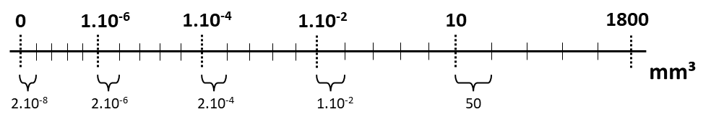
Figure 1: Graphical representation of the flexible mesh used in the W/B microemulsion modeling.

  - Results and discussion

Initially, an analysis was conducted to observe the effect of the correction factor CF on the system and determine which one is most suitable for W/B microemulsions. As established earlier, droplet breakage is favored for CF < 1, and only values within this range were employed. Table 2 summarizes the results of CF testing using the Standardized Mean Difference (SMD) as an effective quantitative metric (Equation 6) to determine the best CF for Dataset A. As expected, without the correction factor (CF=1), the model is unable to describe the behavior of systems at the micro/nanoscale.
Table 2: Effect of the correction factor on the Dataset A distribution.
CF | Emulsion distribution  Dataset A | SMD
1 | 101.05 ± 67.60 μm | 97.916
0.1 | 23.81 ± 16.05 μm | 12.846
0.01 | 5.65 ± 3.89 μm | 0.671
0.0072 | 4.66 ± 3.11 μm | 0.007
0.005 | 3.86 ± 1.46 μm | 0.543

From this analysis, a CF of 0.0072 was determined, resulting in a distribution with a diameter of 4.66 μm and a mean deviation of 3.11 μm. In this case, the SMD is equal to 0.007, indicating that the values obtained by the phenomenology are close to Dataset A compared to the other CF values (Table 2). Figure 2 shows that the standard deviation of the Gaussian distribution is higher for the model, resulting in a lower peak and a less uniform distribution. However, considering the small scale worked in this case, the results of the computational model can describe the behavior of the microemulsions formed by the variables of Table 1 and have a better response concerning the droplet’s mean diameter.

$$SMD= \frac{\left|μ_{data}-μ_{dist}\right|}{{SD}_{data}}$$ | (6)

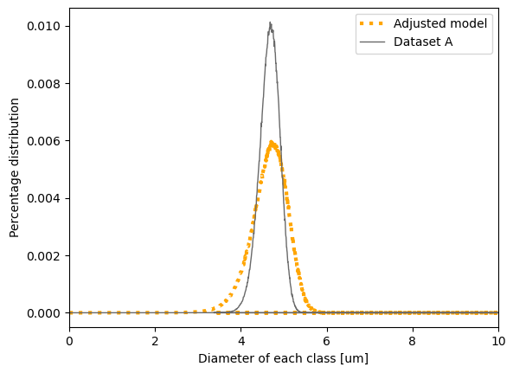
Figure 2: Distribution of the results achieved by the phenomenological model compared to dataset A.

Next, the same methodology was applied to dataset B. A distribution of 2.45±1.21 was obtained by the mathematical model (Figure 3) using a CF (correction factor) of 0.0045. When compared with the experimental values, an SMD (Standardized Mean Difference) of 0.227 was obtained.

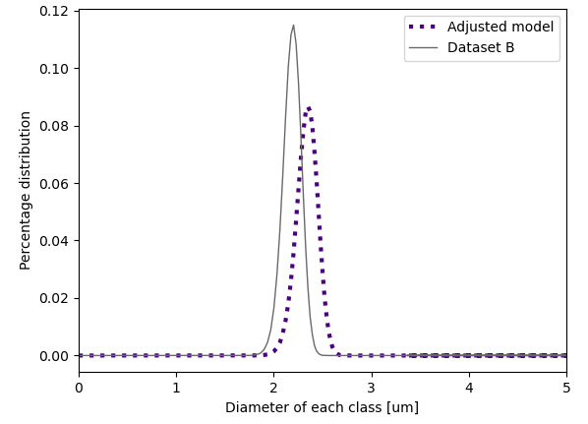
Figure 3: Distribution of the results achieved by the phenomenological model compared to the dataset B.

Figure 3 (Dataset B) illustrates a shift in peak position towards higher diameters along with a decrease in peak value, demonstrating that the model obtained a worse prediction when comparing it to Dataset A. The model’s lower effectiveness can be attributed to the reduced scale in this case, as noted by Khouri et al. (2023). However, the computational result in this case produced a more uniform emulsion, being closer to representing Dataset B characteristics.
  - Conclusions

The main objective of this study has been achieved: population balance-based modeling adequately describes the formation of biodiesel/water microemulsions. In essence, this work has showcased the potential and versatility of the population balance methodology, illustrating the application of established codes across diverse systems. As a future direction, it is advisable to evaluate various blends with bio-oils and investigate the influence of physical-chemical and operational variables on the process. Additionally, with the results obtained from the emulsions, the mathematical formulation can be enhanced to evaluate the combustion of these fuels and their impact on environmental aspects, such as improving the life cycle of heavy-duty vehicles.

Nomenclature

B – birth of particles by a discrete event
CF – correction factor
$d$ – droplet’s diameter
D – death of particles by a discrete event
$e_{disp}$ – energy available
f(v,v’) – distribution function of the daughter droplet’s size
g(v) – breakage function
m(v’) – density function of the fragments formed by droplet breakage;
n(v,t) – numerical density function of countable entities
SMD = standardized mean difference
SD = standard deviation
t = time
$v$ = droplet’s volume
$v'$ = mother droplet’s volume

Greek letters
• ρ = density
• $λ$= eddy size;
• $σ$ = interfacial tension.
• µ = mean;
• ψ = energy dissipation rate;
• $χ_{Ecrit}$ = critical energy criterion;
• $χ_{Tcrit}$ = critical stress criterion;

Subscripts
• d = diesel – continuous phase;
• data = dataset value;
• dist = model distribution value;
• g = breakage;
• w = water – dispersed phase;
-
Acknowledgments
The authors acknowledge the Universidade Estadual de Campinas (UNICAMP) and the School of Chemical Engineering, Campinas, SP, Brazil.
References
R. Andersson, B. Andersson, 2006, Modeling the breakup of fluid particles in turbulent flows, AIChE Journal, 52, 2031-2038. https://doi.org/10.1002/aic.10832.
C.A. Coulaloglou, L.L. Tavlarides, 1977, Description of interaction processes in agitated liquid-liquid dispersions, Chemical Engineering Science, 32, 1289-1297, https://doi.org/10.1016/0009 2509(77)85023-9.
B.K. Debnath, U.K. Saha, N. Sahoo, 2015, A comprehensive review on the application of emulsions as an alternative fuel for diesel engines, Renewable and Sustainable Energy Reviews, 42, 196 211, http://dx.doi.org/10.1016/j.rser.2014.10.023.
J. A. Driscoll, 1997, Acid rain demonstration: The formation of nitrogen oxides as a by-product of high-temperature flames in connection with internal combustion engines, Journal of Chemical Education, 74, 12, 1424, https://doi.org/10.1021/ed074p1424.
S. Heidari, R. Najjar, G. Burnens, S. Awad, M. Tazerout, 2018, Experimental Investigation of Emission, Combustion, and Energy Performance of a Novel Diesel/Colza Oil Fuel Microemulsion in a Direct-Injection Diesel Engine, Energy & Fuels, 32 (10), 10923-10932, https://doi.org/10.1021/acs.energyfuels.7b03181
M. Y. Khan, Z. A. A. Karim, A. R. A. Aziz, I. M. Tan, 2017, A Case Study on the Influence of Selected Parameters on Microexplosion Behavior of Water in Biodiesel Emulsion Droplets, 139(2), 022203, https://doi.org/10.1115/1.4034230
N. G. Khouri, J. O. Bahú, N. T. Miranda, C. B. Batistella, M. R. W. Maciel, V. O. C. Concha, R. Maciel Filho, 2023, Diesel upgrading: A modeling of its microemulsions, Fuel Processing Technology, 239, 107545, https://doi.org/10.1016/j.fuproc.2022.107545.
L. Leng, P. Han, X. Yuan, J. Li, W. Zhou, 2018, Biodiesel microemulsion upgrading and thermogravimetric study of bio-oil produced by liquefaction of different sludges, Energy,153,1061-1072, https://doi.org/10.1016/j.energy.2018.04.087.
L. Leng, L. Wei, W. Li, X. Xu, S. Leng, J. Li, W. Zhou, 2022, Determination and comparison of the activation energies of biodiesel microemulsion and biodiesel blends, Energy Sources, Part A: Recovery, Utilization, and Environmental Effects, 44:1, 116-125, https://doi.org/10.1080/15567036.2019.1648594
D. L. Marchisio, R. O. Fox, 2013, Computational Models for Polydisperse Particulate and Multiphase Systems. 1st ed. Cambridge University Press.
Z. Nissar, O. Rybdylova, S.S. Sazhin, M. Heikal, A.Rashid B.A. Aziz, Mhadi A. Ismael, 2020, A model for puffing/microexplosions in water/fuel emulsion droplets, International Journal of Heat and Mass Transfer, 149,119208,https://doi.org/10.1016/j.ijheatmasstransfer.2019.119208.

