CHEMICAL ENGINEERING TRANSACTIONS  VOL. , 2024 | A publication of
The Italian Association
of Chemical Engineering
Online at www.cetjournal.it

Guest Editors: Leonardo Tognotti, Rubens Maciel Filho, Viatcheslav Kafarov
Copyright © 2024, AIDIC Servizi S.r.l.
ISBN 979-12-81206-09-0; ISSN 2283-9216

Production of Sustainable Aviation Fuel in Brazil Integrating Biochemical and Thermochemical Routes. Techno-economic and Environmental Assessment Considering Alcohol to Jet and Fischer-Tropsch Strategies
York C. Santiago ^{a,b}, Henrique R. Guimarães ª, Mateus F. Chagas ^{a,b}, Jéssica M. Bressanin ^{c}, Diogo A. Simões ^{c}, Antonio Bonomi ^{a,*}
ªBrazilian Biorenewables National Laboratory (LNBR), Brazilian Center for Research in Energy and Materials (CNPEM), 13083-970 Campinas, São Paulo, Brazil.
^{b}Laboratory of Optimization, Design, and Advanced Control (LOPCA), School of Chemical Engineering, University of Campinas (UNICAMP), Av. Albert Einstein 500, Campinas-SP, 13083-852 – Brazil.
^{c}Fuel Laboratory, Petroleum and Energy Research Institute (LITPEG), Federal University of Pernambuco (UFPE), 50740-550 Recife, Pernambuco, Brazil.
* antonio.bonomi@lnbr.cnpem.br

While the aviation sector is trying to reach the net zero-carbon status in 2050, sustainable aviation fuel (SAF) is a possible strategy to help achieve this target. The present study compares alternative SAF production routes to meet future demands in the Brazilian and World markets. One possible SAF production chain includes the internationally approved alcohol-to-jet (ATJ) technology using the well-established Brazilian first-generation (1G) sugarcane ethanol as raw material (scenario I). This alternative was compared with technologies that utilize the excess lignocellulosic residues of the 1G sugarcane ethanol production either to produce SAF through gasification and Fischer-Tropsch (FT) synthesis combination (scenario II) or to produce more ethanol in an integrated first- and second-generation plant (1G2G) to serve as input to the ATJ process (scenario III).
The assessment and comparison of the proposed SAF production alternatives were performed by adapting and using the models included in the Virtual Biorefinery (VB) platform developed by the LNBR/CNPEM to simulate the various biochemical and thermochemical integrated value chains. The major performed activities were: (i) technical, economic, and environmental assessments of sugarcane production and straw recovery; (ii) simulation of 1G and 1G2G ethanol production processes; (iii) simulation of the SAF production processes considered for the ATJ and FT alternative routes; (iv) economic and Life Cycle Assessment (LCA) of SAF production.
The economic assessment results indicated that scenario I has the lower minimum selling price (MSP) for SAF (0.85 US$/L) attributed to the lower investments for the process, while scenarios II (1.10 US$/L) and III (1.07 US$/L) confirmed that the MSP of all scenarios was higher than the fossil fuel price (0.54 US$/L). Nevertheless, the technical results showed that scenario III presented a higher SAF production (135.3 million L/year) than scenarios I and II (98.5 and 114.3 million L/year, respectively). Regarding LCA, it could be mentioned that SAF emissions obtained in all scenarios (the lowest is 20.1 gCO₂eq/MJ for scenario II) were lower than fossil fuel (87.5 gCO₂eq/MJ). Finally, it can be indicated that the availability of sugarcane in Brazil converts the country into a potentially essential participant for the deployment of large-scale projects for SAF production, which can reduce greenhouse gas emissions compared with the conventional kerosene production chain. Furthermore, the learning curve of new technologies included in scenarios II and III, as well as the implementation of policies associated with the production of biofuels, could strongly reduce the MSP of SAF produced in integrated chains.
  - Introduction
The efficient and sustainable use of biomass for producing biofuels, chemical products, energy (thermal and electric), and food is performed through biorefineries, considered an economic, environmental, and politically correct strategy (Saleem, 2022). In the Brazilian sugar and alcohol industry (known for its high biomass generation rates), the expectation of growth is differentiated by some competitive advantages, with the availability of raw materials being the most important one. According to data offered by the National Supply Company (CONAB, 2023), sugarcane production in the 2022/23 harvest is estimated at 610.1 million tons (a growth of 5.4% compared to the previous season). Consequently, products derived from sugarcane and the biomass generated have increased their participation in the Brazilian energy matrix.
However, it is worth mentioning that there are several possibilities for more efficient use of large quantities of sugarcane biomass, especially in the transport sector, as they have the potential to be transformed into biofuel of 1st (1G) and 2nd (2G) generation (Alalwan et al., 2019). The 1G biofuels are produced in conventional mills, while the main routes for 2G biofuels under development are classified into biochemical and thermochemical technologies. Both routes use lignocellulosic material (e.g., biomass and residues of sugarcane conversion) as raw material. In the conventional biochemical alternative, the biomass is pretreated and hydrolyzed into sugars to be fermented into ethanol, methanol, butanol, acetic acid, hydrogen, and other chemicals (Devi et al., 2021). In the thermochemical route, it can be highlighted gasification, a process that converts carbonaceous materials in syngas, which could be used as raw material to obtain synthetic liquid fuels (such as sustainable aviation fuel, green diesel, and green gasoline) through Fischer-Tropsch (FT) synthesis, substitute natural gas, or obtain a mixture of alcohol (Santos and Alencar, 2020). Liquid biofuels from FT synthesis present similar characteristics to fossil fuels with the added benefit of lower life cycle greenhouse gas (GHG) emissions. Nevertheless, some of these fuels, such as sustainable aviation fuel (SAF), are not attractive to implement due to higher operational costs. In consequence, policies and government strategies, such as ReFuelEU aviation (in Europe) and RenovaBio (in Brazil), aspire to contribute to the increase in the production and use of biofuels (especially SAF). Hence, due to the diversity of products (sugar, ethanol, biofuels, bioelectricity, etc.) and the adequate use of industrial and agricultural residues, the Brazilian sugar and alcohol sector is already a critical Biorefinery model (Batlle et al., 2022).
Therefore, the future biorefinery must be an integrated complex that produces diverse products (for example, biofuels, chemicals, energy, and proteins) from various feedstocks to reduce or eliminate fossil fuel consumption share in its production chain. The present work aims to assess the techno-economic and environmental performance of advanced liquid biofuel production options. For this purpose, three scenarios were considered: (i) first-generation sugarcane plant coupled with alcohol-to-jet technology; (ii) biomass gasification and FT synthesis integrated into a 1G sugarcane biorefinery; (iii) 1G2G sugarcane plant coupled with alcohol-to-jet technology. The evaluation of different routes and technologies associated with the sugarcane production chain was performed through the Virtual Biorefinery platform (VB). Hence, the manuscript's contribution is the gasification/FT conversion and the Brazilian sugarcane sector integration evaluation based on biochemical platforms. The goal is to assess these different strategies both in terms of economic and environmental performance through techno-economic analysis and life cycle assessment (LCA), respectively.
  - Materials and methods
    - 2.1 Scenarios description
The first scenario (Scenario I) for sustainable aviation fuel (SAF) production consists of an Alcohol-to-Jet (ATJ) plant integrated into a first-generation ethanol distillery (1G), using lignocellulosic material – LCM (surplus bagasse and straw) to produce electricity. Scenario II combines this configuration with a thermochemical technology (gasification and FT), which uses LCM to produce synthetic fuels. In Scenario III, the LCM feeds a 2G process to increase ethanol production, which feeds the ATJ process. A schematic representation of three scenarios is shown in Figure 1.
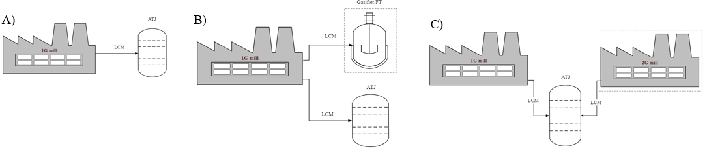
Figure 1: Schematic representation of scenarios A) I, B) II, C) III.
    - 2.2 Sugarcane production
The simulation of sugarcane production was carried out using the CanaSoft model, a platform developed as part of the VB framework, available on request (Bonomi et al., 2016). CanaSoft evaluates all stages of the biomass production system, including pre-planting operations, soil preparation, mechanized planting, cultivation, mechanized harvesting, and transportation of biomass to the industrial park. The scenarios considered the better practices employed in Brazilian sugarcane biorefineries and include the recovery of 50% of the produced sugarcane straw to increase LCM availability in the industry. For all scenarios, it is considered that the fossil diesel required by agricultural and transport activities during the sugarcane harvest season is replaced by biomethane produced in the biorefineries (biodigestion of vinasse). The costs and environmental impacts of sugarcane and collected straw are calculated using the CanaSoft model of VB.
    - 2.3 Biorefineries
The operational parameters of the 1G plant are obtained from the literature (Dias et al., 2016), considering an optimized autonomous ethanol distillery as the basis for integration with the SAF plant. This 1G plant operates during the sugarcane harvest (200 days/year) with a total processing capacity of 4 million tons of sugarcane/year, producing hydrated ethanol converted to SAF in an ATJ process based on Klein et al. (2018). 2G uses the parameters for a medium-term technology described by Junqueira et al. (2017),while GFT considers the configuration presented by Real Guimarães et al. (2023). It is worth mentioning that ATJ, GFT, and 2G processes operate 330 days/year using ethanol and LCM stored during the sugarcane harvest season.
    - 2.4 Economic assessment
The main inputs required for the techno-economic evaluation are fuel production rate, investment, operational costs, and project revenues. Capital costs (CAPEX) are estimated based on equipment sizing, including an additional 10% as working capital. Regarding annual operating costs (OPEX), variable costs, including the costs of biomass and other inputs, like chemical products, are considered. Fixed operating costs include employee salary costs, maintenance, and insurance. Prices of the products (SAF, green gasoline, green diesel, and surplus electricity) to quantify the revenues consider the ten-year average historical data available in the database of the National Agency of Petroleum, Natural Gas and Biofuels (ANP, 2019). Based on the discounted cash flow analysis, the internal rate of return (IRR), net present value (NPV), and minimum selling prices (MSP) are calculated to select the most competitive alternatives. More details about the economic parameters can be found in (Real Guimarães et al., 2023).
    - 2.5 Life cycle assessment
The Life Cycle Assessment (LCA) methodology estimates the environmental impacts of each scenario in the Climate Change category. LCA follows the methods described by ISO 14,040 and ISO 14,044 (Marques et al., 2021), integrating the foreground inventories modeled according to the VB framework (Bonomi et al., 2016) with background inventories from ecoinvent database V3.9.1. System boundaries include the entire production chain, from sugarcane production to its industrial conversion and biofuel use. This analysis considered integrated processes for industrial conversion and energy allocation to determine the impact-sharing between the different products. Industrial residues, like vinasse, were used in the sugarcane agricultural production. This study focused only on the Climate Change impact category attributed to SAF production, considering the global warming potential within the Intergovernmental Panel on Climate Change's 100-year time horizon (GWP 100) (Bressanin et al., 2020).
  - Discussion and results
    - 3.1 Techno-economic evaluation
Figure 2 shows estimated investments in fixed capital per production area in the biorefinery for the three scenarios. Scenario II (1G and Gasification-FT) CAPEX is estimated at US$750.8 million, while for scenario III (1G2G), the value is US$611.1 million; both are higher than scenario I (US$451.7 million). The fixed capital costs associated with the 1G unit increase in scenario III (US$391.5 million) compared to scenario I (US$363.6 million) since the 1G2G configuration requires more investments in fermentation and ethanol storage areas. Besides, scenario III has a higher total capital investment than scenario I due to equipment employed in sugarcane LCM processing into 2G ethanol. This CAPEX trend was also observed by Vasconcelos et al. (2020); the authors compared the investments for 1G and 1G2G sugarcane biorefineries and determined that the CAPEX increase to 1G2G configuration is mainly attributed to the equipment exclusively used for cellulosic ethanol production. For scenario II, the significant contribution of capital costs comes from the thermochemical processes (syngas production, cleaning and conditioning, fuel synthesis, and biofuel refining), which plants are complex and expensive to build. It is essential to mention that the CAPEX associated with the thermochemical process includes shared units, such as steam and power generation areas, which also meet the requirements of the 1G plant, reducing the participation of the 1G section since no LCM-based CHP is required.
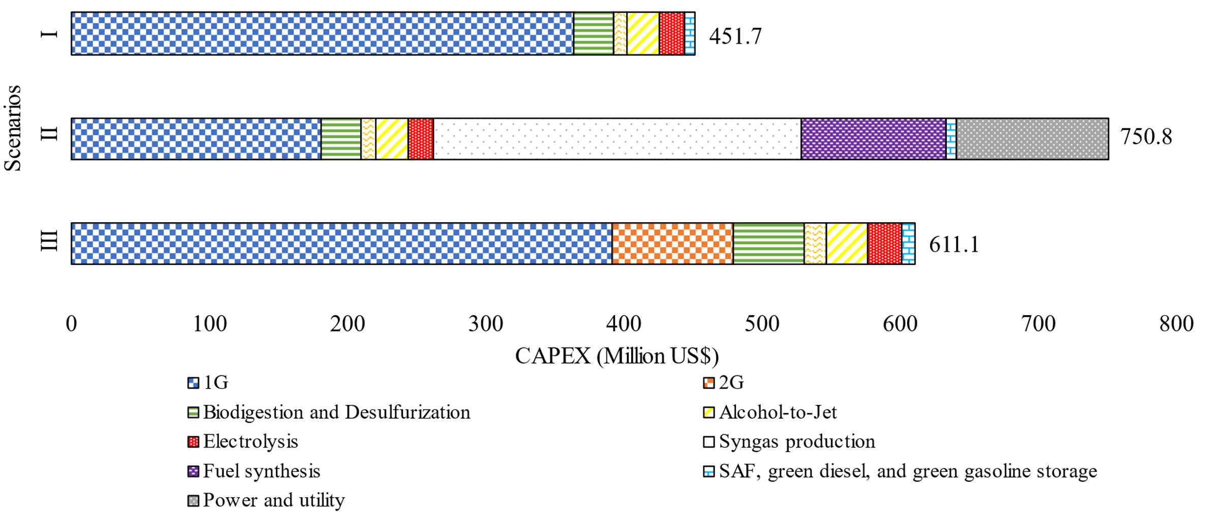
Figure 2: Estimated fixed capital investment shared by area for the three scenarios.
Table 1 presents the technical output (production rate of biofuels), the total CAPEX, and other parameters for economic analysis. Scenario III shows an increase in biofuel production compared with scenario I due to integrating the 1G and 2G mills, which leads to 37.4% more liquid biofuel production. Scenario I has the highest electricity output (670.5 GWh/year) since the conventional 1G mill uses the surplus LCM to produce bioelectricity and has a minor energy requirement compared to the other scenarios. On the other hand, the MSP of the SAF (0.85 US$/L) and green diesel (0.79 US$/L) are higher than the selling prices of fossil fuel (0.54 US$/L for aviation kerosene and 0.57 for diesel fossil) in this scenario. This behavior could also be observed in scenarios II and III, where the MSP of SAF are 1.10 US$/L and 1.07, respectively. It is essential to indicate that the MSP obtained corresponds to the producer price, excluding marketing taxes. Scenarios II and III presented higher MSP of SAF due to the higher CAPEX associated with these configurations, although the technical assessment indicated a higher production than in scenario I. The higher SAF production of scenario III (135.3 million L/year) is attributed to LCM used to produce ethanol.
Table 1: Techno-economic outputs of scenarios.
Parameter | Scenario I | Scenario II | Scenario III
Product output (per year) Green diesel (million L) | 7.9 | 7.9 | 10.8
SAF (million L) | 98.5 | 114.3 | 135.3
Green Gasoline (million L) | 49.5 | 58.4 | 68.1
Electricity (GWh) | 670.5 | 406.3 | 127.8
CAPEX total (US$ Million) | 451.7 | 750.8 | 611.1
OPEX total (US$ Million) | 106.8 | 129.6 | 133.1
Minimum selling price
Electricity (US$/MWh) | 98.03 | 126.55 | 122.69
Green Gasoline (US$/L) | 0.72 | 0.90 | 0.91
SAF (US$/L) | 0.85 | 1.10 | 1.07
Green Diesel (US$/L) | 0.79 | 1.03 | 0.99
NPV (Million US$) | 362.2 | 712.9 | 637.1
NPV/CAPEX (%) | 0.8 | 0.9 | 1.0
IRR (% per year) | -2.6 | -7.5 | -12.1

The IRR for all integrated scenarios is lower than the established MARR (12%), which was also obtained by Bressanin et al. (2020). Scenario I had the highest IRR (-2.6%) due to the broad knowledge of unit operations and the process maturity of Brazil's 1G sugarcane mills. The IRR result of scenario II is congruent since the gasification process could be considered a non-commercial technology at current biomass prices. However, even with the substantial CAPEX and OPEX of the thermochemical plant, fuel sales prices could compete with petroleum-derived fuels.
    - 3.2 Environmental assessment
Figure 3 presents the life cycle GHG emissions attributed to SAF in the three biorefinery scenarios evaluated. All life cycle stages are considered in the assessment, from sugarcane production and transportation to its conversion into biofuels and, finally, SAF distribution and use. The benefits of replacing fossil diesel with biomethane in biomass production and transport operations, as well as the hydrogen production through water electrolysis using the electricity produced in the biorefineries, are considered in the LCA and are essential factors for the reduced GHG emissions of SAF production.
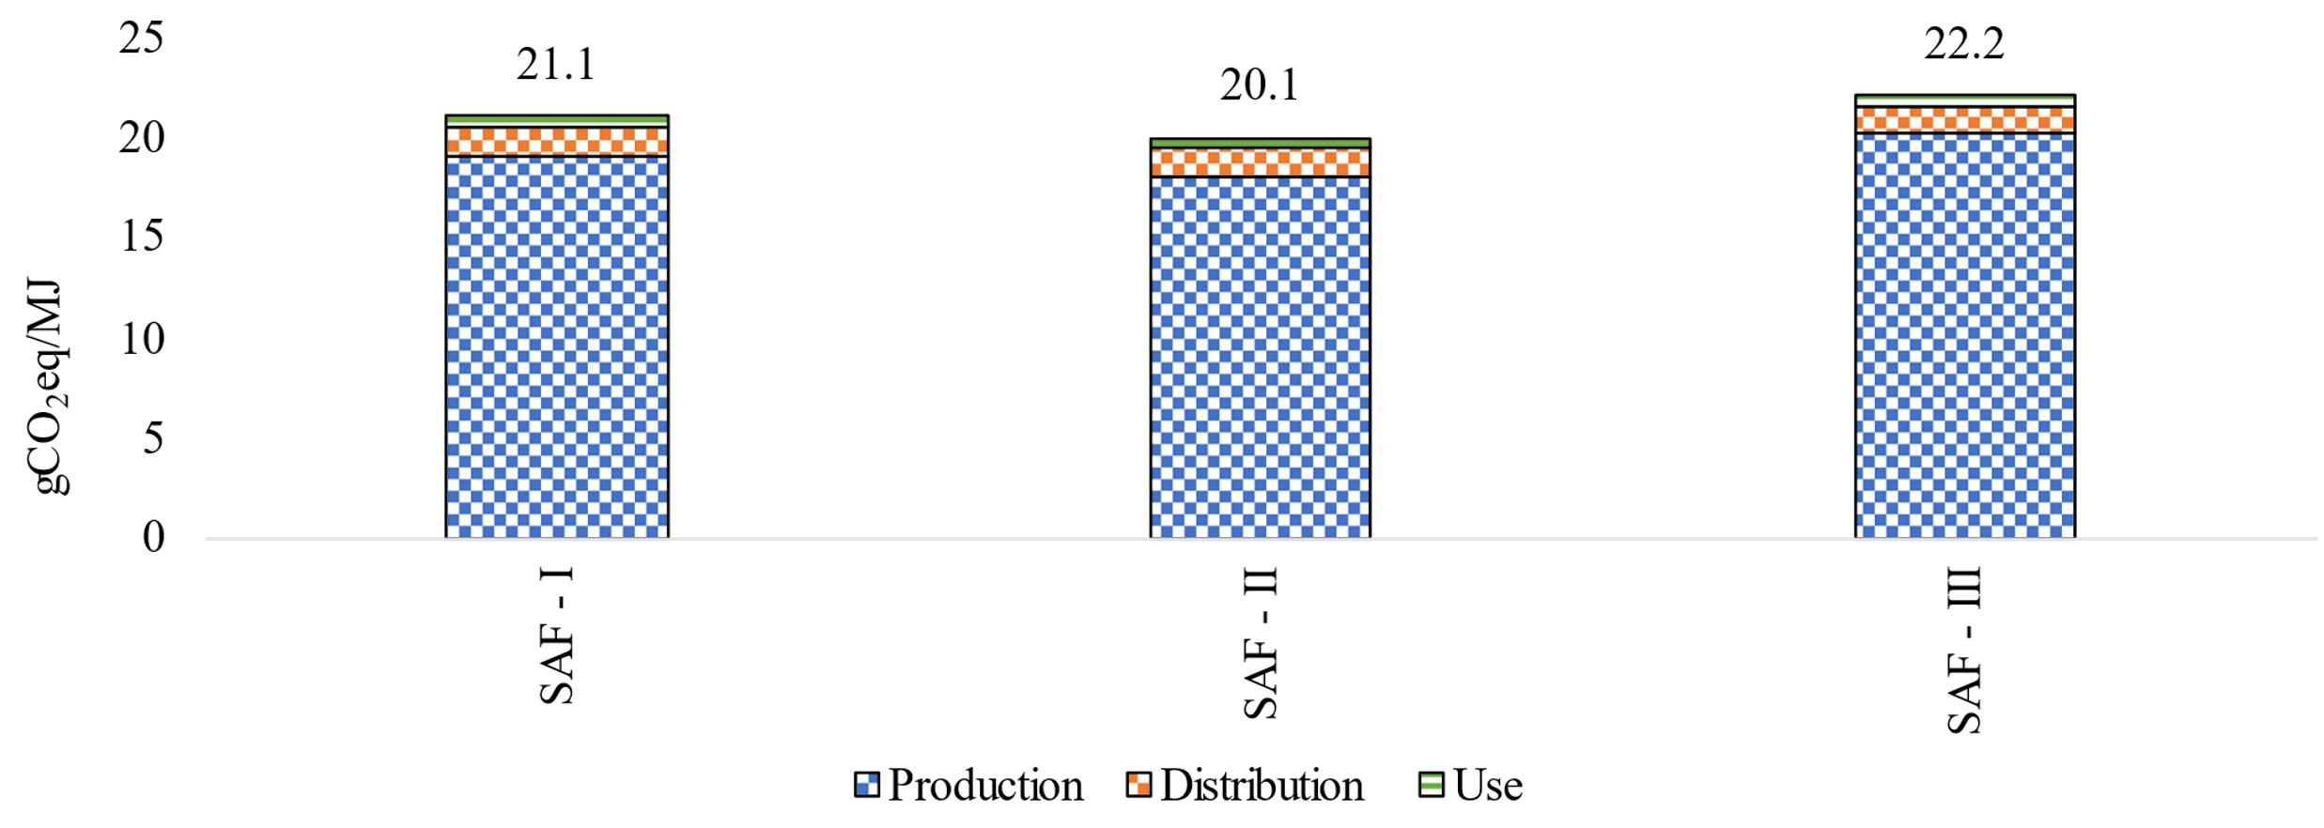
Figure 3: GHG emissions of SAF in the evaluated scenarios.

The results indicated that SAF has lower GHG emissions in the 1G plant (21.1 gCO₂eq/MJ in scenario I) than biorefinery 1G2G (22.2 gCO2eq/MJ in scenario III), and both are consistently lower than fossil kerosene (87.5 gCO₂eq/MJ). These results are congruent with the obtained by Klein et al. (2018), who obtained values between 18 and 25 gCO2eq/MJ for SAF production considering the ATJ process. Besides, the higher emissions of scenarios I and III (compared to scenario II) are due to the burning of LCM in the CHP boiler, which generates some emissions that are avoided in scenario II in the gasification/FT process. Finally, it is possible to observe that the environmental impact of all scenarios is concentrated in SAF production, which could be mainly attributed to the emissions from sugarcane and LCM acquisition.
  - Conclusions
This work proposed three scenarios to analyze the SAF production considering ATJ coupled to 1G, 1G+GFT, and 1G2G configurations. The assessment and comparison of the proposed SAF production alternatives were performed by adapting and using models (such as CanaSoft) included in the Virtual Biorefinery platform to simulate the various biochemical and thermochemical integrated value chains. The ecoinvent database and energy allocation for the biorefineries were considered for LCA. Parameters such as CAPEX, IRR, NPV, and MSP were analyzed for economic evaluation. The results indicated that the lower SAF MSP was obtained for the scenario I (0.85 US$/L) and, consequently, the higher IRR (-2.6%/year) due to the lower investment. Besides, the MSP of the SAF for scenarios II and III (1.10 US$/L and 1.07 US$/L) indicate that all scenarios have higher values than the selling price of fossil jet fuel (0.54 US$/L); therefore, policy implementation is essential to improve the MSP of SAF. However, the technical assessment results showed that the higher SAF production (135.3 million L/year) corresponds to scenario III due to the LCM use in a 2G plant producing more ethanol. The LCA indicated that the emissions of SAF obtained in scenario II (20.1 gCO₂eq/MJ) are lower due to industrial process efficiency increased by the integrated thermochemical route. All scenarios have minor emissions (21.1 and 22.2 gCO₂eq/MJ for scenarios I and III, respectively) compared with fossil jet fuel (87.5 gCO₂eq/MJ). Hence, the mitigation of GHG emissions of SAF generation can vary depending on the feedstock and ATJ production route. Finally, it is essential to consider the integrated biorefinery concept in the context of a bioindustrial economy, as it can provide a range of attractive bioenergy and co-products for the energy and transportation sector.​ An optimization of economic and environmental benefits assessment to analyze the biorefinery cost limitations is recommended for future studies.
Nomenclature
1G – First-generation | IRR – Internal rate of return
1G2G – Integrated first and second-generation | LCM - lignocellulosic material
ATJ – Alcohol-to-Jet | NPV – Net present value
CAPEX – Capital costs | OPEX – Operating costs
FT – Fischer-Tropsch | SAF – Sustainable aviation fuel
LCA – Life cycle assessment | VB – Virtual Biorefinery
Acknowledgments
This research was supported by São Paulo Research Foundation – FAPESP (Grant 2016/50403-2) along with four Brazilian Companies: EMBRAER S.A., KLABIN S.A., PETROBRAS S.A., and SUZANO S.A.
References
Alalwan, H.A., Alminshid, A.H., Aljaafari, H.A.S., 2019. Promising evolution of biofuel generations. Subject review. Renewable Energy Focus 28, 127–139.
ANP, 2019. Preços de produtores e importadores de derivados de petróleo e biodiesel [WWW Document]. Agência Nacional do Petróleo, Gás Natural e Biocombustíveis. URL https://www.gov.br/anp/pt-br/assuntos/precos-e-defesa-da-concorrencia/precos/precos-de-produtores-e-importadores-de-derivados-de-petroleo-e-biodiesel (accessed 11.21.23).
Batlle, E.A.O., Julio, A.A.V., Santiago, Y.C., Palácio, J.C.E., Bortoni, E.D.C., Nogueira, L.A.H., Dias, M.V.X., González, A.M., 2022. Brazilian integrated oilpalm-sugarcane biorefinery: An energetic, exergetic, economic, and environmental (4E) assessment. Energy Convers Manag 268, 116066.
Bonomi, A., Cavalett, Otávio, da Cunha, M.P., Lima, M.A.P., 2016. The Virtual Sugarcane Biorefinery Concept, in: Bonomi, A., Cavalett, Otavio, Pereira da Cunha, M., Lima, M.A.P. (Eds.), Virtual Biorefinery: An Optimization Strategy for Renewable Carbon Valorization. Springer International Publishing, Cham, pp. 5–11.
Bressanin, J.M., Klein, B.C., Chagas, M.F., Watanabe, M.D.B., de Mesquita Sampaio, I.L., Bonomi, A., de Morais, E.R., Cavalett, O., 2020. Techno-economic and environmental assessment of biomass gasification and fischer-tropsch synthesis integrated to sugarcane biorefineries. Energies (Basel) 13.
CONAB, 2023. Produção de cana chega a 610,1 milhões de toneladas na safra 2022/23 com melhora na produtividade nas lavouras [WWW Document]. Boletim de Safra da Cana-de-Açúcar. URL https://www.conab.gov.br/ultimas-noticias/4977-producao-de-cana-chega-a-610-1-milhoes-de-toneladas-na-safra-2022-23-com-melhora-na-produtividade-nas-lavouras (accessed 12.22.23).
Devi, A., Singh, A., Bajar, S., Pant, D., Din, Z.U., 2021. Ethanol from lignocellulosic biomass: An in-depth analysis of pre-treatment methods, fermentation approaches and detoxification processes. J Environ Chem Eng 9, 105798.
Dias, M.O.S., Junqueira, T.L., Sampaio, I.L.M., Chagas, M.F., Watanabe, M.D.B., Morais, E.R., Gouveia, V.L.R., Klein, B.C., Rezende, M.C.A.F., Cardoso, T.F., Souza, A., Jesus, C.D.F., Pereira, L.G., Rivera, E.C., Maciel Filho, R., Bonomi, A., 2016. Use of the VSB to Assess Biorefinery Strategies, in: Bonomi, A., Cavalett, O., Pereira da Cunha, M., Lima, M.A.P. (Eds.), Virtual Biorefinery: An Optimization Strategy for Renewable Carbon Valorization. Springer International Publishing, Cham, pp. 189–256.
Junqueira, T.L., Chagas, M.F., Gouveia, V.L.R., Rezende, M.C.A.F., Watanabe, M.D.B., Jesus, C.D.F., Cavalett, O., Milanez, A.Y., Bonomi, A., 2017. Techno-economic analysis and climate change impacts of sugarcane biorefineries considering different time horizons. Biotechnol Biofuels 10, 50.
Klein, B.C., Chagas, M.F., Junqueira, T.L., Rezende, M.C.A.F., Cardoso, T. de F., Cavalett, O., Bonomi, A., 2018. Techno-economic and environmental assessment of renewable jet fuel production in integrated Brazilian sugarcane biorefineries. Appl Energy 209, 290–305.
Marques, T.E., Castillo Santiago, Y., Renó, M.L., Yepes Maya, D.M., Sphaier, L.A., Shi, Y., Ratner, A., 2021. Environmental and Energetic Evaluation of Refuse-Derived Fuel Gasification for Electricity Generation. Processes 9(12).
Real Guimarães, H., Marcon Bressanin, J., Lopes Motta, I., Ferreira Chagas, M., Colling Klein, B., Bonomi, A., Maciel Filho, R., Djun Barbosa Watanabe, M., 2023. Decentralization of sustainable aviation fuel production in Brazil through Biomass-to-Liquids routes: A techno-economic and environmental evaluation. Energy Convers Manag 276, 116547.
Saleem, M., 2022. Possibility of utilizing agriculture biomass as a renewable and sustainable future energy source. Heliyon 8, e08905. https://doi.org/https://doi.org/10.1016/j.heliyon.2022.e08905
Santos, R.G. dos, Alencar, A.C., 2020. Biomass-derived syngas production via gasification process and its catalytic conversion into fuels by Fischer Tropsch synthesis: A review. Int J Hydrogen Energy 45, 18114–18132. https://doi.org/https://doi.org/10.1016/j.ijhydene.2019.07.133
Vasconcelos, M.H., Mendes, F.M., Ramos, L., Dias, M.O.S., Bonomi, A., Jesus, C.D.F., Watanabe, M.D.B., Junqueira, T.L., Milagres, A.M.F., Ferraz, A., Santos, J.C. dos, 2020. Techno-economic assessment of bioenergy and biofuel production in integrated sugarcane biorefinery: Identification of technological bottlenecks and economic feasibility of dilute acid pretreatment. Energy 199, 117422.

