CHEMICAL ENGINEERING TRANSACTIONS  VOL. , 2023 | A publication of
The Italian Association
of Chemical Engineering
Online at www.cetjournal.it

Guest Editors:
Copyright © 2023, AIDIC Servizi S.r.l.
ISBN 979-12-81206-XX-X; ISSN 2283-9216

Hydrogen and Bio-oil Production from Diverse Biomass through Microwave-assisted Pyrolysis
Mahendra Tiwari*, M V Pragadeshwar Babu, R. Vinu
Department of Chemical Engineering, Indian Institute of Technology Madras, Chennai 600036, India.
mahendra050495@gmail.com
Hydrogen production from lignocellulosic biomass (rice husk (RH) and saw dust (SD)) and macroalgal biomass (Kappaphycus alvarezii (KA) and Eucheuma spinosum (ES)) through pyrolysis has been studied using a lab- scale microwave reactor. The reactions were carried out at 800 W and 800 °C using activated carbon as susceptor to evaluate the potential of biomass for hydrogen production. Elemental analysis and proximate of the feedstocks were performed and the pyrolysis products were thoroughly characterized. Higher heating value of the biomass (in MJ kg⁻¹) follows the trend: SD (25.2) > RH (14.6) > KA (8.7) > ES (7.8). Thermogravimetric data shows that the maximum decomposition temperature follows the trend: SD (362°C) > RH (340°C) > KA (197°C) > ES (178°C). The gaseous yield from microwave pyrolysis was maximum from SD (39 wt.%) and minimum from ES (33 wt.%), while the bio-oil yield was highest from SD (33 wt.%) and lowest from RH (25 wt.%). The hydrogen yield from biomass follows the trend: SD (28 vol.%) > ES (27 vol.%) > RH (26 vol.%) > KA (24 vol.%). The H₂:CO (mol/mol) ratio was: SD (0.94) > RH (0.81) > ES (0.73) > KA (0.59). The bio-oil from KA and ES mainly contains linear oxygenates (~53%), while the bio-oils from RH and SD were rich in phenolics (58-77%).
  - Introduction
The excessive reliance on fossil fuels across diverse sectors like energy, transportation, industries, and mining has triggered a significant surge in greenhouse gas (GHG) emissions. The GHGs, effectively trap heat within the earth's atmosphere, thus fostering conditions conducive to global warming. Projections indicate that GHG emissions could skyrocket to 62 gigatons by 2030, potentially resulting in a myriad of environmental issues (GIS (Geopolitical Intelligence Services) report, 2023). Compounding this issue is the ever-increasing global population, contributing to a scarcity of fossil fuel resources. Consequently, there is a pressing need to transition away from fossil fuels and embrace renewable energy sources. Among the alternative solutions, hydrogen is a promising candidate due to its high heating value, and CO₂-free clean combustion. Looking ahead to 2050, hydrogen is anticipated to meet a substantial 20% of the world's energy demand, with the global hydrogen market poised to reach an impressive 600-650 million tonnes (IEA Bioenergy, 2023). Hydrogen (H₂) can be derived from various sources, including water, biomass, H₂S, natural gases, and others. Notably, biomass takes the centre stage as a readily available source for hydrogen production. Currently, biomass energy contributes over 55% to the renewable energy sector, constituting 6% of the global energy supply. Diverse thermal and chemical processes, such as combustion, gasification, hydrothermal liquefaction, and pyrolysis, facilitate biomass conversion. In this landscape, microwave-assisted pyrolysis emerges as a noteworthy hybrid technique, offering the advantage of energy-efficient conversion. This technique proves effective even for non-homogeneous and large-sized biomass (Robinson et al. 2010). The process involves the thermal conversion of biomass into products at a high heating rate in an inert atmosphere (N₂) (Mishra et al., 2023). The use of microwave-absorbing material or susceptor, particularly activated carbon, promotes uniform heating and accelerates the heating rate. The selection of the optimal microwave-absorbing material in precise proportions is a critical parameter in deciding the product distribution, which encompass bio-char, bio-oil, and syngas (CO, CO₂, H₂ and CH₄), and their yield. Most of the existing studies on hydrogen production from biomass are focused on gasification, while only a notable few studies are related to hydrogen production from biomass pyrolysis. In general, microwave-assisted heating promotes the production of hydrogen and methane even at low bulk temperatures of the reaction as compared to conventional pyrolysis. Shoja et al. (2013) conducted bagasse pyrolysis at 600-900°C using a dual bed reactor and obtained hydrogen yield ~10 vol.%. In a similar study (Zhang et al., 2022), the hydrogen yield was ~38 vol.% through microwave assisted pyrolysis of bagasse. To the best of authors knowledge this is the first study to compare the product yields and their quality from four different biomass feedstocks including lignocellulosic and macroalgae, with a focus on hydrogen.
In this study, microwave pyrolysis is conducted on rice husk (RH), pine sawdust (SD), Kappaphycus alvarezii (KA), and Eucheuma spinosum (ES). Pyrolysis was conducted in a microwave reactor at 800 W and upto 800 °C, and the product yields were evaluated. Furthermore, the oil and gas fractions were thoroughly characterized to unveil the potential of microwave pyrolysis for achieving high selectivity to hydrogen along with other valuable chemicals in the oil fraction.
  - Experimental section
    - Feedstocks and their characterizations
Four different biomasses, which include two lignocellulosic biomasses, viz. rice husk (RH), pine saw dust (SD), and two macroalgae, viz. Kappaphycus alvarezii (KA) and Eucheuma spinosum (ES), were used in this study. RH and SD were procured locally, while KA and ES were supplied by Sea6 Energy Pvt. Ltd. Bangalore, India. After collecting the seaweeds from Bali, Indonesia, both seaweeds underwent mechanical processing to eliminate excess water. Finally, the KA and ES granules were obtained after sun-drying. All feedstocks were ground to particle size in the range of 0.5-1 mm, and kept in the oven at 105°C for 24 h to remove the moisture prior to analysis and pyrolysis experiments.
The feedstocks were subjected to elemental and proximate analyses in accordance with ASTM D5291 and ASTM E1131-08, respectively, using an elemental analyzer (Thermo Flash 2000) and SDT Q600 thermogravimetric analyzer (TGA; TA Instruments, USA). Thermogravimetric test (SDT Q600 TA instruments) for each biomass was performed at 10 °C min⁻¹ in nitrogen atmosphere. For higher heating value (HHV) analysis IKA C200 bomb calorimeter was used. Each test was repeated twice, and the average values are reported on a dry sample basis. The more details on feedstock characterization methodology can be found in Tiwari et al. (2024).
    - Microwave pyrolysis experiment
Microwave pyrolysis experiments were carried out in batch mode using a Samsung MW73AD-B household multimode microwave oven. By drilling a hole on the top, the microwave oven was customized to collect the pyrolysis gases during the process. A two-stage condenser was used to condense the vapors, and the non-condensable gases were collected in a 5 L Tedlar® gas bag at the reactor outlet. The gases were collected when the pyrolysis temperature was 150-800°C and gases were analyzed using a gas chromatograph equipped with thermal conductivity and flame ionization detectors (GC-TCD/FID) for the composition analysis. Teflon® was used to seal every junction to prevent vapor escape. The temperature of the reaction mixture was noted using a modified K-type thermocouple. The temperature reading was accurate to ±2 °C. During operation, there were no signs of the microwave oven tripping or arcing. The schematic of the reactor set up is available in our previous publication (Tiwari et al., 2024).
Typically, 10 g of each feedstock with 10 g of susceptor (activated carbon) were taken in 250 mL quartz round bottom flask, which was covered with quartz wool for insulation. In each experiment, biomass:susceptor ratio of 1:1 (10 g/10 g) was used. To promote improved susceptor distribution, feedstock and susceptor were thoroughly mixed using a mixer grinder prior to pyrolysis. To ensure inert ambience, nitrogen gas was purged through the reactor, including the condensers, at a rate of 100 mL min⁻¹ for 20 min before the start of every experiment. The reaction mixture was subjected to microwave heating at 800 W of power until the temperature of the reaction mixture reached to 800 °C. This corresponds to 40 W of microwave power used per gram of the reaction mixture. The reason for choosing higher biomass:suceptor ratio (1:1), microwave power (800 W) and final temperature (800°C) was to ensure faster heating rate and high production of gases.
An analytical balance was used to determine the mass of bio-oil (organics + moisture). In order to calculate the amount of char produced, the mass of the residue (char + susceptor) was also measured and the initial amount of susceptor was deducted. Using mass balance, the mass of non-condensable gases was determined. Dichloromethane (DCM) solvent was used to completely extract the organic portion of the bio-oil. The yields of different product fractions were calculated using the following formula.
$$Product yield \left(wt.\%\right)=\frac{wt. of product }{wt. of biomass} ×100 (1)$$
The majority of the experiments were conducted twice non-consecutively, and the standard deviation in the yields of bio-oil, gas, and char was with 5-7%.
    - Gas and oil analysis
A GC/FID-TCD (Agilent 7820 A) was used to analyze the composition of the gases that were collected from microwave pyrolysis reactor. The gases were separated using Porapak Q and CP Molsieve 5 Å columns that were coupled in series. The injector and detector temperatures were 200 °C and 260 °C, respectively, and the oven was maintained isothermally at 50 °C for 20 min. The carrier gas, ultra-pure Ar (99.995%), was introduced into the column at a flow rate of 15 mL min⁻¹. The GC was calibrated using reference gas mixtures of known compositions.

A GC with mass spectrometer (GC/MS, Shimadzu GC2010 Plus/QP2020) was used to analyze the bio-oil fraction. Pyrolysis vapors were separated using an RESTEK, Rxi®-5SIL MS column (30 m length, 0.25 mm i.d., 0.25 μm film thickness). The carrier gas utilized was ultra-high pure helium (99.9995%) flowing at a rate of 1.49 mL min⁻¹. The column oven was initially maintained at 45 °C for 2 min, then ramped up to 300 °C at a rate of 7 °C min⁻¹ and kept isothermal at 300 ºC for 10 min. A dilution ratio of 100:1 (vol/vol) was used to dilute the bio-oil fraction before injecting 0.2 μL of the sample. The temperatures of the injector, MS ion source, and detector were 300°C, 200°C, and 280°C, respectively. The electron ionization voltage was 70 eV, and the mass range scanned was from 50 to 500 Da. The split ratio at the injector was 25:1. By comparing the mass spectra of each peak in the bio-oil with the NIST library, the organics were identified, and the compounds with match factors greater than 80% were classified into different groups. To close the mass balance, the unidentified chemicals were placed under the category of “other” compounds. The compounds were semi-quantitatively analyzed using peak area%.
  - Results and discussions
    - Feedstock characterization
Table 1 shows the ultimate and proximate analyses of the feedstocks. The ash content of the biomasses varied significantly. SD had the least amount of ash (0.7 wt.%), whereas RH had the highest ash (30.6 wt.%) and low levels of volatile matter (53 wt.%) and oxygen (29.6 wt.%). The aquatic macroalga, Kappaphycus alvarezii (KA), is prevalent across the Indian peninsula's coastal regions. India currently lacks a source of Eucheuma spinosum (ES), which is currently grown in Indonesia and other South-East Asian regions. These two are the most popular seaweeds used to extract carrageenan at commercial scales. The proximate analysis shows that the volatile matter content of both macroalgae is about the same (∼68.8 wt.%). The ash content in the both macroalgae, KA (24.1 wt.%) and ES (25.9 wt.%), was lower than RH. The nitrogen content in KA (0.9 wt.%) and ES (1 wt.%) was relatively higher than RH (0.3 wt.%) and SD (0.1 wt.%). This is because macroalgae contain organic as well as inorganic nitrogen. KA and ES resulted in gel formation when mixed with water, which is primarily due to the high carrageenan content. Red algae's cell walls include carrageenans, which are used in the food and feed sectors as texturizing and gelling agents. HHVs of KA and ES were relatively lower than RH and SD, which can be attributed to the influence of ash levels and elemental carbon in these feedstocks. The feedstock characterization data are in line with the literature (Gautam et al., 2019). The ash content for RH in the current study is relatively higher than the reported ash content in a study by Balasundram et al. (2017), and this is mainly attributed to the source of biomass.

Table 1: Physicochemical properties of biomass

Analysis |  | Rice husk (RH) | Pine saw dust (SD) | Kappaphycus alvarezii (KA) | Eucheuma spinosum (ES)
Ultimate Analysis (wt.%),db | C | 34.9 | 47.9 | 22.5 | 21.7
 | H | 4.6 | 5.8 | 3.5 | 4
 | N | 0.3 | 0.1 | 0.9 | 1
 | S | 0 | 0 | 1.2 | 0.9
Proximate Analysis (wt.%),db | O* | 29.6 | 45.5 | 47.8 | 46.5
 | Volatile matter | 53.0 | 83.7 | 68.8 | 68.7
 | Fixed Carbon | 16.4 | 15.6 | 7.1 | 5.4
 | Ash | 30.6 | 0.7 | 24.1 | 25.9
 | HHV (MJ kg⁻¹) | 14.6 | 25.2 | 8.7 | 7.8
O*= 100-[C%]-[H%]-[N%]-[S%]-[Ash%]
Figure 1 shows the TG mass loss profiles of the biomasses. Devolatilization started at 180 °C, 200 °C, 345 °C and 360 °C, respectively, for ES, KA, SD and RH. The low temperature decomposition was observed for KA and ES in 170-230°C, while for RH and SD the maximum mass loss was observed in the range of 200-400°C. The early decomposition peak for KA and ES is attributed to presence of high amount of carbohydrate in macroalgae. The derivative TG (DTG) curve showed a sharp peak centered at 178 °C and 197 °C for ES and KA, respectively, which is related to the decomposition of κ-carrageenan, and a peak corresponding to ~220 °C is attributed to the possible degradation of 4-sulfate-β-D-galactose, which was present in the carbohydrate fraction of the macroalgae (Gautam et al., 2019). This temperature also represents the onset of protein decomposition. The decomposition of minerals present as alkali and alkaline metal salts is responsible for the DTG peaks in the range 700–800 °C for KA and ES.
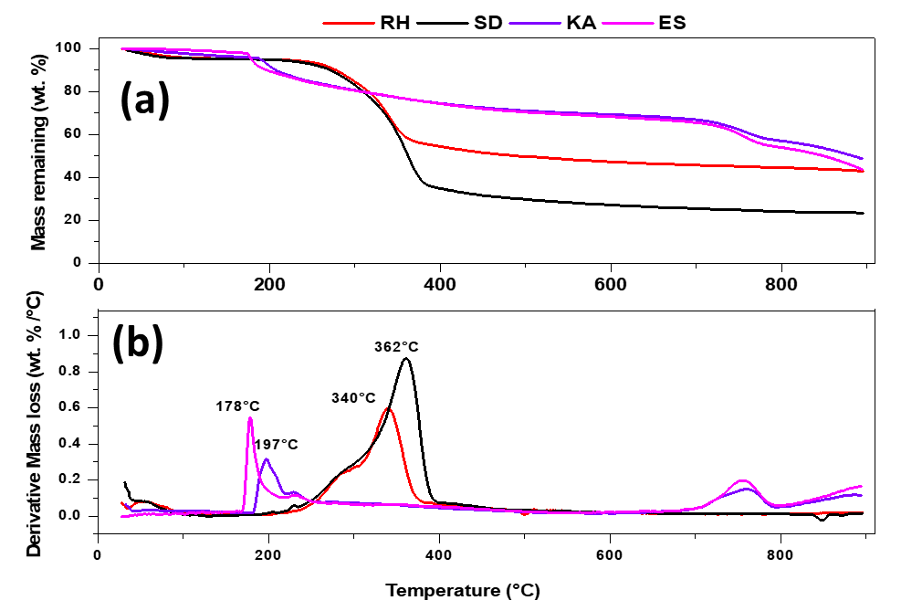
Figure 1: (a) Mass loss, and (b) derivative mass loss profiles of biomasses obtained using a thermogravimetric analyzer at 10 °C min⁻¹.

    - Product yield from microwave pyrolysis
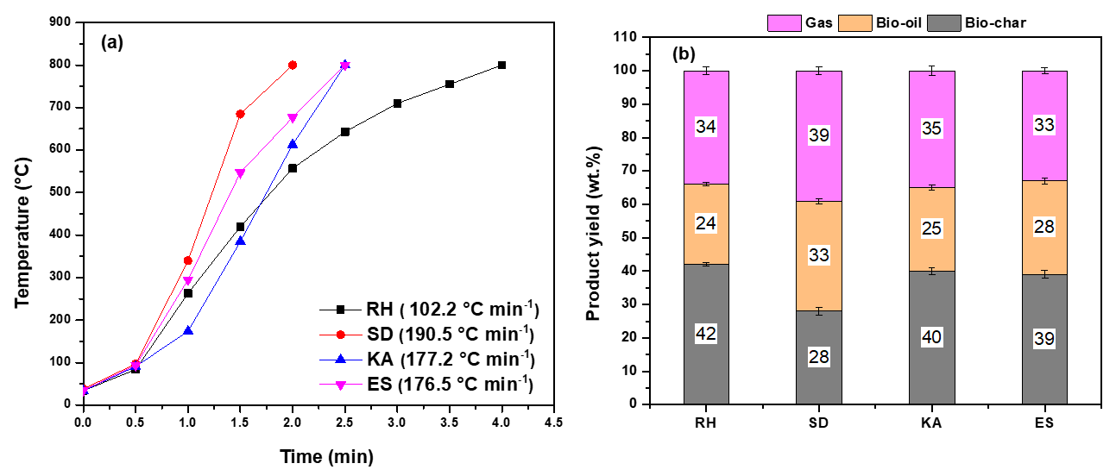Figure 2: (a) Reactant temperature profiles during microwave-assisted pyrolysis of biomass. (b) Product yields from microwave-assisted pyrolysis of biomass at 800W-800°C
The reactant temperature profiles achieved during microwave pyrolysis of biomasses are shown in figure 2(a). Compared to RH, the reaction temperature increased more rapidly in KA and ES due to the high volatile content (~69 wt.%) and reactive ash, which may exhibit catalytic effect. In general, the carbon-rich feedstocks are rapidly pyrolyzed in presence of microwaves. SD pyrolysis exhibited highest heating rate (190.5 °C min⁻¹) among all the biomasses due to its high carbon and volatile matter content. Hong et al. (2017) reported that heating rate is proportional to the combustible content (volatile matter and fixed carbon) of biomass. The respective product yield depends on heating rate, residence time, temperature and microwave power. A faster heating rate results in more bio-oil yield while slower heating rate produces more amount of bio-char. Figure 2(b) depicts the product yields from microwave pyrolysis of biomasses. The gaseous yield from SD was comparatively higher than that from RS, KA and ES, which is attributed to more amount of volatile matter and higher heating rate. The product yields from the two macroalgae (KA and ES) were almost similar due to the similarity in their physicochemical properties (as shown in table 1). RH pyrolysis shows the maximum amount of bio-char due to slowest heating rate and higher ash content compared to other biomasses.
    - Gas and Oil composition
Figure 3 (a) shows the composition of evolved gases from microwave pyrolysis of biomass feedstocks. The hydrogen yield was in the range 24-28 vol.% from all biomasses, and SD shows a maximum yield of hydrogen. The higher heating rate and presence of high volatile matter are possible reasons for the higher hydrogen from SD. Hydrogen is produced through recombination of H radicals, which are often produced via R–H bond fission reactions. This reaction has a high bond dissociation energy of 432 kJ mol⁻¹. C–H bond dissociation is shown to be a viable mechanism for H₂ generation in microwave plasma conditions. Additionally, the dehydrogenation-related aromatization reaction may also be the source of the hydrogen generated during microwave pyrolysis of biomass. Generally, hydrogen content in the evolved gases is more from microwave pyrolysis. Conversion of CH₄ to hydrogen is possible at microwave pyrolysis condition. SD shows a higher content of CH₄ which is potential source for hydrogen. The hydrogen yield from biomass follows the trend: SD (28 vol.%) > ES (27 vol.%) > RH (26 vol.%) > KA (24 vol.%). The H₂:CO ratio is also an important parameter to evaluate the potential for syngas production from biomass. H₂:CO ratio (mol/mol) follows the trend: SD (0.94) > RH (0.81) > ES (0.73) > KA (0.59). The syngas production (CO+H₂) from macroalgae (KA (65 vol.%) and ES (64 vol.%) was higher than that from RH and SD (58 vol.%). In a study on microwave enhanced pyrolysis of Porphyra (a type of macroalgae), Hong et al. (2017) reported 62 vol.% yield of syngas at 700°C. In one of our earlier studies, The hydrogen production from RH and SD was reported to be 15.9 vol.% and 17.5 vol.%, respectively, at 450 W-600 ºC (Suriapparao et al., 2018). The higher yields of hydrogen and syngas in present study are due to higher microwave power and feed-to-susceptor ratio.
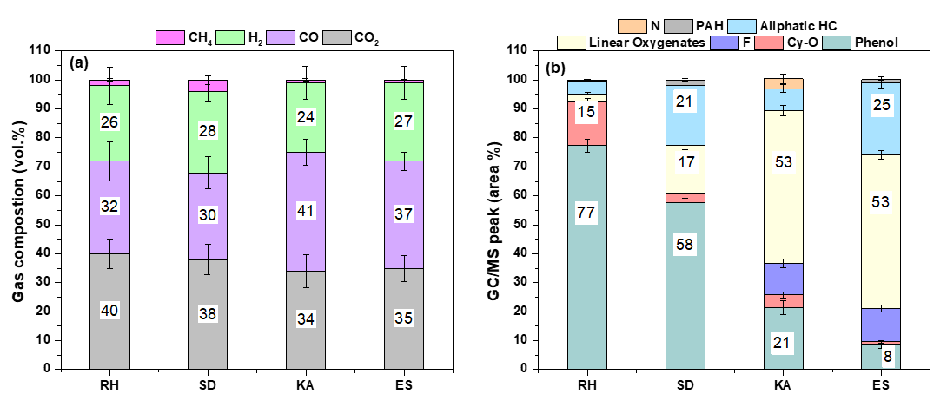Figure 3: (a) composition non-condensable gases, and (b) Composition of bio-oil from microwave-assisted pyrolysis of different biomass at 800W-800 °C.

The bio-oil yield from different biomass follows the trend: SD (33 wt.%) > ES (28 wt.%) > KA (25 wt.%) > RH (24 wt.%). SD shows maximum bio-oil yield due to its higher volatile mater and faster heating rate. Figure 3 (b) depicts the bio-oil composition. The organics observed in the bio-oil based on GC/MS analysis were classified into the following categories: phenols, cyclic oxygenates (Cy-O), furans (F), linear oxygenates, aliphatic hydrocarbons, polyromantic hydrocarbons (PAH) and nitrogen containing compounds (N). KA pyrolysis results in lower bio-oil yield compared to ES, which is attributed to higher lipid content in KA, which can be justified from the oil analysis. It is evident that the presence of N-containing compounds was maximum in the oil produced from KA. The compounds observed in the bio-oil derived from macroalgae (KA and ES) can be related to the pyrolysis of several components, mostly carbohydrates, along with proteins and lipids. Pyrolysis of carbohydrates results in the production of furan derivatives and other low-molecular weight (LMW) carbonyl compounds such as alkyl cyclopentene-1-one. Selectivity to furans (10%) and linear oxygenates (53%) in the bio-oil from macroalgae was higher compared to RH and SD. The selectivity to phenolic compounds was higher for RH (77%) and SD (58%) compared to KA (21%) and ES (8%). The formation of phenols can be related to the interaction of moisture/steam with aromatics produced during biomass pyrolysis (Mukarakate et al., 2015). Many N-containing compounds, including acid amides, nitriles, pyrroles, indoles, and pyridines, are produced from KA due to pyrolysis of proteins. These compounds are produced by cyclization, deamination, and amino acid decarboxylation reactions. Aliphatic hydrocarbons are typically produced by the decarboxylation of carboxylic acids, which are present in the macroalgae in the form of lipids and in the form of extractives in SD.
  - Conclusions
The present study provides the baseline yield of hydrogen from microwave-assisted pyrolysis of rice husk (RH), pine saw dust (SD), Kappaphycus alvarezii (KA), Eucheuma spinosum (ES) at 800 W-800 °C. Even though the macroalgae (KA and ES) are different in composition as compared to lignocellulosic biomass (RH and SD), the hydrogen yields from macroalgae are comparable to other biomasses. SD demonstrates a higher heating rate and higher yield of gases compared to other biomass feedstocks. Hydrogen yield follows the trend: SD (28 vol.%) > ES (27 vol.%) > RH (26 vol.%) > KA (24 vol.%). The oil analysis shows that bio-oils from KA and ES are rich in linear oxygenates (~53%), while RH and SD oils are rich in phenolics (58-77%). The oil from KA shows the highest selectivity to nitrogen-containing compounds compared to other biomasses. The H₂:CO ratio (mol/mol) in the gas fraction follows the trend: SD (0.94) > RH (0.81) > ES (0.73) > KA (0.59). The hydrogen production among the biomasses follows the trend: SD > ES > RS > KA. The overall syngas production from macroalgae (KA and ES) is higher compared to RH and SD. The future scope of this study includes the use of appropriate catalysts and a systematic optimization strategy to further enhance the hydrogen yield.
References
Balasundram, V., Ibrahim, N., Kasmani, R. M., Hamid, M. K. A., Isha, R., Hasbullah, H., & Ali, R. R., 2017, Catalytic Pyrolysis of Coconut Copra and Rice Husk for Possible Maximum Production of Bio-Oil. Chemical Engineering Transactions, 56, 1177-1182.
Bioenergy – IEA, Global hydrogen review 2023 <iea.blob.core.windows.net/assets/ecdfc3bb-d212-4a4c-9ff7-6ce5b1e19cef/GlobalHydrogenReview2023.pdf> accessed: 10-01-2024.
Gautam, R., Shyam, S., Reddy, B. R., Govindaraju, K., & Vinu, R., 2019, Microwave-assisted pyrolysis and analytical fast pyrolysis of macroalgae: product analysis and effect of heating mechanism. Sustainable Energy & Fuels, 3(11), 3009-3020.
GIS report (Geopolitical Intelligence Services), 2023, Is green hydrogen the fuel of the future? <gisreportsonline.com/r/green-hydrogen/> accessed: 10-01-2024.
Hong, Y., Chen, W., Luo, X., Pang, C., Lester, E., & Wu, T., 2017, Microwave-enhanced pyrolysis of macroalgae and microalgae for syngas production. Bioresource Technology, 237, 47-56.
Mishra, K., Siwal, S. S., Saini, A. K., & Thakur, V. K., 2023, Recent update on gasification and pyrolysis processes of lignocellulosic and algal biomass for hydrogen production. Fuel, 332, 126169.
Mukarakate, C., McBrayer, J. D., Evans, T. J., Budhi, S., Robichaud, D. J., Iisa, K., ten Dam J., Watson M.J., Baldwin, R.M., Nimlos, M. R., 2015, Catalytic fast pyrolysis of biomass: the reactions of water and aromatic intermediates produces phenols. Green Chemistry, 17(8), 4217-4227.
Robinson, J. P., Kingman, S. W., Barranco, R., Snape, C. E., & Al-Sayegh, H., 2010, Microwave pyrolysis of wood pellets. Industrial & Engineering Chemistry Research, 49(2), 459-463.
Shoja, M., Babatabar, M. A., Tavasoli, A., & Ataei, A., 2013as. Production of hydrogen and syngas via pyrolysis of bagasse in a dual bed reactor. Journal of Energy Chemistry, 22(4), 639-644.
Suriapparao, D. V., Boruah, B., Raja, D., & Vinu, R., 2018, Microwave assisted co-pyrolysis of biomasses with polypropylene and polystyrene for high quality bio-oil production. Fuel Processing Technology, 175, 64-75.
Tiwari, M., Dirbeba, M. J., Lehmusto, J., Yrjas, P., & Vinu, R., 2024, Analytical and Applied Pyrolysis of Challenging Biomass Feedstocks: Effect of Pyrolysis Conditions on Product Yield and Composition. Journal of Analytical and Applied Pyrolysis, 177, 106355.
Zhang, Z., Huang, K., Mao, C., Huang, J., Xu, Q., Liao, L., Wang, R., Chen, S., Li, P., Zhang, C., 2022, Microwave assisted catalytic pyrolysis of bagasse to produce hydrogen. International Journal of Hydrogen Energy, 47(84), 35626-35634.

