CHEMICAL ENGINEERING TRANSACTIONS  VOL. , 2024 | A publication of
The Italian Association
of Chemical Engineering
Online at www.cetjournal.it

Guest Editors: Leonardo Tognotti, Rubens Maciel Filho, Viatcheslav Kafarov
Copyright © 2024, AIDIC Servizi S.r.l.
ISBN 979-12-81206-09-0; ISSN 2283-9216

The upcycling of natural waste materials: alternative fibers in papermaking
*Flavia Rosa Squillanteª, Rosa Colucci Canteª, Isidoro Garella^{b}, Roberto Nigroª
ªUniversity of Naples Federico II, DICMAPI, Piazzale Tecchio 80, 80125, Naples, Italy
^{b}ITP S.r.l. Innovation and Technology Provider, Via Bisignano a Chiaia, 68, 80125, Naples, Italy
flaviarosa.squillante@unina.it
In the actual scenario, characterised by a global crisis, sustainability is not a minor player; it has a crucial role in the global outlook. Sustainability at the environmental level evolves in recycling, reusing, upcycling, and no squandering policies. Nowadays, the incessant, excessive, and growing use of plastic has a strong impact on global warming and represents a threat to the Oceans and the Planet. The paper industry can play a crucial role in addressing this emergency, by substituting mostly or totally (where it is possible) this impacting material. To confer paper materials the same plastic resistances, some additives could be used. In detail, the feasibility of upcycling silk waste was investigated and paper products containing silk fibers were formulated to realize worthy substitutes for plastic materials. These alternative fibers were inserted as a filler (20%wt. and 30% wt) in the cellulosic matrix and the resulting suspension was used to produce special papers for packaging. Silk, in both cases, was subjected to a chemical pretreatment with NaOH before paper sheet formation, which guaranteed an appropriate silk-cellulose interaction, without compromising the final chemichal-physical properties. Moreover, the sheets were subjected to non-destructive and destructive testing, which confirmed respectively their high-quality degree and good mechanical resistances. Silk confers special characteristics, in particular, the resulting sheets with silk were fluffier to the touch than the reference in pure cellulose. The resulting materials can be used as semi-finished products to obtain more sustainable paper-based packaging materials and promote a plastic-to-paper transition.
Keywords: Upcycling; Waste; Pretreatment; Sustainability, Paper-Based Packaging
  - Introduction
After wars, natural disasters, and other catastrophic events, humans have always tried to improve their conditions. A wind of change has pervaded all humanity’s souls. A death has always been followed by a rebirth. After the Second World War, the plastic era dawned (Geyer et al., 2017), this new inexpensive and resistant material started to substitute all other materials such as ceramic, metal, glass…(Kedzierski et al., 2020). for the production of Fast-Moving Consumer Goods (FMCG) with a low lifetime. Consequently, a significant amount of municipal solid waste was generated, resulting in global pollution and climate change. In this catastrophic scenario, the paper industry can play a fundamental role. Paper products allow to facilitate goods production and transportation, guaranteeing high thermal insulation and resistance properties, in a cheaper and eco-friendly way (Hurtado et al., 2016). From 1950 to 2015, 6300 million tonnes of plastic waste were produced, and around 4900 million tonnes were discarded in landfills. Most of them were not recyclable FMCG packaging products (Geyer et al., 2017); on the contrary paper packaging products were demonstrated to have more eco-friendly disposal possibilities (recycling, incineration…) (Deshwal et al., 2019). Paper is defined as ‘the material made from wood, rags, etc. and used for writing, printing, wrapping parcels, etc.’ (Cambridge Dictionary). Starting from a uniform suspension of cellulosic fibers in water, the resulting pulp is filtered, sedimented on a wire, and dried, forming a flat sheet. At a molecular level, when the pulp is formed, water can break the hydrogen bonds of cellulose; then, during the drying, water is removed, cellulosic fibers are pulled against one another, and hydrogen bonds can form. As a result, fibers form a rigid network, as shown in Figure 1 with a scanning electron microscope (SEM) image of a paper sheet. The bond’s strength influences the mechanical properties of paper (Alava & Niskanen, 2006).
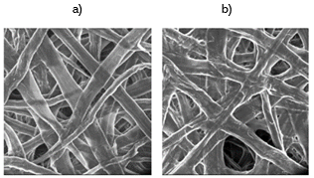
Figure 1: Scanning electron microscope images of a paper surface, dried respectively under tension (a, on the left) or not (b, on the right) (Alava & Niskanen, 2006).
Thanks to the natural origin of cellulosic fibers, paper is considered one of the most eco-friendly materials. Due to its bio-based and biodegradable nature (Oloyede & Lignou, 2021) it results in being a valid plastic substitute. In particular, in the above-mentioned study, the author proposed five paper-based packages for two foods, biscuits and meat. They were able to create innovative, well-designed, functional, and recyclable packaging, aimed at the abatement of plastic production, without any action on the existent pollution. In the perspective of simultaneously also reducing the main causes of pollution, alternative fibers can be found in municipal wastes (Soni et al., 2022). Actually, Municipal Waste is considered one of the worst causes of pollution. Most municipal solid waste includes glass, organic waste, plastic, leather, and textiles. (Agrawal & Sharan, 2015). The related materials to the paper industry are undoubtedly organic and textile wastes, with the addition of inorganic chemicals during processing. Cellulose-based materials, such as cotton, hemp, flax, jute, but also tree pruning (Low et al., 2019) are ideal materials for papermaking because of their ability to bond adjacent cellulose fibers through hydrogen bonds, forming the solid network of the typical paper sheet (Ryder & Morley, 2012). Rummaging through this panoply of abundant waste the most attractive candidate seemed to be the silk, a protein-based textile waste. Silk is well-known for its good resistance, softness, and elasticity; for this reason, the valorisation and the reuse of silk waste cover different application fields, such as tissue engineering (Lu et al., 2022). Silk is a natural fiber formed by two kinds of proteins, as depicted in Figure 2. The shell, around 20-30% of the silk structure, is called sericin and because of its gummy-like consistency, it is mostly removed with a degumming process. The most interesting silk component is the fibroin, around 65-75% of the whole structure, which represents the core of the fibers and gives astonishing properties to the material. The last 5% of the structure includes wax, pigments, sugars, and other impurities (Kostag et al., 2021). According to the silk composition, several pretreatments are mandatory to adapt the fiber to a specific application field (Kostag et al., 2021). In the papermaking sector, silk has to interact with cellulose: the dissolution of fibroin in a cellulosic matrix can be done by using strong electrolytes or solvents such as LiBr, LiSCN, Ca(NO3)2, CaCl2 (Kundu et al., 2014) and NaOH (Kostag et al., 2021). In particular, in the latter paper, the capability of each of these solvents in dissolving different kinds of fibroin was studied, as shown in Figure 3.
In this paper, a novel formulation for paper products was investigated to formulate worthy substitutes for plastic materials. In detail, silk fibers were added to the cellulosic matrix to obtain non-conventional sheets. The resulting sheets were subjected to non-destructive and destructive testing, and their qualitative and chemical-physical properties were analysed, thus verifying the fiber’s potential. In this way, the feasibility of upcycling of pre and post-consumer silk waste was demonstrated. These products can have an application in the secondary packaging paper sector.

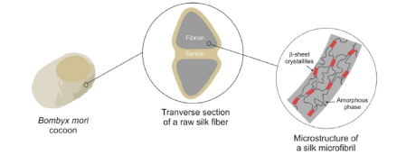
Figure 2: Silk composition (Kostag et al., 2021).
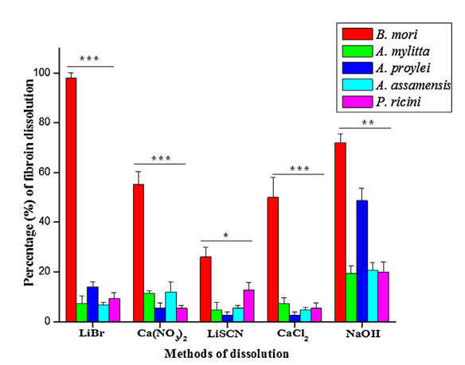
Figure 3: Percentage of fibroin dissolution by using several solvents and referring to silk of different origins (Kundu et al.,2014).
  - Materials and Methods
    - Materials
Figure 4 illustrates the three typologies of fibers experimentally used. In detail, cellulose short fiber (SF) (Figure 4a) and cellulose long fiber(LF) (Figure 4c), or degummed silk fibers(Bombyx Mori) of 4 cm (Figure 4b) were added. Three kinds of formulations were made for sheets: the reference sample was made of 50%wt. of SF and 50%wt. of LF; another sample included 20% wt. of silk and 40% wt. of both SF and LF; the last one was made using 30% wt. of silk and 35% wt. of both SF and LF. For the silk pretreatment, NaOH pellets (BIOCHEM Chemopharma) were dissolved in distilled water. Additionally, ninhydrin reagent (ACROS ORGANICS) was useful for qualitative analysis.
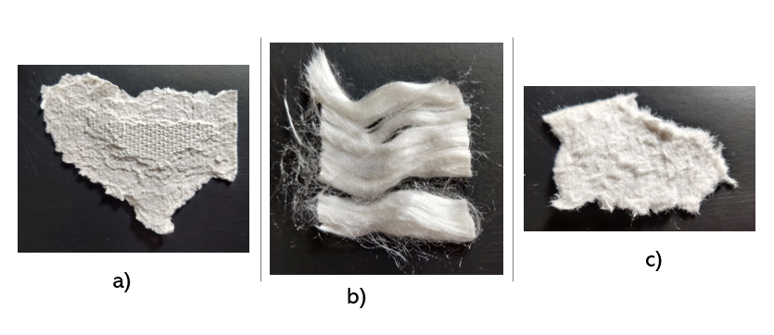
Figure 4: Fibers used for papermaking: a) cellulose short fibers, b) silk fibers, c) cellulose long fibers
    - Methods
Silk needed a pretreatment. 0.8 g of silk fibers were added to 100 ml of 3 M NaOH solution and placed on a magnetic hot stirrer for 30 min at 55°C, this would subsequently permit cellulose-fibroin interaction. The silk composition, before and after the pretreatment, was analyzed with an FT-IR spectrometer. With the pretreatment, all fibers were ready for use and the sheet-forming process started. The paper sheets were formulated by following the confidential protocol adopted by a paper industry specialised in packaging products.
Firstly, the pretreated silk and cellulose fibers (SF and LF ratio of 1:1) were mixed together and pulped with a disintegrator; then the paper sheets were formed with a Semi-Automatic sheet former (ERNST HAAGE). Secondly, the wet sheet was dried with a drying plate and the resulting product was left overnight in a conditioning room, at 23°C and 50% of relative humidity. Non-destructive and destructive tests on paper sheets were carried out. In detail, an analytical balance and an L&W micrometer were adopted to evaluate respectively the weight and the mean thickness of the paper sheets. In terms of destructive analysis, the L&W tensile tester and FRANK-PTI tear tester were used. Lastly, a ninhydrin test was performed to qualitatively ensure the uniform distribution of silk in the cellulose matrix. By following the just mentioned procedures, two additional reference sheets were created: one in pure cellulose and the other using silk without any pretreatment but respecting the same formulation procedure described above. All tests were repeated twice; the reported numerical values are the result of a duplicate analysis.
  - Results and Discussion
A first investigation was made by simply observing the samples reported in Figure 5. An inhomogeneity in silk distribution was observed in the absence of silk pretreatment (Figure 5a), due to the absence of silk-cellulose interactions. This problem was solved through the pretreatment, shown in picture 5b, where no isolated or agglomerated silk filaments can be noticed. The last picture (5c) shows the pure cellulose sheet used as a reference for the quantitative analysis. On the paper samples, obtained using raw and pre-treated silk, further qualitative investigations were conducted. A preliminary qualitative result was linked to the consistency of the paper sheet. The paper with silk felt to be fluffy and soft to the touch, among all the paper surfaces.
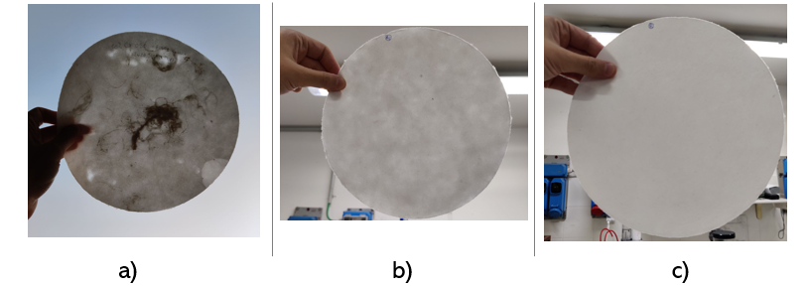
Figure 5: Paper sheets made of: a) cellulose (35% wt.SF and 35% LF) and 30% wt.silk without pretreatment, b) pretreated 30% wt. silk and cellulose (35% wt.SF and 35% LF), c) pure cellulose(50% wt.SF and 50% LF).
Moreover, observations using ninhydrin reagent and an optical microscope were carried out to evaluate the silk fibers distribution inside the cellulosic matrix; in Figure 6 the result was depicted. The image of the ninhydrin-treated sheet is shown on the left side of the paper represented in Figure 6. Referring to the same figure, on the right, the optical microscope image of a silk-cellulose paper sheet appeared. Despite the whole panoply of fibers, different typologies can be recognised. In detail, on the right of Figure 6 were highlighted the short fiber of cellulose (a), the silk fiber (b), and the long fiber of cellulose (c).
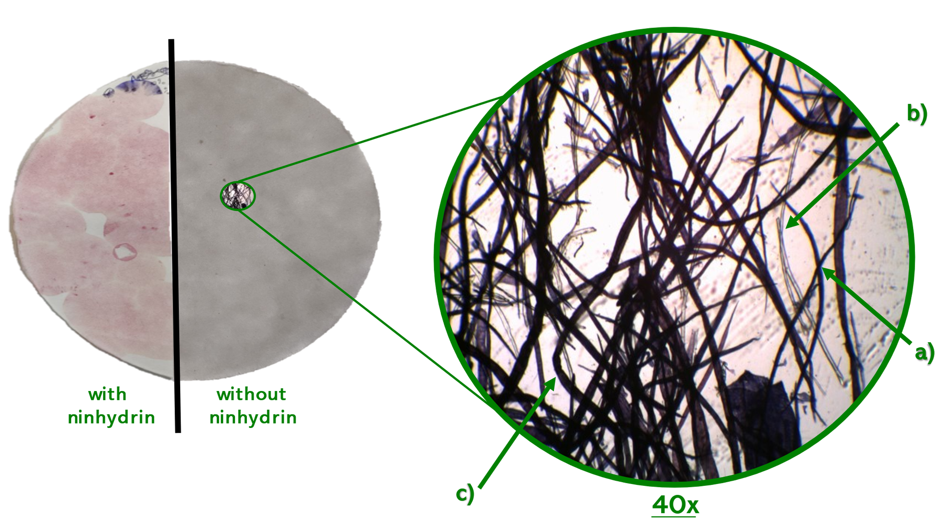
Figure 6: Qualitative analysis: ninhydrin test on the left and Optical Microscope image with 40x magnification of.silk-cellulose paper sheet with 30% wt. of silk on the right: a) cellulose short fiber, b)silk fiber, c)cellulose long fiber.
The last qualitative analysis regarded the evaluation of silk composition by FT-IR spectroscopy. The main peaks representing silk components were noted in Figure 7 for raw and pretreated silk. In detail, the maximum of 1698 $cm^{-1}$ revealed β-turn conformation of amide I, while those of 1616 $cm^{-1}$ ,1515 $cm^{-1}$, and 1261 $cm^{-1}$ indicating β-sheets crystallites of amide I, II, III, respectively, which formed the secondary structure of the fibroin backbone (Baranowska-Korczyc et al., 2021). On the other hand, the absence of bands at 1637 $cm^{-1}$ made evident the absence of sericin content (Chen et al., 2012). The fact that the main peaks of both raw and treated samples overlapped, demonstrated that the pretreatment was not invasive; confirming this, the peaks at 1001 $cm^{-1}$ and 975 $cm^{-1}$ were observed. They showed -glycine-alanine- and -glycine-glycine- fragments (Baranowska-Korczyc et al., 2021), already present in raw silk, due to a preliminary degummed process.
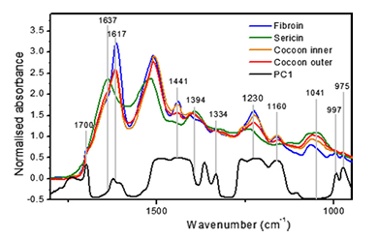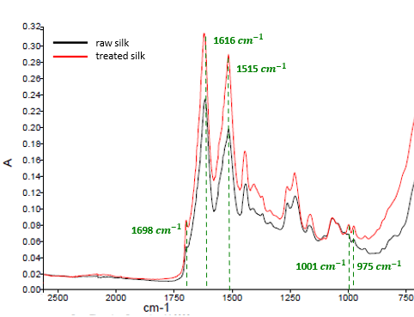
Figure 7: FT-IR spectra of pure fibroin and sericin (Chen et al., 2012), on the left, and of the currently investigated raw and pretreated silk, on the right.
From a quantitative point of view, the sheet properties acquired by implementing the silk fibers were listed in Table 1. Referring to non-destructive analysis, paper grammage, thickness, and density were obtained, whereas mechanical properties like tensile and tearing resistance were investigated by exploiting destructive tests. All results were compared to those of reference paper sheets, made of pure cellulose.
Table 1: Physical and Mechanical properties of paper sheets obtained with pure cellulose (Reference), 20%wt. pretreated silk, and 30% wt. pretreated silk.
Sample | Grammage [g/m²] | Thickness [µm] | Density  [g/cm³] | Elongation at break [%] | Breaking Length [m] | Tearing  Factor
Reference | 126.2 | 250.3 | 0.51 | 0.63 | 1087 | 138.6
20% pretreated silk | 119.9 | 245.5 | 0.49 | 0.58 | 1245 | 138.5
30% pretreated silk | 118.8 | 251.3 | 0.48 | 0.55 | 976 | 114.1
At first glance, it can be noticed that the silk pretreatment caused weight loss. As a result, a lower grammage and thickness value were obtained. Their ratio expressed the density of the paper sheet, which seemed to be similar for the three samples. A similar discussion could be made on mechanical properties: the elongation at break, dependent on grammage and thickness, appeared to be lower, on the contrary, the breaking length, linked to the tensile strength and tearing factor, linked to the tearing strength, were almost the same, especially in the case of the sheet made of 20% wt. pretreated silk.
  - Conclusions
The study demonstrates the possibility of using some alternative silk-based fibers in papermaking. They were not useful without a pretreatment. In particular, a paper sheet with raw silk filler was formed, but it appeared to be inhomogeneous, with silk fibers agglomeration, and a huge porosity so that some holes were visible. The sheet made of pretreated silk, from a qualitative point of view, seemed to be intact, uniform and well-designed. Furthermore, the sheet with silk was fluffier to the touch than the reference one. The use of NaOH guaranteed an appropriate silk-cellulose interaction: this statement was confirmed by optical microscope images and ninhydrin tests. Additionally, the presence of the characteristic fibroin peaks, shown in the FTIR spectra, ensured that the pretreatment was non-invasive, as the chemical-physical properties were not compromised. The high quality of the innovative product was also confirmed by the destructive analysis since the mechanical resistance of the silk paper sheet resulted in being similar to or even better than the one made of pure cellulose. Consequently, the main advantages of using silk-based fibers in papermaking, include sustainability at the environmental (decreasing in textile waste) and economic level (waste materials are cheaper than virgin cellulose), obtaining products with a better texture and aspect, and preserving, at the same time, the mechanical properties of sheets. These kinds of products could be used for example to produce molded pulp packaging used as secondary packaging for cosmetic goods or foods. These consistent results open the way to new investigations. Different concentrations of silk will be tested, and the results will be compared to this work. The wettability of the papers can be investigated in order to expand the applicability of these formulations to a wide range of paper industries, like self-adhesive and glassine papers. However, physical and mechanical properties could be influenced by the sheet forming process, for this reason, to further confirm the data, the production with a completely automatic pilot scale machine could be taken into account. In conclusion, it can be affirmed that the use of alternative fibers in papermaking is feasible and deserves further investigation; the scale-up to pilot machines is likely the greatest challenge of the next few years.
Acknowledgments
The authors thank sincerely the industrial partner, ITP, the Food Lab Engineering, and FEDERICO II University, which provided the raw materials and the lab scale devices useful for this publication. Furthermore, they are grateful to all people, who in the limits of their possibilities, have given whatever contribution. Final thanks go to the anonymous peer-reviewers who have considered publishable, thus praiseworthy, the results achieved.
References
Agrawal R., Sharan M., 2015, Municipal Textile Waste and Its Management, Research Journal of Family, Community and Consumer Sciences, Volume 3(1), 4-9.
Alava M., Niskanen K., 2006, The physics of paper, Reports on Progress in Physics, 669–723.
Baranowska-Korczyc A., Hudecki A., Kamińska I., Cieślak M., 2021, Silk Powder from Cocoons and Woven Fabric as a Potential Bio-Modifier, Materials, 14, 6919.
Chen F., Porter D., Vollrath F., 2012, Silkcocoon (Bombyx mori): Multi-layer structure and mechanical properties, Acta Biomaterialia, 2620–2627.
Deshwal G.K., Panjagari N.R., Alam T., 2019, An overview of paper and paper based food packaging materials: health safety and environmental concerns, Journal of food science and technology, 4391–4403
Geyer R., Jambeck J. R., Law K. L., 2017, Production, use, and fate of all plastics ever made, Science Advances, Vol 3, Issue 7.
Hurtado P.L, Rouilly A., Vandenbossche V., Raynaud C., 2016, A review on the properties of cellulose fibre insulation, Building and Environment, Vol 96, 170-177.
Kedzierski M., Frère D., Le Maguer G., Bruzaud S., 2020, Why is there plastic packaging in the natural environment? Understanding the roots of our individual plastic waste management behaviours, Science of The Total Environment, Volume 740, 139985.
Kostag M., Jedvert K., El Seoud O. A., 2021, Engineering of sustainable biomaterial composites from cellulose and silk fibroin: Fundamentals and applications. International Journal of Biological Macromolecules, Volume 167, 687-718.
Kundu B., Kurland N. E., Yadavalli V. K., Kundu S. C.,2014, Isolation and processing of silk proteins for biomedical applications, International Journal of Biological Macromolecules, 70-77.
Low J. H., Xun L. Z., Yoon L. W., Pang M. M., Wong S., 2019, Exploration of tree pruning waste for papermaking, AIP Conference Proceedings, 2137, 020008.
Lu L., Fan W., Ge S., Liew R. K., Shi Y., Dou H., Wang S., Lam S. S., 2022, Progress in recycling and valorization of waste silk, Science of the Total Environment, Volume 830, 154812.
Oloyede O. O., Lignou S., 2021, Sustainable Paper-Based Packaging: A Consumer’s Perspective, Foods, 10, 1035.
Ryder K., Morley N., 2012, Pulp Fiction? Re-innovation of Paper Manufacture from Textiles, Textile: The Journal of Cloth and Culture, 10:2, 238-247.
Soni A., Das P. K., Hashmi A. W., Yusuf M., Kamyab H., Chelliapan S., 2022, Challenges and opportunities of utilizing municipal solid waste as alternative building materials for sustainable development goals: A review, Sustainable Chemistry and Pharmacy, Volume 27, 100706.
Thompson R. C., Moore C. J., Vom Saal F. S., Swan S. H., 2009, Plastics, the environment and human health: current consensus and future trends, Philosophical Transactions of the Royal Society of London. Series B, Biological Sciences., 364(1526), 2153–2166.

