CHEMICAL ENGINEERING TRANSACTIONS  VOL. , 2023 | A publication of
The Italian Association
of Chemical Engineering
Online at www.cetjournal.it

Guest Editors:
Copyright © 2023, AIDIC Servizi S.r.l.
ISBN 979-12-81206-XX-X; ISSN 2283-9216

Nutritional Content of Black Soldier Fly Larvae Achieved during Biotransformation of Organic Wastes
Laura V. Barrantes-Sandovalª, Diana M. Cuesta-Parra^{b,}*, Felipe Correa-Mahecha^{b}, Juan F. García-Trejo^{c}
ªChemical Engineering Department, Universidad de América, Ak. 1 #20-53, Bogotá D.C., Colombia
^{b}Chemical Engineering and Environmental Department, Universidad de América, Ak. 1 #20-53, Bogotá D.C., Colombia
^{c}Engineering Department, Universidad Autónoma de Querétaro, Campus Amazcala 76265, Amazcala, Querétaro, México
diana.cuesta@profesorees.uamerica.edu.co

The purpose of the research was to study the nutritional content in the larvae of the black soldier fly BSF (Hermetia Illucens) during the biotransformation of organic wastes at laboratory scale in a controlled reactor, comparing growth at ambient temperatures of 27 and 29 °C, maintaining relative humidity between 65 and 80 %. Eggs were incubated until hatching, 4 mixtures of organic wastes were evaluated with carbon-nitrogen-ratio (C/N) of 14:1, 12:1, 10:1 and 8:1, composed of fresh, cooked, meat, pruning and grass wastes, with a feeding rate of 47.62 mg substrate/larva∙day for 21 days, during growth moisture, pH and ashes of the substrate were measured, length, width and mass of 3% of the population were measured in the larvae. Moisture ashes, ethereal extract, organic nitrogen and crude protein of the larvae of each trial were characterized, obtaining moisture between 64-73, ashes 3.5-5.7, ethereal extract 28-35, crude protein 48-51 and organic nitrogen 7.6-8.4 % at 27 °C; moisture between 53-60, ashes 4.6-6.4, ethereal extract 34-39, crude protein 41-52 and organic nitrogen 6.6-8.3 % at 29 °C. The bioconversion rate was between 16-25 % at 27 °C and 9-20 % at 29 °C, the conversion efficiency to protein was between 7-13% at 27 °C and 3.6-9.7 % at 29 °C; the conversion efficiency to fat was between 1.7-8.4% at 27 °C and 3.4-6.9 % at 29 °C; the growth rates show that the larval development speed is an exponential model between the sixth and ninth day of measurement with C/N 14:1 and 10:1 at 27 °C and between the sixth and eighth day with C/N 12:1 and 10:1 at 29 °C. BSF larvae are a promising source of food due to the short time utilization of organic residues.
  - Introduction
The United Nations projected that the world population will reach 8.5 billion by 2030, 9.7 billion by 2050 and 10.4 billion by 2100 (United Nations Department of Economic and Social Affairs, 2022), world food demand is expected to increase significantly and consumption patterns are expected to change as well (FAO of the United Nations, 2022). In its Food Outlook report, the FAO estimates that in 2023 the world food bill will amount to $1.98 trillion, 1.5% more than in 2022 (FAO, 2023). It is known that more than 3 million people worldwide do not have access to healthy diets (FAO of the United Nations, 2022). According to FAO figures, between 702 and 828 million people will suffer from famine in 2021, 56.5 million (8.6%) are undernourished people in Latin America and the Caribbean (FAO et al., 2022). Consequence of inadequate treatment of food systems is the loss and waste of food, occurring from production in the supply chain to consumption (UNEP, 2021). FAO estimated that 1.26 billion people could be fed each year with the amount of food wasted (FAO, 2022).
Two billion tons per year of waste are produced worldwide; in Latin America, 200 million tons are generated per year, of which 100 million tons are biodegradable organic waste (United Nations One Planet, 2022), which are generally deposited in landfill sites (Z. Liu et al., 2018); according to the What a waste 2.0 report, inadequate waste management causes soil, water and air pollution, promotes climate change, harms human health, and also hinders economic development worldwide (Kaza et al., 2018). To address improper waste disposal, the use of insects for biomass production has been proposed as a promising alternative. Black soldier fly (BSF) larvae are considered effective insects in the bioconversion of organic wastes, qualified to transform and recover nutrients (Kaza et al., 2018). The cycle of BSF (Hermetia Illucens) is short, is not a vector of pests or diseases (X. Liu et al., 2017), its optimal biotransformation efficiency depends on abiotic factors such as temperature, relative humidity, oxygen level, light source, pH, physical profiles and the nutritional content of the substrates (Singh & Kumari, 2019; Salam et al., 2022; Naser El Deen et al., 2023). According to Arabzadeh et al. (2022) it has been proven that values lower than 20:1 carbon-to-nitrogen ratio (C/N) favor the development of BSF larvae. The benefits of organic waste processing using BFS larvae is the obtaining of proteins and lipids with several applications as nutritional sources for poultry animals (Tran et al., 2022).
The objective of the research was to study the growth and larval development of BSF, the conversion rates to protein and fat of organic wastes at ambient temperatures of 27 and 29 °C, maintaining relative humidity between 65 and 80 %.
  - Materials and methods
Hatching of 1 g of eggs (Evolutio SAS Group) to BSF larvae was done for 7 days fed with chicken feed (Table 1) in incubator with controlled environment at 27 ± 0.5 °C and relative humidity of 70 ± 5 %, with the eggs in a plastic cup, which was transferred through plastic containers covered with thick porous cloth to prevent escape of hatchlings (Acosta & Guzmán, 2022; Arabzadeh et al., 2022; Muñoz & Parada, 2022). Larvae were counted in 0.5 g of the sieved substrate quartile whose standard deviation among 3 replicates was less than 5%; with the mass balance, the number of larvae hatched per day was calculated (Muñoz & Parada, 2022).
Table 1: Hatching diets
Diet per day | 1 | 2 | 3 | 4 | 5 | 6 | 7
Water (mL) | 25 | 100 | 100 | 100 | 75 | 50 | 25
Chicken feed (g) | 25 | 100 | 100 | 100 | 75 | 50 | 25

The particle size of fresh (f), cooked (c), meat (m) and pruning and grass (p) wastes collected in Bogotá and sent for laboratory analysis was reduced with a press mil (Naser El Deen et al., 2023). Four mixtures of organic waste with C/N 14:1, 12:1, 10:1 and 8:1, with different percentages of waste (Table 2) were evaluated until completing 700 g at 80 % moisture in plastic containers (16.50 x 12.71 x 5.60 cm) covered with porous fine cloth to prevent larvae escape, were 1 blank and 3 replicates, the containers with the highest moisture content were placed in the lower part of the reactor with controlled environment at 27 and 29 ± 0.5 °C and relative humidity between 65-80 % for 21 days (Z. Liu et al., 2018; Muñoz & Parada, 2022; Arabzadeh et al., 2022; Naser El Deen et al., 2023); the reactor includes an electrical resistance, a head incubator ultrasonic humidifier and a SHT2000 thermostat (Dualtronica) for control and monitoring of the process variables (temperature and humidity), the operating time of the VN-583 fan (Techman Electronic) and PHX120X120X38 extractor (Phoenix) were programmed in an analog timer (EBCHQ). A total of 700 larvae were added per replicate, the feeding rate was 47.62 mg substrate/larva∙day and the larval density 3,338 larvae/cm².
Table 2: Percentages of residues per mixture
C/N | f (%) | c (%) | m (%) | p (%)
14:1 | 52.00 | 38.00 | - | 10.00
12:1 | 39.20 | 29.30 | 23.60 | 7.90
10:1 | 30.60 | 22.30 | 41.20 | 5.90
8:1 | 21.30 | 15.60 | 59.00 | 4.10

On days 3, 6, 8, 10, 13, 15, 17 and 20, moisture (%H) and ash calculated with equations (1) and (2) were measured according to NTC 5167: 2022, 1 g sample of the substrate was taken in porcelain capsules on analytical balance BC220M - series 260 (Precisa Instruments AG, Dietikon, Switzerland), taken to drying and sterilization oven TE - 393/1 (Tecnal, Brazil) at 105 ± 3 °C (Gold et al., 2020), after 3 h, 16 capsules were cooled in a glass desiccator for 30 min, transferred to the MM10 muffle - 0150 series (Terrigeno, Medellín, Colombia) at 650 ± 3 °C for 2 h and again cooled in the desiccator (ICONTEC, 2022). Substrate pH was also measured by Milwaukee MW101 (Milwaukee, Romania) of 1 g of substrate dissolved in 5 mL of water in a 50 mL beaker; mass, length and width of 3% of the larvae population per container were measured with a vernier caliper and the analytical balance (larvae were cleaned from the substrate with reusable towels for accuracy) (ICONTEC, 2022; Arabzadeh et al., 2022). On day 21, the larval biomass was separated from the frass and the number of live and dead larvae of the experiment was counted (Naser El Deen et al., 2023). For larvae biomass, 4 samples were prepared and sent to the laboratory (three replicates per C/N ratio are 1 sample) for partial bromatological analysis by gravimetry technique, and characterization of the organic fraction of crude protein by volumetry and ethereal extract by gravimetry (Barragan et al., 2019; Naser El Deen et al., 2023).
$\% M=\frac{wet sample \left(g\right)-dry sample (g)}{wet sample (g)} x 100$ | (1)
Ashes $=\left[\frac{final mass (g) }{initial mass (g)}\right]x100-\left[\frac{100 - \% M}{100}\right]$ | (2)
Larval counts, substrate mass and laboratory results were used to calculate 4 BSF larval yield parameters on a dry mass. Equation (3) was used to determine the survival rate by the ratio of live larvae at the end (larvae_{end}) to larvae at the beginning (larvae_{beg}) of the experiment (Gold et al., 2020):
$Survival rate \left(\%\right)=\frac{larvae_{end}}{larvae_{beg}}∙100$ | (3)
The bioconversion rate was calculated with equation (4) by the ratio of the larval dry mass gain (larvae_{gain}) to the initial feedmass, where the larval gain was equal to the difference between the larval dry mass at the end and at the beginning multiplied by the live larvae of the last day (Gold et al., 2020):
$$Bioconversion rate \left(\%\right)=\frac{larvae_{gain}(g)}{feed_{mass}(g)}∙100$$ | (4)
The protein conversion efficiency was calculated with equation (5) as the ratio between the amount of accumulated larval protein (protein_{gain}) and the feedmass supplie (feed_{mass}). The amount of accumulated larval protein was equal to the difference between the larval dry mass at the end and at the beginning multiplied by the percentage of crude protein obtained from the laboratory results (Gold et al., 2020):
$$Protein conversion efficiency=\frac{protein_{gain}(g)}{feed_{mass}(g)}$$ | (5)
Finally, for the calculation of fat conversion efficiency, equation (5) was modified in terms of the percentage of ethereal extract obtained from laboratory results, as equation (6) (Gold et al., 2020):
$Fat conversion efficiency=\frac{fat_{gain}(g)}{feed_{mass}(g)}$ | (6)
Four diets with different C/N ratios (14:1, 12:1, 10:1 and 8:1) were formulated at temperatures of 27 and 29 °C, each with 3 replicates. The response variables are mass, length and width of larvae BFS. The F distribution was used to measure significant differences in ANOVA analysis of variance with p < 0.05.
  - Results and discussion
On day 1 of measurement the pH of the substrate was at 27 °C between 4.34 and 4.60, and at 29 °C between 4.25 and 4.45. In both trials the pH started acidic as Barragan et al. (2019), who deduce that the humic and fulvic organic acids proper to the waste degradation process, product of the microbial activity of the substrate, are the cause of the low pH values. On day 3 of measurement at 27 °C the pH rose to values between 5.30 and 6.80, while at 29 °C between 4.24 and 4.68; the cause of the pH tending to basic values is due to the consumption of acids by BSF larvae and the conversion of nutrients to minerals (Michishita et al., 2023). Outliers of the mixtures were observed on days 8 for C/N 12:1 and 21 for C/N 8:1 at 27 °C, and day 9 for C/N 14:1 at 29 °C, the model C/N 14:1 at 27 °C maintained a trend over time from day 9 with values between 9.20 and 9.62, far from the results in the range of 7 to 8 of the remaining substrates (Figure 1-a).

On day 1 of measurement, moisture of the substrate was at 27 °C between 62.35 and 72.18 %, and at 29 °C between 70.89 and 75.96 %. On day 6 of measurement the mixtures at 29 °C began to decrease the water content between 61.40 and 65.21 % until day 21 when values decreased between 2.56 and 17.39 %; similar trend of the results at 27 °C, but the reduction of moisture in these mixtures was not significant, between 8.67 and 61.57 %, where the minimum values are of C/N ratios 14:1 and 12:1 from day 17 of measurement (Figure 1-b). In both trials it is interpreted that the mixtures with C/N 10:1 and 8:1 are those with the highest water content over time, due to the nature and quantity of meat residues in the substrates (Table 2) and the position in the reactor (Arabzadeh et al., 2022). The decrease in moisture was due to water evaporation, for assimilation of BSF larvae nutrients and the percentage of water in the waste (Delgado et al., 2019).

The ash data are contrary to the humidity data. On day 1 of measurement the ashes of the substrate at 27 °C were between 8.04 and 11.86 %, and at 29 °C between 2.81 and 7.60%. In both trials from day 3 an exponential pattern in the increase of ashes is observed, mixtures with C/N 14:1, 12:1 and 10:1 at 29 °C reach values between 26.52 and 34.70 %, the maximum results obtained by mixtures with C/N 14:1, 12:1 and 10:1 at 27 °C were between 19. 30 and 23.61 %; the ash data of the substrate with C/N 8:1 ratio in both trials are below the ranges mentioned before, 12.57 % at 27 °C and 19.16 % at 29 °C. Due to the inverse relationship between moisture and ash, the results at 27 °C did not significantly increase the dry mass content of the substrate, unlike at 29 °C, where the loss of water increased the amount of dry matter in the mixtures (Eggink et al., 2022) (Figure 1-c).
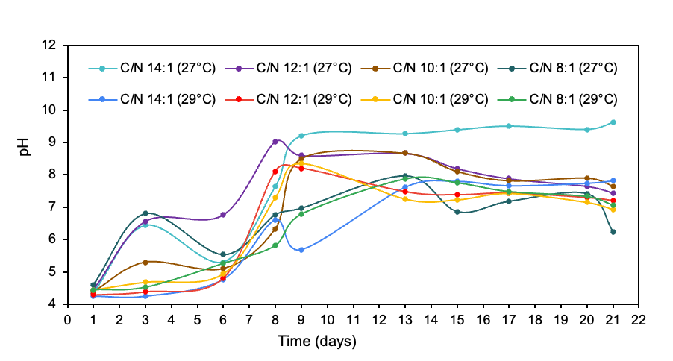
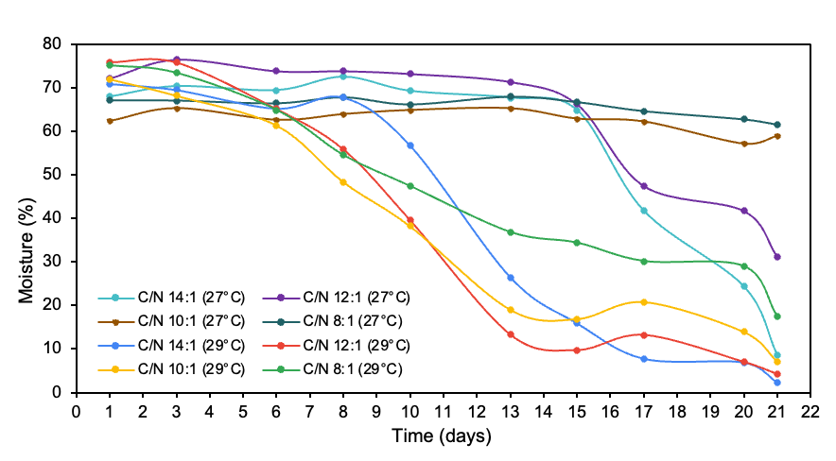
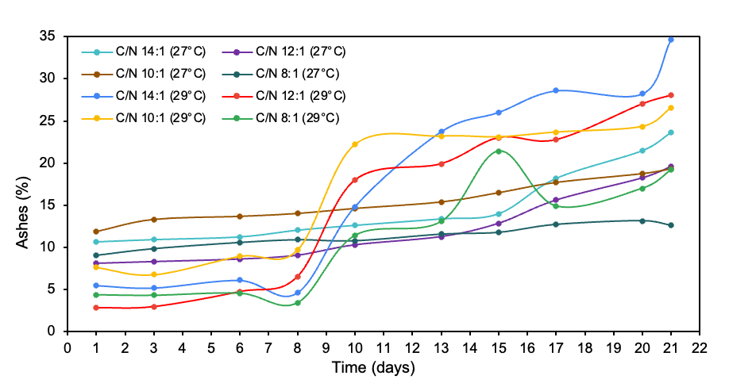
Figure 1: a pH evolution over time, b moisture evolution over time and c ashes evolution over time.
a | b | c

The results of the bromatological analysis of BSF larvae indicate that at 27 °C (Table 3) the diet with C/N 8:1 ratio obtained higher percentage of moisture (73.40%) and ethereal extract (34.80%), with C/N 14:1 ratio was ash (5.74%), with C/N 12:1 was organic nitrogen (8.37%) and with C/N 10:1 was crude protein (53.39%); at 29 °C the diet with C/N 14:1 ratio obtained higher percentage of moisture (60.20%) and ethereal extract (39.00%), and the diet with C/N 10:1 ratio reached the highest percentage of crude protein (53.00%), ash (6.40%) and organic nitrogen (8.32%). Eggink et al. (2022) used six types of diets, after 12 days of hatching reported high levels of ash dry mass (22.90 %) in diet 4, crude protein (59.80 %) in diet 3, extracted free nitrogen (20.90 %) in diet 2, and crude lipids (32.90 %) in diet 1; diet 6 was shrimp waste, which suggests that a substrate of only animal protein does not lead to the highest percentage of protein in the larva, in their research they obtained 49.50 % crude protein, same value of 29 °C with C/N 8:1 (higher percentage of meat waste). The results indicate that there is higher mineral disposition in BSF larvae at 29 °C because the amount of ash is higher than at 27 °C (Arabzadeh et al., 2022); the data of ethereal extract are similar at both temperatures, however, at 29 °C the fat content is higher; in a range of 6.57 to 8.32% are the percentages of nitrogen and between 41.10 to 52.00% of crude protein but they are obtained in higher proportion at 27 °C (7.62-8.37 % and 47.60-52.39%). Some values of this research are higher than those documented by Eggink et al. (2022), such as crude protein and ethereal extract, except for ash and organic nitrogen, because the initial composition of substrates 4 and 1, had high percentages of ash and lipids, respectively, and the same proportion occurs in diet 2 with nitrogen, i.e., the data reported in Table 3 are related to the composition, quality and quantity of substrates at the beginning of the experiment (Prakoso et al., 2022).
Table 3: Partial bromatological analysis and characterization of organic fraction of BSF larvae at 27 and 29 °C
Variable | Unit | 27 °C |  |  |  | 29 °C
 |  | 14:1 | 12:1 | 10:1 | 8:1 | 14:1 | 12:1 | 10:1 | 8:1
Moisture | % DM | 66.50 | 65.60 | 64.10 | 73.40 | 60.20 | 53.20 | 56.50 | 55.90
Ashes | % DM | 5.74 | 4.34 | 3.58 | 3.49 | 6.33 | 5.80 | 6.40 | 4.55
Exthereal extract | % DM | 29.90 | 27.90 | 33.50 | 34.80 | 39.00 | 33.90 | 34.90 | 35.40
Organic nitrogen | % DM | 7.62 | 8.37 | 8.16 | - | 6.57 | 7.68 | 8.32 | 7.92
Crude protein | % DM | 47.60 | 52.39 | 51.00 | - | 41.10 | 48.00 | 52.00 | 49.50
- Insufficient dry sample for the analysis of organic nitrogen and crude protein due to alterations of the larvae in the medium.
DM: dry matter

The survival rate at 27 °C of the mixture with C/N 14:1 was 90.48, 12:1 was 98.29, 10:1 was 82.19 and 8:1 was 0% and at 29 °C of the mixture with C/N 14:1 was 63.38, 12:1 was 48.95, 10:1 was 71.52 and 8:1 was 80.14 %. Tschirner & Simon (2015) used three substrates with different nutrient composition (carbohydrates, proteins and fibers), the reported rates were 55.60 ± 5.40, 21.70 ± 7.70 and 78.30 ± 9.00 %, as in this research the low values of survival rates were reported in diets with excessive protein content, a component that limits the development of BSF larvae. At 27 °C with C/N 8:1 it was 0% due to the nature of the meat waste and reactor position that promoted the humidity to increase until the larvae died by drowning (Arabzadeh et al., 2022). In a range of 25 to 30 °C the effect of temperature was not significant on survival rates (Chia et al., 2018).

Gold et al. (2020) in their research used 7 bioresidues with different content of proteins, non-fibre carbohydrates (NFC), and lipids, the data showed that the bioconversion rate was between 3.80 % (cow dung) and 22. 70 %, (human feces), cow dung in its initial composition was low in protein and lipids, and high in NFC, on the other hand in human feces the opposite occurs, suggesting that the bioconversion rate depends on the initial characteristics of the substrate, specifically the protein and lipid content, because BSF larvae are able to ingest protein easier than fiber lignin, indicating that at 29 °C the bioconversion rate with C/N 14:1 was 9.01, C/N 12:1 was 9.26, C/N 10:1 was 16.24 and with C/N 8:1 was 19.80 %, so the highest lignin content was in the substrate with C/N 14:1 and protein with C/N 8:1 (Table 2) and at 27 °C the bioconversion rate with C/N 14:1 was 15. 74, C/N 12:1 was 21.29 and C/N 10:1 was 25.21 % (the calculation of the bioconversion rate with C/N 8:1 could not be done because the survival rate was 0%) (Arabzadeh et al., 2022).

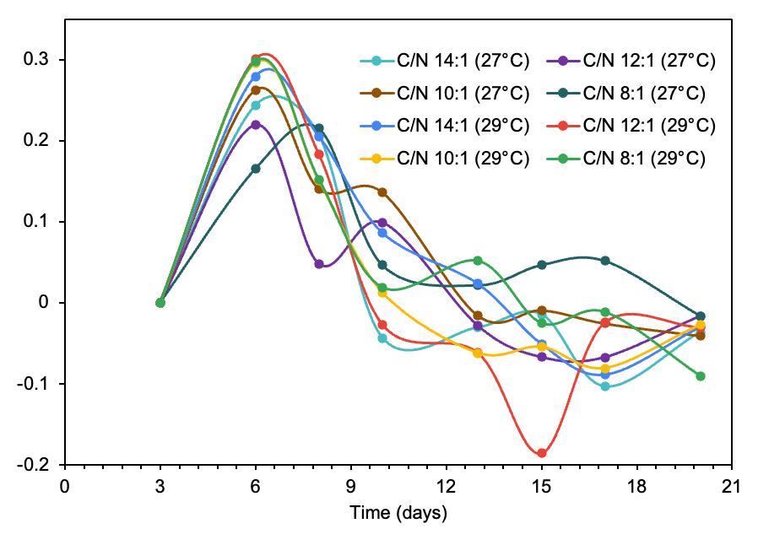
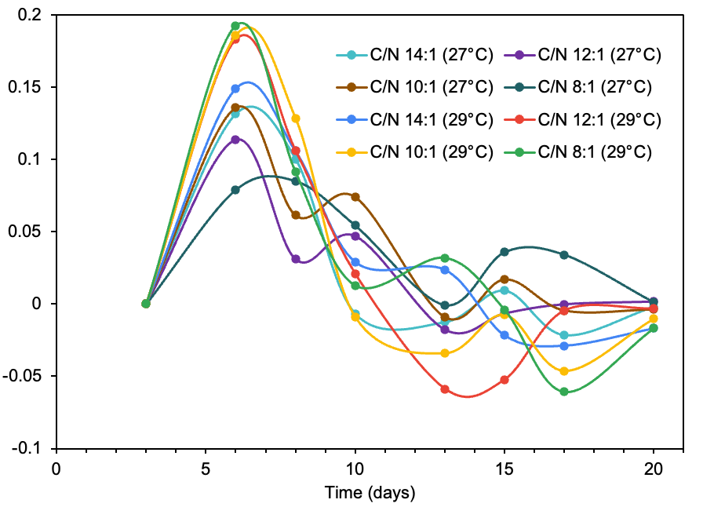
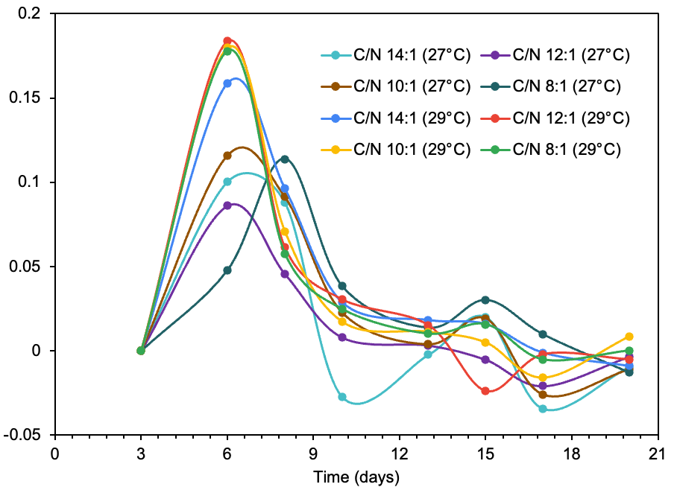
Protein conversion efficiency at 27 °C with C/N 14:1 was 7.48, C/N 12:1 was 11.13 and C/N 10:1 was 12.84 % (protein conversion efficiency could not be calculated with C/N 8:1 because there is no crude protein result), and at 29 °C with C/N 14:1 was 3.56, C/N 12:1 was 4.17, C/N 10:1 was 8.29 and with C/N 8:1 was 9.70 %. Fat conversion efficiency at 27 °C with C/N 14:1 was 4.70, C/N 12:1 was 5.94, C/N 10:1 was 8.43 and C/N 8:1 was 1.71 %, and at 29 °C with C/N 14:1 was 3.34, C/N 12:1 was 2.95, C/N 10:1 was 5.56 and with C/N 8:1 was 6.94 %. At 27 °C the conversion to protein and fat was higher than at 29 °C.
a | b | c
Figure 2: Larvae growth rates of mass, length and width over time (a-c). In the measurements of mass, width and length of BSF larvae, there are no significant differences between C/N ratios and temperatures (p<0.05).

At 27 °C the growth rates (Figure 2) show that the larval development speed in terms of mass is an exponential pattern between the sixth and ninth day of measurement with higher values for C/N 14:1 and 10:1; at 29 °C the maximum growth speed reached was between the sixth and eighth day of measurement with higher values for C/N 12:1 and 10:1; the maximum reach time in both experiments was different. From day 10 the values decrease to negative data representing the reduction in mass, length and width due to metamorphosis (X. Liu et al., 2017). According to Chia et al. (2018) at 30 °C, the growth rates in their study reported more favorable results, similar case to the growth rates of mass, length and width where higher values of velocity were obtained at 29 °C than at 27 °C of the 4 diets. Broeckx et al. (2021) evaluated 12 by-product substrates and 2 standard diets for BSF larvae and concluded that a diet without protein content and very high in fiber hinders the growth of BSF larvae, so that diets with C/N 14:1 with pruning slow the growth rate because they hinder the digestive processes of BSF larvae due to the lignin content, and substrates with high protein concentrations, such as C/N 8:1, limit access for feeding BSF larvae.
  - Conclusion
It was demonstrated that BSF larvae are a promising alternative in the use of fresh, cooked, meat, pruning and grass organic waste, capable of transforming and recovering nutrients depending on the characteristics and initial composition of the substrate, such as the C/N ratios 10:1 and 12:1 (balanced diets), where there is no excess of protein that limits the process due to the nature of the meat waste and the position of the reactor, and also no excess of pruning and grass due to its lignin content. For the highest protein, fat and nutrient yields, with relatively high survival rate, bioconversion rate and conversion efficiency, it is set at 27 °C if better protein and nitrogen results are expected, and at 29 °C if high fat and nutrient values are expected, maintaining relative humidity between 65 and 80 % in the laboratory-scale reactor configuration. To enhance the potential of the process, the possibility of cryopreserving the pre-spawns on the sixth and ninth days of measurement is proposed, this strategy seeks to make better use of nutrients; it is proposed to use another type of waste where the physical and nutritional profiles are adjusted to the requirements of BSF adapted in an automated reactor for greater precision of the data and operating conditions, and also evaluate the amino acid profile of substrates and BSF larvae to determine whether they meet the essential amino acid requirements proposed by FAO for human nutrition. The advancement of this research highlights the feasibility of using BSF larvae as an alternative source in terms of nutritional efficacy for the development and growth of animals, in particular poultry and ruminants, which represent valuable sources of protein and fat in the human diet for the purpose of alleviating starvation and strengthening food security. This approach carried out in a short time frame, contributing to the application of sustainable technologies for waste management, with economic viability and engineering efficiency.

References

Acosta, M., & Guzmán, V. (2022). Evaluación del contenido proteico de las larvas de la mosca soldado negro ( Hermetia Illucens Sp .) durante el proceso de degradación de biorresiduos. Universidad de América.
Arabzadeh, G., Delisle-Houde, M., Tweddell, R., Deschamps, M.-H., Dorais, M., Lebeuf, Y., Derome, N., & Vandenberg, G. (2022). Diet Composition Influences Growth Performance, Bioconversion of Black Soldier Fly Larvae: Agronomic Value and In Vitro Biofungicidal Activity of Derived Frass. Agronomy, 12.
Barragan, K., Gort, G., Dicke, M., & Van Loon, J. (2019). Effects of dietary protein and carbohydrate onlife-history traits and body protein and fat contents ofthe black soldier flyHermetia illucens. Physiological Entomology, 44, 148–159.
Broeckx, L., Frooninckx, L., Slegers, L., Berrens, S., Noyens, I., Goossens, S., Verheyen, G., Wuyts, A., & Van Miert, S. (2021). Growth of Black Soldier Fly Larvae Reared on Organic Side-Streams. Sustainability, 13.
Chia, S., Tanga, C., Khamis, F., Mohamed, S., Salifu, D., Sevgan, S., Fiaboe, K., Niassy, S., Loon, J., Dicke, M., & Ekesi, S. (2018). Threshold temperatures and thermal requirements of black soldier fly Hermetia illucens: Implications for mass production. PLoS ONE, 13(11).
Delgado, M., Mendoza, K., González, M., Tadeo, J., & Martín, J. (2019). Evaluación del proceso de compostaje de residuos avícolas empleando diferentes mezclas de sustratos. 965–977.
Eggink, K., Lund, I., Pedersen, P., Hansen, B., & Dalsgaard, J. (2022). Biowaste and by-products as rearing substrates for black soldier fly (Hermetia illucens) larvae: Effects on larval body composition and performance. Plos One, 17(9).
FAO. (2022, September). Tackling food loss and waste: A triple win opportunity.
FAO. (2023, June 15). Perspectivas alimentarias de la FAO: La producción mundial se expandirá, pero la disminución de las importaciones de los países más vulnerables es motivo de preocupación.
FAO, FIDA, OMS, PMA, & UNICEF. (2022). The State of Food Security and Nutrition in the World 2022. In FAO publications catalogue 2022. FAO. https://doi.org/10.4060/CC2323EN
FAO of the United Nations. (2022). Voluntary Code of Conduct for Food Loss and Waste Reduction.
Gold, M., Cassar, C., Zurbrügg, C., Kreuze, M., & Boulos, S. (2020). Biowaste treatment with black soldier fly larvae: Increasing performance through the formulation of biowastes based on protein and carbohydrates. Waste Management.
ICONTEC. (2022). NTC 5167 Productos para la industria agrícola. Productos orgánicos usados como abonos o fertilizantes y enmiendas o acondicionadores de suelo.
Kaza, S., Yao, L. C., Bhada-Tata, P., & Van Woerden, F. (2018). What a Waste 2.0. What a Waste 2.0: A Global Snapshot of Solid Waste Management to 2050. https://doi.org/10.1596/978-1-4648-1329-0
Liu, X., Chen, X., Wang, H., Yang, Q., Rehman, K., Li, W., Cai, M., Ling, Q., Mazza, L., Zhang, J., Yu, Z., & Zheng, L. (2017). Dynamic changes of nutrient composition throughout the entire life cycle of black soldier fly. Plos One, 2.
Liu, Z., Minor, M., Morel, P. C. H., & Najar-Rodriguez, A. J. (2018). Bioconversion of Three Organic Wastes by Black Soldier Fly (Diptera: Stratiomyidae) Larvae. Environmental Entomology, 47(6), 1609–1617.
Michishita, R., Shimoda, M., Furukawa, S., & Uehara, T. (2023). Inoculation with black soldier fly larvae alters the microbiome and volatile organic compound profile of decomposing food waste. Scientific Reports.
Muñoz, L., & Parada, M. (2022). Definición de las condiciones de operación para la producción de larva de mosca soldado negra (Hermetia Illucens). Fundación Universidad de América.
Naser El Deen, S., van Rozen, K., Elissen, H., Wikselaar, P., Fodor, I., van der Weide, R., Hoek-van den Hil, E. F., Rezaei Far, A., & Veldkamp, T. (2023). Bioconversion of Different Waste Streams of Animal and Vegetal Origin and Manure by Black Soldier Fly Larvae Hermetia illucens L. (Diptera: Stratiomyidae). Insects.
Prakoso, V. A., Irawan, A., Iswantari, A., Maulana, F., Samsudin, R., & Jayanegara, A. (2022). Evaluation of dietary inclusion of black soldier fly (Hermetia illucens) larvae on fish production performance: a meta-analysis. Journal of Insects as Food and Feed, 8(11), 1373–1384.
Salam, M., Shahzadi, A., Zheng, H., Alam, F., Nabi, G., Dezhi, S., Ullah, W., Ammara, S., Ali, N., & Bilal, M. (2022). Effect of different environmental conditions on the growth and development of Black Soldier Fly Larvae and its utilization in solid waste management and pollution mitigation. Environmental Technology and Innovation, 28. https://doi.org/10.1016/J.ETI.2022.102649
Singh, A., & Kumari, K. (2019). An inclusive approach for organic waste treatment and valorisation using Black Soldier Fly larvae: A review. Environmental Management, 2–4.
Tran, C., Le, T., Pham, C. D., Doung, Y., Le, P., & Tran, T. (2022). Valorization of Black Soldier Flies at Different Life Cycle Stages. CHEMICAL ENGINEERING TRANSACTIONS, 97, 139–144. https://doi.org/10.3303/CET2297024
Tschirner, M., & Simon, A. (2015). Influencia de diferentes sustratos de cultivo y procesamiento en la composición de nutrientes.de larvas de mosca soldado negra destinadas a la ali. Journal of Insects as Food and Feed, 1(4), 249–259.
UNEP. (2021). UN: 17% of all food available at consumer levels is wasted.
United Nations Department of Economic and Social Affairs, P. D. (2022). World Population Prospects 2022 Summary of Results.
United Nations One Planet. (2022, September 1). Circular Economy of organic waste for the city and the countryside.

