CHEMICAL ENGINEERING TRANSACTIONS  VOL. , 2024 | A publication of
The Italian Association
of Chemical Engineering
Online at www.cetjournal.it

Guest Editors: Leonardo Tognotti, Rubens Maciel Filho, Viatcheslav Kafarov
Copyright © 2024, AIDIC Servizi S.r.l.
ISBN 979-12-81206-09-0; ISSN 2283-9216

Bio-aviation fuels from lignocellulose fast pyrolysis oils
Dong Jin Suh^{a,*}, Chun-Jae Yooª, Jae-Wook Choiª, Jeong-Myeong Haª
ªClean Energy Research Center, Korea Institute of Science and Technology, Seoul 02792, Republic of Korea
djsuh@kist.re.kr
Bio-aviation fuels were prepared by the catalytic upgrading of lignocellulose fast pyrolysis oil, or bio-crude. Hydrotreating was performed for upgrading the oils. The oxygen atoms in the bio-crude were removed using the fixed bed continuous flow reaction systems composed of the multiple catalyst beds. The complete deoxygenation was observed and the possible applications of bio-crude-derived deoxygenated hydrocarbon fuels for aviation fuels were discussed. The detailed characterizations of catalysts using Raman, XRD, XPS, TEM, and other methods confirmed the improved activity or selectivity of the catalysts used in this study. The reaction products were also analyzed using GC, GPC, Karl Fischer titration, and other methods for understanding the reaction pathways and for obtaining the insight to improve the upgrading process.
  - Introduction
Sustainable aviation fuels are being intensively studied because of international regulations for reducing carbon footprint in the aviation industry. While the paraffins obtained from lipids or synthesis gas are widely selected as sustainable aviation fuels, the limited feedstocks of lipids cannot fulfil the global demands, and the lignocellulose can supply the cheap and sustainable feedstock for the bio-aviation fuels (Kim et al., 2020). The biomass pyrolysis oil, or bio-crude, produced by the fast pyrolysis of lignocellulose contains a large quantity of oxygenates and water, increasing its acidity and viscosity. Because the petroleum-based liquid fuels do not contain oxygen atoms, the deoxygenation of bio-crude is required and the hydrodeoxygenation of bio-crude has been studied as feasible methods to obtain hydrocarbon fuels from biomass. The low carbon number hydrocarbons can be obtained by the hydrodeoxygenation of lignin-derived monomeric phenolic molecules and cellulose-derived small oxygenates, which are not appropriate as aviation fuels. In this study, the production of high carbon number cycloalkanes, or naphthenes, from these low carbon number phenolic molecules was performed. The cyclic alcohols, prepared by the selective hydrogenation of phenols, were condensed with the phenolic molecules by the alkylation, which can be further hydrodeoxygenated to obtain the high carbon number naphthenes as appropriate candidates for aviation fuels. The detailed reaction mechanism and the roles of catalysts in the multiple reaction steps were discussed to maximize the production of bio-aviation fuels from bio-crude.
  - Experimental methods
The catalytic conversion of lignocellulose fast pyrolysis oil (bio-crude) and its corresponding model reactants to bio-aviation fuels was performed using three- or four-step reaction. The catalysts and reaction products were characterized to understand the reaction mechanisms.
    - Three-step reaction using model reactants
The three-step hydrotreating reaction was performed using a 150-mL batch reactor. The first step converted the phenolic model compounds (syringol, 4-ethyl guaiacol, and propyl phenol) into the corresponding cyclic alcohols. NiFe/TiO₂ catalyst was mixed with reactants and n-decane solvent in the reactor, and the reaction was performed at 270 °C and 5 MPa H₂. The second step condensed the cyclic alcohols with phenol in the presence of catalysts, including H-form of Y zeolite (HY30, Si/Al = 30 mol/mol), H-form of β-zeolite (HBEA38, Si/Al = 30 mol/mol), tungstated zirconia (WZr), sulfated ZrO₂ (S-ZrO₂), γ-alumina (γ-Al₂O₃), and silica-alumina (SiO₂-Al₂O₃), at 160 °C and 4 MPa H₂. The third step hydrodeoxygenated the products of the second step using 3 wt% Ru/WZr at 200 °C and 5 MPa H₂. A mixture consisting of products and the catalyst was collected using a conical tube (50 mL). 1 mL of the product was filtered using a PTFE membrane syringe filter (pore size: 0.45 μm). Following this, the liquid was transferred to a 5 mL volumetric flask. 1 mL of an internal standard (n-hexadecane) solvent was mixed and diluted in n-decane. The liquid products were characterized using the gas chromatography-mass spectrometry (GC–MS). The GC–MS system (Agilent 78900A; 5975C inert MS XLD with triple axis-detector) was equipped with an autosampler injector (Agilent 7860 N) and an HP–5MS capillary column (60 m × 0.25 μm × 0.25 mm ID). The liquid product was quantitatively analyzed using a gas chromatography–flame ionization detector (GC–FID, Hewlett 5890 Packard Series II, USA) equipped with an autosampler injector (6890 series injector) and HP–5MS capillary column (60 m × 0.25 μm × 0.25 mm ID). The spent catalyst was recovered from the residual mixture of products following the vacuum filtration. The recovered catalyst was washed with acetone to remove n-decane and organic compounds. The obtained catalyst was dried at 105 °C for 16 h, and the dried catalyst was analysed by Thermogravimetric Analysis (TG) to calculate the coke.
    - Four-step reaction using bio-crude
The four-step reaction was performed using a 150-mL batch reactor. The first step hydrotreated the bio-crude (6 g, purchased from BTG Biomass Technology Group BV) mixed with n-decane (50 mL) using 5 wt% Pd/C at 200 °c and 5 MPa H₂. The second step hydrogenated the phenolic monomers prepared in the first step to the corresponding cyclic alcohols using NiFe/TiO₂ at 270 °C and 5 MPa H₂. The third step condensed the cyclic alcohols and phenolic compounds using HY30, HBEA38, and WZr at 160 °C and 4 MPa H₂. The fourth step hydrodeoxygenated the products of the third step using 3 wt% Ru/WZr at 200 °C and 5 MPa H₂. The bio-oil products of each step also were identified using a GC-MS.
    - Catalyst characterizations
Temperature programmed desorption of NH₃ (NH₃-TPD) and temperature programmed reduction of H₂ (H₂-TPR) analyses were performed using a BELCAT-B catalyst analyzer (BEL Japan, Osaka, Japan) equipped with a thermal conductivity detector (TCD). For NH₃-TPD, the catalyst (50-100 mg) was heated at 300 ◦C for 1 h under a flow of He (a flow rate of 50 mL/min). Following this, the sample had been stabilized at 100 ◦C, NH/He (4.96 % v/v) mixture was added for 30 min, followed by flushing with He flow for 15 min. The desorption of NH₃ was observed in the He using TCD at 100-900 ◦C with a heating rate of 10 ◦C/min. For H₂-TPR, the catalyst (100-200 mg) was pretreated at 400 ◦C for 1 h under a flow of O₂/He (5.03% v/v). Following this, the catalyst was heated to 600-800 ◦C under a flow of H₂/Ar (5% v/v) with a heating rate 10 ◦C/min (a flow rate of 30 mL/min). The produced water was removed using a molecular sieve trap.
  - Results and discussion
    - Catalysis using phenolic model mixtures
The process suggested in this study requires three or four step reaction to obtain condensed hydrocarbons as final products. Prior to performing the actual bio crude, a mode mixture of syringol, 4-ethyl guaiacol, and 4-propyl phenol mixed with n-decane solvent was used for the reactions. The first step reaction, designed to selectively hydrogenate phenolic molecules to their corresponding saturated cyclic alcohols, was performed using NiFe/TiO₂ (Figure 1 and Table 1). Nearly complete conversion (approximately 100%) of phenolic molecules was observed, and the cyclic alcohols, including cyclohexanol, 4-ethyl cyclohexanol, and 4-propyl cyclohexanol, were obtained as major products (79% yield).
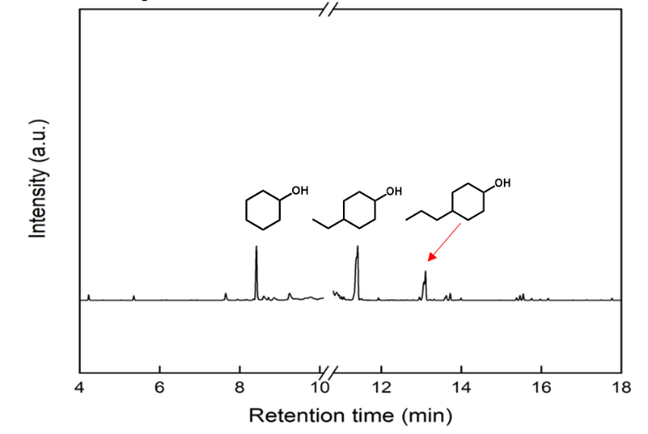
Figure 1: GC-MS result of the first step hydrogenation of model phenolic mixtures
The second step reaction, designed to condense cyclic alcohols and phenols, was performed using several solid acid catalysts including HY30, HBEA38, WZr, S-ZrO₂, γ-Al₂O₃, and SiO₂-Al₂O₃. The cyclic alcohols prepared in the first step were mixed with phenols for the condensation Dimers composed of cyclic alcohols and phenols were observed only for HY30, HBEA38, and WZr, exhibiting 39%, 26%, and 17%, respectively, although the large yields of cokes were also observed for HY30 and HBEA38 (Figure 2 and Table 2).
Table 1: Products of the first step hydrogenation of model phenolic mixtures
Product | Yield (%)
Paraffins | 12
Cyclic alcohols | 79
Others | 8
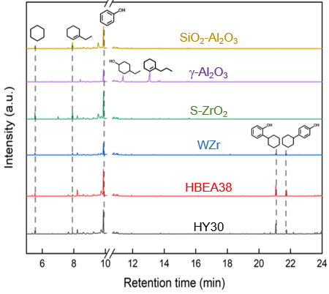
Figure 2: GC-MS results for the second step alkylation of cyclic alcohols and phenol
Table 2: Product distribution of the second step alkylation of cyclic alcohols and phenol
Catalyst | Reactants (%) |  | Product (%)
 | Phenols | Cyclic alcohols | Monomers | Dimers | Trimers | Coke
HY | 31 | 0 | 40 | 29 | 1 | 11
Hβ | 33 | 0 | 40 | 26 | 1 | 10
WZr | 39 | 0 | 43 | 17 | 1 | 1
S-ZrO₂ | 40 | 0 | 60 | 1 | 0 | 1
γ-Al₂O₃ | 28 | 0 | 42 | 0 | 0 | 0.04
SiO₂-Al₂O₃ | 43 | 0.1 | 57 | 0 | 0 | 2

The better alkylation activity of HY30 and HBEA38 can be attributed to their larger quantities of acid sites as measured by NH₃-TPD (Table 3). The quantity of acid sites decreased in the order of HY30 > HBEA38 > S-ZrO₂ > SiO₂-Al₂O₃ > γ-Al₂O₃ >WZr suggesting that more acid sites can improve the alkylation (Yang et al., 2021). The high alkylation activity of WZr has been reported in the literature (Sarish et al., 2005). The total quantity of acid sites, measured by NH₃-TPD, was not fully correlated with the alkylation results, which can be attributed to the pore structures of catalysts (Lee et al., 2015). The acid sites on the external surface of catalysts can be more easily accessed by the reactants, and the catalysts with higher external surface areas can exhibit higher catalytic activity.
Table 3: Quantity of acid sites on the catalysts measured using NH₃-TPD
Catalyst | Quantity of acid sites (mmol·g⁻¹)
HY | 0.988
Hβ | 0.729
WZr | 0.164
S-ZrO₂ | 0.557
γ-Al₂O₃ | 0.335
SiO₂-Al₂O₃ | 0.439

The third step reaction, designed to hydrodeoxygenate the products of second step reaction, was performed using Ru/WZr (Figure 6). The production of cycloalkanes, or naphthenes, was observed. Because the alkylated compounds composed of two ring moieties were present in the reactant mixture of the third step reaction, the production of cycloalkanes composed of two saturated cyclohexyl rings was observed. Notably, Ru/WZr was used because it was a highly active hydrodeoxygenation catalyst as suggested in our previous study (Jo et al., 2022).

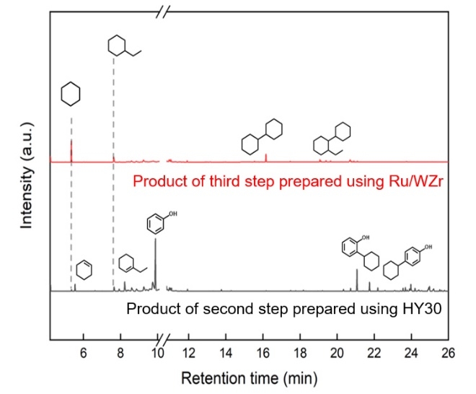
Figure 3: GC-MS results for the third step hydrodeoxygenation of second step product prepared using HY30. The hydrodeoxygenation was performed using Ru/WZr
    - Catalysis results using bio-crude
Based on the three step reaction using a model mixture of phenolic molecules, the four step reaction using bio-crude was designed and performed. The first step reaction, designed to hydrotreat raw bio-crude, was performed using 5 wt% Pd/C (Figure 7). By the first hydrotreating, the bio-crude was stabilized. The presence of phenolic monomers including guaiacol, creosol, 4-ehtyl guaiacol, and 4-propyl guaiacol was observed in the hydrotreated bio-crude. The second step reaction, designed to hydrogenate the phenyl rings in the bio-crude, was performed using NiFe/TiO₂. The production of cyclic alcohols and other compounds containing saturated rings was observed. After the second step reaction, almost all phenyl rings in the bio-crude were converted to the saturated rings.
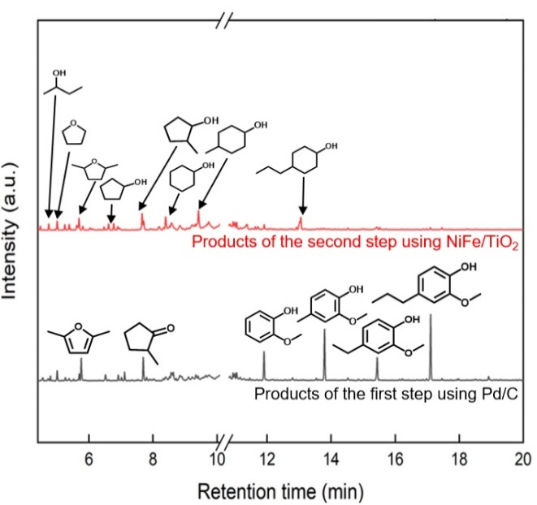
Figure 4: GC-MS result for the first and second step reacionts using bio-crude
For the third step reaction, designed to condense cyclic alcohols with phenols, using the products of second step reaction, HY30, HBEA38, and WZr were used as catalysts because they exhibited the higher yields of dimeric compounds for the alkylation using phenolic model compounds. Only HY30 produced dimeric compounds (Figure 5), indicating the large amount of acid sites are required for the reaction.
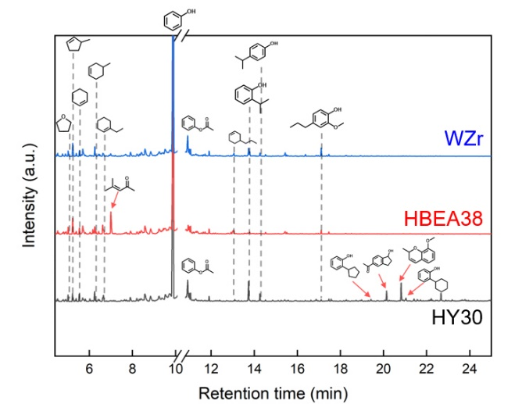
Figure 5: GC-MS results for the third step alkylation of bio-crude-derived cyclic alcohols using phenol on WZr, HBEA38, and HY30 catalysts
The fourth step reaction, designed to hydrodeoxygenate the products of the third step reaction, was performed using Ru/WZr (Figure 6). Complete hydrodeoxygenation was observed, and the production of saturated dimeric cycloalkanes containing C12-15 was observed.
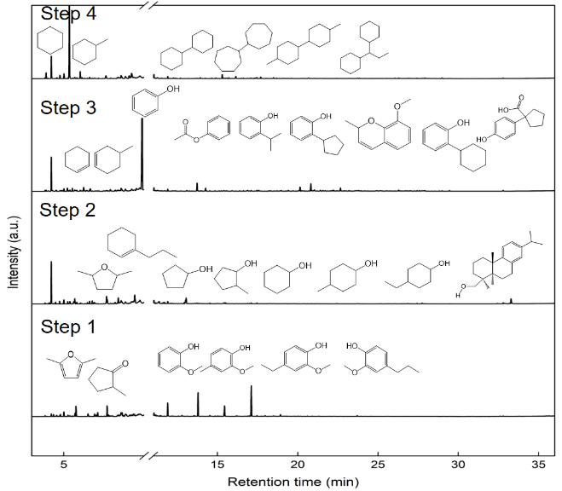
Figure 6: GC-MS results for products from each step using bio-crude
Based on the observed reaction results, the reaction mechanism was suggested (Figure 7). The cyclic alcohols were dehydrated to form cycloalkene which was condensed with phenols. Dimers prepared by this reaction can be further hydrogenated and hydrodeoxygenated to obtain cycloalkanes containing two or more saturated rings.
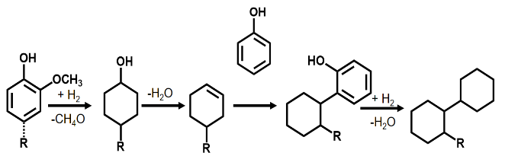
Figure 7: Suggested reaction mechanism
    - Catalyst characterization
H₂-TPR was performed to understand the reducibility and hydrogenation activity of NiFe/TiO₂ and Ru/WZr catalysts (Figure 8). While Ru/WZr exhibited the low temperature reduction of RuO_{x} to Ru⁰ (< 180 °C), NiFe/TiO₂ exhibited the reduction of Ni²⁺ to Ni⁰ at 200-300 °C, which is lower than the observed reduction temperature (300-400 °C) for the reduction of Ni oxides. The shift of the reduction temperature peak to the lower temperature can be attributed to the modification of Ni by the addition of Fe (Insyani et al., 2022). Notably, two reduction peaks at 94 and 120 °C observed in Ru/WZr can be attributed to the large Ru particles (Wang et al., 2012).

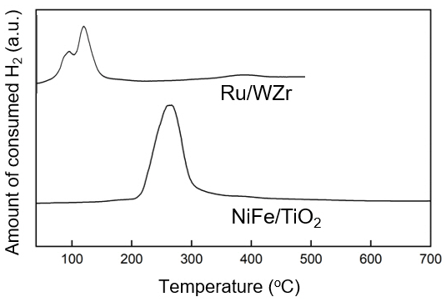
Figure 8: H2-TPR results of Ru/WZr and NiFe/TiO₂
The unique structure of NiFe/TiO₂ was also observed using TEM-EDS mapping and the formation of NiFe-FeO_{x} shells and Ni core on TiO₂ support as reported in our previous study (Figure 9) (Insyani et al., 2022).
Figure 9: (A) STEM image and (B) EDS map of NiFe/TiO₂
  - Conclusions
The overall reaction pathway of bio-crude into high carbon number cycloalkanes, or naphthenes, containing two or more saturated rings was suggested through the multi-step reaction. Selective hydrogenation, alkylation, and hydrodeoxygenation were used to convert the phenolic compounds in the bio-crude. The suggested process can be useful to obtain the high carbon number hydrocarbons appropriate to the aviation fuels.
Acknowledgments
This work was supported by the Technology Development Program to Solve Climate Change of the National Research Foundation (NRF) funded by the Ministry of Science and ICT of Republic of Korea (NRF-2020M1A2A2079798).
References
Insyani, R., Kim, M.-K., Choi, J.-W., Yoo, C.-J., Suh, D.J., Lee, H., Kim, C.S., Ho Kim, K., Kim, K., Ha, J.-M., 2022, Selective hydrodeoxygenation of biomass pyrolysis oil and lignin-derived oxygenates to cyclic alcohols using the bimetallic NiFe core-shell supported on TiO₂, Chemical Engineering Journal, 446, 136578.
Jo, H., Choo, H., Choi, J.-W., Suh, D.J., Yoo, C.-J., Kim, C.S., Ho Kim, K., Lee, H., Kim, K., Choi, J., Ha, J.-M., 2022, One-pot selective production of deoxygenated monomeric, dimeric, and trimeric hydrocarbons from xylose-derived 2-methylfuran using multifunctional tungstate-zirconia-supported Ru, Pd, and Ni catalysts, Chemical Engineering Journal, 441, 135581.
Kim, Y., Shim, J., Choi, J.-W., Suh, D.J., Park, Y.-K., Lee, U., Choi, J., Ha, J.-M., 2020, Continuous-flow production of petroleum-replacing fuels from highly viscous Kraft lignin pyrolysis oil using its hydrocracked oil as a solvent, Energy Conversion and Management, 213, 112728.
Lee, Y., Choi, J.-W., Suh, D.J., Ha, J.-M., Lee, C.-H., 2015, Ketonization of hexanoic acid to diesel-blendable 6-undecanone on the stable zirconia aerogel catalyst, Applied Catalysis A: General, 506, 288-293.
Sarish, S., Devassy, B.M., Böhringer, W., Fletcher, J., Halligudi, S.B., 2005, Liquid-phase alkylation of phenol with long-chain olefins over WO_{x}/ZrO₂ solid acid catalysts, Journal of Molecular Catalysis A: Chemical, 240, 123-131.
Wang, L., Chen, J., Patel, A., Rudolph, V., Zhu, Z., 2012, Catalytic performance of Ru nanoparticles supported on different mesoporous silicas for preferential oxidation of CO in H₂-rich atmosphere, Applied Catalysis A: General, 447-448, 200-209.
Yang, H., Joh, H.-I., Choo, H., Choi, J.-W., Suh, D.J., Lee, U., Choi, J., Ha, J.-M., 2021, Condensation of furans for the production of diesel precursors: A study on the effects of surface acid sites of sulfonated carbon catalysts, Catalysis Today, 375, 155-163.

