CHEMICAL ENGINEERING TRANSACTIONS  VOL. , 2024 | A publication of
The Italian Association
of Chemical Engineering
Online at www.cetjournal.it

Guest Editors: Leonardo Tognotti, Rubens Maciel Filho, Viatcheslav Kafarov
Copyright © 2024, AIDIC Servizi S.r.l.
ISBN 979-12-81206-09-0; ISSN 2283-9216

Innovative Application of Kolbe Reaction on Constituents of Plant Oils
Haroon Ahmad*, Benedetta Bertolotti, Isabella Natali Sora
Department of Engineering and Applied Sciences and CSGI, University of Bergamo, 24044 Dalmine, BG, Italy
haroon.ahmad@unibg.it
This work presents the conversion of single and mixture of fatty acids (1:1) into defined chemical products using an electrolysis technique. Lauric acid and palmitic acid are used as substrates as both acids are principal constituents of different vegetable oils like coconut oil and palm oil. The impact of operating parameters such as current intensity (10 mA–100 mA), amount of KOH (0.4–1.7 eq.), electrolysis time (2–18 h), and different solvent environments on the process performance has been investigated in terms of chemicals production, especially focusing on the dimers yield. The achieved results show 65% and 23% of the dimers yield from the electrolysis of lauric acid and palmitic acid respectively, with nearly full dissociation of substrate acids, at 70 mA current intensity with alternate polarity of 30 minutes, 1.5 eq. of KOH, 6 h of electrolysis time in EtOH:MeOH:H₂O solvent system. Whereas, using the same experimental conditions, the mixture of both acids (1:1) shows 45% of the dimers including n-docosane and n-triacontane as homocoupling and n-hexacosane as hetero-coupling, with nearly fully dissociation of acid substrate.
1. Introduction
In recent times, the demand for clean, economically viable and renewable energy sources like biofuel has risen because of environmental concerns. Biofuels are energy sources that can be prepared from waste cooking oil, animal fats and vegetable and plant oils (Ho et al., 2014). The high-energy storage substances like fats and oils from plants and animals can be used to produce biofuels and other useful chemicals (Kalnes et al., 2007). Biofuel has many advantages in comparison to petroleum such as low sulfur content, domestic origin, safer handling due to high flash point and biodegradability (Cai et al., 2015). One barrier to biofuel commercialization is the high production cost i.e., only the raw materials account for nearly 80% cost of producing biofuels (Semwal et al., 2011).
The are many approaches for the production of biofuels. The most common and conventional method is the transesterification method, in which biofuel is straightforwardly produced using an acid or base catalyst in shorter chain alcohols like methanol (Mansir et al., 2017). The other pathways include thermal cracking (Weisz et al., 1979), combustion of raw oil and electrolysis methods (Fereidooni et al., 2018). In the electrolysis method has the advantages of time-saving, reduced energy usage and no need for purification stages for dewatering (Putra et al., 2015). Different electrochemistry reactions like anodic coupling of biomolecules (Kirste et al., 2012), cathodic decarboxylation (Hegner et al., 2019), and hydrogenation reactions are on the frontline. The anodic decarboxylation of carboxylic acids also known as Kolbe electrolysis shows a great potential for the development of electro-biorefineries.
The Kolbe electrolysis which was discovered in the 19th century is an environmentally friendly pathway because it can be conducted in aqueous solutions and at room temperature. Until now, many studies on the conditions of the Kolbe electrolysis reaction have been carried out for tuning the selectivity of the specific reaction pathway. The concentration of fatty acid, current density, electrode material, temperature, solvent nature and pH value are found to have a broad effect on the selectivity of the products.
Many researchers utilize the Kolbe electrolysis for many different applications, especially to open a way for direct electrolysis on the bio-resources into biofuels. For example, (R. dos Santos et al., 2015) investigated the conversion of fatty acids and triglycerides in organic and aqueous solvents into ether and olefins. (Meyers et al., 2019) investigated the Kolbe electrolysis of 3-hydroxy-decanoic acid into diesel like fuels. Joschka Holzhäuser et al., (2019) investigated the direct electrocatalytic conversion of lignocellulose biomass for fuel production. (Nilges et al., 2012) used two-step electrochemical conversion for the production of octane as a fuel from levulinic acid through valeric acid.
A common restriction in the electrochemical process for the conversion of biomass feedstock is their solubility. Therefore, a recent trend in the Kolbe electrolysis is to use the process in combination with biological, chemical or thermal pretreatment processes for the conversion of biomass into biofuels. Recently, (Urban et al., 2017) successfully proved the conversion of corn beer to a hydrocarbon mixture as a drop-in-fuel by using combined microbial and electrolysis methods. Similarly, (Teetz et al., 2022) produces green fuels and solvents by utilizing the combination of biosynthesis and electrosynthesis. The second challenge for the direct electrochemical conversion of biomass is its complex structure. Therefore, it is important to ensure the contact between substrate and electrode for the efficient conversion. A very important work for understanding the mechanism of homo- and hetero-coupling of bio-based mixture of fatty acids providing full detail of electrons transfers and product formation was done by (Neubert et al., 2022).
This study describes the Kolbe electrolysis of single long-chain carboxylic acids (lauric and palmitic acids) that are the essential parts of different vegetable oils. Lauric acid is the main constituent of coconut oil (45,4 g/100 g f.a._{tot}, where f.a._{tot} is the total of fatty acids) and of palm-kernel oil (46,9 g/100 g f.a._{tot}). Palmitic acid constitutes 40,1 g/100 g f.a._{tot} of palm oil (Johnstone, 1991). These acids are commonly obtained from vegetable oils through biological conversion, and thereof the electrolysis on the mixture of carboxylic acids is also performed. Since using the mixture of carboxylic acids can be a representative for the implementation of combined electrochemical with biological process. The electrolysis of single and mixture of carboxylic acids were conducted for the production of long chain hydrocarbons as a result of homo- and hetero-coupling of radicals, which have many industrial applications like diesel and heavy fuel production, waxes and lubricants, pharmaceutical and agrochemicals etc. The effect of different parameters on the electrolysis of single/mixture of carboxylic acids and their product distribution were investigated.

2. Materials
Lauric acid (n-dodecanoic acid, C12H24O₂, 97 %, white powder), palmitic acid (hexadecanoic acid, C₁₆H₃₂O₂, 97 %, white scales), potassium hydroxide (KOH, 97 %,) ethyl acetate (99.5 %) methanol (MeOH, 99.5 %), ethanol (EtOH, 99.5 %), and hexane (n-hexane, 99.5 %), were used as purchased (Sigma-Aldrich).

3. Experimental setup and procedure
All the experiments were conducted using a galvanostatic/potentiostatic controlled system, commercially available, easy to use ElectraSyn 2.0 (IKA®), figure 1a. Two non-commercial platinum electrodes were used, as working and counter electrodes, to overcome the electrode damage observed during prolonged electrolysis arising when a commercial Pt-coated electrode is used (Ahmad et al., 2023) (figure 1b). The dimensions (W x L x H) of both electrodes were 0.7cm x 5.3cm x 0.04cm, the total geometrical surface area was 7.9 cm² and 5 mm the gap between the electrodes. In a detailed procedure, a 20 mL vial with a magnetic bar was sequentially charged with acid i.e., lauric acid (C₁₂H₂₄O₂), palmitic acid (C₁₆H₃₂O₂), mixture C₁₂:C₁₆ (1:1), KOH and solvent. Then, the electrodes were inserted in the vial, which was closed with a cap, and the reaction mixture was stirred for 5 minutes at 500 rpm. Next, the vial was connected with the ElectraSyn 2.0 setup, and the experiment was carried out at room temperature with the stirring at 600 rpm. All the experiments were conducted in a duplicate trail and the final value was taken as an average. After completion, the mixture was transferred quantitively to a round-bottom flask, and the solvent was evaporated by rotary evaporator. The residues were then treated with acidified water to transform laurate and palmitate salts back into corresponding acids and the organic layer was extracted with ethyl acetate. The organic phase was dried with sodium sulfate and then analyzed by gas chromatography-mass spectrometry (GC/MS) to determine the product distribution. The GC/MS analysis was performed on an Agilent 6850 chromatography instrument equipped with an Agilent 5975N mass spectrometer.
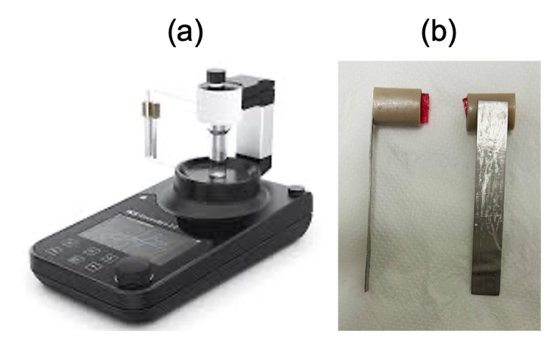
Figure 1: (a) ElectraSyn 2.0 instrument (b) Non-commercial platinum electrodes.
4. Results and discussion
4.1. Kolbe electrolysis of lauric acid
Four factors (electrolysis conditions and reaction parameters) were studied for the electrolysis of lauric acid: (1) current intensity; (2) KOH loading; (3) electrolysis duration; and (4) the nature of the solvent. The first set of tests examined the impact of constant current intensity within the range of 10 mA to 100 mA with an alternate polarity (AP) after each 30 minutes. The remaining parameters remained constant, with the following values: 0.7 mmol lauric acid, 0.4 eq. of KOH, MeOH as the solvent, and 6 h for electrolysis. Figure 2a displays a product spectrum that includes the formation of docosane as a dimer, undecane and undecene as other hydrocarbons resulting from the disproportionation of radicals, undecanol as alcohol, and undecanal as aldehydes. Alkene and ester formation is presumably caused by a small degree of carbocation generation known as non-Kolbe or Hofer-Moest reaction. Because a significant quantity of unreacted lauric acid was detected in the product distribution, it was determined that, when employing MeOH as the solvent system at 0.4 eq. of KOH, there was a small conversion rate of lauric acid even at higher current intensities. A small portion of the peaks that were undetected by GC/MS in the trials with current intensities of 70 mA and 85 mA emerged and are named undetected peaks.
The impact of KOH loading (0.4, 0.7, 1, 1.3, and 1.5 eq.) was then examined while keeping constant the remaining parameters as 0.7 mmol acid, 70 mA of current intensity (AP=30 min), MeOH as the solvent, and a 6 h electrolysis time. Figure 2b illustrates that using 0.4 eq. of KOH results in a greater dimer yield (19%); nonetheless, overall, the conversion rate was low, with almost 80% of the unreacted acid remaining visible in all experiments. Aldehydes, alcohol, and a lower quantity of other hydrocarbons were also produced.

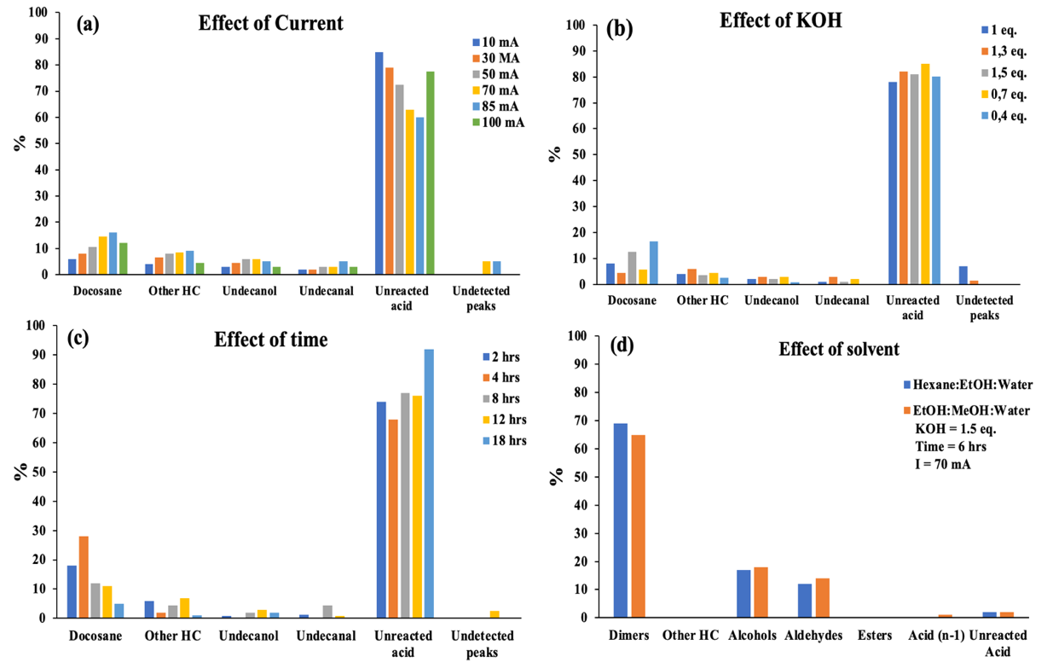
Figure 2: Kolbe electrolysis of lauric acid investigating the influence parameters (a) effect of current intensity (b) effect of KOH (c) effect of time and (d) effect of solvent environment.

The next series of experiments were to investigate the effect of electrolysis time from 2-18 h and other conditions were constant like 0.4 eq. of KOH, MeOH as solvent and current intensity of 70 mA (AP=30 min). As shown in figure 2c, using MeOH as a solvent and 0.4 eq. of KOH, the conversion rate was very modest after 8 h or more of electrolysis. Therefore, the impact of different solvent types was investigated in an effort to boost the conversion rate.
Table 1 displays the specifics of each experiment's solvent type, KOH amount, and dimer yield percentage. These studies were all carried out with an acid content of 0.7 mmol, a constant current intensity of 70 mA (AP=30 min), and an electrolysis duration of 6 h. As shown in Figure 2d, the best results, with the highest dimer yield of 69% and 65%, as well as the highest degree of acid dissociation, were produced using hexane:EtOH:Water and EtOH:MeOH:Water as solvents, respectively (table 1- entries 8, 9). The solvent system Hexane:EtOH:Water produces mostly dimers (n-docosane), accounting for 69% of the product; alcohol (undecanol) accounts for 17%; aldehydes (undecanal) accounts for 12%; and unreacted acids make up a very small percentage. Comparably, larger levels of dimer (n-docosane) at 65%, alcohols (undecanol) at 18%, aldehydes (undecanal) at 14%, acids (n-1) (undecanoic acid) at 1%, and very few unreacted acids were formed in the EtOH:MeOH:Water solvent system. These results imply that both of these mixtures of solvents are highly efficient in electrolyzing lauric acid, and that the solvents' chemical makeup has a significant impact on the number and diversity of products that are produced.
Table 1: Reaction conditions and resulting GC dimer yield (%) for investigating the effect of solvent nature on the electrolysis of lauric acid.
Entry | Solvent % | KOH eq. | Dimer %
1 | MeOH | 0.4 | 25
2 | EtOH | 0.4 | 30
3 | MeOH:EtOH (50:50) | 0.4 | 28
4 | MeOH:EtOH (33.33:66.66) | 0.4 | 25
5 | MeOH:EtOH (25:75) | 0.4 | 27
6 | MeOH:EtOH (75:25) | 0.4 | 29
7 | MeOH:EtOH:H₂O (38.89:38.89:22.22) | 0.4 | 17
8 | MeOH:EtOH:H₂O (16.67:16.67:66.67) | 1.5 | 65
9 | Hexane:EtOH:H₂O (38.89:38.89:22.22) | 1.5 | 69

4.2. Kolbe electrolysis of palmitic acid
Once the reaction conditions were fixed from the electrolysis of lauric acid, the same parameters were applied to the electrolysis of palmitic acid. Table 2 displays the specifics of the reaction conditions, and Figure 3 displays the product distribution. Dimers make up the majority of the product in the MeOH:EtOH:Water solvent system, with 23%, followed by “other hydrocarbons” (19.5%) and alcohols (18%). The Hexane:EtOH:Water system produces 15% of dimers and 30% of other hydrocarbons. The larger percentages of dimers (9%), alcohol (20%), and aldehydes (21.79%) are produced in the EtOH:Water solvent environment. Since the solution was not homogenous, as indicated in Table 2 (entry 3), the quantity of KOH was raised from 1.5 eq. to 1.7 eq. These results led to the conclusion that the selectivity and distribution of a particular product are significantly influenced by the nature of the solvent. (Zhang et al., 2018) investigated the electrolysis of palmitic acid using platinum foil electrodes and biphasic solvent system (H₂O:MeOH:petroleum ether) with 1.5 eq. of KOH achieved 27% of dimers yield. A solvent system with a greater water content and a lower alcohol content produces a larger percentage of dimers, whereas a solvent system with a high alcohol content and a low water content produces a higher concentration of alcohol and aldehyde. The details of the observed products are shown in table 3.

Table 2: Experimental conditions for the electrolysis of palmitic acid and GC dimer yield (%)
Entry | mmol | Solvent% | KOH eq. | Dimer %
1 | 0.7 | EtOH:MeOH:H₂O (16.67:16.67:66.67) | 1.5 | 23
2 | 0.7 | Hexane:EtOH:H₂O (38.89:38.89:22.22) | 1.5 | 15
3 | 0.7 | EtOH:H₂O (66.67:33.33) | 1.7 | 9

Figure 3: Product distribution of electrolysis of palmitic acid using different solvent environments. The experimental conditions for each entry are as follows, Time = 6 hours, current intensity = 70 mA (AP=30 min), 1.5 eq. of KOH for EtOH:MeOH:H₂O and Hexane:EtOH:H₂O while 1.7 eq. for EtOH:H₂O solvent system.

Table 3: Summary of product observed from the electrolysis of palmitic acid.
Product | Example
Dimer | Triacontane
Other Hydrocarbon | Pentadecane, Pentadecene, Hexadecane, Tetradecane
Alcohol | Pentadecanol, Hexadecanol
Aldehyde | Pentadecanal, Hexadecanal
Esters | Pentadecanoic acid, methyl ester
Acid (n-1) | Pentadecanoic acid
4.3. Kolbe Electrolysis of Mixture of Acids
Following the conclusion of the lauric acid and palmitic acid electrolysis tests, the two acids were mixed ratio (1:1) to examine the distribution trend of the products, particularly the formation of dimers. Table 4 displays the experimental parameters as well as the dimer yield (%) of docosane, triacontane and hexacosane. As expected, a broad spectrum of product distribution was observed when using a mixture of acids as compared to single acid electrolysis because of the higher possible combination of formed radicals. When using the mixture of acids, the dimers were formed either by homocoupling i.e., a combination of radicals of the same chain length or by hetero-coupling i.e., a combination of radicals of two different chain lengths. The dimers docosane (C₂₂) and triacontane (C₃₀) were formed by the combination homocoupling of C₁₁ and C₁₅ radicals, respectively, and hexacosane was formed by hetero-coupling of C₁₁ and C₁₅ radicals.
The details of all the experimental parameters along with the percentage of dimers are shown in the Table 4 and product formation and their percentage are shown in Figure 4. In the EtOH:MeOH:Water solvent system, a notably high percentage 45% of dimers were produced followed by alcohols at 19.6%, other hydrocarbons at 17.7% and aldehydes at 10%. A very little percentage of esters and acids (n-1) were also formed. On the other hand, in the EtOH:Water system, alcohols were the most dominant with 31.4% and a lower number of dimers at 10.4%. This might suggest that the absence of MeOH discourages dimer formation and leads to the higher formation of alcohols and aldehydes. Lastly, the Hexane:EtOH:Water system leads to the substantial formation of dimers 32.2% and also a significant number of alcohols 25.4%. Based on these observations, the MeOH:EtOH:Water solvent system is the most efficient choice for dimers production from the mixture (1:1) of lauric and palmitic acids. (Neubert et al., 2022) findings show that using artificial mixture of acids (C₄:C₆:C₈) in 3:8:1 molar ratio at 150 mA/cm² of current density gives alkane production of 55 + 10% and acid degradation with columbic efficiency of around 82%. Therefore, understanding these variations in experimental conditions is important in optimizing the electrolysis process to explore reaction scalability and potential for industrial applications. The details of the products observed from the electrolysis of mixture of lauric and palmitic acid are shown in Table 5.

Table 4: Reaction conditions for the electrolysis of mixture of acids C₁₂:C₁₆ (1:1) and GC dimer yield (%).
Entry | mmol | Solvent% | KOH eq. | Current mA | Dimer %
1 | 0.7 | Hexane:EtOH:H₂O (38.89:38.89:22.22) | 1.5 | 70 | 32.2
2 | 0.7 | MeOH:EtOH:H₂O (16.67:16.67:66.67) | 1.5 | 70 | 45
3 | 0.7 | EtOH:H₂O (66.67:33.33) | 1.7 | 70 | 10.4

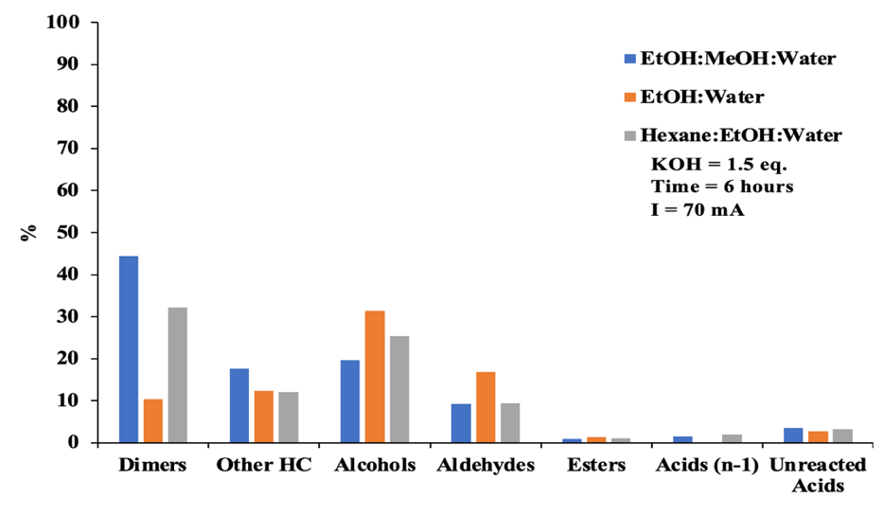
Figure 4: Product distribution of electrolysis of mixture of lauric and palmitic acid (1:1) using different solvent environments

Table 5: Summary of product observed from the electrolysis of mixture of lauric and palmitic acids (1:1).
Product | Example
Dimers | Docosane, triacontane, hexacosane
Other hydrocarbon | Undecane, undecene, pentadecane, pentadecene, tetradecane, hexadecane
Alcohols | Undecanol, pentadecanol, hexadecanol, tetradecanol
Aldehydes | Undecanal, pentadecanal,
Esters | Pentadecanoic acid, methyl ester, undecanoic acid methyl ester
Acid (n-1) | Pentadecanoic acid, undecanoic acid

5. Conclusion
The study shows a safe and green electrochemical approach for the production of useful chemical products. The biobased fatty acids lauric acid and palmitic acid are converted into chemical products by electrochemical technique. The electrolysis of single lauric acid, palmitic acid, and a mixture of both acids through Kolbe electrolysis gives 65%, 23% and 45% of dimers respectively. Using non-commercial platinum electrodes, the Kolbe electrolysis in MeOH:EtOH:H₂O (16.67:16.67:66.67) solvent system shows nearly full dissociation of the substrate acids into useful chemical products like alcohols, aldehydes, and other hydrocarbons with shorter chain then dimers.

References
Ahmad, H., Pelosato, R., Sora, I. N., & Fontana, F. (2023). Electrochemical Conversion of Lauric Acid Through Kolbe Electrolysis for the Synthesis of N-docosane. Chemical Engineering Transactions, 98, 105–110.
Cai, Z.-Z., Wang, Y., Teng, Y.-L., Chong, K.-M., Wang, J.-W., Zhang, J.-W., & Yang, D.-P. (2015). A two-step biodiesel production process from waste cooking oil via recycling crude glycerol esterification catalyzed by alkali catalyst. Fuel Processing Technology, 137, 186–193.
Fereidooni, L., Tahvildari, K., & Mehrpooya, M. (2018). Trans-esterification of waste cooking oil with methanol by electrolysis process using KOH. Renewable Energy, 116, 183–193.
Hegner, R., Neubert, K., Rosa, L. F. M., & Harnisch, F. (2019). Engineering electrochemical CO2 reduction to formate under bioprocess-compatible conditions to bioreactor scale. ChemElectroChem, 6(14), 3731–3735.
Ho, D. P., Ngo, H. H., & Guo, W. (2014). A mini review on renewable sources for biofuel. Bioresource Technology, 169, 742–749.
Johnstone, A. H. (1991). CRC Handbook of Chemistry and Physics—69th Edition Editor in Chief R. C. Weast, CRC Press Inc. Journal of Chemical Technology & Biotechnology, 50(2), 294–295.
Joschka Holzhäuser, F., Creusen, G., Moos, G., Dahmen, M., König, A., Artz, J., Palkovits, S., & Palkovits, R. (2019). Electrochemical cross-coupling of biogenic di-acids for sustainable fuel production. Green Chemistry, 21(9), 2334–2344.
Kalnes, T., Marker, T., & Shonnard, D. R. (2007). Green Diesel: A Second Generation Biofuel. International Journal of Chemical Reactor Engineering, 5(1).
Kirste, A., Elsler, B., Schnakenburg, G., & Waldvogel, S. R. (2012). Efficient Anodic and Direct Phenol-Arene C,C Cross-Coupling: The Benign Role of Water or Methanol. Journal of the American Chemical Society, 134(7), 3571–3576.
Mansir, N., Taufiq-Yap, Y. H., Rashid, U., & Lokman, I. M. (2017). Investigation of heterogeneous solid acid catalyst performance on low grade feedstocks for biodiesel production: A review. Energy Conversion and Management, 141, 171–182.
Meyers, J., Mensah, J. B., Holzhäuser, F. J., Omari, A., Blesken, C. C., Tiso, T., Palkovits, S., Blank, L. M., Pischinger, S., & Palkovits, R. (2019). Electrochemical conversion of a bio-derivable hydroxy acid to a drop-in oxygenate diesel fuel. Energy & Environmental Science, 12(8), 2406–2411.
Neubert, K., Hell, M., Chávez Morejón, M., & Harnisch, F. (2022). Hetero-Coupling of Bio-Based Medium-Chain Carboxylic Acids by Kolbe Electrolysis Enables High Fuel Yield and Efficiency. ChemSusChem, 15(21), e202201426.
Nilges, P., Santos, T. R. dos, Harnisch, F., & Schröder, U. (2012). Electrochemistry for biofuel generation: Electrochemical conversion of levulinic acid to octane. Energy & Environmental Science, 5(1), 5231–5235.
Putra, R. S., Hartono, P., & Julianto, T. S. (2015). Conversion of Methyl Ester from Used Cooking Oil: The Combined Use of Electrolysis Process and Chitosan. Energy Procedia, 65, 309–316.
R. dos Santos, T., Harnisch, F., Nilges, P., & Schröder, U. (2015). Electrochemistry for Biofuel Generation: Transformation of Fatty Acids and Triglycerides to Diesel-Like Olefin/Ether Mixtures and Olefins. ChemSusChem, 8(5), 886–893.
Semwal, S., Arora, A. K., Badoni, R. P., & Tuli, D. K. (2011). Biodiesel production using heterogeneous catalysts. Bioresource Technology, 102(3), 2151–2161.
Teetz, N., Holtmann, D., Harnisch, F., & Stöckl, M. (2022). Upgrading Kolbe Electrolysis—Highly Efficient Production of Green Fuels and Solvents by Coupling Biosynthesis and Electrosynthesis. Angewandte Chemie International Edition, 61(50), e202210596.
Urban, C., Xu, J., Sträuber, H., Dantas, T. R. dos S., Mühlenberg, J., Härtig, C., Angenent, L. T., & Harnisch, F. (2017). Production of drop-in fuels from biomass at high selectivity by combined microbial and electrochemical conversion. Energy & Environmental Science, 10(10), 2231–2244.
Weisz, P. B., Haag, W. O., & Rodewald, P. G. (1979). Catalytic Production of High-Grade Fuel (Gasoline) from Biomass Compounds by Shape-Selective Catalysis. Science, 206(4414), 57–58.
Zhang, Y., Liu, G., & Wu, J. (2018). Electrochemical conversion of palmitic acid via Kolbe electrolysis for synthesis of n-triacontane. Journal of Electroanalytical Chemistry, 822, 73–80.

