ds CHEMICAL ENGINEERING TRANSACTIONS  VOL., 2024 | A publication of
The Italian Association
of Chemical Engineering
Online at www.cetjournal.it

Guest Editors: Leonardo Tognotti, Rubens Maciel Filho, Viatcheslav Kafarov
Copyright © 2024, AIDIC Servizi S.r.l.
ISBN 979-12-81206-09-0; ISSN 2283-9216

Bioproducts extraction from agro-industrial by-products and their valorisation. Development of process layouts.
Vittoria Fatta^{a,}*, Maria Teresa Petrone^{b}, Aristide Giuliano^{b}, Isabella De Bari^{b}, Nicola Pierro^{b}, Valeria Rosso^{c}, Emanuele Ocleppo^{c}
ªItalian National Agency for New Technologies, Energy and Sustainable Economic Development (ENEA), Energy Technologies and Renewable Sources Department (TERIN), Bioenergy, Biorefinery and Green Chemistry Division (BBC), Palermo office, Via Principe di Granatelli, 24 90139 Palermo Italy
^{b}Italian National Agency for New Technologies, Energy and Sustainable Economic Development (ENEA), Energy Technologies and Renewable Sources Department (TERIN), Bioenergy, Biorefinery and Green Chemistry Division (BBC), Trisaia research centre, S.S. 106 Ionica, km 419+500 75026 Rotondella (MT) Italy
^{c}Asja Ambiente Italia S.p.A. Via Ivrea,70 10098 Rivoli (TO)
vittoria.fatta@enea.it
The agro-food industry generates important quantities of by-products, often considered waste, which represent for the companies huge costs of handling and disposal. On the other hand, they contain copious amounts and varieties of compounds that, appropriately extracted, purified, and processed, can be valued in several industrial sectors. Their exploitation generates an improvement of the sustainability performance of the supply chains, since it generates economic advantages, making available new commercial products and reducing disposal costs, improves the environmental performance of the agro-industrial productions, and allows new employment opportunities, thanks to the development of new industrial sectors. The Percival project aims to valorize the by-products of agro-industrial supply chains of South of Italy, converting them into high-added value products, through innovative, efficient, and low environmental impact processes, going for the development of technologies that could represent new business opportunities for this territory. Particularly, the project deals with the development of processes for pretreatment, extraction, separation, and chemical/biotechnological transformation, using a biorefinery cascade approach. Indeed, the study of processes having the purpose of converting the residues from the above-mentioned transformations into advanced biofuels (biomethane) and agricultural products (e.g. soil improver and bio-stimulants) are also included in the project’s scope. The present paper provides an overview of the Percival project, along with the evaluation of the availability of residual biomasses from the supply chains of typical Southern agricultural products, and the valuable bioproducts achievable from these feedstocks, through a biorefinery processing scheme.
  - Introduction
The stringent issues of environmental pollution and resources depletion continually push towards the search for new solutions in term of processes and products. The agro-food industries generate important quantities of by-products, often considered wastes. They contain large amounts and varieties of compounds that, appropriately extracted, purified, and processed, can be valued in several industrial sectors, entailing undoubted advantages on sustainability (Squillaci et al., 2021) of the value chains. First, the use of residual biomass to produce added value chemical intermediates and/or final products, leads to lower environmental impact than exploiting the fossil counterparts (Prasetyo et al., 2020) given the use of renewable raw materials. Then, it represents an excellent opportunity to develop local economic sectors, thanks to the creation of integrated, interconnected, and interdisciplinary local supply chains (Giuliano et al., 2019) generating new commercial products and creating new jobs. Finally, the improvement of the environmental performance of agro-industrial productions, mainly due to the reduction of waste, and the containment of disposal costs can be considered further consequences giving a positive effect on sustainability. Southern Italy has always had a strong agricultural vocation, therefore the implementation of processes and innovative technologies to valorize the agro-industrial by-products seems to be one of the most promising development paths for this territory. The conceptual scheme of biorefinery is potentially capable of making the most of the residual biomass as a source of biochemicals, biomaterials and bioenergy. Among biochemicals, important building blocks for bioplastics such as lactic acid (Li et al., 2021), occupy an important place, along with biomolecules for cosmetics and nutraceutical, such as resveratrol (Arias et al., 2024) and lycopene (Scaglia et al., 2023). Moreover bio-based agrochemicals (soil improvers, bio stimulants and biopesticides) can be also obtained from waste biomass and replace the synthetic ones, with undoubted benefits on health and environment (Sojka et al., 2022; Priya et al., 2023). Finally, lignin can be treated as a source of bio-aromatics and building blocks for functional fibres based on nano-structured materials (Brienza et al., 2024) and the cascade approach consents to recover for energy and agronomic purposes also the residues of transformation. The availability and type of agro-industrial biomass residues is not constant over time due to the climatic and phytosanitary conditions and market fluctuations. Indeed, these factors affect the yield and productivity of biomass, the collection, and transformation activities, and, consequently, the quantity of by-products. Therefore, appropriate methods of evaluation of the availability of residual biomasses from the different agro-industrial supply chains should be applied, to verify the technical-economic feasibility of a project aimed at valorizing agricultural by-products. The aim of Percival project (Processi di EstRazione di bioprodotti da sCarti agroIndustriali e VALorizzazione in cascata) is the valorization of the by-products of agro-industrial supply chains of South of Italy, through the development of innovative, efficient, and low environmental impact processes, to convert these feedstocks into high-added value products, according to a biorefinery scheme. In this work an overview of the project was presented, and some preliminary results of the activities were discussed. In particular, the quantities of by-products obtainable from the supply chains of three relevant agricultural products of South of Italy were calculated. Then, for each product, a biorefinery flowsheet draft was presented and discussed.
  - The Percival project
The Percival’s goal is the valorisation of by-products, originating from agro-industrial supply chains typical of the South of Italy, through the production of biochemicals, biomaterials, and biofuel. For this purpose, the activities of the project consist in developing efficient and low environmental impact production processes, as pre-treatment, extraction, and fractionation, based on chemical and biotechnological cascade transformation, interconnected and integrated, according to a biorefinery scheme. Feedstocks include processing residues from some of the main agricultural supply chains of South of Italy, such as citrus fruits, wine, tomatoes, apples etc., while, the range of the obtainable products the project focuses on encompasses building blocks for the bioplastic markets, such as polylactic acid and succinic acid, as well as pectin, lycopene, volatile fatty acids, and bioactive compound for the cosmetic, nutraceutical, and agronomic sectors (antioxidants, resveratrol, bioammendants, biostimulants, and biocides). In addition, other products considered are lignin-based biomaterials, biomethane, and biochar. The study of separation, purification, and characterization techniques of the above-mentioned products are also activities covered by the project. Moreover, in vitro evaluations of the bioactive agronomic molecules are carried out, individually and/or as formulates in association with other natural ingredients, to quantify their effects in the agricultural productions of the South of Italy. At the same time, long-term stability, bioavailability, efficacy are tested in prototypal cosmetics and nutraceutical products. Finally, life cycle assessment, cost analysis and market trends are elaborated for industrial applications. Percival project is articulated into five activity lines, and each of them is divided into several sub-lines. Figure 1 shows the project structure and the flows of data/results among the lines.
  - Materials and Methods
3.1 Availability of agro-industrial by-products in Southern Italy
To estimate the potential production of some target biomolecules, the availability in Southern Italy of residual biomass from wine, citrus and tomato agroindustry was carried out, based on a methodology developed by ENEA, (Motola et al., 2009; Pierro et al., 2021). The sources of residual agricultural biomass in a given territory can be huge and of different nature. Given this variability, the estimation of the quantities obtainable is often subject to great uncertainty. Among the many variables affecting the actual annual availability of agricultural residual biomass there are climatic factors, the productivity of agricultural crops, the amount of residues actually usable, and that already destined for other purposes.
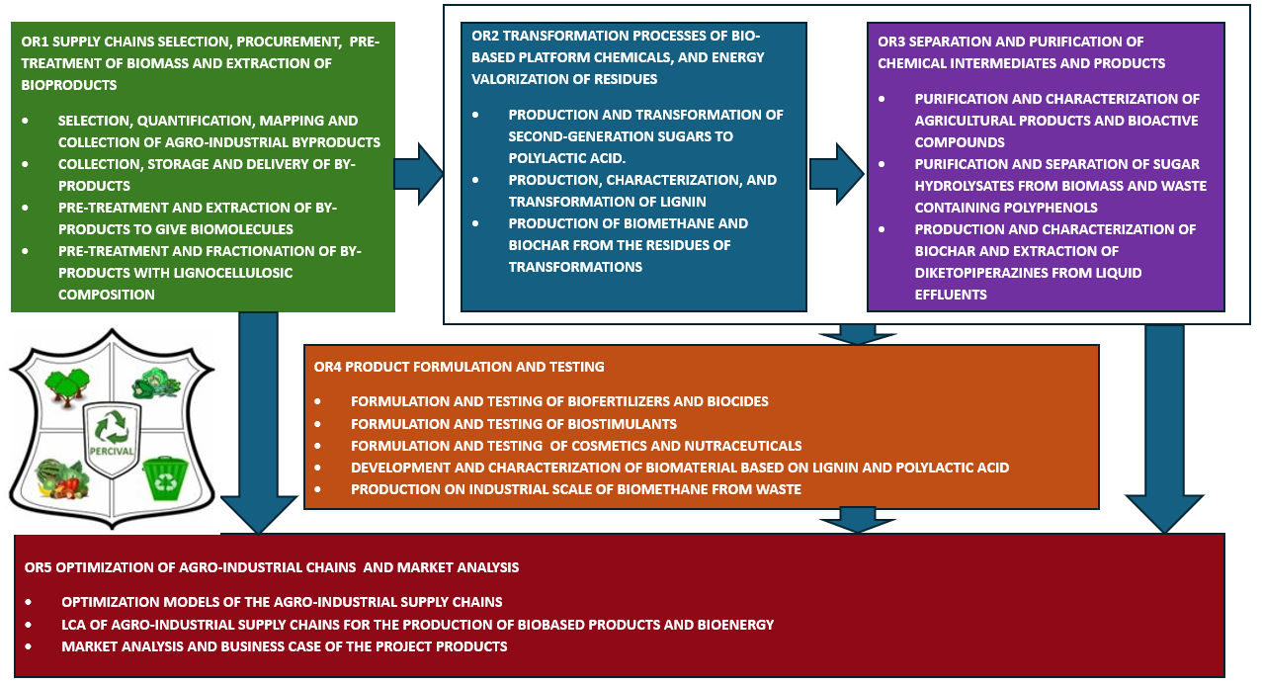
The Figure 1: Structure of Percival project

The methodology applied in the present work evaluates the theoretical potential, which is the total amount of biomass that can be produced (or formed) within physical and biological constraints (Brosowsky et al., 2020). According to this methodological approach, the by-products of agricultural and agro-industrial activities are associated with the areas where their agricultural reference products are collected, even if sometimes they can be produced in a different place, for example where the reference products are manufactured. The residual biomasses evaluated in the present study were wine pomace, wine grapes pruning, citrus pomace, citrus pruning, tomato peels, and tomato seeds. The methodology applied for the evaluation of the potential availability of wine pomace, wine grapes pruning, citrus pomace, citrus pruning, tomato peels is based on the formula:
Theoretical potential availability = Harvested Production * Residue to product ratios | (1)
Where:
- Harvested Production is the mass of product harvested on the area under production (ISTATa);
- Residue to product ratios is the ratio between the masses of product and by-product reported by literature (Motola et al., 2009; Pierro et al., 2021).
The assessment of wine lees, which are deposits of dead yeast or residual yeast and other materials that are left over after the fermentation process used to make wine, is made considering the production of wine on a regional scale, surveyed by ISTAT (ISTATa), and the coefficients reported by literature (Bevilacqua et al., 2017). Furthermore, the assessment of tomato seeds potential derives from a literature review (Casa et al., 2021) and data from ISTAT (ISTATa).
3.2 Agro-industrial residues conversion to target products
Biomass residues can be converted into several bioproducts, that depend on specific characteristics of the starting material. The selected target products from the conversion of residues of the supply chains described in the previous section can be grouped in three kinds of compounds:
- high-added value compounds: i.e. resveratrol, antioxidants, and lycopene;
- biopolymers' precursors and bio-based fibers: lactic acid, precursor of poly lactic acid (PLA), volatile fatty acids, precursors of polyhydroxybutyrate/polyhydroxyalkanoate (PHB/PHA) and lignin based fibers;
- energy vectors/biofuels: biomethane, and biochar/hydrochar.
To obtain these products, several process pathways can be considered using a cascade approach. In a valued-added cascade approach, the first step is the extraction of the high-added value compounds that are present in the feedstock in a very small quantity (0.1-2.0 %). A next step could regard the valorization of the solid residues coming from the extraction, through biomethane’s production via anaerobic digestion and biogas upgrading. Moreover, the processing of the lignocellulosic streams, leading to second-generation sugars platform, from which LA and PLA can be obtained, offers a further possibility of by-products valorization. Finally, the residues of the last two treatments, poor in structured compounds (cellulose, lignin, sugars, proteins), but with a residual high content in carbon, can in turn be valorized by producing biochar or hydrochar, the latter through a thermochemical process such as the hydrothermal carbonization (HTC), and lignin-based fibers respectively.
  - Preliminary results
4.1 Agro-industrial residual biomass availability in Southern Italy
The table 1 shows the results of the availability analysis of residual biomass from wine, citrus, and tomato supply chain in Southern Italy. The Italian regions with the greatest availability of residues, deriving from the wine supply chain are Apulia and Sicily. As regards the citrus supply chain, the Regions with the greatest availability of residual biomass are Sicily, Calabria, and Apulia. Instead, the biomass deriving from the tomato processing supply chain is more abundant in Apulia and Campania. The strong agricultural vocation of Southern Italy, confirmed by the data of the latest agricultural census of 2020 (ISTATb), where almost 50% of the used agricultural surface is found in the South and in the Islands, determine the potential presence of a high quantity of residues (Table 1), The valorization of such residues, according to a cascade approach, in which all biomass
components are transformed into high-value products, and there are no valueless wastes, represents an economically and environmentally much more advantageous alternative compared to their disposal in landfill. All this resolved to be in accordance with new European directives, such as the Renewable energy directive EU 2023/2413 and the Waste Frame Directive.
Table 1: Theoretical potential, at regional scale, of evaluated biomass expressed in tons of wet material (t w.m.), 2022.
 | Grape  marc  (t_{w.m.}) | Wine Lees  (t_{w.m.}) | Wine grapes Pruning  (t_{w.m.}) | Citrus  Pomace  (t_{w.m.}) | Citrus  Pruning  (t_{w.m.}) | Tomato  Peels  (t_{w.m.}) | Tomato  Seeds  (t_{w.m.})
Molise | 49’203 | 3’078 | 23’057 | 66 | 34 | 1’976 | 1’373
Apulia | 245’730 | 65’079 | 456’409 | 159’112 | 99’833 | 44’021 | 30’591
Basilicata | 2’734 | 518 | 4’153 | 61’759 | 36’110 | 3’482 | 2’419
Calabria | 6’627 | 1’619 | 15’625 | 595’067 | 316’336 | 3’296 | 2’290
Campania | 154’879 | 8’855 | 72’308 | 19’002 | 12’451 | 7’035 | 4’889
Sicily | 186’229 | 35’287 | 288’100 | 759’015 | 198’094 | 2’267 | 1’575
Sardinia | 9’512 | 4’106 | 79’114 | 31’893 | 8’757 | 1’168 | 811

4.2 Cascade valorization of Agro-industrial residual biomass
Using the methodology of section 2.2, biorefinery’s schemes were assessed for the byproducts’ valorization of wine, citrus, and tomato supply chains. Figure 1 shows the identified opportunities derived from the application of a cascade methodology, through block flow diagrams. Process design methodologies were applied to assess the multi product biorefinery based approach (Giuliano et al, 2015). Processes were selected based on the research focus of the Percival Project. The techno-economic and environmental feasibility of the defined multi-products layouts will be assessed as part of future developments. From the grape marc and wine lees quantified in section 3.1, (Figure 1.a), resveratrol extraction by ultrasound-assisted extraction (UAE) was first proposed (Singh et al., 2017). Then, since the residual solid (about 80-90 %wt) of the extraction is a good substrate for anaerobic digestion (AD), it was assumed to obtain biogas and subsequently biomethane. The latter is an energy-product, and it can be blended with natural gas in the grid, as, after the upgrading, its concentration can be >99%vol. Moreover, for the digestate, having a high content in carbon, the conversion into hydrochar by HTC was proposed. The other byproduct from the wine agroindustry consists of pruning lignocellulosic material having a content of cellulose/hemicellulose/lignin of 21, 12 and 30 % respectively (Jesus et al., 2022). According to the scheme in Fig. 1a, after pretreatment and fractionation, enzymatic hydrolysis was used to convert cellulose/hemicellulose to 2nd generation sugars. Then, polylactic acid was produced by the sugars' fermentation to lactic acid, followed by polymerization. Lastly, the other stream from hydrolysis, consisting of a lignin-rich stream, was used to produce fibers as target product. Figure 1.b shows the biorefinery flow sheet hypothesized for the valorization of tomato agroindustry residues i.e. tomato peels and seeds. The first one has a high content of lycopene and pectin (Casa et al., 2021^{b}), which were extracted by supercritical CO₂ and acid, respectively. Regarding the seeds, they were considered as a substrate to produce volatile fatty acids by AD. These chemicals are the precursors of polyhydroxybutyrate/polyhydroxyalkanoate (PHA/PHB), polymers belonging to the polyesters class, which are of interest as bio-based and biodegradable plastics. Moreover, also in this case, the solids from digestate were used to produce hydrochar by HTC. As far as the Citrus fruit agroindustry is concerned, it can provide two main residual materials, the pomace, containing antioxidant molecules, and the pruning. According to the block flow diagram in Fig. 1c, a similar cascade valorization procedure, as the wine agroindustry, was proposed for them: extraction of antioxidants from the pomace, AD of extraction’s residues, biogas upgrading to biomethane, HTC of the digestate to hydrochar, while from pruning, PLA and lignin-based fibers were produced. Based on some literature data and on the results of table 1, an estimate of the production potential of southern Italy was obtained regarding some of the above-mentioned products. In particular, antioxidants compounds could be produced for about 3-4 kt/y, biopolymers in the range of 350 – 450 kt/y and biomethane until to 2.5 10⁷ GJ/y. Furthermore, the quantities of pectin and lycopene that could be produced from tomato peels amount to 0,63 t/y and 0,38 t/y respectively.

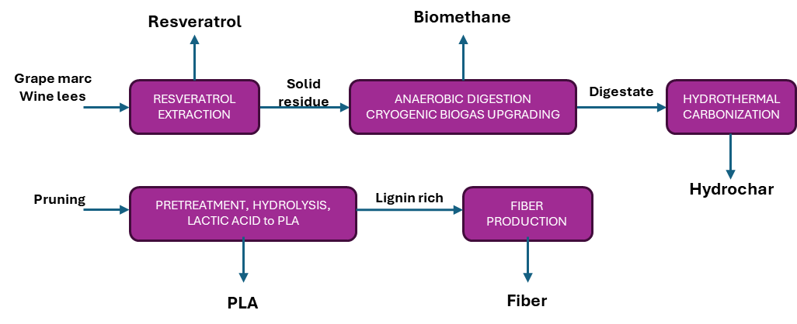
(a)
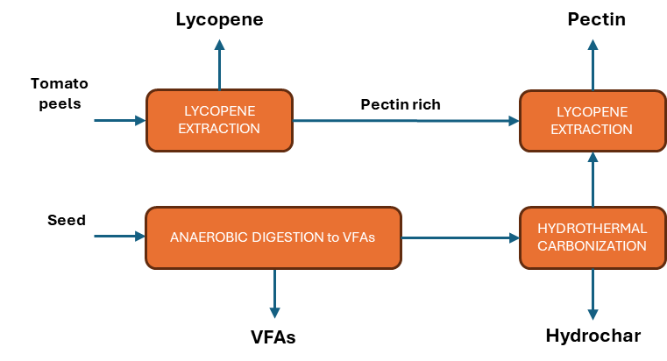
(b)
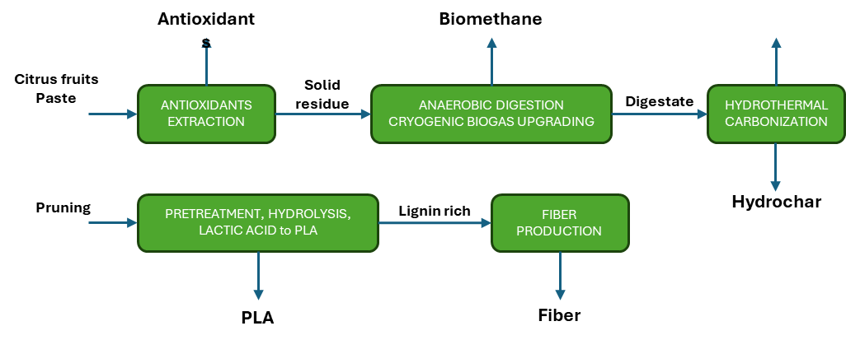
(c)
Figure 2: Block Flow Diagram for the cascade valorisation of residues from three agroindustry supply chains of South Italy: Wine (a), Tomato (b), Citrus fruits (c)
  - Conclusions and future works
Different by-products can be produced from agro-industrial activities and processes. These residual biomasses that often represent an economic and environmental problem, can be the source of large amounts and varieties of valuable products. Southern Italy, with its agricultural vocation, can be a suitable place for the development of an industry for the transformation and valorization of agro-industrial by-products, that would generate economic, social, and environmental benefits. The Percival project takes advantage from the synergy between research institutions and companies, for the development of innovative processes, devoted to the production of biochemicals, biomaterials and biofuels from the by-products of the agricultural supply chains typical of South of Italy. In this work the outcomes of the first project's activities were reported. In particular, the availability of the by-products of wine, citrus, and tomato supply chains in Southern Italy was calculated, concluding that the quantities involved make the exploitation of this by-products feasible. Techno-economic analysis and environmental analysis will be part of future publications.

Acknowledgments
The present work is part of the national project PERCIVAL funded through the program PON 2014-2020.
References
Arias A., Costa C.E., Moreira M.T., Feijoo G., Domingues L., 2024, Resveratrol-based biorefinery models for favouring its inclusion along the market value-added chains: A critical review, Sci Total Environ., 1, 168199.
Bevilacqua N., Morassut M., Serra M.C., Cecchini F., 2017, Determinazione dell’impronta carbonica dei sottoprodotti della vinificazione e loro valenza biologica, Ingegneria dell’Ambiente, 4, 277-285.
Brienza F., Cannella D., Montesdeoca D., Cybulska I., Debecker D.P., 2024, A guide to lignin valorization in biorefineries: traditional, recent, and forthcoming approaches to convert raw lignocellulose into valuable materials and chemicals, RSC Sustainability, 2, 37.
Brosowski A., Bill R., Thrän D., Temporal and spatial availability of cereal straw in Germany - Case study: Biomethane for the transport sector, 2020, Energ. Sustain. Soc., 10, 1712.
Casa M., Miccio M., 2021ª, Thinking, Modeling and Assessing Costs of Extracting Added-value Components from Tomato Industrial By-products on a Regional Basis, Chemical Engineering Transactions, 87, 163-168
Casa M., Miccio M., De Feo G., Paulillo A., Chirone R., Paulillo D., Lettieri P., Chirone R., 2021^{b}, Brief Overview On Valorization Of Industrial Tomato By-Products Using The Biorefinery Cascade Approach, Detritus, 15, 31-39.
Giuliano A.; Bari I.; Motola V.; Pierro N.; Giocoli A.; Barletta D., 2019, Techno-environmental Assessment of Two Biorefinery Systems to Valorize the Residual Lignocellulosic Biomass of the Basilicata Region., Math. Model. Eng. Probl., 6, 317–323.
Giuliano A., Poletto M., Barletta D., 2015. Process Design of a Multi-Product Lignocellulosic Biorefinery. Computer Aided Chemical Engineering 37, 1313–1318.
ISTATa, <http://dati.istat.it/> accessed 15.03.2024.
ISTATb, <https://esploradati.istat.it/databrowser/#/it/censimentoagricoltura> accessed on the 15.03.2024.
Jesus M., Romaní A., Mata F., Domingues, L., 2022, Current Options in the Valorisation of Vine Pruning Residue for the Production of Biofuels, Biopolymers, Antioxidants, and Bio-Composites following the Concept of Biorefinery: A Review, Polymers, 14, 1640.
Li Y., Bhagwat S.S., Cortés-Peña Y.R., Ki D., Rao C.V., Jin Y., Guest J.S., 2021, Sustainable Lactic Acid Production from Lignocellulosic Biomass, Sustainable Chemistry & Engineering, 9 (3), 1341-135.
Motola V., Colonna N., Alfano V., Gaeta M., Sasso S., De Luca V., De Angelis C., Soda A., Braccio G. 2009, Censimento potenziale energetico biomasse, metodo indagine, atlante Biomasse su WEB-GIS, Report RSE/2009/167.
Pierro N., Dipinto S., Motola V., Giocoli A., 2021, Valutazione disponibilità biomasse agro-industriali a livello nazionale e loro pubblicazione sul portale webgis atlante delle biomasse, Report RT/2021/4/ENEA.
Prasetyo, W.D.; Putra, Z.A.; Bilad, M.R.; Mahlia, T.M.I.; Wibisono, Y.; Nordin, N.A.H.M.; Wirzal, M.D.H., 2020, Insight into the Sustainable Integration of Bio- and Petroleum Refineries for the Production of Fuels and Chemicals, Polymers, 12, 1091.
Priya A. K., Alagumalai A., Balaji D., Song H., 2023, Bio-based agricultural products: a sustainable alternative to agrochemicals for promoting a circular economy, RSC Sustainability, 1, 746.
Scaglia B., Squillace P., Parizad P., Papa G., De Nisi P., Tambone F., 2023, Valorization of the tomato pomace to obtain lycopene, carbohydrates-rich fraction and oil by applying a hydrolytic enzyme-based approach, Bioresource Technology Reports, 24,101693.
Singh B., Singh N., Thakur S., Kaur A., 2017, Ultrasound assisted extraction of polyphenols and their distribution in whole mung bean, hull and cotyledon, J Food Sci Technol., 54, 921-932.
Sojka M., Saeid A., 2022, Chapter 10 - Bio-Based Products for Agriculture, Smart Agrochemicals for Sustainable Agriculture, 279–310.
Squillaci G., La Cara F., Roseiro L.B., Marques I., Morana A., 2021, Agro-industrial Wastes as Bioactive Molecules Source, Chemical Engineering Transactions, 86, 37-42.

