|  |  |
| --- | --- |
| cetlogo ***CHEMICAL ENGINEERING TRANSACTIONS***  ***VOL. , 2024*** | A publication of  aidiclogo_grande |
| The Italian Association  of Chemical Engineering  Online at www.cetjournal.it |
| Guest Editors: Leonardo Tognotti, Rubens Maciel Filho, Viatcheslav Kafarov  Copyright © 2024, AIDIC Servizi S.r.l. **ISBN** 979-12-81206-09-0; **ISSN** 2283-9216 | |

Co-pyrolysis of lignocellulosic residues and plastics: a simulation approach to predict product yields

Ingrid L. Mottaa\*, Andressa N. Marchesanb, Henrique R. Guimarãesc, Mateus F. Chagasc, Antonio Bonomic, Maria Regina W. Macielb, Rubens Maciel Filhob

aSchool of Mechanical Engineering, University of Campinas, Rua Mendeleyev 200, Campinas, Brazil. 13083-860

bSchool of Chemical Engineering, University of Campinas, Av. Albert Einstein 500, Campinas, Brazil. 13083-852

cBrazilian Biorenewables National Laboratory, Brazilian Center for Research in Energy and Materials, R. Giuseppe Máximo Scolfaro, 10000, Campinas, Brazil. 13083-970

\*imotta@unicamp.br

Plastic waste generation, a global environmental concern, has more than doubled over the past two decades. Given the rising projections of plastic use and waste by 2060, immediate actions are required to improve waste management and reduce plastic leakage. Plastic-to-fuel technologies such as co-pyrolysis of plastic and biomass residues are interesting options for polymer chemical recycling. Co-pyrolysis happens at high temperatures, low residence times, and inert atmospheres and converts plastics and biomasses into liquid (bio-oil and wax), solid (char), and gaseous products of high heating value and economic interest. Although some development has been made in understanding the key aspects of biomass-plastic co-pyrolysis, little has been done toward representing such a process via simulation. In this context, this work developed, in Aspen PlusTM, a simulation of the co-pyrolysis of xylan, a hemicellulose type, and high-density polyethylene (PE). The simulation aimed at representing the main co-pyrolysis phenomena using a hybrid equilibrium-kinetic approach and properly predicting pyrolysis yields. The simulation was run at different temperatures (500–700 °C) and PE blending proportions (10–90 wt%) and the results were compared to experimental data. The results have shown that increasing pyrolysis temperatures produced higher bio-oil and gas yields as a result of higher degradation of the feedstock structure, while higher PE blending proportions had the opposite effect. As for the char yields, PE contents up to 70 wt% decreased the char yields, while higher PE levels resulted in an opposing trend. This work shows that combining polymer decomposition equilibrium and biomass fast pyrolysis kinetics reasonably predicts product yields and can be used for the design of co-pyrolysis processes and waste management chains.

* 1. Introduction

Plastic pollution is a global environmental issue, causing adverse effects on human health and ecosystems. Plastic waste generation worldwide more than doubled from 2000 to 2019, adding up to 353 million tonnes of polymer waste materials that are either recycled (9%), incinerated (19%), landfilled (50%), or mismanaged in the waste management chain (22%) (OECD, 2022a). Considering the current impacts and the increasing projections on plastic use and waste by 2060 (OECD, 2022a), alternative chemical recycling methods are encouraged, such as the “plastic-to-fuel” route or thermochemical conversion processes (OECD, 2022b).

Thermochemical conversion technologies such as gasification (Motta et al., 2018) and pyrolysis (Motta et al., 2023) consist of transforming a wide range of high-carbon-content materials into intermediate products using heat and catalysts (Guimarães et al., 2022). Particularly, fast pyrolysis operates in the absence of oxygen at high temperatures (450–550 °C) and low residence times (0.5–5 s) to majorly convert carbonaceous feedstocks into a liquid product known as bio-oil or pyrolysis oil, as well as char and non-condensable gases (Demirbas, 2007).

Among the several pyrolysis approaches, co-pyrolysis of lignocellulosic biomass and polymers has received great attention. The blending of biomass and polymer wastes generates a feed of increased H/C atomic ratio which, when pyrolyzed, results in suppressed coke formation, improved bio-oil quality, and enhanced carbon conversion efficiency (Xie et al., 2023). Also, the fact that the structure of many polymers is degraded at temperatures higher than those of biomass constituents allows pyrolysis to happen at temperature levels higher than the usual pyrolysis temperatures ($≥$ 500 °C), affecting pyrolytic product yields. However, such effects are mostly studied via experiments (Kumagai et al., 2020; Xie et al., 2023), in a way that co-pyrolysis simulation could provide information on the effect of process variables on product quality and yields for process design purposes in a faster and cheaper way.

This work developed the simulation of a co-pyrolysis reactor in Aspen PlusTM, aiming to represent the phenomena involved in the co-pyrolysis of polymer and lignocellulosic residues and predict product yields. Feedstock composition and product outputs of the work of Xie et al. (2023) on the experimental co-pyrolysis of xylan and high-density polyethylene (PE) have been used for feedstock selection, process simulation, and validation. This work shows that the combination of polymer decomposition and biomass fast pyrolysis kinetic expressions satisfactorily predicts product yields and can be used for further process design and evaluation.

* 1. Methods
     1. Feedstock composition and co-pyrolysis scenarios

The feedstocks used in this work were xylan and high-density PE, as these were the materials assessed in the work of Xie et al. (2023), used as an experimental reference in the present study. Xylan was represented by glutaric acid (C5H8O4) (Ranzi et al., 2017). PE ((C2H4)n) was represented by its ultimate (85.6 wt% C, 14.4 wt% H) and proximate analyses (0.02 wt% fixed carbon, 99.19 wt% volatiles, 0.79 wt% ash, a mean composition calculated from the values reported by Sharuddin et al. (2016)). Mixtures of xylan and PE at different PE proportions were considered: 10PE, 30PE, 50PE, 70PE, and 90PE, referring to feeds with 10, 30, 50, 70, and 90 wt% PE in the composition, respectively. The co-pyrolysis simulation of the xylan-PE feedstocks was run in the temperature range of 500–700 °C, as per the work of Xie et al. (2023).

* + 1. Simulation in Aspen PlusTM

The xylan-PE co-pyrolysis simulation was built in Aspen PlusTM v.10 (see Figure 1) and consisted of combining fast pyrolysis simulation approaches of the individual feedstocks. As xylan is a type of hemicellulose, its pyrolysis consisted of the conversion of hemicellulose (HCEL) into two intermediates (HCE1, HCE2), which will later form smaller species (Ranzi et al., 2017). As for PE, its pyrolysis simulation considered that PE is depolymerized into wax (Xie et al., 2023) (here represented by C31H64­), which is further converted into smaller alcanes, carbon, and H2.

Several assumptions were made in the simulation. The pyrolyzer operates under steady-state and isothermal conditions. Xylan and PE are ash, N, S, and Cl-free. Ash was considered inert. Heat loss within the pyrolyzer was disregarded, and the impacts of particle size and feedstock density were not taken into account. The thermodynamic models employed were Peng-Robinson with Boston-Mathias modifications (PR-BM) for co-pyrolysis and NRTL for product recovery (bio-oil, char, gas, wax) (Motta et al., 2023).



*Figure 1: Simulation flowsheet of the co-pyrolysis process in Aspen PlusTM.*

In the simulation, xylan was inserted as a conventional component (stream *XYLAN*, consisting of glutaric acid (C5H8O4 at 25 °C, 1 atm). PE, on the other hand, was inserted as a nonconventional component (stream *PE*, also at 25 °C, 1 atm), following the proximate and ultimate analyses reported in section 2.1. The yield reactor DECOMP converts the nonconventional stream *PE* into its ultimate analysis (C, H2, and ash), generating the stream *PE-DEC*. The latter then enters the Gibbs reactor DEGRADE (500–700 °C, 1 atm), which performs the PE depolymerization to produce wax (C31H64), C, and H2 (inserted as possible products), generating the stream *PE-DEG*. In the block DEGRADE, a fraction of the H2 available must be set as an inert, which was calculated based on experimental xylan-PE co-pyrolysis yield equations determined by Xie et al. (2023) as a function of the temperature and PE proportion. The H2 yield () was estimated as the difference between the gas yield ($Y_{gas}$) and the CO, CO2, CH4, C2H4, and C4Hn yields using Eq(1). The H2 fraction consisted of the ratio between the estimated pyrolysis H2 yield and the PE hydrogen content from the ultimate analysis, as shown in Eq(2).

|  |  |
| --- | --- |
| $$Y_{H_{2}}=Y_{gas}-Y_{CO}-Y_{CO_{2}}-Y_{CH_{4}}-Y_{C_{2}H_{4}}-Y_{C_{4}H_{n}}$$ | (1) |
| $$H_{2} fraction=\frac{Y_{H_{2}}}{PE_{H_{2}}(ultimate analysis)}$$ | (2) |

Both the streams *XYLAN* and *PE-DEG* finally enter the CSTR reactor RKINETIC, which represents the co-pyrolysis process using the kinetic expressions from Ranzi et al. (2017) shown in Table 1. The main components of the kinetic equations are shown in Table 2, with the suffix “-T” indicating components trapped in the char. The co-pyrolysis process happens at the pyrolytic temperatures (500–700 °C), 1 atm, 1-s residence time, in the presence of pre-heated and compressed nitrogen (stream *N2-HOT*, 480 °C, 1 atm). The nitrogen mass flow rate was set as half of the combined mass flow rates of *XYLAN* and *PE-DEG*. The block RKINETIC generates the pyrolytic compounds (stream *PRODUCTS*), which are separated into bio-oil, char, wax, and gas streams in a separation unit described elsewhere (Motta et al., 2023).

Table 1: Xylan pyrolysis reactions inserted in the simulation *in Aspen PlusTM (Ranzi et al., 2017). The suffix “-T” refers to components trapped in the char.*

|  |  |  |
| --- | --- | --- |
| Xylan (hemicellulose) pyrolysis reactions | A (s-1) | Ea (kJ/mol) |
| HCEL → 0.70 HCE1 + 0.30 HCE2 | 1.0.1010 | 31 |
| HCE1 → 0.6 XYLAN + 0.2 C3H6O2 + 0.12 GLYOX + 0.2 FURF + 0.4 H2O +  0.08 H2-T + 0.16 CO | 3.0 T | 11 |
| HCE1 → 0.4 H2O + 0.79 CO2 + 0.05 HCOOH + 0.69 CO + 0.01 CO-T + 0.01 CO2-T  + 0.35 H2-T + 0.3 CH2O+ 0.9 CH2O-T + 0.625 CH4-T + 0.375 C2H4-T + 0.875 CHAR | 1.8.10-3 T | 3 |
| HCE2 → 0.2 H2O + 0.275 CO + 0.275 CO2 + 0.4 CH2O+ 0.1 C2H5OH + 0.05 HAA  + 0.35ACAC + 0.025 HCOOH + 0.25 CH4-T + 0.3 CH3OH-T + 0.225 C2H4-T +  0.3 CO2-T + 0.725 CH2O-T + CHAR | 5.0.109 | 31.5 |

Table 2: Fast pyrolysis components inserted in the simulation. -T: component trapped in char. *The suffix “-T” refers to components trapped in the char.*

|  |  |  |  |
| --- | --- | --- | --- |
| Component ID | Component name (Alias) | Component ID | Component name (Alias) |
| ACAC | Acetic acid (C2H4O2-1) | CO, CO-T | Carbon monoxide (CO) |
| ASH | Ash (nonconventional) | CO2, CO2-T | Carbon monoxide (CO2) |
| C2H4, C2H4-T | Ethylene (C2H4) | FURF | Furfural (C5H4O2) |
| C2H5OH | Ethanol (C2H6O-2) | GLYOX | Glyoxal (C2H2O2) |
| C3H6O2 | Acetol (C3H6O2-D1) | H2, H2-T | Hydrogen (H2) |
| C31H64 | N-hentriacontane (C31H64) | H2O | Water (H2O) |
| CH2O, CH2O-T | Formaldehyde (CH2O) | HAA | Glycol aldehyde (C2H4O2-D1) |
| CH3OH-T | Methanol (CH3OH) | HDPE | HDPE (nonconventional) |
| CH4, CH4-T | Methane (CH4) | HCEL, HCE1, HCE2,  XYLAN | Glutaric acid (C5H8O4) |
| CHAR | Carbon graphite (C) | HCOOH | Formic acid (CH2O2) |

The simulation was validated against the experimental xylan-PE co-pyrolysis results of Xie et al. (2023) obtained in a quartz tube reactor heated by an electric furnace. As the co-pyrolysis scenarios cover PE proportions of 10-90 wt% PE and a temperature range of 500–700 °C, the simulation was validated at the mid-range PE proportion (50 wt% PE) at 500, 600, and 700 °C.

* 1. Results and Discussion

Figure 2 shows the van Krevelen diagram of the feedstocks ranging from 10 to 90 wt% PE. One can see that the feedstocks at lower PE proportions, namely pure xylan and 10PE, are located along the average biomass region of the diagram. However, the higher the PE proportion, the lower the O/C atomic ratio, as PE is solely composed of carbon and hydrogen. The addition of PE also increases the H/C atomic ratio compared to pure xylan as expected (Kumagai et al., 2020), but to a smaller extent compared to the O/C ratio. Similar behavior was observed for mixtures of walnut shell and low-density polyethylene in the work of Yu et al. (2021). Such a higher H/C ratio is expected to affect the pyrolytic yields and carbon conversion efficiency.

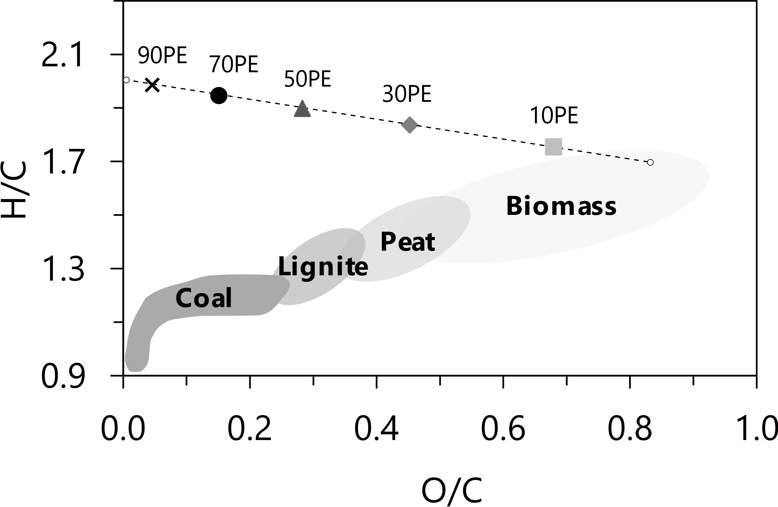

*Figure 2: van Krevelen diagram of the feedstocks. The left and right edges of the curve refer to pure PE and xylan, respectively.*

Table 3 shows the results obtained in the simulation validation. The co-pyrolysis yields at 500 and 600 °C show good agreement with the experimental data, while a small discrepancy is observed for bio-oil and wax yields at higher temperatures (700 °C). Overall, the co-pyrolysis simulation combining individual xylan and PE pyrolysis approaches satisfactorily represented the process in the assessed temperatures. Therefore, the present simulation was used to assess the effects of temperature and PE proportion in a broader range than that studied in the work of Xie et al. (2023), as follows.

Table 3: Simulation validation against experimental results of Xie et al. (2023). E: experiment; S: simulation.

|  |  |  |  |  |
| --- | --- | --- | --- | --- |
| Case (Temperature-PE proportion) | Ybio-oil (%) | Ychar (%) | Ywax (%) | Ygas (%) |
| 500-50 (S) | 34.8 | 12.4 | 44.5 | 8.3 |
| 500-50 (E) | 33.7 | 12.3 | 45.2 | 8.8 |
| 600-50 (S) | 35.5 | 11.8 | 44.0 | 8.6 |
| 600-50 (E) | 37.3 | 11.6 | 41.6 | 9.6 |
| 700-50 (S) | 36.4 | 11.1 | 43.6 | 8.9 |
| 700-50 (E) | 44.8 | 8.4 | 36.2 | 10.6 |

Figure 3 shows the bio-oil, char, wax, and gas yields obtained in the co-pyrolysis simulation at 500–700 °C and with feedstocks containing 10–90 wt% PE.

Figure 3a shows that increasing temperatures result in higher bio-oil yields, which occurs because higher temperatures induce, at fixed residence times, the degradation of the feedstock structure to a higher extent (Demirbas, 2007). Such an effect is especially important for PE, as its decomposition temperatures are higher than those of hemicellulose fractions (Zhou et al., 2017). The higher the PE content in the feedstock, the lower the bio-oil yields, as PE at temperatures below 700 °C will preferentially form wax. Indeed, the higher the PE content, the higher the wax content, as shown in Figure 3c.

Figure 3b shows that, overall, the higher the PE proportion, the lower the char produced, which agrees with char yields obtained in the co-pyrolysis of polystyrene and coffee grounds (Choi et al., 2023). The lower char yields may also be an indication of the suppressed coke formation during co-pyrolysis. The effect of temperature on the char yields, on the other hand, depends on the PE blending proportion. For PE contents of 10–70 wt%, higher temperatures decrease the char yield, while the opposite occurs for 90 wt% PE contents.

Figure 3d shows that increasing temperatures result in higher gas yields. Also, increasing PE contents in the feedstock produces lower gas yields, as similarly observed by Choi et al. (2023) in the co-pyrolysis of biomass materials and styrene.

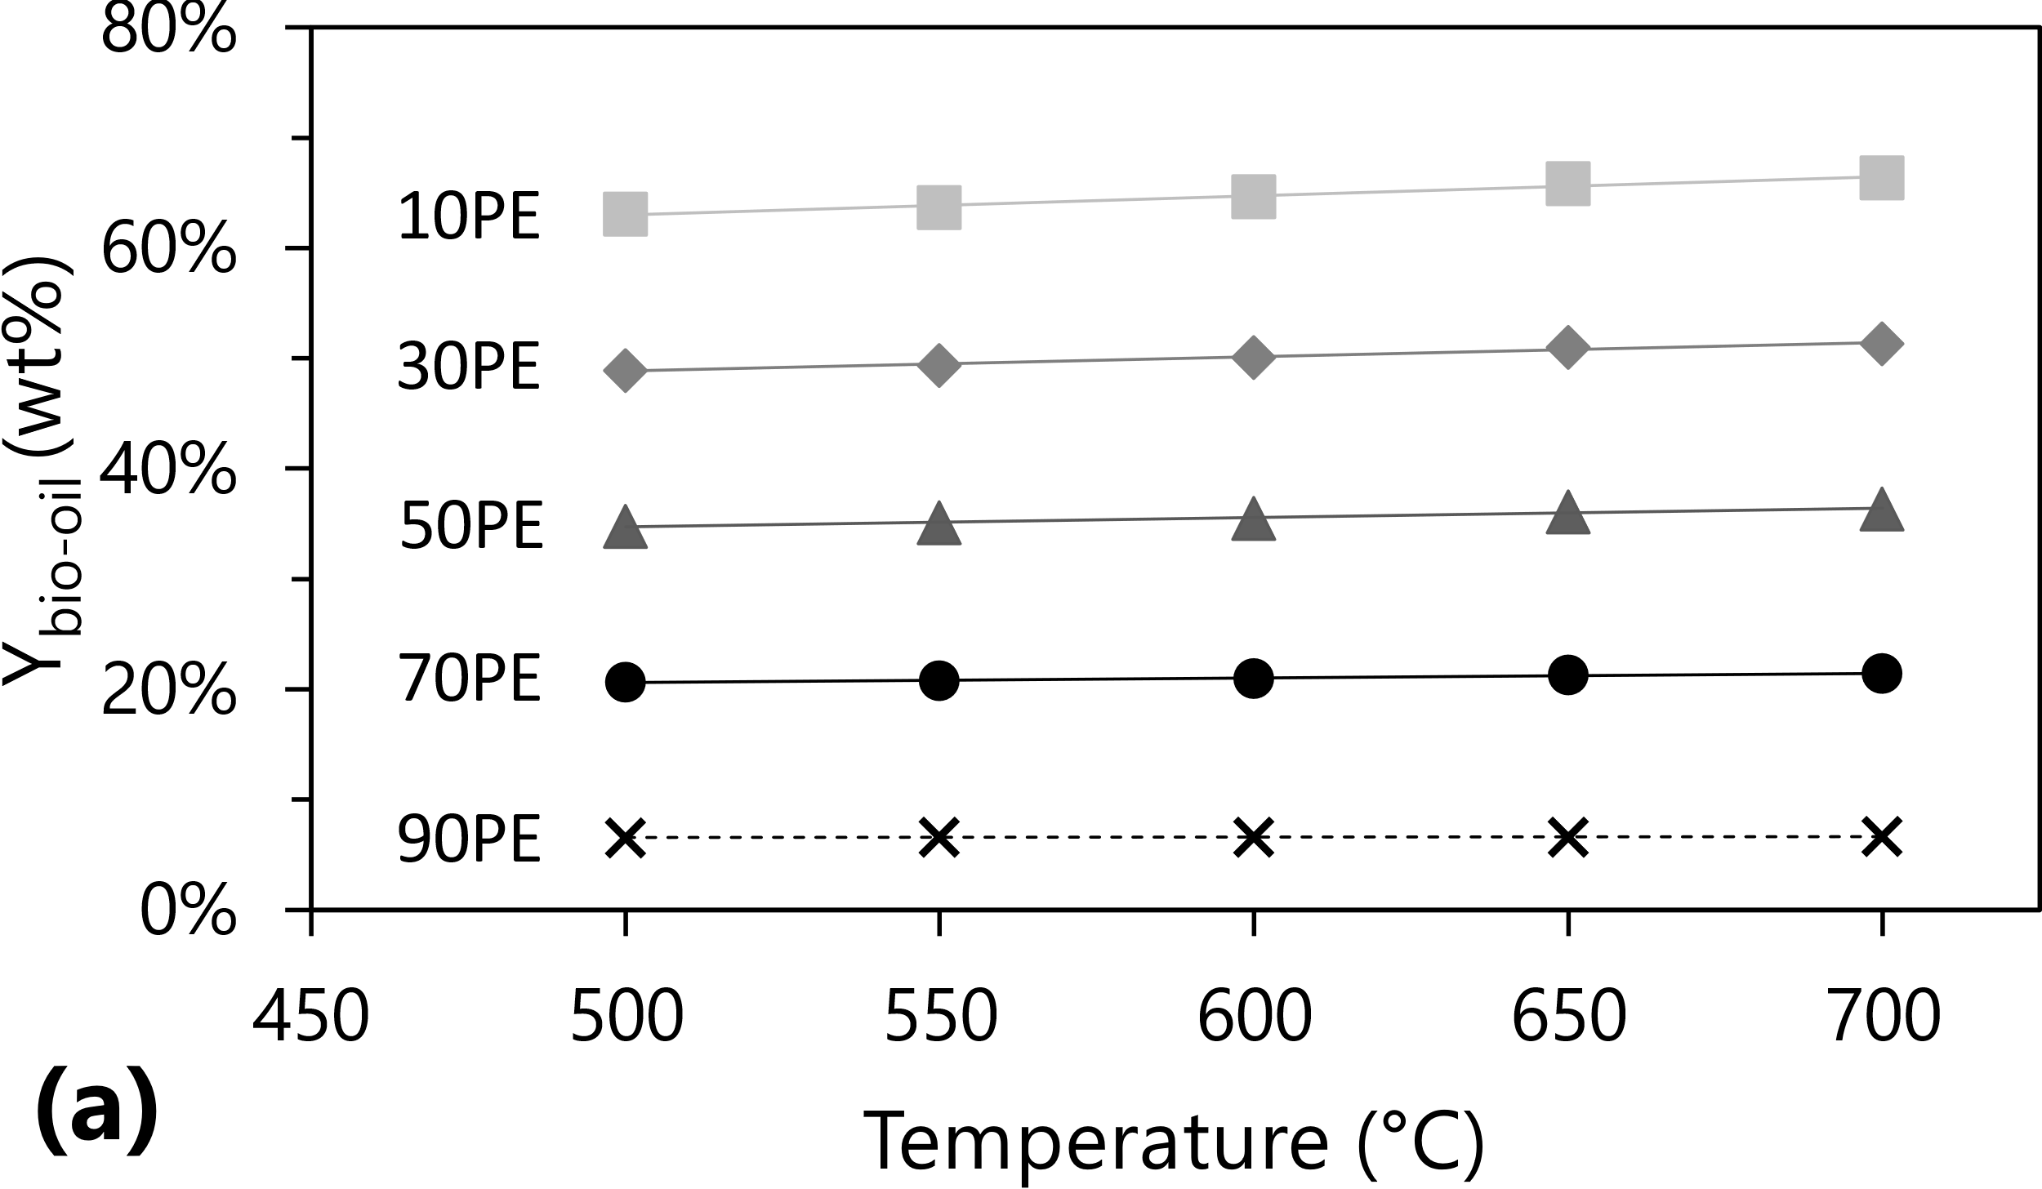 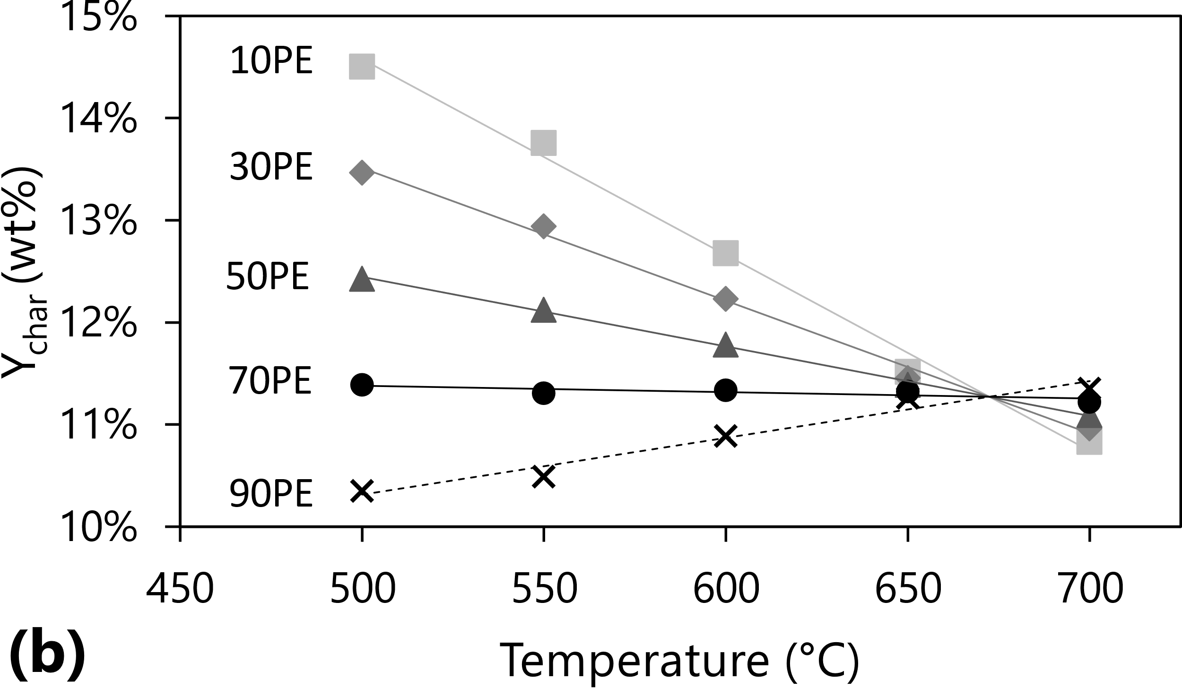

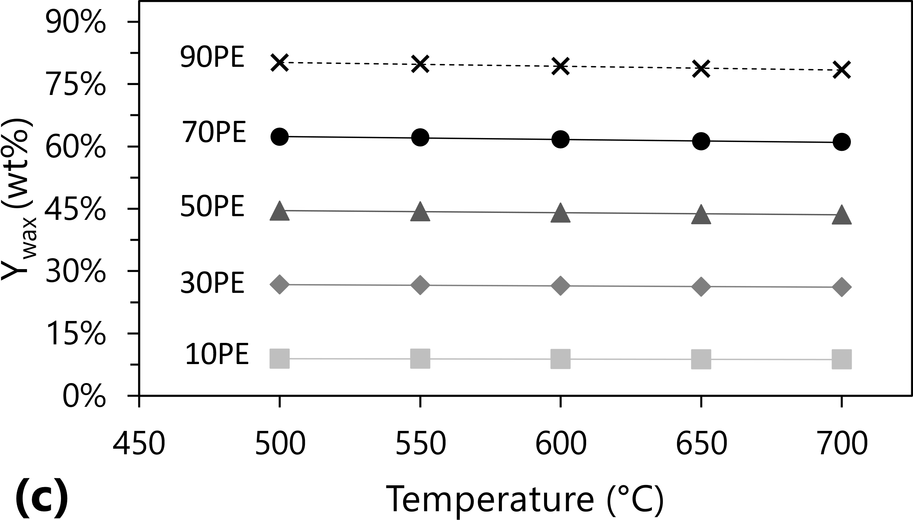 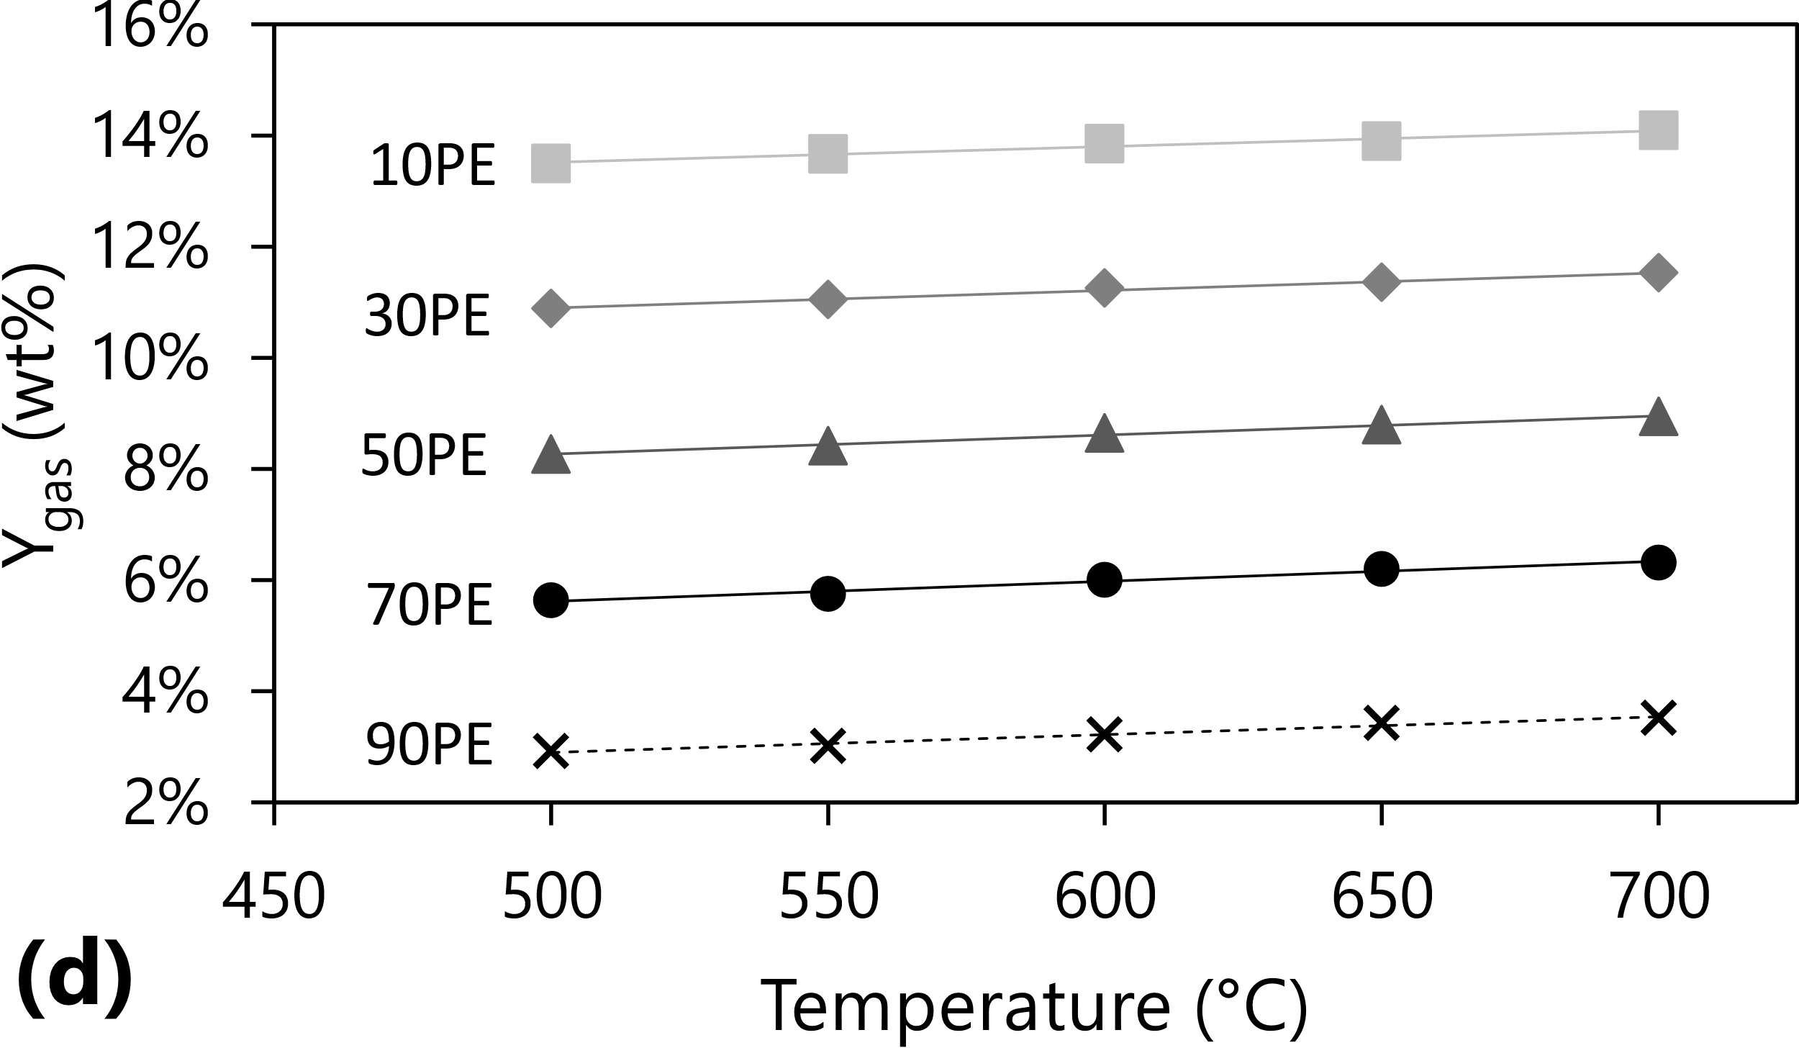

*Figure 3: Co-pyrolysis product yields obtained via simulation: (a) bio-oil, (b) char, (c) wax, and (d) gas yields.*

The simulation has shown the effects of co-pyrolysis temperature and PE proportion on the pyrolytic yields. Higher temperatures affected the feedstock degradation, while higher PE contents increased the feedstock H/C atomic ratio. The present simulation can be used as a starting point for the design of co-pyrolysis processes with either xylan-PE mixtures or blends with other polymers and lignocellulosic residues. Future works may also focus on exploring more detailed kinetic expressions for co-pyrolysis simulation, as well as developing co-pyrolysis simulations that consider the effects of biomass particle size and density. Also, future studies may work on defining acceptable polymer blending proportions aiming to deal with plastic waste generation while also obtaining adequate pyrolysis yields.

* 1. Conclusions

The present work developed the simulation of the co-pyrolysis of xylan, a lignocellulosic derivative, and high-density polyethylene (PE), a widely produced polymer. The co-pyrolysis simulation was developed in Aspen PlusTM and attempted to combine Gibbs free energy minimization and kinetic approaches to represent the pyrolysis of PE and xylan, respectively. During validation against co-pyrolysis experimental data, it was observed that the simulation satisfactorily predicted pyrolytic yields up to temperatures no higher than 700 °C, from which higher deviations start to appear. Sensitivity analyses showed that increasing pyrolysis temperatures in the range of 500–700 °C produced higher bio-oil and gas yields as a result of higher degradation of the feedstock structure. Specifically, the effect of temperature will depend on the PE content in the feeds: for PE contents of 10–70 wt%, temperature will have a decreasing effect on the char yields, while the opposite is observed for higher PE proportions. Lower PE proportions result in higher bio-oil and gas yields, as well as lower wax yields. This study demonstrated that integrating kinetic and equilibrium simulation approaches is an interesting option for the design of co-pyrolysis processes, effectively predicting product yields and indicating possible future works.

Acknowledgments

The authors would like to thank the funding received from Coordenação de Aperfeiçoamento de Pessoal de Nível Superior - Brasil (CAPES) - Finance Code 001, São Paulo Research Foundation (FAPESP) grants #2015/20630-4 and #2016/50403-2, and four Brazilian companies (EMBRAER S.A., KLABIN S.A., PETROBRAS S.A., and SUZANO S.A). This research was started by ILM during her period at the “Pesquisador Colaborador” program of the School of Chemical Engineering (University of Campinas) and finished at the School of Mechanical Engineering (University of Campinas).

References

Choi S.K., Choi Y.S., Jeong Y.W., Han S.Y., Nguyen Q.V., 2023, Simulation of co-pyrolysis of coffee ground and waste polystyrene foam in a tilted-slide reactor, Biomass and Bioenergy, 177, 106933–106943.

Demirbas A., 2007, The influence of temperature on the yields of compounds existing in bio-oils obtained from biomass samples via pyrolysis, Fuel Processing Technology, 88, 591-597.

Guimarães H.R., Bressanin J.M., Motta, I.L., Chagas M.F., Bonomi A. Maciel Filho R., Watanabe M.D.B., 2022, Techno-Economic and Environmental Assessments of Thermochemical Routes Integrated into the Brazilian Sugarcane Industry for the Production of Renewable Jet Fuel, Chemical Engineering Transactions, 92, 115–120.

Kumagai S., Matsukami A., Kabashima F., Sakurai M., Kanai M., Kameda T., Saito Y., Yoshioka T., 2020, Combining pyrolysis–two-dimensional gas chromatography–time-of-flight mass spectrometry with hierarchical cluster analysis for rapid identification of pyrolytic interactions: Case study of co-pyrolysis of PVC and biomass components, Process Safety and Environmental Protection, 143, 91–100.

Motta I.L., Marchesan A.N., Real Guimarães H., Chagas M.F., Bonomi A., Wolf Maciel M.R., Maciel Filho R., 2023, Fast pyrolysis simulation via kinetic approach and multivariate analysis to assess the effect of biomass properties on product yields, properties, and pyrolyzer performance, Energy Conversion and Management, 296, 117676.

Motta I.L., Miranda N.T., Maciel Filho R., Wolf Maciel M.R., 2018, Sugarcane bagasse gasification: thermodynamic modelling and analysis of operating effects in a steam-oxygen-blown fluidized bed using Aspen PlusTM, Chemical Engineering Transactions, 65, 169–174.

Ranzi E., Debiagi P.E.A., Frassoldati A., 2017, Mathematical Modeling of Fast Biomass Pyrolysis and Bio-Oil Formation. Note I: Kinetic Mechanism of Biomass Pyrolysis, ACS Sustainable Chemistry & Engineering, 5, 2867–2881.

Sharuddin S.D.A., Abnisa F., Daud W.M.A.W., Aroua M.K., 2016, A review on pyrolysis of plastic wastes, Energy Conversion and Management, 115, 308–326.

OECD, 2022a, Global Plastics Outlook: Policy Scenarios to 2060 <https://www.oecd-ilibrary.org/sites/aa1edf33-en/index.html?itemId=/content/publication/aa1edf33-en> accessed 12.06.2023.

OECD, 2022b, Innovations on Plastics <https://www.oecd-ilibrary.org/docserver/bb1ff6fa-en.pdf?expires=1686601708&id=id&accname=ocid54025470&checksum=6F9D46671C5DA18EF75A04AC18741011> accessed 12.06.2023.

Yu D., Hui H., Ding G., Dong N., Li S., 2021, Enhancement of aromatics production from catalytic co-pyrolysis of walnut shell and LDPE via a two-step approach. Journal of Analytical and Applied Pyrolysis, 157, 105216–105224.

Xie S., Kumagai S., Takahashi N., Kameda T., Saito Y., Yoshioka T., 2023, A novel strategy for rapid identification of pyrolytic synergy and prediction of product yield: Insight into co-pyrolysis of xylan and polyethylene. Chemical Engineering Journal, 453, 139958–139969.

Zhou L., Zou H., Wang Y. Le Z., Liu Z., Adesina A.A., 2017, Effect of potassium on thermogravimetric behavior and co-pyrolytic kinetics of wood biomass and low density polyethylene, Renewable Energy, 102, 134-141.