CHEMICAL ENGINEERING TRANSACTIONS  VOL. , 2024 | A publication of
The Italian Association
of Chemical Engineering
Online at www.cetjournal.it

Guest Editors:
Copyright © 2023, AIDIC Servizi S.r.l.
ISBN 979-12-81206-XX-X; ISSN 2283-9216
Analysis of the Content of Nutrients in the Southern Chernozem of Kazakhstan Based on Remote Sensing Data
Gulnara Rashidenovna Kabzhanovaª, Razia Kairbekovna Khusainova^{b}, Anara Abilzhanovna Sarsenova^{b}, Aisulu Zhumabaykyzy Kurmashevaª, Abilzhan Tokanovich Khusainov^{b}

ªJSC “National Company “Kazakhstan Gharysh Sapary”, Turan ave., 89, 010000, Astana, Kazakhstan
^{b}Priority Department Centre «Veritas» D. Serikbayev East Kazakhstan technical university, Serikbayev str., 19, 020000, Kokchetau, Kazakhstan
gurashkab@mail.ru
Optimization of mineral nutrition for grain crops is based on the constructive and prompt use of mineral fertilizers in accordance with the need and economic efficiency. Given the spatial extent of Kazakhstan's agricultural resources, the use of remote tools for diagnosing the content of basic plant nutrition elements is the most optimal solution. In a scientific study conducted on southern chernozems in Northern Kazakhstan, remote sensing data analysis methods were used to predict the content of NPK.
  - Introduction
One of the aspects of agricultural intensification for economically developed countries is the adoption of effective agricultural management decisions based on modern tools, including information technology and remote sensing. The principle of greening in intensive agriculture implies the development of balanced and environmentally safe production and rational use of natural resources (Gorbatovskij and Gorbatovskaya, 2010). Optimization of the mineral nutrition of cultivated plants due to an environmentally adaptive approach when applying fertilizers, reliable operational remote monitoring of plants will allow the introduction of tools for the intensification of agricultural production.
From the materials of Baktybekov K. (2018), the space monitoring tool in Kazakhstan is effectively used for operational assessment of the crops condition. However, these services currently can show limited parameters of crops – only soil surface moisture, biomass, degradation signs, and the agrochemical state from space is still impossible to determine, since there is no scale of dependence of the actual state of the plant and the spectral radiation of plants.
Optimization of mineral nutrition and modeling of agrochemical processes is the final part of empirical research, which allows systematic crop planning. Such modeling was carried out in the south of Western Siberia by Dr. Ermokhin Yu. I. (Sarsenova, 2021). The continuation of this trend in combination with remote sensing methods has undoubtedly scientific novelty, relevance and practical significance.
Thus, the integration of methods of ground diagnostics of plants and their spectral response according to remote sensing data in the system of regional monitoring of agricultural production will allow us to develop a comprehensive adapted method for the operational assessment of the condition of agricultural plants, namely grain crops of Northern Kazakhstan, which are of high food importance in the country. Given the spatial extent of Kazakhstan's agricultural resources, remote monitoring will solve the problems of prompt provision of data, monitoring and effective management of agricultural production resources.
The researchers set a goal to study methods for analyzing the spectral response of plants according to remote sensing data and diagnosing the content of basic nutrients in the soil in the regional agricultural production system using ground monitoring tools, remote sensing data and geoinformation design. To achieve this goal, a geoinformation base of the research area was created, the selection of methods for assessing the seasonal variability of the state of agricultural plants, taking into account regional characteristics according to remote sensing data, a ground assessment of the provision of basic nutrients by agrochemical soil analysis, an analysis of the validation of remote and ground monitoring data of the main indicators of agricultural production in the area of interest.
  - Materials and methods
Scientific research was carried out on sowing of grain crops of the “Lobanovo” LLP farm in Northern Kazakhstan, on southern medium-grained chernozems.
The description of the physical-geographical, soil-climatic characteristics of the zone of interest, the analysis of agricultural territories at the level of the region, district and economy, the assessment of the dynamics of land use and condition based on a comparative analysis of multi-time cartographic materials, remote sensing data and ground surveys.
Ground survey of the area of interest: agrochemical analysis of soil samples for the content of N-NO₃ by the Tyurin and Kononova method, P₂O_{5,} K₂O by the Machigin method for carbonate soils.
Development of a spatial database: collection of stock cartographic material, development of a topographic basis, digitization of monitoring objects, creation of a geodata database.
Remote sensing data analysis: thematic processing of medium-resolution satellite image data (10 m), calculation of vegetation indices and extraction of biophysical vegetation parameters (LAI, FCOVER, FAPAR), interpretation of the analysis results.
Mathematical data processing: spatial analysis and validation of agrochemical soil analysis data with remote sensing data analysis, regression analysis of the data obtained.
  - Results and discussion
The selection of soil samples for agrochemical analysis was carried out for each spectral classification unit, depending on the results of remote classification of vegetation cover, with coordination of selection sites and determination of the main indicators of soil fertility (nitrogen, phosphorus, potassium, humus, pH, absorbed bases, etc.). To create cartograms of the availability of basic plant nutrition elements according to agrochemical soil analysis (Figure 1), the geoinformation software ArcGIS Desktop was used.
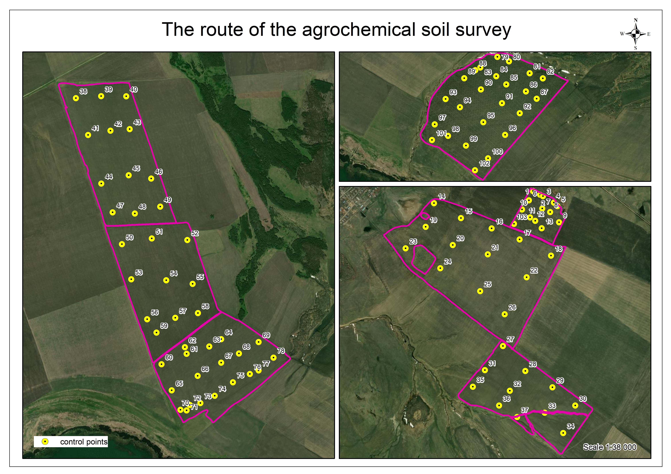

Figure 1: Scheme of agrochemical soil survey in Lobanovo village

The results of agrochemical soil analysis were transformed into cartograms, which were created using the IDW (Inverse Distance Weighing) method. This method interpolates the surface with sufficient accuracy if the sampling points are distributed relatively normally and the surface is homogeneous and suitable for predicting the spatial distribution of the main nutrients of the soil cover (Myslyva and Kutsaeva, 2019). When applying this method, the main requirements for the correct use of geostatistical methods must be met – the initial data set must contain at least 100 observation points (Oliver et al., 2010; Lark, 2000) and have a normal statistical distribution. Using the IDW tool in ArcGIS Desktop, interpolation models were built based on the values of the main elements of nutrition to estimate the content of phosphorus, potassium and nitrogen (Figures 2-4).
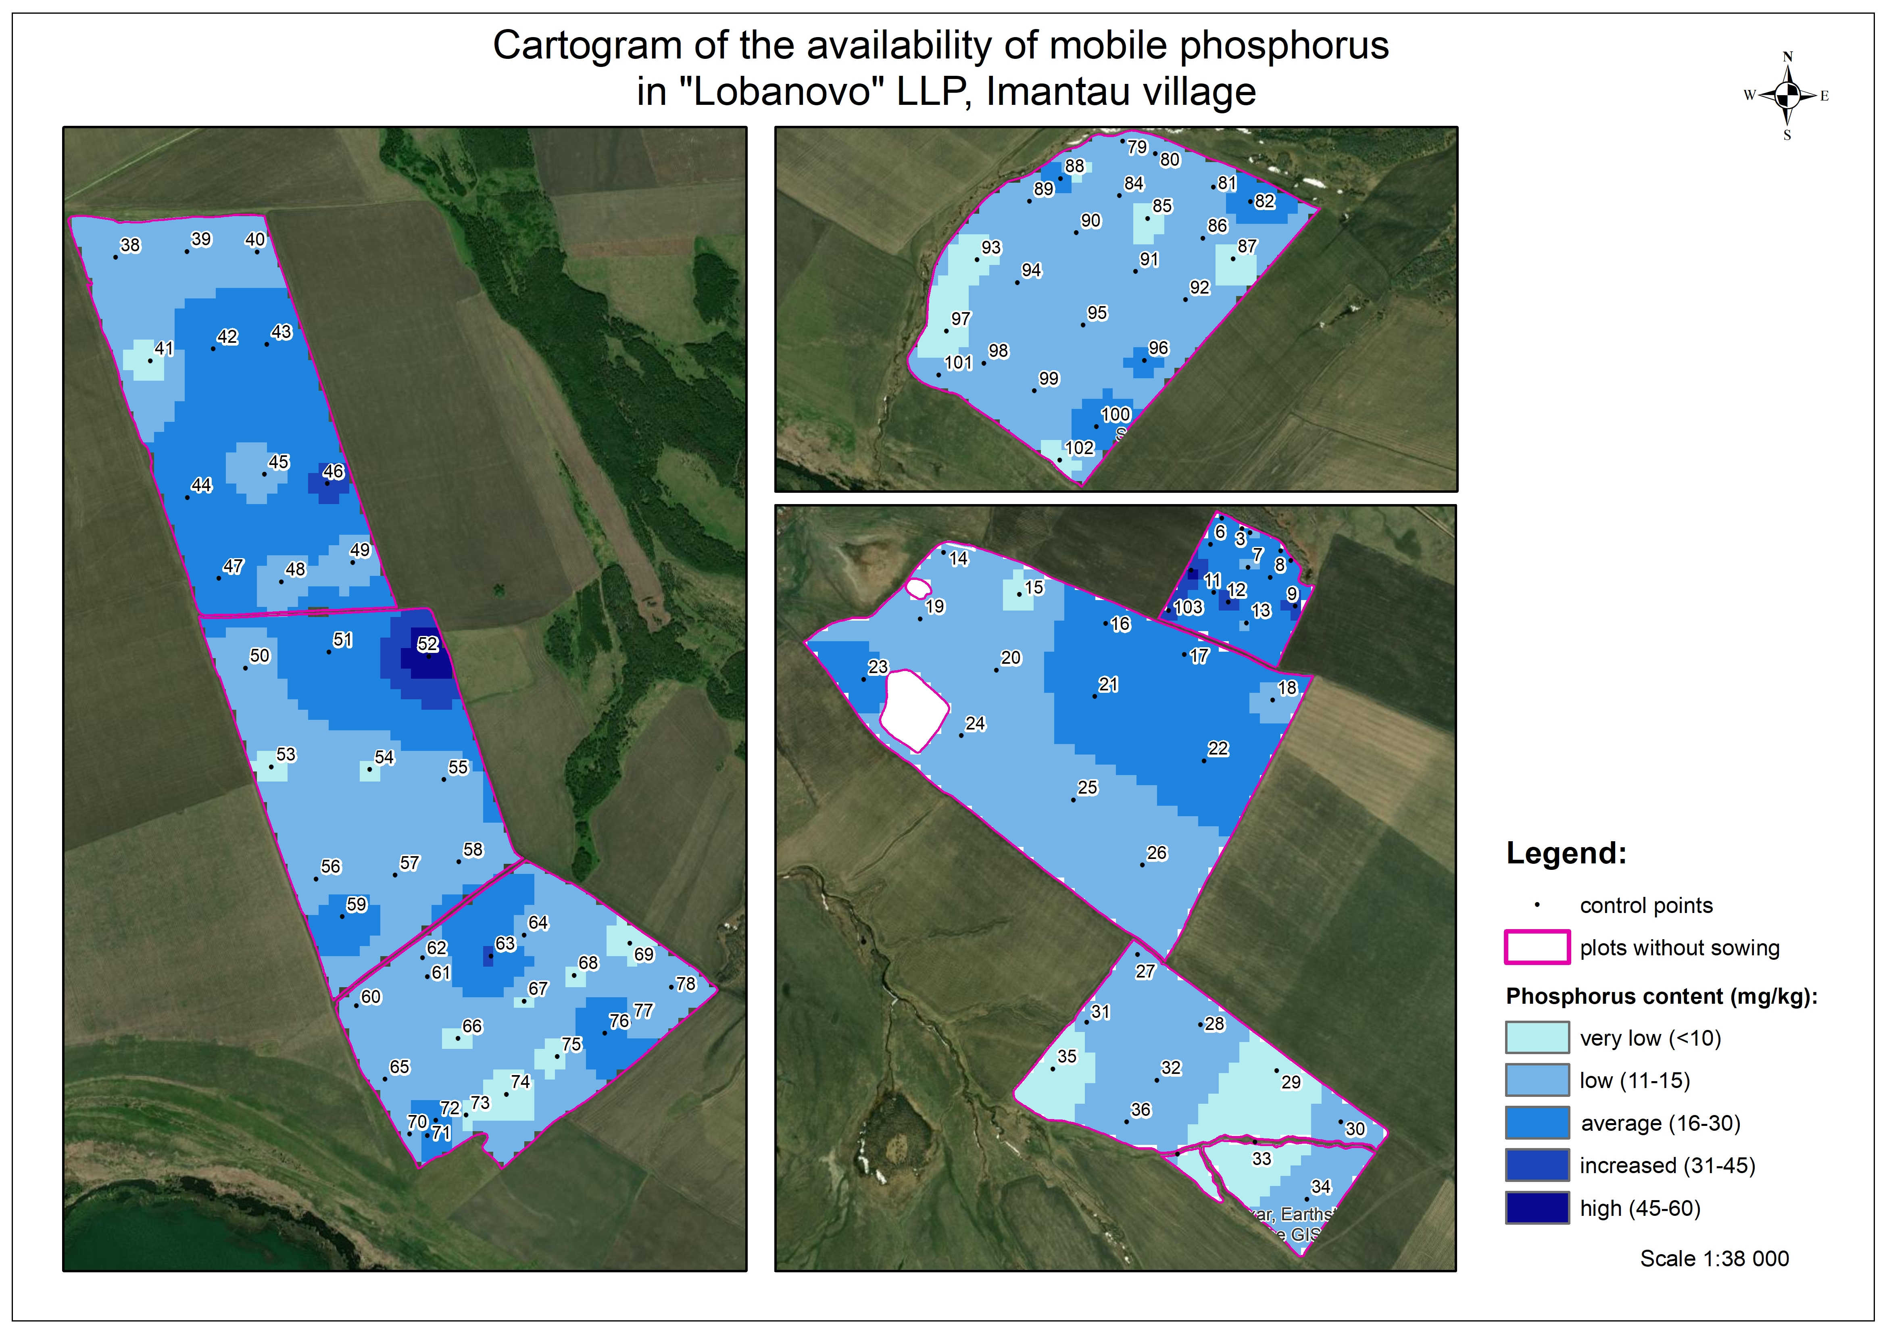

Figure 2: Interpolation models for estimating the phosphorus content in the soil in the area of interest

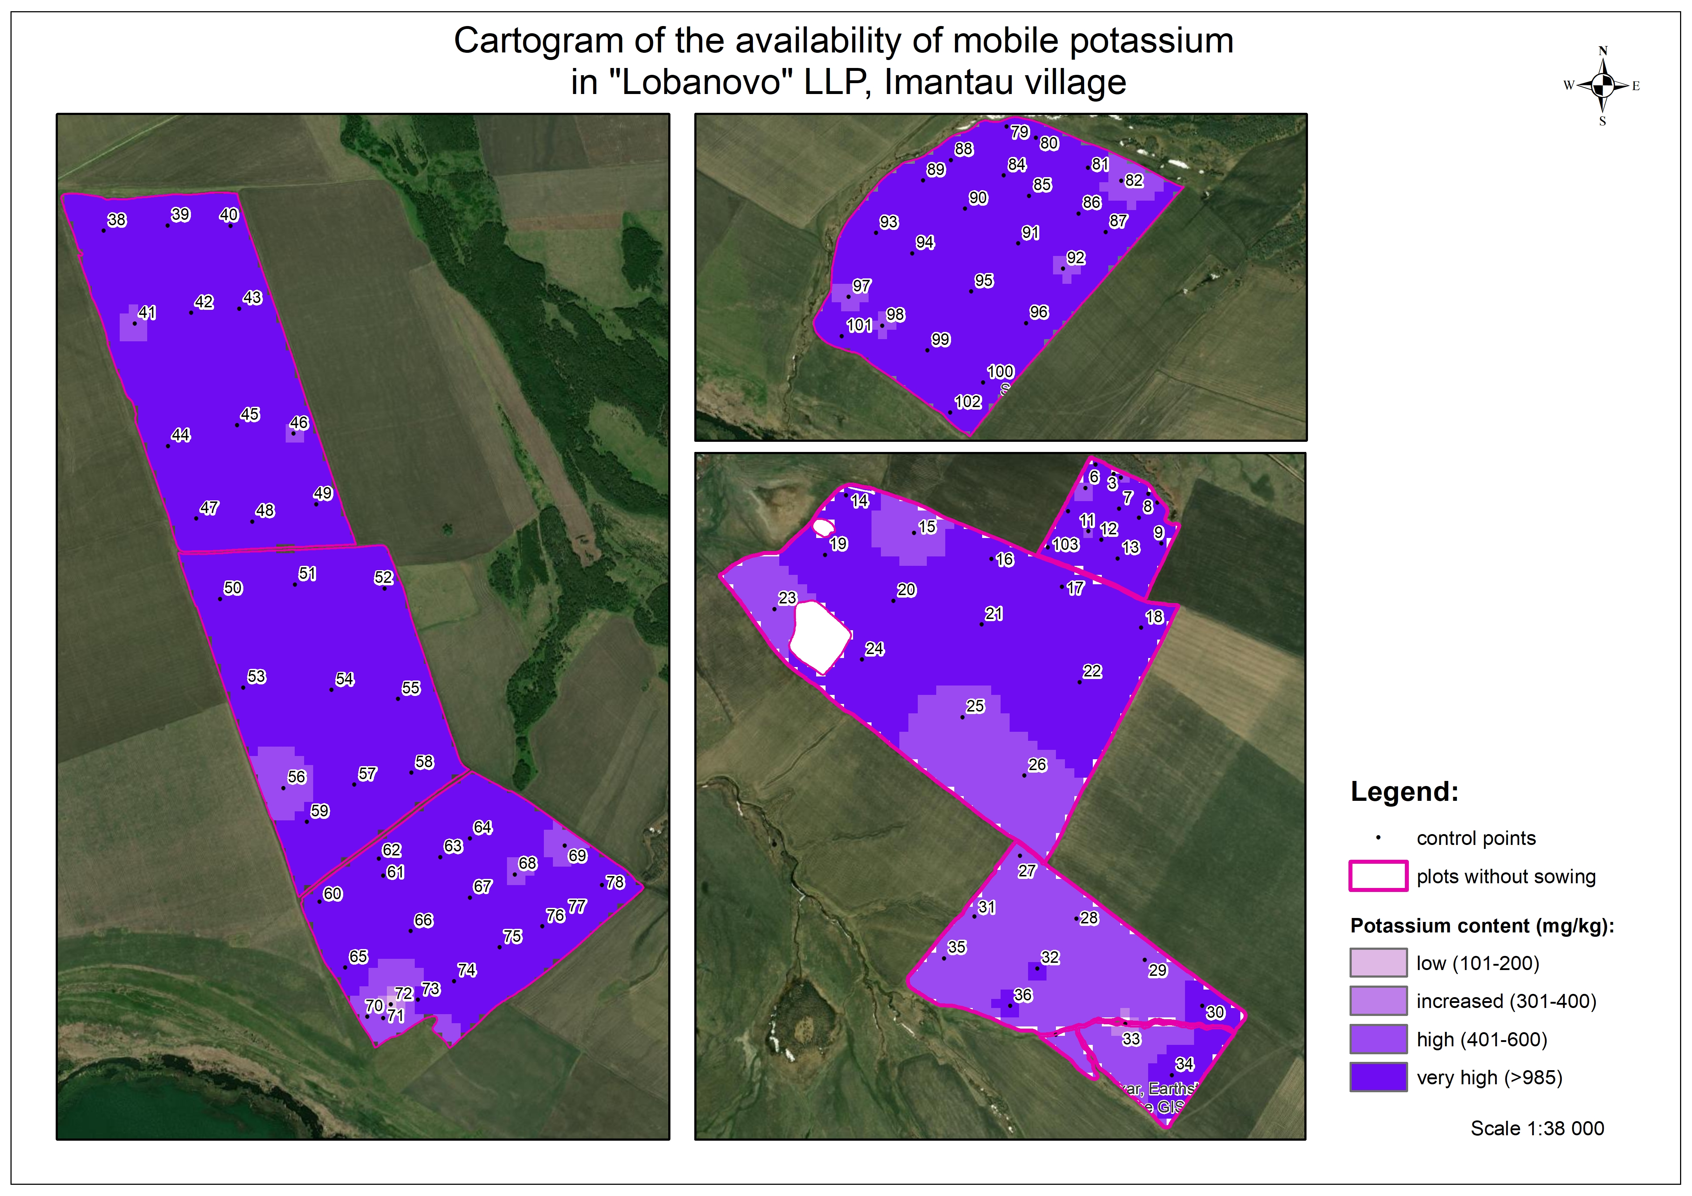

Figure 3: Interpolation models for estimating the potassium content in the soil in the area of interest

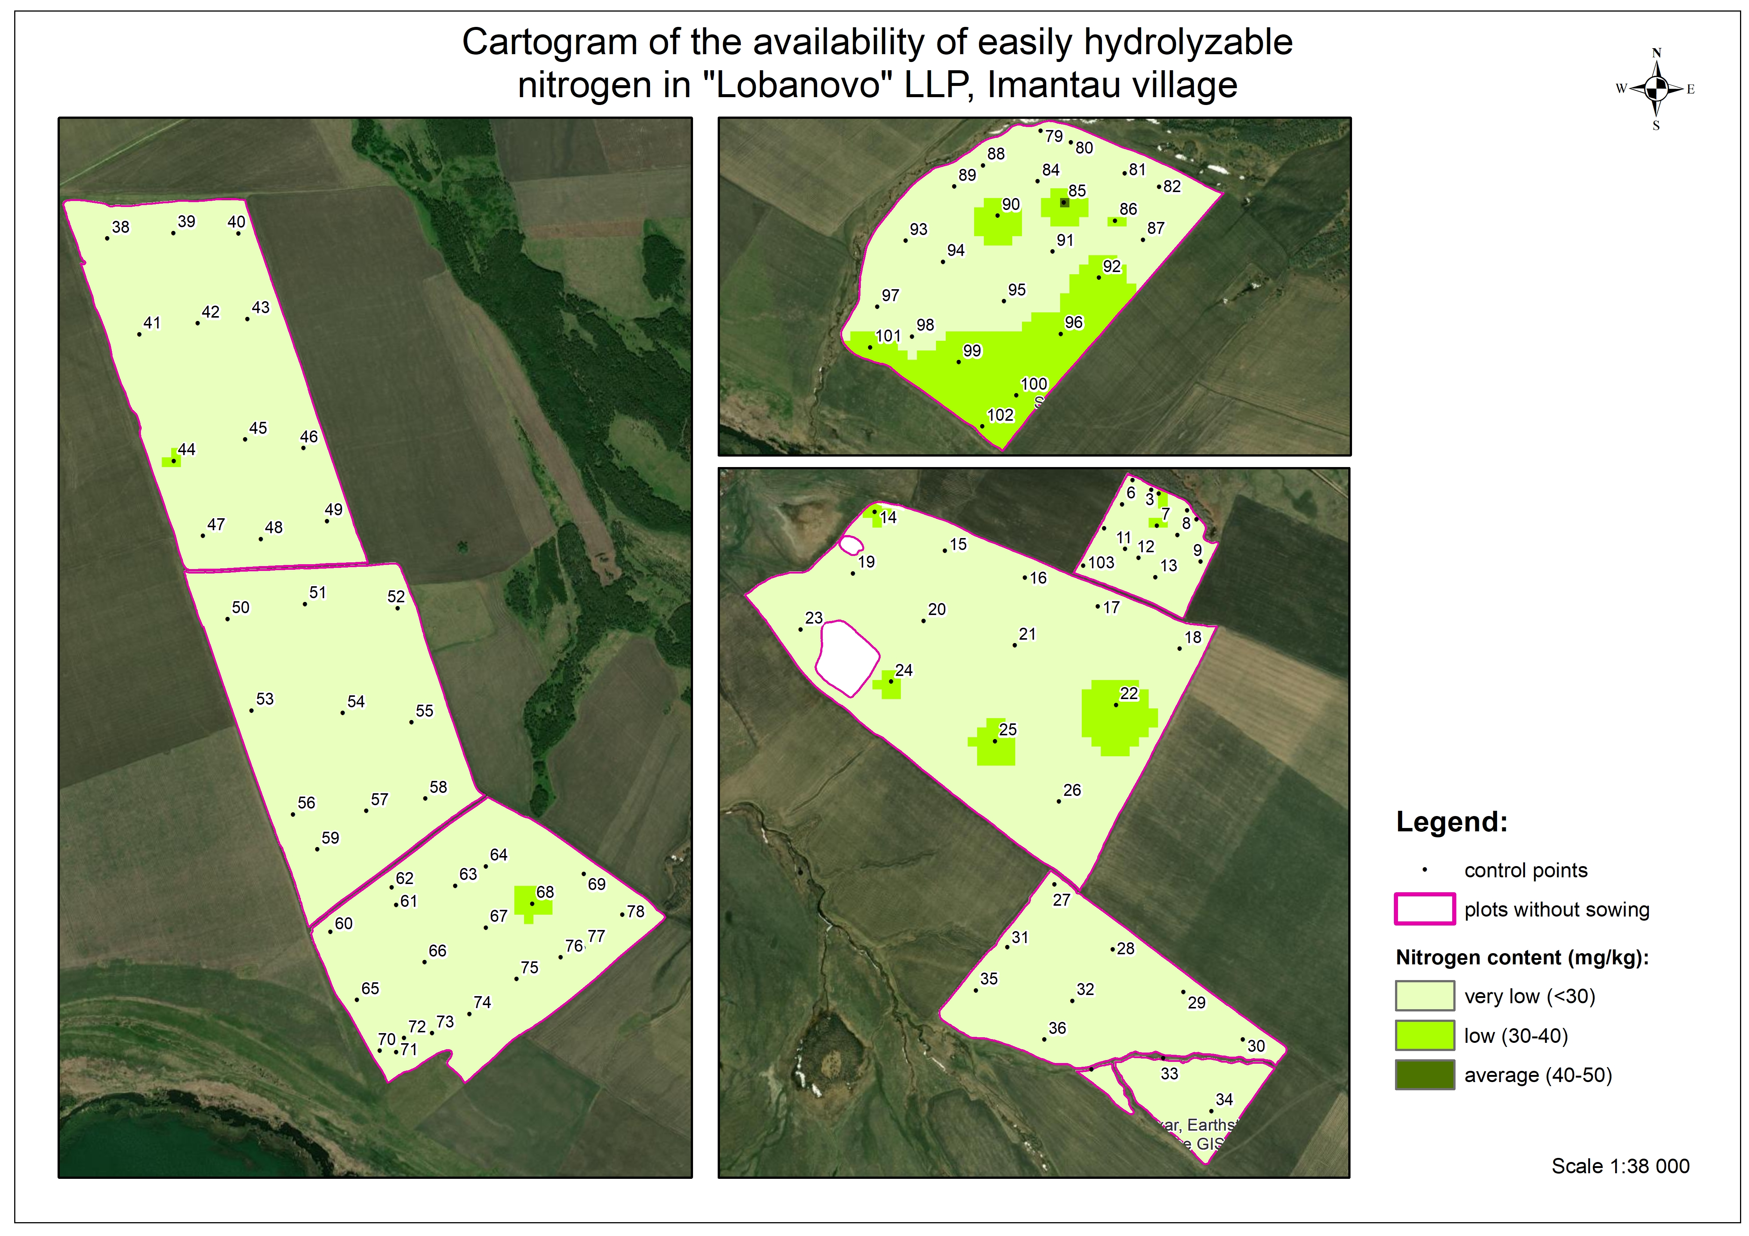

Figure 4: Interpolation models for estimating the nitrogen content in the soil in the area of interest

To assess the correlation of the state of crops according to remote sensing data with ground-based agrochemical analysis data, biophysical parameters was used. Biophysical parameters were presented in this analysis by LAI (The Leaf Area Index), FCOVER (The Fraction of Vegetation Cover), FAPAR (The Fraction of Absorbed Photosynthetically Active Radiation). The FCOVER coefficient ranges from 0 to 1 and refers to the part of the earth's surface that is covered by a vertical projection of vegetation cover. FCOVER is an indicator of plant growth in the early periods before the soil is completely covered by the canopy. This is an important indicator of crop formation and early germination (Pask et al., 2012). LAI is the ratio of the area of green leaves to the area of the measured plot of land (Bell and Fischer, 1994). LAI is one of the indicators of crop growth. But it should be noted that, unlike another biophysical parameter FCOVER, LAI continues to increase after the land/soil is completely covered and reaches maximum values for winter wheat during ear formation (AHDB, 2018). FAPAR is an indicator of the proportion of incoming photosynthetically active radiation absorbed by the canopy, estimates the real importance of the area and angle of inclination of the leaves for capturing solar energy for photosynthesis (Bell and Fischer, 1994).
Currently, the “soil-vegetation” recognition system is used. The main properties of the reflectivity of solar radiation from this system are distinguished:
- the visual properties of plants and other solar cells, which are subject to change during the growing season and depend mainly on environmental parameters;
- the structural plant surface, which is also variable over time (the density of plant standing, the area of the leaf surface, mainly the orientation of the leaves, the degree of projective soil coverage by plants);
- the reflectivity of the soil, which is determined by the type of soil, humidity, and the presence of plant residues on the soil surface (Buldakova, 2021).
The authors determined the biophysical parameters of crops of “Lobanovo” LLP in the North Kazakhstan region using data from the Sentinel-2 (MSI). For this purpose, satellite images were used for May 15, June 14, July 14 and August 18, 2023. The results of calculations of the biophysical parameters of the vegetation of the zone of interest are presented in Table 1.

Table 1: Descriptive statistics of biophysical parameters for area of interest

Values | The vegetation season of 2023
 | May 15 | June 14 | July 14 | August 18
LAI
min | 0,17 | 0,19 | 0,24 | 0,11
max | 0,78 | 2,25 | 3,13 | 2,24
mean | 0,22 | 0,35 | 1,03 | 0,38
FCOVER
min | 0,03 | 0,05 | 0,1 | 0,05
max | 0,35 | 0,66 | 0,76 | 0,72
mean | 0,05 | 0,14 | 0,35 | 0,22
FAPAR
min | 0,0 | 0,04 | 0,13 | 0,05
max | 0,38 | 0,7 | 0,8 | 0,72
mean | 0,02 | 0,15 | 0,39 | 0,22

The extracted biophysical parameters clearly demonstrate the relationship with vegetation indices, since the trend of crop development can be analyzed by the minimum, maximum and average values of biophysical parameters. The use of such indicators can contribute to the control of the growth and physiological status of an agricultural crop.
In the practice of agricultural research, it is often necessary to study the nature of the relationship between two (or more) varying features or properties of soil and vegetation cover. Many signs and properties of the soil and vegetation cover are interconnected in a certain relationship.
In this study, the use of correlation and regression analysis to study the relationship between quantitative indicators characterizing the state of crops according to biophysical parameters and the content of basic nutrients became possible, since a large number of test sites were used in the assessment (103).
Correlation and regression analysis are methods of mathematical statistics that allow us to identify the relationship between two quantities, the values of which are obtained as a result of statistical observations. The main task of correlation analysis is to assess the closeness of the relationship between the values, and regression analysis is to establish its type (Mylnikov and Kulikova, 2013).
The statistical analysis includes correlation and linear regression analysis between the values of the contents of the main nutrients (nitrogen, phosphorus, potassium) and the average values of biophysical parameters for the control polygons for which the agrochemical analysis was carried out.
In most statistical analysis scenarios, the results were weak and inconsistent due to the lack of a positive relationship (Figures 5-6).

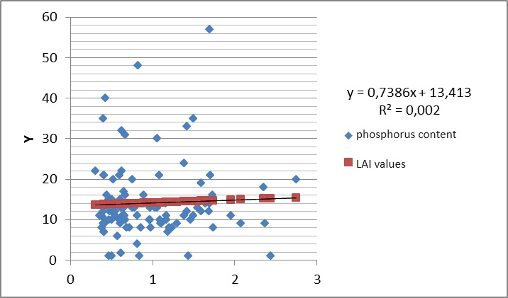

Figure 5: Relationship between phosphorus content and LAI values

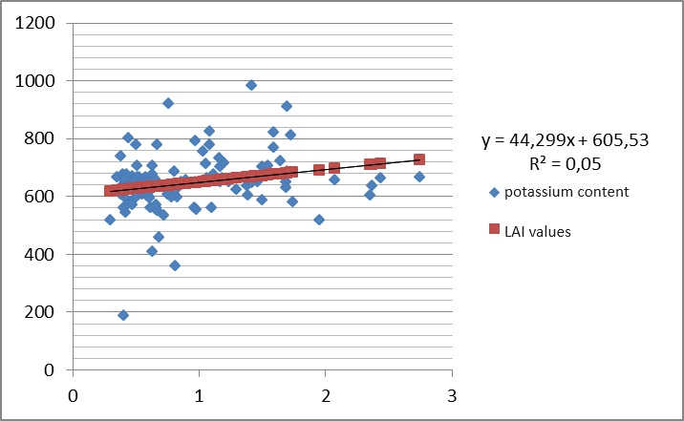

Figure 6: Relationship between potassium content and LAI values

The exception was the relationship revealed by the authors between the values of nitrogen and LAI during the period of maximum plant growth (data for July 14, 2023), where, according to regression statistics, R² = 0,89 (Figure 7). Thus, the pictures from July 14, during the period of maximum plant growth and development, turned out to be the most informative. It is also necessary to note the advantage of the biophysical parameter LAI.

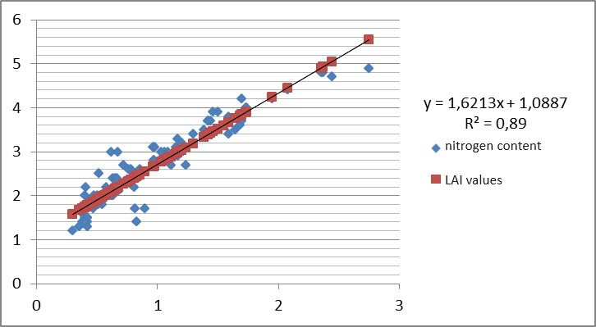

Figure 7: Relationship between nitrogen content and LAI values

Nitrogen is the main limiting factor in obtaining sustainable grain yields for the soils of Northern Kazakhstan. Since most of the nitrogen in crops is contained in green leaves during the growth period of the crop, LAI is a very sensitive indicator of changes in the nitrogen demand of the crop during the growing season. The nitrogen content has a noticeable effect on the spectral values of LAI. In order to study and optimize the management of nitrogen content in agricultural crops, diagnostic methods based on the measurement of nitrate content in soil (Isfan et al., 1995), nitrogen nutrition index (NNI) (Debaeke et al., 2006; Zaidi et al., 2008) and nitrogen concentration in leaves (LNC) (Errecart P., 2012). But it is worth noting that despite the number of studies conducted to optimize the determination of nitrogen in crop production, contradictions exist to this day. Despite this, LAI is of great importance as a basis for assessing the condition of crops, assessing the nitrogen content in the soil and for varying nitrogen application rates. Within the framework of this study, LAI is a suitable tool for diagnosing the state of nitrogen in the surface layer of the soil.
  - Conclusion
In this study, using data from remote monitoring of the territory of the North Kazakhstan region, the possibility of assessing the parameters of soil fertility of southern chernozems from satellite images was evaluated. To carry out this work, agrochemical surveys of the soils of control polygons with coordinate selection of soil samples (about 103 samples) were carried out. A detailed analysis of the content of the main elements of NPK nutrition was carried out. To study the spectral response of plants according to remote sensing data, a selection of cloudless satellite images from the Sentinel-2 for the main phases of plant development was carried out. Thematic processing of remote sensing data with determination of biophysical parameters (LAI, FCOVER, FAPAR) was carried out. These biophysical parameters accurately characterize the condition of plants and can diagnose the ecological conditions of agrocenoses. In this study, a correlation and regression analysis was carried out to study the relationship between quantitative indicators characterizing the state of crops according to biophysical parameters and the content of basic nutrients in the sowing layer of the soil. According to the analysis, the correlations were weak and inconsistent, with the exception of the relationship between nitrogen and LAI values during the period of maximum plant growth, where, according to regression statistics, R² = 0,89. As part of this study, LAI is a suitable tool for diagnosing nitrogen content in the seedbed of the soil. Remote monitoring of spectral responses of plants and biophysical parameters according to remote sensing data makes it possible to diagnose the content of nitrate nitrogen in the soil.
Acknowledgments
This research has been/was/is funded by the Science Committee of the Ministry of Science and Higher Education of the Republic of Kazakhstan (Grant No. AP19679364).
References
AHDB, 2018, Wheat growth guide, In AHDB Cereals & Oilseeds (Agriculture and Horticulture Development Board). <cereals.ahdb.org.uk/media/185687/g66- wheat-growth-guide.pdf> accessed 22.08.2023.
Baktybekov K., Kabzhanova G., Aimbetov A., Kabdulova G., Rahimzhanov B., Zelenovskij A., 2018, The results of the use of space technologies in the management of agricultural resources of the Republic of Kazakhstan, 18th International Scientific and Technical Conference “From snapshot to digital reality: remote sensing of the Earth and photogrammetry”. (in Russian)
Bell M. A., Fischer R. A., 1994, Guide to plant and crop sampling: Measurements and observations for agronomic and physiological research in small grain cereals, CIMMYT.
Buldakova E.D., 2021, Requirements for remote sensing data for determining the state of vegetation cover // Bulletin of the Magistracy, 6-3(117), 4–6.
Debaeke P., Rouet P., Justes E., 2006, Relationship between the normalized SPAD index and the nitrogen nutrition index: Application to durum wheat, Journal of Plant Nutrition, 29, 75–92.
Errecart P. M., Agnusdei M. G., Lattanzi F. A., Marino M. A., 2012, Leaf nitrogen concentration and chlorophyll meter readings as predictors of tall fescue nitrogen nutrition status, Field Crops Research, 129, 46–58.
Gorbatovskij A.V., Gorbatovskaya O.N., 2010, Adaptive intensification of agriculture: principles and directions. Economic issues of the development of agriculture in Belarus, 38, 76–84. (in Russian)
Isfan D., Zizka J., D’Avignon A., Deschênes M., 1995, Relationships between nitrogen rate, plant nitrogen concentration, yield and residual soil nitrate-nitrogen in silage corn, Communications in Soil Science and Plant Analysis, 26, 2531–2557.
Lark R.M., 2000, Estimating variograms of soil properties by the method-ofmoments and maximum likelihood, European Journal of Soil Science, Vol 51, 717–728.
Mylnikov M.M., Kulikova O.V., 2013, Correlation and regression analysis of quantitative indicators of educational tasks, Modern high-tech technologies, 6, 61–62.
Myslyva T., Kutsaeva O., 2019, Efficiency of Interpolation Methods Based on GIS for Estimating of Spatial Distribution of PH in Soil, Baltic Surveying, 11, 53–59, doi: 10.22616/j.balticsurveying.2019.017.
Oliver V.A., Kerry R., Frogbrook Z.L., 2010, Sampling in Precision Agriculture, Geostatistical Applications for Precision Agriculture, Springer Science + Business Media B.V., 35–64.
Pask A., Pietragalla J., Mullan D., 2012, Physiological breeding II: A field guide to wheat phenotyping, CIMMYT, Mexico, doi: 10.1017/CBO9781107415324.004.
Sarsenova A.A., 2021, Sustainable management of industrial waste to increase soil fertility, Study guide, Almaty, 100. (in Russian)
Ziadi N., Brassard M., Bélanger G., Claessens A., Tremblay N., Cambouris A. N., Nolin M. C., Parent L. É., 2008, Chlorophyll measurements and nitrogen nutrition index for the evaluation of corn nitrogen status, Agronomy Journal, 100, 1264–1273.

