CHEMICAL ENGINEERING TRANSACTIONS  VOL. , 2024 | A publication of
The Italian Association
of Chemical Engineering
Online at www.cetjournal.it

Guest Editors: Leonardo Tognotti, Rubens Maciel Filho, Viatcheslav Kafarov
Copyright © 2024, AIDIC Servizi S.r.l.
ISBN 979-12-81206-09-0; ISSN 2283-9216

Application of the chitin biopolymer extracted from Emerita analoga for the removal of boron in contaminated waters
Jesson Gurmendi-Calderonª, Vladimir Camel^{a*}, Freddy Pillpa-Aliagaª Rita Cabello-Torresª
ªUniversidad César Vallejo, Campus San Juan de Lurigancho, Lima, Perú
vcamelpa@ucv.edu.pe
Pollution of rivers by Boron (B) causes alterations to biodiversity, ecosystems and generates risk to human health. At present, the removal of boron using conventional methods is difficult and expensive. Therefore, it is crucial to develop practical and cost-effective methods. This research involved the characterization and extraction of chitin from Emerita analoga, as well as the determination of the effective dose for reducing high concentrations of boron (904 mg/L) in contaminated waters. To evaluate the relationship between the size and weight of E. analoga, the Schumacher allometric model was employed. Chitin has been extracted from the shell using chemical processes of deproteinization and demineralization. The quality of chitin was analyzed using the FTIR. For quantifying boron in the water, the ICP–MS (Inductively Coupled Plasma - Mass Spectrometry) method was used. Our results indicate sexual dimorphism in E. analoga, with females and males reaching average weights of 5.27 g and 3.92 g, respectively. On the other hand, the regression model (r²=0.97) indicated a progressive reduction of Boron when chitin beads were increased. Using 1 g of chitin, 57% (514 mg/L) of Boron was reduced in 500 ml of contaminated water. Consequently, our study suggests the great potential and simplicity of using chitin for removing Boron from drinking water.

  - Introduction
The contamination of rivers by mining tailings is a problem in various parts of the world, as it degrades and damages the biodiversity of flora and fauna, constraining their habitats and causing alterations in the ecosystem (Tumanyan et al., 2020), it also harms human health by generating various chronic diseases (Mitra et al., 2022). On the other hand, some reports indicate that some rivers in Peru are highly contaminated with mining tailings, due to their rich mineral deposits such as: gold, silver, copper, etc. (Alfonso et al., 2023). A critical example is the contamination of the Escalera and Huachucolpa rivers in the Cerro de Pasco region of Peru, where heavy metals such as lead, zinc, copper, and silver have been identified at levels exceeding the maximum permissible levels. These contaminants settle and accumulate indefinitely, posing risks to both human health and the environment (Becerra-Lira et al., 2024; Malone et al., 2023). Another alarming case is the dumping of mining tailings in the headwaters of the Santa Eulalia Lima River basin. It is noteworthy that this river joins the Rímac River, which serves as the primary water source for supplying water to the population of Lima, the capital of Peru, totaling more than 11 million inhabitants.
Therefore, it is crucial to develop methodologies for the removal and reduction of metalloids and heavy metals in various water sources. In this study, we focus on boron, a chemical compound used in various applications including jewelry and embalming (Li et al., 2021; Türker & Baran, 2018), however, excessive consumption of boron can adversely affect the stomach, liver, kidneys, and brain, and in severe cases, may lead to death (Nielsen, 2014; Nielsen and Meacham, 2011). Therefore, we aim to reduce the concentration of boron present in various bodies of water. On the other hand, one of the most commonly used techniques for reducing metal levels in water is the utilization of biopolymers, as they offer a clean and cost-effective alternative (Elgarahy et al., 2023; Kostal et al., 2005). In this regard, chitin and its derivatives, such as chitosan, are utilized as primary coagulants for treating wastewater with high turbidity and alkalinity. They act as flocculants for removing solid colloidal particles. These biomolecules capture heavy metals and pesticides in aqueous solutions, exhibiting high effectiveness in removing metals such as lead, copper, cadmium, etc., (Smolarkiewicz-Wyczachowski et al., 2023; Türker and Baran, 2018).
Consequently, some antecedents using chitin managed to reduce iron concentration by 56%, copper by 50%, and lead by 45% (De Oliveira Franco et al., 2004; Zhang et al., 2021; Zia et al., 2019). Likewise, cadmium was successfully removed from aqueous solutions (Benguella and Benaissa, 2002; Rodríguez et al., 2012), chromium and mercury. This process contributes to mitigating the toxic effects of heavy metals without posing the risk of chitin toxicity, thanks to its biodegradability and bioadsorption properties. On the other hand, other studies (Zhang et al., 2021; Zia et al., 2019) have demonstrated that chitin and chitosan derived from shrimp shells are economical and effective bioadsorbents for the removal of organophosphate pesticides.
For this reason, this research involved the characterization and extraction of chitin from Emerita analoga, as well as the determination of the effective dose for reducing high concentrations of boron (904 mg/L) in contaminated waters.

2. Materials y Methods

2.1. Collection and morphological characterization of Emerita analoga

For effective management in the production of the species E. analoga, it is important to understand its allometric development for each sex, as previous studies have indicated that it exhibits sexual dimorphism. The collection of E. analoga individuals took place on "El Silencio" beach, located in the department of Lima, Peru. For this purpose, a transect was conducted along a 50-meter stretch of coastline, with collections made every 5 meters. Additionally, the size, weight, and sex of 1524 individuals were randomly determined. Sex was identified using the reference provided by Sánchez (1988) which considers the oval and flat morphology of the fifth leg in males, while in females it ends in a subcheliform shape.

2.2. Extraction of chitin from E. analoga

The shell was extracted from 25 kg of E. analoga, then the samples were dried in the oven at a temperature of 65 °C for a period of 2.5 hours. Subsequently, grinding and sieving were performed using a 500 µm mesh. Next, the samples underwent deproteinization, for which 12% NaOH was used at a solid-liquid ratio of 1:5, and the temperature was maintained at 50°C. Additionally, two washes with distilled water were conducted for 60 minutes each until a neutral pH was achieved. Subsequently, the sample underwent demineralization using 8% HCl at a solid-liquid ratio of 1:5, at room temperature. Two washes were performed for 45 minutes at 1030 rpm, after it was left to dry for 24 hours at room temperature. Then, another washing process was conducted using 10% HCl at a solid-liquid ratio of 1:5, at room temperature. Two washes were performed for 30 minutes at 1030 rpm. Finally, the byproduct was rinsed repeatedly with distilled water using a shaker at room temperature until a neutral pH was achieved.
2.3. Measurement of chemical parameters of the water sample
Under laboratory conditions, 30 L of a Boron solution was obtained at a concentration of 904 mg/L prepared with distilled water. This artificial contamination aimed to mimic the 850 mg/L boron concentration reported in the Duero River in Mexico (Martha Velazques & Manuel Ortega, 2011). Likewise, the Jar Test was employed to demonstrate the effectiveness of chitin in removing boron. Six different doses (0.1, 0.2, 0.4, 0.6, 0.8, and 1 g of chitin beads) were applied, each with three replicates. For the experiment, all samples were adjusted to a neutral pH, based on reports by (Türker & Baran, 2018) who found that chitin removes a greater concentration of metalloids at pH 7. To quantify the Boron concentration, the water samples were analyzed using the ICP-MS (Inductively Coupled Plasma - Mass Spectrometry) methodology at the laboratory of the Instituto Nacional de Innovación Agraria (INIA).

2.4. Data analysis method
To determine the relationship between the size and weight of Emerita analogous, the nonlinear Schumacher model and the linear equation were used. These models were implemented and adjusted using the NLS package. The best model was chosen based on the coefficient of determination and the Akaike Information Criterion (AIC). Additionally, to analyze the statistical differences in the experiment, an Analysis of Variance (ANOVA) was conducted using a mixed linear model. TUKEY statistical tests were then performed using the lme4 package in R-Project.

3. Results and Discussions

3.1. Morphological characterization of E. analoga
According to Schumacher's mathematical model, it is estimated that E. analoga females reach an average weight of 5.274 g. and an approximate size of 35 mm, while the males would reach an approximate weight of 3.919 g. and a length of 38 mm, that is, the females are larger than the males, presenting sexual dimorphism and reinforcing the information reported by Sánchez (1988).
Understanding the allometric relationships of E. analoga is crucial as it facilitates the sustainable utilization of this resource rich in chitin, proteins, etc. These biomolecules can be employed in various industries, including wastewater purification processes.

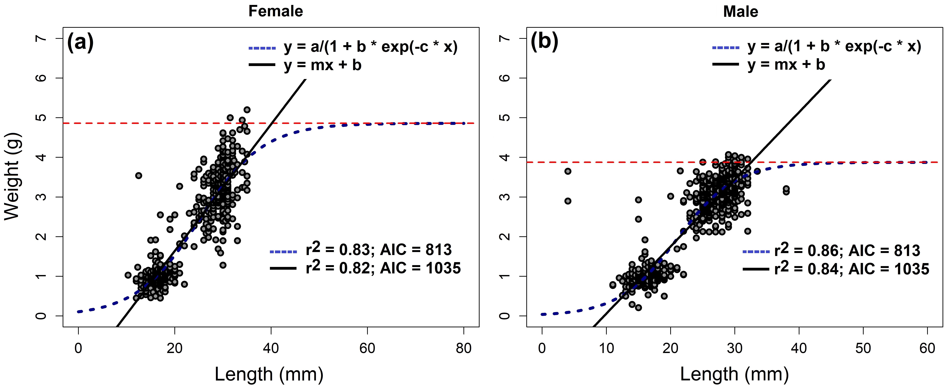
Figure 1. Growth models of E. analoga, a) Allometric relationship between length and weight of females of E. analoga, and b) allometric relationship between length and weight of males. The blue dashed line represents the fitted curve of the Schumacher model, while the solid black line represents the linear model
Table 1. Parameters of Schumacher's mathematical models and linear regression.
Sex | Model | Estimate | Stu. Error | T-value | Pr (>|t|)
Female | Schumacher | a = 5.273 | 0.647 | 8.149 | 1.84E-15
 |  | b = 36.413 | 453.728 | 8.025 | 4.65E-15
 |  | c = 0.136 | 0.013 | 98.43 | < 2e-16
 | Lineal | a = -1.337 | 0.092 | -14.44 | <2e-16
 |  | b = 0.151 | 0.004 | 37.21 | <2e-16
Male | Schumacher | a = 3.918 | 0.108 | 360.77 | <2e-16
 |  | b = 94.891 | 13.535 | 7.011 | 4.79E-12
 |  | c = 0.215 | 0.009 | 21.731 | <2e-16
 | Lineal | a = -1.516 | 0.061 | -247.2 | <2e-16
 |  | b = 0.164 | 0.002 | 59.86 | <2e-16

3.2. Removal of boron in contaminated water using chitin from E. analoga

From 24.25 kg of E. analoga exoskeleton, a total of 250 g of chitin was extracted. Subsequently, the biopolymer obtained was identified and characterized by FTIR before and after boron loading (Figure 2a). The FTIR results show that the bands at 3452 and 3266 cm⁻¹ are attributed to the stretching of OH and NH, respectively, which are similar to the findings from previous studies on pure chitin (Wako Pure Chemical Industry) (Chen et al., 2014) and unpurified chitin (Golden-Shell Biochemical Co. Ltd.) (Li et al., 2021). Likewise, the bands observed between 2886 and 2961 cm⁻¹ correspond to CH stretching and symmetric stretching of CH₃. Additionally, the bands at 1380 and 1312 cm⁻¹ indicate CH bending, symmetrical deformation of CH₃, and movement of CH₂. These patterns were similar to those previously reported by (Chen et al., 2014). However, differences in % transmission levels are attributed to the chitin's origin (fungi, arthropods, etc.), as biosynthesis processes vary among different species and their interactions with other molecules (Dornjak et al., 2022; Li et al., 2021).
The peaks observed at 1662 and 1629 cm⁻¹ are associated with the Amide I band, representing two types of hydrogen bonds found within a C═O group: one formed between the NH group of the adjacent chain, and another between the OH group of the inter-chain. Meanwhile, the Amide II band, have signifies modes of in-plane N–H bending and C–N stretching (Chen et al., 2014). The bands spanning from 1027 to 1163 cm⁻¹ are ascribed to asymmetric oxygen bridging and C-O stretching (Chen et al., 2014). In the FTIR spectrum of the recovered solid, the shape and relative position of all the characteristic peaks remained conserved; however, the intensity varied, indicating modifications in the chemical structure, including the functional groups and the hydrogen bond network (Chen et al., 2014). As shown in Figure 2a, the absorption peaks of amide bands I and II broadened after dissolution and regeneration. The intensity of the peak at 1629 and 1662 cm⁻¹ decreased, while the intensity of the bands ranging from 1027 to 1163 cm⁻¹ increased (Figure 2a). This implies that both intermolecular and intramolecular hydrogen bonds were disrupted and then reformed. Furthermore, the peaks that occurred at 3442 cm⁻¹ and 3265 cm⁻¹ corresponded to the two typical stretching vibrations of O-H and N-H, respectively (Chen et al., 2014), which became less broad due to the formation of hydrogen bonds within the molecular medium during the process of chitin formation.
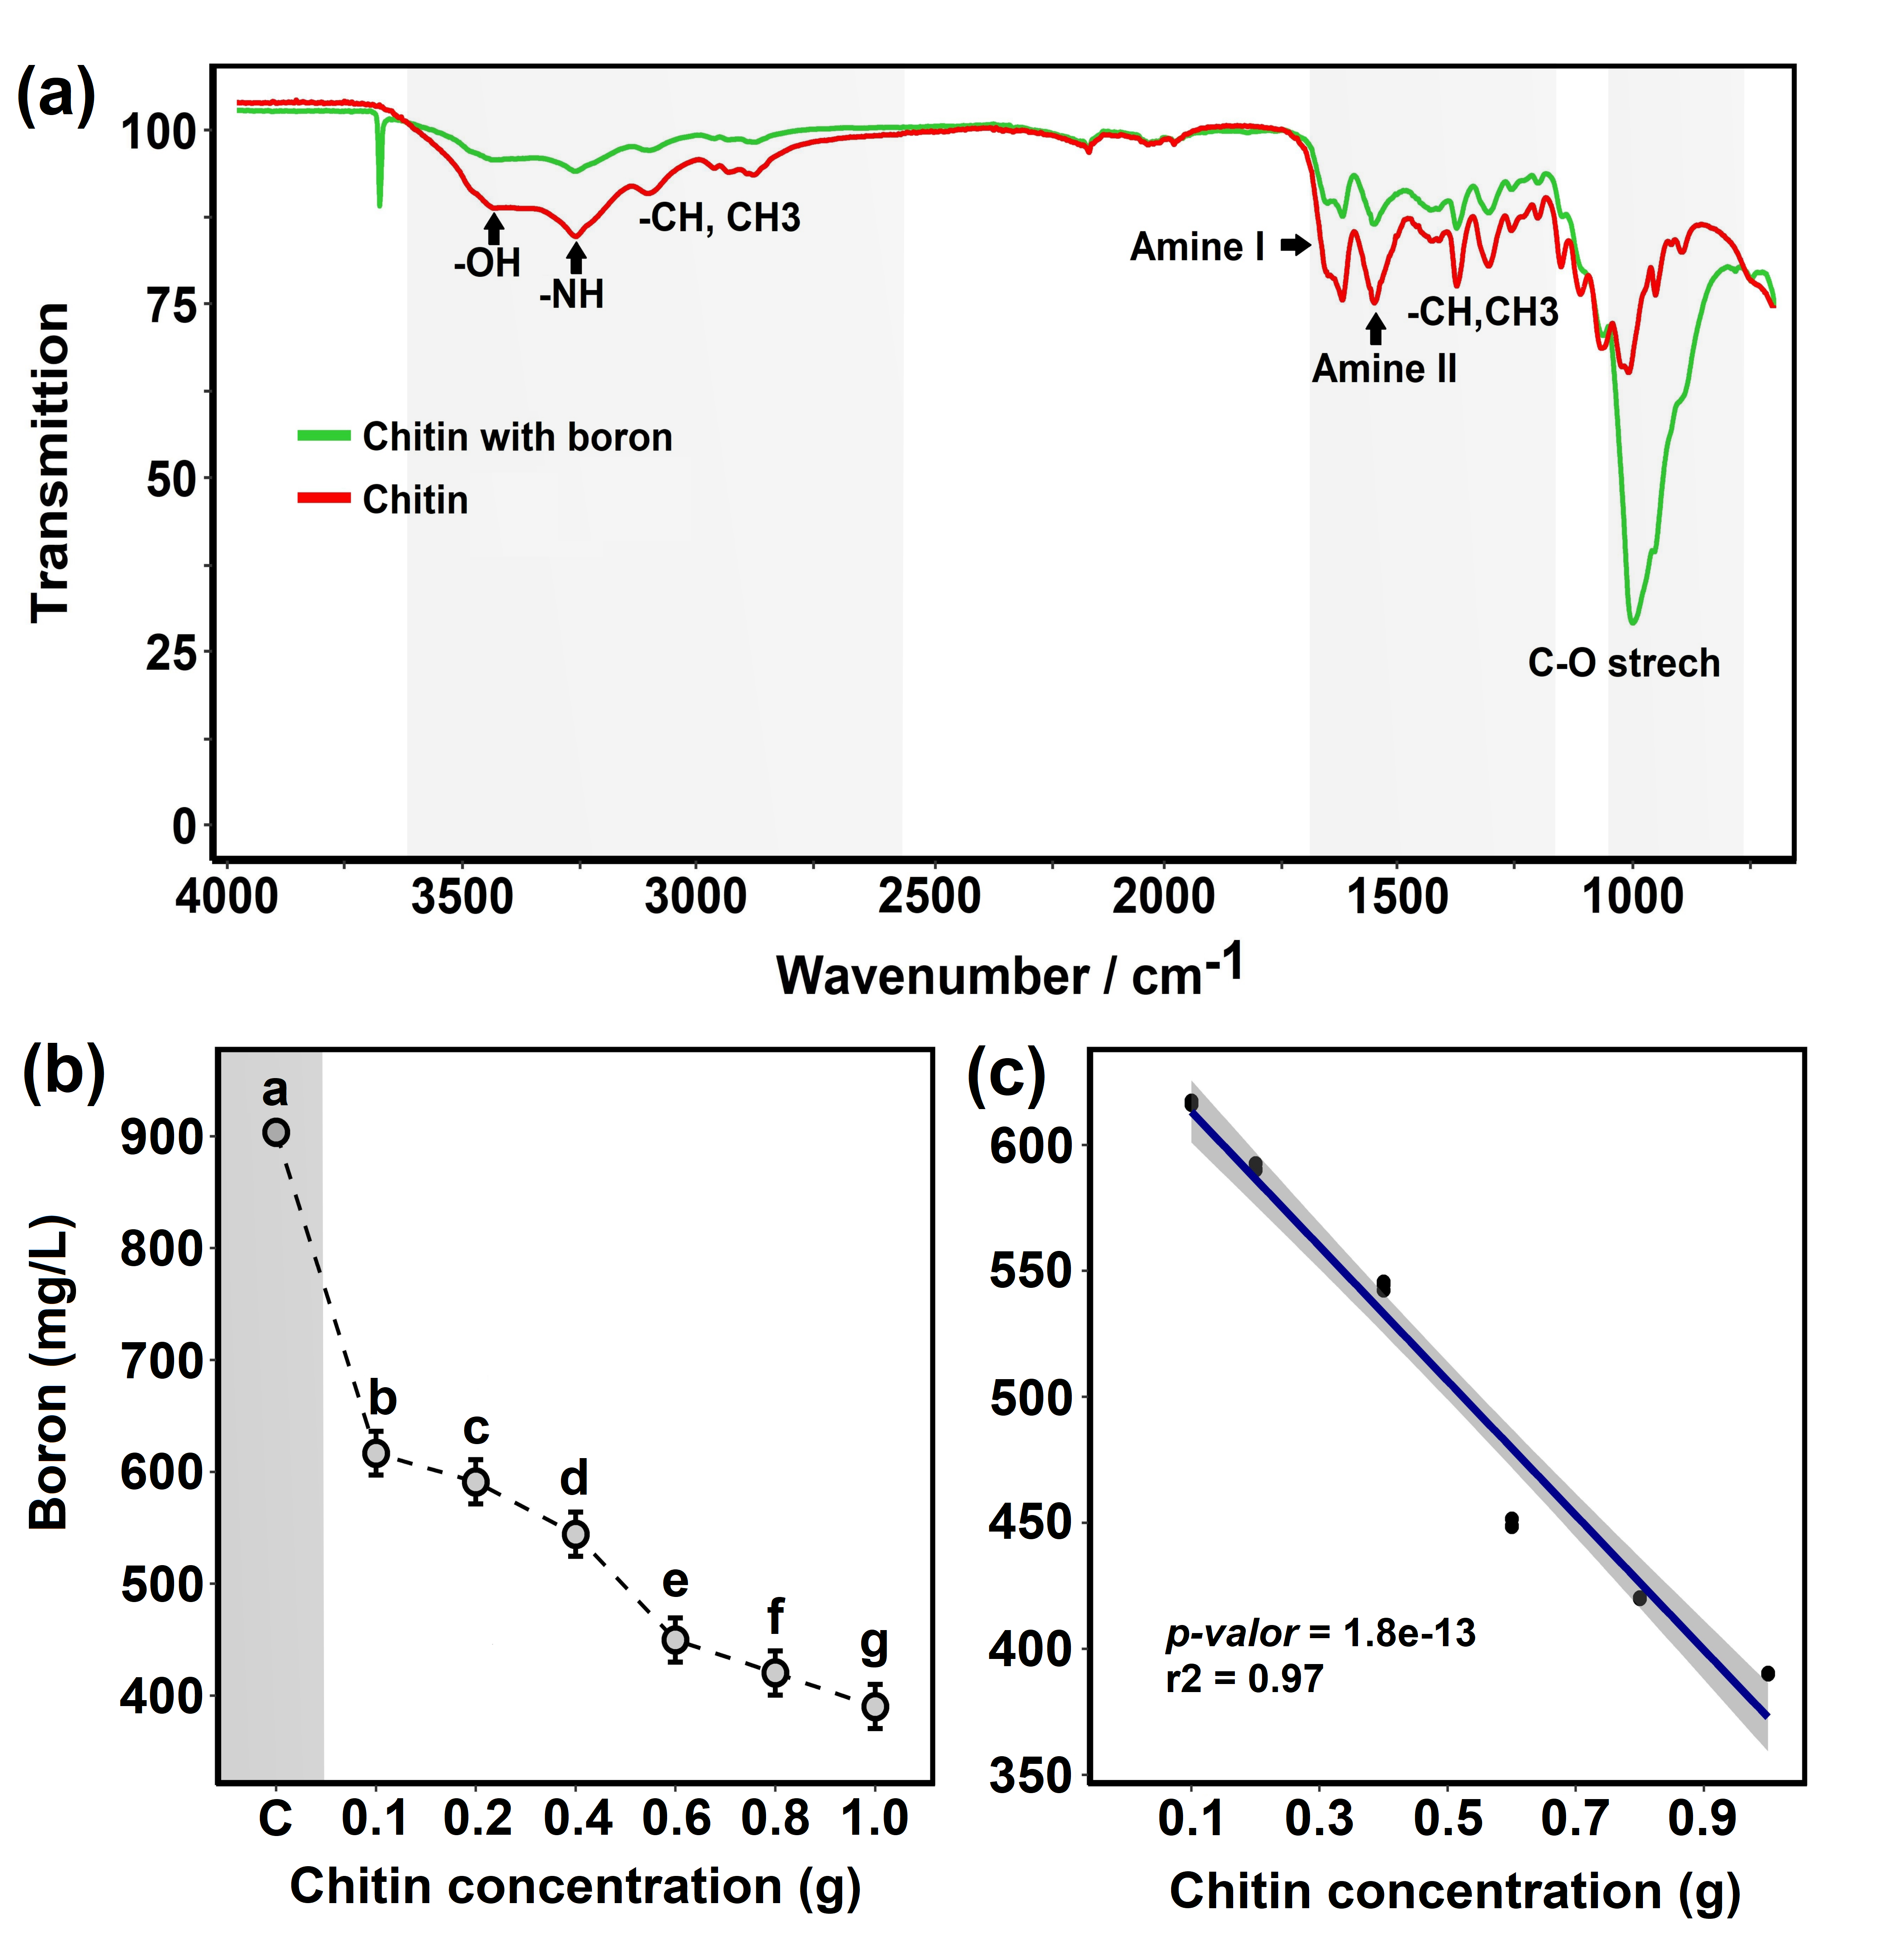
Figure 2. Characterization of chitin by FTIR and Reduction of Boron in contaminated water. a) Identification and characterization of chitin by FTIR before and after B loading. b) Statistical differences in chitin concentration with respect to B reduction. c) Correlation between the amount of chitin used and the B concentration (mg/L).

On the other hand, the results indicate that 1 g of chitin beads allowed the Boron concentration to be reduced from 904 to 390 mg/L, representing a removal of 57% (Figure 2a). However, the linear equation (r² = 0.97, p-value = 1.8e-13) suggests that the greater the amount of chitin, the greater the significant reduction of boron (Figure 2b). Other studies have also recognized chitin as a highly effective biopolymer for removing heavy metals from contaminated waters. Boulaiche et al., (2019), successfully reduced Cd, Ni, Cu, Pb, and Zn levels in contaminated samples. Similarly, in the research conducted by (Abril et al., 2007), a reduction of 65.85% in hexavalent chromium was achieved using 1 g of chitin extracted from the Emerita analoga in 200 ml of contaminated water. Therefore, in our study, we achieved a 57% reduction using 1 g of chitin in a volume of 500 ml

The reduction is attributed to the chemical structure of chitin, which contains hydroxyl (-OH) and acetylamine (-NHCOCH₃) functional groups. These groups possess a pair of free electrons, which participate in the interaction process with boron (Smolarkiewicz-Wyczachowski et al., 2023; Türker and Baran, 2018); in aqueous solutions, the amino groups of chitin ionize, enabling the adsorption of anions from other compounds (Chen et al., 2014; Li et al., 2021). In other words, the interaction between boron and chitin occurs through chemical adsorption. Boron atoms intertwine with the hydroxyl and acetylamine functional groups of chitin, causing these particles to aggregate and precipitate. This process reduces the concentration of boron and the turbidity of contaminated waters (Boulaiche et al., 2019).
4. Conclusions
From 25 kg of E. analoga 25.14 g. of chitin was extracted with a particle size of 500 μm. A total of 1524 individuals of the species E. analoga were characterized, obtaining 862 males and 663 females. The species presents sexual dimorphism, with females reaching an average weight of 5.27 g, while males weigh approximately 3.92 g. With the extracted chitin, 57% of the boron was removed from contaminated waters, reducing the initial high concentration from 904 mg/L to 390 mg/L. Our results demonstrate that chitin beads can effectively reduce high concentrations of metalloids, such as boron, in contaminated water
Acknowledgments
We would like to express our gratitude to Universidad Cesar Vallejo for their financial support in the publication of this scientific article
References
Abril R., Chávez M., Coronel G., and Ramírez D., 2007. Quitosan extraido de Emerita análoga (MUY MUY) absorption of Hexavalent of chromiun in aqueous solutions using chitosan extracted from Emerita analoga (MUY MUY). https://doi.org/10.35286/veritas.v10i1.49
Alfonso P., Ccolqque E., Garcia-Valles M., Martínez A., Yubero M. T., Anticoi, H., and Sidki-Rius N., 2023. Mineralogy and Mineral Chemistry of the Au-Ag-Te-(Bi-Se) San Luis Alta Deposit, Mid-South Peru. Minerals, 13(4). https://doi.org/10.3390/min13040568
Becerra-Lira E., Rodriguez-Achata L., Muñoz Ushñahua, A., Corvera R., Thomas E., Garate-Quispe J., Hilares Vargas L., Nascimento Herbay P. R., Gamarra Miranda L. A., Umpiérrez E., Guerrero J. A., Pillaca M., Cusi E., Peña J., Russo R., del Castillo D., and Velasquez M. G., 2024. Spatio-temporal trends of mercury levels in alluvial gold mining spoils areas monitored between rainy and dry seasons in the Peruvian Amazon. Environmental Research, 245. https://doi.org/10.1016/j.envres.2023.118073
Benguella and Benaissa H., 2002. Cadmium removal from aqueous solutions by chitin: kinetic and equilibrium studies. In Water Research (Vol. 36).
Boulaiche W., Hamdi B., and Trari M., 2019. Removal of heavy metals by chitin: equilibrium, kinetic and thermodynamic studies. Applied Water Science, 9(2). https://doi.org/10.1007/s13201-019-0926-8
Burk G. A., Herath A., Crisler G. B., Bridges D., Patel S., Pittman C. U., and Mlsna T., 2020. Cadmium and Copper Removal From Aqueous Solutions Using Chitosan-Coated Gasifier Biochar. Frontiers in Environmental Science, 8. https://doi.org/10.3389/fenvs.2020.541203
Chen X., Chew S. L., Kerton F. M., and Yan N. (2014). Direct conversion of chitin into a N-containing furan derivative. Green Chemistry, 16(4), 2204–2212. https://doi.org/10.1039/c3gc42436g
De Oliveira Franco L., De Cássia R., Maia C., Lúcia A., Porto F., Arminda, Messias S., Fukushima K., Galba, and De Campos-Takaki M., 2004. HEAVY METAL BIOSORPTION BY CHITIN AND CHITOSAN ISOLATED FROM CUNNINGHAMELLA ELEGANS (IFM 46109). Brazilian Journal of Microbiology, 35, 243–247.
Dornjak L., Kovačić M., Ostojić K., Angaits A., Szpunar J., Urlić I., and Rogina A., 2022. Chitosan-Boric Acid Scaffolds for Doxorubicin Delivery in the Osteosarcoma Treatment. Polymers, 14(21). https://doi.org/10.3390/polym14214753
Elgarahy A. M., Eloffy M. G., Guibal E., Alghamdi H. M., and Elwakeel K. Z., 2023. Use of biopolymers in wastewater treatment: A brief review of current trends and prospects. In Chinese Journal of Chemical Engineering (Vol. 64, pp. 292–320). Materials China. https://doi.org/10.1016/j.cjche.2023.05.018
Kostal J., Prabhukumar G., Lao U. L., Chen A., Matsumoto M., Mulchandani A., and Chen W., 2005. Customizable biopolymers for heavy metal remediation. Journal of Nanoparticle Research, 7(4–5), 517–523. https://doi.org/10.1007/s11051-005-5132-y
Li X., Wang J., Chen H., Xiong C., Shi Z., and Yang Q., 2021. Flexible dielectric nanocomposite films based on chitin/boron nitride/copper calcium titanate with high energy density. Composites Part A: Applied Science and Manufacturing, 149. https://doi.org/10.1016/j.compositesa.2021.106554
Malone A., Smith N. M., Zeballos E., Quispe R., Tapia U., Gutiérrez J. M., Salas G., Madariaga Z., and Herrera J., 2023. Analyzing a deadly confrontation to understand the roots of conflict in artisanal and small-scale mining: A case study from Arequipa, Peru. Extractive Industries and Society, 15. https://doi.org/10.1016/j.exis.2023.101274
Martha J. P., and Manuel Ortega., 2011. Estudio de la distribución de boro en fuentes de agua de la cuenca del rio Duero, Mexico, utilizando análisis estadístico multivariado. Rev. Int. Contam. Ambie., 27(1), 19–30.
Mitra S., Chakraborty A. J., Tareq A. M., Emran T., Bin Nainu F., Khusro A., Idris A. M., Khandaker M. U., Osman H., Alhumaydhi F. A., and Simal-Gandara J., 2022. Impact of heavy metals on the environment and human health: Novel therapeutic insights to counter the toxicity. Journal of King Saud University - Science, 34(3). https://doi.org/10.1016/j.jksus.2022.101865
Nielsen F. H.,2014. Update on human health effects of boron. In Journal of Trace Elements in Medicine and Biology (Vol. 28, Issue 4, pp. 383–387). Elsevier GmbH. https://doi.org/10.1016/j.jtemb.2014.06.023
Nielsen F. H., and Meacham S. L., 2011. Growing Evidence for Human Health Benefits of Boron. In Journal of Evidence-Based Complementary & Alternative Medicine (Vol. 16, Issue 3, pp. 169–180). https://doi.org/10.1177/2156587211407638
Rodríguez M. S., Zalba M., Goitía M. T., Pugliese A., Debbaudt A., Agulló E., Schulz P. C., and Albertengo L. (2012). Calcareous Chitin: A novel low-cost sorbent for Cadmium (II). In Latin American Applied Research (Vol. 42).
Sánchez R., 1988. Algunos aspectos Bio-ecologicos del “Muy Muy” Emerita analoga (Stimpson, 1857) (DECAPODA: ANOMURA) en playas al sur de Lima. https://repositorio.imarpe.gob.pe/bitstream/20.500.12958/2247/1/Sanchez%20Rivas%2c%20G..pdf
Smolarkiewicz-Wyczachowski A., Kaczmarek H., Piskorz J., Nowak P., and Ziegler-Borowska M., (2023). Chitosan Composites Containing Boron-Dipyrromethene Derivatives for Biomedical Applications. International Journal of Molecular Sciences, 24(2). https://doi.org/10.3390/ijms24021770
Tumanyan A. F., Seliverstova A. P., and Zaitseva, N. A., 2020. Effect of Heavy Metals on Ecosystems. Chemistry and Technology of Fuels and Oils, 56(3), 390–394. https://doi.org/10.1007/s10553-020-01149-z
Türker O. C., and Baran T., 2018. A combination method based on chitosan adsorption and duckweed (Lemna gibba L.) phytoremediation for boron (b) removal from drinking water. International Journal of Phytoremediation, 20(2), 175–183. https://doi.org/10.1080/15226514.2017.1350137
Zhang Y., Zhao M., Cheng Q., Wang C., Li H., Han X., Fan Z., Su G., Pan D., and Li Z., 2021. Research progress of adsorption and removal of heavy metals by chitosan and its derivatives: A review. In Chemosphere (Vol. 279). Elsevier Ltd. https://doi.org/10.1016/j.chemosphere.2021.130927
Zia Q., Tabassum M., Gong H., and Li J., 2019. A Review on Chitosan for the Removal of Heavy Metals Ions. In Journal of Fiber Bioengineering and Informatics (Vol. 12, Issue 3, pp. 103–128). Global Science Press. https://doi.org/10.3993/JFBIM00301

