CHEMICAL ENGINEERING TRANSACTIONS  VOL. , 2024 | A publication of
The Italian Association
of Chemical Engineering
Online at www.cetjournal.it

Guest Editors: Leonardo Tognotti, Rubens Maciel Filho, Viatcheslav Kafarov
Copyright © 2024, AIDIC Servizi S.r.l.
ISBN 979-12-81206-09-0; ISSN 2283-9216

Development of flexible fluidised-bed gasification process for co-production of synthesis gas and biochar
Esa Kurkela, Minna Kurkela, Sanna Tuomi, Ilkka Hiltunen
VTT Technical Research Centre of Finland Ltd, P.O. Box 1000, FI-02044 VTT, Finland
esa.kurkela@vtt.fi
In the FlexSNG project, a fluidized-bed gasification process is developed that can co-produce biochar and good-quality synthesis gas and can also switch between two operation modes: (1) co-producing biochar and synthesis gas that is further converted to biomethane or other synthesis products, and (2) maximizing the fuel conversion to syngas. Three test runs were conducted at an atmospheric-pressure Circulating Fluidized-Bed (CFB) gasification test rig of VTT to identify optimal gasification and gas clean-up process conditions for both operation modes. The studied gasification process consists of a fluidized-bed gasifier, a hot gas filter and a catalytic reformer. The tests were focused on finding optimal process conditions in the gasifier for the co-production of biochar and synthesis gas from woody residues and straw. Two different operating principles were examined: an ordinary CFB gasifier operated at different temperatures and a so-called Bubbling Circulating Fluidized-Bed (BCFB), in which the lower part of the gasifier is operated at low temperature and secondary oxygen is used to raise the temperature in the upper part of the gasifier.
  - introduction
A fluidized-bed reactor is one of the leading reactor types applied for biomass and waste gasification (Lopes Motta et al., 2018). It is especially suitable for inhomogeneous feedstocks that have high volatile matter content and high char reactivity. The massive bed stabilizes pyrolysis, gasification and combustion reactions and helps to maintain good mixing of the reacting feedstock particles and gasification agents (Kuba et al., 2021). The temperature distribution throughout the gasifier is also rather uniform, which is not the case in fixed-bed or entrained-flow gasifiers. The principal differences between the two basic types of the fluidized-bed gasifier (BFB and CFB) and the third modified version (BCFB) also applied in the experiments of this paper are described in detail in (Kurkela et al., 2022).
The original hypothesis of the FlexSNG project (FlexSNG, 2021) was that the circulating fluidized-bed (CFB) reactor could not be operated in a flexible way also enabling biochar production. Consequently, a bubbling circulating fluidized-bed (BCFB) gasifier design was considered to offer the best potential for flexible operation. The BCFB is essentially a combination of a bubbling fluidized-bed (BFB) bottom and a CFB top aiming to couple the benefits of both reactor technologies. In this process, the feeding of gasification agents (a mixture of steam/CO₂ and oxygen) is divided into primary and secondary feeds. A mixture of coarse and hard bed material (sand) with finer and softer material (dolomite) is used to achieve a stable bubbling bed at the bottom of the reactor and a circulating fluidized-bed above the dense bed. The upper part of the reactor operates in circulating fluidized-bed mode to partially decompose tars before subsequent clean-up steps and thus preventing tar-related issues downstream of the gasifier, e.g. tar deposition, filter blinding, or catalyst coking. This is achieved by introducing a catalytically active bed material (e.g. limestone or dolomite) in the top section and elevating the temperature to 850-900 °C through secondary steam and oxygen injection. The presence of fine particles provides the required active surfaces for tar decomposition reactions. In the case of an ordinary CFB gasifier, flexible operation is achieved by operating the gasifier over a vast temperature range.
  - Experimental
    - CFB and BCFB pilot plant
The test runs were carried out at the pilot plant illustrated in Figure 1. The pilot plant consisted of a fluidized-bed gasifier followed by hot filtration, catalytic reforming and two gas coolers located in between the gasifier and the filter and after the catalytic reformer. Furthermore, a sorbent-based final gas cleaning can be tested in a slip stream of the gasifier.
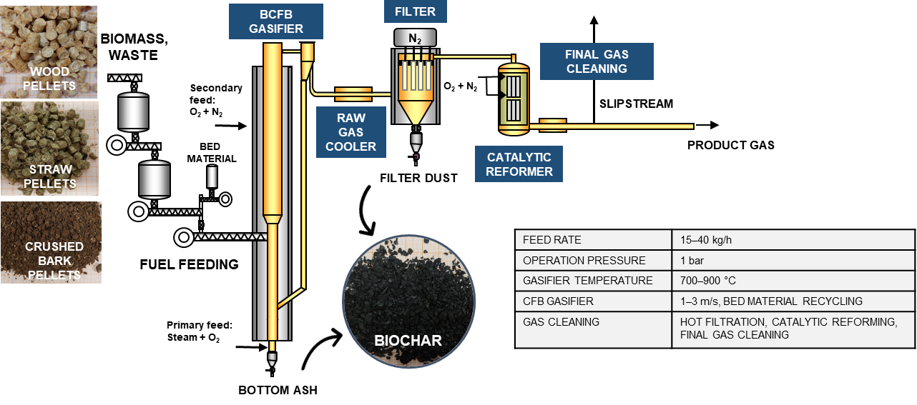
Figure 1: Bubbling Circulating Fluidized-Bed (BCFB) gasifier at VTT’s Piloting Centre Bioruukki, Finland.
For the tests of this paper, the pre-existing Dual Fluidized-Bed (DFB) gasifier described in (Kurkela et al., 2019) was modified to allow flexible operation under BCFB as well as CFB mode of operation. This work consisted of: a) converting the dual fluidized-bed gasifier to a steam-oxygen-blown CFB gasifier, b) lowering the fluidization gas distributor to create a deeper bed and simulating BCFB design where the recycling material is fed to the upper part of the denser section of the bed, c) applying a uniform reactor diameter of 102 mm (no freeboard enlargement) to increase the gas velocity at the upper part of the reactor (also related to BCFB design). After the first test week carried out in week 42 of 2022, the inner tube of 102 mm diameter was removed from the upper part of the gasifier and the reactor was returned to the original dimensions described in (Kurkela et al., 2019). A secondary oxygen feeding point was added to the upper part of the gasifier where the diameter was enlarged from 102 mm to 154 mm. In the tests of this paper, the fuel feeding point was located at 1365 mm and the cyclone recycle at 555 mm above the distributor plate.
The raw gas was filtered using 12 one-meter-long metal candle filter elements organized in four clusters as described in (Tuomi et al., 2019). The filters were pulse-cleaned with nitrogen at regular intervals to detach the accumulated filter dust and maintain a stable pressure drop. The filtered raw gas was led into a two-stage catalytic reformer, which was loaded with granular nickel catalysts supplied by project partner Johnson Matthey. The inner diameter and length of the first bed were 220 mm and 300 mm and those of the second bed were 290 mm and 300 mm respectively. The reformer was operated autothermally, and the target operation temperatures were reached by controlling the oxygen feed rates.
2.2 Gasifier feedstocks
Table 1 presents the averaged results for the analyses of the feedstocks used in the test campaigns. All feedstocks were pelletized. Bark pellets were crushed to below 8 mm sieve before use. Mixtures of silica sand with a wide particle size distribution of 0.1-0.8 mm and Myanit dolomite (0.1-0.8 mm) were used as the bed material.
Table 1: Feedstock analyses as used in the gasification campaigns.
 | Moisture  wt% | Volatiles  wt% d.b. | C | H | N | wt% d.b.  Cl | S | O | Ash | LHV  MJ/kg d.b.
Bark  Wood  Straw | 9.4  7.5  7.7 | 73.5  78.0  74.8 | 51.6  50.2  45.9 | 5.7  6.5  6.1 | 0.5  0.1  0.3 | 0.008  0.002  0.087 | 0.03  0.01  0.08 | 38.3  42.9  41.2 | 3.9  0.3  6.3 | 19.3  18.9  17.2

  - Gasification results
Gasification tests were carried out during three separate weeks in autumn 2021 and early 2022. During each test week, several setpoints (4 to 12 hours long) were realized during which the feed rates of gasification agents and biomass were kept constant. The operation methods, analytical procedures, and methods for calculating mass balances and performance indicators were similar as those described in (Kurkela et al., 2019). Based on the averaged measuring results elemental mass balances and product yields were calculated. In the following the gasification results are presented separately for the setpoints simulating CFB and BCFB operations.
    - CFB gasification tests
The CFB setpoints presented in Table 2 were measured in week 18 of 2022 (22/18) and week 42 of 2021 (21/42). The carbon conversion to dry gas, tars and solid output streams are illustrated in Figure 2.
Table 2: Main operating conditions of the gasifier at the CFB setpoints.
Setpoint  Feedstock | 22/18H  Wood | 22/18B  Wood | 21/42A  Bark | 21/42C  Bark | 22/18C  Straw | 22/18F  Straw
Fuel feed rate, g/s | 6.2 | 4.0 | 4.8 | 4.8 | 4.6 | 6.0
Bed additives*  Sand + dolomite feed, g/s  Primary O₂ feed, g/s  Primary air feed, g/s  Secondary O₂ feed, g/s  N₂ feed, g/s  Steam feed, g/s  T bed, °C  T freeboard, °C  Fluidization velocity, m/s  Wet gas flow rate, m³/h (STP**) | ½S+½D  0.41  2.42  0  0.2  2.7  3.5  892  894  2.8  53.1 | ½S+½D  0.25  1.21  0  1.2  3.7  3.5  746  757  2.1  44.6 | ¹/₃S+²/₃D  0.55  1.50  0.69  0  2.0  3.5  883  874  2.7  43.8 | ¹/₃S+²/₃D  0.55  1.10  0.68  0  2.0  2.4  818  806  1.9  38.0 | ½S+½D  0.41  1.19  0  0.2  3.5  3.5  753  759  2.1  43.1 | ½S+½D  0.57  1.76  0  0.2  2.7  3.5  834  824  2.4  49.0
Dry gas composition, vol%  CO  CO₂  H₂  N₂ (as difference)  CH₄  C₂H_{y}  C₃-C₅Hy  H₂O in wet gas, vol% | 16.9  28.0  26.4  21.8  5.62  1.22  0  34.8 | 16.6  19.8  11.1  45.2  5.32  1.91  0.08  44.8 | 12.9  29.6  26.4  24.7  4.72  1.68  0  37.3 | 15.0  25.6  27.8  24.9  4.74  1.90  0.04  28.8 | 11.4  23.7  15.9  41.9  5.07  1.90  0.13  47.2 | 13.6  28.1  26.8  25.0  4.92  1.56  0.02  38.4
Tars + benzene, g/m³_{STP} | 13.9 | 19.5 | 16.6 | 14.8 | 16.8 | 12.3
Filter temperature, °C  Dust content in filter inlet, g/m³_{STP}  Filter pressure drop, mbar  Filter face velocity, cm/s | 552  7.1  35  2.0 | 548  6.9  26  1.7 | 549  25.7  22  1.7 | 547  37.6  23  1.5 | 548  54.9  39  1.6 | 550  50.0  41  1.8
C-conversion to gas & tars, % | 98.3 | 96.1 | 94.8 | 90.6 | 80.5 | 89.8
* S + P3: The mixture of sand and Myanit dolomite, ** STP: at 273.15 K and 101,325 kPa
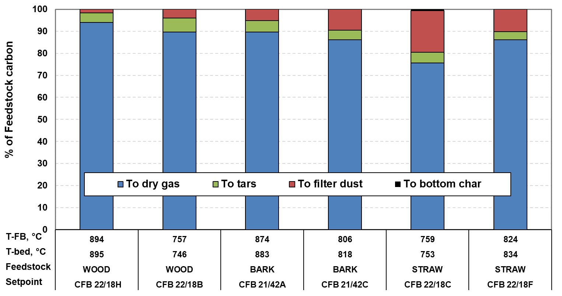
Figure 2: Conversion of feedstock carbon at the CFB setpoints.
The differences between the gasification behaviour of these three biomass qualities can be seen in the carbon conversion results (Figure 2) as well as in the measured tar and benzene concentrations illustrated in Figure 3. Straw ash contains high levels of potassium and silica and therefore, it must be gasified at a lower temperature than woody biomass feedstocks to avoid ash sintering and fouling problems. However, the tar concentrations of straw gasification carried out at 824 °C, are of the same order of magnitude as determined in wood gasification at 70 °C higher temperature. The low temperature tar, however, contains more low-molecular weight components like toluene and phenol, while the concentrations of naphthalene and PAH components are higher in high-temperature wood gasification. As illustrated in Figure 2, carbon conversion to gas and tars in the gasification of clean wood is significantly higher than in straw or bark gasification. Even at 750 °C, 96 % of wood carbon is converted to dry gas and tars. Thus, with this type of feedstock that has very high volatile matter content it is difficult to produce significant amounts of biochar. Bark and straw have lower volatile matter contents and consequently, it is possible to produce more biochar even in CFB gasification although the CFB gasifier typically has higher carbon conversion efficiencies than BFB gasifiers (Kurkela et al., 2022).
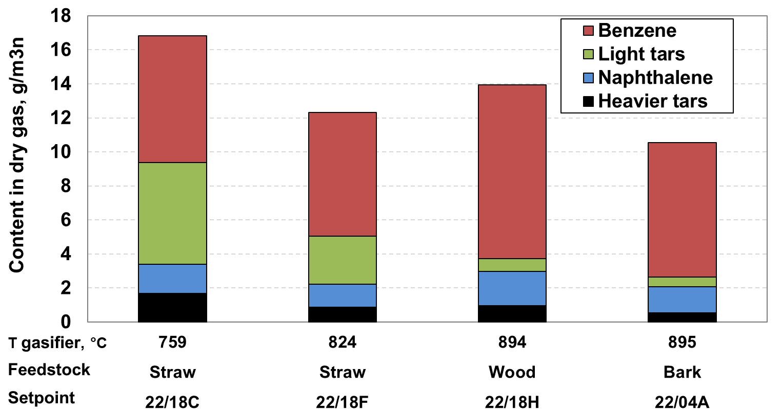
Figure 3: Measured benzene and tar concentrations in selected CFB test points.
The operation of the whole gasification process was very stable in all CFB gasification tests, and it was easy to change the operating conditions as well as to shift the gasifier from wood to straw gasification. No signs of ash-related problems were met, and the pressure drops of the filter unit and catalytic reformer remained constant in all CFB setpoints. However, as illustrated in Figure 2 practically no biochar was recovered as bottom char because biochar was attrited to fine particles, which finally passed the recycling cyclone and ended to filter fines.
    - BCFB gasification tests
The test run of week 4 of 2022 was focused on exploring the potential for biochar production with the BCFB gasifier. The main operating conditions are summarized in Table 3 and the carbon conversions are illustrated in Figure 4. Five setpoints were realized; the first 22/04A was a reference setpoint carried out in CFB mode. In setpoints 22/04B, 22/18C, 22/18D and 22/18D2, the gasifier was operated according to the BCFB principle. The gasifier bed was operated at a lower temperature and using fluidizing velocities typical to BFB gasifiers. Secondary oxygen was fed to the freeboard which resulted in increased temperature and gas velocity. In setpoints B, C and D, silica sand was used as bed material, while the last setpoint D2 was carried without bed material feeding and the bed was then composed of only wood char particles.
As illustrated in Figure 4, almost 15 % of bark carbon ends up in the biochar already in the first BCFB setpoint 22/04B. When the bed temperature was decreased from 740 °C to ca. 705 °C in setpoint C, the biochar yield increased to 25 % and by shifting even more of oxygen from primary to secondary feeding, the biochar yield raised to over 30 % (of bark carbon). However, at setpoints B, C and D where sand was used to stabilize the bed, almost all biochar was attrited into fine particles which were then captured by the hot filter. The yield of coarser bottom char could be increased only by operating the gasifier without additional inert bed material. Even at the last setpoint D2, however, roughly two thirds of biochar was captured as filter fines. The tar contents measured in the BCFB setpoints (see Table 3) were relatively low considering the low gasification temperature applied. Especially in setpoints where most of the oxygen was fed into the freeboard, at least part of tars was decomposed already in this secondary gasification zone. The operation of the gasifier was rather unstable in the last setpoint, which was observed as very large variation in bed temperatures and bed pressure drops. The presence of sand or dolomite in the bed and the recycling solids stream stabilizes the gasifier operation but, on the other hand, results in crushing the softer biochar particles into fine dust, which cannot be captured as bottom biochar. After test run 22/04, it was noticed that part of bark ash had sintered in the freeboard evidently when passing through the high-temperature flame of the secondary oxygen feed. This would also create challenges in designing gasification systems based on staged BFB reactors.

Table 3: Main operating conditions of the BCFB gasifier at the setpoints in week 22/04.
Setpoint  Feedstock | 22/04A  Bark | 22/04B  Bark | 22/04C  Bark | 22/04D  Bark | 22/04D2  Bark
Fuel feed rate, g/s | 4.8 | 4.8 | 4.8 | 4.8 | 4.8
Bed additives*  Sand + dolomite feed, g/s  Primary O₂ feed, g/s  Primary air feed, g/s  Secondary O₂ feed, g/s  N₂ feed, g/s  Steam feed, g/s  T bed, °C  T freeboard, °C  Fluidization velocity, m/s  Gas velocity at gasifier top, m/s  Wet gas flow rate, m³/h (STP**) | ¹/₃S+²/₃D  0.25  1.67  0  0  3.0  3.5  882  895  2.6  2.9  46.7 | S  0.25  0.91  0  0.6  4.2  2.0  740  825  1.3  2.3  41.6 | S  0.5  0.61  0  0.89  4.2  1.7  704  826  1.0  2.2  38.1 | S  0.5  0.41  0  1.29  4.2  1.7  706  863  0.93  2.2  37.2 | -  0  0.29  0  1.34  4.2  1.7  661  859  0.86  2.2  37.2
Dry gas composition, vol%  CO  CO₂  H₂  N₂ (as difference)  CH₄  C₂H_{y}  C₃-C₅Hy  H₂O in wet gas, vol% | 16.3  22.6  27.5  28.4  4.19  1.01  0  32.2 | 12.2  20.3  18.3  42.2  4.46  1.53  0.02  27.9 | 13.0  20.0  16.8  44.3  4.46  1.45  0.02  29.3 | 14.0  19.1  18.6  43.3  3.90  1.02  0  31.9 | 13.7  18.8  18.7  44.0  3.78  0.98  0  31.6
Tars + benzene, g/m³_{STP} | 10.5 | 14.9 | 14.3 | 9.3 | 9.3
Filter temperature, °C  Dust content in filter inlet, g/m³_{STP}  Filter pressure drop, mbar  Filter face velocity, cm/s | 550  25  27  1.8 | 548  38  35  1.6 | 548  64  39  1.4 | 522  90  36  1.4 | 516  65  36  1.4
C-conversion to gas and tars, % | 93.5 | 85.7 | 75.5 | 67.5 | 66.6
* S + P3: The mixture of sand and Myanit limestone, ** STP: at 273.15 K and 101,325 kPa
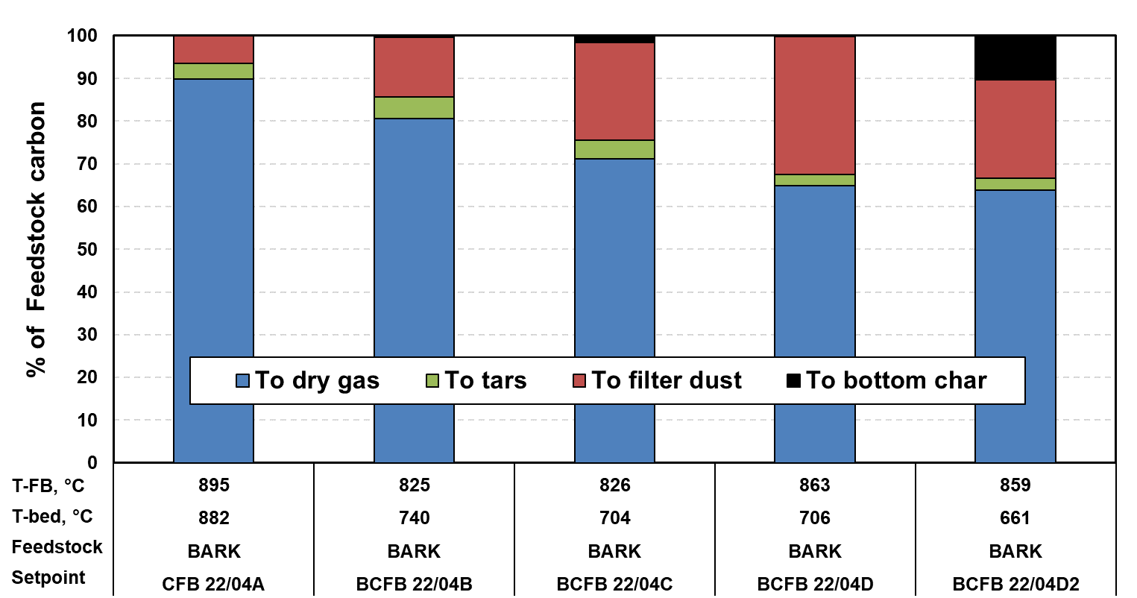
Figure 4: Carbon conversions in BCFB gasification tests.
  - Catalytic reforming results
The catalytic reformer was operated with the same set of nickel catalysts in all three test runs. The operating conditions and achieved conversions of tars, benzene, C₂-hydrocarbons and methane are summarized in Table 4. The residual benzene and tar concentrations measured after the reformer are shown in Figure 5. In setpoints 22/18C and 22/18H, the effect of the operating temperature of the second reformer bed on the achieved conversions and residual tar contents was studied. The gasifier was operated under constant conditions at these sub-setpoints. The results show that with clean wood (sulfur content 0.01 %) the tar conversion is complete already at a reformer outlet temperature of 860 °C, while with straw (sulfur content 0.08 %) the required temperature is ca. 70 °C higher. The results also indicate that selective reforming of tar and benzene without extensive conversion of methane is not feasible at least with these nickel-based catalysts; complete reforming of tars and benzene was found to result in ca. 50 % conversion of methane in the reformer.
The operation of the reformer was stable in all setpoints, and the pressure drop remained constant. No signs of soot formation were detected after the final test run when the reformer was opened for inspection and the catalyst particles looked intact. Further increase in methane and benzene reforming could be achieved with a three-stage design instead of the two-stage reformer tested in these tests. Alternatively, the reformer outlet temperature could be increased to 900 °C with low-sulfur feedstocks and to 950 °C with straw and other residues with higher sulfur content. These potential improvements will be tested in the next phase of the project.
Table 4: Main operating conditions and achieved conversions in the reformer at selected setpoints.
Setpoint  Feedstock | 22/18C4  straw | 22/18C1  straw | 22/18C2  straw | 22/18C3  straw | 22/18H1  wood | 22/18H2  wood | 22/18H3  wood | 22/04A  bark
Wet gas flow to reformer, g/s  O₂ feed to reformer (stage 1 & 2), g/s  N₂ feed to reformer (stage 1 & 2), g/s  Steam feed to reformer (stage 1 & 2), g/s  Reformer stage 1 outlet temperature, °C  Reformer stage 2 outlet temperature, °C  GHSV - stage 1 (273.15 K, 1.01325 bar)  GHSV - stage 2 (273.15 K, 1.01325 bar)  Wet gas flow after reformer, g/s  Tar conversion, %  Benzene conversion, %  C₂Hy conversion, %  Methane conversion, % | 12.4  0.74  0.2  1.6  880  923  4240  2790  15.1  100  96.8  100  59.2 | 12.1  0.61  0  1.6  865  900  4140  2730  14.5  99.8  94.9  100  46.4 | 12.3  0.48  0.2  1.6  873  872  4220  2730  14.7  98.9  83.1  98.0  27.1 | 12.4  0.34  0.4  1.6  877  838  4250  2770  14.9  96.6  66.2  95.6  19.5 | 14.6  0.76  0.2  1.6  857  890  5030  3310  17.5  100  99.2  100  71.0 | 14.8  0.58  0.2  1.6  854  860  5060  3300  17.5  100  97.9  100  47.8 | 15.3  0.40  0.4  1.6  857  827  5210  3400  18.2  99.4  95.3  100  36.9 | 12.3  0.51  0  1.7  873  871  4510  2930  15.0  99.7  97.1  100  49.7
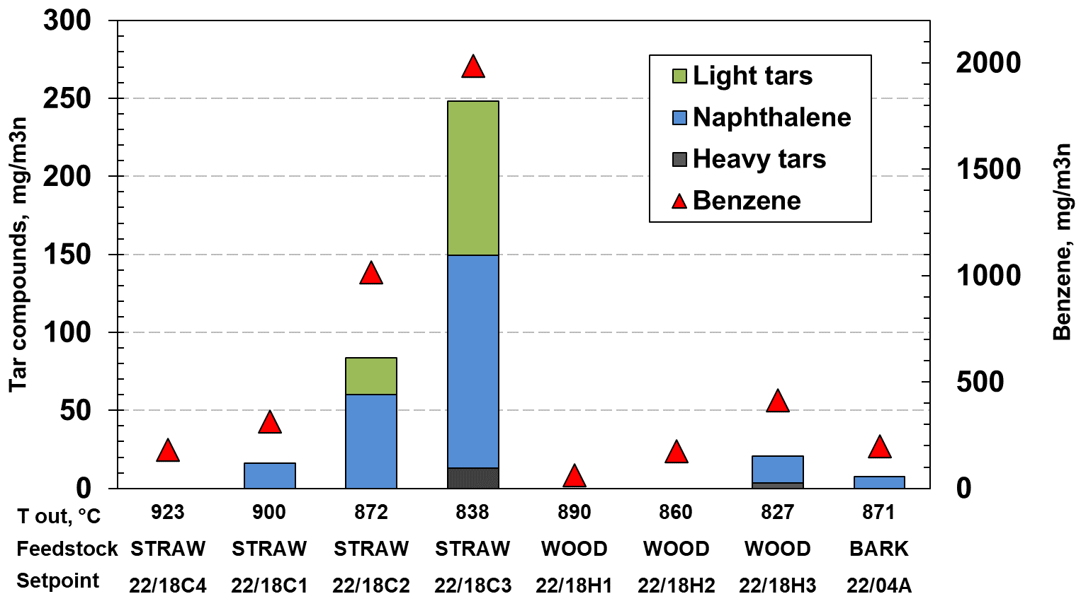
Figure 5: Benzene and tar concentrations measured after the reformer.
  - Conclusions and further R&D
These tests showed that both CFB and BCFB gasifiers can be operated flexibly to either maximize the syngas yield or co-produce syngas and biochar. The BCFB gasifier has potential for higher biochar yields but the CFB gasifier is more flexible and could be operated with various feedstocks without operational problems. Especially the BFB operation without an external bed material and with a high degree of secondary oxygen feeding was found to be unstable and led to deposit formation in the upper part of the gasifier. The work of the project will continue at VTT with a pressurized CFB gasification test rig.
Acknowledgements
This work is part of the FlexSNG project, which has received funding from the European Union’s Horizon 2020 Research and Innovation Programme under Grant Agreement No 101022432 and the Government of Canada’s New Frontiers in Research Fund and the Fonds de recherche du Québec.
References
FlexSNG-project presentation, 2021, <https://cordis.europa.eu/project/id/101022432> accessed 18.12.2023.
Kuba, M., Skoglund, N., Öhman, M., Hofbauer, H.,2021, A review on bed material particle layer formation and its influence on the performance of thermo-chemical biomass conversion. Fuel, 291, 120214.
Kurkela E., Kurkela M., Hiltunen I., 2022, Development of a bubbling circulating fluidized-bed reactor for biomass and waste gasification. Chemical Engineering Transactions, 92, 385-390.
Kurkela, E., Kurkela, M., Tuomi, S., Frilund, C., & Hiltunen, I., 2019, Efficient use of biomass residues for combined production of transport fuels and heat. VTT Technology No. 347.
Lopes Motta, I., Toscano Miranda, N., Maciel Filho, R., Wolf Maciel, M., 2018, Biomass gasification in fluidized beds. Renewable and Sustainable Energy Reviews, 94, 998-1023.
Tuomi S., et al., 2019, Novel sintered metal filter elements: Performance evaluation in biomass gasification conditions, In FILTECH 2019, Conference proc. Cologne, Germany.

